////////////////////////////////////////////////////////////////////////////////////
// Running the start-up codes in VSCode:

Run VSCode, then open the folder containing your program.
Select the file, named tasks.json.

As shown below, locate the “command” entry, then change the folder according to your gcc installation location in your machine.

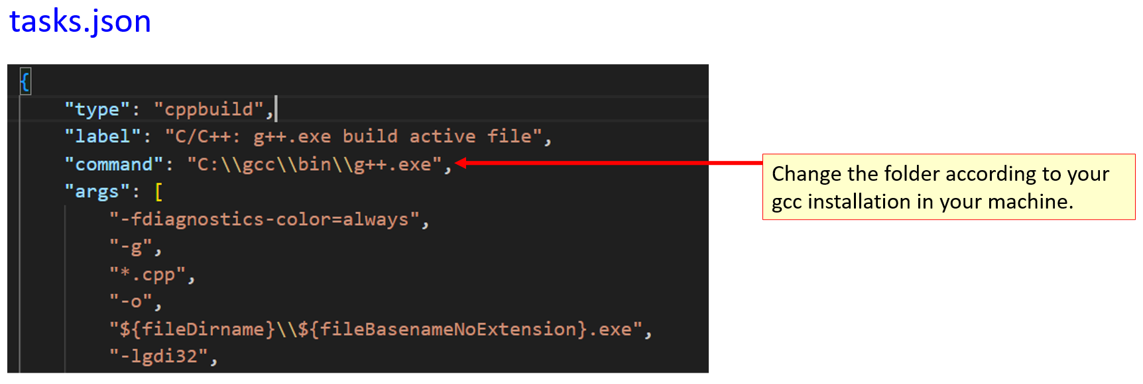

Press Ctrl + Shift + B to build the codes.
Open a command prompt where your program resides.

Run the program via the command prompt. Note that the program expects some arguments. Look at the sample command lines below.
//////////////////////////////////////////////////////
// sample command lines
//////////////////////////////////////////////////////

search.exe.exe "single_run" astar_explist_manhattan "608435127" "123456780"
search.exe.exe single_run astar_explist_manhattan 608435127 123456780
search.exe.exe "animate_run" astar_explist_manhattan "608435127" "123456780"
search.exe.exe "batch_run" astar_explist_manhattan
search.exe.exe "batch_run" astar_explist_misplacedtiles
search.exe.exe "batch_run" uc_explist
search.exe.exe "batch_run" all

