SKILL DEVELOPMENT COURSE (NODE JS / REACT JS / DJANGO) – LAB MANUAL

Experiment 10
AIM: Develop an Express web application that can interact with a REST API to perform CRUD operations on student data (use Postman).
DESCRIPTION: We build a REST API using Express with an SQLite database. The API exposes endpoints to create, read, update and delete student records, and each endpoint is tested using Postman.

Setup
- Create a new folder and open it in a terminal.
- Initialise the project: npm init -y
- Open the folder in VS Code: code .
- Install the required packages: npm install express sqlite3
- Create two files named db.js and app.js.

Project Structure
experiment-10/
├── app.js
├── db.js
├── mydatabase.db # created automatically
└── package.json

Code
db.js
const sqlite3 = require('sqlite3').verbose();

// Function to initialize the database schema
function initializeDatabase() {
const db = new sqlite3.Database('./mydatabase.db', (err) => {
if (err) {
console.error(err.message);
} else {
console.log('Connected to the SQLite database.');
createStudentsTable(db);
}
});

// Close the database connection when the Node process exits
process.on('exit', () => {
db.close((err) => {
if (err) {
console.error(err.message);
} else {
console.log('Disconnected from the SQLite database.');
}
});
});
}

// Function to create the 'students' table if it doesn't exist
function createStudentsTable(db) {
const createTableQuery = `
CREATE TABLE IF NOT EXISTS students (
id INTEGER PRIMARY KEY AUTOINCREMENT,
name TEXT,
age INTEGER,
grade TEXT
);
`;

db.run(createTableQuery, (err) => {
if (err) {
console.error(err.message);
} else {
console.log('The students table has been created or already exists.');
}
});
}

module.exports = { initializeDatabase };

// Running "node db.js" directly creates mydatabase.db with the students table
if (require.main === module) {
initializeDatabase();
}

When db.js (or app.js) is executed, the database file mydatabase.db is created together with the students table.
app.js
const express = require('express');
const sqlite3 = require('sqlite3');
const { initializeDatabase } = require('./db');

const app = express();
const port = 3000;

// Make sure the database file and the students table exist
initializeDatabase();

// Connect to SQLite database
const db = new sqlite3.Database('./mydatabase.db', (err) => {
if (err) {
console.log(err.message);
} else {
console.log('Connected to the SQLite database.');
}
});

// Middleware to parse request body as JSON
app.use(express.json());

app.get('/', (req, res) => {
res.send('Welcome to the Student');
});

// READ: get all students
app.get('/students', (req, res) => {
db.all('SELECT * FROM students', [], (err, rows) => {
if (err) {
return res.status(500).json({ error: err.message });
}
res.json(rows);
});
});

// READ: get a single student by id
app.get('/students/:id', (req, res) => {
const id = req.params.id;
db.get('SELECT * FROM students WHERE id = ?', [id], (err, row) => {
if (err) {
return res.status(500).json({ error: err.message });
}
if (!row) {
return res.status(404).json({ error: 'Student not found' });
}
res.json(row);
});
});

// CREATE: add a new student
app.post('/students', (req, res) => {
const { name, age, grade } = req.body;
db.run(
'INSERT INTO students (name, age, grade) VALUES (?, ?, ?)',
[name, age, grade],
function (err) {
if (err) {
return res.status(500).json({ error: err.message });
}
res.status(201).json({ id: this.lastID });
}
);
});

// UPDATE: update an existing student
app.put('/students/:id', (req, res) => {
const id = req.params.id;
const { name, age, grade } = req.body;
db.run(
'UPDATE students SET name = ?, age = ?, grade = ? WHERE id = ?',
[name, age, grade, id],
function (err) {
if (err) {
return res.status(500).json({ error: err.message });
}
res.json({ updatedID: id });
}
);
});

// DELETE: remove a student
app.delete('/students/:id', (req, res) => {
const id = req.params.id;
db.run('DELETE FROM students WHERE id = ?', id, function (err) {
if (err) {
return res.status(500).json({ error: err.message });
}
res.json({ deletedID: id });
});
});

app.listen(port, () => {
console.log(`Server running at http://localhost:${port}`);
});

Run the server
node app.js

API Endpoints
- GET / – welcome message
- GET /students – list all students
- GET /students/:id – get one student
- POST /students – create a student
- PUT /students/:id – update a student
- DELETE /students/:id – delete a student

Output (Postman)

GET – Welcome route
- Open Postman.
- Set the request type to GET.
- Enter the URL: http://localhost:3000/.
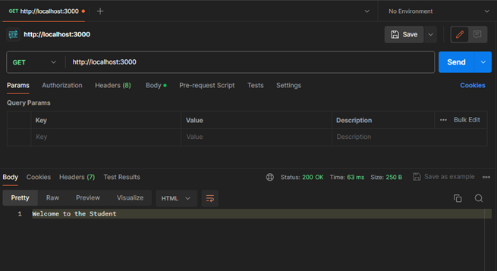
GET http://localhost:3000/

POST – Create a new student
- Set the request type to POST.
- Enter the URL: http://localhost:3000/students.
- Go to the Body tab, select raw and set the format to JSON.
- Enter a body such as {"name": "Hemanth", "age": 21, "grade": "A"} and click Send.
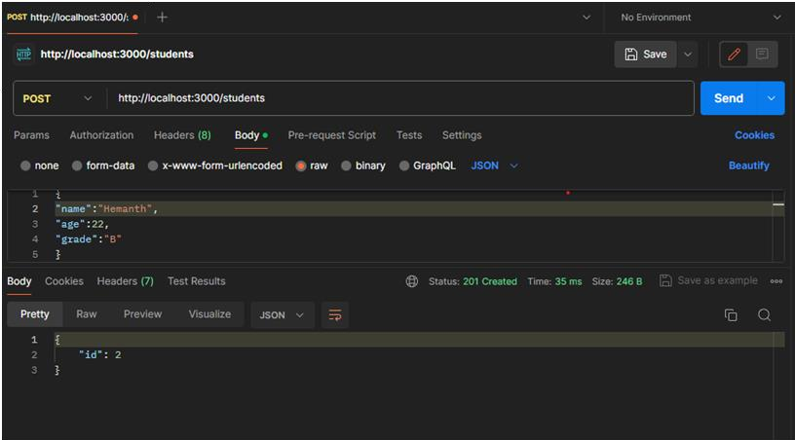
POST http://localhost:3000/students

GET – All students
- Set the request type to GET.
- Enter the URL: http://localhost:3000/students and click Send.
- You receive the details of all students stored in the SQLite database.
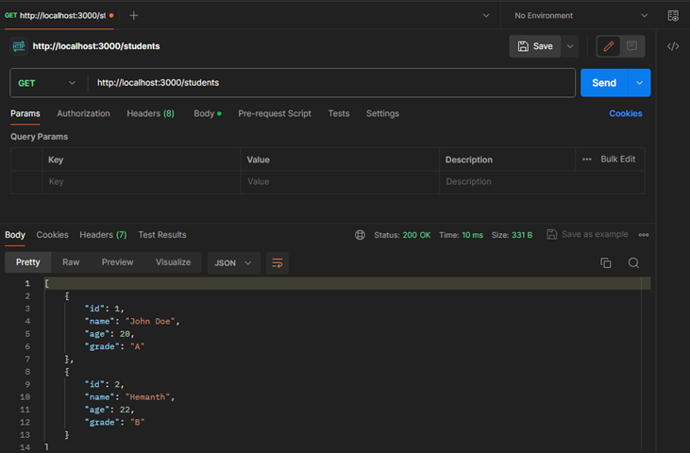
GET http://localhost:3000/students

PUT – Update a student
- Set the request type to PUT.
- Enter the URL with an existing student ID: http://localhost:3000/students/1.
- In the Body tab choose raw → JSON and give the updated values, then click Send.
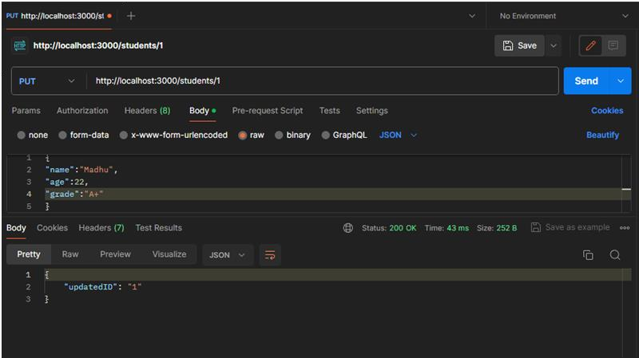
PUT http://localhost:3000/students/1

DELETE – Delete a student
- Set the request type to DELETE.
- Enter the URL, replacing the id with the actual student ID: http://localhost:3000/students/2.
- Click Send.
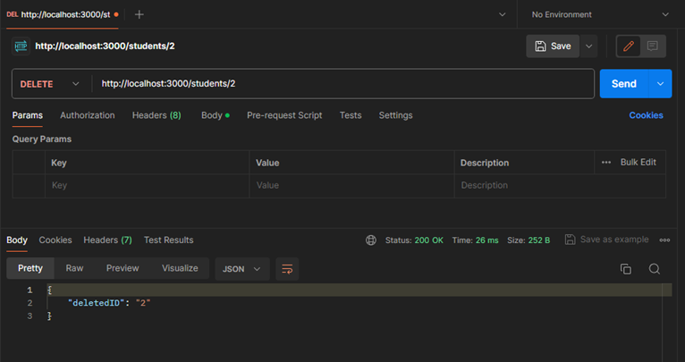
DELETE http://localhost:3000/students/2

Conclusion
A REST API with full CRUD operations on student data was developed using Express and SQLite, and verified using Postman.

