SKILL DEVELOPMENT COURSE (NODE JS / REACT JS / DJANGO) – LAB MANUAL

Experiment 12
AIM: Create a React application for a student management system having registration, login, contact and about pages, and implement routing to navigate through these pages.
DESCRIPTION: Below is a step-by-step guide to create a simple React application for a student management system with Registration, Login, Contact and About pages. react-router-dom is used for routing.

Steps

Step 1: Set up a new React app
npx create-react-app student-management-system
cd student-management-system

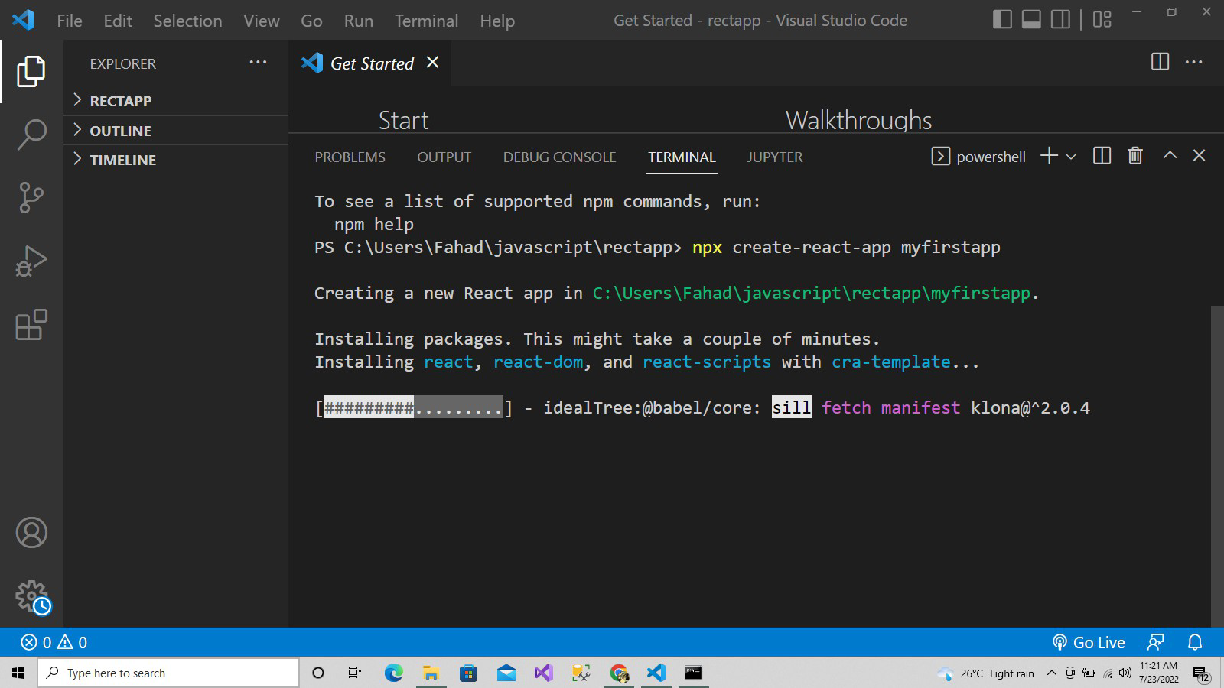
Creating the React app in the terminal

Step 2: Install react-router-dom
npm install react-router-dom

Step 3: Create components for each page
Create a folder src/components and add the following files.
src/components/Home.js
import React from 'react';

const Home = () => {
return (
<div>
<h1>Welcome to Student Management System</h1>
</div>
);
};

export default Home;

src/components/Register.js
import React, { useState } from 'react';

const Register = () => {
const [form, setForm] = useState({ name: '', email: '', password: '' });

const handleChange = (e) => {
setForm({ ...form, [e.target.name]: e.target.value });
};

const handleSubmit = (e) => {
e.preventDefault();
alert(`Registered successfully: ${form.name} (${form.email})`);
setForm({ name: '', email: '', password: '' });
};

return (
<div>
<h1>Registration Page</h1>
<form onSubmit={handleSubmit}>
<div>
<input name="name" placeholder="Full name" value={form.name} onChange={handleChange} required />
</div>
<div>
<input name="email" type="email" placeholder="Email" value={form.email} onChange={handleChange} required />
</div>
<div>
<input name="password" type="password" placeholder="Password" value={form.password} onChange={handleChange} required />
</div>
<button type="submit">Register</button>
</form>
</div>
);
};

export default Register;

src/components/Login.js
import React, { useState } from 'react';

const Login = () => {
const [form, setForm] = useState({ email: '', password: '' });

const handleChange = (e) => {
setForm({ ...form, [e.target.name]: e.target.value });
};

const handleSubmit = (e) => {
e.preventDefault();
alert(`Login attempted for: ${form.email}`);
};

return (
<div>
<h1>Login Page</h1>
<form onSubmit={handleSubmit}>
<div>
<input name="email" type="email" placeholder="Email" value={form.email} onChange={handleChange} required />
</div>
<div>
<input name="password" type="password" placeholder="Password" value={form.password} onChange={handleChange} required />
</div>
<button type="submit">Login</button>
</form>
</div>
);
};

export default Login;

src/components/Contact.js
import React from 'react';

const Contact = () => {
return (
<div>
<h1>Contact Page</h1>
<p>Email: support@studentmanagement.example</p>
<p>Phone: +91 00000 00000</p>
</div>
);
};

export default Contact;

src/components/About.js
import React from 'react';

const About = () => {
return (
<div>
<h1>About Page</h1>
<p>This is the about page of the Student Management System.</p>
</div>
);
};

export default About;

Step 4: Create App component with routing
Replace the contents of src/App.js. This uses the React Router v6+ API (Routes and element).
src/App.js
import React from 'react';
import { BrowserRouter as Router, Routes, Route, Link } from 'react-router-dom';
import Home from './components/Home';
import Register from './components/Register';
import Login from './components/Login';
import Contact from './components/Contact';
import About from './components/About';

const App = () => {
return (
<Router>
<div>
<nav>
<ul>
<li><Link to="/">Home</Link></li>
<li><Link to="/register">Register</Link></li>
<li><Link to="/login">Login</Link></li>
<li><Link to="/contact">Contact</Link></li>
<li><Link to="/about">About</Link></li>
</ul>
</nav>
<hr />
<Routes>
<Route path="/" element={<Home />} />
<Route path="/register" element={<Register />} />
<Route path="/login" element={<Login />} />
<Route path="/contact" element={<Contact />} />
<Route path="/about" element={<About />} />
</Routes>
</div>
</Router>
);
};

export default App;

Step 5: Start the React app
npm start

Visit http://localhost:3000 in your browser. You will see the navigation links for Home, Register, Login, Contact and About; clicking a link navigates to the respective page without reloading.

Project Structure
student-management-system/
├── public/
├── src/
│ ├── components/
│ │ ├── About.js
│ │ ├── Contact.js
│ │ ├── Home.js
│ │ ├── Login.js
│ │ └── Register.js
│ ├── App.js
│ └── index.js
└── package.json

Conclusion
A multi-page React application was created and client-side routing was implemented using react-router-dom. It can be extended with state management and a backend (for example the API from Experiments 10 and 11) for real registration and login.

