SKILL DEVELOPMENT COURSE (NODE JS / REACT JS / DJANGO) – LAB MANUAL

Experiment 13
AIM: Create a service in React that fetches weather information from openweathermap.org and displays the current and historical weather information using graphical representation with Chart.js.

Solution

Step 1: Create an OpenWeatherMap account and generate an API key
- Visit the OpenWeatherMap website (https://openweathermap.org/) and click Sign Up / Log In.
- Once logged in, navigate to your account dashboard.
- Locate the My API keys section.
- Provide a name for the key (for example "WeatherApp") and click Generate.
- Copy the generated API key – it is needed later.
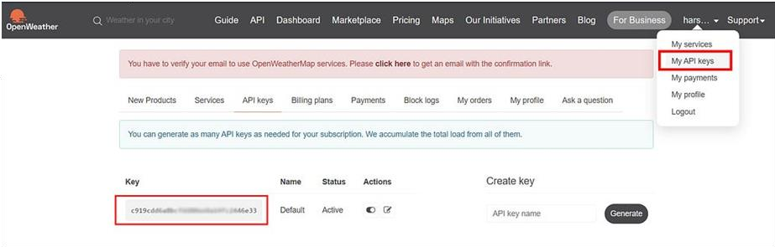
Locating the API key in the OpenWeatherMap dashboard

Step 2: Set up a new React project
npx create-react-app weather-app
cd weather-app

Step 3: Install required packages
We use the Axios library to make HTTP requests to the OpenWeatherMap API, and Chart.js (with its React wrapper) for the graph.
npm install axios chart.js react-chartjs-2

Step 4: Store the API key safely
Create a file named .env in the project root (next to package.json) and add your key. Do not commit this file to GitHub – add .env to .gitignore.
REACT_APP_OPENWEATHER_API_KEY=your_api_key_here

Restart npm start after creating or changing the .env file.

Step 5: Create the Weather component
Inside the src directory create Weather.js. It fetches the current weather for the entered city.
src/Weather.js
import React, { useEffect, useState } from 'react';
import axios from 'axios';

const Weather = () => {
const [city, setCity] = useState('London');
const [weatherData, setWeatherData] = useState(null);

// API key is read from the .env file (REACT_APP_OPENWEATHER_API_KEY)
const apiKey = process.env.REACT_APP_OPENWEATHER_API_KEY;

const fetchData = async () => {
try {
const response = await axios.get(
`https://api.openweathermap.org/data/2.5/weather?q=${city}&units=metric&appid=${apiKey}`
);
setWeatherData(response.data);
console.log(response.data); // You can see all the weather data in the console
} catch (error) {
console.error(error);
}
};

useEffect(() => {
fetchData();
// eslint-disable-next-line react-hooks/exhaustive-deps
}, []);

const handleInputChange = (e) => {
setCity(e.target.value);
};

const handleSubmit = (e) => {
e.preventDefault();
fetchData();
};

return (
<div>
<form onSubmit={handleSubmit}>
<input
type="text"
placeholder="Enter city name"
value={city}
onChange={handleInputChange}
/>
<button type="submit">Get Weather</button>
</form>

{weatherData ? (
<>
<h2>{weatherData.name}</h2>
<p>Temperature: {weatherData.main.temp} °C</p>
<p>Description: {weatherData.weather[0].description}</p>
<p>Feels like: {weatherData.main.feels_like} °C</p>
<p>Humidity: {weatherData.main.humidity}%</p>
<p>Pressure: {weatherData.main.pressure}</p>
<p>Wind Speed: {weatherData.wind.speed} m/s</p>
</>
) : (
<p>Loading weather data...</p>
)}
</div>
);
};

export default Weather;

Step 6: Connect the Weather component to the app
src/App.js
import React from 'react';
import Weather from './Weather';

const App = () => {
return (
<div>
<h1>Weather Forecast App</h1>
<Weather />
</div>
);
};

export default App;

Run
npm start

Output

Initial screen
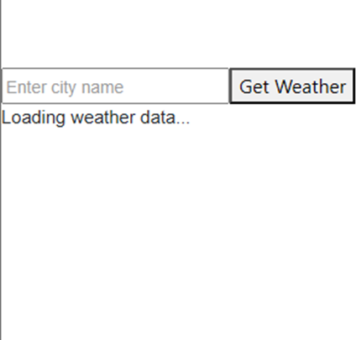
Initial screen before data is loaded

After supplying the city name
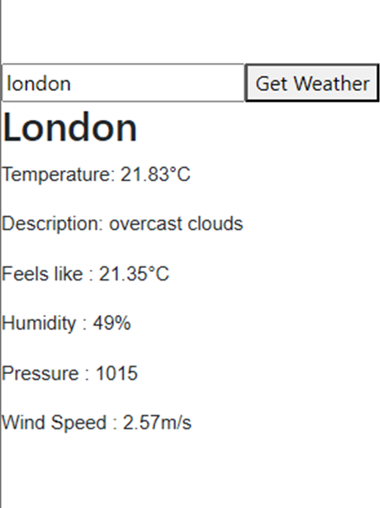
Current weather for London

Graphical Representation using Chart.js (Extension)
To show the temperature trend as a graph, add the following component. It uses the free 5-day / 3-hour forecast endpoint of OpenWeatherMap. (True historical data requires a paid OpenWeatherMap plan.)
src/WeatherChart.js
import React, { useEffect, useState } from 'react';
import axios from 'axios';
import {
Chart as ChartJS,
CategoryScale,
LinearScale,
PointElement,
LineElement,
Title,
Tooltip,
Legend,
} from 'chart.js';
import { Line } from 'react-chartjs-2';

ChartJS.register(CategoryScale, LinearScale, PointElement, LineElement, Title, Tooltip, Legend);

const WeatherChart = ({ city }) => {
const [forecast, setForecast] = useState([]);
const apiKey = process.env.REACT_APP_OPENWEATHER_API_KEY;

useEffect(() => {
const fetchForecast = async () => {
try {
// 5-day / 3-hour forecast endpoint (free plan)
const response = await axios.get(
`https://api.openweathermap.org/data/2.5/forecast?q=${city}&units=metric&appid=${apiKey}`
);
setForecast(response.data.list);
} catch (error) {
console.error(error);
}
};
fetchForecast();
}, [city, apiKey]);

const data = {
labels: forecast.map((item) => item.dt_txt),
datasets: [
{
label: `Temperature (°C) - ${city}`,
data: forecast.map((item) => item.main.temp),
borderColor: 'rgb(54, 162, 235)',
backgroundColor: 'rgba(54, 162, 235, 0.4)',
tension: 0.3,
},
],
};

const options = {
responsive: true,
plugins: {
legend: { position: 'top' },
title: { display: true, text: '5-Day Temperature Forecast' },
},
};

return forecast.length > 0 ? <Line data={data} options={options} /> : <p>Loading chart...</p>;
};

export default WeatherChart;

Then use it inside Weather.js (add import WeatherChart from './WeatherChart'; at the top and place <WeatherChart city={weatherData.name} /> below the weather details, inside the weatherData ? branch).

Conclusion
A React weather service was created that fetches data from the OpenWeatherMap API using Axios and displays it with a Chart.js line graph.

