SKILL DEVELOPMENT COURSE (NODE JS / REACT JS / DJANGO) – LAB MANUAL

Experiment 9
AIM: Create a custom server using the http module and explore the other modules of Node.js like os, path and events.
DESCRIPTION: We create a simple custom HTTP server using the built-in http module in Node.js, and then explore the os, path and events modules with examples. No external packages are required.

Project Structure
experiment-09/
└── server.js

Program
server.js
// Step 1: Import required modules
const http = require('http');
const os = require('os');
const path = require('path');
const { EventEmitter } = require('events');

// Step 2: Create an instance of EventEmitter
const eventEmitter = new EventEmitter();

// Step 3: Create a simple HTTP server
const server = http.createServer((req, res) => {
res.writeHead(200, { 'Content-Type': 'text/plain' });
res.end('Hello, World!\n');
});

// Step 4: Define server port and hostname
const port = 3000;
const hostname = '127.0.0.1';

// Step 5: Listen for requests on the specified port and hostname
server.listen(port, hostname, () => {
console.log(`Server running at http://${hostname}:${port}/`);
});

// Step 6: Print OS information
console.log('OS Type:', os.type());
console.log('OS Platform:', os.platform());
console.log('OS Architecture:', os.arch());
console.log('CPU Cores:', os.cpus().length);

// Step 7: Print current working directory
console.log('Current Working Directory:', process.cwd());

// Step 8: Join paths using the path module
const joinedPath = path.join(__dirname, 'public', 'images');
console.log('Joined Path:', joinedPath);

// Step 9: Handle a custom event
eventEmitter.on('customEvent', (data) => {
console.log('Custom Event Triggered:', data);
});

// Step 10: Emit a custom event
eventEmitter.emit('customEvent', { message: 'Hello from custom event!' });

Steps to Run
- Open a terminal or command prompt in the directory where you saved server.js.
- Run the server script using Node.js: node server.js. You should see the message "Server running at http://127.0.0.1:3000/".
- Access the server: open http://127.0.0.1:3000/ or http://localhost:3000/ in the browser. You should see the response "Hello, World!".
- Check OS information: in the terminal you will see the OS type, platform, architecture and the number of CPU cores.
- Check current working directory: the working directory of the script is printed in the terminal.
- Check joined path: the path created using path.join() is printed in the terminal.
- Check custom event: the script emits a custom event and listens for it; the terminal shows "Custom Event Triggered: { message: 'Hello from custom event!' }".
- Stop the server: press Ctrl+C in the terminal.

Modules Explored
- http – creates the web server and handles requests/responses.
- os – gives information about the operating system (type, platform, architecture, CPUs).
- path – works with file and directory paths (path.join).
- events – EventEmitter is used to create and handle custom events.

Output

In the Terminal
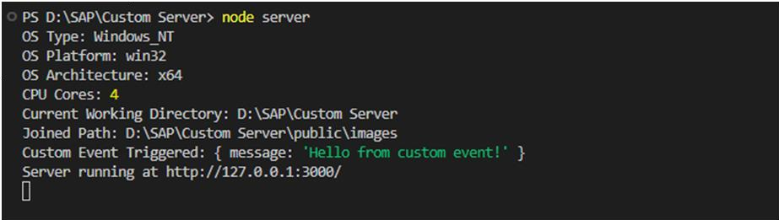
Terminal output of server.js

In the Browser
Link: http://127.0.0.1:3000/
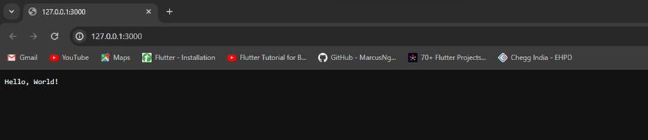
Browser output: Hello, World!

