Optimization and tradeoff analysis of tumor mechanics models

Tarini Thiagarajan (tt25926)

Tools and Techniques Course

1 Introduction and objectives
This project quantifies the tradeoff between accuracy and computational performance in 2D tumor mechanics simulations. Three modeling approaches were compared:
- Full-order model (FOM): the baseline reference for accuracy and runtime.
- Subsampled FOM (SFOM): a stride-based reduction in computation steps to accelerate performance, with quantified error relative to the FOM.
- Reduced-order model (ROM): a projection-based approach using Proper Orthogonal Decomposition (POD) to achieve further speedup while controlling error.
The study was conducted using simulated breast cancer patient data and repurposed code from our lab’s PODforTumors Github repository. Mechanics matrices were assembled, and von Mises stress was computed across all three approaches. Correctness and stability were verified through unit tests, sanity checks, and per-step error plots. Performance was profiled using MATLAB’s timing tools, with speedup factors reported for subsampling and ROM. To further optimize runtime, LU factorization was applied once and reused across solves, reducing redundant computation. MATLAB’s built-in linear algebra functions were integrated to ensure robustness and reproducibility.
The objectives of this work were to:
- develop mechanics simulation code: Build mechanics matrices from patient data, run all three mechanics models (i.e., FOM, SFOM, and ROM), and compute von Mises stress as the primary accuracy metric.
- ensure correctness and stability: Debug the workflow (optimization_analysis.m) with unit tests and sanity checks. Then, analyze results using a per-step error plot and a von Mises error versus speedup plot.
- optimize computational performance: Profile runtimes to find bottlenecks, quantify speedup factors, and improve efficiency by reducing number of expensive computations (e.g., avoiding repeated stiffness matrix $M$ assembly).
- integrate tools and libraries: Employ MATLAB’s built-in, optimized linear algebra libraries (e.g., lu) and lab-specific helper functions.
- generate reproducible outputs: Produce plots and logs that document per-step errors, speedup factors, and tradeoff curves for comparison.

2 Inputs, outputs, and reproducibility
2.1 Inputs
The primary input for this project is data/Ex5_patient.mat, which contains:
- image_data fields: NTC1–3 (tumor maps at different time points), Tissues, and BreastMask.
- schedule_info fields: imaging times and grid dimensions (imagedims).
Optimization was not conducted on input loading (0.016s) as this was not a bottleneck in this framework.
  - Outputs
Relevant result files can be found in results/full_FOM_results.mat, which contains von Mises stress maps for the full-order model (VM_full), subsampled FOM (VM_sub), and reduced-order model (sig_vm_ROM).
  - Profiling and logs
Profiles and logs can be found in the results and profiling folder. For instance, results/optimization_log.txt records runtime logs, environment info, and error messages. profiling/timings.mat stores timing measurements for FOM, subsampled FOM, and ROM profiling/tradeoff_sweep.mat contains stride sweep data (runtime vs average von Mises error).
  - Figures
Per-step error plot (stride = 4) showing temporal error structure and a tradeoff plot (average von Mises error vs speedup) comparing subsampled FOM and ROM can be found in the results folder.
  - Run environment and reproducibility design
Environment metadata (MATLAB version, operating system, CPU core count) is saved in run_env.mat. Crash dumps are automatically saved to results/crash_dumps on exceptions, preserving state for debugging. Logs and profiling outputs provide documentation of runtime behavior. Figures and .mat files summarize key results, ensuring that readers can reproduce plots and verify metrics without rerunning the full pipeline.
3 Methods and design decisions
3.1 Mechanics assembly
First, stiffness matrix ($M$), Young’s modulus ($E$), and Poisson’s ratio ($ν$) were constructed with boundary conditions derived from the breast mask via mech_matrix_build_2D. Then, grad_matrix was used to build gradient operators ($∂/∂X,∂/∂Y$) to support strain and stress calculations. Finally, von Mises stress was computed using get_damper, providing the FOM baseline for accuracy and subsequent error analysis. This stage established the reference mechanics environment against which subsampled and reduced-order models were compared.
3.2 Reduced-Order Model (ROM) construction
Augmented snapshots of tumor volume fractions (N) were generated via augmentCellMaps_2D to supply the training set with temporal variation. Mechanics outputs from Section 2.1 were collected across the augmented time series to form the basis for Proper Orthogonal Decomposition (POD). POD bases were computed separately for displacement, strain, and stress fields. This ensures that reduced operators capture the essential physics. Then, reduced operators were assembled, including the reduced stiffness matrix $M_{r}$, gradient compositions, and stress mapping matrices. Finally, the initial state was projected into the reduced space ($N_{0}^{r}$), enabling efficient reduced solves while preserving fidelity to the full-order baseline. This design allowed the ROM to achieve significant computational speedups by solving in a lower‑dimensional space, while maintaining controlled error relative to the FOM.

  - Motivation: Can FOM be made competitive with ROM using simple computational tools?
Previous work in our lab’s PODforTumors GitHub repository has shown that ROMs on POD achieve substantial speedups with limited accuracy loss in tumor mechanics simulations.
In this project, I asked a complementary question: to what extent can the FOM be improved using simple computational tools, without building a reduced basis? Specifically:
- Can stride-based subsampling reduce runtime enough to make FOM competitive with ROM?
- Can algorithmic refinements such as LU factorizations further accelerate FOM solves?
- What is the practical limit of these optimizations (i.e., how close can FOM get to ROM in terms of speedup, while maintaining acceptable accuracy)?
This motivation sets the stage for Section 2.4, where subsampling strategies are systematically tested and compared against ROM performance.
3.4 Subsampling strategy and performance safeguards
Since an initial Profiling report (mechanics-profiler.pdf) identified repeated calls to get_damper as a major computational bottleneck. To address this, I tested whether updating mechanics less frequently could reduce runtime without significantly degrading accuracy. As a baseline test, a stride of 4 was first applied, meaning mechanics were updated only every fourth time step in the augmented tumor maps. This reduced the number of mechanics solves while still capturing the overall temporal dynamics. To evaluate speed–accuracy tradeoffs, mechanics computations were repeated with stride values {1, 2, 4, 8, 16}. Each stride corresponds to skipping intermediate time steps in the augmented tumor maps, thereby reducing the number of mechanics solves. For each stride, runtime was measured using MATLAB’s timeit function and the average von Mises error was computed relative to the FOM. The sweep produced a tradeoff curve showing how increasing stride improves runtime but introduces error. Stride = 1 corresponds to the full mechanics baseline, while larger strides progressively accelerated runtime at the cost of accuracy.
This design method was chosen as subsampling requires no changes to the underlying mechanics model: only fewer evaluations. By combining runtime profiling with error analysis, the method highlights where subsampling remains acceptable and where accuracy loss becomes excessive.
For all analyses, relative errors were computed using denominators of the form $max⁡(∥⋅∥,{10}^{-12})$ to avoid division by near-zero norms. Assertions were placed on matrix sizes (e.g., stiffness matrix $M$ must be $2n×2n$) to prevent silent dimension mismatches. These safeguards ensured numerical stability and reproducibility across different stride values.
3.5 Can we do even better?: LU optimization (LU-once)
Another bottleneck (i.e., repeated matrix factorization) was identified by the Profiler (mechanics-profiler-2.pdf). Thus, I tested a performance enhancement by storing LU factorizations once and reusing them across subsampled solves. The original mechanics path (getMechanicsMaps_2D) was compared against a variant (getMechanicsMaps_2D_LUonce) that avoids repeated LU decompositions. Accuracy was verified by computing the von Mises delta between the two approaches, confirming numerical equivalence. This optimization reduced redundant computation and yielded measurable runtime improvements without sacrificing accuracy.
- Testing and verification
4.1 Automated unit tests
Automated unit tests were executed to validate core functionality. Four tests passed (TestCore, TestSolverConsistency), with zero failures. Total runtime for the testing was 0.091 seconds, and results were saved in tests/test_results.mat. These tests confirmed that mechanics assembly, solver routines, and stress computations behaved consistently across different configurations.
  - Sanity checks
In addition to automated unit tests, a series of sanity checks were embedded throughout the workflow to ensure numerical stability and accuracy. Each mechanics matrix was validated against expected dimensions (e.g., stiffness matrix $M$ must be $2n×2n$). These assertions prevented silent dimension mismatches that could otherwise propagate undetected errors through the solver. Additionally, relative errors were computed using denominators of the form $max⁡(∥⋅∥,{10}^{-12})$. This safeguard avoided division by near-zero norms, which could lead to unstable or misleading error values. Finally, gradient operators and stress mappings were verified to align with the grid dimensions specified in schedule_info. This ensured that displacement and stress fields were consistently defined across all time steps. Together, these sanity checks provided confidence that the mechanics assembly and error calculations were robust across different stride values and model variants.
  - Saved test results
All automated test outcomes and sanity check logs were stored for reproducibility and later inspection. The four automated tests (TestCore, TestSolverConsistency) passed with zero failures, and results were saved in tests/test_results.mat. Runtime measurements and optimization logs were recorded in profiling/timings.mat and results/optimization_log.txt. Subsampling tradeoff data (runtime vs. average von Mises error) was saved in profiling/tradeoff_sweep.mat. On exceptions, crash dumps were automatically saved to results/crash_dumps, and environment metadata (MATLAB version, OS, CPU) was preserved in run_env.mat. By saving all test results and profiling data, the workflow ensured that readers could reproduce the analysis, verify correctness, and trace any anomalies without rerunning the full pipeline.
- Performance results and error analysis
To quantify the balance between accuracy and computational efficiency, runtimes and error metrics were compared across the full-order model (FOM), subsampled FOM (stride = 4), and reduced-order model (ROM).
5.1 Ground truth FOM vs. SFOM approximations (per-step errors, Figure 1).
Subsampling errors were computed at each time step and summarized across displacement components ($U_{x},U_{y}$), stress components ($S_{xx},S_{yy},S_{xy}$), and von Mises stress. This provided a detailed breakdown of how stride-based subsampling deviated from the FOM. For the ROM, the von Mises stress at the initial state was compared directly against the FOM baseline, ensuring projection accuracy at the starting point.
Figure 1 reveals periodic spikes at regular intervals for stride = 4 subsampling. These spikes were consistent across both displacement and stress components, reflecting the temporal structure of skipped updates. Despite the spikes, the average von Mises error remained modest at approximately 4.45%, demonstrating that subsampling preserved overall accuracy while reducing runtime.
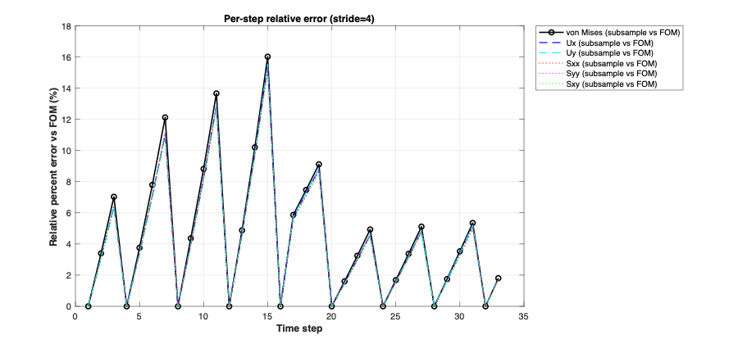Figure 1. Relative error at each time step with a stride of 4.
5.2 Tradeoff Analysis: SFOM vs ROM (error vs speedup, Figure 2).
Figure 2 illustrates the tradeoff between accuracy and computational speedup for SFOM compared to ROM. As the subsampling stride increases (S = 1, 4, 8, 16), the average von Mises error also increases, rising from zero at S = 1 to ~20% at S = 16. At the same time, subsample speedup improves dramatically, reaching nearly 6000× at the highest stride. ROM performance is shown as a constant reference point, with error around 2.1% and speedup near 4500×. This comparison reveals that while high-stride SFOM can outperform ROM in speed, it does so at the cost of higher error. Intermediate strides (e.g., S = 4 or S = 8) offer a practical balance, achieving significant speedup with modest error, and may be preferable when ROM construction is infeasible. Overall, the figure highlights how far FOM can be pushed using simple subsampling tools before ROM becomes the clearly superior choice.
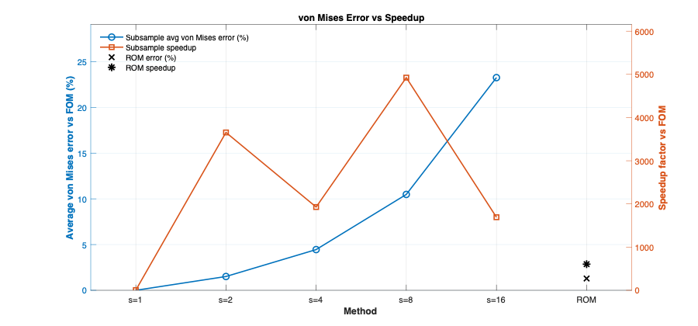 Figure 2. Average von Mises stress error (%) and speedup factors for SROM across stride values (S = 1, 4, 8, 16), compared against ROM performance.
5.3 LU optimization accuracy (bit-level agreement)
To verify the accuracy of the LU optimization, results from the original mechanics path (getMechanicsMaps_2D) were compared against the LU-once variant (getMechanicsMaps_2D_LUonce). The von Mises delta between the two approaches was $1.311×{10}^{-14}$, indicating bit-level agreement. Relative norm errors across displacement and stress components were all below ${10}^{-13}$, and the maximum absolute difference across stress fields was $6.2×{10}^{-15}$. Runtime decreased from 0.000061 s (original) to 0.000059 s (LU-once), yielding a local speedup of 1.04×. These results confirm that LU-once factorizations preserve numerical fidelity while reducing redundant computation with negligible memory overhead.
5.4 Summary metrics
To consolidate performance and accuracy results, Table 1 summarizes runtimes, speedup factors, and average relative errors for the default subsampling stride (S = 4) and the reduced‑order model (ROM), compared against the full‑order baseline (FOM). The von Mises error was computed as follows:
$${Error}_{i}=\frac{\left\|σ_{vm}^{full}(i)-σ_{vm}^{sub}(i)\right\|}{max⁡(\left\|σ_{vm}^{full}\left(i\right)\right\|-ε)},$$ | [1]
where $σ_{vm}^{full}$ is the von Mises stress at time step $i$from the full-order model, $σ_{vm}^{sub}$ is the corresponding value from the subsampled model, and $ε$ = ${10}^{-12}$is a small constant to avoid division by near-zero norms. Relative error norm (for displacement or stress components) was calculated using:

$${Relerror}_{i}=\frac{\left\|u^{FOM}(i)-u^{SFOM}(i)\right\|}{max⁡(\left\|u^{FOM}\left(i\right)\right\|-ε)},$$ | [1]
where $u(i)$ is the vectorized field (e.g., displacement or stress) at time step $i$. Subsampling at stride = 4 achieved greater speedup than ROM (1268× vs. 605×) but introduced modest errors (~4–5%). ROM maintained lower von Mises error (1.29%) while still offering substantial speedup. These results highlight the complementary strengths of the two approaches: subsampling as an efficiency knob, and ROM as a dimensionality-reduction method with superior accuracy.
Model | Runtime (s) | Speedup  vs FOM | Avg. Error (%) | Von Mises Error (%)
FOM (baseline) | 0.193 | 1.0× | – | –
SFOM  (stride = 4) | 0.000153 | 1268.8× | ~4.2–4.3% across Ux, Uy, Sxx, Syy, Sxy | 4.45%
SFOM  (stride = 4 +  LU-once) | 0.000059 | 3279.9× | ~4.2–4.3% across Ux, Uy, Sxx, Syy, Sxy | 4.45%
ROM | 0.000320 | 605.1× | – | 1.29%
Table 1. Summary of runtimes, speedup factors, and average relative errors for FOM, SFOM, and ROM.
6 Discussion and conclusion
This project demonstrated the tradeoffs between FOM, SFOM, SFOM with LU-once, and ROM in tumor mechanics simulations. Subsampling of the full-order model (SFOM) achieved extreme speedups (in some cases surpassing ROM performance) but introduced modest errors (~4–5% at stride = 4, rising to ~20% at stride = 16). Incorporating LU caching into the subsampled pipeline provided an additional implementation-level gain, reducing redundant factorizations and yielding a local speedup of ~1.04× while preserving bit-level numerical agreement (von Mises delta $1.3×{10}^{-14}$). In contrast, the reduced-order model (ROM) offered a more balanced compromise, maintaining lower von Mises error (~1–2%) while still achieving substantial speedup (~600×).
The practical takeaway is that the choice of method depends on whether runtime or accuracy is prioritized. SFOM is attractive when computational efficiency is the dominant concern, particularly for exploratory analyses or resource-constrained environments. ROM is preferable when accuracy must be tightly controlled, as it provides consistent fidelity with strong performance gains.
Finally, reproducibility was emphasized throughout the workflow. Automated tests, sanity checks, crash dumps, environment capture, and structured logging ensured that results can be verified and reproduced by reviewers without rerunning the full pipeline.

