The Third Assignment:

Group Details:
No. | Student ID | Student Name
1 | 446002124 | طارق عماد الحازمي
2 | 446004997 | عبدالله عارف العميري
3 | 446008531 | عمر سلمان الشمراني

Project Title (Maximum 10 words):
AI-Based Performance Analysis and Prediction Model for Saudi High Schools

Project Description (Minimum 100 words):
This project uses practical AI techniques to look into high school data from Saudi and predict future academic performance. Education quality matters a lot to the local community, so having an early view of how schools are doing helps administrators act quickly when issues show up.
We gathered real numbers from past years, mainly looking at student averages in Qudrat and Tahsili exams, along with official school evaluation results. By running simple machine learning model like Linear Regression and Random Forests, our system picks up trends from older data to predict upcoming test performance. This gives school managers in Saudi a clear idea of which schools need extra support or better resources.

Define the AI technologies that will be applied in your project? (Minimum 500 words):
1- Data Preprocessing and Normalization : This is the preliminary stage that precedes feeding data into the algorithms used to build artificial intelligence; it consists of two phases:
The first is preprocessing : transforming raw data—which is typically messy, incomplete, unformatted (numbers written as words), and unprepared in real-world scenarios—into a format that the machine can understand and process.
The second step is normalization: a mathematical technique applied to the data organized and cleaned in the first step. It aims to standardize the numerical scale for instance, compressing values to a range between 0 and 1 to ensure unbiased comparisons between different features. For example, if comparing an age feature (0 to 100) against an "income" feature (measured in the thousands), or an academic score (out of 100) against a school level (1 to 31), normalization ensures that algorithms assign equal importance to every feature in the project, preventing the model from becoming biased toward features with larger numerical values.
When we began analyzing high school data in Saudi, we quickly realized that simply gathering numbers was insufficient for generating accurate predictions. To build a reliable system that helps local administrators and decisionmakers predict academic performance, we had to subject this raw data to a crucial preparatory phase known
as Data Preprocessing and Normalization. Consequently, we collected official records from all boys' and girls' high schools in the Saudi sector; while the data was difficult to obtain... We obtained results from the General Achievement Test and the Aptitude Test spanning the last three years, alongside official school assessment data. However, we encountered common datarelated challenges regarding clarity and organization. For instance, some schools lacked data for specific years, or there were human errors in data entry. This is where the normalization algorithm comes into play a process that transforms raw, scattered data into a format ready for analysis. We carefully addressed missing values to fill gaps and excluded anomalies and outliers that could mislead models and lead to erroneous conclusions about a school's performance level.
Once the data was cleaned and verified for completeness, another challenge emerged: the significant disparity in numerical scales. Aptitude and Achievement test scores are typically based on a scale of 100, whereas official school assessments often rely on much smaller scales. If we were to feed these raw figures directly into an algorithm like Linear Regression, the model would automatically prioritize the Achievement scores simply because the numbers are larger, thereby ignoring the profound impact of the school assessment.
To resolve this issue, we applied a "normalization" step. Through this mathematical process, we compressed and standardized the ranges of all inputs to a uniform, equitable scale. This step is crucial to ensure that machine learning algorithms— whether Linear Regression or Random Forests—evaluate the impact of each factor on equal footing, assigning fair weight to school assessments just as they do to standardized test scores.
Ultimately, the effort invested in cleaning and normalizing the data for Saudi Governorate... It is the solid foundation upon which we built the accuracy of our projections. This effort transformed scattered historical data into a clear, reliable picture, providing the Education Department with early, precise insight into which schools are on the right track and which require urgent intervention and additional resource allocation to improve the quality of education.

2- Multiple Linear Regression : Multiple Linear Regression is a straightforward machine learning method that predicts a single number (like an upcoming test score) by looking at several factors at once. Instead of relying on just one clue, it combines multiple inputs and figures out how much each one actually matters. The formula is basically an expanded line equation: Y prime =w0+w1x1+w2x2+w3x3+w4x4 How we apply it to our Saudi project: Instead of guessing blindly, we use this model to predict how high schools in Saudi will perform on
upcoming standardized tests based on their past track record: What we want to predict (Y):
The school’s expected average score in the upcoming Tahsili exam. The clues we feed into the model (X): X1: The school's past average in the Qudrat
exam. X2: The school's past average in the Tahsili exam. X3: The school's official rating from the Education and Training Evaluation Commission (ETEC). X4: The average internal high school GPA.
What the weights (w) tell us: The weights are the most practical part for school administrators. They show the real world impact of each factor on its own. For instance, the weight for ETEC (w3) tells
us:
"If a school improves its operational rating by one level, how many points will that add to its students' test scores?"
Why we start with this model: We picked Multiple Linear Regression as our starting baseline because it isn't a "black box." It gives local supervisors in Saudi a clear, readable formula that shows whether a school is falling behind because of basic student performance or because the school environment itself needs immediate support.
3- Random Forest : We selected Random Forest because relying on a single decision tree usually leads to predictive mistakes. If a model uses only one tree, it easily overfits the training data. Random Forest resolves this issue by building an ensemble of many trees, where each tree analyzes a random subset of the dataset. At the end of the process, all trees vote, and the model selects the most common outcome.
For our Saudi school project, this algorithm provides support in two practical ways: School Categorization: It groups high schools into distinct categories, clearly showing which institutions perform well and which require extra administrative attention.
Feature Importance: It calculates the exact factors that drive student results in Qiyas exams. This allows us to determine whether academic success is most affected by teacher availability, leadership quality, or school resources.
Seeing these specific driving factors makes it significantly easier for local educational authorities in Saudi to make data-driven decisions and allocate help exactly where it should go first.

Define Dataset that will be used in your project with Samples? (Minimum 500 words):
Project Dataset Specification: High School Performance & Evaluation Index
1- Dataset Overview and Context For this project we created a dataset where each record stands for a school in Saudi Arabia, not an individual student. Our main goal is to build an objective data-driven evaluation index that shows academic quality and actual performance at the school level. We do not want to rely on raw classroom grades because those often give a picture of how schools are really doing.
We gathered data from three major national education sources:
The Ministry of Education (Noor System): This provides internal classroom grades and
cumulative high school averages.
The National Center for Assessment (Qiyas): This gives standardized exam results that are completely separate from each school’s own grading.
The Education and Training Evaluation Commission (ETEC): This offers accreditation scores based on site visits and audits of each school.
Looking at the data at the school level helps our machine learning models spot which schools are truly performing well which ones are struggling and which ones appear strong only because they use grading practices.
2- Feature Definitions (Independent Variables)
Our feature set includes four numerical inputs for each school:
Average General Aptitude Test Score (X_1): This is a continuous score on a scale from 0 to 100 taken from Qiyas (Qudurat). This test checks reasoning, analytical thinking and reading comprehension. It doesn’t depend on memorizing textbooks. So it shows whether a school actually teaches students how to think
Average Scholastic Achievement Admission Test Score (X_2): This is another score from 0 to 100 also from Qiyas (Tahsili). Unlike the aptitude test this one measures how well students remember the curriculum material—subjects like mathematics, physics, chemistry and biology—from their three years of high school.
Average High School GPA (X_3): This is a percentage score from 0% to 100% pulled directly from the Noor platform. It reflects student work—homework, attendance, semester exams—all graded by the school’s own teachers.
ETEC Institutional Evaluation Score (X_4): This is a score from 0 to 100 assigned by ETEC inspection teams after visiting each campus. It covers things that standard student tests don’t catch—like leadership, teaching methods, safety and physical infrastructure. These are parts of what makes a school good or bad.
3- Weighting Methodology and Logic
To combine these four variables into one performance score (Y) we use a linear equation:
Composite Score (Y) = 0.25X₁. 0.25X₂ + 0.10X₃ + 0.40X₄
The weights add up to 1.00 (or 100%). They are chosen with reasoning behind them:
Why does ETEC get the biggest weight (w₄ = 0.40)? Because external audits give the reliable look at a school’s true quality. Student test scores can be misleading. A school might have numbers just because parents pay for private tutoring outside class hours even if the school itself has bad buildings or poor management. The ETEC audit looks at
the institution—how it runs, how it teaches, how safe it is—and that matters more than test results alone.
Why do standardized tests share weight (w₁ = 0.25 w₂ = 0.25)? Because Qiyas exams are the fair and objective tools we have. Every student in the country takes them under the conditions. Computers grade them without bias or regional differences. Splitting 50% between GAT (which measures thinking skills) and SAAT (which checks knowledge retention) makes sure both sides of learning are valued fairly.
Why does internal GPA get the weight (w₃ = 0.10)? Because grade inflation is an issue in secondary schools. Some schools— private ones chasing higher enrollment—give out 98% and 99% GPAs just to keep parents happy. If we gave GPA much importance schools with easy grading would automatically rank higher. Keeping this weight at 10% still rewards students who show up and put in effort. It stops schools with loose standards from getting unfair advantages.
4- Synthetic Sample Dataset
The CSV file attached below provides a sample slice of our dataset across school profiles to demonstrate how the scoring works in practice.

5- Data Preprocessing Considerations
Before feeding this data into machine learning models—like Linear Regression, Random Forest or K-Means clustering—we handle two issues.
Feature Scaling (Normalization): The four features have different distributions. GAT and SAAT scores tend to follow a bell curve centered around 65 to 70.. High school GPAs are heavily skewed toward the upper end with most values between 90% and 100%. To prevent GPA from overpowering variables during model training we use Min-Max scaling or Z-score standardization so all inputs are, on a similar scale.
Handling Values: Some new schools don’t have SAAT averages yet because their first group hasn’t finished grade 12. Others may not yet have had an ETEC audit. Rather than fill in missing values using data—which could mess up rankings—we remove any incomplete school records. That way our models train on verified, complete institutional data.

Similar Projects (Minimum 3 Projects):
1. https://se.etec.gov.sa/#identify
2. https://tarteeb.etec.gov.sa/ar/home
3. https://noor.moe.gov.sa/Noor/EduWaveLanding/Home.aspx
..

References:
1. García, S., Luengo, J., & Herrera, F. (2015). Data Preprocessing in Data Mining. Springer.
2. Kutner, M. H., Nachtsheim, C. J., Neter, J., & Li, W. (2005). Applied Linear Statistical Models. McGraw-Hill.
3. https://youtu.be/gkXX4h3qYm4
..

Define Dataset Manipulation that will be used in your project with Samples? (Minimum 500 words):
Gathering our initial dataset from the Saudi Open Data portal and combining it with synthetic (simulated) records was just the first step. You can't simply feed this mixed information straight into a machine learning algorithm. Whether the numbers are from official open data or generated to reflect real-world school scenarios, the dataset is usually pretty messy at first. You will frequently run into missing numbers, mismatched scales, and weird text formats. Because of this, preparing the dataset became a major part of our workflow. We had to fix these formatting issues before we could even think about running our Multiple Linear Regression or Random Forest models. Below are the main manipulation steps we applied using Python's Pandas library.
1- Data Loading and Initial Inspection : Our main CSV file, which merges the official open data with our synthetic records, holds several years of performance metrics for thousands of Saudi high schools. To actually work with this information, we load it using Python's Pandas library. By converting the CSV into a DataFrame, we can clearly see the rows, columns, and data types we are dealing with. This initial check helps us figure out exactly which parts of our mixed dataset need cleaning.
2- Handling Missing and Incomplete Records : When evaluating entire schools, having accurate data is incredibly important. While exploring our combined dataset of official Open Data and simulated records, we noticed a common real-world issue: missing records. For instance, a brand-new high school will not have older Tahsili scores simply because they have not graduated a senior class yet. Other schools might not have a recent ETEC audit published on the portal. We had to decide how to handle these blank spots. Ultimately, we chose not to guess or fill in missing numbers using statistical averages. Doing that would basically create fake performance metrics for those specific schools and ruin our model's overall accuracy. Instead, we dropped the incomplete rows entirely.
3- Data Formatting and Type Casting : Another common headache we faced when merging different data sources was numbers showing up as text. For example, columns tracking progress percentages contained actual percentage symbols (%). Machine learning algorithms do not understand symbols; they only work with pure numbers. So, we wrote a script to strip away these '%' characters and convert the remaining text into workable math decimals.
4- Feature Engineering: Calculating the Evaluation Gap : Sometimes, the raw data we pulled from the Saudi Open Data portal—even when supplemented with synthetic records—doesn't tell the whole story. So, we have to create new variables out of the existing ones. We noticed that some schools give themselves really high internal ratings, but their official ETEC audit scores are much lower. To capture this exaggeration, we created a new column called the "Evaluation Gap". We literally just subtracted the external audit score from the school's self-evaluation. This gave our AI models a solid number to measure how much a school might be overstating its quality.
5- Feature Scaling and Normalization : Finally, we had to balance the scales. Because our dataset combines various official metrics and simulated scores, it has totally different number ranges. GPAs are usually sitting up in the 90s, while standardized test scores hover around 60 or 70. If we just dumped this into a regression model, the AI would unfairly focus on the GPA just because the numbers look bigger. To fix this bias, we used Min-Max Scaling. This technique squashes all our numeric columns down into a standard range between 0 and 1, ensuring that ETEC audits, GPAs, and Qiyas exams all get a fair vote in the final prediction.

Implementation with Screenshot of your Outcomes:
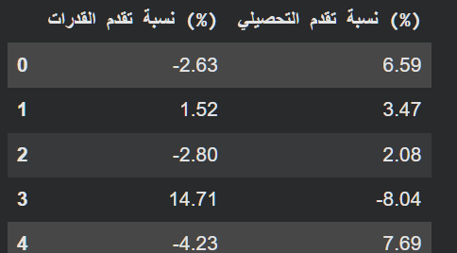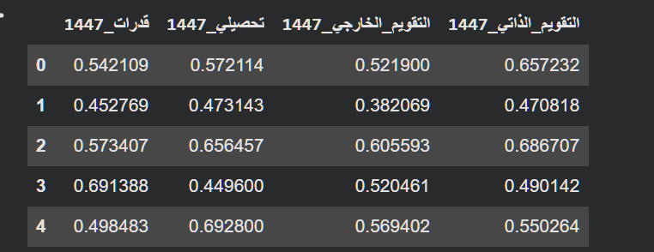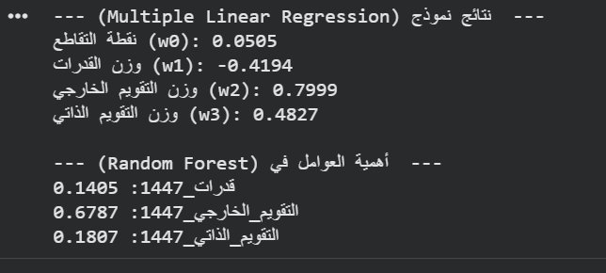
https://github.com/tariq-alhazmi/project_AI3101

