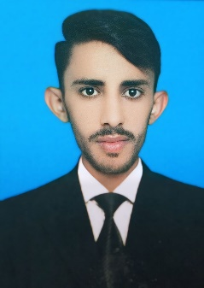
Tariq Hanif

Email: tariqhanif755@gmail.com
Cell: +92 3269857971
Address: Gullberg_111, Lahore

SUMMARY

SEO Specialist with 2 years of experience in Search Engine Optimization (SEO) and Local SEO, focused on improving website visibility, organic traffic, search rankings, and local search performance.
Experienced in keyword research, on-page SEO, off-page SEO, technical SEO, SEO audits, schema markup, website optimization, and internal linking. Skilled in optimizing meta titles, meta descriptions, heading tags, image alt text, and URL structures to improve search engine visibility and user experience.
Hands-on experience in Google Business Profile (GBP) optimization, including profile management, business information updates, keyword-optimized descriptions, post publishing, review management, citation building, NAP consistency, local competitor analysis, and Google Maps ranking improvement.
Familiar with Google Search Console and Google Analytics for monitoring organic traffic, impressions, clicks, click-through rate (CTR), and website performance. Continuously learning and applying SEO best practices to develop effective strategies that help businesses strengthen their online presence and attract relevant organic traffic.

EDUCATION

Description | Institute | Year of Passing
BS Computer Science | The Hajvery University of Lahore (Euro Campus Lahore) | 2028
ICS | ILM College, Renala Khurd | 2023

Experience
Alpha Tech software House
Digixlink
Marketing Mindz 360

SKILLSET

- Keyword Research & Competitor Analysis
- On-Page SEO Optimization
- Off-Page SEO & Backlink Building
- Technical SEO (Basic)
- Local SEO Strategy
- Google Business Profile (GBP) Optimization
- Google Maps Ranking Optimization
- SEO Audits & Website Optimization
- Meta Titles & Meta Descriptions Optimization
- Heading Tags, URL Structure & Internal Linking
- Schema Markup (Basic)
- Google Search Console
- Google Analytics
- Cloud Stacking
- Citation Building & NAP Consistency
- Organic Traffic Growth Strategies

REFERENCES
References shall be furnished upon request.

