Name: Tariq Hussain

Registration#: 49455

Project Report: Software Construction

Electrical Billing Management System

**Project Title**: Electrical Billing Management System

**Author**: Tariq Hussain

**Abstract**: This project has been made to make billing management for electrical managing companies using this project user can able to calculate the monthly billing and according the usage of the customer it manages and calculates data faster and it is very time efficient. The interface is very easy to understand and use for any employee of the company this project does not require any big hardware to use it can be used to on any desktop computer.

It is created using java programming language and GUI is created using java and implemented and tested on NETBEANS, below it will show how the project is created step by step and documentation will be given and designs and how all the parts were joined to make this project work.

Project Advisor: Sir Farooq Iqbal and Sir Syed Nadeem Ahsan.

**Table of Contents**

**Introduction and overview………………………………………………Page #1**

**Interface and Design Objectives……………………… Pages # 2 to 5**

**Source Code……………………………………………….. Page # 6 to 7**

**Key Construction Decision……………………………………….Page# 9**

**Levels of Design……………………………………………………Page# 10 to 13**

**Conclusions and GitHub Link ……………………………………..Page # 14**

**INTRODUCTION:**

1

It is an billing management system used essentially for business purpose only interface is user friendly its GUI is created using java swing, this project is can be used with any desktop application with any IDE e.g NetBeans or Java Eclipse***.***

The Electricity Billing System has been developed to override the problems prevailing in the practicing manual system. This software is supported to eliminate and In Some cases reduce the hardships faced by this existing system.

Moreover this system is designed for the particular need of the company to carry out operation in a smooth and effective manner.

The application is reduced as much as possible to avoid errors while entering the data. It also provides errors message while entering invalid data. No formal knowledge is needed for the user to use this system.

**Overview of the System:**

Electricity Billing System as described above can lead to error free, secure, reliable and fast management system **t**he main Objective of the project on Electricity Billing System is to manage the details of Electricity, Unit of Energy,Bill, Store Record, Electricity Board. It manages all the information about Electricity, connections, Electricity Board, Electricity.

**INTERFACE AND DESIGN OBJECTIVES.**

2

**Below it is explained how this system works and how it measures data.**

Modules OF Electricity Billing SYSTEM:-

Login module: Used for managing the login details.

Users module: Used for storing detail of user information.

Electricity Management Module: Used for managing the Electricity details.

Electricity Board Module: Used for managing the details of Electricity Board.

Connections Module: Used for managing the details of connections

Unit of Energy Management Module: Used for managing the information and details of the Unit of Energy.

Bill module: Used for managing the Bill details

Store Record Module: Used for managing the Store Record information**.**

**Techniques and Implementation:**

TECHNIQUE USE IN THE PROJECT:-

LANGUAGE:-

JAVA (NetBeans)

PLATFORM:-

WINDOWS

**TO perform the output the following steps are required.**

**Frame 1**

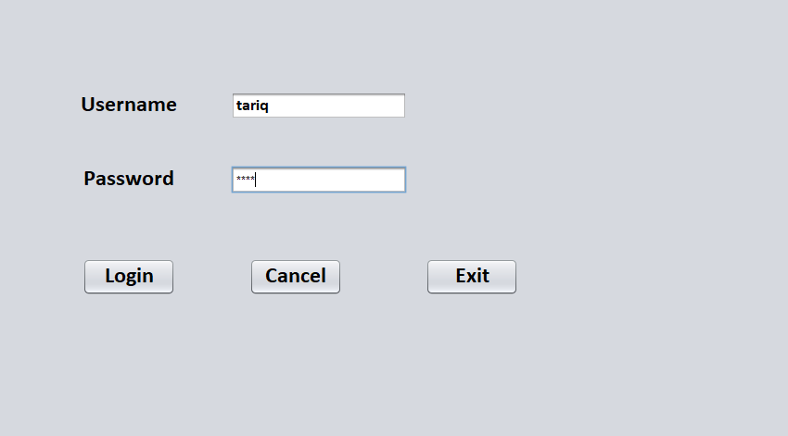

3

Open FOLDER of ' Electricity Billing SYSTEM PROJECT' file.

Run the program in : JAVA NEATBEAN by creating main class name Login

To get the output run the process use existing Username and password created in the file.

If Username no and password are equal permission is granted to access Registration form.

4

**Frame 2**

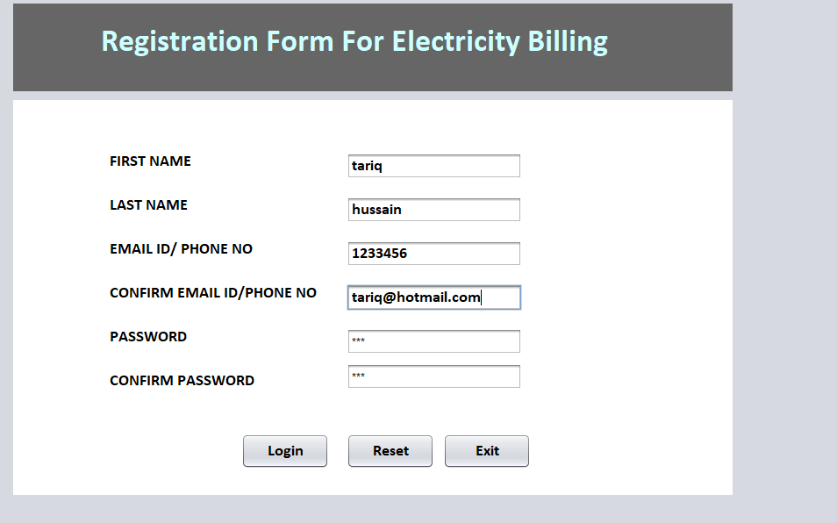

To get the output run the process use existing FIRST NAME, LAST NAME EMAIL ID/ PHONE NO, CONFIRM PASSWORD, CONFIRM EMAIL ID/PHONE NO, Password, Confirm Password, Login, Reset, Exit **created in the**

**file.**

If FIRST NAME, LAST NAME EMAIL ID/PHONE NO, CONFIRM PASSWORD, CONFIRM EMAIL ID/PHONE NO, Password, Confirm Password. Enter their input and

You will granted to access.

**Frame 3**

To get the output run the process use existing CUSTOMERNO, AREACODE, METERREADERCODE, CONNECTEDLAOD, BILLNUMBER created in the file.

If AREACODE, METERREADERCODE, CONNECTEDLAOD Enter Their input and

You will the Calculation of COST OF ENERGYCHARGE, COST OF FIXEDCHARGE,

COST OF GOVTELECTRITCITY DUTY, CGST, SGST, SUB TOTAL, TAX, AND TOTAL AMOUNT.

5

You can also calculate the amount in the **Calculator** in Left hand side of the screen.

This is the last step in this step you can click on **Exit button** and exit the program or else you can click on **Reset button** to start once again.

**Frame 4**

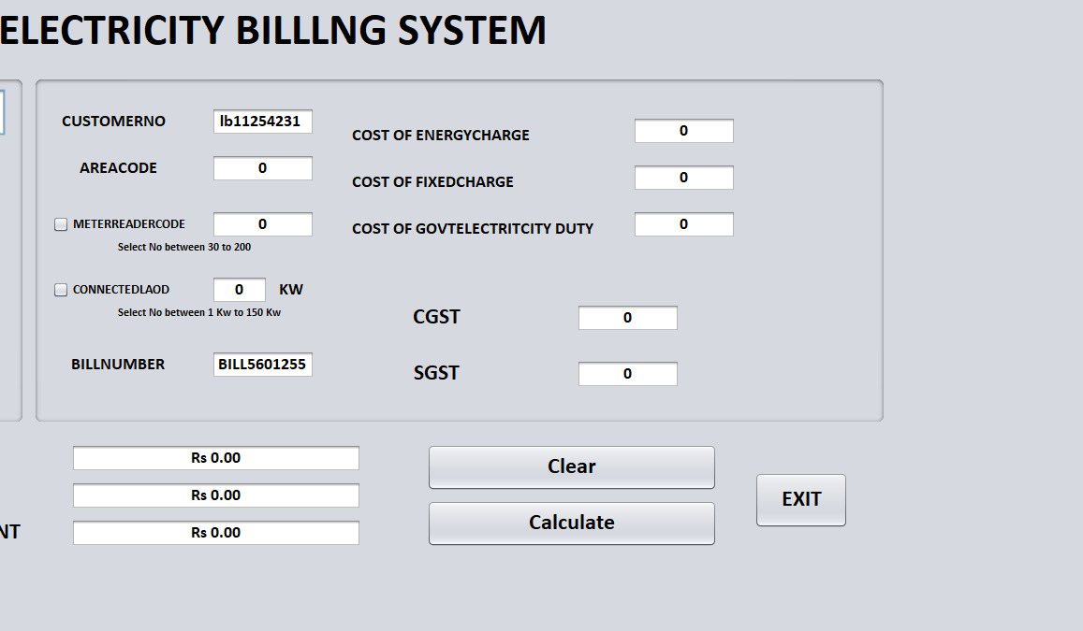

CUSTOMERNO module: It is use for Identify CUSTOMERNO.

AREACODE module: It is use for Identify your local AREACODE.

METERREADERCODE module: It is use for taking input of METERREADERCODE

CONNECTEDLAOD module: It is use for taking input of CONNECTEDLAOD.

BILLNUMBER No module: It is use for Identify BILLNUMBER NO.

Calculatormodule: It is use for Calculate all Electricity modules billing.

6

E6xitmodule: It is use for stop the process and come out from terminal.

Resetmodule: It is use for Reset all module data enter on it.

**Source Code:**

**There is total of Three classes created for this project Login, Registration Form, and the main Electricity Billing System, below screen shots are given for the source , Full source is give in the GITHUB Link of This Project.**

**LogIn:**

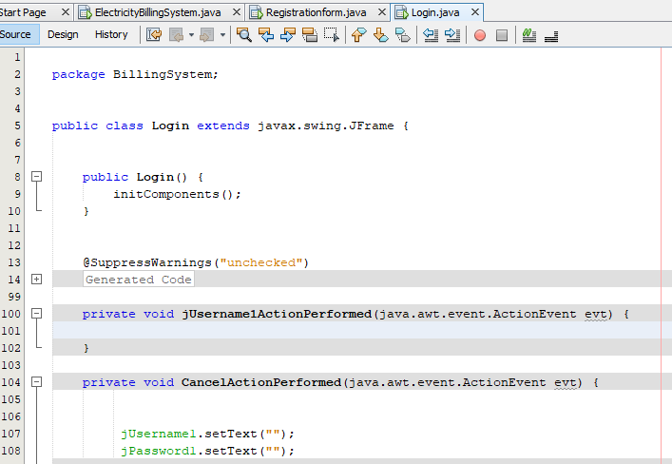

**Registration Form:**

7

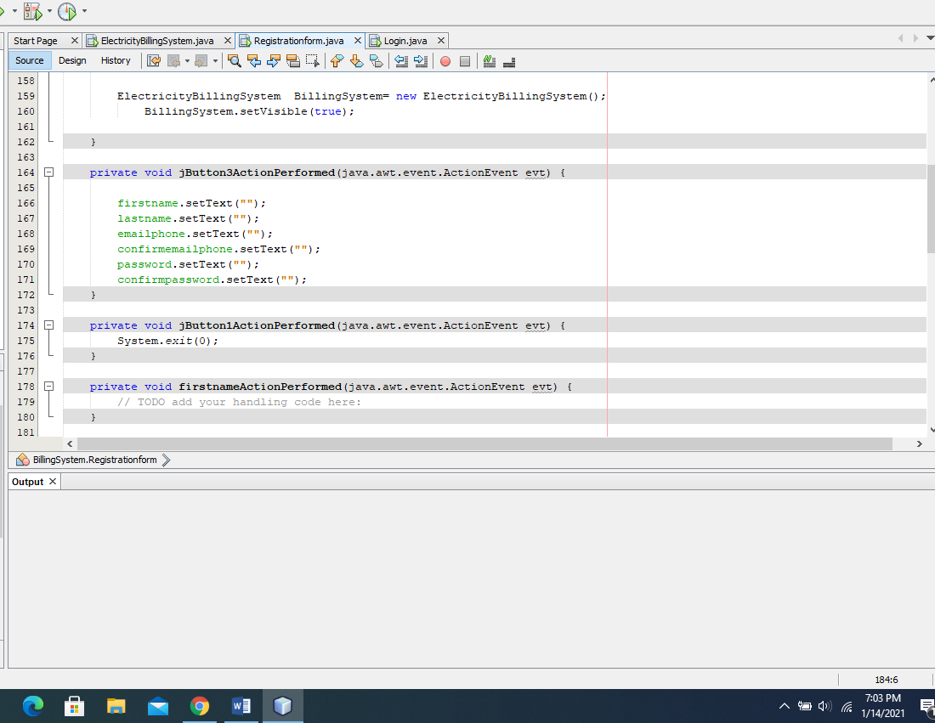

**Main Screen Billing Management System.**

8

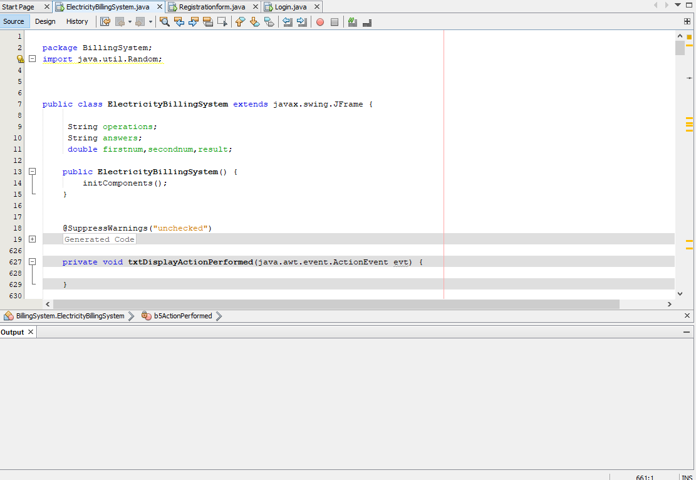

**Key Construction Decisions of This Project.**

9

**Choice of Programming Language:**

Programming language used in this project is Java and Java Swing for the GUI java language was choosen for this project after looking at various factors which could affect the project.

**Programming Conventions**:

Programming conventions are used from java all packages and classes are accordingly created from java language and all the variables and input methods it is safe and secure and efficient to use

**Your Location on the Technology Wave:**

This project is based on new technology which is commonly used in nowadays time it is efficient and easy to use, this will be helpful in coming future as well for the user and it will highly effective in future as it is now**.**

**Selection of Major Construction Practices:**

This project has been gone through many construction practices while being created every code line was thoroughly checked for any errors or bugs, how comments and layouts were made and how they can be made user friendly, the architecture of the project and how this project will face the challenges and competitions from other similar projects**.**

**Levels of System:**

10

**Entire System:**

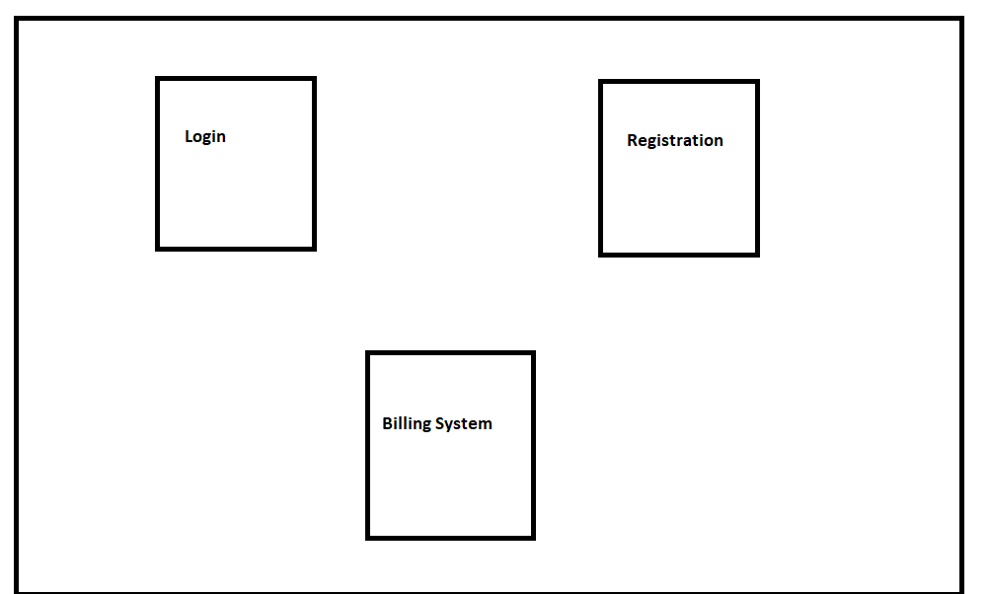

11

**Sub System:**

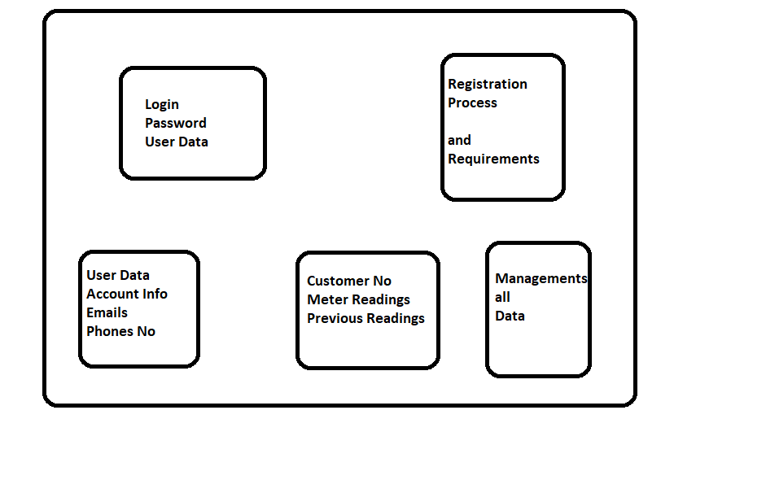

**Division Into Packages.**

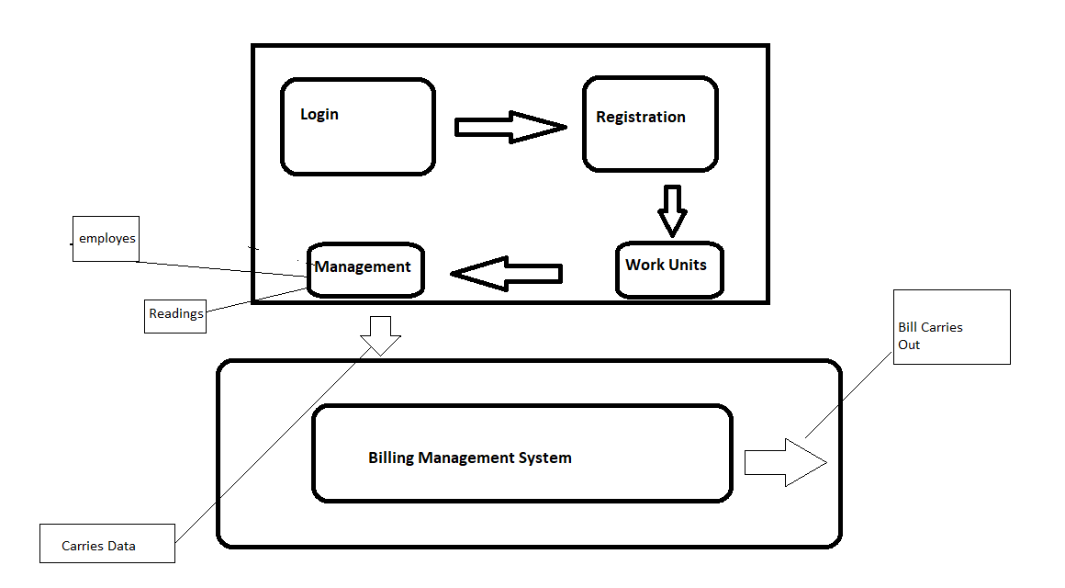

**Division Into Data Routines Within Classes:**

12

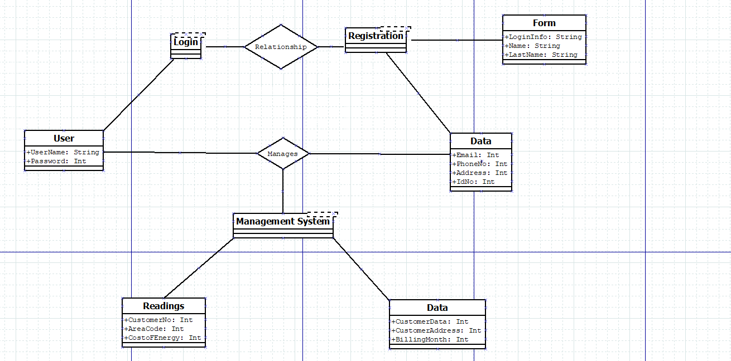

Internal Routine Design:

13

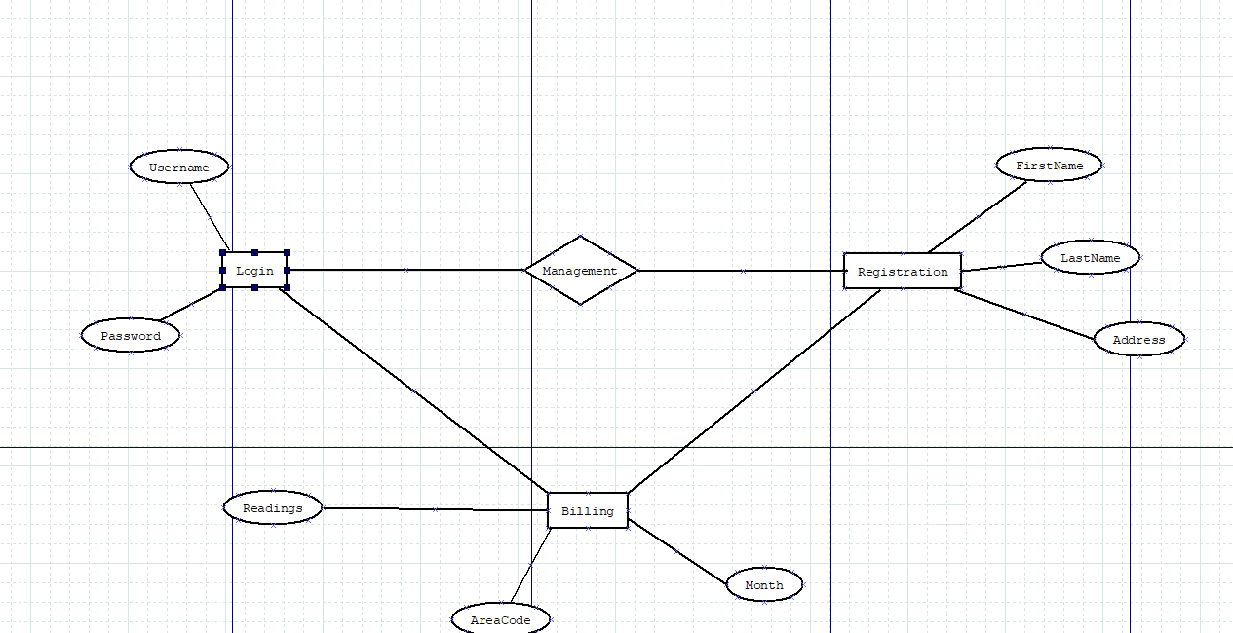

**Conclusion and GitHub Link:**

**Results and Conclusion:**

This project and java application can be used anywhere using a desktop computer and it is very easy and it has user friendly GUI interface user can easily manage and generate monthly bills as per monthly usage of the customer it has all the meter readings available.

The implantation on this project gives big advantage to the user of this application it is easier to understand it is very effective and smooth.

**GitHub Link of this Project**: