1. Setup username and email:

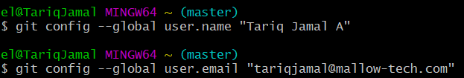

This commands is used to save the username and email for further use

1. Creating empty repository:



This command is used to create a empty repository in current directory.

1. Checking the status

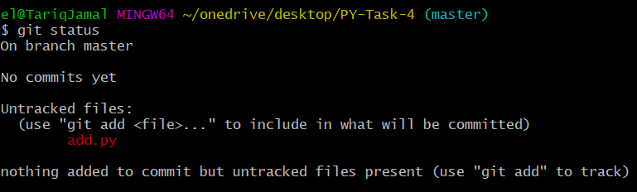

This command is used to display the state of working repository.

1. Staging and committing the changes  
   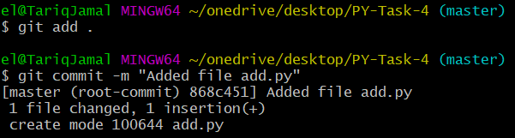

git add – is used to place the modified file in the staging area.

git commit – it takes everything from the staging area and makes a permanent screenshot of the current state of the repository that is associated with a unique identifier**.**

1. Access to remote repository



This command is used is used to get access of remote repository, After getting an access you can able to make changes in that repository

1. Adding local repository files to remote repository

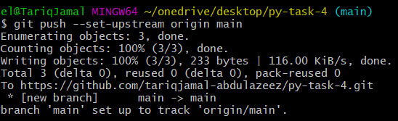

This command is used to add the local repository files to remote repository

1. Fetching files from remote to local repository

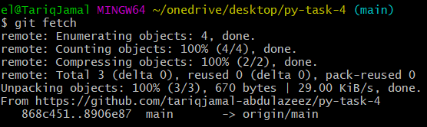

This command is used to download the content from remote repository

1. Merging the changes

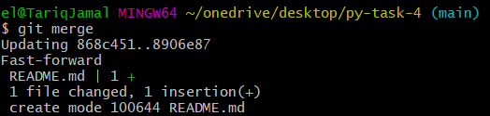

After download the content from remote repository using git fetch command, After that merge the content of remote to local repository by using this command

1. Pulling changes

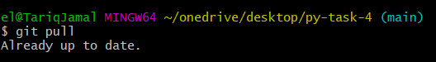

This command does same work which is done by git fetch and git merge

1. Get history

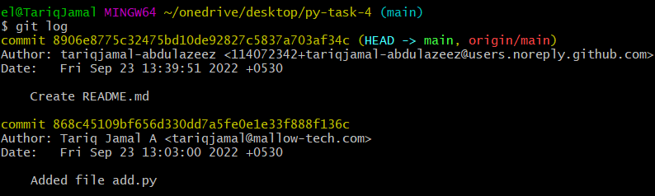

This command is used to get the commit history

1. Get particular commit history

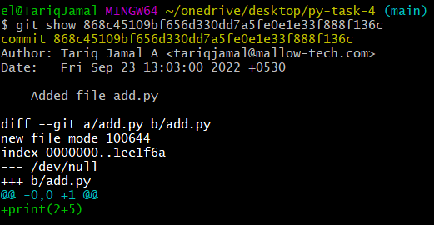

The output shows the details of the commit history based on the particular commit SHA value.

1. Branch

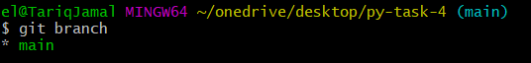

This command is used to get the list of all banches and to know the current working branch by indicating in a different color

1. Switch Branch

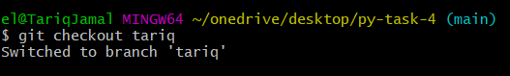

This command is used to switch the branch in the current repository

1. Create tag

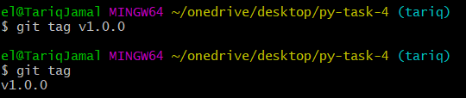

This command is used to create a tag

1. Move file



This command is used to move the add.py to lib folder

1. Merging branch

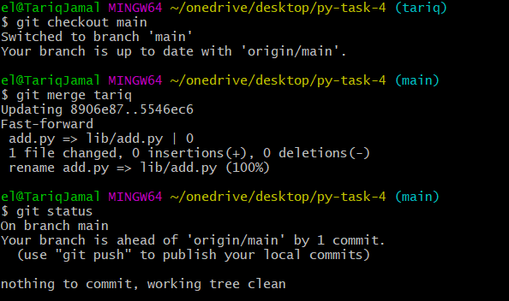

This command is used to merge a branch in main branch