**Chemistry Chapter 15 Revision Notes**

How nitrates and phosphates effect river water

They cause growth of algae which will float on the water and bacteria will then feed on the dead algae, which will use up dissolved oxygen and kill the fish.

Useful substance for water

Fish depend on the oxygen dissolved in the water, the water flows into their gills and the oxygen diffuses through it and into their blood.

How to separate solid particles from dirty water

* Filter the water through clean gravel or sand
* Let the particles settle at the bottom of a bottle **(sedimentation)**
* Add a something to make the particles stick together then skim them off **(flocculation)**

Test for water

* If a liquid contains water the copper(II) sulfate would go from **white to blue**
* It would turn cobalt(II) chloride paper from **blue to pink**

Test for **PURE** water

Freezes at 0 **°**C

Boils at 100 **°**C

Substance which kills bacteria

Chlorine

Substance which removes bad tastes and smells from water

Carbon

What nitrogen is used for

* Chlorophyll
* Protein
* Main nutrient for plants to grow

Ammonium Sulfate formulae

2NH3(g) + H2SO4(l) = (NH4)2SO4

NPK fertilizer

Mixture of salts that provides all three elements plants need: **Nitrogen, Phosphorus and potassium**

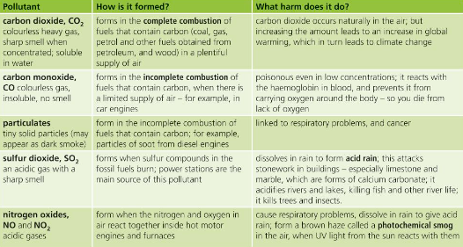Pollutants of fossil fuels

Catalytic converters

Oxides of nitrogen are removed by **reduction**

Example: 2NO(g) N2(g) +2CO2 (g)

Carbon dioxide and Methane increase global warming

Increasing the amount of carbon dioxide causes an increase in global warming which leads to climate change. Burning fossil fuels containing carbon such as coal, and petrol are the main sources of carbon dioxide.

Methane’s main source are the farm animals we breed, Such as buffalo and sheep, the microbes in their stomachs break down grass and methane is the main product.

There is much more carbon dioxide than methane, but methane is much more 28 times more powerful at warming earth.