|  |  |  |
| --- | --- | --- |
| Some areas have well managed farms and small holdings | Some developments are well sited and landscaped such as business parks | Some services such as reservoirs (stores of water) or cemeteries, may be attractive. |
| Transport and Infrastructure | Urban services | Some cycle ways improve access and promote new development |
| Some developments such as out of town malls cause serious pollution. Many businesses are unregulated e.g. scrap metal | Mineral workings, sewage works, landfill sites (for trash) are services which are needed but can be unattractive and polluting. | Farmers often suffer from litter, trespassers and vandalism; some land is derelict in the hope that planning permission for development will be granted. |
| Motorways destroy countryside, especially near junctions. | Country parks, sports fields and golf courses can lead to conservation. | Some sports can have a negative effect on the environment. |
| Recreation and sport | Agriculture | Landscape and nature conservation |
| Development | Conservation area may be included at the edge of the city | There may be degraded land e.g. land ruined by fly tipping (dumping of rubbish). Many conservation areas are under threat. |

**Lesson 7: Features of urban areas**

**Aim:** to identify the different features of urban areas

**Task 1: Connect the land use with the positive or negative statement – Issues in the urban fringe (edge of urban areas)**

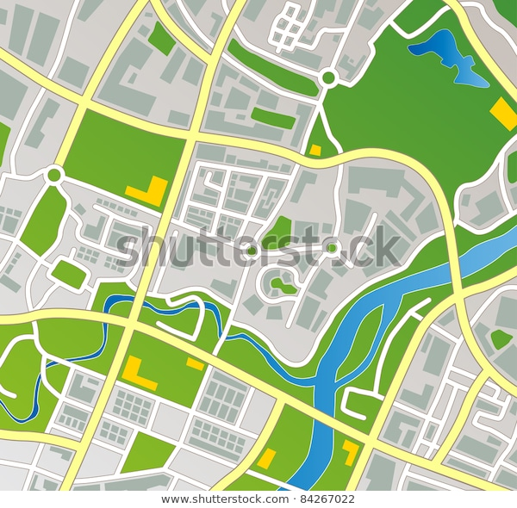

**What are the features of urban areas?**

Rural/Urban Fringe facts:

More housing

Industrial growth

Transport

Agricultural developments

Growth of out-of-town shopping centres:

In developed countries it has changed from an industry dominated by small firms to one being led by large companies.

The increasing use of out-of-town shopping centre

Transport Routes:

Roads were built when the cities were still small

Natural routeways, such as river valleys are important

Open Spaces: it increases towards the edge of the town more land becomes available

Industry facts

Traditional inner city areas close to railways

Areas that require access to water

Radial transport routes

Task 3: What are the advantages and disadvantages of out of town shopping centres?

|  |  |
| --- | --- |
| Advantages | Disadvantages |
| There is plenty of free parking  There is lots of space, so shops are not cramped  They are new developments so are usually quite attractive  There are easily accessible by car | They destroy large amounts of undeveloped greenfield sites  They destroy valuable habitats  They lead to pollution and environmental problems at the edge of town  Many of the jobs created are unskilled |

**Complete the activities on P58**

**1: plenty of free parking, easily accessible by car**

**2: the developments on the edge of town reduce the environmental pressures and problems in city centres**

**3: A: urban services b: Agriculture c: landscape and nature conservation d:Agriculture**