**IELTS Listening Map Exercises**

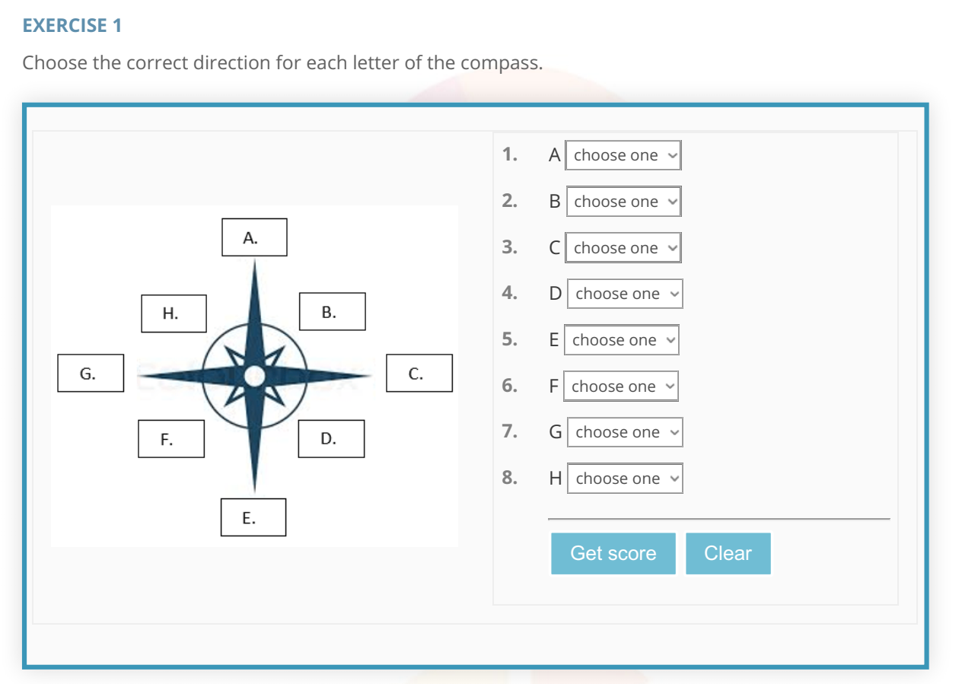

Answers are on the NEXT PAGE

Answers Exercise 1

1. North  
2. Northeast  
3. East  
4. Southeast  
5. South  
6. Southwest  
7. West  
8. Northwest

Exercise 2 (4 Sets of Questions for This One Map)

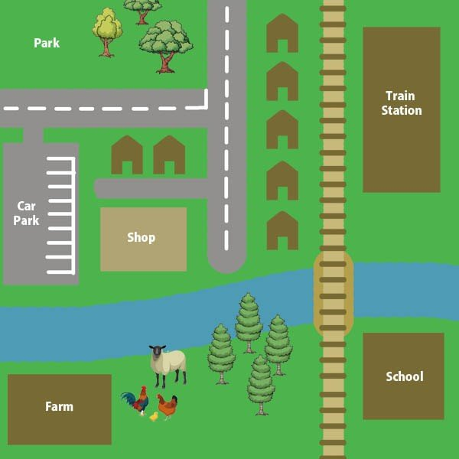

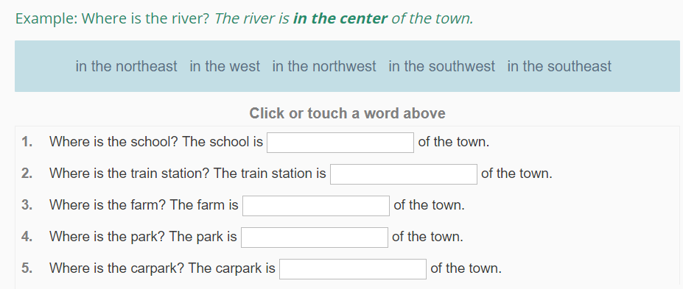

What is the relationship between the two places?

Example: *The school* ***is to the east of*** *the farm***.**

|  |  |
| --- | --- |
| **1.** | The shop  the park. |
| **2.** | The train station  the shop. |
| **3.** | The train station  the river. |
| **4.** | The farm  the park. |
| **5.** | The park  the school. |

*Example:* Where is the main road? *The main road runs****from****the river****to****the north of the town*.

|  |  |
| --- | --- |
| **1.** | Where is the river? The river  the east of the town. |
| **2.** | Where is the train line? The train line  north  the town. |

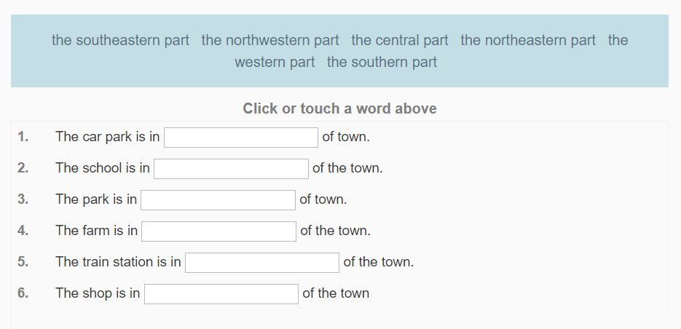

Note: The Answers are on the next page!

**Exercise 2 Answers**

