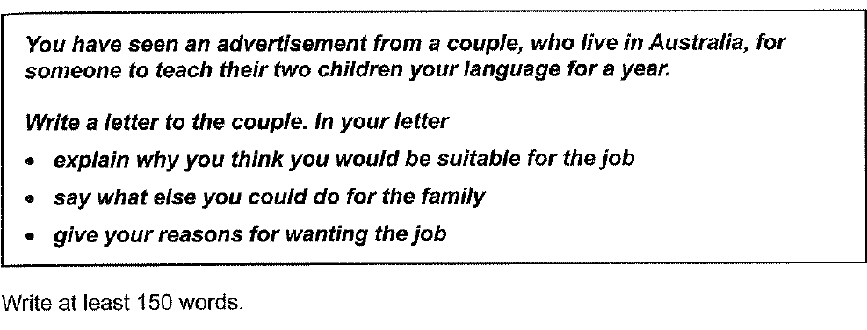

Dear Davis,

I am writing this letter in response to the advertisement by the young couple to tuition the language course for the children for one year. Presently, my designation is a research assistant in the foreign language department at the University of Passau.

I enrolled as a Ph.D. student at the University of Passau and worked with a Professor on how to train students at a young age to adapt to multiple languages. Furthermore, I gained experience teaching adolescents to grab vocabulary from movies and radio for more than five years.

In addition, I will put my best offer to integrate your children into the Indian culture, food, and traditions. Through social bonding, your children will become fluent in the Urdu Language.

I need the Job to fulfill my university’s requirements to complete the credit hours of private tuition. Along with that, it will assist me in paying the university fees for the next semester.

In anticipation, waiting for your response at the earliest.

Yours faithfully,

Sameed Tariq

In the modern world, the Fintech Industry is evolving at the fastest rate. With the restriction in mind, the payment industry has diversified itself to e-commerce, social media, and smartphone applications. I agree with the statement that the payment of services via mobile applications has more benefits in a number of countries.

As an initial point, the advancement of technology and the presence of highly skilled software engineers made it possible for the tech industry to connect mobile applications with the bank and deduct money from users’ accounts. For instance, the routing services for navigation on the road are easily availed by adding your credit card information to Google Play Store.

In addition, increasing the security of the payment gateway, settlement of payments, and accessibility to the Internet made it possible for individuals to pay their utility bills online. To illustrate, the Government of Pakistan launched an application to pay electricity bills at home while sitting at home. It helps the government to reduce the operational costs of the bank and reduce the hassle for customers to stand in long queues.

Last but not least, the financial industry increase the cap of payments to 100,000 dollars per annum. By increasing the transaction limit of online payments, individuals do not need to hire consultants to pay for their student fees. For example, the introduction of “wise” applications on smartphones made it easy for university fees by uploading supporting educational documents.

In conclusion, the benefits of payments in mobile applications led the fintech industry to increase the security of payments preventing hackers from gaining illegal access to user details and fraudulent activities. The accessibility of the Internet and instant transfer of money to the organization benefits all the users’ communities in various countries.