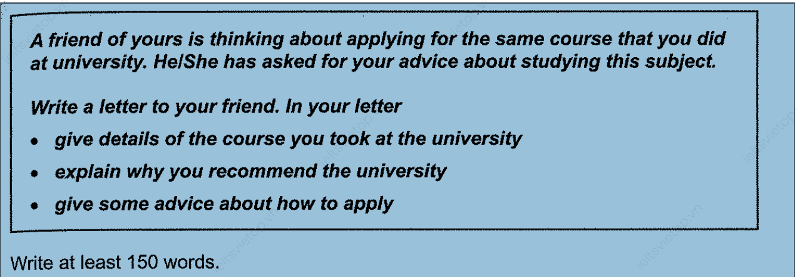

Dear Davis,

Thanks for writing the letter and seeking advice for the course selection at the University of Passau. I am glad to know that you have finally made plans to attend the university of your choice.

While studying at the University of Passau, I enrolled myself in the Information and Communication program which consists of courses related to software engineering, Game development, and machine learning. All these courses involved mathematical computation, logical thinking, and regex expression that prepare you for the technical industry around the globe.

The campus is located ten kilometers north of Swabi near the Tarbela Dam surrounded by small towns and has facilities related to sports, extra-curricular societies, and hiking. In addition, the research faculty of the university graduated from the top ten universities of the world and trained in well-equipped labs.

Presently, you have to register yourself for the entrance examination at the University of Passau online and submit the fees via bank transfer. You must have to score at least sixty-five percent in the entrance to secure a seat in the university.

If you need any further information regarding the university and entrance examination. Just write me an email.

Warm Wishes

Sameed Tariq.

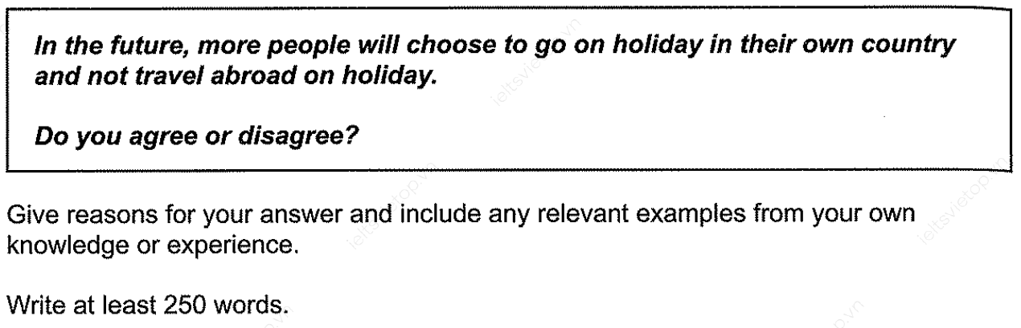

In the modern world, the community spends a great deal of wealth on touring historical places on holidays. This essay will discuss why individuals prefer to pick their own country for tourism rather than traveling abroad. I agree with the opinion of the essay and will outline the reason behind growing domestic tourism.

As an initial point, domestic tourism will be a more affordable option for people to travel across the country as jet fuel prices are constantly increasing which results in a high fare for international travel. For instance, Pakistan developed the Karakoram Highway to connect the Himalayas and the Salt Range for tourism by road which is quite cheaper than traveling internationally by air. Traveling by road offers unique experiences such as waterfalls, pine forests, dams, and valleys.

Secondly, touring the local places on vacations boost the local economy of the region. It supports the food industry, hotels, agriculture, and markets and has a positive impact on the region by increasing the employment rate. To illustrate, the United Nations report states that Pakistan’s Tourism Industry shows a growth of nine percent in 2023 contributing indirectly to the economy of the country.

Last but not least, domestic tourism benefits society by learning different languages, cultures, and traditions by engaging in communities of various regions. It assists society in forming social bonds among the people bringing pride and unity. For Example, Pakistan Tourism Development Corporation initiated a cultural exchange program among tourists to learn and adapt to the culture and traditions to preserve the identity of the region.

In conclusion, travelers who are visiting their own country on holiday contribute to the local economy, culture, and traditions. I strongly believe that boosting local tourism promotes the development of the area and is quite better than traveling abroad which offers a similar experience at a low travelling cost.