**Note: This document contains all the writing tasks 1 & 2 of Book 16.**

**Test 1, Task 2:**

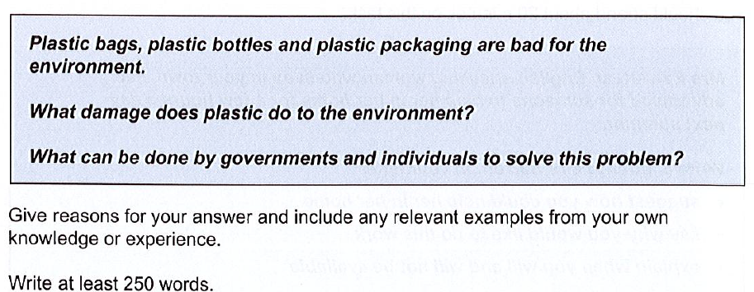

In the modern world, environmental protection is the community’s priority to extend the earth’s life. It is irrefutable that plastic harms the environment to a great extent. In this essay, the action on how to solve the plastic problems will be mentioned to reduce the risk of damage occurring through plastic packaging.

Plastic products significantly contribute the environmental pollution. Firstly, the deposition of plastics in the soil reduces the fertility of the soil. Consequently, the soil becomes poor, and less nutrients. In addition, the emittance of acidic fumes from the plastic industry lowers the quality of the air in the surrounding. Therefore, more people are having asthma issues. Lastly, all the plastic must not be drained off into the river and sea despite the Government restrictions. As a result, the marine ecosystem is threatened by non-biodegradable plastics.

Be that as it may, the solution exists for the problems mentioned above to reduce environmental damage. Plastic bags should be replaced with biodegradable materials like bags made with jute fiber. Along with that, the government should impose a policy of shutting down industries contributing to ground pollution. If the government provides funds to the influencers to make programs on the effect of plastics and create awareness in society, then society can collaborate with the government to reduce the use of plastic bags. The Industrialist Association in collaboration with Academic Institutions can perform a scientific study to convert non-biodegradable products to biodegradable products and acidic fumes to T-shirts and recyclable products.

In conclusion, the production of plastic products plays a leading role in damaging the earth. Considering the solution above, the individuals and government can take a significant step in reducing the pollution of the earth.

**Test 2, Task 2:  
  
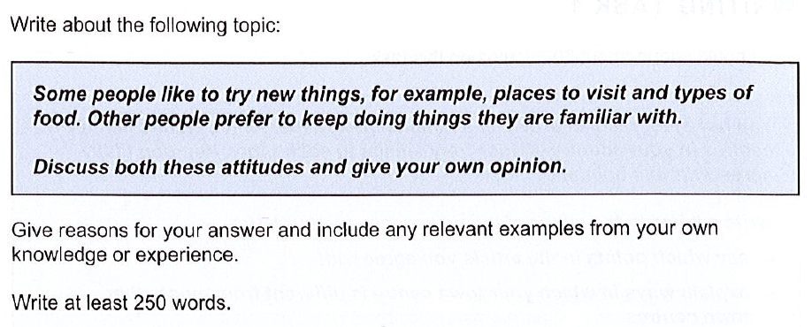**

With the passage of time, the evolving nature of the human being has made different choices for the young generation. Some people yearn for new experiences by trying new things and taking risks. While some prefer to stay in their comfort zone and do not adapt to any changes. In this essay, we will discuss both perspectives.

On the one hand, visiting new places increases the knowledge of the person about the traditions, culture, and languages. As a result, social bonding is formed between the regions of different people. Despite trying the old way of scientific study, it is not necessary for the research students to succeed in their experiments. However, they must try new ideas to succeed. For Instance, one of my cousins started a solar panel business although he was working in a multinational company. No one initially supported the move and he became a millionaire by doing business.

On the contrary, people who are having a monotonous routine have a less complicated life and have more time for leisure activities such as watching movies or skating. In addition, it is easy to navigate through hilly areas by visiting the same place again and again, although the person gets bored and avoids traveling to scenic areas. To illustrate, the travelers’ possessed inadequate knowledge about the geographic landscape, culture, and tradition of Pakistan who prefer to travel to the same area frequently.

In my opinion, those who try a new way of living and adopt new ideas in life have more chances to succeed than living a life with no adventures at all.

In conclusion, the growth and stability of the person come from those who are willing to take more risks in life rather than spend a life with the same routine with inadequate knowledge.

**Test 3, Task 2:**

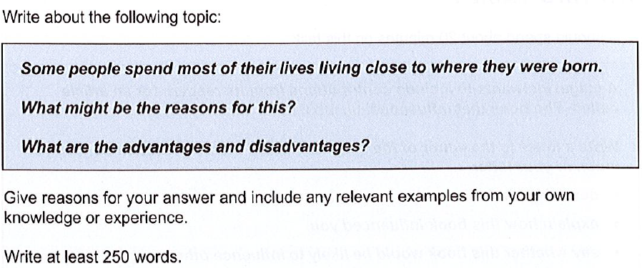

In the modern world, migration to faraway places from their hometown is the most common tradition. However, history shows that people prefer to live close to their birthplace. This essay will discuss the pros and cons of living close to the birth town and the reason behind it.

One of the major reasons for desiring to live close to their birthplace is to keep themselves connected to their relatives and the local community. Along with that, they have to care of properties, and farmland inherited from their ancestors. Despite spending time away from downtown, they feel pride in learning their culture, languages, and traditions.

A healthy lifestyle and social contribution are major advantages of living close to the place of birth. Although the person living away from the state capital does not have access to modern education and well-equipped labs, they can contribute to the development of the local area by collecting funds from the community. In addition, mental well-being and physical health can be in good shape by participating in local festivals, events, and celebrations.

On the other hand, meddling in private affairs and low growth are the major disadvantages of living in the same location. For instance, Grandchildren at adult age leave their hometown for cities due to constant interference of their relatives in their private matters. Moreover, living close to family makes the person lazy and dragged them into their comfort zone. It hinders the person from accepting new challenges for growth and career opportunities.

In conclusion, most people choose to live close to they were born because it provides them with social security and unity in learning their culture. While this decision has many significant disadvantages such as limited opportunities for personal growth and exposure to diversity.

**Test 1, Task 1:**

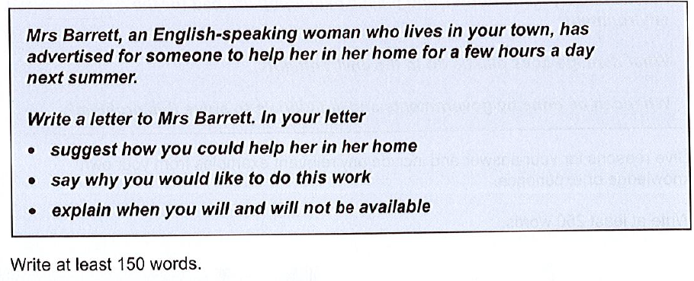

Dear Mrs Barrett,

I am writing this letter in response to the advertisement to assist you at home next summer. Presently, my designation is a social worker at the University of Passau.

With regard to what sort of assistance I could offer you, I could do anything from assembling the parts of the furniture and preparing the meal three times a day. In addition, I can mow the lawn in summer to clean your garden and wash your cars. While you go grocery shopping, I can take care of your pets and children.

I am interested in the opportunity to work for you to attain the certificate of local helper for my admission to graduate studies. Furthermore, it will assist me to save money for my tuition fees for next semester.

I will be available for the paid work by coming Friday till the end of September and will be flexible with working hours at your house. Let me know if you require any further information to qualify for the position. I am looking forward to hearing from you.

Yours faithfully

**Test 2, Task 1:**

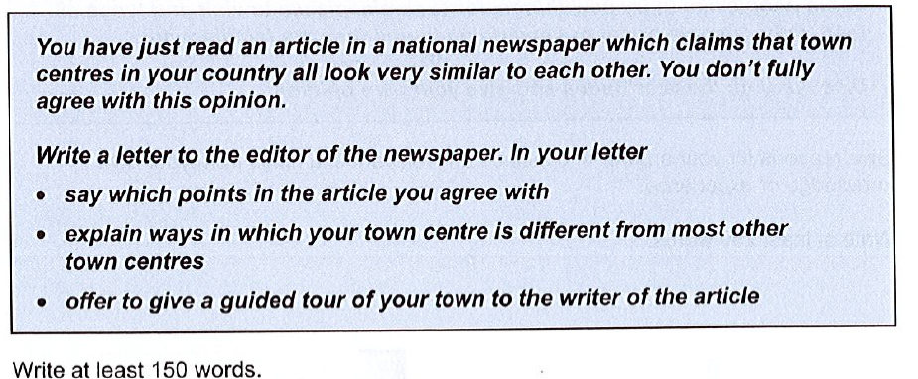

Dear Sir,

I am writing this letter in response to your newspaper article in Dawn stating that towns look similar in our country. Presently, my designation is an Assistant Professor in the Urban Planning Department at the University of Passau.

I agree about the similarity in cities to the extent that they are divided into square blocks and round blocks. Each square block represents the residential block, and the circle shows the commercial block. The architecture of the houses is similar across the country consisting of wooden floors and a dome at the top of the house whereas commercial blocks are five-story buildings due to government policies.

However, I found that our city, the state capital, is quite different from other cities. Although, the city is old and trams go through the busiest main square. The houses are built with wood and the design on the walls shows the architecture of the Mughal Emperor.

Finally, I would like to offer you a tour of the state capital on weekends around 2:00 PM to change your perspective on the cities. Please do not hesitate to contact me.

Regards