**Enquiry list**

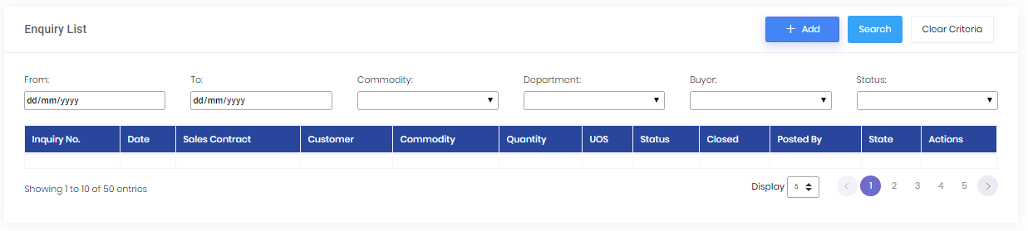

* **Click on add button**

**Create enquiry**

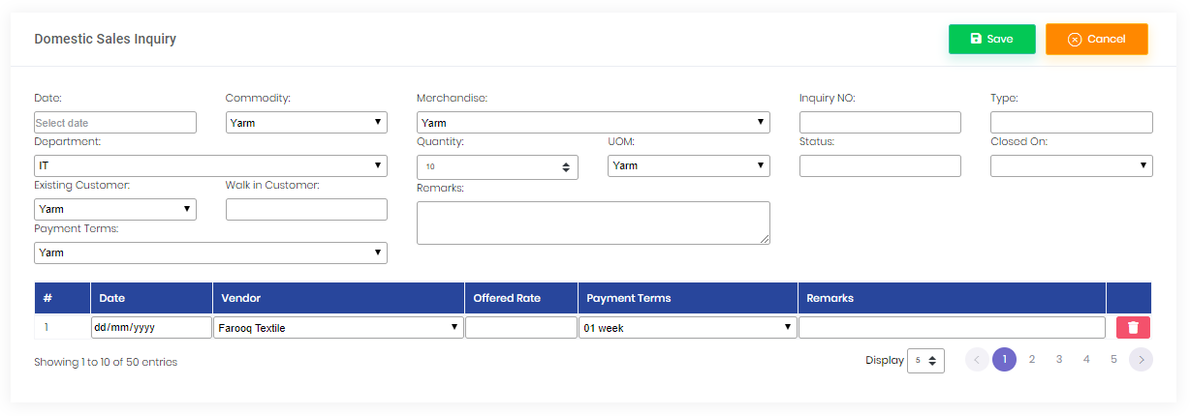

* **Click on enquiry review**

**Enquiry review**

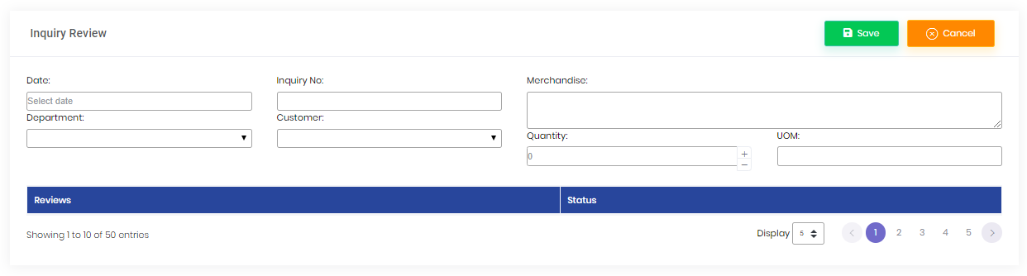

* **Repository complete enquiry forms.**

**Contract yarn& fabric**

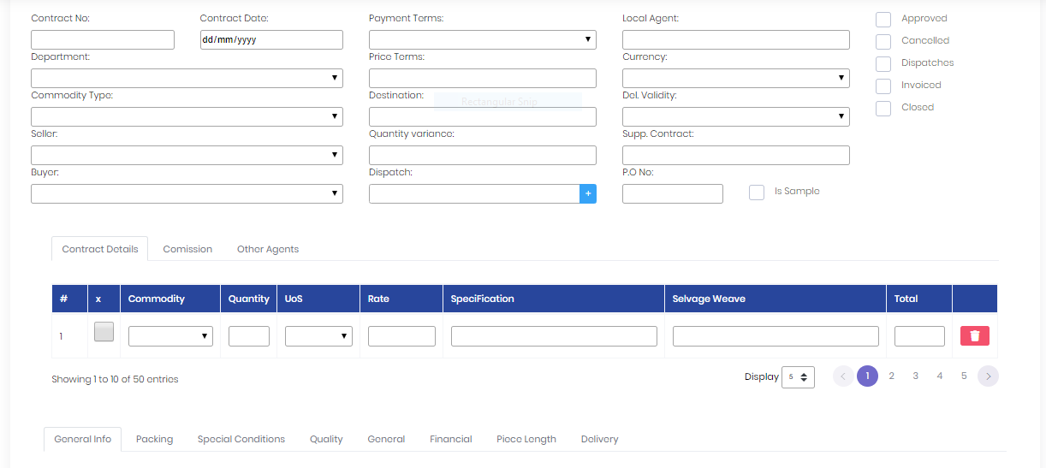

* **Repository complete**

**Yarn Inspection Register**

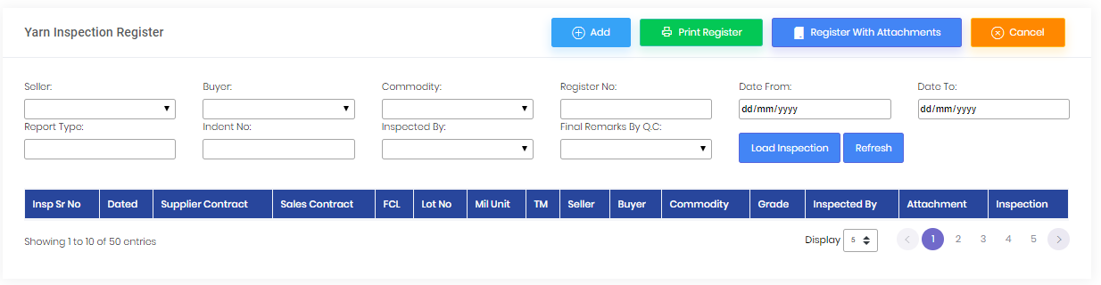

**Yarn Inspection Add**

**With tab 1**

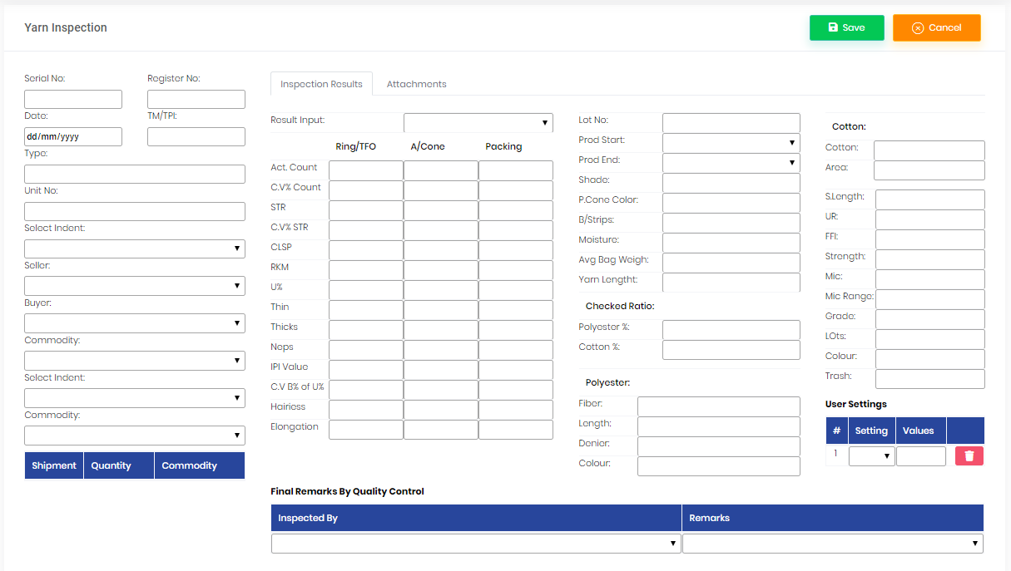

**With Tab 2**

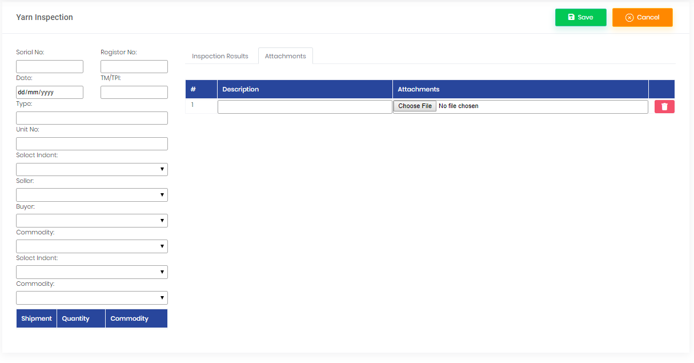

* **Required repository of yarn inspection**

**Fabric Inspection Register**

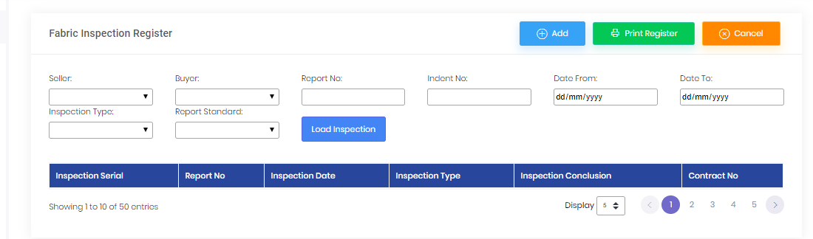

**Fabric Inspection Add**

**With tab 1**

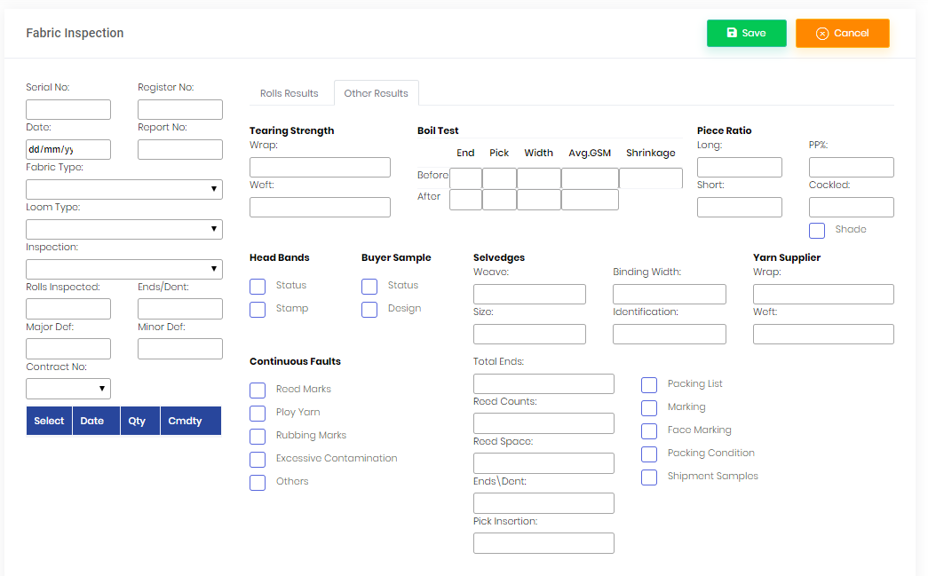

* **Repository complete.**

**Follow up sheets**

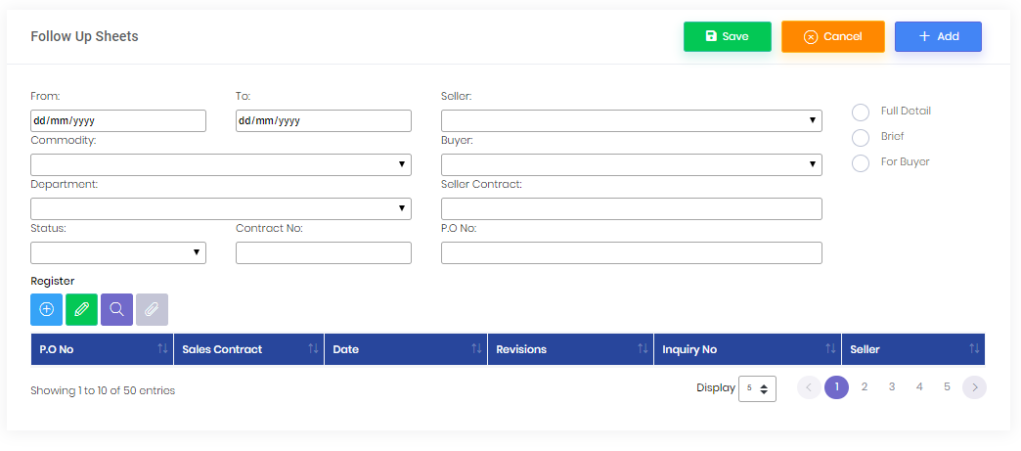

**Dispatch**

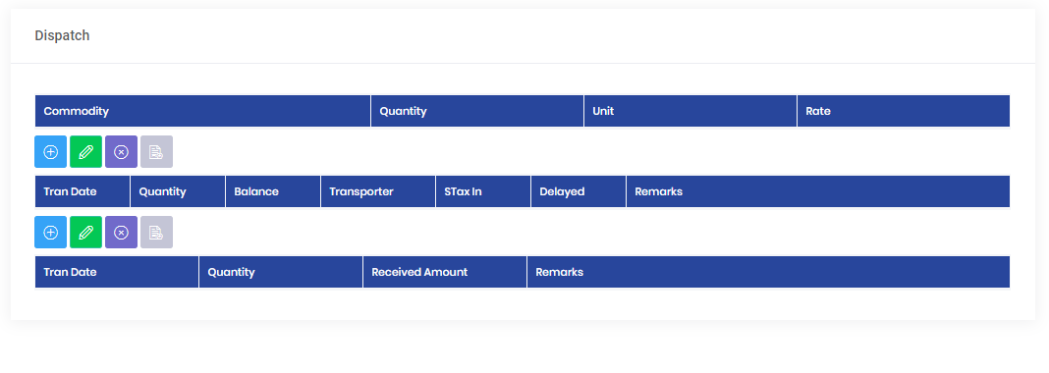

**Click to add button on Dispatch form and add dispatch**

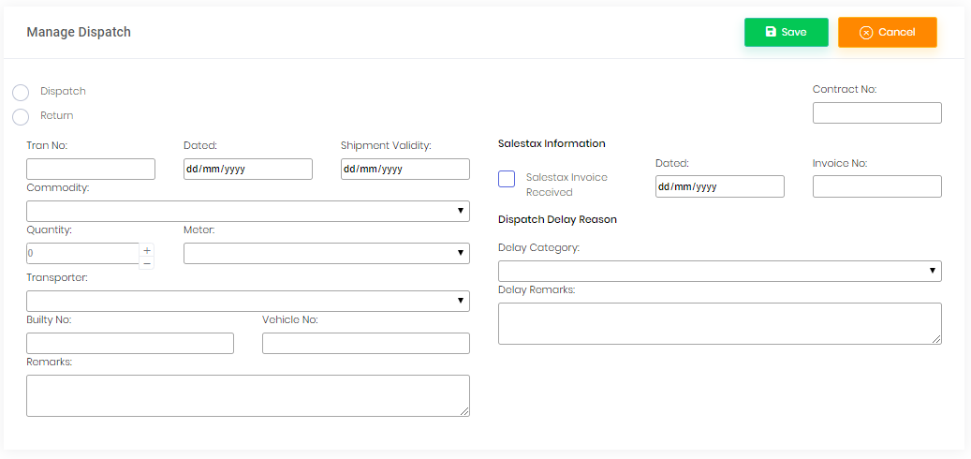

**Click to add button on dispatch form then show Manage Payments**

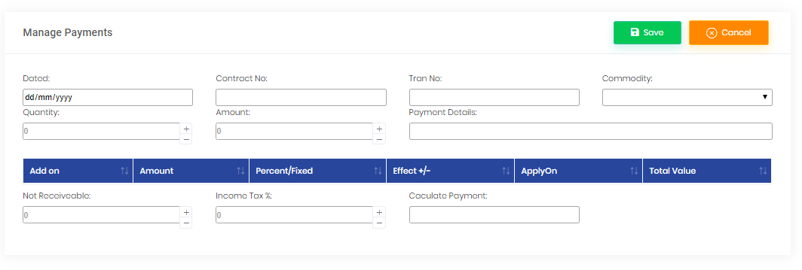

* **Pending**

**Click E-File button on the follow up sheet**

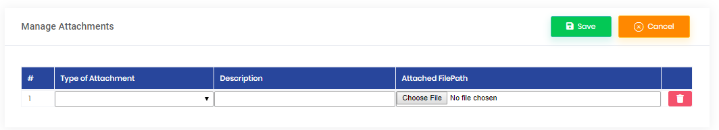

* **Required Repository**

**Click Sales contract status show on the follow up sheet**

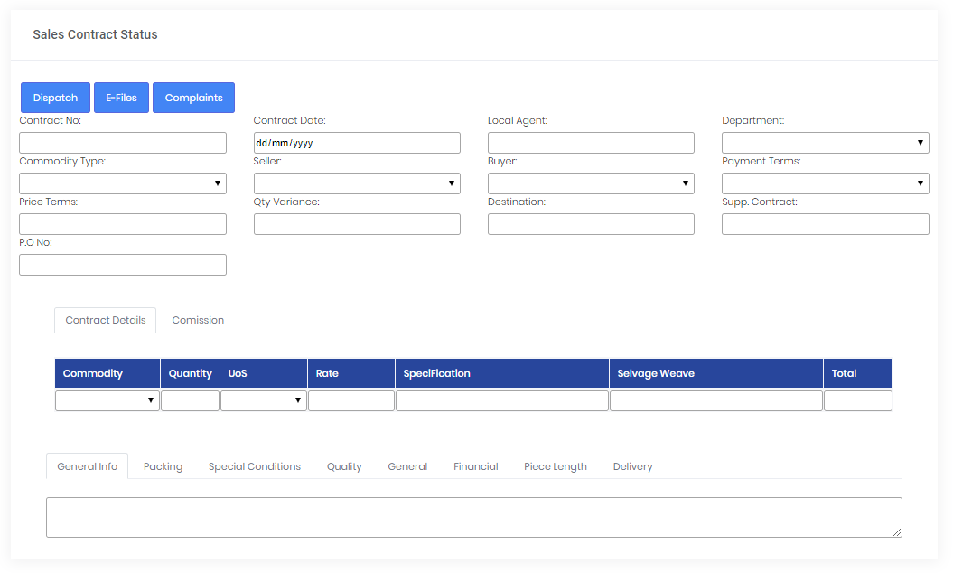

* **Pending**

**Fabric Samples details**

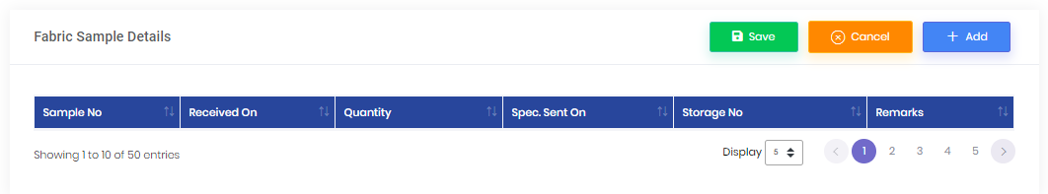

**Add fabric sample**

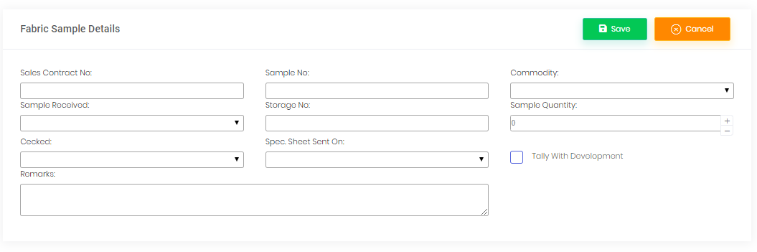

* **Required Repository**

**Sales Report**

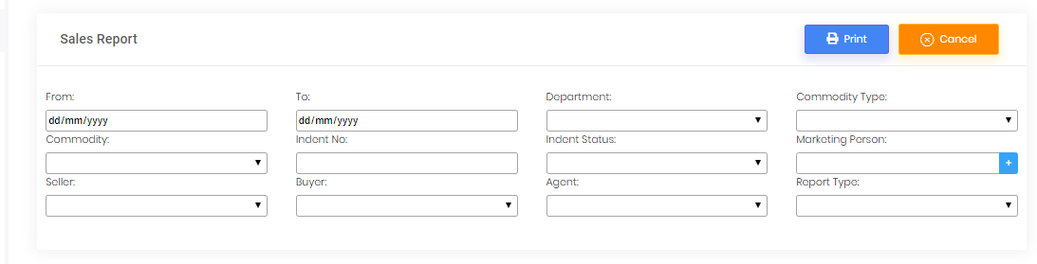

**Dispatch Report**

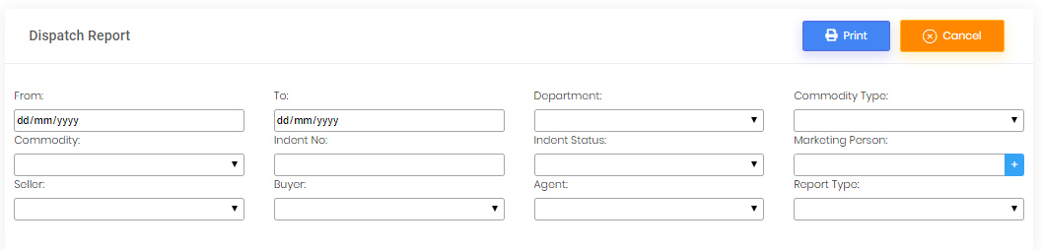

**Supplier Performance**

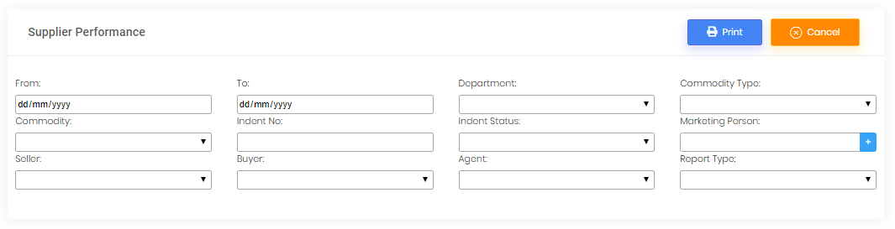

**Invoice Not Generated**

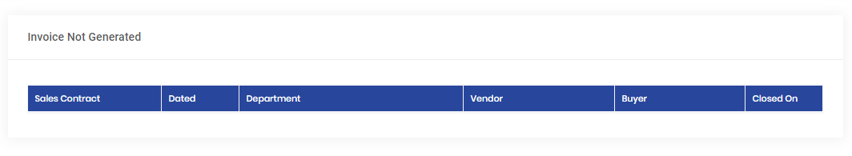

**Yarn Inspection Report**

