**NAMA : TARISA DINA LUTFIANA**

**NIM : A11.2020.13105**

Hasil Code:

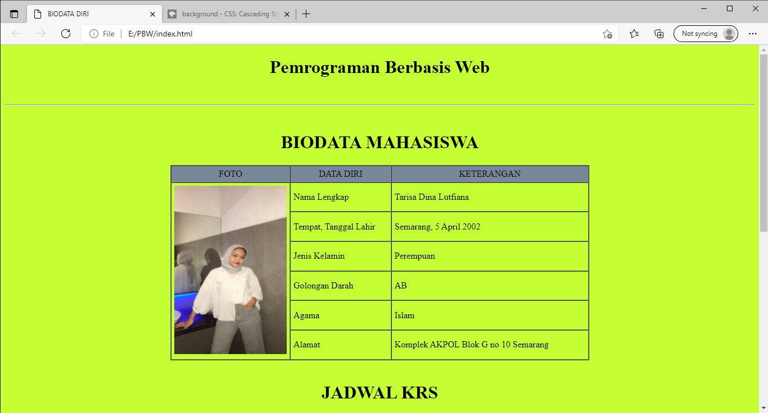

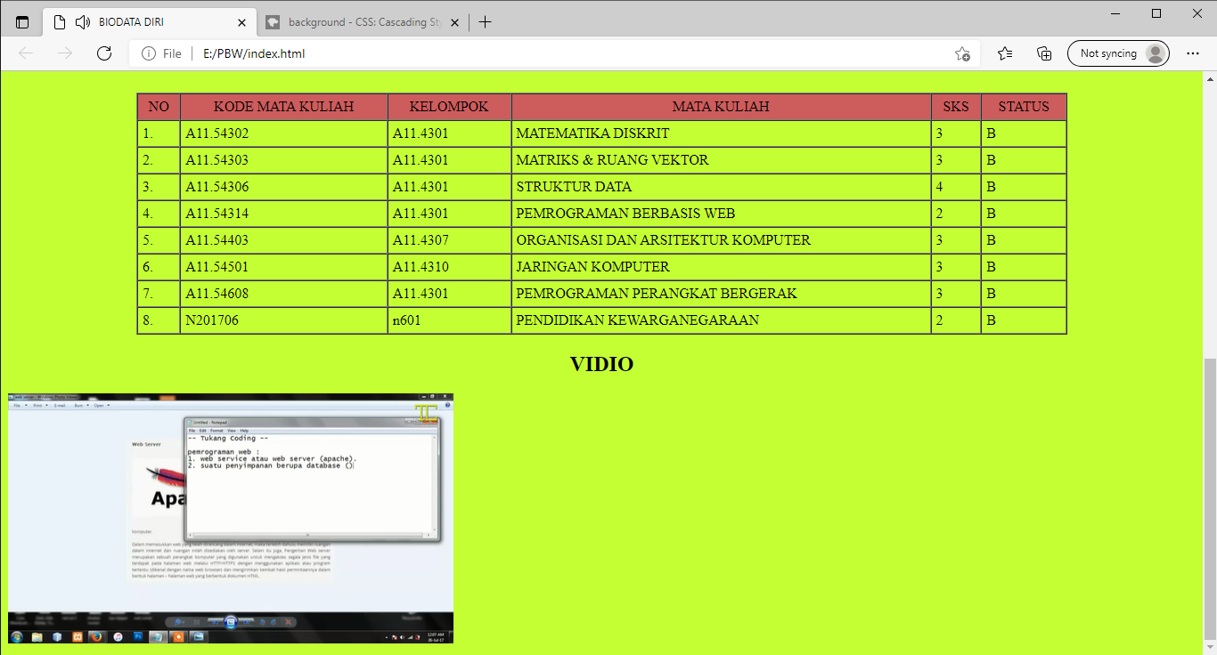

Code Program:

<!DOCTYPE html>

<html>

    <head>

        <title>BIODATA DIRI</title>

    </head>

    <body bgcolor="#C4FF33">

        <h1 align="center">Pemrograman Berbasis Web</h1>

        <br>

        <hr align="center">

        <br>

        <h1 align="center">BIODATA MAHASISWA</h1>

        <table width="745" border="1" cellspacing="0" cellpadding="5" align="center">

        <tr align="center" bgcolor="#778899">

            <td width+"200">FOTO</td>

            <td width="174">DATA DIRI</td>

        <td width="353">KETERANGAN</td>

        </tr>

        <tr>

            <td rowspan="10" align="center"><img src="tdl.jpeg" width="200" height="300"/>

            <td>Nama Lengkap</td>

        <td>Tarisa Dina Lutfiana</td>

        </tr>

        <tr>

        <td>Tempat, Tanggal Lahir</td>

        <td>Semarang, 5 April 2002</td>

        </tr>

        <tr>

        <td>Jenis Kelamin</td>

        <td>Perempuan</td>

        </tr>

        <tr>

        <td>Golongan Darah</td>

        <td>AB</td>

        </tr>

        <tr>

        <td>Agama</td>

        <td>Islam</td>

        </tr>

        <tr>

        <td>Alamat</td>

        <td>Komplek AKPOL Blok G no 10 Semarang</td>

        </tr>

        </table>

        </body>

    &nbsp

    <h1 align="center">JADWAL KRS</h1>

    <table width="1045" border="1" cellspacing="0" cellpadding="5" align="center">

        <tr align="center" bgcolor="#CD5C5C">

            <td width>NO</td>

            <td width>KODE MATA KULIAH</td>

            <td width>KELOMPOK</td>

            <td width>MATA KULIAH</td>

            <td width>SKS</td>

            <td width>STATUS</td>

        </tr>

        <tr>

            <td>1.</td>

            <td>A11.54302</td>

            <td>A11.4301</td>

            <td>MATEMATIKA DISKRIT</td>

            <td>3</td>

            <td>B</td>

        </tr>

        <tr>

            <td>2.</td>

            <td>A11.54303</td>

            <td>A11.4301</td>

            <td>MATRIKS & RUANG VEKTOR</td>

            <td>3</td>

            <td>B</td>

        </tr>

        <tr>

            <td>3.</td>

            <td>A11.54306</td>

            <td>A11.4301</td>

            <td>STRUKTUR DATA</td>

            <td>4</td>

            <td>B</td>

        </tr>

        <tr>

            <td>4.</td>

            <td>A11.54314</td>

            <td>A11.4301</td>

            <td>PEMROGRAMAN BERBASIS WEB</td>

            <td>2</td>

            <td>B</td>

        </tr>

        <tr>

            <td>5.</td>

            <td>A11.54403</td>

            <td>A11.4307</td>

            <td>ORGANISASI DAN ARSITEKTUR KOMPUTER</td>

            <td>3</td>

            <td>B</td>

        </tr>

        <tr>

            <td>6.</td>

            <td>A11.54501</td>

            <td>A11.4310</td>

            <td>JARINGAN KOMPUTER</td>

            <td>3</td>

            <td>B</td>

        </tr>

        <tr>

            <td>7.</td>

            <td>A11.54608</td>

            <td>A11.4301</td>

            <td>PEMROGRAMAN PERANGKAT BERGERAK</td>

            <td>3</td>

            <td>B</td>

        </tr>

        <tr>

            <td>8.</td>

            <td>N201706</td>

            <td>n601</td>

            <td>PENDIDIKAN KEWARGANEGARAAN</td>

            <td>2</td>

            <td>B</td>

        </tr>

    </table>

    <h2 align="center">VIDIO</h2>

    <body>

    <video width="500" border="1" cellspacing="0" cellpadding="5" align="center" controls>

        <source src="tdlvidio.mp4" type="video/mp4"

    </video>

    </body>

</html>