Name: _ Tariye Precious Inaibagha____ Date: ________________________

**Student Exploration:** **RNA and Protein Synthesis**

**Vocabulary:** amino acid, anticodon, codon, gene, messenger RNA, nucleotide, ribosome, RNA, RNA polymerase, transcription, transfer RNA, translation

**Prior Knowledge Questions** (Do these BEFORE using the Gizmo.)

1. Suppose you want to design and build a house. How would you communicate your design plans with the construction crew that would work on the house?

1. __ Building plan.________________________________________________________

_________________________________________________________________________

1. Cells build large, complicated molecules, such as proteins. What do you think cells use as their “design plans” for proteins?

_____DNA________________________________________________________________

_________________________________________________________________________

**Gizmo Warm-up**

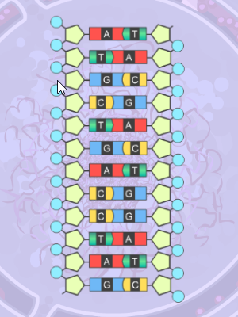

Just as a construction crew uses blueprints to build a house, a cell uses DNA as plans for building proteins. In addition to DNA, another nucleic acid, called **RNA**, is involved in making proteins. In the *RNA and Protein Synthesis* Gizmo™, you will use both DNA and RNA to construct a protein out of **amino acids**.

1. DNA is composed of the bases adenine (A), cytosine (C), guanine (G), and thymine (T). RNA is composed of adenine, cytosine, guanine, and uracil (U).

Look at the SIMULATION pane. Is the displayed segment a part of a DNA or RNA molecule? How do you know?

* + - 1. __ DNA. It has a double helix structure.___________

1. **RNA polymerase** is a type of enzyme. Enzymes help chemical reactions occur quickly. Click the **Release enzyme** button, and describe what happens.
   * + 1. _ The DNA splits._____________________________________________________

|  |  |  |
| --- | --- | --- |
| **Activity A:**  **Transcription** | Get the Gizmo ready:   * If necessary, click **Release enzyme**. | 442SE2 |

**Introduction:** The first stage of building a protein involves a process known as **transcription**. In transcription, a segment of DNA serves as a template to produce a complementary strand of RNA. This complementary strand is called **messenger RNA**, or mRNA.

**Question: What occurs during transcription?**

1. Experiment: Like DNA, RNA follows base-pairing rules. Experiment to find which RNA **nucleotide** on the right side of the Gizmo will successfully pair with the thymine at the top of the template strand of DNA. (NOTE: The DNA on the right side is the template strand.)

Which RNA base bonded with the thymine? ___ Adenine.____________________

1. Experiment: The next three bases on the DNA template strand are adenine, cytosine, and guanine. Use the Gizmo to answer the following questions:
   * 1. Which RNA base bonds with adenine? ___ Thymine __________________
     2. Which RNA base bonds with cytosine? ___ Guanine ______________________
     3. Which RNA base bonds with guanine? ____ Cytosine ______________________

1. Observe: In molecules of RNA, uracil takes the place of the DNA base __ Thymine ____.
2. Build: Continue building the strand of mRNA until you have used all of the RNA nucleotides. What is the nucleotide sequence of the mRNA strand you built?

__ AUGCUGACCUAG ___________________________________________________

1. Apply: Suppose a template strand of DNA had the following sequence:

T A C G G A T A A C T A C C G G G T A T T C A A

What would be the complementary strand of mRNA?

1. A U G C C A A U U G A U G G C U A A G T T
2. Predict: How would a change to the sequence of nucleotides in a DNA segment affect the mRNA transcribed from the DNA? __ It would change the corresponding sequence of mrna

_________________________________________________________________________

|  |  |  |
| --- | --- | --- |
| **Activity B:**  **Translation** | Get the Gizmo ready:   * Once the mRNA strand has been built, click **Continue**. | 442SE3 |

**Introduction:** After a strand of mRNA has been built, the strand exits the cell’s nucleus. The second stage of protein synthesis, called **translation**, occurs next. During translation, the strand of mRNA is used to build a chain of amino acids.

**Question: What occurs during translation?**

1. Observe: Examine the strand of mRNA on the SIMULATION pane. Every group of three bases of mRNA is called a **codon**.

In the table at right, list the nitrogen bases in each codon. (Hint: Start from the top of the strand and read down.) The first mRNA codon is called the *universal start codon*.

|  |  |
| --- | --- |
| **Codon** | **mRNA bases** |
| 1 | AUG |
| 2 | CUG |
| 3 | ACC |
| 4 | UAG |

1. Predict: Translation starts when a **ribosome** (the purple structure on the SIMULATION pane) binds to a strand of mRNA. **Transfer RNA**, or tRNA, begins bringing amino acids into the ribosome. Each tRNA molecule carries only one kind of amino acid. This amino acid is determined by the tRNA’s **anticodon**, a set of three unpaired bases.

Which anticodon do you think would attach to the mRNA’s start codon? __UAC _____

Use the Gizmo to check your answer.

1. Observe: Place the next two tRNA molecules on the mRNA strand. What happens?

__The ribosome moves down and the first tRNA is moved and there is a growing amino chain__________________________________________________________________

As each tRNA molecule binds to the mRNA, the ribosome joins the amino acid carried by the tRNA to the growing amino acid chain.

1. Describe: UAG (as well as UAA and UGA) is an example of a *stop codon*. Molecules called *release factors* bind to stop codons. Place the release factor on the mRNA molecule.

What happens? ________The tRNA goes away leaving an amino chain behind_______

_________________________________________________________________________

Click **Continue**. Your protein is now complete. Most actual proteins consist of sequences of hundreds of amino acids.

**(Activity B continued on next page)**

**Activity B (continued from previous page)**

1. Infer: Why do you think stop and start codon signals are necessary for protein synthesis?

__There would be no way to begin or end the process of translation without codon signals

_________________________________________________________________________

_________________________________________________________________________

1. Summarize: Describe the processes of transcription and translation in your own words, based on what you have observed in the Gizmo.

Transcription: __This involves the splitting of a DNA strand to form an mRNA strand. It involves the DNA being split by an enzyme then the RNA strand being bonded to the respective DNA nucleotide.___________________________________________________

_________________________________________________________________________

_________________________________________________________________________

Translation: ____This involves an mRNA strand building an amino acid chain. The mRNA is bonded to tRNA to form the amino acid chain and it is detached by release factors______

_________________________________________________________________________

_________________________________________________________________________

_________________________________________________________________________

|  |  |  |
| --- | --- | --- |
| **Extension:**  **Genes and traits** | Get the Gizmo ready:   * You will not need to use the Gizmo for this activity. | RNAProteinSynthesisSEB1 |

**Introduction:** Inside a ribosome, amino acids are linked together to form a protein molecule. As the chain of amino acids grows, it folds and coils to form a three-dimensional shape. The complex shape that results determines the properties of the protein. Proteins have a wide variety of structures and perform many essential functions in living things.

A sequence of DNA that codes for a specific protein is called a **gene**. By coding for proteins, genes determine an organism’s inherited traits.

**Question: How do genes code for specific proteins and traits?**

1. Translate: Each codon codes for one of 20 amino acids. This code is universal among all living things. For example, the mRNA codon GGU codes for the amino acid glycine in every living thing, from a bacteria to an elephant.

Examine the codon chart below. The amino acid coded for by a specific mRNA codon can be determined by finding the first base of the codon along the left side of the table, the second base along the top of the table, and the third base along the right side of the table.

[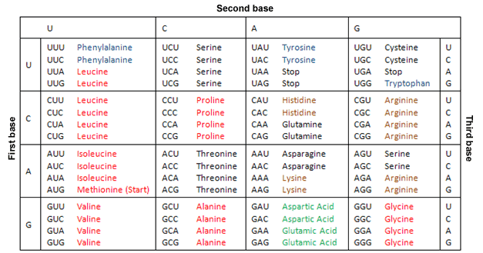](http://upload.wikimedia.org/wikipedia/commons/c/cc/Codontable1.PNG)

_________________________________________________________________________

What amino acids do the following codons code for?

AUG: __Methionine_ CUG: __Leucine___ ACC: _Threonine__ UAG: __Stop__

**(Extension continued on next page)**

**Extension (continued from previous page)**

1. Apply: Suppose you wanted a protein that consists of the amino acid sequence methionine, asparagine, valine, and histidine. Give an mRNA sequence that would code for this protein.

_AUG_ _AAU_ _GUC_ _CAU_

1. Summarize: How do genes determine the traits of an organism? Explain in detail.

__Genes are the features that everyone has. Each parent passes on a unique set of genes in the DNA to their child. This means that they pass on their traits and features to their offspring. _________________________________________________________________

_________________________________________________________________________

_________________________________________________________________________

1. Extend your thinking: Sometimes errors occur during transcription or translation. Examine the codon chart on the previous page. Notice that each amino acid is coded for by several different codons. For example, alanine is coded for by GCU, GCC, GCA, and GCG.

How might this offset transcription or translation errors? Amino acids are coded by several different codons. It causes a mutation if there is a change. _____________________________

_________________________________________________________________________

1. Think and discuss: Consider the two following statements:

* The theory of evolution states that all living things had a single common ancestor.
* The translation between mRNA and amino acids is the same for all living things. (For example, the mRNA codon CAG codes for glutamine in all living things.)

Does the second statement support the theory of evolution? Explain why or why not. If possible, discuss your answer with your teacher and classmates.

Yes. Because the ancestor is the same, the same codon code is passed down. The only change would be in the instance of a mutation. ___________________________________

_________________________________________________________________________

_________________________________________________________________________

_________________________________________________________________________