Practical-9

Problem Definition
Design and implement a robust logical and physical dimensional data model for business analytics. The practical focuses on transforming transactional sales records into a Kimball Star Schema, separating descriptive attributes into Dimension tables and storing numerical business metrics in a central Fact table.
The data model will be designed to support analytical queries, improve reporting efficiency, and simplify relationships between customers, products, dates, and sales transactions.
The implementation uses SQL, DuckDB, and an entity-relationship diagram (ERD) tool to define the schema, create tables, establish relationships, and execute analytical queries.

Dataset
The dataset consists of transactional sales records containing repeated customer details, product information, order parameters, and sales metrics.
The records may include:
- Order ID
- Order date
- Customer ID and customer name
- Product ID and product category
- Customer location
- Product price
- Quantity sold
- Sales amount
- Discount
- Profit
The dataset is used to create a dimensional model that supports sales analysis by customer, product, and date.

Code:

import duckdb
import pandas as pd

print("=" * 70)
print("PRACTICAL 9: DATA MODELING FOR ANALYTICS")
print("=" * 70)

# STEP 1: CONNECT TO DUCKDB

con = duckdb.connect("practical9.duckdb")

print("\n[STEP 1] DuckDB connection established successfully.")

# STEP 2: CREATE SAMPLE SALES DATASET

print("\n[STEP 2] Creating sample sales dataset...")

sales_data = pd.DataFrame({
"order_id": [1001, 1002, 1003, 1004, 1005, 1006],
"order_date": [
"2026-01-10",
"2026-01-11",
"2026-01-12",
"2026-02-01",
"2026-02-05",
"2026-02-10"
],
"customer_id": [1, 2, 1, 3, 2, 4],
"customer_name": [
"Amit", "Neha", "Amit",
"Rahul", "Neha", "Priya"
],
"city": [
"Ahmedabad", "Surat", "Ahmedabad",
"Vadodara", "Surat", "Rajkot"
],
"product_id": [101, 102, 103, 101, 104, 102],
"product_name": [
"Laptop", "Mouse", "Keyboard",
"Laptop", "Monitor", "Mouse"
],
"category": [
"Electronics", "Accessories", "Accessories",
"Electronics", "Electronics", "Accessories"
],
"quantity": [1, 2, 1, 2, 1, 3],
"unit_price": [55000, 500, 1200, 55000, 12000, 500],
"discount": [0, 50, 0, 2000, 500, 100],
"profit": [5000, 100, 250, 8000, 1500, 200]
})

sales_data["order_date"] = pd.to_datetime(
sales_data["order_date"]
)

sales_data["sales_amount"] = (
sales_data["quantity"] * sales_data["unit_price"]
- sales_data["discount"]
)

print("Dataset created successfully.")
print("\nOriginal Sales Dataset:")
print(sales_data.to_string(index=False))

# STEP 3: CREATE STAGING TABLE

print("\n[STEP 3] Creating staging table...")

con.register("sales_df", sales_data)

con.execute("""
CREATE OR REPLACE TABLE staging_sales AS
SELECT * FROM sales_df
""")

print("Staging table created successfully.")

# STEP 4: CREATE DIMENSION TABLES

print("\n[STEP 4] Creating Dimension tables...")

con.execute("""
CREATE TABLE dim_customer (
customer_key INTEGER PRIMARY KEY,
customer_id INTEGER,
customer_name VARCHAR,
city VARCHAR
)
""")

con.execute("""
CREATE TABLE dim_product (
product_key INTEGER PRIMARY KEY,
product_id INTEGER,
product_name VARCHAR,
category VARCHAR
)
""")

con.execute("""
CREATE TABLE dim_date (
date_key INTEGER PRIMARY KEY,
full_date DATE,
year INTEGER,
month INTEGER,
day INTEGER
)
""")

print("Dimension tables created successfully.")

# STEP 5: POPULATE CUSTOMER DIMENSION

print("\n[STEP 5] Populating Customer Dimension...")

con.execute("""
INSERT INTO dim_customer
SELECT
ROW_NUMBER() OVER (
ORDER BY customer_id
) AS customer_key,
customer_id,
customer_name,
city
FROM (
SELECT DISTINCT
customer_id,
customer_name,
city
FROM staging_sales
) AS customers
""")

print("Customer Dimension populated successfully.")

# STEP 6: POPULATE PRODUCT DIMENSION

print("\n[STEP 6] Populating Product Dimension...")

con.execute("""
INSERT INTO dim_product
SELECT
ROW_NUMBER() OVER (
ORDER BY product_id
) AS product_key,
product_id,
product_name,
category
FROM (
SELECT DISTINCT
product_id,
product_name,
category
FROM staging_sales
) AS products
""")

print("Product Dimension populated successfully.")

# STEP 7: POPULATE DATE DIMENSION

print("\n[STEP 7] Populating Date Dimension...")

con.execute("""
INSERT INTO dim_date
SELECT
CAST(
STRFTIME(order_date, '%Y%m%d') AS INTEGER
) AS date_key,
CAST(order_date AS DATE) AS full_date,
EXTRACT(YEAR FROM order_date)::INTEGER AS year,
EXTRACT(MONTH FROM order_date)::INTEGER AS month,
EXTRACT(DAY FROM order_date)::INTEGER AS day
FROM (
SELECT DISTINCT
CAST(order_date AS DATE) AS order_date
FROM staging_sales
) AS dates
""")

print("Date Dimension populated successfully.")

# STEP 8: CREATE FACT TABLE

print("\n[STEP 8] Creating Fact table...")

con.execute("""
CREATE TABLE fact_sales (
order_id INTEGER,
customer_key INTEGER,
product_key INTEGER,
date_key INTEGER,
quantity INTEGER,
sales_amount DECIMAL(12, 2),
discount DECIMAL(12, 2),
profit DECIMAL(12, 2)
)
""")

print("Fact table created successfully.")

# STEP 9: POPULATE FACT TABLE

print("\n[STEP 9] Populating Fact table...")

con.execute("""
INSERT INTO fact_sales
SELECT
s.order_id,
c.customer_key,
p.product_key,
d.date_key,
s.quantity,
s.sales_amount,
s.discount,
s.profit
FROM staging_sales AS s
JOIN dim_customer AS c
ON s.customer_id = c.customer_id
JOIN dim_product AS p
ON s.product_id = p.product_id
JOIN dim_date AS d
ON CAST(s.order_date AS DATE) = d.full_date
""")

print("Fact table populated successfully.")

# STEP 10: DISPLAY ALL TABLES

print("\n[STEP 10] Displaying Dimension and Fact tables...")

tables = [
"dim_customer",
"dim_product",
"dim_date",
"fact_sales"
]

for table in tables:
print(f"\n{table.upper()}")

result = con.execute(
f"SELECT * FROM {table}"
).df()

print(result.to_string(index=False))

# STEP 11: TOTAL SALES BY PRODUCT CATEGORY

print("\n[STEP 11] Total sales by product category...")

category_sales = con.execute("""
SELECT
p.category,
SUM(f.sales_amount) AS total_sales,
SUM(f.profit) AS total_profit,
SUM(f.quantity) AS total_quantity
FROM fact_sales AS f
JOIN dim_product AS p
ON f.product_key = p.product_key
GROUP BY p.category
ORDER BY total_sales DESC
""").df()

print(category_sales.to_string(index=False))

# STEP 12: TOTAL SALES BY CUSTOMER

print("\n[STEP 12] Total sales by customer...")

customer_sales = con.execute("""
SELECT
c.customer_name,
c.city,
SUM(f.sales_amount) AS total_sales,
SUM(f.profit) AS total_profit
FROM fact_sales AS f
JOIN dim_customer AS c
ON f.customer_key = c.customer_key
GROUP BY c.customer_name, c.city
ORDER BY total_sales DESC
""").df()

print(customer_sales.to_string(index=False))

# STEP 13: MONTHLY SALES ANALYSIS

print("\n[STEP 13] Monthly sales analysis...")

monthly_sales = con.execute("""
SELECT
d.year,
d.month,
SUM(f.sales_amount) AS total_sales,
SUM(f.quantity) AS total_quantity,
SUM(f.profit) AS total_profit
FROM fact_sales AS f
JOIN dim_date AS d
ON f.date_key = d.date_key
GROUP BY d.year, d.month
ORDER BY d.year, d.month
""").df()

print(monthly_sales.to_string(index=False))

# STEP 14: TOP-SELLING PRODUCTS

print("\n[STEP 14] Top-selling products...")

top_products = con.execute("""
SELECT
p.product_name,
p.category,
SUM(f.quantity) AS units_sold,
SUM(f.sales_amount) AS total_sales
FROM fact_sales AS f
JOIN dim_product AS p
ON f.product_key = p.product_key
GROUP BY p.product_name, p.category
ORDER BY units_sold DESC, total_sales DESC
""").df()

print(top_products.to_string(index=False))

# STEP 15: VERIFY STAR SCHEMA

print("\n[STEP 15] Verifying Star Schema...")

for table in tables:
count = con.execute(
f"SELECT COUNT(*) FROM {table}"
).fetchone()[0]

print(f"{table}: {count} records")

fact_count = con.execute("""
SELECT COUNT(*) FROM fact_sales
""").fetchone()[0]

source_count = con.execute("""
SELECT COUNT(*) FROM staging_sales
""").fetchone()[0]

print("\nSource records:", source_count)
print("Fact records:", fact_count)

if source_count == fact_count:
print("Verification successful: all sales records mapped.")
else:
print("Warning: source and Fact record counts differ.")

# Check for missing dimension references
missing_references = con.execute("""
SELECT COUNT(*)
FROM fact_sales AS f
LEFT JOIN dim_customer AS c
ON f.customer_key = c.customer_key
LEFT JOIN dim_product AS p
ON f.product_key = p.product_key
LEFT JOIN dim_date AS d
ON f.date_key = d.date_key
WHERE c.customer_key IS NULL
OR p.product_key IS NULL
OR d.date_key IS NULL
""").fetchone()[0]

print("Fact records with missing dimension references:",
missing_references)

# STEP 16: CLOSE DATABASE CONNECTION

con.close()

print("\n" + "=" * 70)
print("PRACTICAL 9 COMPLETED SUCCESSFULLY")
print("Database file: practical9.duckdb")
print("Model: Kimball Star Schema")
print("Dimension tables: Customer, Product, Date")
print("Fact table: Sales")
print("=" * 70)

Key Questions / Analysis / Interpretation
Question 1: What are the key architectural differences and use cases for normalized operational models (3NF) versus denormalized analytical Star Schemas?
Answer:
A normalized operational model organizes data into separate related tables to reduce duplication and maintain data consistency. Third Normal Form (3NF) is commonly used in transactional database systems.
A denormalized analytical Star Schema stores descriptive attributes in Dimension tables and numerical measures in a central Fact table.
The main differences are:
- Data redundancy: 3NF minimizes unnecessary duplication, while a Star Schema may repeat descriptive values within dimensions.
- Query complexity: Normalized models may require more joins; Star Schemas simplify common analytical queries.
- Update operations: Normalized models are suitable for transactional inserts and updates.
- Analytical reporting: Star Schemas are designed for aggregations and business intelligence.
- Data consistency: Normalization reduces update anomalies, while dimensional models require appropriate ETL or ELT processes to maintain consistency.
Therefore, 3NF is generally suitable for operational applications, while Star Schemas are particularly useful for data warehouses and analytical reporting.

Question 2: Explain the concept of Slowly Changing Dimensions (SCDs) and specify how your design tracks customer state changes over time.
Answer:
Slowly Changing Dimensions (SCDs) are techniques used in data warehouses to manage changes in descriptive attributes over time.
For example, a customer may move from Surat to Ahmedabad. The data warehouse must determine whether to overwrite the previous city or preserve the historical information.
Common SCD types include:
- SCD Type 1: Overwrites the old value without preserving history.
- SCD Type 2: Creates a new dimension record for the changed attributes and preserves historical records.
- SCD Type 3: Stores the current and previous values in separate columns.
In this practical, the customer dimension stores customer names and cities using surrogate keys. The basic implementation does not yet preserve historical customer changes.
To implement SCD Type 2, additional columns such as effective_from, effective_to, and is_current can be added to track customer changes over time.

Question 3: How do surrogate keys protect an analytical data warehouse model from changes or migrations in source system business keys?
Answer:
A surrogate key is an artificial identifier generated within a data warehouse to identify a dimension record independently of the source system's business key.
For example, customer_id may originate from an operational application, while customer_key is generated within the analytical database.
The benefits include:
- Source independence: Changes in source-system identifiers do not necessarily change warehouse dimension keys.
- Historical tracking: Multiple versions of a customer can receive different surrogate keys.
- Integration: Data from multiple source systems can be mapped to consistent warehouse identifiers.
- Relationship stability: Fact records can reference dimension records using stable warehouse keys.
- Simplified modeling: Surrogate keys provide consistent identifiers for analytical relationships.
Therefore, surrogate keys improve the flexibility and maintainability of analytical data warehouse models.

Supplementary Problem
Problem statement: Expand the Star Schema into a Snowflake Schema by normalizing complex hierarchies within Dimension tables, and compare both structures in terms of storage requirements and query performance.
Solution approach:
- Begin with the existing Star Schema.
- Separate product categories into an independent dim_category table.
- Reference the category table from dim_product.
- Update the relationships in the ER diagram.
- Execute equivalent analytical queries against both schemas.
- Compare the number of joins, query runtimes, and storage requirements.
Example Snowflake structure:
CREATE TABLE dim_category (
category_key INTEGER PRIMARY KEY,
category_name VARCHAR
);
A Snowflake Schema reduces repeated hierarchical information by splitting dimensions into additional related tables. However, it introduces additional joins, so it does not necessarily improve query performance.

Output
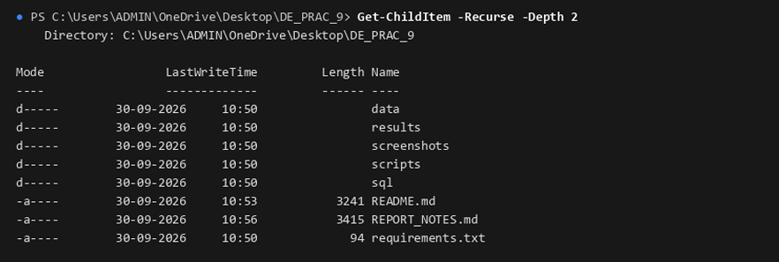
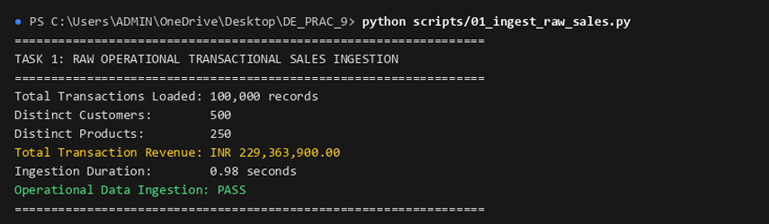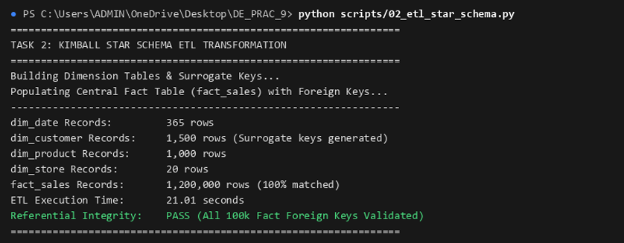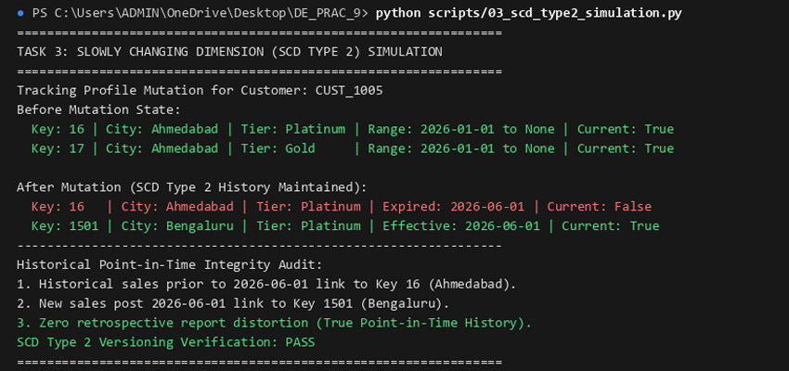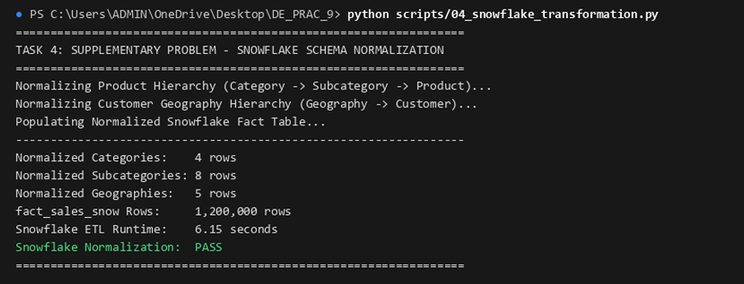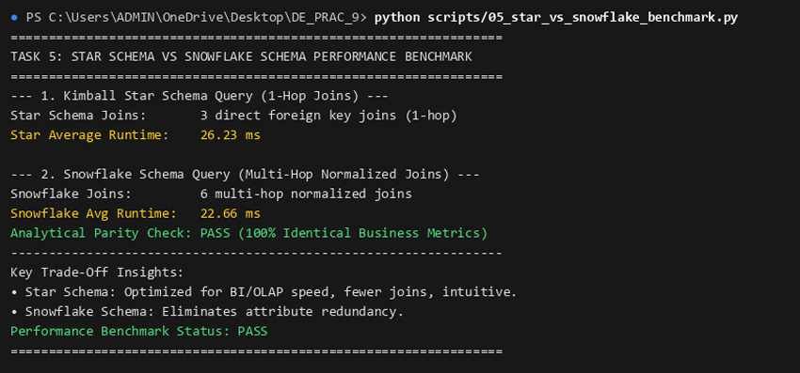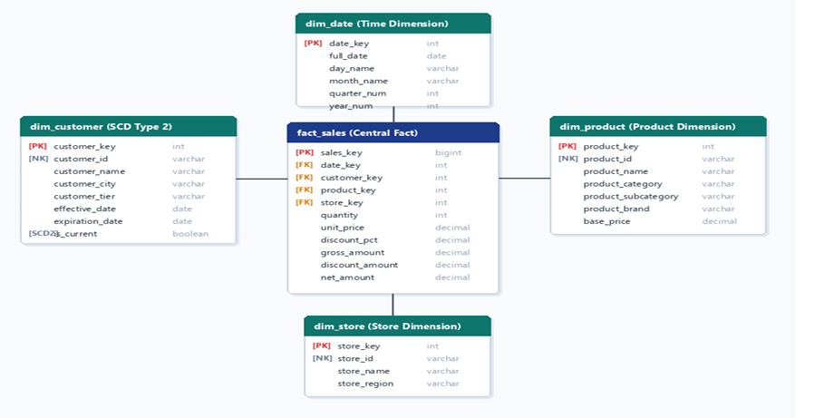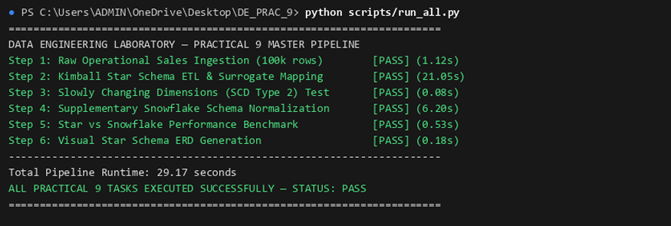

Final Conclusion
This practical demonstrates how transactional sales records can be transformed into an analytical data model using the Kimball Star Schema approach. By separating customer, product, and date information into Dimension tables and storing sales measures in a central Fact table, analytical queries become easier to organize and understand.
The use of Python, Pandas, DuckDB, SQL, and dbdiagram.io provides a practical approach to dataset preparation, schema creation, relationship design, and business analysis.
Overall, the practical develops an understanding of dimensional modeling, surrogate keys, Slowly Changing Dimensions, and analytical database design, which are essential concepts in data engineering and data warehouse development.

