Project 2
Report

Mert İlik 150114010
Tarkan Batar 150114033

- Foreground / Background Processes and Forks:

“sleep1.sh contains twoı echo lines for start and finish and sleep(20).”
“When put on foreground, ‘ls’ waits for 20 second countdown to finish.”

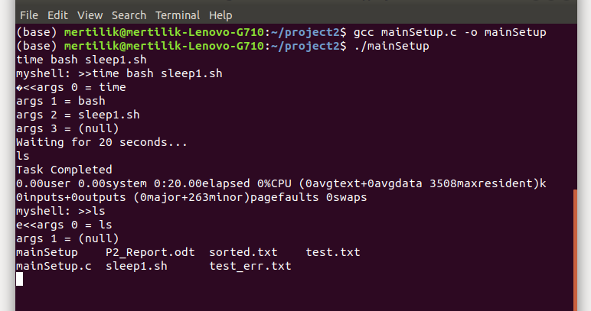
“When put on background, ‘ls’ can be called without waiting 20 seconds.”
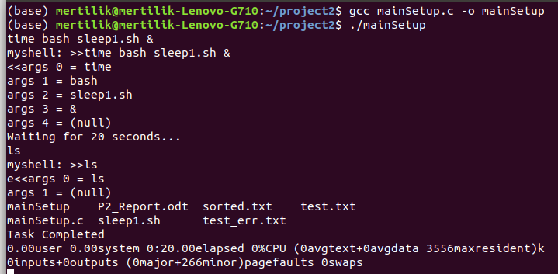

- Internal Commands
- History

“History is a linked list and each valid command is added to the beginning of the list. User can call any command listed in the history by giving index value.”
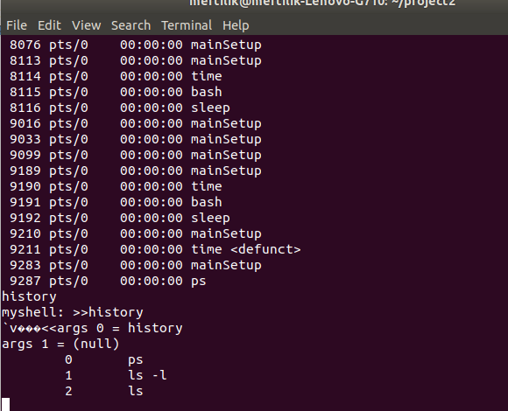

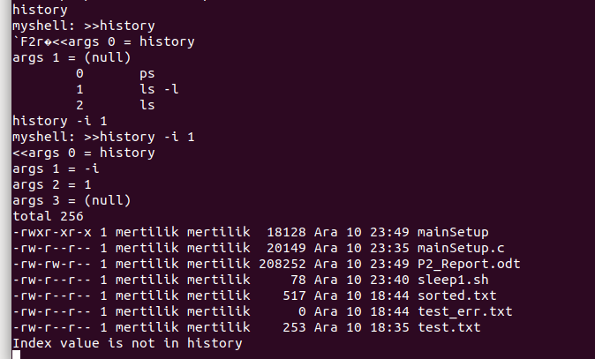

- path
“Path is initialized by reading path environment variable into a list. Then directories can be appended or deleted.”

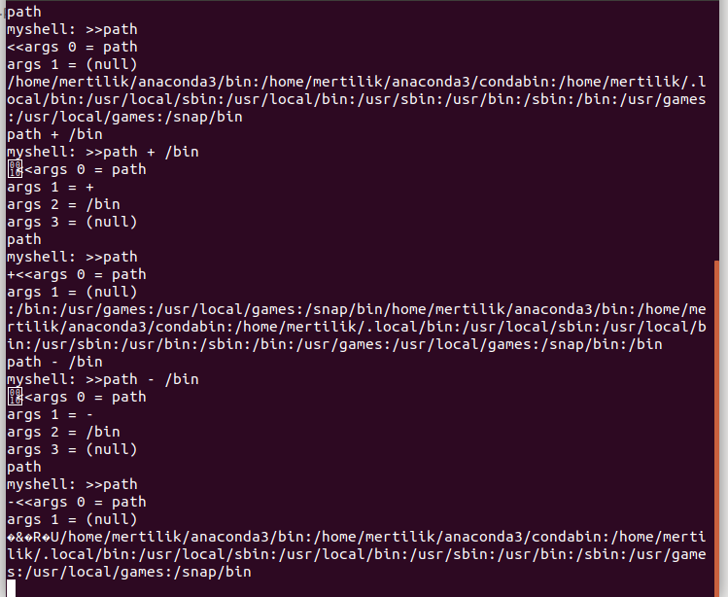

- exit
“Exit works only when there are no background processes, otherwise informs the user.”

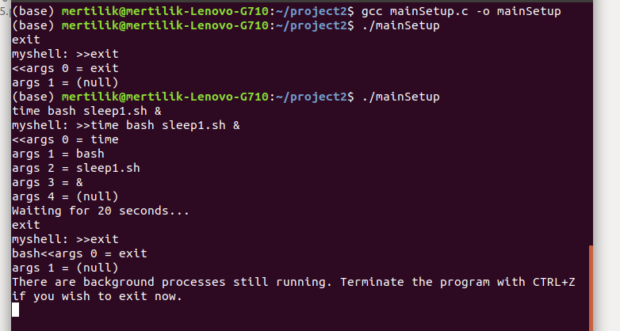

- I/O Redirection

“Using dup2(), below is the shell example of test.txt as input and sorted.txt as output.”

