|  |  |
| --- | --- |
| Date: | June 3rd, 2013 to June 6th, 2013 |
| Name: | Michael Mancuso |
| Course: | MUX |
| Director: | Megan Hunter |
| document: | Application UX Plan |
| Oshieru  Overview: https://www.youtube.com/watch?v=dELCllc9obM  Prototype: https://github.com/tarkenfire/oshi-ios/tree/master/testApp | |

Application Definition Statement

A concise, concrete declara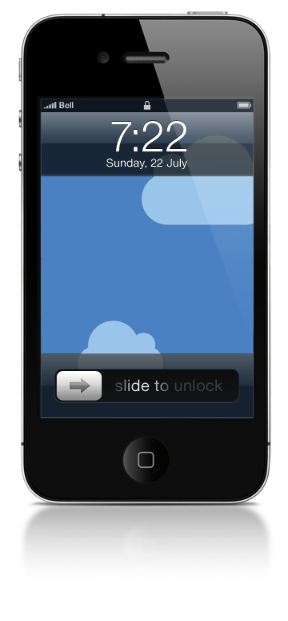tion of the app’s main purpose and its intended audience

|  |  |  |
| --- | --- | --- |
| Purpose or Main Intent | | |
| Oshieru is an app that assists in the learning of the Japanese language by students of formal language classes, providing supplemental tools useful to those in formal classes. (Oshieru means “to teach” in Japanese) | | |
| Description of Intended Audience | | |
| Students of formal Japanese teaching, either in college or through private tutors. It may be of limited use to self-learners, though that is not the focus of the app. | | |
| Core Functionality | | |
| Allows users quick, offline or online access a set of tools that would help students in formal classes without providing “cheating tools”. | | |
| **Feature Set** |  | **Nice-to-Have** |
| * + - Hiragana Chart     - Hiragana Quizzer     - Grammar Tools     - Conjugation Sifters |  | * Katakana Support * Sentence Structure Quizzer * Basic Kanji Dictionary * Audio pronunciations for characters |

User Research

Screener Questionnaire Questions Asked

The questions asked in the survey

MC: Multiple Choice | YN: Yes/No | FI: Fill In | 1T5: 1 to 5 Scale

|  |  |
| --- | --- |
| **General Information** | **Language Information** |
| 1. What is your gender? (MC: Male, Female) | 1. Do you speak more than one language? (YN) |
| 2. What is your nationality? (FI) | 2. Of any of the languages that you speak, are any of them Chinese or Japanese? (YN) |
| 3. What is your job title/profession? (FI) | 3. Have you ever had any formal language training in Japanese or Chinese? (YN) |
| 4. On a scale from 1 to 5, how would your rate your proficiency with computers and smartphones? (1T5) | 4. Would an application that supplemented a formal training class in Chinese or Japanese be useful to you? (YN) |
| **Phones** | **Language App**  (will only be shown if question 4 from above is answered “yes”) |
| 1. What kind of cell phone do you have? (MC: Android, iPhone, Feature Phone, Windows Phone, No Phone) | 1. Would an application that helped you learn the basic Japanese characters (hiragana and katakana) be useful to you? (YN) |
| iOS  (will only be shown if question 4 from above is answered “iPhone”) | 2. Would an application that helped you learn the most common Chinese characters be useful to you? (YN) |
| 1. How long have you had your iPhone? (FI) | 3. Would an application that helped you learn basic Japanese grammar and conjugation be useful to you? (YN) |
| 2. On a scale of 1 to 5, how often do you use your iPhone for tasks other than phone calls? (1T5) | 4. Would an application that helped you learn basic Chinese grammar and tone be useful to you? (YN) |
| 3. Are you familiar with finding and using apps on your iPhone? (YN) |  |
| 4. What type of app do you use most often? (MC: News App, Social Networking App, Productivity App, Games) |  |

Charts

Graphical representation of the raw data for multiple-choice questions

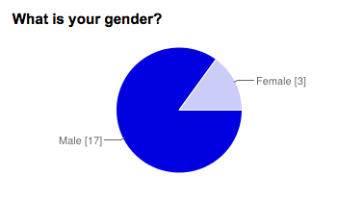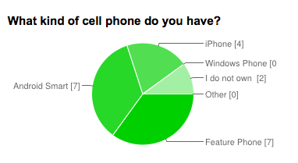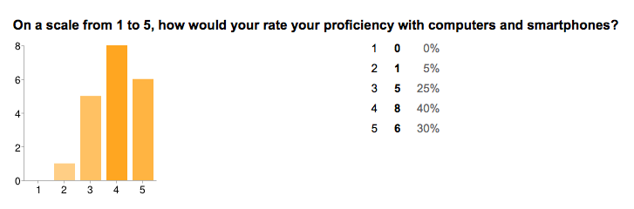

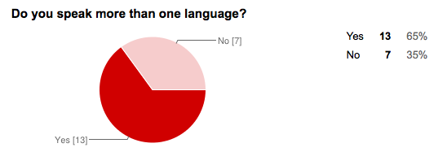

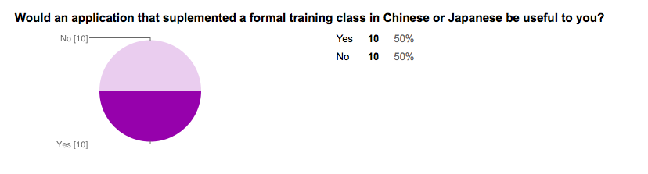

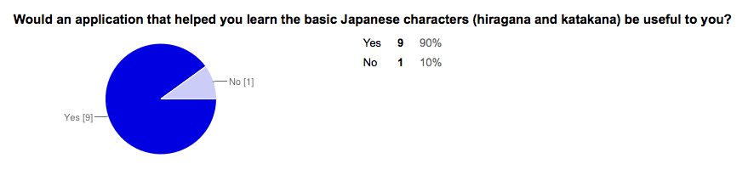

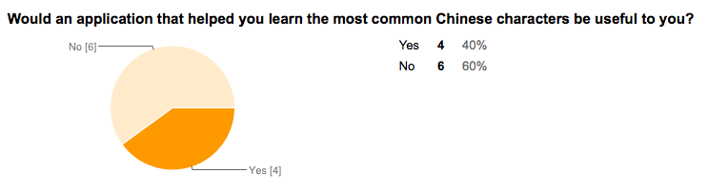

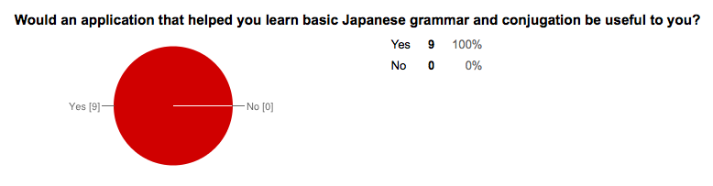

Raw Data

The raw data from the survey, in table form

(1/3)

|  |  |  |  |  |  |  |  |  |
| --- | --- | --- | --- | --- | --- | --- | --- | --- |
| **Timestamp** | **6/3/2013 16:31:07** | **6/3/2013 16:33:11** | **6/3/2013 19:45:16** | **6/3/2013 19:46:44** | **6/3/2013 19:46:53** | **6/3/2013 19:46:57** | **6/3/2013 19:48:37** | **6/3/2013 19:55:55** |
| **Gender** | Male | Female | Male | Male | Male | Male | Male | Male |
| **Nationality** | American | French | caucasian |  | Swedish | Scottish | Irish | Italian |
| **Job** | Student Aide | Professor | unemployed | unemployed | unemployed | unemployed | mover | Exterminator |
| **Computer Proficiency** | 5 | 1 | 3 | 3 | 5 | 4 | 4 | 2 |
| **Timestamp** | **6/3/2013 16:31:07** | **6/3/2013 16:33:11** | **6/3/2013 19:45:16** | **6/3/2013 19:46:44** | **6/3/2013 19:46:53** | **6/3/2013 19:46:57** | **6/3/2013 19:48:37** | **6/3/2013 19:55:55** |
| **Is Multilingual** | Yes | Yes | No | No | Yes | Yes | Yes | No |
| **Knows Chinese or Japanese** | Yes | No | No | No | No | No | No | No |
| **Has Formal Japanese/Chinese Training** | Yes | No | No | No | No | No | No | No |
| **Would App Be Useful** | Yes | No | Yes | Yes | Yes | No | Yes | No |
| **Timestamp** | **6/3/2013 16:31:07** | **6/3/2013 16:33:11** | **6/3/2013 19:45:16** | **6/3/2013 19:46:44** | **6/3/2013 19:46:53** | **6/3/2013 19:46:57** | **6/3/2013 19:48:37** | **6/3/2013 19:55:55** |
| **Useful: Japanese Characters** | Yes |  | Yes | Yes | Yes |  | Yes |  |
| **Useful: Chinese Characters** |  |  | No | Yes | No |  | Yes |  |
| **Useful: Japanese Grammar** | Yes |  | Yes | Yes | Yes |  | Yes |  |
| **Useful: Chinese Grammar** | Yes |  | No | Yes | No |  | Yes |  |
| **Non-Core Features** | Direct conjugation tool, dictionary, vocab lists |  | sentence structure, rules, grammar, slang |  |  |  | iskabibilekidle |  |
| **Timestamp** | **6/3/2013 16:31:07** | **6/3/2013 16:33:11** | **6/3/2013 19:45:16** | **6/3/2013 19:46:44** | **6/3/2013 19:46:53** | **6/3/2013 19:46:57** | **6/3/2013 19:48:37** | **6/3/2013 19:55:55** |
| **Cell Phone Type** | Android | iPhone | No Phone | Feature Phone | iPhone | Android | Android | Android |
| **iPhone Ownership Time** |  | 6 months |  |  | 3-4 weeks |  |  |  |
| **Non-Phone Call Use** |  | 4 |  |  | 3 |  |  |  |
| **Can find/use apps** |  | Yes |  |  | Yes |  |  |  |
| **Preferred Apps** |  | Social |  |  | Social |  |  |  |

(2/3)

|  |  |  |  |  |  |  |  |  |
| --- | --- | --- | --- | --- | --- | --- | --- | --- |
| **Timestamp** | **6/3/2013 21:58:28** | **6/3/2013 22:27:25** | **6/4/2013 0:16:57** | **6/4/2013 0:34:54** | **6/4/2013 4:29:12** | **6/4/2013 6:28:19** | **6/4/2013 13:20:48** | **6/4/2013 17:36:24** |
| **Gender** | Male | Male | Female | Male | Male | Female | Male | Female |
| **Nationality** | American | American | American |  | danish | British | German | American |
| **Job** | Student | Student | Substitute Teacher | Wine Maker | early retired | Unemployed | Mate | Translator |
| **Computer Proficiency** | 4 | 5 | 4 | 5 | 5 | 4 | 4 | 3 |
| **Timestamp** | **6/3/2013 21:58:28** | **6/3/2013 22:27:25** | **6/4/2013 0:16:57** | **6/4/2013 0:34:54** | **6/4/2013 4:29:12** | **6/4/2013 6:28:19** | **6/4/2013 13:20:48** | **6/4/2013 17:36:24** |
| **Is Multilingual** | Yes | Yes | No | Yes | Yes | Yes | No | Yes |
| **Knows Chinese or Japanese** | Yes | No | No | No | No | Yes | No | Yes |
| **Has Formal Japanese/Chinese Training** | Yes | No | No | No | No | Yes | No | Yes |
| **Would App Be Useful** | Yes | Yes | No | No | No | Yes | No | No |
| **Timestamp** | **6/3/2013 21:58:28** | **6/3/2013 22:27:25** | **6/4/2013 0:16:57** | **6/4/2013 0:34:54** | **6/4/2013 4:29:12** | **6/4/2013 6:28:19** | **6/4/2013 13:20:48** | **6/4/2013 17:36:24** |
| **Useful: Japanese Characters** | Yes | Yes |  |  |  | No |  |  |
| **Useful: Chinese Characters** | Yes | No |  |  |  | No |  |  |
| **Useful: Japanese Grammar** | Yes |  |  |  |  | Yes |  |  |
| **Useful: Chinese Grammar** | Yes | No |  |  |  | No |  |  |
| **Non-Core Features** | Detail conjugation charts, and proper stroke order on characters. | Audio clips. Situational variations. |  |  |  | stroke orders for charecters, other meanings, fun lerning games |  |  |
| **Timestamp** | **6/3/2013 21:58:28** | **6/3/2013 22:27:25** | **6/4/2013 0:16:57** | **6/4/2013 0:34:54** | **6/4/2013 4:29:12** | **6/4/2013 6:28:19** | **6/4/2013 13:20:48** | **6/4/2013 17:36:24** |
| **Cell Phone Type** | Android | Android | Feature Phone | Feature Phone | Feature Phone | Android | iPhone | iPhone |
| **iPhone Ownership Time** |  |  |  |  |  |  | 6 months | 2 years |
| **Non-Phone Call Use** |  |  |  |  |  |  | 4 | 5 |
| **Can find/use apps** |  |  |  |  |  |  | Yes | Yes |
| **Preferred Apps** |  |  |  |  |  |  | Social | Social |

(3/3)

|  |  |  |  |  |  |
| --- | --- | --- | --- | --- | --- |
| **Timestamp** | **6/4/2013 17:37:40** | **6/4/2013 20:41:48** | **6/5/2013 5:02:35** | **6/5/2013 12:16:55** | **6/5/2013 13:21:10** |
| **Gender** | Male | Male | Male | Male | Male |
| **Nationality** | Mexican | caucasion | Finland | austrian | Brazilian |
| **Job** | Systems Analyst | bakery assistant | University student | student | Student |
| **Computer Proficiency** | 5 | 3 | 4 | 5 | 4 |
| **Timestamp** | **6/4/2013 17:37:40** | **6/4/2013 20:41:48** | **6/5/2013 5:02:35** | **6/5/2013 12:16:55** | **6/5/2013 13:21:10** |
| **Is Multilingual** | Yes | No | Yes | Yes | Yes |
| **Knows Chinese or Japanese** | No | No | No | No | No |
| **Has Formal Japanese/Chinese Training** | No | No | No | No | No |
| **Would App Be Useful** | Yes | Yes | No | No | Yes |
| **Timestamp** | **6/4/2013 17:37:40** | **6/4/2013 20:41:48** | **6/5/2013 5:02:35** | **6/5/2013 12:16:55** | **6/5/2013 13:21:10** |
| **Useful: Japanese Characters** | Yes | Yes |  |  | Yes |
| **Useful: Chinese Characters** | No | No |  |  | Yes |
| **Useful: Japanese Grammar** | Yes | Yes |  |  | Yes |
| **Useful: Chinese Grammar** | No | No |  |  | Yes |
| **Non-Core Features** |  |  |  |  | Some kind simple database with audio of the pronunciation of all words /characters/whatever one wants to call them. |
| **Timestamp** | **6/4/2013 17:37:40** | **6/4/2013 20:41:48** | **6/5/2013 5:02:35** | **6/5/2013 12:16:55** | **6/5/2013 13:21:10** |
| **Cell Phone Type** | iPhone | Feature Phone | Feature Phone | Android | Feature Phone |
| **iPhone Ownership Time** | 3 years |  |  |  |  |
| **Non-Phone Call Use** | 5 |  |  |  |  |
| **Can find/use apps** | Yes |  |  |  |  |
| **Preferred Apps** | Productivity |  |  |  |  |

Survey URL

<https://docs.google.com/forms/d/1tXQwYY1K9PwuB1Fr8gAmCq4y6ehEr712MvoMYt_IZz8/viewform>

User Personas

And User Scenarios

|  |  |  |
| --- | --- | --- |
| **Sam Roberson** | **Primary Persona** | |
|  | “I don’t want my interests to conflict with my degree.”  Sam is a sophomore computer science student who is taking out-of-degree Japanese classes at his college because of an interest in learning a second language. However, he is in an intensive program and struggles to balance his degree programs with the amount of time he must dedicate to language study. | |
| **Characteristics** | **Influencers** | **Pain Points** |
| Age: 19  Education: High School  Job Title: Student (Computer Science, A.A.S)  Tech Competence: Very High  Tech Usage: Daily  Platform: iOS, Windows, OSX | * A way to practice Japanese characters without using notebooks and a textbook * Ability to study portably and quickly * Capability to be used in formal class as a quick reference | * Inconvenience of using bulky traditional textbooks for ALL study * Balancing study between languages and his core degree classes |
| **Scenarios** |  | |
| **Goal:**  Study Hiragana and Katakana | **Method:**  Sam spends an hour on making index cards in a flashcard app on his iPhone for self-quizzing purposes. He then uses a note-taking application on an iPad to keep track of his progress. He wishes this process would be condensed so he didn’t need to use two general-purpose apps for his specific purpose. | |
| **Goal:**  Study for Grammar Quiz | **Method:**  Sam prepares his notes and spends time reviewing this and his textbook, as well as drilling on workbook questions. He wishes he could do this more rapidly to allow for more study time for his other classes. | |

|  |  |  |
| --- | --- | --- |
| **Min-Jae Kim** | **Secondary Persona** | |
|  | “I want to be able to study Japanese without interrupting my busy work schedule.”  Min-Jae is a mid-level executive representing a large Korean tech firm. Over the past 20 years, the South Korean government has passed a group of xenophobic laws aimed at curbing both Chinese and Japanese literacy, so despite being an expat with an advanced business degree, Min-Jae only knows one language. Because of the economic prospects in the two countries, he has been learning the two languages. Chinese is fairly close to Korean, but Min-Jae has been having trouble with Japanese and is wary of needing to use cumbersome textbooks for even simple study. | |
| **Characteristics** | **Influencers** | **Pain Points** |
| Age: 48  Education: MBA  Job: VP of Marketing  Tech Competence: Average  Tech Usage: Bi-daily  Platform: iOS | * Ability to study Japanese during lunch break without bulky textbooks * Ability to study easily on train/bus to and from work * Ability to learn unfamiliar | * Preference to use of non-digital study aids * Time needed to use traditional study aids |
| **Scenarios** |  | |
| **Goal:**  Study Hiragana and Katakana | **Method:**  Min-Jae spends an hour preparing specific flash cards on index cards for self-quizzing purposes. He then must set up a manual tracking system in a notebook to track his progress with the flash cards. He would prefer not to have to manually track this and would like to not have to carry around a large stack of index cards. | |
| **Goal:**  Study for Grammar Quiz | **Method:**  Min-Jae spends time collating grammar-specific classroom notes and textbook materials into a separate notebook for each specific grammar construct and furthermore must spend time copying questions from a workbook to self-quiz. He would like it if he could do this without having to spend so much time preparing materials. | |

Competitive App Analysis

Heuristics Evaluation

Heuristic Evaluation Sheet

Comparing the quick and easy evaluation of UI decisions

|  |  |  |
| --- | --- | --- |
| Heuristics | Name: Hiragana and Katakana – Complete Basics of Japanese  Dev: TheJapanesePage.com  Price: Free (has ads & “premium” unlock) | Name: StickyStudy: Japanese Kana (Hiragana and Katakana Study)  Dev: StickyStudy  Price: $1.99 |
| Visibility of app status  Does the app keep users informed about what is going on, through appropriate feedback? | Feedback is in form of obtrusive modal dialogs. During quizzes, there is audio feedback as to correct or incorrect answers. | Feedback is not obvious at first blush. It uses subtle color changes to give feedback on quiz results. |
| Match between app and the real world  Does the app sense the user’s environment and adapt the information display accordingly? | Not relevant to this app. | Not relevant to this app. |
| User control and freedom  Users often choose app functions by mistake and will need a clearly marked “emergency exit.” Does the app contain safe exploration features? (back, cancel, undo) | No “back” button as there are no nav controllers. All models do not use a “close” button, opting for a poorly placed “Main Menu” button. There are “back” buttons on SOME model windows. | Uses a standard iOS tab view controller for navigation as well as standard iOS nav controllers. |
| Error prevention  Does the app eliminate error-prone conditions and present users with a confirmation option? | No true opportunity to cause user-errors seems to exist. No errors occurred during normal use. | No errors were encountered. If there was an error, it was handled silently. |
| Consistency and Standards  Users should not have to wonder whether different words, situations, or actions mean the same thing. | Does not follow any traditional Apple-made standards, and uses non-standard words for common navigation buttons. | Consistant for the most part, using only some non-standard buttons (“X” instead of back on SOME nav controller windows) |
| Recognition rather than recall  Minimize the user’s memory load by making objects, actions, and options visible. | App does not seem to remember any information whatsoever. | Memorizes completed quiz results, options, filter options on lists. |
| Flexibility and efficiency of use  Reduce the number of steps required by anticipating user needs and enabling customization. | Interface is convoluted and wastes large amounts of space. “Help menu” is hidden and hard to find. User must experiment and guess to find gestures and methods of use. | Use of mostly-standard iOS constructs makes use fairly strait forward. |
| Aesthetic and minimalist design  Screens should not contain information which is irrelevant or rarely needed | Approximately 50-60% of “home page” is unused whitespace. Elements overlap each other and are overly gaudy. | All space is used wisely. |
| Help users recognize, diagnose, and recover from errors  Error messages should be expressed in plain language precisely indicating the problem and solution | No errors were encountered. | No errors were encountered aside from an error in the App Store app, which was handled by the App Sore app. |
| Help and documentation  Help should be focused on the user’s task, list concrete steps to be carried out, and not be too long | Help documentation takes form of single modal dialog that is incorrectly formatted so one side is cut off. Help does show screenshots and explanations. | Help is “hidden” in the settings menu and is only provided for “advanced subjects”. Basic use is simple enough to not need detailed help screens however. |
| Linguistic Accuracy  Whether or not the actual grammar and syntax of the Japanese being taught is correct. | The grammar and syntax is correct. | The grammar and syntax is correct. |
| Customization and Settings  Level of control the application gives to the user in settings. | The only “setting” is to buy the “ad free version”, which seems to do nothing more than remove ads. | Settings allow a moderate amount of customization. |

(end of week one)

Usability Testing Plan

And Discussion Guide

Usability Testing Plan

|  |  |  |  |  |  |  |  |  |
| --- | --- | --- | --- | --- | --- | --- | --- | --- |
| Purpose & Objective | | | | |  | User Profiles | | |
| To evaluate the app’s intended flow and interactions, with an emphasis on the primary and secondary goals. The objective is to uncover any UX issues that might be present, and use these to direct the iteration process. | | | | |  | Sam Roberson | | Min-Jae Kim |
| Roles | | | | |
| I alone will proxy the roles and responsibilities of the interviewer, note taker, and observer. Legal complexities involved with some of the testing locations and local laws/ordinances make filming prohibitively taxing, therefore there will be no cameraman. There will be one role defined as participant. | | | | |
| Method | | | | |  | Participant Count | | |
| A combination of controlled and guerrilla testing methods will be employed. This Hybrid approach will utilize an indoor facility to observe user interactions while in a controlled environment state. Outdoor (guerrilla) tests will reveal user interactions with variance resulting from environmental factors such as glare, noise, and movement. | | | | |  | 10 to 15 | As participants will be pseudo-random, assuring complete even gender distribution will not be possible. However, an attempt will be made to come close to an even gender split. | |
| Metrics |  | Equipment |  | Locations |  |  | | |
| * Completion Rates * Time on Task * Satisfaction Rating * Usefulness |  | * iPad (testing device) * Secondary tablet (note-taking) * Smart Phone (stopwatch app) |  | * Times Square * Columbia University * Japanese Cultural Appreciation Group Meeting |  |  | | |

Discussion Guide

The step-by-step dialog of conducting usability tests

|  |  |  |  |
| --- | --- | --- | --- |
| 1 | Introduction | **Times Square and Columbia University**  “[Good Morning/Good Afternoon/Good Evening], my name is Michael Mancuso and I’m a student at Full Sail University. I am currently enrolled in a Mobile User Experience Class and am wondering if I could have a few moments of your time in order to help with the project I am currently assigned. I need to test whether or not my app is both easy and enjoyable to use when it is used for accomplishing basic tasks. May I ask for your assistance in this?”  **JCAG Meeting** (more personal/casual environment)  “皆さん、こんばんは。I am currently in the process of taking a University class in Mobile User Experience and am wondering if I could ask some of you guys for help in testing the usability of an app with regards to how easy (or how not easy) it is to use. Is anyone willing to take a few minutes to help with this?” | |
| 2 | Explain the Test Goals | “I need your help to determine if my app makes it easy for people to perform a couple basic tasks, like finding a particular movie time or sport’s score.” | |
| 3 | Complete the Questionnaire | [SEE USER QUESTIONNAIRE]  [ACTION: Ask participants to answer the screener questions to qualify them as users that most closely represent your intended audience. The app’s intended audience is represented in the user personas] | |
| 4 | Introduce the Test Scenario | “First, I’ll ask you to complete a series of three sequential tasks using my app. Along the way I encourage you to THINK OUT-LOUD. This will help me to better understand what aspects of my app seem to be obvious or confusing and unclear. After you complete the last task, you will be prompted to answer a short multiple-choice survey about some aspects of the application. Whenever you are ready, you may begin.“ | |
| 5 | Define the Tasks | VERB BASED TASKS | |
| (Second Task) Find the correct causative form conjugation of the Japanese verb “taberu” using the app.  (Third Task) Complete a 5-question quiz on hiragana characters. | |
| SCAVENGER HUNT TASKS | |
| (First Task) Find the definition of two randomly selected hiragana characters. (pool – a, e, i, o,u, ka, ke, ki, ko, ku) | |
| 6 | Complete Follow-Up Survey  (completed by the user) | QUESTION | ANSWERS |
| What is your overall impression of the app? | awesome - good - fair - poor |
| Was the brand distinguishable from other app’s like it? | yes - kinda - no - unsure |
| How difficult was completing the basic tasks? | easy - fair - difficult |
| Were the navigation cues easy to interpret? | yes - maybe - no |
| What was confusing if anything? | navigating - organization - selecting - other - none |
| Did the use of many colors in the app help or hinder you? | yes - kinda - no – unsure |
| 7 | Thank your Participants | **Times Square / Columbia University**  “Thank you very much for your time. You’ve helped me to improve the usability and quality of my app.”  **JCAG Meeting**  “貴重なお時間をありがとうございました.” (Thank you very much for your valuable time.) | |
| 8 | Report your Findings  (week reflection video) | [SEE WEEK REFLECTION VIDEO] | |