Supplementary: The Proprioceptive Noise Chain
From Spindle Noise to Elliptical Hand-Position Uncertainty
Computational Sensorimotor Control — Week 9 | Penn State | Fall 2026
1. Overview
The lecture notes state that proprioceptive hand-position noise is approximately 12 mm (van Beers et al. 1998) and that this noise is anisotropic — the uncertainty is elongated along specific directions depending on the arm configuration. This supplement derives that result step by step, tracing the noise from its source at the muscle spindle through three coordinate transformations to the hand.
Critically, proprioception provides two independent signals: muscle length (from group II afferents) and muscle velocity (from group Ia afferents). Both signals propagate through the same geometric chain but carry different information. The position chain gives the Kalman filter its measurement update; the velocity chain gives it a direct velocity estimate without differentiating noisy position — this is what makes the forward model work (§2 of the lecture).
The chain for each signal is: spindle noise → moment arm mapping → joint-space noise → Jacobian mapping → hand-space noise. At each step, a linear transformation preserves the Gaussian nature of the noise but reshapes its covariance, producing an elliptical distribution at the hand even if the original spindle noise is isotropic.

2. Spindle Noise on Muscle Length and Velocity
Muscle spindles provide two distinct signals via different afferent fibers. Group II afferents encode the static length of the muscle. Group Ia afferents encode the velocity of muscle stretch — they fire vigorously during rapid lengthening and fall silent during shortening. Crucially, the Ia velocity signal is a direct measurement, not a differentiated position signal. This distinction is central to the forward model story in §2 of the lecture.
We model each spindle’s measurements as the true value plus independent Gaussian noise:
Spindle measurement models:

Position (group II): l̂_i = l_i(q) + ε_l,i, ε_l ~ N(0, σ_l²)
Velocity (group Ia): dl̂_i/dt = dl_i/dt(q,qd) + ε_v,i, ε_v ~ N(0, σ_v²)

where l_i(q) is the true length of muscle i at joint configuration q,
dl_i/dt is the true rate of length change, and σ_l, σ_v are noise SDs.
Noise is independent across muscles and between the two signal types.

Both σ_l and σ_v are small at the spindle level — spindles can detect length changes on the order of tens of micrometers and velocity changes of fractions of a millimeter per second. The large hand-level noise (12 mm position, ~39 mm/s velocity) arises not from poor spindle acuity but from the geometric transformations that follow.

3. From Muscle Lengths to Joint Angles: The Moment Arm Mapping
Each muscle’s length depends on one or both joint angles through the moment arm geometry. For our six-muscle model (Gribble et al. 1998), the relationship is approximately linear near the reference posture:
Muscle length model (linearized):
l_i(q) ≈ l_i(q_ref) + r_sh,i · (q_1 − q_1,ref) + r_el,i · (q_2 − q_2,ref)

where r_sh,i and r_el,i are the moment arms at the shoulder and elbow.
In matrix form for all six muscles: l = l_ref + A · Δq

A = [r_sh,1 r_el,1] (6×2 moment arm matrix)
[r_sh,2 r_el,2]
[ ... ... ]
[r_sh,6 r_el,6]

For our arm model, the moment arms (in meters) are:
 | pec | bic_l | bic_s | delt | tri_l | tri_lg
r_sh (m) | +0.040 | 0.000 | +0.025 | −0.040 | 0.000 | −0.040
r_el (m) | 0.000 | +0.030 | +0.030 | 0.000 | −0.020 | −0.020
Crosses | Shoulder | Elbow | Both | Shoulder | Elbow | Both

The nervous system must solve the inverse problem: given noisy muscle length measurements, estimate the joint angles. With six muscles and two joints, the system is overdetermined (6 equations, 2 unknowns). The optimal least-squares estimate of Δq from noisy length measurements is:
Joint-angle estimation (least-squares):
Δq̂ = (A^T A)^{-1} A^T Δl̂

If the muscle-length noise is isotropic (σ_l² I_6), the joint-angle covariance is:
R_q = σ_l² (A^T A)^{-1}

The matrix (A^T A) aggregates the moment arms across all six muscles.
Joints served by muscles with larger moment arms have lower noise.

Because the shoulder and elbow are served by different numbers of muscles with different moment arms, R_q is generally not isotropic — one joint’s angle estimate may be more precise than the other’s.
The same mapping applies to velocity. Since dl_i/dt = r_sh,i · dq₁/dt + r_el,i · dq₂/dt, the same matrix A relates muscle velocities to joint velocities: dl/dt = A · dq/dt. The least-squares estimate of joint velocity from noisy Ia afferent signals is:
Joint-velocity estimation (same structure as position):
dΔq̂/dt = (A^T A)^{-1} A^T (dΔl̂/dt)

R_qd = σ_v² (A^T A)^{-1}

The matrix (A^T A)^{-1} is the same for both position and velocity chains.
Only the input noise magnitude differs (σ_l for position, σ_v for velocity).

The dominant source of anisotropy in hand-space noise comes from the next step: the Jacobian.

4. From Joint Space to Hand Space: The Jacobian
Position Chain
The forward kinematics maps joint angles to hand position. For small perturbations around a configuration q, this mapping is linearized by the Jacobian:
Hand-position perturbation:
Δx_hand = J(q) · Δq

where J(q) is the 2×2 Jacobian matrix:

J = [∂x/∂q₁ ∂x/∂q₂] = [−L₁ sin(q₁) − L₂ sin(q₁+q₂) −L₂ sin(q₁+q₂)]
[∂y/∂q₁ ∂y/∂q₂] [ L₁ cos(q₁) + L₂ cos(q₁+q₂) L₂ cos(q₁+q₂)]

If the joint-angle noise has covariance R_q, then the hand-position noise covariance is obtained by the standard linear transformation rule for Gaussian random variables:
Hand-position covariance (the key result):

R_hand = J(q) · R_q · J(q)^T

This is a 2×2 symmetric positive-definite matrix.
Its eigenvalues give the variances along the principal axes.
Its eigenvectors give the orientation of those axes.
The result is an elliptical uncertainty distribution at the hand.

Why an ellipse? If R_q is a scaled identity (isotropic joint noise), then R_hand = σ_q² · J J^T. The matrix J J^T is symmetric but not generally a scaled identity — its eigenvalues differ because the Jacobian stretches and rotates the joint-angle noise differently along different directions. The eigenvalues of J J^T are the squared singular values of J, and the eigenvectors define the directions of maximum and minimum hand-position sensitivity. The noise is stretched most along the direction in which the hand is most sensitive to joint-angle changes — roughly the radial (forearm) direction — and compressed along the perpendicular direction.
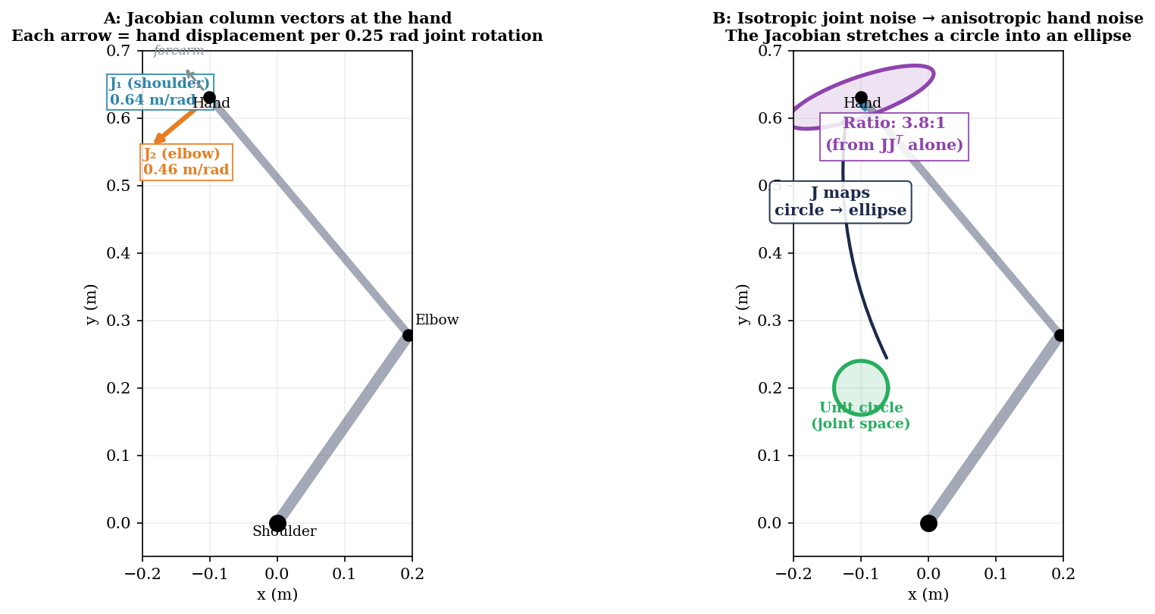
Figure 1. The Jacobian transforms noise from joint space to hand space. A: Jacobian column vectors at the hand position. Column 1 (teal, shoulder) and Column 2 (orange, elbow) show the direction and magnitude of hand displacement per unit joint rotation. The elbow column points along the forearm direction, which is why noise is amplified more in the radial direction. B: A unit circle of isotropic noise in joint space (green) maps through J to an anisotropic ellipse at the hand (purple). The axis ratio (3.8:1 from JJ^T alone) reflects the differential amplification by the Jacobian. When combined with the moment arm anisotropy (A^T A)^{-1}, the full chain produces the 2.3:1 ratio derived in §5.

Velocity Chain
The same Jacobian relates joint velocities to hand velocities: dx_hand/dt = J(q) · dq/dt. The hand-velocity covariance therefore follows exactly the same transformation:
Hand-velocity covariance:
R_hand_vel = J(q) · R_qd · J(q)^T

This has the same eigenvector structure as R_hand_pos (the anisotropy
directions are identical), but different eigenvalue magnitudes because
the input noise σ_v (on spindle velocity) differs from σ_l (on spindle length).

Why this matters for the Kalman filter. The KF’s state vector is [x, y, v_x, v_y]. The position components are updated by the position chain (R_hand_pos). The velocity components can be updated by the velocity chain (R_hand_vel) — and this is a direct measurement from Ia afferents, not a differentiated position signal. In Week 8 §4, our controller tried to extract velocity by differentiating delayed visual position, and the noise was amplified to the point of being unusable. The Ia velocity channel avoids this problem entirely because spindles measure velocity natively. Note that the visual system also extracts velocity directly via motion-sensitive areas (MT/V5), particularly in the periphery — we simply have not modeled that channel. The point is that direct velocity measurement from any source avoids the differentiation problem.

5. Numerical Example at Q_REF
At the reference posture Q_REF = (55°, 75°), with L₁ = 0.34 m (upper arm) and L₂ = 0.46 m (forearm):
Jacobian at Q_REF:

J = [−0.6309 −0.3524]
[−0.1007 −0.2957]

With σ_l = 1.54 mm (calibrated for 12 mm mean hand SD):
R_q = σ_l² (A^T A)^{-1} = [5.24×10⁻⁴ ... ] (σ_q1 = 1.31°)
[ ... 1.09×10⁻³] (σ_q2 = 1.90°)
Note: R_q is NOT isotropic — the moment arm geometry makes elbow noisier.

R_hand = J R_q J^T = [2.06×10⁻⁴ 7.79×10⁻⁵]
[7.79×10⁻⁵ 8.24×10⁻⁵]

σ_x = sqrt(2.06×10⁻⁴) = 14.3 mm
σ_y = sqrt(8.24×10⁻⁵) = 9.1 mm
Mean σ = sqrt(mean of diagonal) = 12.0 mm ✔

Eigendecomposition:
Eigenvalues of R_hand:
λ₁ = 4.47×10⁻⁵ → σ_minor = 6.7 mm
λ₂ = 2.43×10⁻⁴ → σ_major = 15.6 mm

Eigenvectors:
v₁ = [0.44, −0.90] (minor axis: roughly perpendicular to forearm)
v₂ = [−0.90, −0.44] (major axis: roughly along forearm direction)

Axis ratio: σ_major / σ_minor = 15.6 / 6.7 = 2.3 : 1
The anisotropy comes from both the moment arm geometry (R_q is not isotropic)
and the Jacobian (which stretches further along the radial direction).

The physical interpretation: a small error in joint angle produces a large hand-position error in the radial direction (along the forearm) because the hand is far from the joints, but a smaller error in the tangential direction. This is why proprioceptive hand-position uncertainty is fundamentally anisotropic — it is a geometric consequence of the arm’s kinematic structure, not a property of the spindles themselves.

Velocity chain at Q_REF
The velocity chain uses the same Jacobian and moment arm matrix. With Ia afferent velocity noise σ_v = 5 mm/s per muscle:
Velocity chain at Q_REF (same J and A as above):

R_qd = σ_v² (A^T A)^{-1}
R_hand_vel = J R_qd J^T

σ_vx = 46.7 mm/s, σ_vy = 29.5 mm/s, mean = 39.1 mm/s
Axis ratio: 2.3 : 1 (same eigenvector directions as position)

Peak hand velocity (10 cm reach, 600 ms): ~312 mm/s
Ia velocity noise / peak velocity = 12.5% — a usable signal for state estimation.

The Ia velocity signal has noise on the order of 12% of the peak hand velocity. This is a direct measurement from spindle afferents — no differentiation of a position signal is involved. The Ia channel provides velocity information that complements the position chain from group II afferents. Note that the visual system also has direct motion processing (area MT/V5) that avoids differentiation — we have not modeled that channel, so we cannot compare visual and proprioceptive velocity accuracy.

6. Configuration Dependence
Because the Jacobian changes with joint configuration, the shape and orientation of the proprioceptive uncertainty ellipse also changes across the workspace. When the arm is fully extended (elbow near 0°), the Jacobian is nearly singular and the noise ellipse becomes extremely elongated — the hand is very sensitive to shoulder rotation but insensitive to elbow rotation. When the arm is folded (elbow near 180°), the ellipse is more compact but rotated. Van Beers et al. (1998) confirmed this configuration dependence experimentally: proprioceptive variability varied systematically across workspace locations, with the pattern matching the Jacobian-predicted anisotropy.
This configuration dependence is why we defer the full anisotropic treatment to Week 10, where the Kalman filter will receive the actual R_hand(q) at each timestep. For Week 9, we use the isotropic approximation σ = 12 mm for the endpoint SD simulations, which captures the average noise magnitude correctly while simplifying the filter implementation.

7. Summary of the Noise Chain
The proprioceptive noise chains:

POSITION CHAIN (group II afferents):
Spindle length noise (σ_l, small)
↓ moment arm mapping (A matrix, 6×2)
Joint-angle noise (R_q = σ_l² (A^T A)^{-1})
↓ Jacobian mapping (J matrix, 2×2)
Hand-position noise (R_hand = J R_q J^T, anisotropic, ~12 mm mean)

VELOCITY CHAIN (group Ia afferents):
Spindle velocity noise (σ_v, small)
↓ moment arm mapping (same A matrix)
Joint-velocity noise (R_qd = σ_v² (A^T A)^{-1})
↓ Jacobian mapping (same J matrix)
Hand-velocity noise (R_hand_vel = J R_qd J^T, anisotropic, ~39 mm/s mean)

Both chains share the same A and J matrices (same anisotropy directions).
The velocity chain provides the Kalman filter with a direct velocity
measurement, avoiding the noise amplification inherent in differentiating
delayed position signals.

