WEEK 9
State Estimation
Proprioception, Forward Models, and the Kalman Filter
Reading: Wolpert, D. M., Ghahramani, Z., & Jordan, M. I. (1995). An internal model for sensorimotor integration. Science, 269(5232), 1880–1882.
Reading: Crevecoeur, F., Munoz, D. P. & Scott, S. H. (2016). Dynamic multisensory integration: somatosensory speed trumps visual accuracy during feedback control. Journal of Neuroscience, 36(33), 8598–8611.
Supplementary: van Beers, R. J., Sittig, A. C., & Denier van der Gon, J. J. (1998). The precision of proprioceptive position sense. Experimental Brain Research, 122, 367–377.
Supplementary: Proske, U., & Gandevia, S. C. (2012). The proprioceptive senses: their roles in signaling body shape, body position and movement, and muscle force. Physiological Reviews, 92(4), 1651–1697.

Introduction
Week 8 established the visual sensory pipeline: two channels with complementary delay-noise profiles serving two distinct online correction processes. The peripheral channel (gaze on target, Δ = 80 ms, σ = 5 mm) outperformed the central channel (gaze tracks hand, Δ = 150 ms, σ = 1 mm) for continuous trajectory correction — its shorter delay means corrections begin sooner and are based on a less stale estimate of the hand’s position. The fixate-target strategy emerged as optimal, and the updated frontier showed two crossovers in the speed-accuracy plane.
But three gaps remained. First, our controller had no proprioception — it was blind in the dark. Keele and Posner found that accuracy improves even without vision, but our open-loop simulation could not reproduce this. Second, our controller used raw delayed measurements, with no mechanism to predict the current state of the hand. When we tried to estimate velocity by differentiating noisy delayed position, the noise was amplified catastrophically — as we showed in §4 of the Week 8 lecture (“Why Proportional Only — No Derivative Term?”) and in HW 08 Problem 2, where velocity noise from differentiating delayed position far exceeded the actual hand velocity. Third, we had no second hand-sensing channel to combine with peripheral vision — the gaze-on-target architecture places the target at the fovea and the hand in the periphery, but in the real nervous system, proprioception provides a simultaneous independent estimate of hand position that can be fused with the peripheral visual signal.
This week closes all three gaps. We add proprioception as a third sensory channel (§1), introduce the forward model that predicts state through the delay using efference copy (§2), derive Bayesian fusion for combining multiple noisy estimates (§3), and formalize the entire estimation pipeline as a Kalman filter (§4). The endpoint is the three-sensor architecture that Week 10 needs: foveal vision sensing the target, peripheral vision and proprioception jointly sensing the hand, with the Kalman filter fusing the two hand channels optimally (§5). The updated frontier (§6) shows that sensor fusion improves accuracy beyond what any single channel achieves.
The roadmap for the remainder of Module 3: state estimation and the Kalman filter (this week) → multisensory integration under degraded conditions (Week 10) → The Duel (Week 11).

1. Proprioception: The Fastest Channel
Muscle Spindles and Golgi Tendon Organs
The proprioceptive system provides information about the position and movement of the limbs without relying on vision. Two receptor types are central to limb proprioception. Muscle spindles are embedded within the muscle belly, arranged in parallel with the extrafusal (force-generating) fibers. They respond to muscle stretch: when the muscle is lengthened, the spindle’s sensory endings increase their firing rate. Critically, spindles have two types of afferent fibers: group Ia afferents, which are exquisitely sensitive to the velocity of stretch (they fire vigorously during rapid lengthening and fall silent when the muscle shortens), and group II afferents, which encode the static length of the muscle. Together, these fibers provide both position and velocity information.
Golgi tendon organs (GTOs) are located at the muscle-tendon junction, in series with the muscle fibers. They respond to active force production: when the muscle contracts and generates tension, the GTO fires. GTOs thus provide a measure of muscle force rather than length. For the purpose of hand-position estimation in this week, we focus primarily on the spindle signals (length and velocity), though GTOs become important in Week 11 when we discuss force-field perturbations.
Two Proprioceptive Pathways: Spinal and Cortical
Proprioceptive signals travel to the central nervous system via two distinct pathways with different latencies and functions. The spinal reflex arc is the fastest: Ia afferents from the spindle synapse directly onto alpha motoneurons in the spinal cord. The loop delay is approximately 25 ms for upper-limb muscles. Students have already encountered this pathway — it is the stretch reflex built into the λ model since Week 4. When the muscle is stretched beyond its threshold length, the reflex automatically increases activation, providing the intrinsic stiffness and damping that make threshold control work.
The cortical pathway is slower but computationally richer, and it follows at least two major routes. The dorsal column-medial lemniscal (DCML) pathway carries proprioceptive signals to the somatosensory cortex, where they are available for conscious perception of limb position and for integration with visual information. A second route — the spinocerebellar pathway — carries proprioceptive signals to the cerebellum, which is widely regarded as the site of the internal forward model (Wolpert et al., 1998; Miall & Wolpert, 1996). The cerebellum compares predicted and actual sensory feedback and projects corrective signals to primary motor cortex (M1). For the purpose of real-time state estimation during reaching, the spinocerebellar-cerebellar-M1 circuit is likely the more important route: the cerebellum receives proprioceptive input with shorter latency than the somatosensory cortex, and its architecture is well suited to the predictive computations the Kalman filter formalizes. The ~60 ms cortical proprioceptive delay we model probably reflects this cerebellar circuit, though contributions from the DCML route to somatosensory cortex cannot be excluded.
Two feedback loops, one muscle signal. The same muscle spindle fires, and its signal splits: the fast spinal path (25 ms) drives the local stretch reflex inside the λ model; the slow cortical path (60 ms) informs the state estimator. These loops are architecturally distinct — the spinal reflex stabilizes locally, the cortical signal informs global planning. Students have been computing the variables that spindles read (muscle length l and velocity dl/dt) since Week 2. No changes to the Muscle class are needed — the architecture anticipated proprioceptive readout from the start.

Proprioceptive Noise: From Joint Angles to Hand Position
How precise is proprioception? Van Beers et al. (1998) measured proprioceptive hand-position variability by having participants match the position of one hand with the other (no vision). They found standard deviations on the order of 8–15 mm depending on the workspace location and the direction of the error, with larger errors along the axis of the forearm than perpendicular to it. Proprioception is substantially noisier than foveal vision (σ ≈ 1 mm) and somewhat noisier than peripheral vision (σ ≈ 5 mm).
For our simulations, we model proprioception as providing a hand-position estimate with isotropic noise σ_proprio ≈ 12 mm. This noise does not reflect poor spindle acuity — spindles are precise sensors of muscle length and velocity. Rather, the 12 mm figure reflects the full processing chain: spindle noise on muscle length, mapped through the moment arm geometry to joint-angle noise, then amplified through the Jacobian to hand-position noise (R_hand = J R_q Jᵀ). The Jacobian stretches this noise anisotropically, producing an uncertainty ellipse elongated roughly along the forearm direction with a ~2.3:1 axis ratio at Q_REF. The full derivation with numerical values is provided in the Supplementary: Proprioceptive Noise Chain. For Week 9, we use the isotropic approximation σ = 12 mm (the mean of the anisotropic distribution), which captures the average noise magnitude correctly. In Week 10, we will introduce the full anisotropic covariance R_hand(q) to capture the directional structure of proprioceptive uncertainty.
Proprioception is the noisiest of our three channels but also the fastest. In the simulation loop, we instantiate a proprioceptive Sensor with Δ = 60 ms and R = I₂ × (0.012)², reading the hand position at each timestep and corrupting it with delay and noise.
Proprioceptive channel: y_pr(t) = x_hand(t − Δ_pr) + ε_pr(t), ε_pr ~ N(0, R_hand)
Δ_pr = 60 ms (cortical pathway, distinct from 25 ms spinal reflex)

Full noise chain: R_hand = J(q) · R_q · J(q)^T (see Supplementary for derivation)
Isotropic approximation for Week 9: R_hand ≈ σ_pr² · I₂, σ_pr = 12 mm

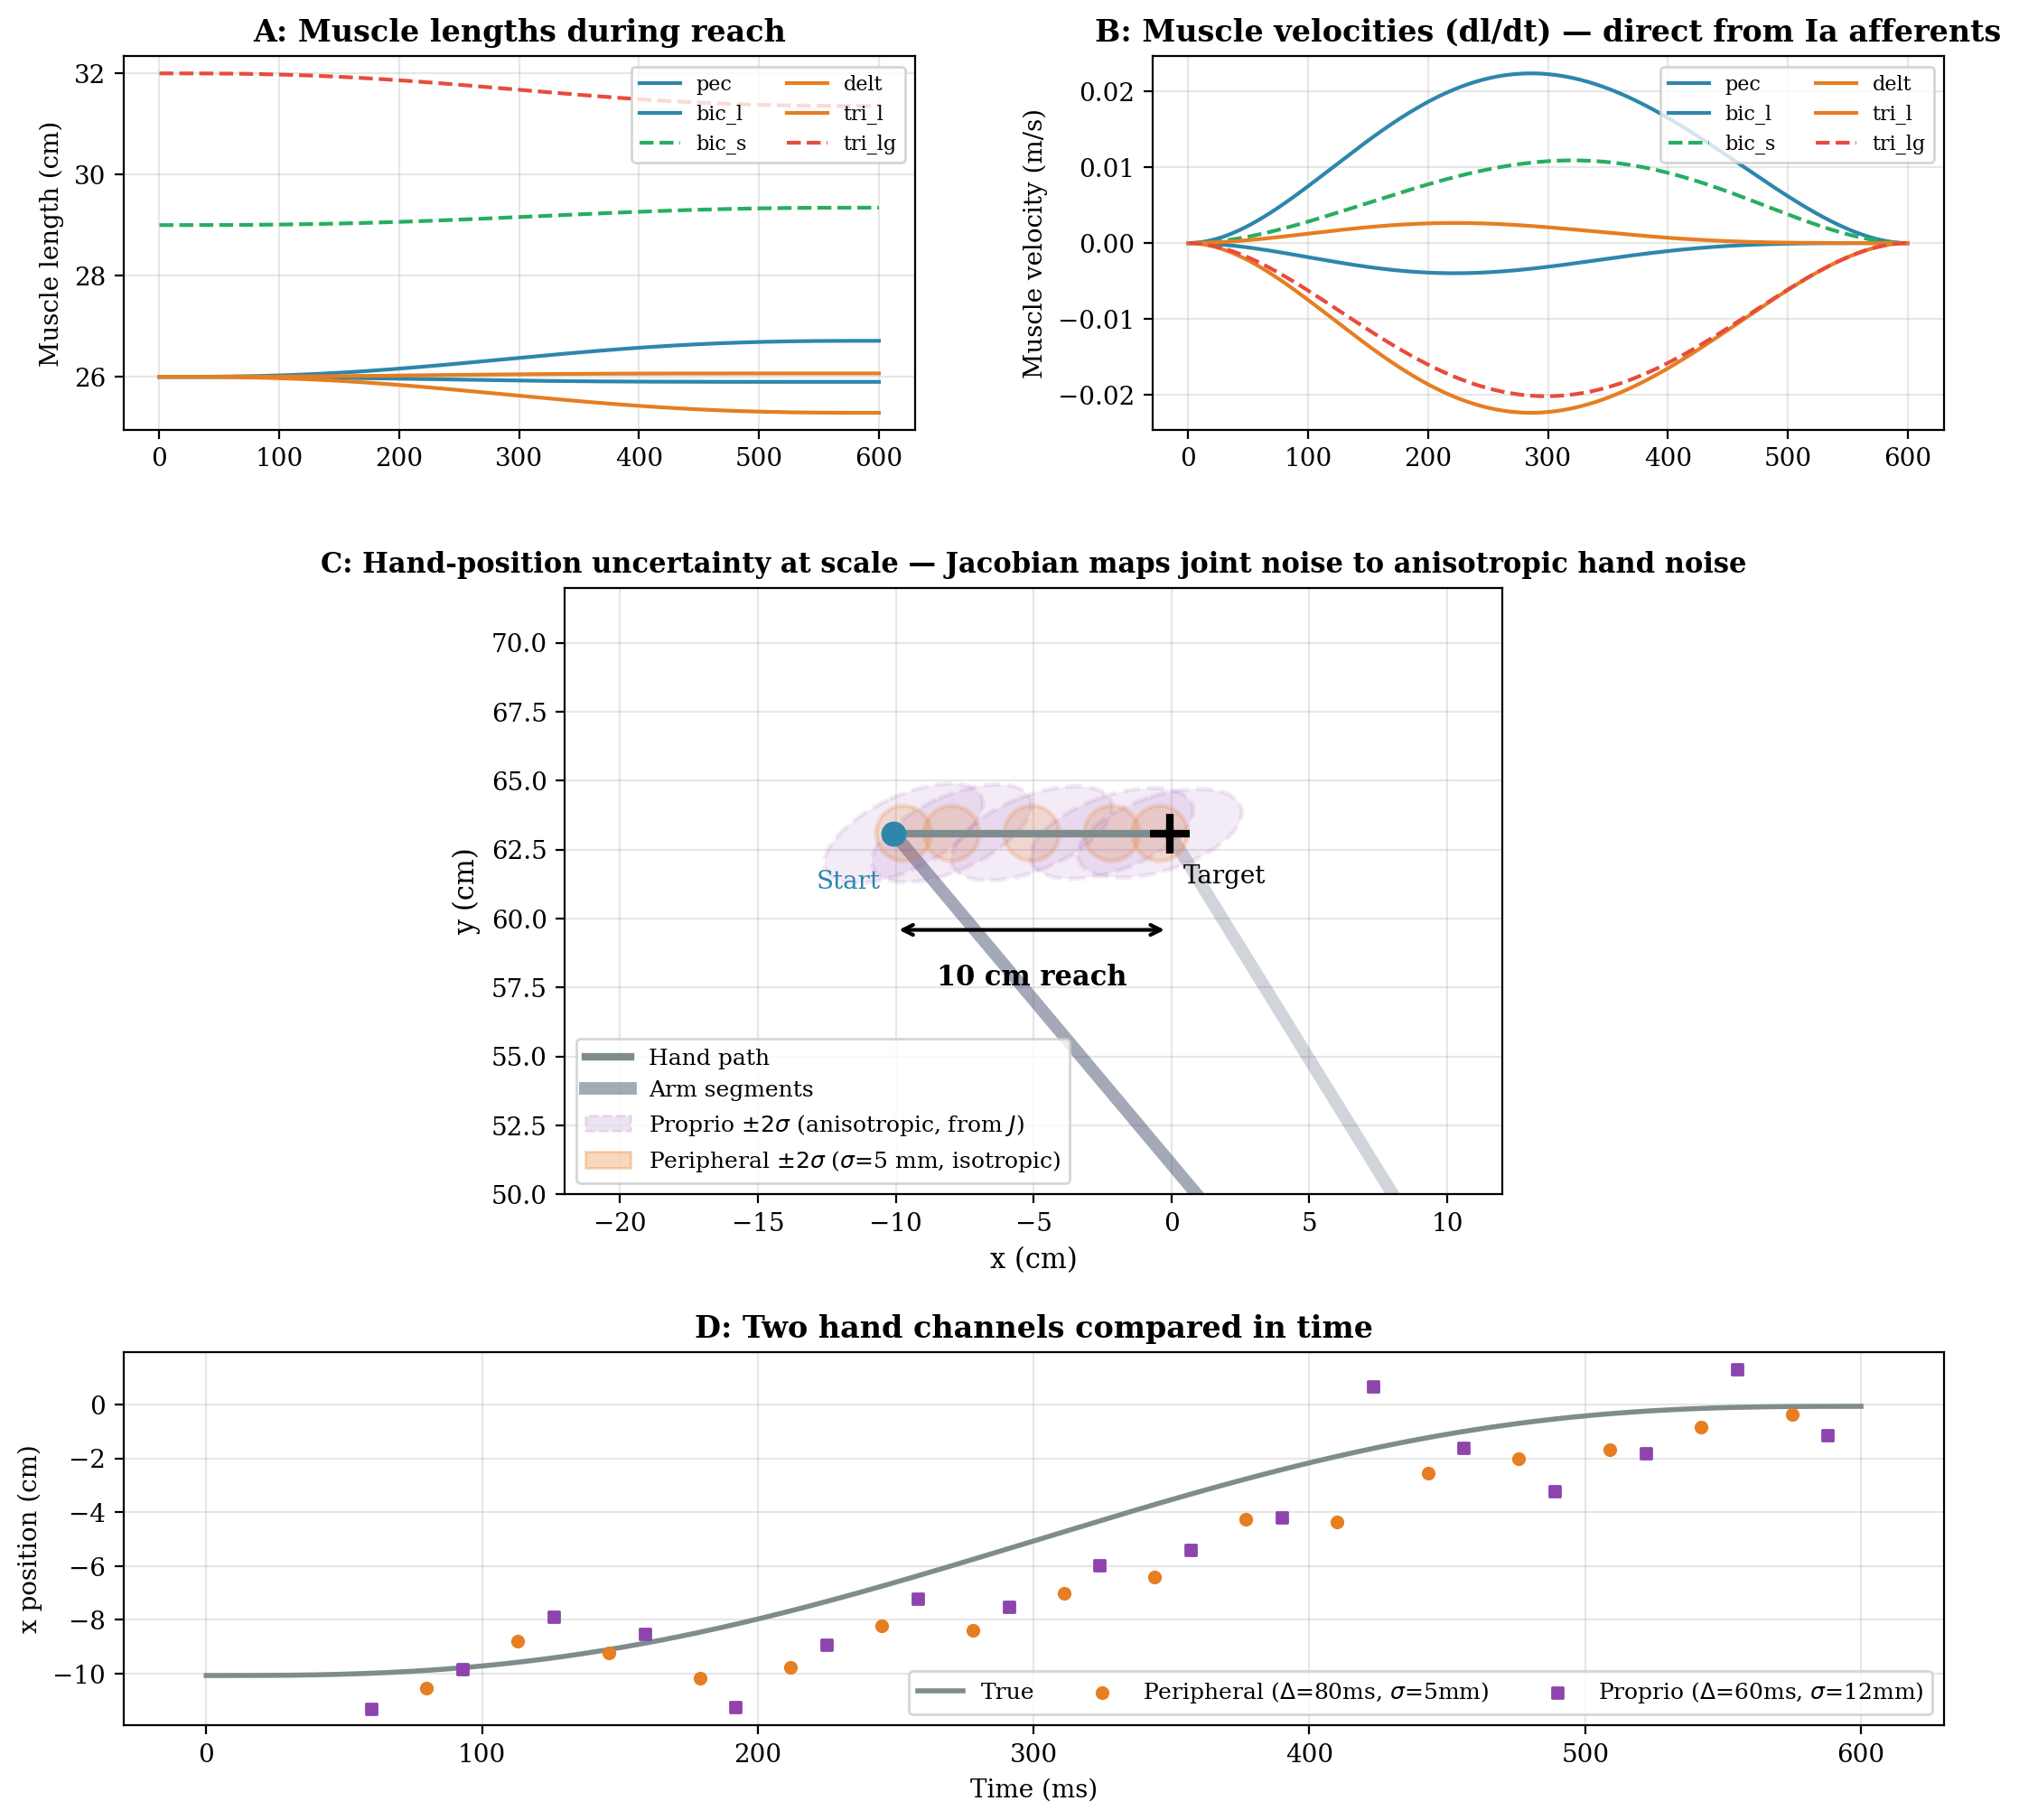
Figure 1. Proprioceptive readout during a 10 cm center-out reach (T = 600 ms). A: Muscle lengths change smoothly during the reach — these are the signals that spindle group II afferents encode. B: Muscle velocities (dl/dt) are the signals that spindle group Ia afferents encode directly, without differentiation; both are readable from the existing Muscle class. C: Hand-position uncertainty at scale, with the arm drawn for reference. Purple dashed ellipses: proprioceptive ±2σ, computed by mapping joint-angle noise through the Jacobian (R_hand = J σ_q² I Jᵀ). The ellipses are elongated along the radial (forearm) direction because the Jacobian amplifies joint noise anisotropically — this is why the 12 mm mean hand-position noise (van Beers et al. 1998) does not imply poor spindle acuity. Orange circles: peripheral vision ±2σ (σ = 5 mm, isotropic). D: The two hand channels in the time domain. Proprioception (purple, Δ = 60 ms, σ = 12 mm) arrives sooner but with more scatter than peripheral vision (orange, Δ = 80 ms, σ = 5 mm).

Closing Gap 1: Accuracy in the Dark
We can now reproduce Keele and Posner’s finding that accuracy improves even in the dark. The controller structure is identical to Week 8’s peripheral vision controller — P-only feedback with the same gain — but using the proprioceptive channel instead:
Dark controller (proprioception only, same structure as Week 8):

Measurement: y_pr(t) = x_hand(t − Δ_pr) + ε(t), ε ~ N(0, σ_pr² · I₂)
Error: e(t) = x_des(t − Δ_pr) − y_pr(t)
Correction: τ_corr = J(q)^T · Kp · e
Total torque: τ = τ_ff + τ_corr + SDN

Δ_pr = 60 ms, σ_pr = 12 mm, Kp = 8

With this controller, endpoint SD on the 6 cm arc drops from 0.256 cm (open-loop) to 0.158 cm, a 38% improvement. This is slightly worse than peripheral vision alone (0.156 cm, 39% improvement), matching the empirical finding that movements in the dark are more variable than movements with vision. (Note: the exact SD values differ from Week 8 because this week’s arc uses a different orientation. The qualitative ordering — open-loop > dark > peripheral — is the same.)
The ordering is: open-loop (worst) > dark (proprioception only) > peripheral vision (gaze on target, best of the three). Vision provides more precise spatial information than proprioception, but proprioception is fast enough to provide meaningful corrections even when the lights are off. Figure 2 shows this comparison. In §5, we will fuse both channels and show that the combination beats either alone.
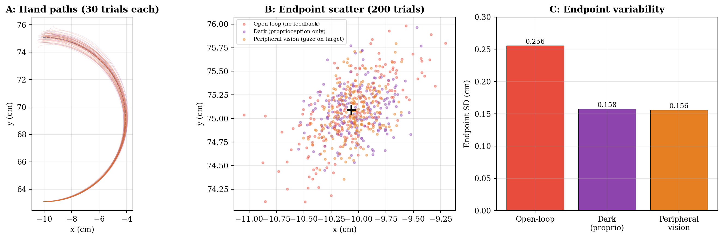
Figure 2. Accuracy in the dark. A: 30 hand paths per condition on the 6 cm arc (T = 800 ms, Kp = 8). Red: open-loop. Purple: dark (proprioception only, Δ = 60 ms, σ = 12 mm). Orange: peripheral vision (gaze on target, Δ = 80 ms, σ = 5 mm). B: Endpoint scatter (200 trials). C: Endpoint SD — the ordering open-loop > dark > peripheral matches the empirical finding that accuracy improves in the dark but improves more with vision.
Note: The simulation uses the isotropic approximation σ = 12 mm for proprioceptive noise. As derived in the Supplementary: Proprioceptive Noise Chain, the true noise is anisotropic (R_hand = J R_q Jᵀ, with a 2.3:1 axis ratio at Q_REF). The isotropic value is the mean of this anisotropic distribution and is sufficient for the endpoint SD comparison here. The full anisotropic treatment is developed in the supplementary materials.
Gap 1 closed. Keele and Posner found accuracy improves in the dark. Our proprioceptive channel (Δ = 60 ms, σ = 12 mm) reproduces this: endpoint SD drops 38% from open-loop. But peripheral vision (Δ = 80 ms, σ = 5 mm) still beats proprioception alone, because its lower noise more than compensates for its longer delay.

2. The State Estimation Problem
Every Sensor Reports the Past
Every sensory channel — proprioception at 60 ms, peripheral vision at 80 ms, central vision at 150 ms — reports where the hand was in the past. On a 10 cm reach at T = 600 ms, the peak hand velocity is about 312 mm/s. During the 80 ms peripheral delay, the hand moves approximately 25 mm (2.5 cm). During the 60 ms proprioceptive delay, it moves about 19 mm. A controller that corrects based on where the hand was 80 ms ago is correcting a ghost. In the Week 8 Introduction, we showed that at Δ = 200 ms, delayed PD feedback actively destabilized the trajectory.
The nervous system needs an estimate of where the hand is now — not where it was 60–150 ms ago. This requires combining three elements: a prediction of how the hand has moved since the last reliable information, the delayed sensory feedback itself, and a principled way to blend prediction and feedback based on their respective reliabilities. A key challenge is that sensors arrive at different times — the state estimator must account for these temporal delays, not just the noise levels (Crevecoeur et al., 2016).
The State-Predicting Feedback Controller (SPFC)
Frens and Donchin (2009), building on Todorov (2004) and Shadmehr and Krakauer (2008), describe a framework with three building blocks:
The SPFC framework (Frens & Donchin, 2009; cf. Miall & Wolpert, 1996):

1. Forward model: takes the current state estimate + motor command
→ predicts the next state

2. State estimator: combines the forward model’s prediction with
delayed sensory feedback → corrected state estimate

3. Feedback controller: maps the corrected state estimate onto
the next motor command

The forward model IS the predict step. The state estimator IS the update step.
Together they form the predict-update cycle that we will formalize as the
Kalman filter (§4).

This framework unifies the three gaps from the introduction. Gap 1 (proprioception) provides a new measurement channel for the state estimator. Gap 2 (the forward model) provides the predict step. Gap 3 (fusion) is the state estimator’s update step, which combines multiple sensory channels optimally. All three emerge from a single recursive architecture.
Supplementary: Miall, R. C. & Wolpert, D. M. (1996). Forward models for physiological motor control. Neural Networks, 9(8), 1265–1279. Frens, M. A. & Donchin, O. (2009). Forward models and state estimation in compensatory eye movements. Frontiers in Cellular Neuroscience, 3(13).

3. The Forward Model: The Predict Step
State-Space Formulation
We describe the hand’s state as a vector containing position and velocity:
State vector: x = [x, y, v_x, v_y]^T (4×1)
Motor command: u_n = [τ_shoulder, τ_elbow]^T (2×1, joint torques at timestep n)

The arm’s dynamics evolve as (Frens & Donchin, Eq. 2):
x_{n+1} = A x_n + B u_n + w_n

A (4×4) propagates position using velocity:
A = [1 0 dt 0 ]
[0 1 0 dt]
[0 0 1 0 ]
[0 0 0 1 ]

B (4×2) maps joint torques to hand acceleration. It depends on
the current arm configuration through J(q) and M(q)⁻¹ (details in Lab 09).

w_n ~ N(0, Q) is process noise — the SDN from Week 7 (k = 0.15).
Q (4×4) is the process noise covariance matrix.
The forward model knows u_n (via efference copy) but not w_n.

The Forward Model Prediction
The forward model maintains an internal estimate of state, x̂, and advances it using the same dynamics equation but with the efference copy (the planned motor command) instead of the actual noisy command:
Forward model prediction (Frens & Donchin, Eq. 3):

x̂_FM,n+1 = Â x̂_n + B̂ u_n

where Â and B̂ are the brain’s internal estimates of the arm’s dynamics,
and u_n is the efference copy of the motor command.

The efference copy is available with no delay (the brain knows what it
commanded immediately). But the prediction is approximate: the actual
execution differs from the plan due to SDN and interaction torques.
This is why the forward model drifts — and why sensory feedback is
needed to correct it (§4).

The connection to Elliott et al. (2017) is direct. Their impulse control process compares the actual sensory consequences of the movement to the expected consequences formed during planning. The forward model is the prediction engine that generates those expected consequences. When the actual feedback deviates from the prediction, the state estimator issues a correction. Figure 3 illustrates this with a target jump: the forward model continues on the original plan while the true hand steers toward the new target.
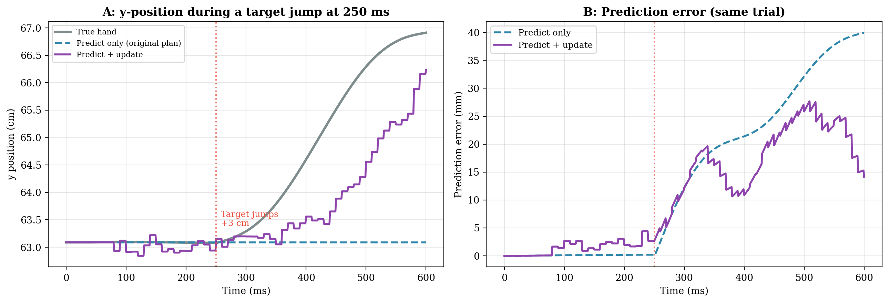
Figure 3. The forward model drifts when reality departs from the plan. A: The target jumps 3 cm upward at 250 ms. The true hand (gray) steers toward the new target. The forward model using only efference copy (teal dashed) stays on the original plan — it does not know the target moved. The predict + update estimate (purple) gradually corrects toward the true hand as delayed sensory measurements arrive and are blended into the prediction. B: Prediction error for the same trial. The predict-only error grows to ~40 mm by end of movement. The predict + update error rises initially (because measurements are delayed) but then levels off as corrections accumulate. The update steps are visible as discrete corrections in the purple trace.
Velocity Information
The state vector includes velocity components [v_x, v_y]. The SPFC framework provides velocity through two sources:
1. Efference copy. The forward model’s prediction of x̂_FM includes velocity components [v̂_x, v̂_y] directly from the state transition equation.
2. Ia afferents. Muscle spindle Ia afferents measure the velocity of muscle stretch directly. This signal propagates through the same moment arm and Jacobian chain as position (§1), arriving at the cortex with 60 ms delay and ~39 mm/s noise. Figure 4 shows the Ia velocity signal during a reach. The Supplementary: Proprioceptive Noise Chain derives this in detail.
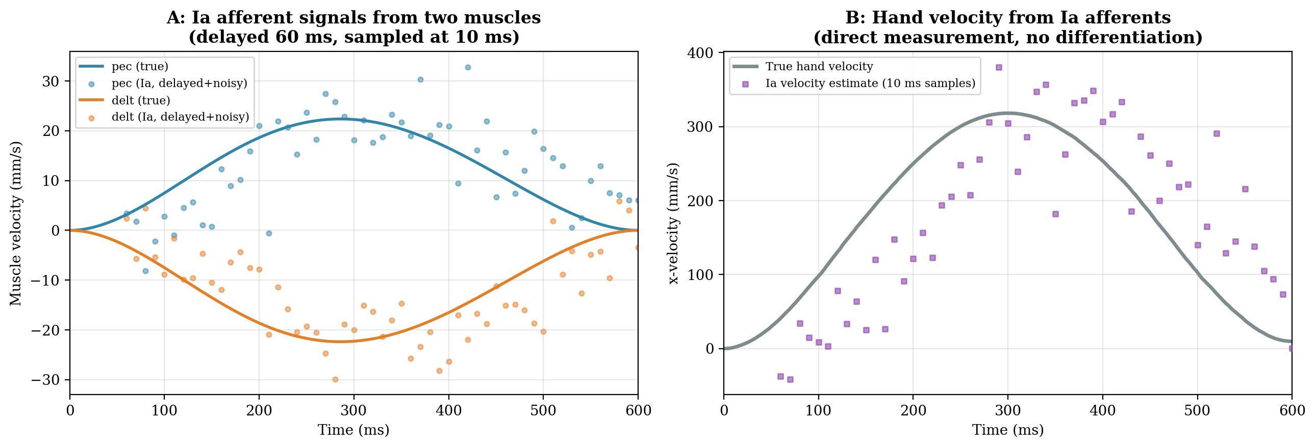
Figure 4. Proprioceptive velocity from Ia afferents during a 10 cm reach (T = 600 ms). A: Ia afferent signals from two muscles (pec and delt). Solid lines: true muscle velocities. Dots: delayed (60 ms) and noisy (σ_v = 5 mm/s) Ia measurements, sampled at 10 ms intervals. B: Hand velocity reconstructed from the Ia signals through the moment arm and Jacobian chain. Purple squares: Ia velocity estimate at 10 ms sample points. Gray line: true hand velocity. The Ia channel provides a direct velocity measurement — no differentiation of a position signal is involved.
Gap 2 closed. The forward model uses efference copy to predict the current state, including velocity from the state transition equation. Ia afferents provide a direct velocity measurement from muscle stretch. Together, they give the Kalman filter both position and velocity information. The predict step advances the state between measurements; the velocity components come from the state-space formulation and from Ia sensory feedback.

4. The Sensory Update: Correcting the Prediction
The Static Case: Inverse-Variance Weighting
Consider first the simplest case: the hand is stationary, and two sensors both report the same position at the same moment. Peripheral vision gives one estimate (σ = 5 mm); proprioception gives another (σ = 12 mm). How should the brain combine them?
Inverse-variance weighting (static case; van Beers et al., 1999; Ernst & Banks, 2002):

y₁, y₂: sensor measurements (scalars, same quantity at same time)
σ₁, σ₂: sensor noise standard deviations

x̂_fused = (y₁ / σ₁² + y₂ / σ₂²) / (1/σ₁² + 1/σ₂²)
σ²_fused = 1 / (1/σ₁² + 1/σ₂²)

With σ_periph = 5 mm and σ_proprio = 12 mm:
σ_fused = 1 / sqrt(1/5² + 1/12²) = 4.6 mm

This gives vision ~85% of the weight and proprioception ~15% (static case only).
The fused estimate is always more precise than either sensor alone.

IMPORTANT: this result assumes both sensors report the SAME moment
in time. During movement, this assumption breaks down
(see Static vs. Dynamic Weighting below).

The weight given to each sensor is proportional to its precision (inverse variance). This static weighting has been confirmed experimentally for stationary hand position judgments (van Beers et al., 1999; Ernst & Banks, 2002). The fused estimate is pulled toward the more precise channel, but always improves on either alone. Figure 5 illustrates this graphically.
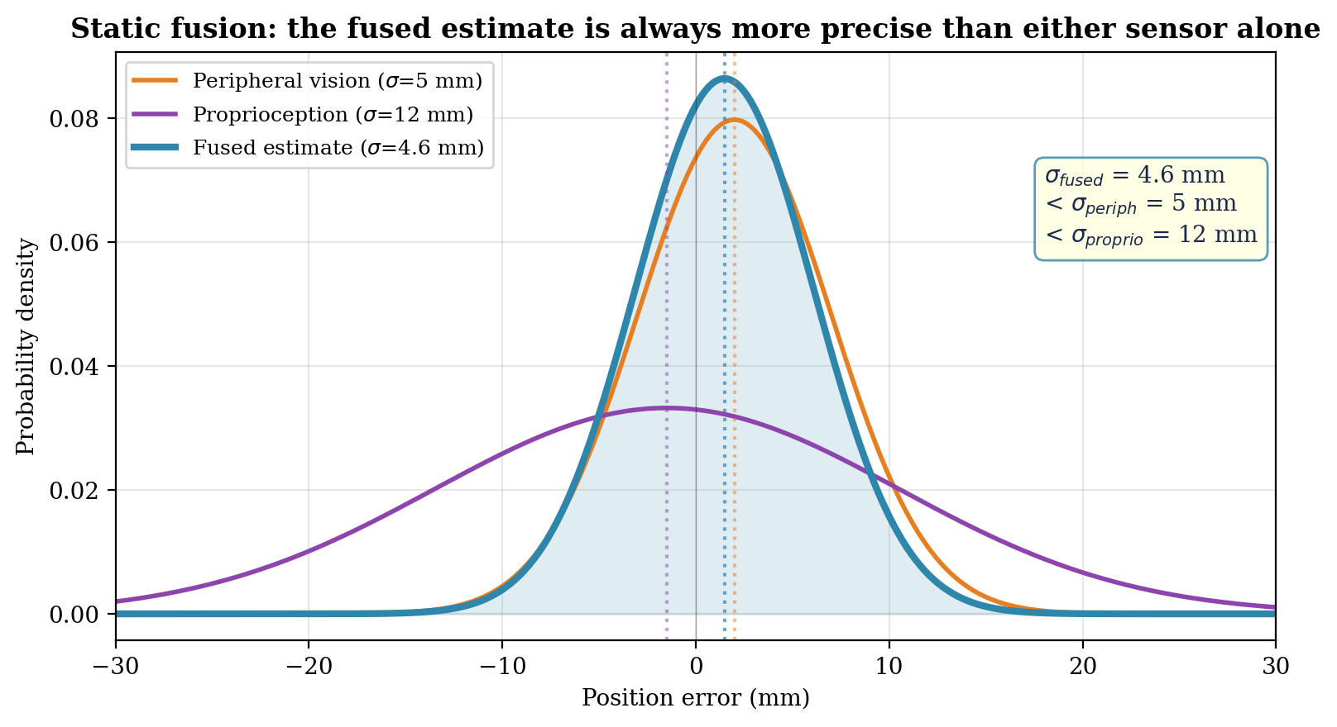
Figure 5. Static inverse-variance weighting of two Gaussian estimates. The peripheral vision distribution (orange, σ = 5 mm) is narrower than the proprioceptive distribution (purple, σ = 12 mm). The fused distribution (teal, σ = 4.6 mm) is narrower than either. This is the static case — valid when both sensors report the same moment in time. During movement, temporal delays change the weighting (see Static vs. Dynamic Weighting).
The Kalman Update: Generalizing to State Vectors
The scalar fusion above generalizes to the full state vector. Each sensor provides an observation of the state through its own observation equation:
Observation equation (Frens & Donchin, Eq. 4):

y_n = H x_n + ε_n

y_n: sensor measurement (k_y × 1, where k_y depends on the sensor)
x_n: true state (4×1)
H: observation matrix (k_y × 4), maps state to observed quantity
ε_n ~ N(0, R): sensor noise (k_y × 1), R is (k_y × k_y)

Each sensor has its own H matrix and noise covariance R.
For our state x = [x, y, v_x, v_y]^T:

Peripheral vision (observes position only, k_y = 2):
H_periph (2×4) = [1 0 0 0] R_periph (2×2) = (5 mm)² [[1,0],[0,1]]
[0 1 0 0]

Proprioception (observes position + velocity, k_y = 4):
H_proprio (4×4) = [1 0 0 0] R_proprio (4×4) = diag(R_pos, R_vel)
[0 1 0 0] (anisotropic — see Supplementary)
[0 0 1 0]
[0 0 0 1]

The Kalman filter combines the forward model’s prediction with each sensor’s measurement using a matrix generalization of inverse-variance weighting:
Kalman update (Frens & Donchin, Eq. 5):

x̂_{n+1} = x̂_{FM,n+1} + K_n (y_n − H x̂_{FM,n+1})

x̂_{FM,n+1} (4×1): forward model prediction from the predict step (§3).
y_n (k_y × 1): sensor measurement (2×1 for vision, 4×1 for proprio).
H (k_y × 4): observation matrix for the sensor providing y_n.
K_n (4 × k_y): Kalman gain matrix.

K_n weights the correction by the relative reliability of prediction
and measurement. When P is small (confident prediction), K is small.
When P is large (uncertain prediction), K is large.

The term (y_n − H x̂_{FM,n+1}) is the sensory prediction error (k_y × 1):
the discrepancy between what the sensor reports and what the
forward model predicted the sensor should report.

CRITICAL: each sensor’s error must compare y_n to the predicted
state AT THE TIME THE SENSOR SAMPLED, not at the current time.
Proprioception (Δ_p = 60 ms): compare y_proprio to x̂(t − Δ_p).
Peripheral vision (Δ_v = 80 ms): compare y_periph to x̂(t − Δ_v).

Crevecoeur et al. (2016, Eq. 8) formalize this as:
x̂(t) = x̂_FM(t) + K_P(y_proprio − x̂(t−Δ_p)) + K_V(y_vision − x̂(t−Δ_v))

x̂(t) (4×1): corrected state estimate at the current time.
K_P (4×k_p): Kalman gain block for proprioception.
K_V (4×k_v): Kalman gain block for vision.
x̂(t−Δ_p) (4×1): predicted state at the proprioceptive delay time.
x̂(t−Δ_v) (4×1): predicted state at the visual delay time.

This requires state augmentation (Crevecoeur et al., Eqs. 3–6).
The state vector is extended to include past states back to the
longest delay, and the observation matrix H selects the correct
past state for each sensor:

Augmented state (Crevecoeur et al., Eq. 3):
x̃_t = [x_t^T, x_{t-1}^T, ..., x_{t-Δ_p}^T, ..., x_{t-Δ_v}^T]^T
Dimension: (n_x × (1 + Δ_v/dt)) × 1, where n_x = 4 is the base
state dimension. Each block is a 4×1 copy of the state at that
past timestep.

Augmented observation matrix (Crevecoeur et al., Eq. 4):
H̃ = [0 ... I_4 ... 0] ← proprio observes x_{t-Δ_p}
[0 ... 0 ... I_4] ← vision observes x_{t-Δ_v}
Dimension: (k_p + k_v) × (n_x × (1 + Δ_v/dt))
I_4 is the 4×4 identity placed at the block corresponding to
each sensor’s delay; all other blocks are 4×4 zeros.

The standard Kalman filter equations then apply to the augmented
system, and the multi-delay fusion falls out automatically.
See Static vs. Dynamic Weighting below for the consequences.

The Two-Step Cycle: Predict and Update
The full Kalman filter alternates between two steps:
The predict-update cycle (Kalman, 1960; applied to motor control
as the observer model by Miall & Wolpert, 1996, Figure 6a):

Predict (forward model, §3):
x̂_{FM,n+1} = A x̂_n + B u_n (advance the state, 4×1)
P_{FM,n+1} = A P_n A^T + Q (advance the uncertainty, 4×4)

Update (sensory correction):
K_n = P_{FM} H^T (H P_{FM} H^T + R)^{-1} (Kalman gain, 4×k_y)
x̂_{n+1} = x̂_{FM} + K (y − H x̂_{FM}) (correct the state, 4×1)
P_{n+1} = (I_4 − K H) P_{FM} (shrink uncertainty, 4×4)

P_n (4×4): state covariance — quantifies uncertainty in the estimate.
Larger P → less confidence → larger K → trust measurement more.
Q (4×4): process noise covariance (from SDN).
R (k_y × k_y): measurement noise covariance.
R quantifies how much noise each sensor adds to its observations.
Peripheral vision: R (2×2), σ = 5 mm per direction.
Proprioception: R (4×4), position ~12 mm, velocity ~39 mm/s.
I_4: the 4×4 identity matrix.

Each predict step grows the uncertainty (because execution is noisy). Each update step shrinks it (because sensory feedback provides information). With multiple sensors arriving at different times, the filter can perform multiple updates per predict step, each one refining the estimate further.
Multiple Sensors, Multiple Updates
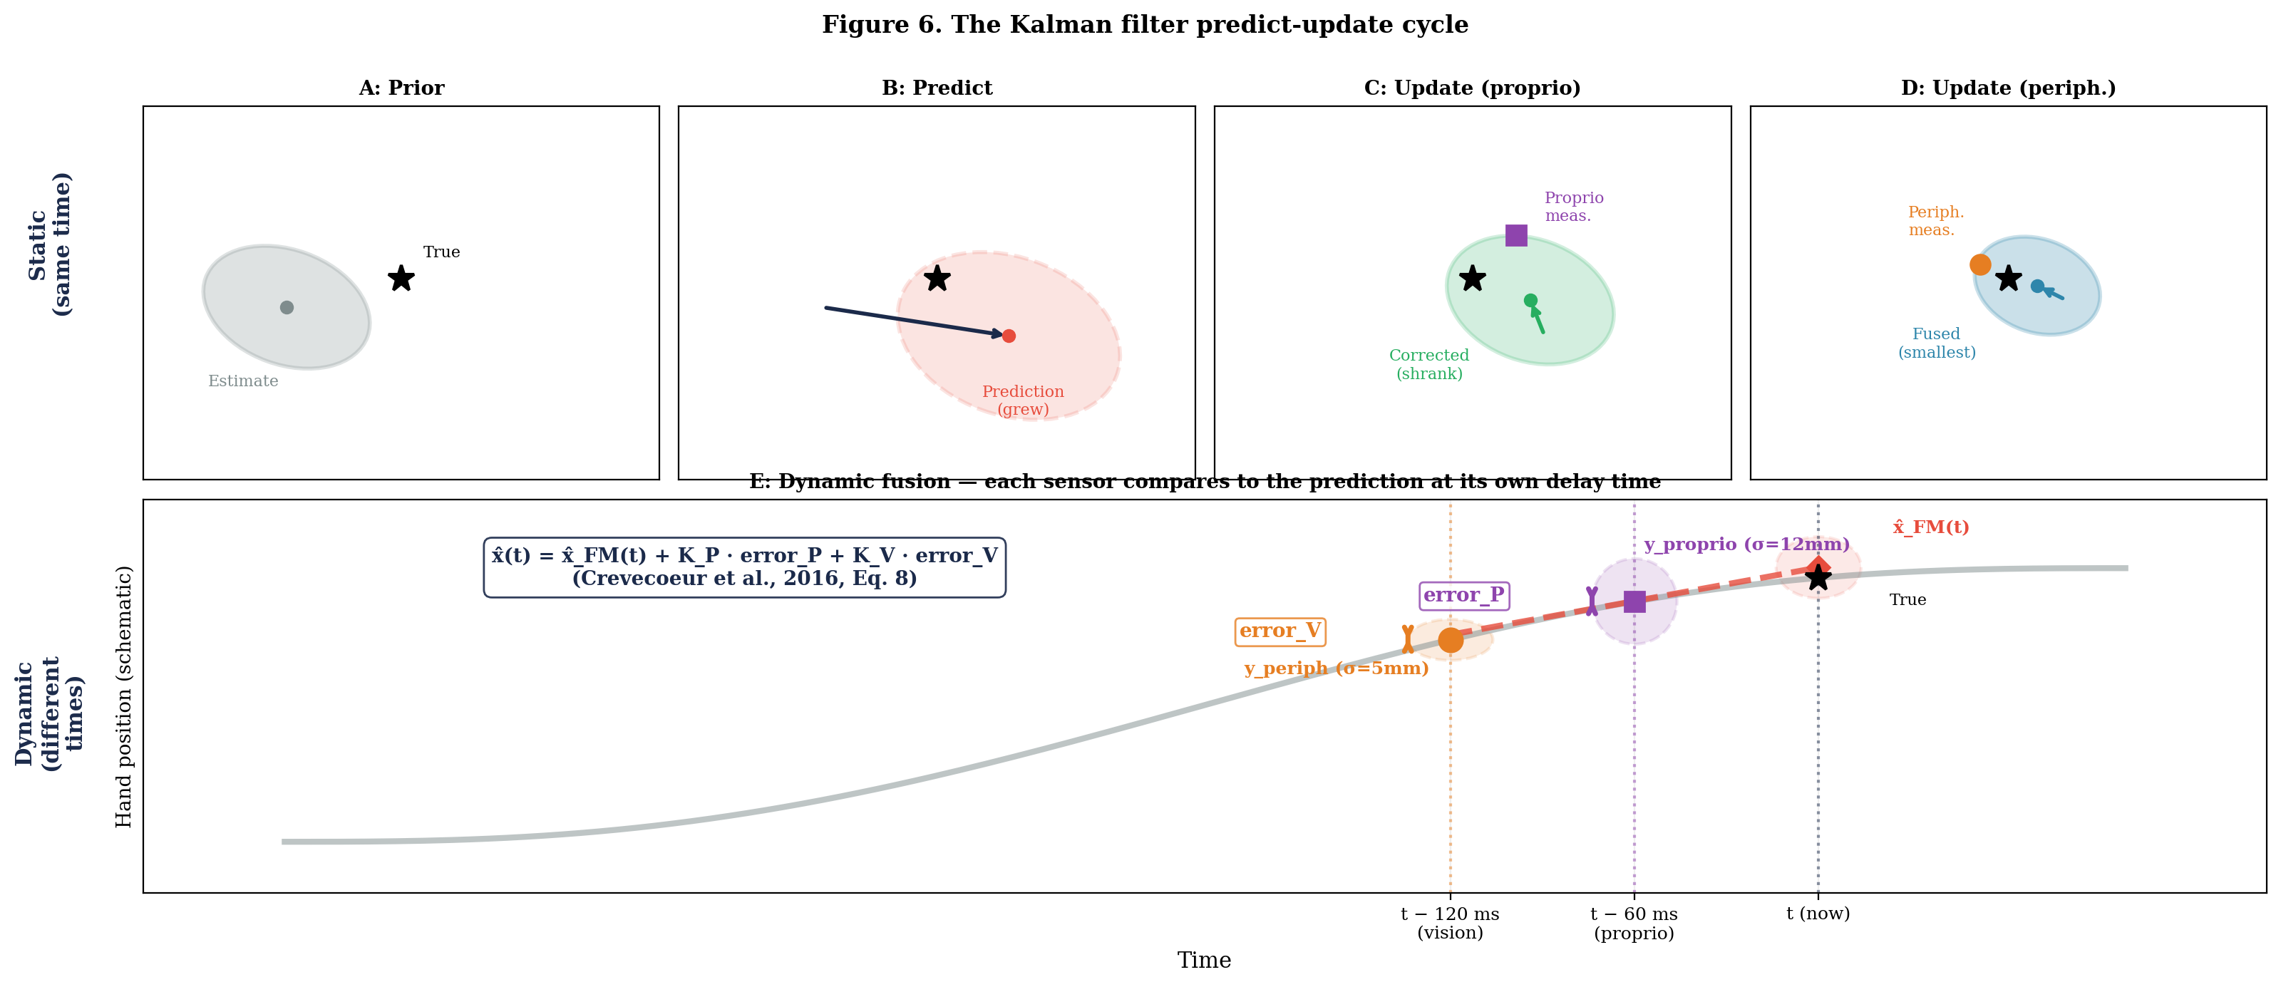
Figure 6. The Kalman filter predict-update cycle. Top row (static case): A–D show the standard predict-update sequence when both sensors report the same moment in time. A: Prior state estimate (gray ellipse). B: Predict — the forward model advances the estimate; the ellipse grows (red dashed) due to motor noise. C: Update with proprioception — a measurement (purple square) corrects the estimate (green); the ellipse shrinks. D: Update with peripheral vision — a second measurement (orange circle) further refines the estimate (teal, smallest ellipse). Bottom row (dynamic case, panel E): During movement, sensors report different moments because their delays differ. The gray curve is the true hand trajectory. Peripheral vision (orange circle, σ = 5 mm) reports the hand at t − 120 ms; proprioception (purple square, σ = 12 mm) reports it at t − 60 ms. The red dashed line is the forward model’s predicted trajectory. Each sensor’s prediction error is computed at its own delay time (error_V and error_P), not at the current time. The state estimate at t combines these errors using separate Kalman gain blocks K_P and K_V (Crevecoeur et al., 2016, Eq. 8). The time separation is exaggerated for visual clarity.
The Kalman filter does three things at once: (1) it predicts through the delay using the forward model (closing Gap 2), (2) it fuses multiple sensors via the Kalman gain (closing Gap 3), and (3) it maintains a full state estimate including velocity from the state dynamics and Ia afferents. All three capabilities emerge from the same two-step cycle.
Static vs. Dynamic Weighting: Why Delays Change Everything
The scalar fusion in §4a assumed both sensors report the same moment. During movement, this assumption fails. Proprioception reports the hand position 60 ms ago; peripheral vision reports it 80 ms ago. These are measurements of different hand positions, because the hand moved during the 20 ms gap between them.
The Kalman filter handles this correctly through the predict step: it projects the state estimate forward to each sensor’s measurement time before computing the prediction error. But this projection accumulates motor noise (SDN) over the delay period. Vision’s extra 20 ms means its measurement is projected through 20 ms more motor noise. The effective uncertainty about the current state from vision can exceed that from proprioception, even if vision is spatially more precise.
Why delays change the weights during movement:

Static case (hand stationary, no motor noise accumulation):
Effective uncertainty = sensor noise only.
Vision (σ = 5 mm) dominates proprioception (σ = 12 mm).
Vision gets ~85% weight.

Dynamic case (hand moving, motor noise accumulates over delay):
Effective uncertainty = sensor noise + accumulated motor noise.
Vision: σ²_eff = (5 mm)² + motor_noise × 80 ms
Proprio: σ²_eff = (12 mm)² + motor_noise × 60 ms
The 20 ms difference can be enough to make proprio’s effective
uncertainty comparable to vision’s, shifting weight toward proprio.

Crevecoeur et al. (2016, Figure 1d): even when vision is 5× more
precise than proprioception, adding vision during movement reduces
the posterior variance by only ~10%. Somatosensory speed trumps
visual accuracy.

Crevecoeur et al. (2016) confirmed this experimentally. Following mechanical perturbations to the arm, saccadic reaction times and motor corrections were nearly identical whether or not visual feedback was available. The dynamic Kalman filter explained this: proprioception dominated the state estimate because its 60 ms delay provided newer information than vision’s 80 ms delay. The modest benefit of adding vision (~30% variance reduction, much less than static weighting predicts) matched the model’s predictions.
This has a practical consequence for our simulations: the Kalman gain K_n is not a fixed matrix determined by sensor noise alone. It evolves over time as motor noise accumulates and measurements arrive. During fast movements, proprioception’s earlier arrival gives it disproportionate influence. During slow movements or at the endpoint (hand nearly stationary), the static weighting re-emerges and vision dominates again.
Gap 3 closed. Sensor fusion is not as simple as inverse-variance weighting. The Kalman filter accounts for both sensor noise AND temporal delays. During movement, proprioception dominates because it provides newer information — somatosensory speed trumps visual accuracy (Crevecoeur et al., 2016). The static 85%/15% vision/proprio split applies only when the hand is stationary. The full predict-update cycle from Frens and Donchin (2009) and Miall and Wolpert (1996) handles all cases automatically.

5. The Three-Sensor Architecture
We now assemble all three sensory channels into the SPFC framework from §2. The two hand-sensing channels (peripheral vision and proprioception) feed the Kalman filter through their observation equations y = H x + ε. Foveal vision observes the target directly and provides the reference signal for the controller:
Three-sensor observation model:
R is the measurement noise covariance: it quantifies how much
noise a sensor adds to its observations.

Foveal vision (observes the TARGET, not the hand state):
y_fov(t) = x_target(t − 150 ms) + ε_fov (2×1 → 2×1)
R_fov (2×2) = (1 mm)² [[1,0],[0,1]] (isotropic)
σ = 1 mm in each direction — foveal vision is the most precise
spatial sensor. Direct 2D observation; not part of the hand-state KF.

Peripheral vision (observes HAND position from state x):
y_periph(t) = H_pos x_hand(t − 80 ms) + ε_periph (2×4 × 4×1 → 2×1)
R_periph (2×2) = (5 mm)² [[1,0],[0,1]] (isotropic)
σ = 5 mm — peripheral vision is noisier due to lower receptor density.
H_pos (2×4) = [1 0 0 0] (selects position, ignores velocity)
[0 1 0 0]

Proprioception (observes HAND position AND velocity from state x):
y_proprio(t) = x_hand(t − 60 ms) + ε_proprio (4×1 → 4×1)
R_proprio (4×4) = diag(R_pos, R_vel)
Position noise ~12 mm (from group II afferents, through the spindle
→ moment arm → Jacobian chain). Velocity noise ~39 mm/s (from
group Ia afferents, through the same chain). See Supplementary.
H = I₄ (the 4×4 identity) — meaning y_proprio = x + ε, i.e.
proprioception measures all four state components directly.

Isotropic approximation used here; see Supplementary for
the anisotropic chain R_hand(q) = J R_q J^T.

The delays listed above (60, 80, 150 ms) determine how much each sensor contributes to the current state estimate during movement. Proprioception’s 60 ms delay means the Kalman filter projects through less motor noise to estimate the present. Peripheral vision’s extra 20 ms of projection degrades its effective contribution. Central vision’s 150 ms delay makes it nearly irrelevant for hand state estimation during fast movements — its main value is sensing the target, which is stationary and does not suffer from motor noise accumulation.
This is the gaze-on-target architecture from Week 8: foveal vision fixates the target, peripheral vision and proprioception both sense the hand. The Kalman filter fuses the two hand channels into a single state estimate x̂_hand. The controller computes the error between the foveal target estimate and the fused hand estimate:
Three-sensor controller:

x̂_hand = [x̂, ŷ, v̂_x, v̂_y]^T (4×1, KF fusion of peripheral + proprio)
x̂_target = [x̂_tgt, ŷ_tgt]^T (2×1, foveal vision estimate of target position)

e(t) = x̂_target − H_pos x̂_hand
(2×1) (2×4)(4×1) → (2×1)
H_pos extracts [x̂, ŷ] from the 4D state so the subtraction is
dimensionally correct: 2×1 − 2×1 = 2×1 (position error only).

τ_corr = J(q)^T · Kp · e (2×2)(scalar)(2×1) → (2×1 joint torques)
τ = τ_ff + τ_corr + SDN (2×1 total torque to arm)

Kp = 8 (scalar proportional gain, same as Weeks 7–8).

The key difference from Week 8: the hand estimate is no longer a raw delayed measurement from a single sensor. It is a Kalman-filtered state estimate that combines the forward model prediction with every available measurement. During movement, proprioception dominates the estimate because its 60 ms delay provides newer information (Crevecoeur et al., 2016). Peripheral vision (80 ms, 5 mm) contributes primarily near the endpoint, when the hand decelerates and motor noise accumulation matters less. The forward model fills the gaps between measurements using efference copy. Figure 7 shows the complete architecture.
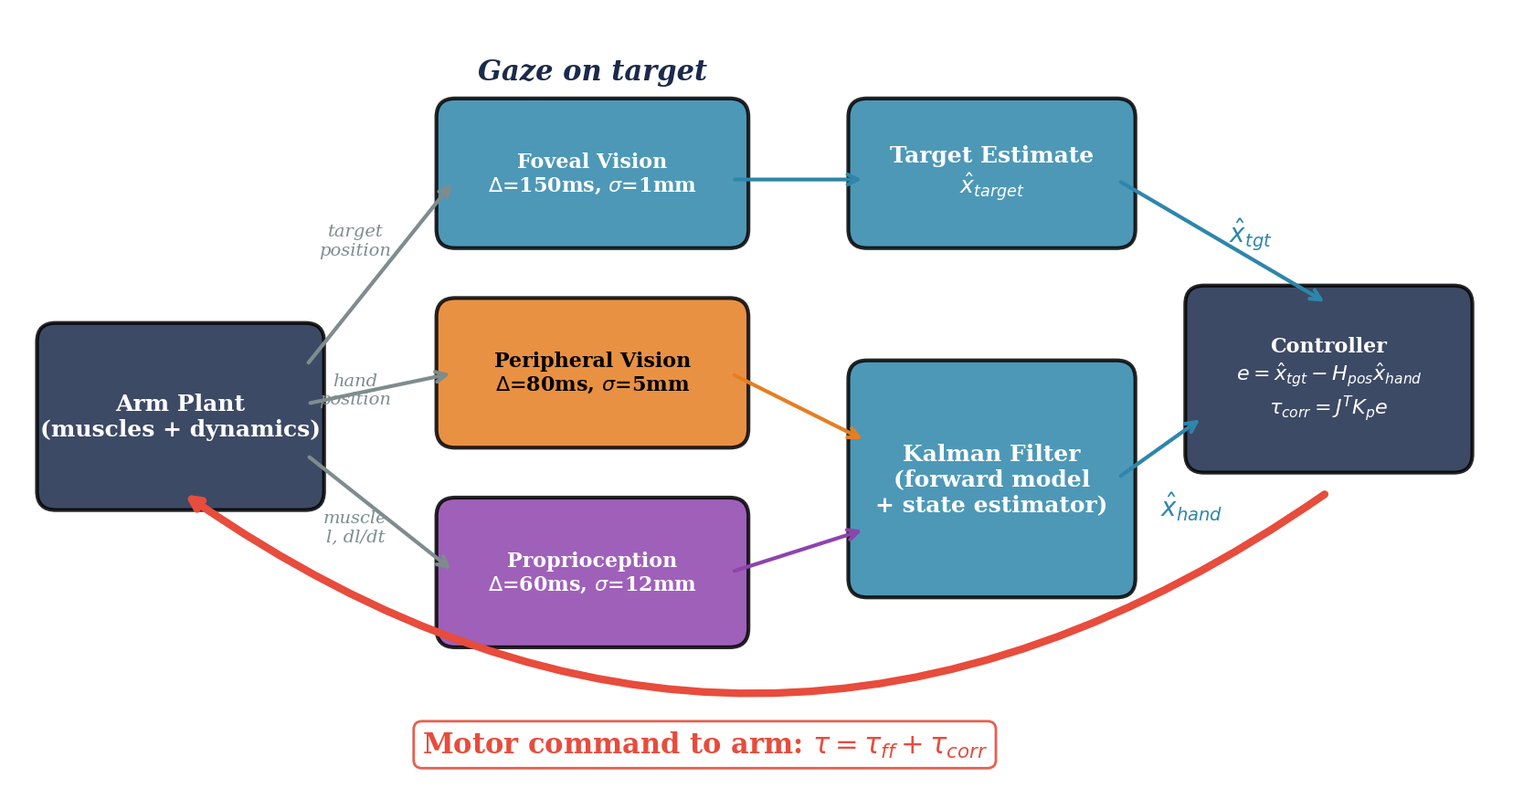
Figure 7. The three-sensor SPFC architecture. The arm plant (left) generates three sensory signals: foveal vision senses the target (Δ = 150 ms, σ = 1 mm), peripheral vision senses the hand (Δ = 80 ms, σ = 5 mm), and proprioception senses the hand via muscle length and velocity (Δ = 60 ms, σ = 12 mm). The forward model (efference copy) predicts the next state. The Kalman filter (state estimator) fuses the prediction with incoming measurements. The controller computes the error between the foveal target estimate and the fused hand estimate. The motor command (red arrow, bottom) is the output to the arm.
The three-sensor architecture separates target sensing (foveal) from hand sensing (peripheral + proprioceptive). During movement, proprioception dominates the hand estimate despite its higher noise — speed trumps precision. Near the endpoint, as the hand decelerates, visual precision reasserts its advantage. In Week 10, we compare this architecture to the gaze-on-hand strategy, where central vision tracks the hand and the target is in the periphery.

6. The Updated Frontier: Sensor Fusion vs. Movement Speed
We demonstrate the fused SPFC controller on the 6 cm arc task from Weeks 6–8. The Kalman filter fuses proprioception and peripheral vision into a single hand state estimate, with the same P-only gain Kp = 8 used throughout. Figure 8 shows the comparison.
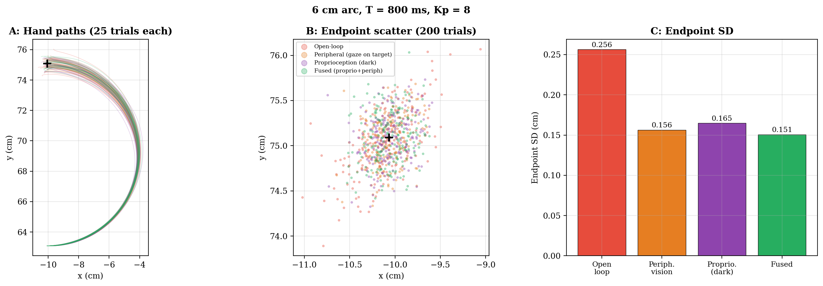
Figure 8. Fused controller on the 6 cm arc (T = 800 ms, Kp = 8, 200 trials). A: Hand paths (25 trials each). Red: open-loop. Orange: peripheral vision only. Purple: proprioception only (dark). Green: fused (proprioception + peripheral). B: Endpoint scatter. C: Endpoint SD. Fusing the two hand channels produces the lowest variability.
The improvement from fusion is modest, consistent with Crevecoeur et al.’s prediction that proprioception dominates during movement. At the 800 ms movement time, the hand has nearly stopped by the time late-arriving visual measurements become available, so vision contributes primarily near the endpoint. Figure 9 extends this comparison across movement speeds:
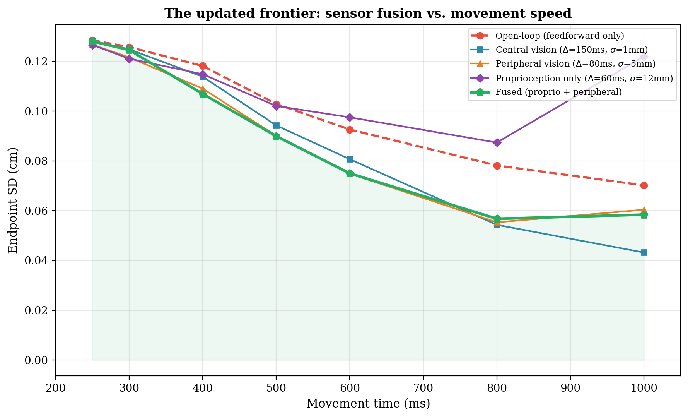
Figure 9. The updated frontier. Endpoint SD vs. movement time for five controllers on a 10 cm center-out reach (Kp = 8, 150 trials per point). The fused controller (green, proprioception + peripheral vision) achieves the lowest variability across the speed range. At fast speeds, the improvement from fusion is small because proprioception dominates the estimate. At slower speeds, vision has more time to contribute and the fusion benefit grows. Note that proprioception alone (purple) degrades at slow speeds, eventually exceeding open-loop — this is a limitation of the fixed-gain P controller, not of proprioception itself: with Kp = 8, the controller keeps correcting to noisy measurements (σ = 12 mm) even when the hand is nearly stationary, injecting more variability than it removes. A proper Kalman gain would automatically reduce corrections as uncertainty decreases near the endpoint.
Sensor fusion always helps, but the benefit depends on movement speed. At fast speeds, proprioception dominates and adding vision provides only a modest improvement — consistent with Crevecoeur et al.’s finding that somatosensory speed trumps visual accuracy during movement. At slow speeds, vision’s lower noise provides a larger benefit. Proprioception alone degrades at slow speeds because our fixed Kp = 8 controller corrects to noisy measurements even when the hand is nearly stationary — the Kalman gain (which decreases automatically as uncertainty stabilizes) would prevent this. In Week 10, when we degrade one channel, the benefit of having the other becomes dramatic.

7. Summary and Looking Ahead
Summary of Key Results
1. Proprioception adds a new sensory channel. Muscle spindles provide both position (group II) and velocity (group Ia) information, with 60 ms cortical delay and ~12 mm hand-position noise. The noise is anisotropic (from the Jacobian mapping) but we use an isotropic approximation for this week’s simulations. Proprioception alone improves accuracy by 38% over open-loop (§1).
2. The SPFC framework unifies prediction and correction. The forward model (predict step) uses efference copy to advance the state estimate between measurements. It drifts due to motor noise, which is why sensory updates are needed. The Kalman filter (update step) corrects the prediction using each sensor’s measurement, weighted by the Kalman gain (§2–§4).
3. Sensor fusion depends on both noise and delay. In the static case (stationary hand), inverse-variance weighting gives vision ~85% of the weight. During movement, the Kalman filter automatically shifts weight toward proprioception because it provides newer information — somatosensory speed trumps visual accuracy (Crevecoeur et al., 2016). The 85%/15% split applies only at the endpoint (§4).
4. Sensor fusion improves the frontier, modestly during fast movements. The fused controller beats every single-channel controller, but the margin is small at fast speeds (where proprioception dominates) and larger at slow speeds (where vision has time to contribute). Proprioception alone degrades at slow speeds with our fixed-gain controller — this motivates the optimal Kalman gain, which automatically reduces corrections as uncertainty stabilizes near the endpoint (§6).
5. Velocity from two sources. The forward model provides velocity from the state dynamics (efference copy), and Ia afferents measure it directly from muscle stretch (§3).
Bridge to Week 10: Gaze Strategies and the Role of Vision
This week’s architecture uses the gaze-on-target strategy: foveal vision fixates the target while peripheral vision and proprioception sense the hand. If proprioception dominates the hand estimate during fast movements, then the main benefit of vision during movement may be precise target sensing rather than hand tracking. This raises the possibility that the gaze-on-target strategy is optimal precisely because it allocates the high-precision fovea to the signal that benefits most from low noise (the stationary target) rather than to the moving hand.
Week 10 tests this by comparing gaze-on-target vs. gaze-on-hand vs. alternating strategies. We will also degrade individual channels (occlude the hand, vibrate tendons) and test whether the Kalman filter automatically reweights as predicted. The state-space framework from this week’s §3–§4 handles all of these configurations: each sensor plugs into the same observation equation y = H x + ε with its own delay, noise, and H matrix. The Kalman gain adapts automatically.
The SPFC framework from this week is the computational backbone for the rest of the course. Every sensor — present or future — plugs into the same predict-update architecture. The key insight: during movement, faster sensors dominate over more precise ones. Next week, we test whether gaze strategies reflect this principle — if proprioception handles the hand, the fovea is free to provide what only vision can: a precise, stable target.

