COMPUTATIONAL SENSORIMOTOR CONTROL

WEEK 3 LECTURE NOTES
Forward Dynamics: Connecting Muscles to Movement
Module 1: The Biological Plant | Fall 2026

Learning Objectives for This Week
By the end of this week, you should be able to:
- Write the Lagrangian equations of motion for a 2-link planar arm: M(q)d²q/dt² = τ − C(q,dq/dt)dq/dt.
- Derive each element of the mass-inertia matrix M(q) from the kinetic energy of the system.
- Explain why interaction torques arise from the off-diagonal elements of M and why they make multi-joint control fundamentally harder than single-joint control.
- Identify the Coriolis and centrifugal terms in C(q,dq/dt) and explain their physical meaning.
- Implement 4th-order Runge–Kutta (RK4) integration to simulate the arm forward in time.
- Connect the 6 muscles from Week 2 to the skeleton and simulate muscle-driven movement.

Required Reading
- Hollerbach, J. M., & Flash, T. (1982). Dynamic interactions between limb segments during planar arm movement. Biological Cybernetics, 44(1), 67–77. — The foundational paper on interaction torques in multi-joint arm movement.
Implementation Reference:
- Gribble, P. L., et al. (1998). Are complex control signals required for human arm movement? J. Neurophysiol., 79(3), 1409–1424. — Appendix: equations of motion, all parameter values.

1. Why Dynamics? From Kinematics to Movement
In Weeks 1–2, we built the arm’s geometry (FK, IK, Jacobian) and its muscles (force-length, calcium kinetics, force-velocity). But neither component can answer the simplest question in motor control: if I activate these muscles, where does the hand go?
To answer this, we need the equations of motion—the physical laws that relate muscle forces to joint accelerations. These equations are the bridge between the neural command (muscle activations) and the observable movement (joint angles over time).
For a single joint (like the elbow in isolation), the equation of motion is simple: I·d²θ/dt² = τ. Torque divided by inertia gives acceleration. But for a multi-joint arm, the situation is fundamentally more complex because of interaction torques—forces at one joint that arise from motion at another. These interaction torques are the central theme of this week.

2. Inertial Parameters of the Arm
The joint angles follow the same conventions as Week 1: θ₁ is measured in the global frame (0° = arm abducted, positive = horizontal flexion), and θ₂ is body-fixed relative to the upper arm (0° = fully extended, positive = flexion). The absolute forearm angle in the global frame is (θ₁ + θ₂) — this is why the forearm’s COM position (Equation 3.2) uses cos(θ₁ + θ₂) and sin(θ₁ + θ₂).
The 2-link arm model requires the following parameters for each segment:
- m — segment mass (kg)
- l — segment length (m)
- s — distance from proximal joint to center of mass (m)
- I — moment of inertia about the center of mass (kg·m²)
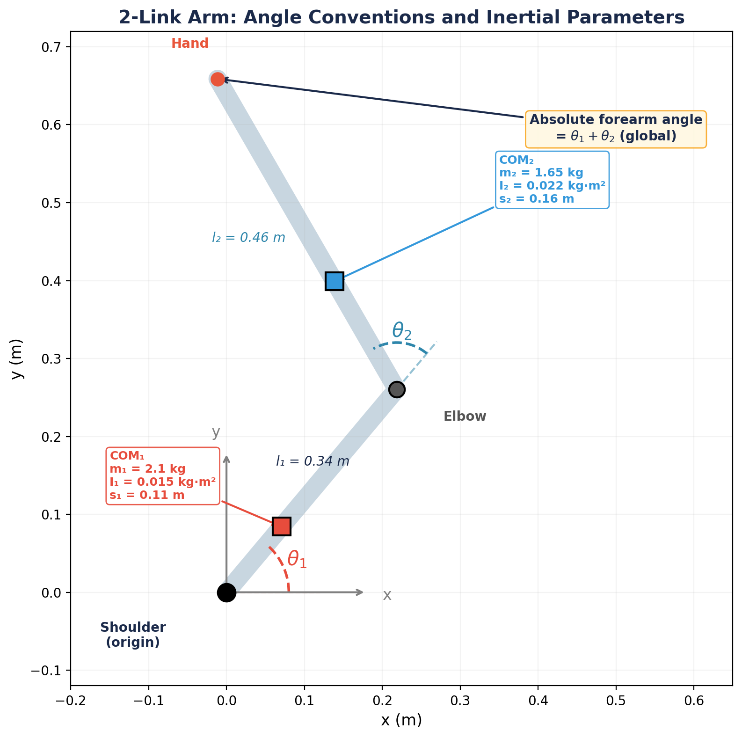
Figure 1. The 2-link arm with angle conventions (same as Week 1) and inertial parameters. θ₁ is global; θ₂ is body-fixed. Squares mark each segment’s center of mass. All parameters from Gribble et al. (1998).
Parameter | Upper Arm | Forearm | Notes
Mass m | 2.10 kg | 1.65 kg
Length l | 0.34 m | 0.46 m
COM distance s | 0.11 m | 0.16 m | from proximal joint
Inertia I (about COM) | 0.015 kg·m² | 0.022 kg·m²

Source: Gribble et al. (1998), p. 1411. The COM distances s₁ = 0.11 m and s₂ = 0.16 m are estimated from standard anatomical proportions (Winter 1990).

3. Deriving the Mass-Inertia Matrix
We derive M(q) step by step from the kinetic energy T of the system. The Lagrangian approach requires T = ½dq/dtᵀM(q)dq/dt, so our goal is to express the total kinetic energy in terms of the joint velocities dθ₁/dt and dθ₂/dt.

3.1 Kinetic Energy of Segment 1
The upper arm rotates about the shoulder. Its center of mass is at distance s₁ from the origin, with velocity v₁ = s₁dθ₁/dt. The kinetic energy of segment 1 is:
T₁ = ½ m₁ s₁² dθ₁/dt² + ½ I₁ dθ₁/dt² = ½ (m₁ s₁² + I₁) dθ₁/dt² (3.1)
This is straightforward: a single rotating body with effective inertia (m₁s₁² + I₁) about the shoulder.

3.2 Kinetic Energy of Segment 2
The forearm’s center of mass has position:
p₂ = (l₁ cosθ₁ + s₂ cos(θ₁+θ₂), l₁ sinθ₁ + s₂ sin(θ₁+θ₂)) (3.2)
Differentiating to get the velocity components:
dx₂/dt = −l₁ sinθ₁ · dθ₁/dt − s₂ sin(θ₁+θ₂) · (dθ₁/dt+dθ₂/dt) (3.3a)
dy₂/dt = l₁ cosθ₁ · dθ₁/dt + s₂ cos(θ₁+θ₂) · (dθ₁/dt+dθ₂/dt) (3.3b)
The translational kinetic energy of segment 2 is ½m₂(dx₂² + dy₂²). Squaring and using cos² + sin² = 1:
v₂² = l₁²dθ₁/dt² + s₂²(dθ₁/dt+dθ₂/dt)² + 2l₁ s₂ cosθ₂ · dθ₁/dt(dθ₁/dt+dθ₂/dt) (3.4)
Note the key term: 2l₁s₂ cosθ₂ — this is the coupling between the two joints. It depends on the elbow angle θ₂, which is why the inertia is configuration-dependent.
Adding the rotational kinetic energy I₂(dθ₁/dt+dθ₂/dt)²/2, the total kinetic energy becomes T = ½dq/dtᵀM(q)dq/dt with:

3.3 The Mass-Inertia Matrix M(q)
Collecting terms by dθ₁/dt², dθ₂/dt², and dθ₁/dtdθ₂/dt, we define three inertial constants:
a₁ = I₁ + I₂ + m₁ s₁² + m₂(l₁² + s₂²) (3.5a)
a₂ = I₂ + m₂ s₂² (3.5b)
a₃ = m₂ l₁ s₂ (3.5c)
Then the mass-inertia matrix is:
M(q) = [ [a₁ + 2a₃ cosθ₂, a₂ + a₃ cosθ₂], [a₂ + a₃ cosθ₂, a₂] ] (3.6)
Why M Depends on θ₂
The cosθ₂ terms arise from the forearm’s position relative to the upper arm. When the arm is extended (θ₂ ≈ 0°), the forearm is far from the shoulder, maximizing the shoulder’s effective inertia (M₁₁ is largest). When the arm is flexed (θ₂ ≈ 90°), the forearm is closer, reducing shoulder inertia. This is why it’s easier to rotate your arm quickly with a bent elbow.
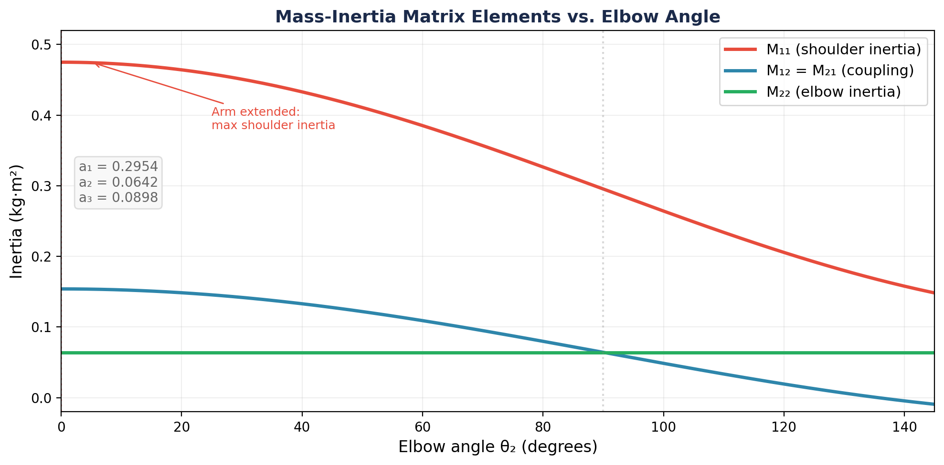
Figure 2. Elements of M(q) vs. elbow angle. M₁₁ (shoulder inertia) varies with configuration; M₂₂ (elbow inertia) is constant; M₁₂ = M₂₁ (coupling) connects the two joints.

3.4 Numerical Values
With the Gribble et al. parameters:
- a₁ = 0.015 + 0.022 + 2.1×0.11² + 1.65×(0.34² + 0.16²) = 0.2533 kg·m²
- a₂ = 0.022 + 1.65×0.16² = 0.0642 kg·m²
- a₃ = 1.65×0.34×0.16 = 0.0897 kg·m²
These three numbers define the entire inertial behavior of the arm. Students will use them directly in the DynamicsEngine class.

4. Coriolis and Centrifugal Terms
The Euler–Lagrange equation is d/dt(∂L/∂dq/dt) − ∂L/∂q = τ. Because M depends on q, the time derivative of ∂T/∂dq/dt generates additional terms beyond Md²q/dt². These are the Coriolis and centrifugal forces.
Where C Comes From
The Coriolis and centrifugal terms arise from the fact that M(q) changes as the arm moves. When you differentiate M(q)dq/dt with respect to time, you get M(q)d²q/dt² + (dM/dt)dq/dt. The second term is the velocity-dependent force. For our 2-link arm, all of these terms depend on a single function: h = −a₃ sinθ₂. This is the derivative of the cosθ₂ coupling term in M.

4.1 The Complete Equations of Motion
The equations of motion for the 2-link arm in the horizontal plane (no gravity) are:
M₁₁ d²θ₁/dt² + M₁₂ d²θ₂/dt² + hdθ₂/dt² + 2hdθ₁/dtdθ₂/dt = τ₁ (4.1a)
M₂₁ d²θ₁/dt² + M₂₂ d²θ₂/dt² − hdθ₁/dt² = τ₂ (4.1b)
where h = −a₃ sinθ₂ and the Mᵢⱼ are the elements of M(q) from Equation 3.6.

4.2 Physical Interpretation
Each velocity-dependent term has a physical meaning:
- hdθ₂/dt² — centrifugal torque at the shoulder due to elbow rotation. The forearm’s angular velocity creates a force that pushes the upper arm outward.
- 2hdθ₁/dtdθ₂/dt — Coriolis torque at the shoulder from the interaction of both joint velocities.
- −hdθ₁/dt² — centrifugal torque at the elbow due to shoulder rotation. When the shoulder rotates, it flings the forearm outward.
The magnitude of all three terms depends on h = −a₃ sinθ₂, which is zero when θ₂ = 0° (arm extended, singularity) and maximal at θ₂ = 90°.
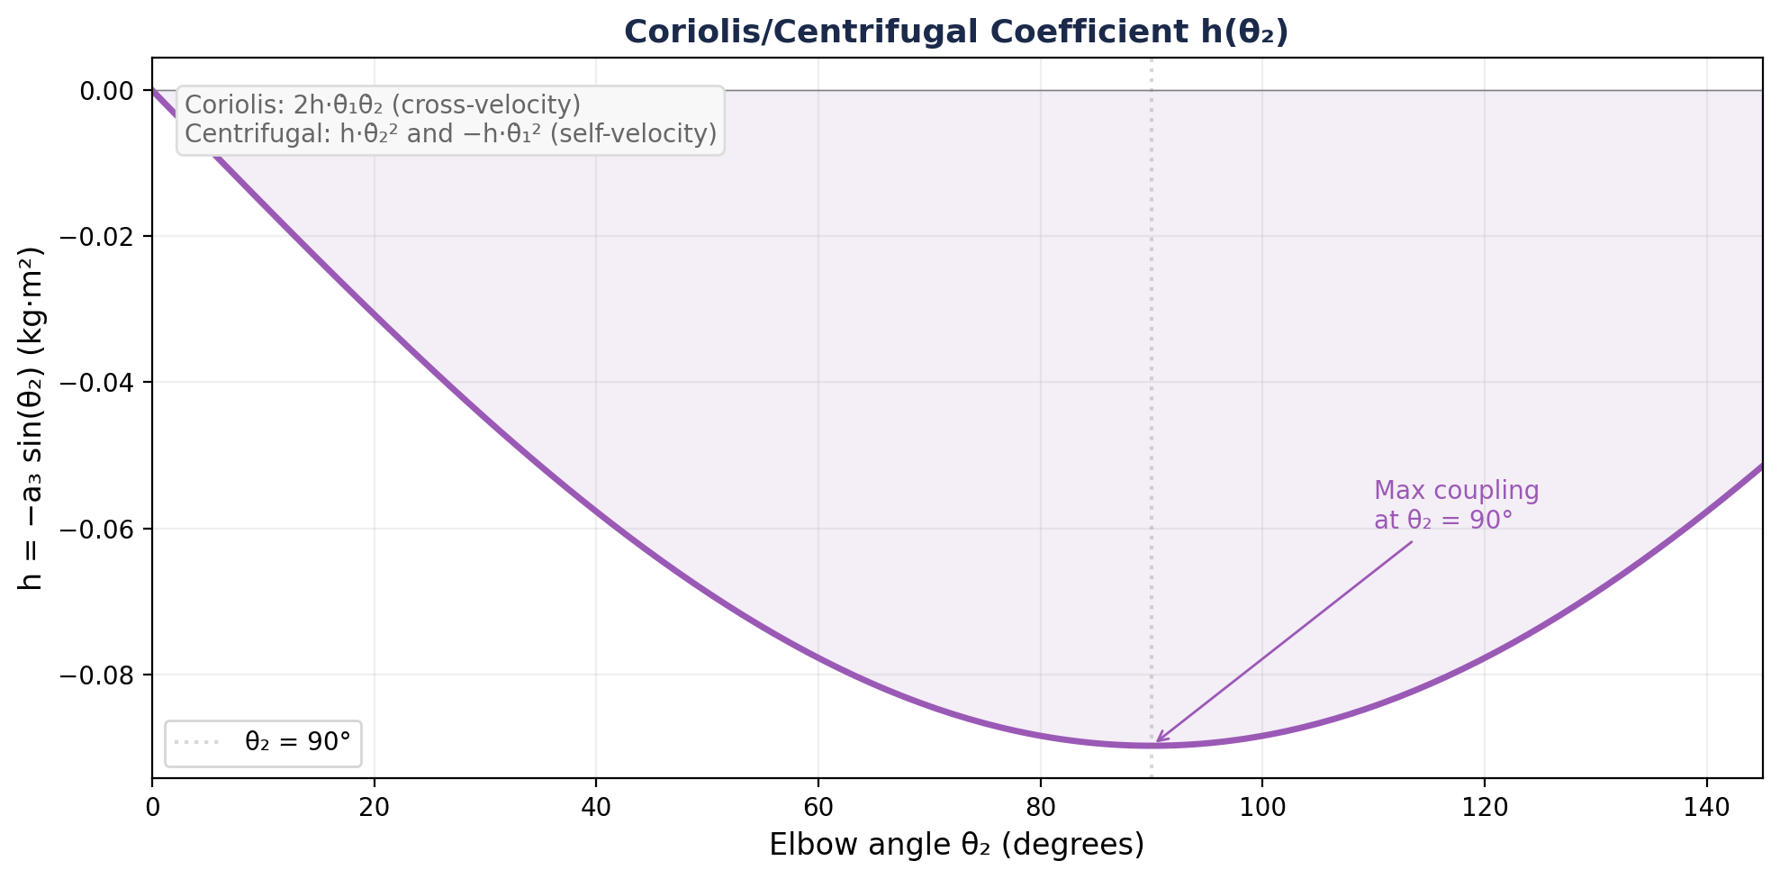
Figure 3. The Coriolis/centrifugal coefficient h(θ₂) = −a₃ sinθ₂. Interaction forces are strongest at θ₂ = 90° and vanish at θ₂ = 0°.

4.3 Compact Matrix Form
In matrix form, we write:
M(q) d²q/dt² = τ − C(q, dq/dt) dq/dt (4.2)
where C encodes the Coriolis and centrifugal terms. Rearranging for the accelerations:
d²q/dt² = M(q)⁻¹ [ τ − C(q, dq/dt) dq/dt ] (4.3)
This is the equation we integrate numerically. At each timestep: given the current state (q, dq/dt) and the muscle torques τ, compute d²q/dt², then update dq/dt and q.

5. Interaction Torques: The Central Challenge
The off-diagonal elements M₁₂ = M₂₁ have a profound consequence: torque at one joint produces acceleration at both joints.
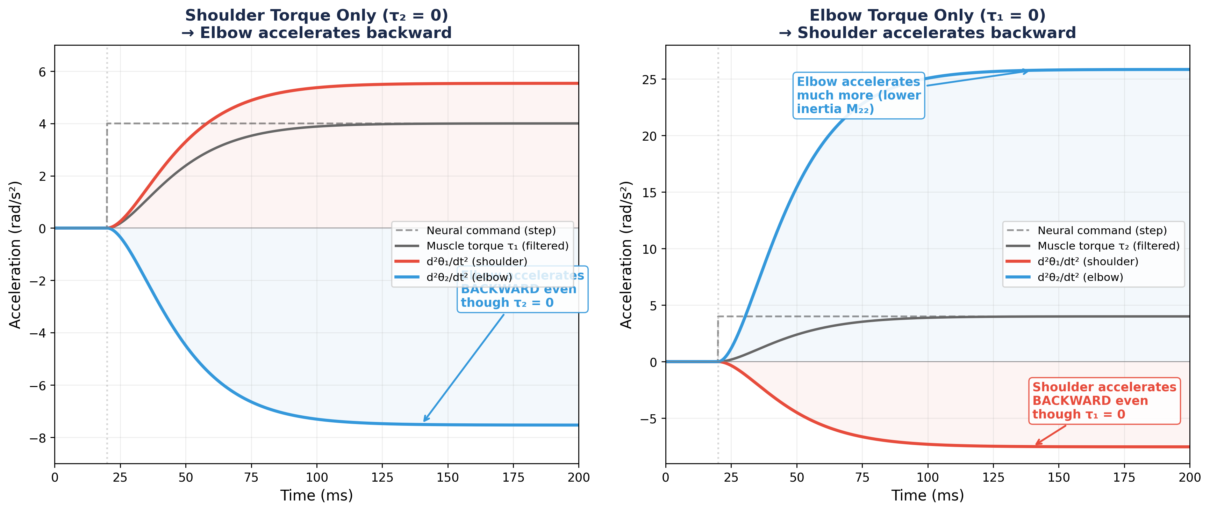
Figure 4. Interaction torques demonstrated with calcium-filtered muscle activation. Left: shoulder torque only — the elbow accelerates backward. Right: elbow torque only — the shoulder accelerates backward. In both cases, the untorqued joint is forced to move by the off-diagonal coupling in M.
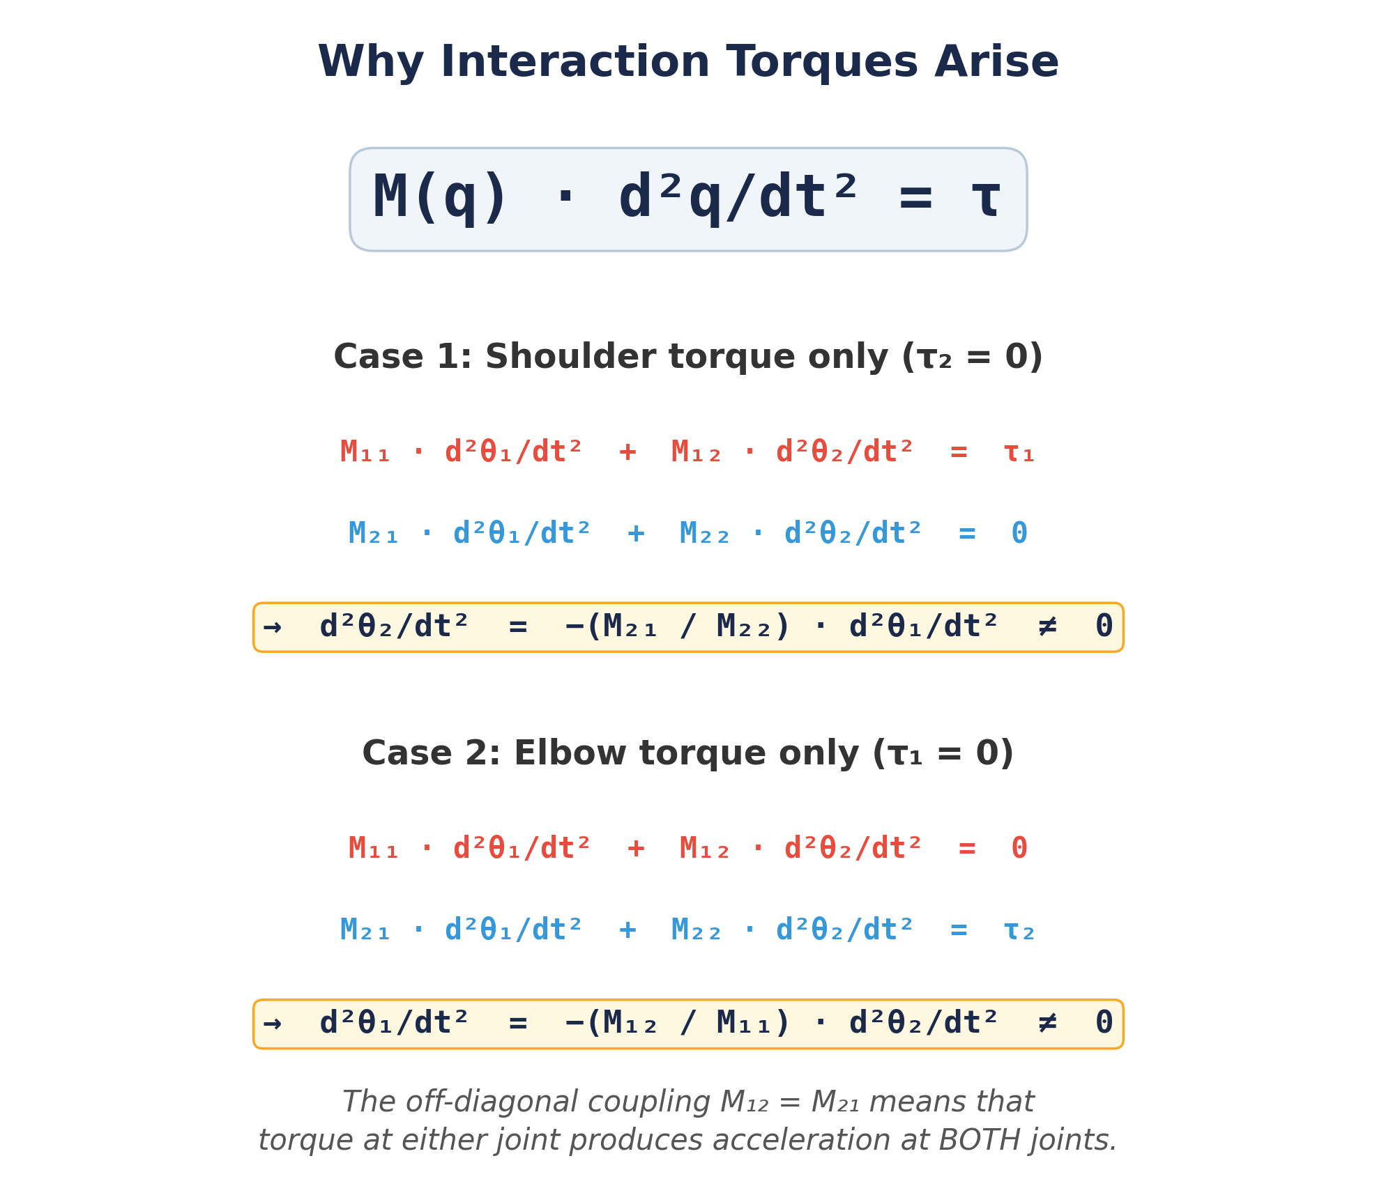
Figure 5. Why interaction torques arise. The off-diagonal elements M₁₂ = M₂₁ couple the two joints: torque at either joint produces acceleration at both.
This is the fundamental reason why multi-joint control is hard. If you want the shoulder to move while the elbow stays still, you cannot simply activate only shoulder muscles. You must also apply a compensatory torque at the elbow to cancel the interaction torque. This compensation requires knowledge of the arm’s dynamics — the mass matrix and the current velocities.
Hollerbach & Flash (1982): The Key Insight
Hollerbach and Flash showed that during normal reaching, the interaction torques at each joint are of the same order of magnitude as the net muscle torques. They are not small perturbations — they are a fundamental part of the dynamics. Any controller that ignores them will produce dramatically wrong movements. This is why the DynamicsEngine is essential: without it, the muscle model from Week 2 cannot predict where the hand actually goes.

5.1 Co-Contraction as a Brute-Force Solution
There is one simple strategy for resisting interaction torques: co-contraction. If you co-contract the muscles at the elbow, the passive stiffness and force-velocity damping resist any displacement caused by the interaction torque from the shoulder. The elbow “locks up” and resists being moved.
This works, but at a cost. Co-contraction increases metabolic energy expenditure and reduces the speed of voluntary movement at the co-contracted joint. It is a brute-force solution: instead of precisely compensating the interaction torque with a targeted muscle command, the system simply stiffens the joint to resist all disturbances.
In Week 4, the λ threshold law will provide a more elegant solution. Because activation depends on muscle length (A = [l − λ]⁺), the λ model automatically generates length-dependent active stiffness that resists perturbations proportionally to their size — without the metabolic cost of full co-contraction. This is one of the key advantages of the equilibrium-point hypothesis over direct activation.

5.2 Demonstrating Interaction Torques: The “Flick” Experiment
In the horizontal plane with no gravity and no muscle activation, an arm at rest stays at rest — nothing drives it. But if someone gives your upper arm a brief push (an initial angular velocity at the shoulder), the interaction torques immediately cause the elbow to move, even though no force was applied there.
Consider the arm starting at rest at θ₁ = 55°, θ₂ = 75°, with an initial shoulder velocity of dθ₁/dt = 2 rad/s and dθ₂/dt = 0. From the equations of motion (Eq. 4.1b), the initial elbow acceleration is:
d²θ₂/dt² = −(M₂₁/M₂₂) · d²θ₁/dt² + h(dθ₁/dt)² / M₂₂ (5.1)
Both terms are nonzero: the coupling term M₂₁ drives the elbow from the shoulder’s acceleration, and the centrifugal term h(dθ₁/dt)² pushes the elbow outward. The result: the shoulder flick drags the elbow along and then the passive muscle springs bring both joints back to rest — a coupled oscillation driven purely by interaction torques.
The reverse experiment is equally revealing: an initial elbow velocity dθ₂/dt = 3 rad/s with dθ₁/dt = 0 causes the shoulder to be dragged along, even though it received no force. The coupling works in both directions because M₁₂ = M₂₁.
In Lab 03, you will simulate both flick experiments and observe the coupled trajectories. This is the most direct demonstration that multi-joint dynamics are fundamentally different from single-joint dynamics: you cannot move one joint without affecting the other.

6. Numerical Integration: RK4
Given d²q/dt² = f(q, dq/dt, τ), we need to integrate forward in time. We use the 4th-order Runge–Kutta (RK4) method, which is the standard workhorse for ODE integration in biomechanics.

6.1 The State Vector
We define the state vector as:
x = [q₁, q₂, dq/dt₁, dq/dt₂] = [θ₁, θ₂, dθ₁/dt, dθ₂/dt] (6.1)
The state derivative is:
dx/dt = [dθ₁/dt, dθ₂/dt, d²θ₁/dt², d²θ₂/dt²] (6.2)
where the accelerations come from Equation 4.3. With 6 muscles, the muscle subsystem adds 12 state variables (M and dM/dt for each muscle), giving a total 16-dimensional state vector.

6.2 RK4 Algorithm
Given state xₙ at time tₙ, the RK4 update is:
k₁ = dt · f(xₙ) (6.3a)
k₂ = dt · f(xₙ + k₁/2) (6.3b)
k₃ = dt · f(xₙ + k₂/2) (6.3c)
k₄ = dt · f(xₙ + k₃) (6.3d)
xₙ₊₁ = xₙ + (k₁ + 2k₂ + 2k₃ + k₄) / 6 (6.4)
For a timestep of dt = 0.0001 s (0.1 ms), RK4 provides excellent accuracy and stability for our system. In Labs 1–2 we used Euler integration for simplicity; from now on we use RK4.
Why Not Euler?
Euler integration (xₙ₊₁ = xₙ + dt·f(xₙ)) is first-order accurate: halving dt halves the error. RK4 is fourth-order: halving dt reduces error by 16×. For the stiff muscle dynamics (fast calcium kinetics τ = 15 ms combined with slow limb dynamics), Euler requires very small timesteps to remain stable. RK4 lets us use larger timesteps, making the simulation faster and more accurate.

7. Connecting the Muscles to the Skeleton
The torque vector τ = [τ₁, τ₂] is the sum of all muscle torques at each joint:
τ₁ = Σᵢ rᵢ,shoulder · Fᵢ (7.1a)
τ₂ = Σᵢ rᵢ,elbow · Fᵢ (7.1b)
where rᵢ is the signed moment arm (from Week 2, Table: 4 cm shoulder extensors, −4 cm flexors, etc.) and Fᵢ is the total force from each muscle’s compute_force method. The muscles use the neural drive gain G = 20 mm introduced in Week 2 to convert dimensionless activations a ∈ [0, 1] to physiologically realistic forces.
The simulation loop at each timestep has two phases:
Phase 1 — Muscle update (once, Euler): The calcium dynamics inside each muscle are integrated with a single Euler step. This is adequate because dt = 0.1 ms is much smaller than the calcium time constant τ = 15 ms.
- For each muscle, compute lᵢ(q) and dlᵢ/dt(q, dq/dt) from the current joint state
- Call compute_force(aᵢ, lᵢ, dlᵢ/dt, dt) to get Fᵢ (this advances the calcium state)
- Sum the torque contributions: τⱼ = Σ rᵢⱼ · Fᵢ
Phase 2 — Kinematic integration (RK4, with τ fixed): RK4 evaluates the derivative function four times per step. If the muscles were called inside that function, their calcium state would advance four times instead of once. Instead, the torque vector τ from Phase 1 is held constant, and RK4 integrates only the kinematic equation d²q/dt² = M(q)⁻¹[τ − C(q,dq/dt)dq/dt].
- Pass the fixed τ to the kinematic derivative function
- Advance [q, dq/dt] with one RK4 step
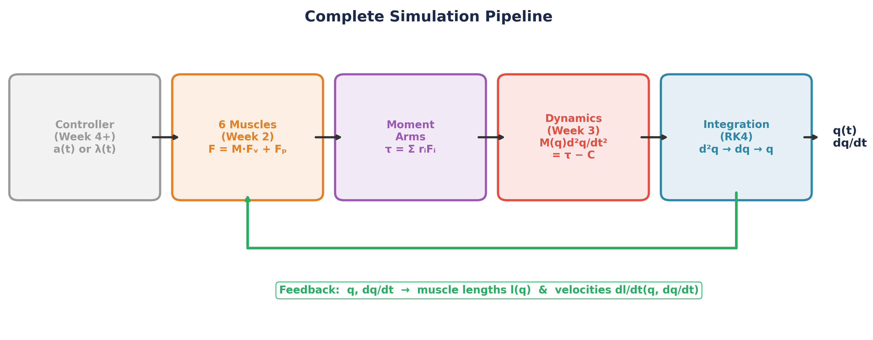
Figure 6. The complete simulation pipeline. The controller sets activations; muscles produce forces; moment arms convert to joint torques; dynamics compute accelerations; integration advances the state. Joint angles and velocities feed back to the muscles.

7.1 Muscle Length and Velocity from Joint State
Each muscle’s length l(q) and velocity dl/dt(q, dq/dt) are computed from the joint angles and velocities using the moment arms:
lᵢ ≈ lᵢ,rest − rᵢ,shoulder · (θ₁ − θ₁,ref) − rᵢ,elbow · (θ₂ − θ₂,ref) (7.2)
dlᵢ/dt = −rᵢ,shoulder · dθ₁/dt − rᵢ,elbow · dθ₂/dt (7.3)
This is a linear approximation using the moment arms. For extensors (constant moment arms), it is exact. For flexors (angle-dependent moment arms), it is accurate over the operating range of our model.

8. The DynamicsEngine Class
In Lab 03, students will build the DynamicsEngine class from scratch. It encapsulates:
- mass_matrix(q) — returns the 2×2 matrix M from Equation 3.6
- coriolis(q, qdot) — returns the 2-vector C(q,dq/dt)dq/dt
- compute_torques(q, qdot, activations) — updates all 6 muscles, sums torques
- derivatives(state, activations) — the dx/dt function for RK4
- step(activations, dt) — advances one RK4 timestep
- simulate(activations_fn, T, dt) — runs a full simulation
The DynamicsEngine holds references to the Arm (Week 1) and the 6 Muscle objects (Week 2). It does not own them — it coordinates them. This modularity means we can swap controllers (Weeks 4–14) without touching the dynamics.
Design Rationale: This is the last class students build from scratch. From Week 4 onward, the tested Arm, Muscle, and DynamicsEngine are provided via the smc package. Students can always read the source, but they don’t have to maintain it.

9. Summary of Key Results
Component | Expression | Reference
Mass-inertia matrix | M(q) [2×2, symmetric] | Eq. 3.6
Inertial constants | a₁=0.253, a₂=0.064, a₃=0.090 | Eq. 3.5
Coriolis/centrifugal | h = −a₃ sinθ₂ | Eq. 4.1
Equations of motion | M(q)d²q/dt² = τ − C(q,dq/dt)dq/dt | Eq. 4.2
Integration | RK4 (dt = 0.1 ms) | Eq. 6.4
State vector | 16D: 4 kinematic + 12 muscle | Eq. 6.1

Next week: We turn on the λ threshold law and let activation emerge from the difference between muscle length and the centrally specified threshold. The DynamicsEngine you build this week is the plant that all future controllers will drive.

