WEEK 7
Signal-Dependent Noise & the Speed-Accuracy Tradeoff
The Fundamental Limit of Feedforward Control
Reading: Harris, C. M., & Wolpert, D. M. (1998). Signal-dependent noise determines motor planning. Nature, 394(6695), 780–784.
Reading: Jones, K. E., Hamilton, A. F. de C., & Wolpert, D. M. (2002). Sources of signal-dependent noise during isometric force production. J. Neurophysiol., 88, 1533–1544.
Reading: Selen, L. P. J., van Dieën, J. H., & Beek, P. J. (2006). Impedance modulation and feedback corrections in tracking targets of variable size and frequency. J. Neurophysiol., 96, 2750–2759.
Supplementary: Woodworth, R. S. (1899). The accuracy of voluntary movement. The Psychological Review: Monograph Supplements, 3(3), i.
Introduction
In Week 6, we compared three open-loop controllers on a semicircular arc task and found that inverse dynamics with a min-jerk trajectory tracked the arc almost perfectly (0.02 cm deviation), while EPH’s best performance was 1.6 cm even after optimizing its R-shift and C parameters. We documented qualitatively different muscle activation patterns: inverse dynamics produced phasic, position-dependent bursts with minimal co-contraction, while EPH produced broad, sustained co-activation. We ended with a promise: both controllers are purely feedforward, and when we add motor noise, both will hit the same fundamental limit.
This week we deliver on that promise. The central idea is signal-dependent noise (SDN): the variability of a motor command scales with its magnitude. Larger forces are noisier forces. Faster movements require larger commands and are therefore less accurate. This single principle produces the speed-accuracy tradeoff, explains why movements are smooth, and predicts Fitts’ Law — all without any free parameters beyond the noise coefficient.
The Task
We stay on the same 6 cm semicircular arc from Week 6 (R = 6 cm, Q_REF start, T = 800 ms default) so that students can directly compare the noisy results in this week with the deterministic results from Week 6. The arc is the primary task for §2–3 and §5. We switch to center-out reaching only for Fitts’ Law (§4), where the distance and target width must be varied independently, and for the submovement simulation (§6), where endpoint accuracy on a straight reach is the clearest demonstration.

1. Signal-Dependent Noise
Every motor command the nervous system generates is corrupted by noise. Motor unit recruitment is probabilistic, synaptic transmission is variable, and the force output of a muscle fluctuates from moment to moment even when the descending drive is held constant. The critical observation, established by Schmidt et al. (1979) for rapid isometric contractions and confirmed by Jones, Hamilton, and Wolpert (2002) at the level of motor unit discharge, is that this noise is not constant — it scales with the magnitude of the command. Larger forces are produced with proportionally greater variability.
Harris and Wolpert (1998) formalized this as signal-dependent noise (SDN). For a motor command u(t), the actual executed command is:
u_executed(t) = u(t) + k · |u(t)| · ε(t)

where ε(t) ~ N(0, 1) and k is the noise coefficient
The Neurophysiological Basis
Why does motor noise scale with command magnitude? Jones, Hamilton, and Wolpert (2002) traced the answer to the biophysics of motor unit recruitment. During voluntary force production, the nervous system recruits motor units in order of increasing size (Henneman’s size principle) and modulates their firing rates. Each motor unit’s discharge timing has a coefficient of variation of approximately 15–25% — the action potentials are not perfectly periodic. As the target force increases, the nervous system must recruit more motor units and drive them at higher rates. Both processes add independent sources of timing variability to the aggregate force output. The result: the standard deviation of force fluctuations scales approximately linearly with mean force, producing the constant coefficient of variation (CV = SD/mean) that is the empirical signature of signal-dependent noise.
Jones et al. measured this directly in isometric elbow flexion across a range of target forces and confirmed that the force SD–mean relationship is linear, with a slope (the noise coefficient) of approximately 1–2% for isometric contractions. The value we use in our simulations (k = 0.15 for dynamic reaching) is higher than the isometric value because dynamic movements involve additional noise sources: time-varying muscle lengths, changing moment arms, and multi-joint coordination all amplify the variability relative to single-joint isometric conditions.
The noise standard deviation is k · |u(t)| — proportional to the absolute command magnitude. When the command is zero, the noise is zero. When the command is large, the noise is large. This single feature — multiplicative rather than additive noise — is the engine that drives everything in this week’s lecture.
For the inverse dynamics controller, the motor command is a 2D torque vector τ = (τ₁, τ₂) computed at each timestep. Signal-dependent noise is added to each component independently:
τ_executed(t) = τ(t) + k · |τ(t)| · ε(t)

where ε(t) ~ N(0, I₂) and the multiplication is element-wise
For all simulations in this week, we use a noise coefficient k = 0.15. The noise is applied at every integration timestep (dt = 1 ms) as independent Gaussian draws.
Why Multiplicative, Not Additive?
If motor noise were constant (additive), then a slow movement and a fast movement to the same target would have the same endpoint variability — the noise would be the same regardless of command magnitude. This contradicts everyday experience: fast movements are less accurate than slow ones. Constant noise also cannot produce Fitts’ Law or the speed-accuracy tradeoff. Signal-dependent (multiplicative) noise is the minimal assumption that explains all of these phenomena from a single mechanism.

Signal-Dependent Noise Also Affects EPH
In EPH, the brain specifies a target posture R = (q₁*, q₂*) and a co-contraction level C. Signal-dependent noise on these three channels propagates through the moment arm geometry to produce correlated noise across all six muscles. A noisy shoulder command perturbs all shoulder muscles coherently; biarticular muscles like BicS and TriLg receive noise from both joints. The muscle dynamics — calcium filter (τ = 15 ms), force-velocity relationship, passive springs — provide partial noise filtering that inverse dynamics, which specifies torques directly and bypasses the muscles, does not have access to. This filtering is a consequence of where EPH sits in the motor hierarchy: it commands thresholds and works through the muscles, while ID commands torques and works around them. But the fundamental limit is the same for both: feedforward control cannot correct errors it does not sense. The detailed EPH-under-noise analysis is deferred to Week 11 (The Duel). Figure 1 demonstrates the R&C noise model on two example reaches.

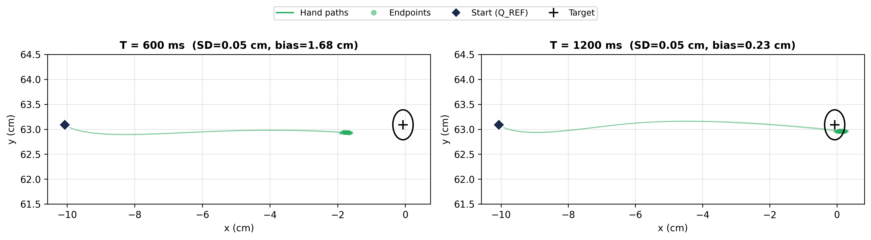
Figure 1. EPH with R&C-level signal-dependent noise on a 10 cm center-out reach at two speeds. Left: T = 600 ms. Right: T = 1200 ms. Green dots show 200 endpoints; green lines show 30 hand paths. The endpoint cluster is tight (SD ≈ 0.05 cm, reflecting the muscle dynamics’ noise filtering) but biased from the target (bias = 1.68 cm at 600 ms, 0.23 cm at 1200 ms — the deterministic dynamics lag from Week 6). Start (diamond) and target (circle) are marked.

2. Noisy Inverse Dynamics on the Arc
We now apply the SDN model to the inverse dynamics controller on the same 6 cm semicircular arc from Week 6. The pipeline computes the required joint torques τ(t) = M(q)·q̈ + C(q,q̇) at every timestep along a min-jerk arc trajectory. The same noise model from §1 applies:
τ_executed(t) = τ_arc(t) + k · |τ_arc(t)| · ε(t)

where τ_arc(t) is the ID torque profile computed for the min-jerk arc trajectory
Each trial is a full forward simulation of the arm dynamics with noisy torques. We run 200 Monte Carlo trials at T = 800 ms.
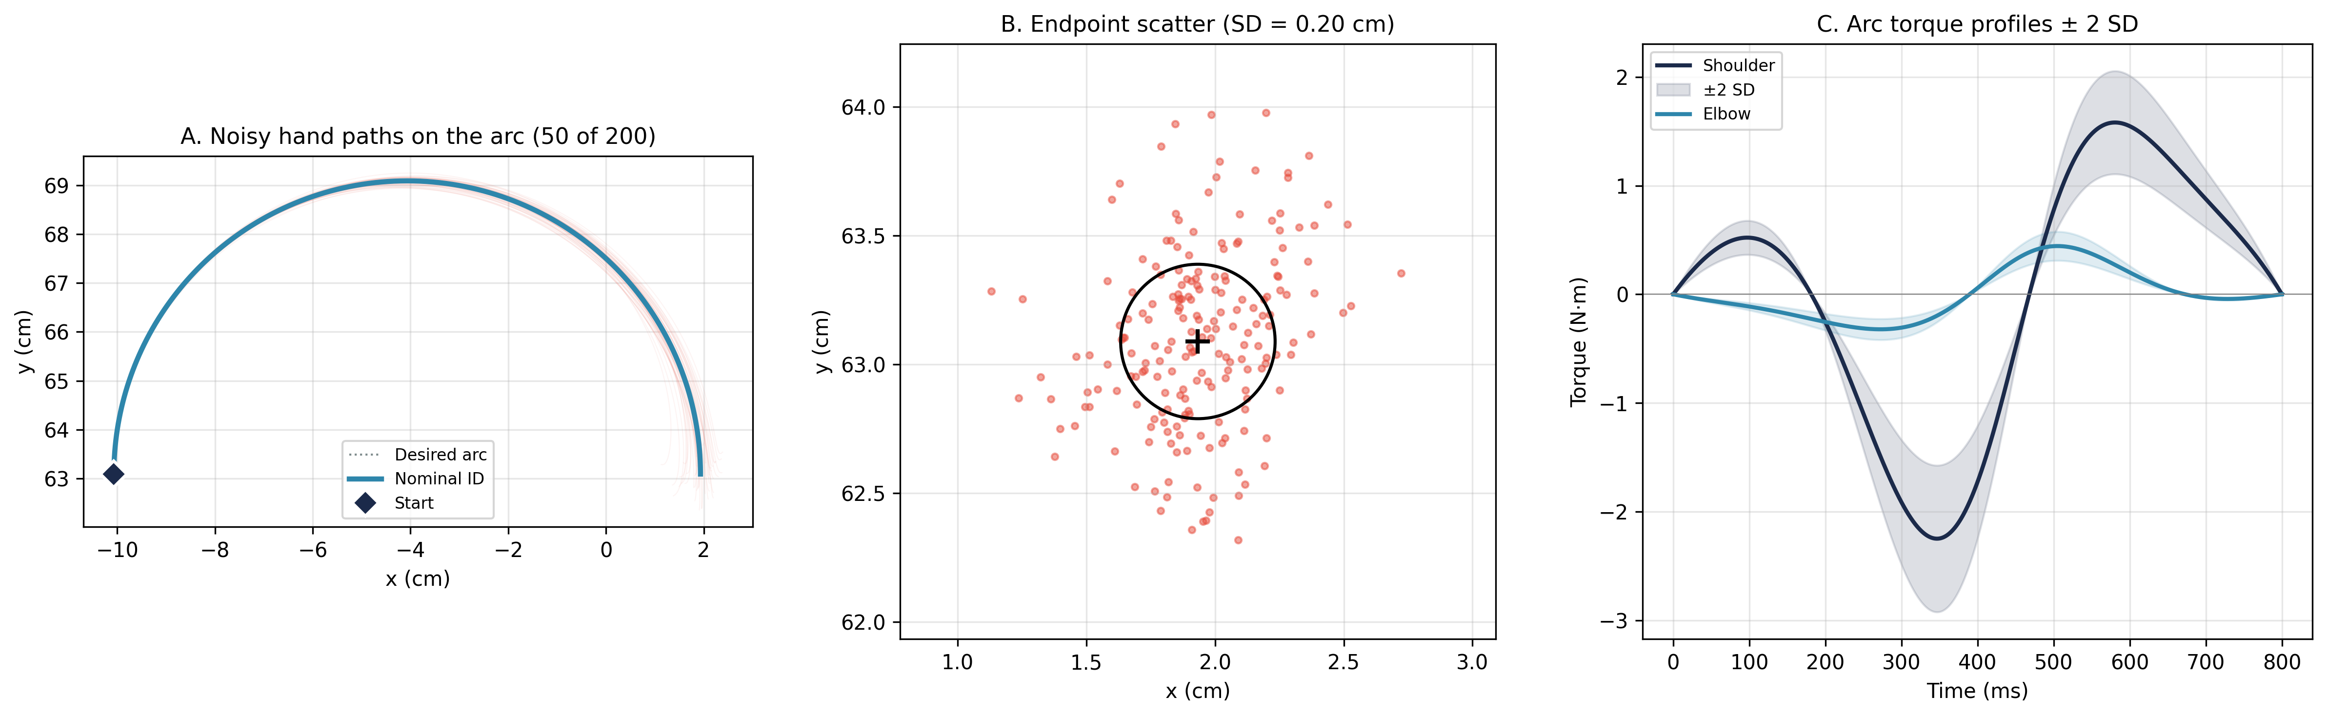
Figure 2. Noisy inverse dynamics on the 6 cm arc (T = 800 ms, k = 0.15). A: 50 noisy hand paths (red) overlaid on the desired arc (gray dotted) and nominal ID trajectory (teal). Start position marked with diamond. B: Endpoint scatter (SD = 0.20 cm) — 200 final hand positions around the arc endpoint. C: Shoulder and elbow torque profiles with ±2 SD noise envelopes. The envelopes track the torque magnitude — widest during the deceleration phase where the arc torques are largest.
Three features of Figure 2 deserve attention. First, the noise fan in Panel A is narrow at the start of the arc and widens toward the endpoint. Noise accumulates along the trajectory: every timestep adds an independent perturbation, and without any corrective mechanism, these perturbations compound. Second, the endpoint scatter in Panel B is centered on the arc endpoint with SD = 0.20 cm — larger than the center-out reach (0.08 cm at the same speed) because the arc trajectory involves larger torques over a longer path. Third, the torque envelopes in Panel C show that the shoulder carries much larger torques (peak ∼2.2 N·m) than the elbow, and the noise envelope scales accordingly.
The noise envelope is widest where the torques are largest — during the deceleration phase of the arc. This is signal-dependent noise in action: the controller works hardest precisely when it is least precise.

3. The Speed-Accuracy Tradeoff
The critical experiment: we vary the movement time from 400 ms (fast) to 1200 ms (slow) in 200 ms steps on the same 6 cm arc, running 200 noisy ID trials at each speed.
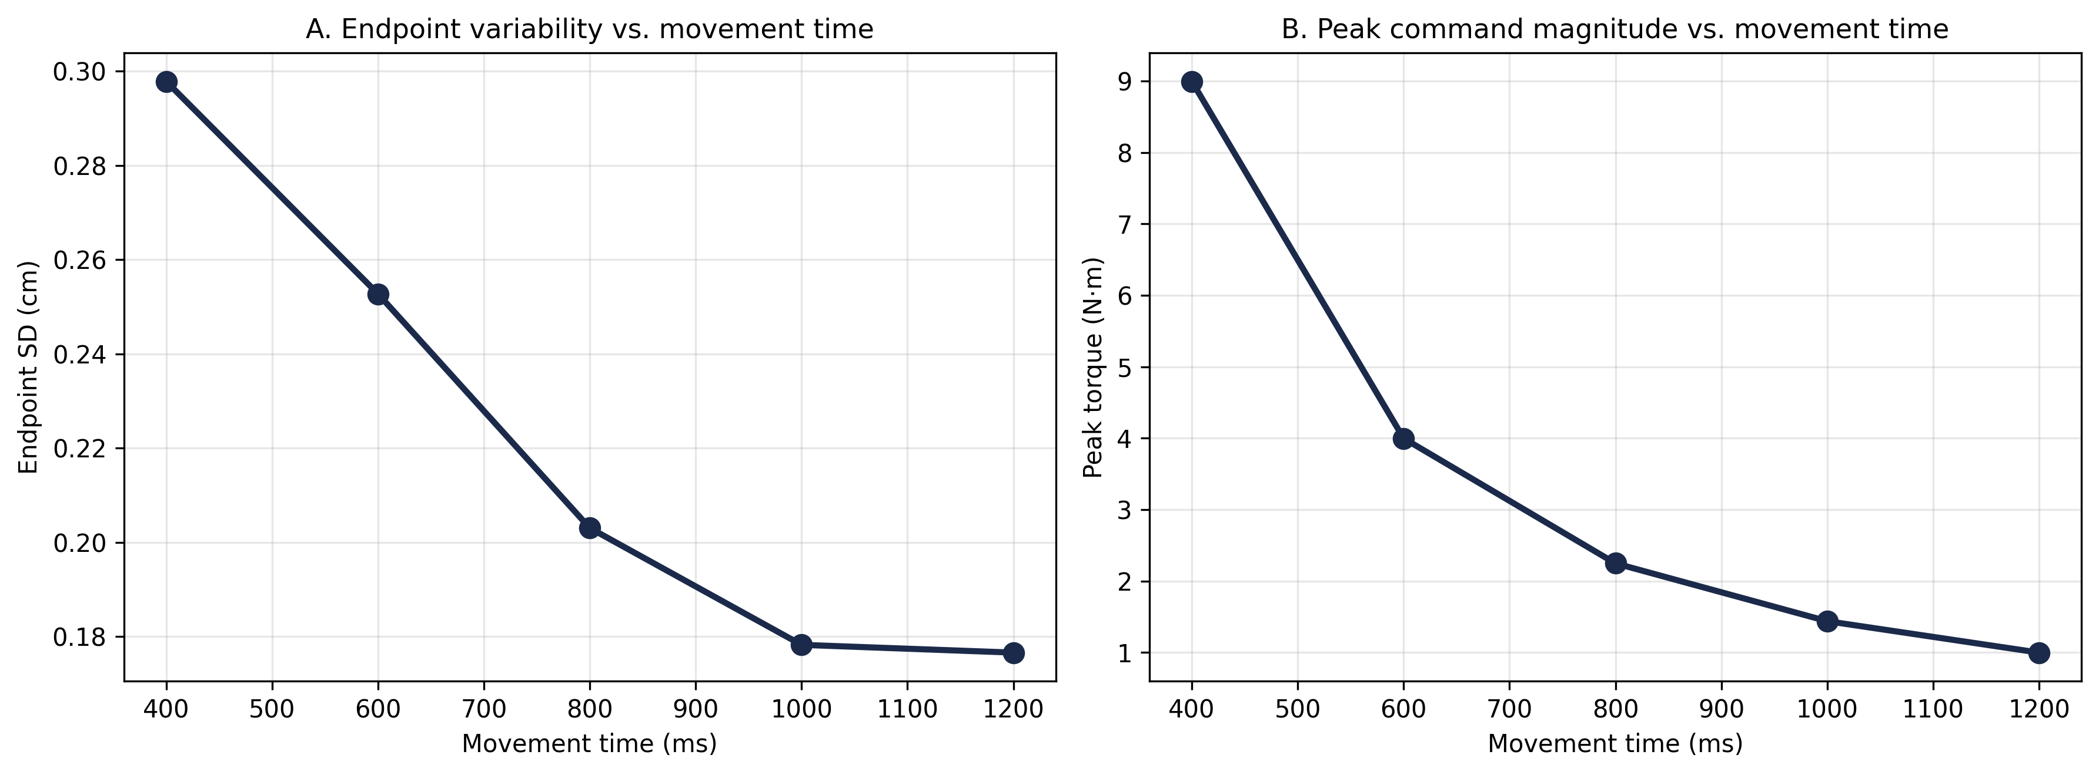
Figure 3. Speed-accuracy tradeoff on the 6 cm arc. A: Endpoint SD vs. movement time, declining from 0.30 cm at 400 ms to 0.18 cm at 1200 ms. B: Peak torque vs. movement time. The inertial term Mq̈ scales roughly as 1/T², driving the noise increase at faster speeds.
Figure 3A shows the classic speed-accuracy tradeoff: faster arc movements produce more endpoint variability. The mechanism is in Panel B: faster movements require larger torques because the inertial term Mq̈ scales approximately as 1/T². Since noise is proportional to torque magnitude, faster movements produce proportionally more noise, which propagates through the dynamics to produce wider endpoint scatter.
For min-jerk: peak acceleration scales as 1 / T-squared
Peak torque scales as 1 / T-squared (inertial term dominates)
Endpoint variance scales as 1 / T-to-the-fourth before filtering
After integration through dynamics: endpoint SD scales as 1 / T
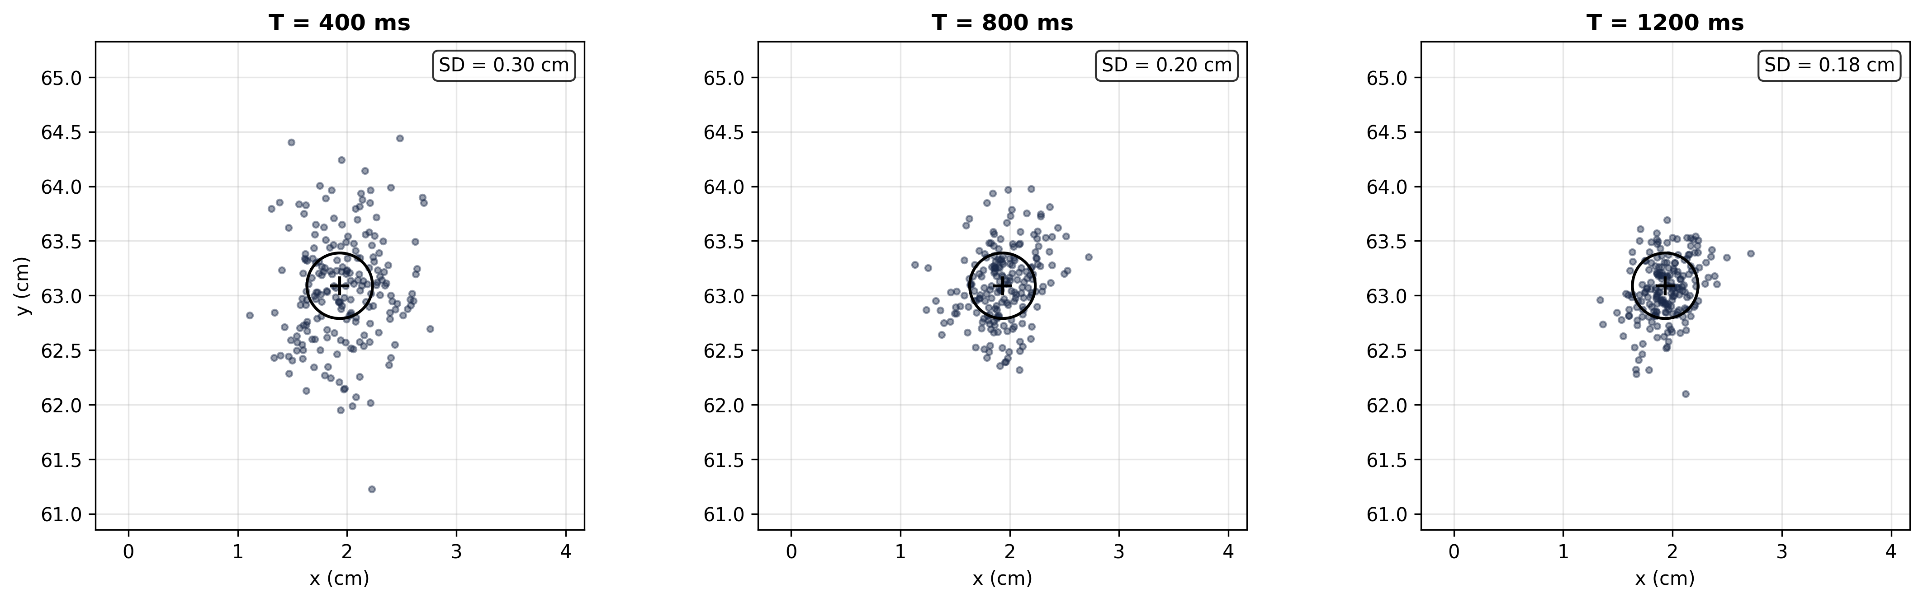
Figure 4. Endpoint scatter at three arc speeds (400, 800, 1200 ms). All panels share the same axis scale; black circle = 0.6 cm diameter reference. The cloud visibly contracts from left to right (0.30 → 0.20 → 0.18 cm SD).
Figure 4 makes the speed-accuracy tradeoff visual. At 400 ms (left panel), the scatter cloud is large and many endpoints fall well outside the reference circle. At 1200 ms (right panel), the cloud has contracted substantially. The same arc, the same noise coefficient — only the speed has changed.
The speed-accuracy tradeoff is not a property of any particular controller — it is a consequence of signal-dependent noise applied to any feedforward system. Faster movements require larger commands, which are noisier, which produce less precise endpoints.

4. Fitts’ Law and Minimum-Variance Theory
Fitts (1954) documented the most robust quantitative law in motor control: the time required to reach a target scales logarithmically with the ratio of movement distance to target width. Movement time MT = a + b · log₂(2D/W), where D is the distance and W is the target width. The quantity log₂(2D/W) is called the Index of Difficulty (ID, in bits).
Harris and Wolpert’s (1998) contribution was to show that Fitts’ Law is a natural consequence of signal-dependent noise combined with the requirement to hit the target:
Endpoint SD is proportional to peak torque, which is proportional to D / T-squared
To achieve 95% hits: SD must be less than W / 4
Solving for T gives: T is proportional to sqrt(D) / sqrt(W)
This yields: MT is proportional to log2(D/W) (Fitts' Law)
We switch from the arc to center-out reaching for this section because Fitts’ Law requires varying distance D and target width W independently, which is natural for straight reaches but not for arc tracking. The same plant and noise model apply; only the trajectory changes.
Smooth Trajectories Minimize Noise
If endpoint variance is proportional to the square of the peak motor command, then the variance-optimal trajectory is the one that minimizes the peak command. Among all trajectories that move the hand from A to B in time T, the one with the lowest peak acceleration is the minimum-jerk trajectory. This is Harris and Wolpert’s central claim: smoothness is not merely aesthetic — it is a noise-minimization strategy. We compare the min-jerk trajectory against a constant-velocity trajectory with 10% raised-cosine ramps.
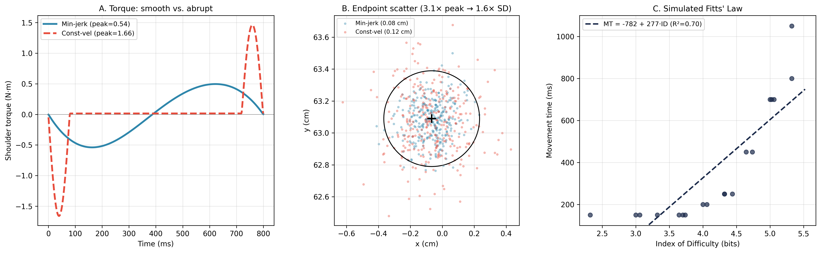
Figure 5. Minimum-variance theory and Fitts’ Law. A: Shoulder torque for min-jerk (teal) vs. constant-velocity with 10% ramps (red dashed). The abrupt profile concentrates acceleration into brief phases, producing higher peak torque. B: Endpoint scatter from 300 trials — the abrupt trajectory produces substantially more variability. C: Simulated Fitts’ Law — minimum movement time to achieve 95% hit rate for various distance/width combinations.
Panel A shows the torque difference: the min-jerk trajectory distributes acceleration smoothly, while the constant-velocity profile concentrates it in the first and last 10% of the movement. Panel B shows the consequence: higher peak torques produce more endpoint scatter.
Simulating Fitts’ Law
Panel C demonstrates that the simulated data obey Fitts’ Law. For each combination of distance D and target width W, we find the minimum movement time:
For each (D, W): find minimum T such that
P( ||hand_final - target|| < W/2 ) ≥ 0.95
over N = 50 Monte Carlo trials with k = 0.15
We test distances D from 5 to 16 cm and target widths W from 3 to 20 mm. The approximately linear relationship on semi-log axes is consistent with Fitts’ empirical law.
Note that minimum-variance theory explains why movements are smooth for point-to-point reaching. For continuous path-tracking tasks like the arc, the optimal trajectory would need to minimize integrated path variance at every instant — a harder optimization that Harris and Wolpert did not solve. Optimal feedback control (Todorov & Jordan 2002) solves this generalization by incorporating signal-dependent noise directly into the cost function, penalizing both endpoint variance and integrated control effort along the entire trajectory (Week 12).

5. Activation Variability on the Arc
We return to the 6 cm arc to ask: where does the noise hit in muscle space? Figure 6 shows the full 200-trial noise fan, emphasizing how the noise accumulates along the path — the hand paths are tightly bundled at the start and diverge progressively toward the endpoint.
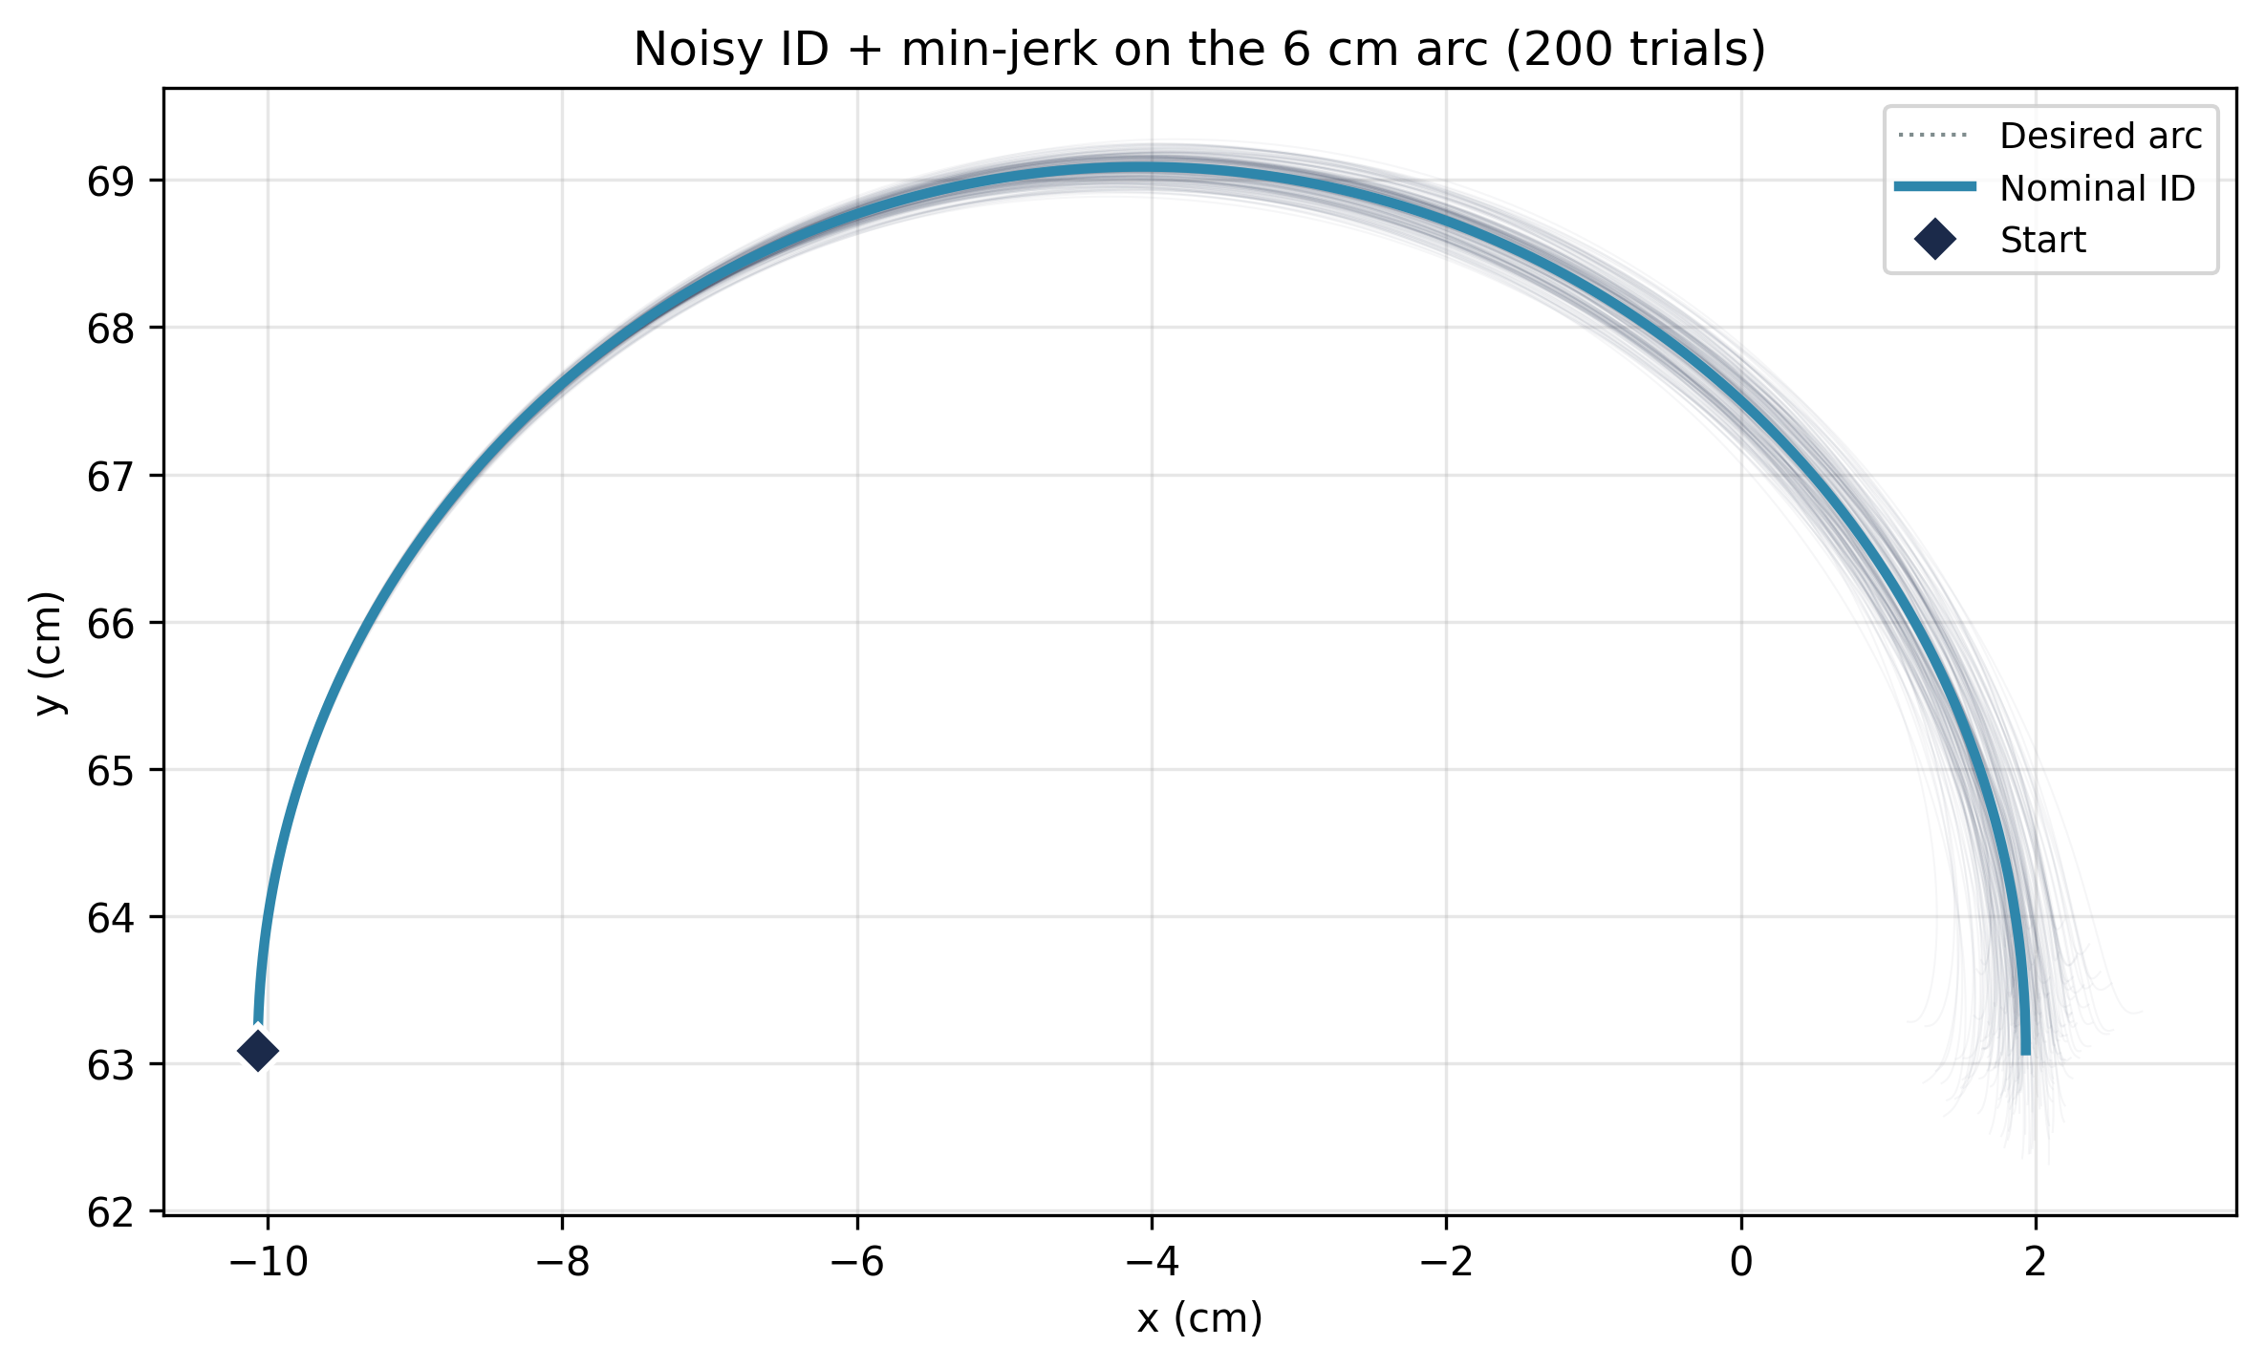
Figure 6. Noisy ID + min-jerk on the 6 cm arc (200 trials). The noise fan widens progressively from start to endpoint. The hand paths diverge most in the final third of the arc, where the deceleration torques are largest.
Since the inverse dynamics controller specifies joint torques, not muscle activations, we map the torque noise into muscle space via the moment arm matrix. For each muscle i, the activation noise SD at time t is:
noise_SD_i(t) = |r_sh_i| · k · |τ_sh(t)| + |r_el_i| · k · |τ_el(t)|

where r_sh_i and r_el_i are the shoulder and elbow moment arms of muscle i
This is not a static optimization — it is a direct linear mapping from the joint-level noise through the moment arm geometry. Each muscle’s noise burden is proportional to its moment arm times the torque noise at the corresponding joint.
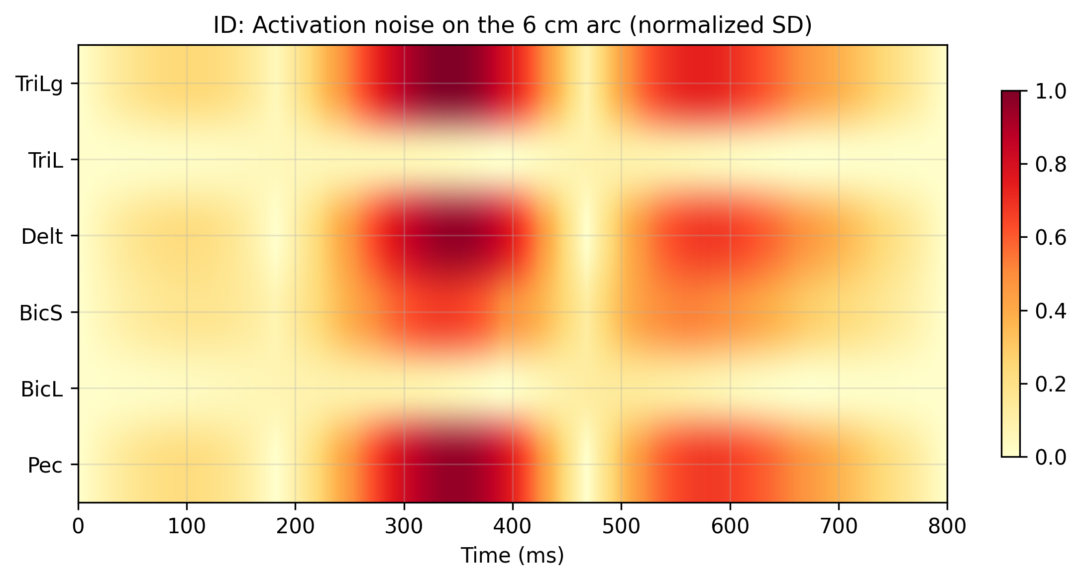
Figure 7. Activation noise on the 6 cm arc (ID controller). The noise at each muscle is proportional to its moment arm times the joint torque noise. Shoulder muscles (Pec, Delt, TriLg) carry concentrated noise bursts at the arc phases where their torque contribution is greatest. Elbow-only muscles (BicL, TriL) are relatively quiet. The pattern mirrors the deterministic activation pattern from Week 6 Figure 9.
Figure 7 extends the Week 6 activation comparison into the noisy regime. The shoulder muscles (Pec, Delt, TriLg) show concentrated noise bursts at specific arc phases, while the elbow-only muscles (BicL, TriL) are relatively quiet. This is a direct consequence of signal-dependent noise — the muscles that work hardest are the noisiest.

6. Submovements — The First Hint of Feedback
The simulations in §2–5 show what happens when a feedforward controller fires its motor command and accepts the result. The controller has no mechanism to detect that the hand has drifted off course, and no mechanism to correct the drift. Humans do not behave this way.
Woodworth (1899) identified two phases of goal-directed movement over a century ago: an initial ballistic impulse that carries the hand most of the distance to the target, and a corrective phase in which the hand is guided to the target using sensory feedback. The corrective phase is visible in kinematic records as submovements — brief, discrete adjustments that appear as oscillations in the velocity profile.
Simulating Intermittent Feedback
To demonstrate the effect of submovements, we build a simple intermittent feedback controller on a 10 cm center-out reach. The controller runs the standard noisy ID feedforward command for a fast primary movement (T = 500 ms, which produces SD = 0.13 cm). After the primary movement ends, the controller waits 150 ms (a realistic sensory delay for visual feedback), senses the current hand position, computes the error relative to the target, and plans a short corrective min-jerk from the current position to the target (duration 150 ms). The correction is executed with the same signal-dependent noise model. A second correction can follow after another 150 ms sensory delay.
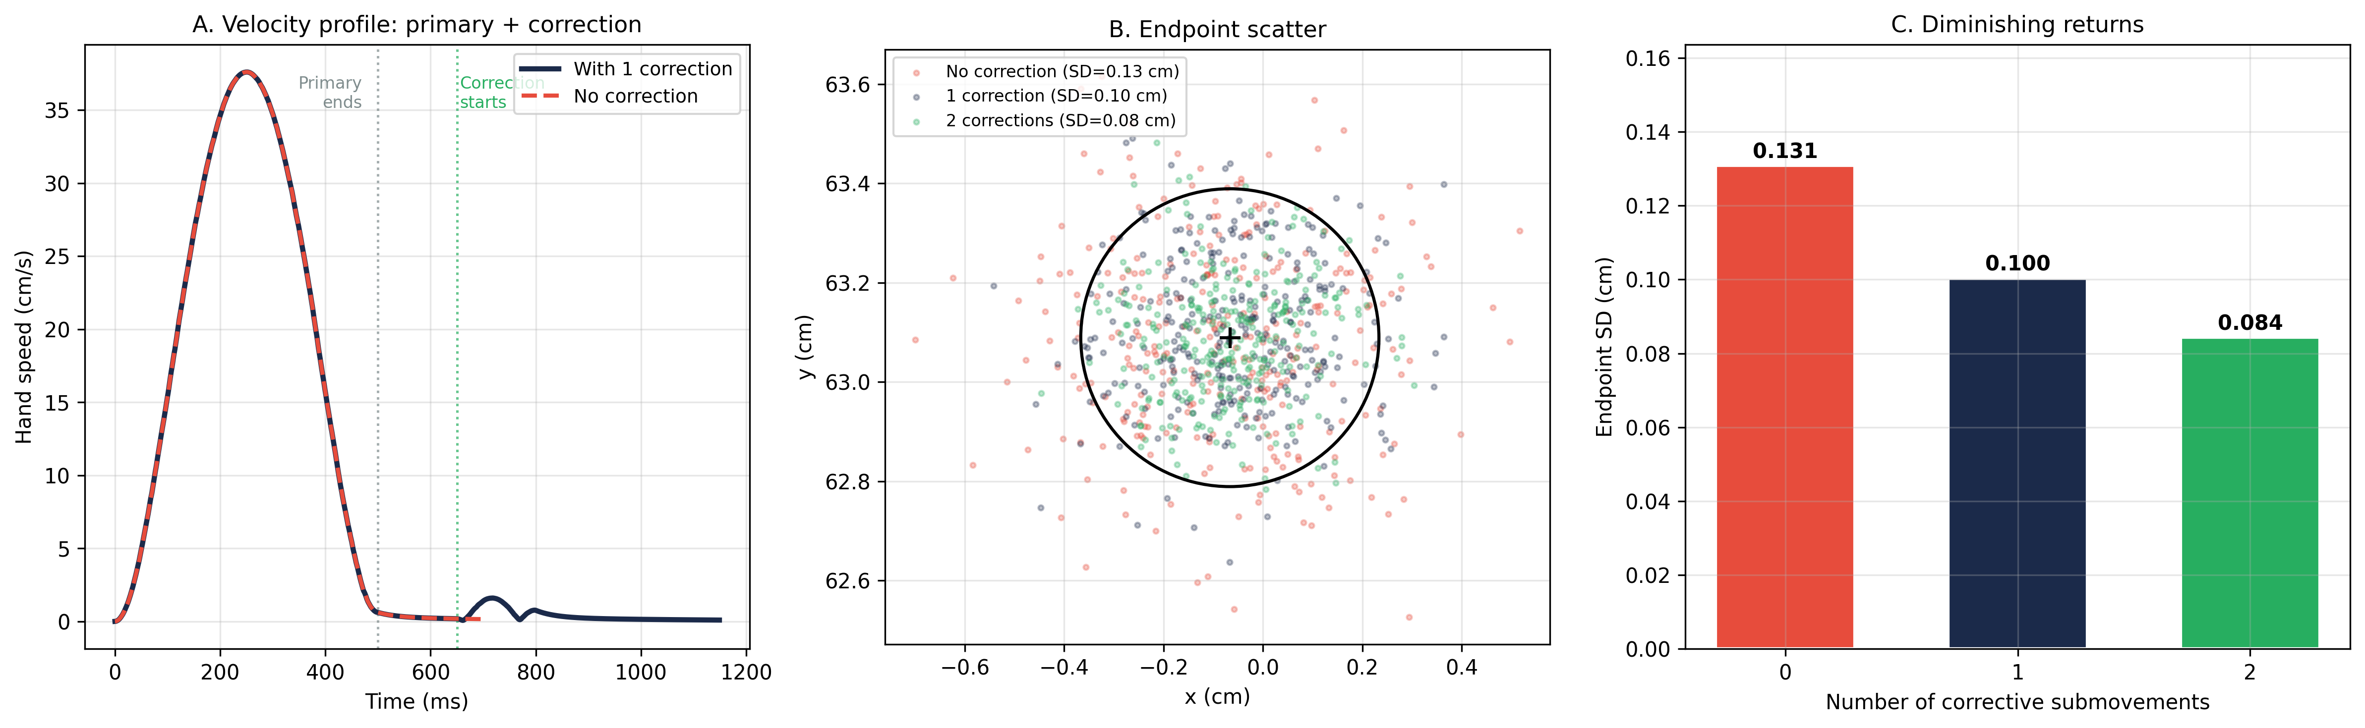
Figure 8. Intermittent feedback corrections on a 10 cm center-out reach (primary T = 500 ms). A: Hand speed profile for a single trial. Red dashed = no correction (primary only); navy = with one corrective submovement. The correction produces a second, smaller velocity peak after the 150 ms sensory delay. B: Endpoint scatter for 300 trials with 0, 1, or 2 corrections. Each correction tightens the cloud. C: Endpoint SD decreases from 0.131 to 0.100 to 0.084 cm — a 24% reduction with the first correction, but diminishing returns thereafter because each correction is itself noisy.
Figure 8A shows the characteristic two-phase velocity profile that Woodworth described: a large primary peak followed by a smaller corrective peak after the sensory delay. Figure 8B shows that each correction tightens the endpoint scatter cloud. Figure 8C quantifies the diminishing returns: the first correction reduces SD by 24%, but the second adds only an additional 16% improvement. Each correction is itself subject to signal-dependent noise, so corrections cannot eliminate variability entirely.
Selen et al. (2006): Two Strategies for Accuracy
Selen et al. (2006) quantified both feedforward and feedback strategies during a single-joint tracking task. Subjects tracked a sinusoidally moving target by moving their forearm. Three target sizes and three movement frequencies were tested, and mechanical perturbations were applied to estimate joint stiffness and damping.
Impedance modulation (feedforward): Joint stiffness and damping increased with smaller targets, independent of movement frequency. Higher impedance acts as a low-pass filter on neuromuscular noise — co-contraction attenuates the kinematic effects of noisy motor commands. This is precisely the mechanism that EPH provides through its threshold law: agonist-antagonist co-activation increases joint stiffness automatically. The Selen et al. result reframes the co-contraction we observed in Week 6 §7 — what we characterized as a difference between the controllers is actually a noise-management strategy that humans actively deploy.
Submovement corrections (feedback): Subjects made corrective submovements throughout the tracking task, quantified as speed pulses in the velocity profile. The gain of these submovements increased with smaller targets and faster movements. Critically, submovement duration remained constant — the nervous system scaled the amplitude of its corrections, not their frequency. This is consistent with SDN: smaller targets and faster speeds produce larger errors, which necessitate larger corrections.
The key result is that impedance modulation and submovement corrections contribute additively to tracking accuracy. The nervous system deploys both simultaneously, each addressing a different aspect of the noise problem.
Two Strategies for Accuracy
Impedance modulation filters noise before it reaches the kinematics (feedforward). Submovements correct errors after they occur (feedback). The feedforward strategy is limited by the impedance paradox: co-contraction increases stiffness but also increases force, which increases noise. The feedback strategy is limited by sensory delays and its own noise, producing diminishing returns (Figure 8C). The optimal combination — how much to stiffen, when to correct, and how to balance the costs of noise, stiffness, and delay — is the central problem of optimal feedback control (Week 12).

7. The Feedforward Limit & Looking Ahead
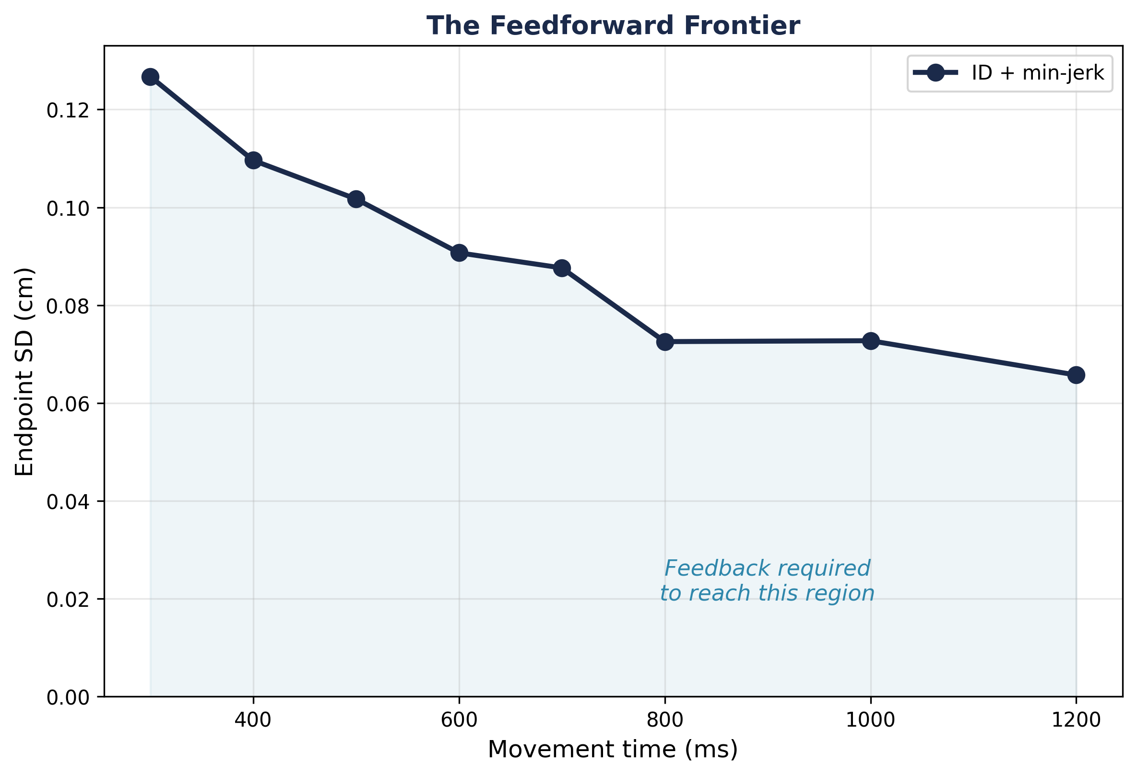
Figure 9. The feedforward frontier. Endpoint SD vs. movement time for the ID controller on 10 cm center-out reaches. Below this curve lies a region inaccessible to any feedforward controller without sensory feedback. Slower movements reduce the frontier, but cannot eliminate it — the curve approaches a noise floor set by the minimum command magnitude required to move the arm.
Figure 9 captures the central message of Week 7. The inverse dynamics controller traces a descending curve through the speed-accuracy plane: the faster the movement, the noisier the endpoint. Below this curve lies a region that no feedforward controller can reach without additional information about the state of the arm.
Summary of Key Results
Property | Value / Result
Noise model | SDN: σ = k · |τ|, k = 0.15
Arc endpoint SD (800 ms) | 0.20 cm
Arc speed-accuracy range | 0.30 cm (400 ms) → 0.18 cm (1200 ms)
Min-jerk vs. abrupt trajectory | Smooth trajectory produces less scatter
Simulated Fitts’ Law | Linear on semi-log axes (center-out)
Arc noise pattern | Concentrated at torque peaks; grows toward endpoint
1 corrective submovement | SD: 0.131 → 0.100 cm (24% reduction)
2 corrective submovements | SD: 0.131 → 0.084 cm (diminishing returns)
Feedforward frontier | ~0.07 cm at 1200 ms (irreducible without feedback)

Looking Ahead
This week established three key results. First, signal-dependent noise produces the speed-accuracy tradeoff as a direct consequence of inertial torque scaling (§3). Second, smooth trajectories minimize noise by minimizing peak commands, and Fitts’ Law emerges naturally from the requirement to hit a target of finite width (§4). Third, the feedforward frontier defines a hard limit on endpoint accuracy that can only be broken by sensory feedback (§6–7).
To get below the frontier, the system needs to sense its own errors and issue online corrections. That is the subject of Module 3 (Weeks 8–11). Week 8 introduces the visual system and the challenges of sensory delay. Week 9 builds the proprioceptive pathway. Week 10 combines them into an optimal state estimator (the Kalman filter). And Week 11 — The Duel — tests EPH, an upgraded EPH with feedback, and inverse dynamics under perturbation on the same plant, using the noise signatures documented this week as the baseline predictions.
The feedforward frontier is not a property of any particular controller — it is the unavoidable consequence of signal-dependent noise applied to any open-loop system. Below the frontier lies a region accessible only to controllers that sense, estimate, and correct. Building those controllers is the work of the next four weeks.

