COMPUTATIONAL SENSORIMOTOR CONTROL

WEEK 2 LECTURE NOTES
Muscle Mechanics: The Actuators
Module 1: The Biological Plant | Fall 2026

Learning Objectives for This Week
By the end of this week, you should be able to:
- Situate the Gribble model within the muscle-modelling landscape — cross-bridge, Hill-type, and simplified Hill variants — and justify the simplifications this course adopts.
- Describe the 6-muscle arrangement (Gribble et al. 1998): 4 mono-articular + 2 bi-articular muscles, their joint actions, and moment arm geometry.
- Implement the exponential force-length relationship: M̃ = ρ[exp(cA) − 1] and explain the role of the recruitment parameter c.
- Implement the sigmoidal force-velocity relationship and explain why lengthening contractions produce more force than shortening contractions.
- Implement the second-order calcium kinetics filter and explain why muscle force cannot change instantaneously.
- Describe passive elasticity and its role in stabilizing the limb at rest.
- Specify all parameter values from their empirical sources and explain the rationale for each.
Required Reading
- Zajac, F. E. (1989). Muscle and tendon: properties, models, scaling, and application to biomechanics and motor control. Critical Reviews in Biomedical Engineering, 17(4), 359–411.
Required Reading (implementation reference):
- Gribble, P. L., et al. (1998). Are complex control signals required for human arm movement? J. Neurophysiol., 79(3), 1409–1424. Sections: Arm Model and Muscle Model, pp. 1410–1411.
Supplementary (for context):
- Kistemaker, D. A., Van Soest, A. J., & Bobbert, M. F. (2006). Is equilibrium point control feasible for fast goal-directed single-joint movements? J. Neurophysiol., 95(5), 2898–2912. — A full Hill-type muscle model with series elastic element and Hatze activation dynamics. Read Fig. 3 for comparison with our pipeline.

1. From Kinematics to Dynamics: Why Muscles Matter
Last week we built the geometric skeleton—a 2-link arm that maps joint angles to hand positions. But the skeleton has no way to move. It has no actuators, no forces, no dynamics. This week we add the engines: muscles.
The distinction is fundamental. Kinematics asks “where is the hand?” Dynamics asks “what forces are required to move the hand there?” The answer depends on the properties of the muscles—their force-generating capacity, their dependence on length and velocity, and the time it takes for force to develop after a neural command.
Our muscle model follows Gribble et al. (1998), which is a variant of the Zajac (1989) framework. It has five components, arranged in a pipeline:
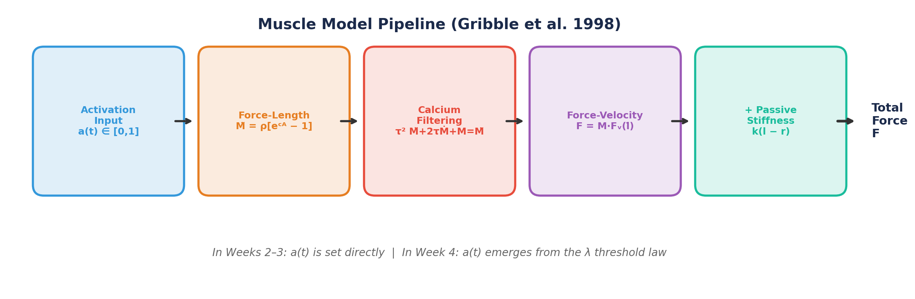
Figure 1. The muscle model pipeline. In Weeks 2–3, activation a(t) is set directly. In Week 4, it will emerge from the λ threshold law.
A key design decision: we build this muscle model to be λ-model compatible from the start. The exponential force-length relation, the reflex delay structure, and the sigmoidal force-velocity curve are all taken from Gribble et al. (1998). In Weeks 2–3, we drive the muscles with direct activation inputs a(t) ∈ [0, 1]. In Week 4, we will “turn on” the threshold control law and let activation emerge naturally from the difference between muscle length and the centrally specified threshold λ.
What Changes in Week 4 — And What Doesn’t
The muscle mechanics (force-length, force-velocity, calcium kinetics, passive stiffness) remain identical throughout the course. Only the source of the activation signal changes: direct input → λ threshold law → inverse dynamics → OFC. One plant, many controllers.

1.1 Choosing a Muscle Model
Before building, it is worth knowing what we are choosing among, and what the choice costs. Muscle models fall into roughly three families.
Cross-bridge models (Huxley, 1957). These describe actin–myosin bond kinetics at the sarcomere level: a muscle’s state is a distribution of attached cross-bridges over bond length, evolving under a partial differential equation. They earn the force–velocity curve and heat production from first principles instead of fitting them. The cost is that each muscle carries a distribution rather than a few numbers — far too expensive for six muscles integrated thousands of times, and far more mechanism than a question about reaching requires.
Hill-type models (Hill, 1938; Zajac, 1989). Phenomenological and lumped: a contractile element in series with an elastic tendon and in parallel with passive tissue, with force built as activation × f(length) × f(velocity). Zajac’s contribution was to standardise this into a dimensionless musculotendon model with normalised curves and pennation — the framework behind most modern biomechanics software, and your required reading this week. The price of a compliant tendon is that contractile-element length is no longer known from the joint angles: it becomes a hidden state, recovered at every timestep by solving an equation that is numerically stiff.
Simplified Hill variants (Gribble et al., 1998). Ours. It keeps the Hill skeleton — activation, force–length, force–velocity, passive elasticity — but assumes a rigid tendon, replaces the bell-shaped force–length curve with an exponential, and lumps activation dynamics into a single second-order filter.
Why we start here. Four reasons, none of which is that it is the most accurate model available:
- State economy. Two states per muscle, twelve for the arm. With the four kinematic states, the entire plant is a 16-dimensional ODE — small enough for RK4 to integrate without trouble, and small enough for you to inspect by hand when it misbehaves.
- Closed form, no inner solve. A rigid tendon means contractile-element length is muscle length, read directly off the joint angles. No hidden state, no per-timestep root-finding, no stiff tendon dynamics. This is what lets you write the muscle in an afternoon.
- λ-compatibility. Week 4 needs activation A = [l − λ]⁺ expressed as a length in millimetres, and the exponential of Equation 4.1 was designed around exactly that.
- A published benchmark. Gribble et al. report multi-joint reaching results from this same model, so your simulations have something external to be checked against.
What we give up. The rigid tendon removes elastic energy storage and recoil. The exponential force–length curve rises monotonically over the operating range, so there is no optimal length and no descending limb. The single filter lumps calcium release and binding together, discarding length-dependent calcium sensitivity. Pennation, fatigue, and history dependence are absent altogether. None of these omissions bite for the slow-to-moderate horizontal reaching we simulate; most of them would for explosive movement. Section 8.3 places our model beside a full Hill-type implementation once you have built it.
The general lesson is worth carrying past this week: a model is a claim about what you intend to explain. Gribble et al. wanted to know whether simple control signals could produce realistic reaching, so they needed a plant faithful enough to be convincing and cheap enough to simulate repeatedly. Ours is the same bargain.

2. The 6-Muscle Arrangement
Gribble et al. (1998) model six muscle groups acting on the 2-joint arm in the horizontal plane. Each joint has a flexor-extensor pair, plus two bi-articular muscles that span both joints:
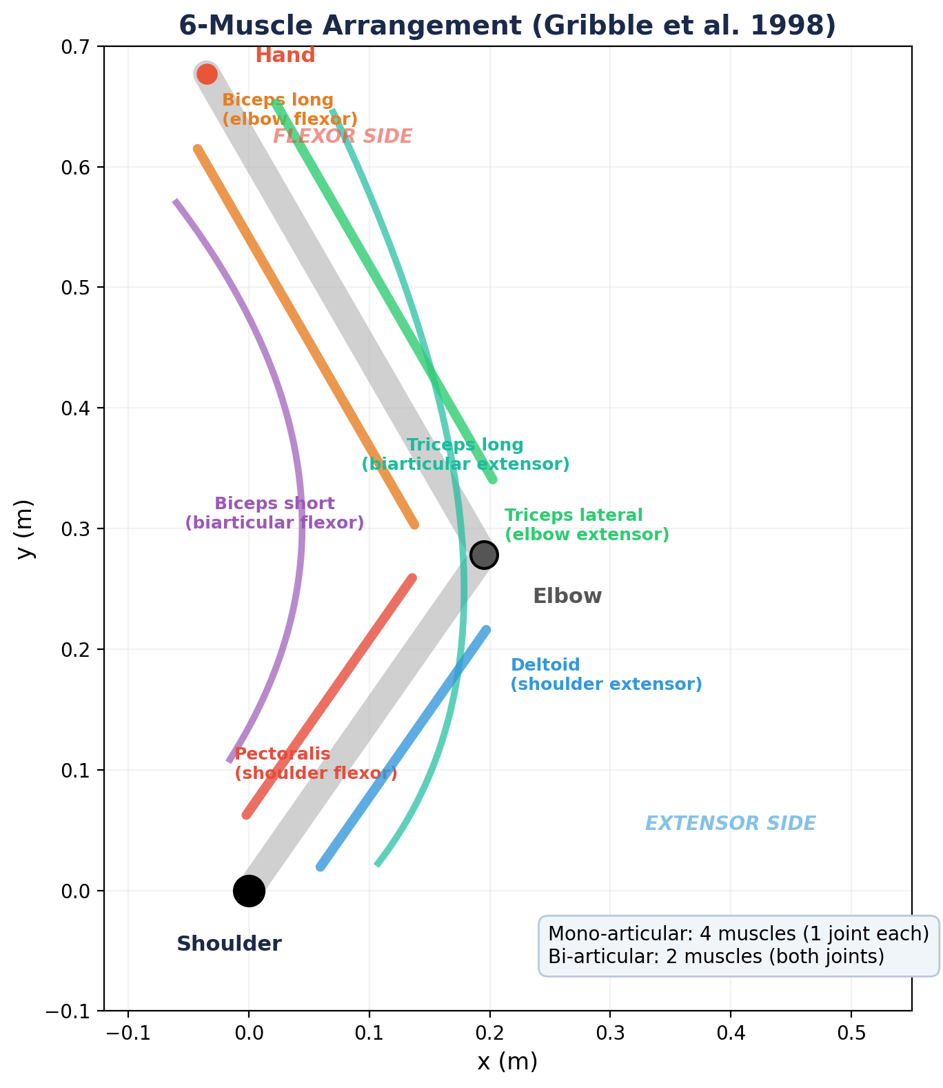
Figure 2. The 6-muscle arrangement. Four mono-articular muscles act on one joint each; two bi-articular muscles span both joints.

2.1 Muscle Groups
Shoulder muscles (mono-articular):
- Pectoralis — shoulder flexor (horizontal adduction). Produces positive torque at the shoulder, increasing θ₁.
- Deltoid (posterior fibers) — shoulder extensor (horizontal abduction). Produces negative torque at the shoulder, decreasing θ₁.
Elbow muscles (mono-articular):
- Biceps long head — elbow flexor. Produces positive torque at the elbow, increasing θ₂.
- Triceps lateral head — elbow extensor. Produces negative torque at the elbow, decreasing θ₂.
Bi-articular muscles:
- Biceps short head — flexor at both joints. When activated, it produces shoulder flexion and elbow flexion simultaneously.
- Triceps long head — extensor at both joints. When activated, it produces shoulder extension and elbow extension simultaneously.
Why Bi-Articular Muscles Matter
Bi-articular muscles create a mechanical coupling between the two joints. When biceps short head contracts, it flexes both the shoulder and elbow. This coupling is not a nuisance—it’s a feature. It means the nervous system can produce coordinated multi-joint movements with fewer independent commands. The Gribble et al. model shows that these couplings, combined with the λ control law, can explain complex movement patterns from simple control signals.

2.2 Force-Generating Capacity (PCSA)
Each muscle’s maximum force is proportional to its physiological cross-sectional area (PCSA). Gribble et al. use PCSA values from Winters & Woo (1990), scaled by ρ = 1 N/cm² to match empirical stiffness data:
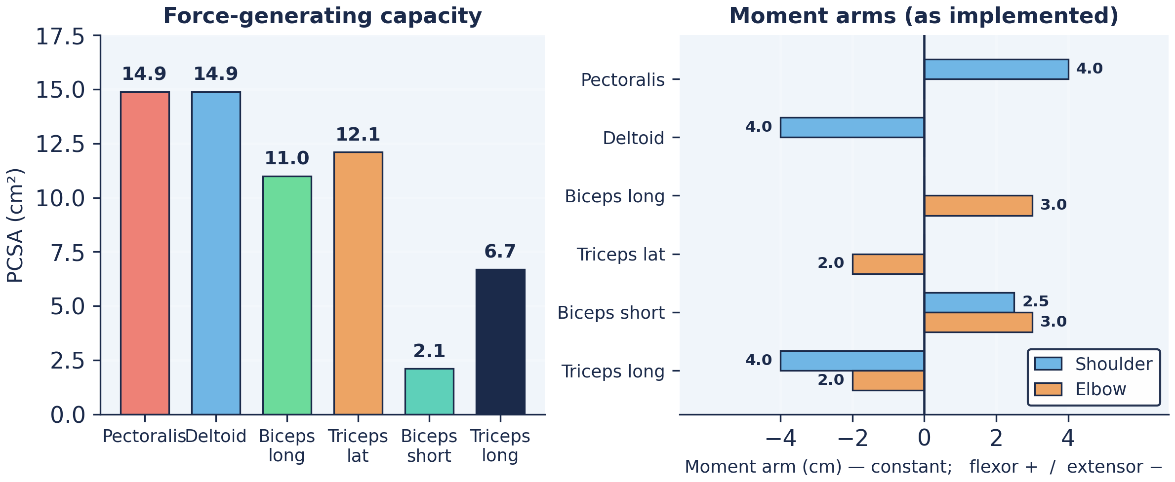
Figure 3. Left: PCSA values determine relative force-generating capacity. Right: the moment arms as implemented in this course — constant for every muscle, positive for flexors and negative for extensors.

3. Moment Arms: From Muscle Force to Joint Torque
A muscle’s moment arm determines how much torque it produces at a joint per unit of force. The relationship is:
τ = r(q) · F (3.1)
where τ is the joint torque, r(q) is the moment arm (which may depend on the joint angle q), and F is the muscle force.

3.1 Extensor Moment Arms
The three extensor muscles (deltoid, triceps lateral, triceps long) have constant moment arms:
- Shoulder extensors: r = 4 cm (0.04 m)
- Elbow extensors: r = 2 cm (0.02 m)

3.2 Flexor Moment Arms, and the Constant-Arm Simplification
In the anatomical data underlying Gribble et al. (1998), the three flexor muscles (pectoralis, biceps long, biceps short) have moment arms that vary with joint angle (An et al., 1981, 1989). A flexor tendon wraps around the joint differently at different angles: at high flexion it sits further from the joint centre, so the moment arm grows.
What this course implements is simpler. We assign every muscle a constant moment arm — for the flexors, a fixed mid-range value. This is the assumption that makes muscle length linear in the joint angles, l(q) = l_ref − r_sh·(θ₁ − θ₁,ref) − r_el·(θ₂ − θ₂,ref), and muscle velocity a fixed linear combination of joint velocities, dl/dt = −r_sh·θ̇₁ − r_el·θ̇₂. Both are the expressions you will implement this week. With angle-dependent arms, neither closed form would hold. The reason is that the moment arm is not an independent quantity: it is the rate at which muscle length changes with joint angle, r = −∂l/∂θ. A constant moment arm and a length that is linear in the joint angles are therefore the same statement, said two ways. Let r vary with q and the consequences follow immediately — length becomes the integral of r along the joint trajectory instead of a straight-line function of it; velocity needs the geometry re-evaluated from the current posture at every timestep rather than read from two fixed coefficients; and the torque r(q)·F changes with posture even when the muscle force does not.
One consequence is worth stating plainly, because it is natural to assume the opposite: with constant moment arms, torque per unit muscle force does not depend on arm configuration. In Weeks 2–3 the only configuration dependence in a muscle’s force is the passive spring k(l − r), which varies because length varies. The configuration dependence you met in Week 1 is real, but it lives in the Jacobian — and, from Week 3, the inertia matrix — not in the moment arms. Week 6 returns to this, where actuator redundancy makes moment-arm geometry matter directly.
For implementation, the moment arm at each joint is computed from the muscle’s origin and insertion points using the geometric relationship between muscle length and joint angle. The key implication: the same muscle activation produces different torques at different arm configurations. This is another source of the configuration dependence we first encountered in the Jacobian.
Moment Arms and Muscle Redundancy
With 6 muscles driving 2 joints, we have actuator redundancy: there are infinitely many combinations of muscle forces that produce the same net joint torques. For example, co-contracting the shoulder flexor and extensor produces no net torque but increases joint stiffness. This is distinct from the kinematic redundancy discussed in Week 1 (which our 2-DOF model does not have). We will encounter this actuator redundancy directly in Week 6 (Inverse Dynamics & Static Optimization).

4. The Force-Length Relationship
The central equation of the Gribble et al. muscle model relates muscle activation to the force produced by the contractile apparatus:
M̃ = ρ [exp(cA) − 1] (4.1)
where:
- M̃ is the instantaneous muscle force (before calcium filtering)
- ρ is the force-magnitude parameter, specific to each muscle, proportional to PCSA
- c = 0.112 mm⁻¹ is the form parameter (same for all muscles)
- A is the muscle activation variable (see below)
A note on the name. Equation 4.1 is called a force–length relationship because of how A is defined in the λ model (Week 4), where A = [l − λ]⁺ is a length — the amount by which the muscle exceeds its centrally specified threshold, in millimetres. That is where the units of c come from. In Weeks 2–3, however, we set A = G·a from a dimensionless activation, and no muscle length enters Equation 4.1 at all. The function you write this week will take an activation and ρ, and never receive l. Active force becomes genuinely length-dependent only in Week 4; until then, the sole length-dependent term in a muscle’s output is the passive spring of Section 7.
Direct Activation and the Neural Drive Gain G
The parameter c has units of mm⁻¹ because Equation 4.1 was designed for the λ model (Week 4), where A = [l − λ]⁺ is a muscle length displacement in millimeters. In Weeks 2–3, we don’t have the λ model yet. Instead, we drive muscles with a dimensionless activation a ∈ [0, 1]. If we plug a directly into Equation 4.1, the product cA = 0.112 × 1.0 = 0.112 at maximum activation. The exponential barely rises: exp(0.112) − 1 ≈ 0.12. For the pectoralis (ρ = 14.9), this gives a maximum force of only 1.8 N — far too small to move the arm. To fix this, we introduce a neural drive gain G = 20 mm that converts the dimensionless activation to an effective displacement: A = G × a. Now at a = 1: cA = 0.112 × 20 = 2.24, producing ~125 N for the pectoralis — a physiologically realistic force. In Week 4, G disappears: the λ model computes A directly in millimeters, and the exponential operates in its designed range without any gain factor.

4.1 The Recruitment Gradient
The exponential form of Equation 4.1 reflects the size principle of motor unit recruitment (Henneman et al., 1965). As activation increases, progressively larger motor units are recruited, each contributing a larger increment of force. The parameter c captures this recruitment gradient.
The value c = 0.112 mm⁻¹ was estimated by Gribble et al. from the force-length data of Feldman & Orlovsky (1972), recorded from cat gastrocnemius muscle with intact dorsal and ventral roots under brainstem stimulation—ensuring physiologically realistic activation patterns.
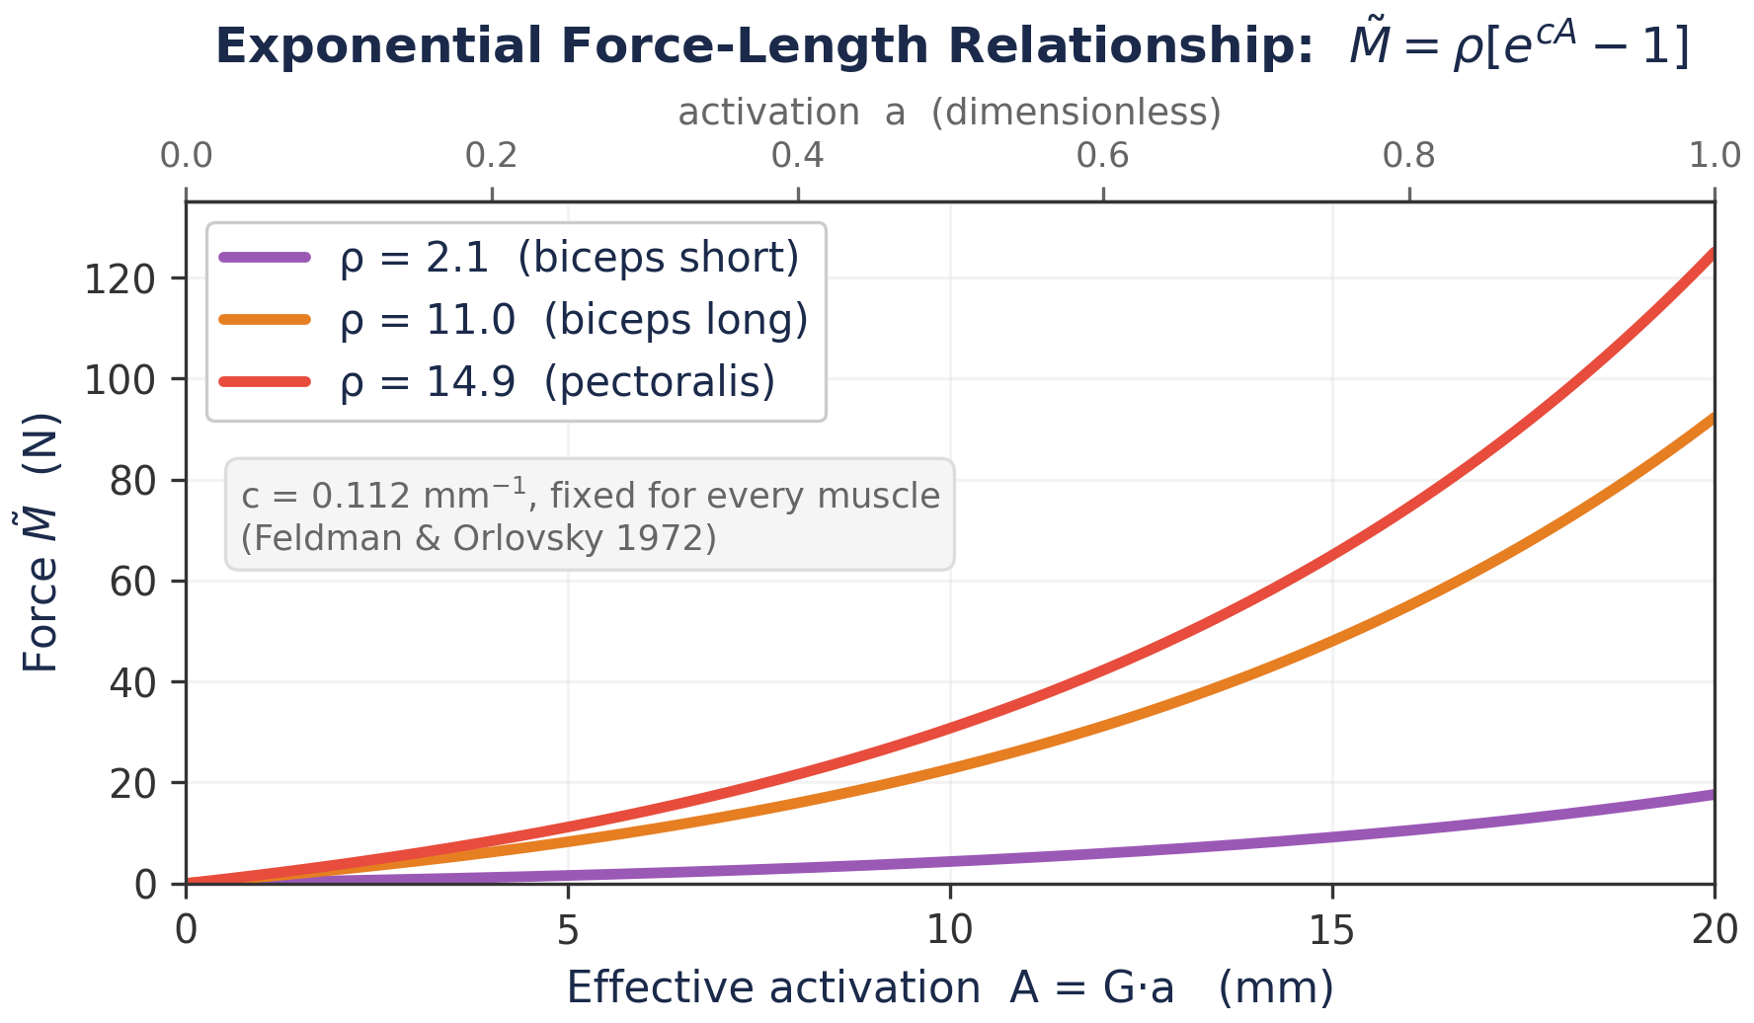
Figure 4. The exponential force-length relationship (Equation 4.1). The recruitment gradient c = 0.112 mm⁻¹ (Feldman & Orlovsky, 1972) is the same for every muscle; only ρ differs. Reading along a curve shows force rising exponentially with activation; reading between curves shows the effect of ρ, and therefore of PCSA. In Weeks 2–3 the effective activation is A = G·a with a ∈ [0, 1], so the curves span A = 0–20 mm; at full activation the pectoralis reaches about 125 N. Lab 02 reproduces this figure.

4.2 The ρ Parameter
The magnitude parameter ρ is specific to each muscle and proportional to its PCSA. Gribble et al. compute ρ by scaling PCSA values by 1 N/cm², chosen to match the predicted static stiffness of the model to empirical measurements (Gomi & Kawato 1995; Tsuji et al. 1995):
Muscle | PCSA (cm²) | ρ (N) | Type
Biceps short head | 2.1 | 2.1 | Bi-articular flexor
Biceps long head | 11.0 | 11.0 | Elbow flexor
Deltoid | 14.9 | 14.9 | Shoulder extensor
Pectoralis | 14.9 | 14.9 | Shoulder flexor
Triceps lateral head | 12.1 | 12.1 | Elbow extensor
Triceps long head | 6.7 | 6.7 | Bi-articular extensor

Table 1. PCSA values and ρ parameters for all six muscles (Winters & Woo, 1990; scaled by 1 N/cm²).

5. Graded Force Development: Calcium Kinetics
Muscle force does not rise instantaneously when activation changes. The calcium kinetics of the contractile machinery impose a low-pass filter on force production. Gribble et al. model this as a second-order, critically damped system:
τ² $\ddot{M}$ + 2τ Ṁ + M = M̃ (5.1)
where M̃ is the instantaneous value of muscle force from Equation 4.1 (the input), M is the actual muscle force (the output), and τ = 15 ms is the time constant.
This filter is critically damped (no oscillation) with a single parameter τ. A value of τ = 15 ms produces a step response that reaches 90% of its final value in about 58 ms, and comes within 2% of it by about 90 ms — matching empirically observed times from stimulus onset to maximum force in human adductor pollicis muscle (Hainaut et al., 1981). Both numbers describe the same curve and differ only in the criterion used, so expect to meet each of them.
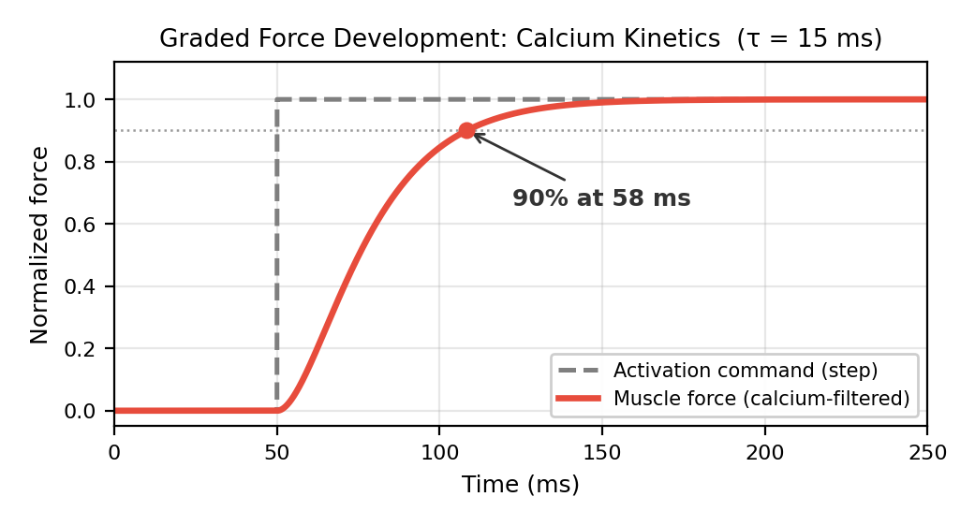
Figure 5. Graded force development. A step change in activation (dashed) produces a smooth, delayed rise in force (solid). The filter reaches ~90% of maximum in ~58 ms after step onset. τ = 15 ms.

5.1 Why This Matters for Control
The calcium filter has profound implications for motor control:
- Force cannot change instantaneously. The brain’s commands are filtered by muscle physiology. A sudden neural command produces a gradual force rise over ~90 ms.
- Deceleration is delayed. To stop a movement, the brain must send a deceleration command well before the hand reaches the target—because the resulting braking force will take ~90 ms to develop.
- Fast movements require anticipatory control. For rapid reaching, the entire force profile must be planned in advance, not computed online, because the muscle’s response is too slow to correct in real time. This is one reason feedforward control (Weeks 4–6) is essential.

5.2 Numerical Implementation
For numerical simulation, Equation 5.1 is converted to two first-order ODEs. Define M₁ = M and M₂ = Ṁ:
Ṁ₁ = M₂ (5.2a)
Ṁ₂ = (M̃ − M₁ − 2τ M₂) / τ² (5.2b)
These are integrated alongside the arm dynamics using Runge-Kutta (RK4). Each muscle adds two state variables (M, Ṁ) to the system, so the 6-muscle model adds 12 state variables to the dynamical system.
Why the Calcium Filter Sits Between Force-Length and Force-Velocity
The pipeline ordering reflects three distinct physiological processes. Force-length (Step 2) computes the force the contractile apparatus is commanded to produce—how many cross-bridges the neural drive requests. Calcium filtering (Step 3) represents the time required for calcium to bind troponin and expose actin sites—a biochemical rate limit on how fast bridges can actually form or dissolve. The output M is the number of bridges currently engaged. Force-velocity (Step 4) is a mechanical property of those engaged bridges: each produces more or less force depending on contraction speed, and this effect is nearly instantaneous. If the filter were placed after the velocity multiplier, the model would predict that muscles respond sluggishly to sudden perturbations—but empirically, the force increase from lengthening an active muscle is immediate. What is slow is recruiting new bridges, not modulating the force of existing ones.

6. The Force-Velocity Relationship
Muscle force depends not only on length but also on the velocity of contraction. A muscle that is shortening (concentric contraction) produces less force than one at rest, while a muscle that is being stretched (eccentric/lengthening contraction) produces more force. This is a fundamental property of the actin-myosin cross-bridge mechanism.
Gribble et al. model this using a sigmoidal function fit to data from cat soleus muscle (Joyce & Rack, 1969):
F = M · [f₁ + f₂ · arctan(f₃ + f₄ · dl/dt)] + k(l − r) (6.1)
where M is the calcium-filtered force (from Equation 5.1), dl/dt is the rate of change of muscle length (muscle velocity), and the coefficients are:
- f₁ = 0.82 — baseline force level
- f₂ = 0.50 — amplitude of velocity modulation
- f₃ = 0.43 — horizontal offset
- f₄ = 58 s/m — slope parameter (determines how steeply force varies with velocity)
The final term k(l − r) is the passive stiffness (Section 7). Note that Equation 6.1 gives the total muscle force: the product of the calcium-filtered active force M and the velocity-dependent multiplier, plus the passive component.
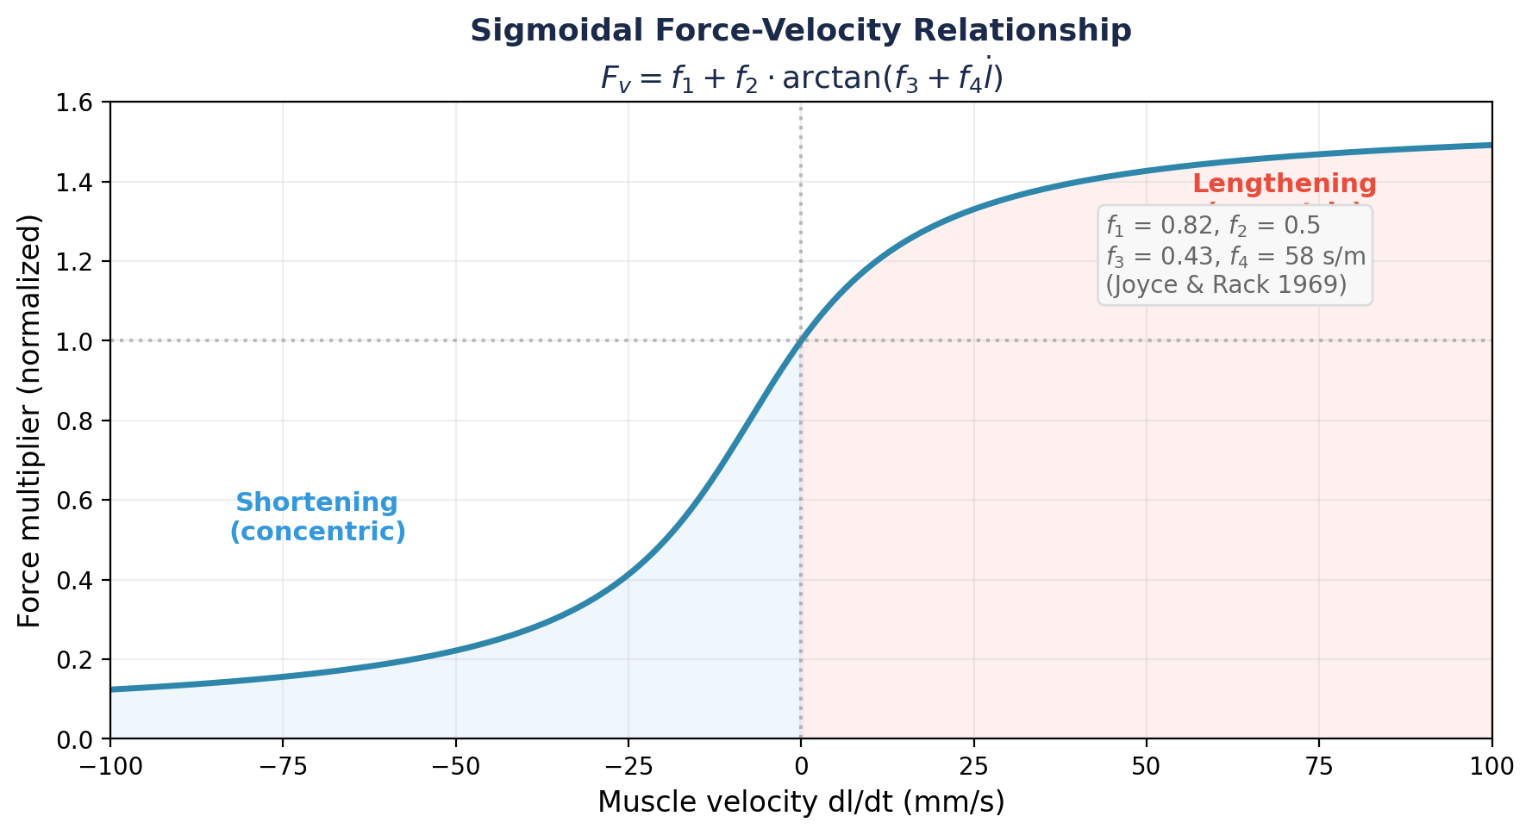
Figure 6. The sigmoidal force-velocity relationship. Lengthening (eccentric) contractions produce more force; shortening (concentric) contractions produce less. Parameters from Joyce & Rack (1969).

6.1 Interpretation
The force-velocity relationship acts as a natural velocity-dependent damping mechanism. When the arm is moving quickly (muscles shortening), the force multiplier drops below 1.0, reducing the net force and naturally decelerating the limb. When the arm is perturbed (muscles forcibly stretched), the multiplier rises above 1.0, providing a stabilizing resistive force.
This intrinsic damping is one of the reasons the Gribble et al. model can produce smooth movements from simple control signals: the muscle’s own mechanics provide “free” deceleration that doesn’t need to be explicitly commanded. We will see this dramatically in Week 4 when constant-rate λ shifts produce realistic reaching movements.

7. Passive Elasticity
Even without neural input (A = 0), muscles resist stretch due to their passive elastic properties—connective tissue, titin filaments, and the parallel elastic element of the sarcomere. Gribble et al. model passive force as linear in the departure from resting length:
F_passive = k · (l − r) (7.1)
where l is current muscle length, r is resting length, and k is passive stiffness. Resting lengths are the muscle lengths at the course reference posture Q_REF = (θ₁, θ₂) = (55°, 75°). The stiffness values are proportional to PCSA, scaled to match the passive component of the force-length data from Feldman & Orlovsky (1972):
Muscle | Passive Stiffness k (N/m)
Biceps short head | 36.5
Biceps long head | 190.9
Deltoid | 258.5
Pectoralis | 258.5
Triceps lateral head | 209.9
Triceps long head | 116.3

Table 2. Passive stiffness values for all six muscles (Feldman & Orlovsky, 1972).
The linear passive stiffness approximation is valid for muscle stretches up to about 75% of maximum departure from resting length. All muscle length changes in our simulations will fall within this range.

8. The Complete Muscle Model
Assembling all components, the total force produced by a single muscle is:

8.1 The Complete Force Equation
Step 1: Activation.
A = a(t) [for Weeks 2–3; in Week 4 this becomes A = [l − λ + μ·(dl/dt)]⁺] (8.1)
Step 2: Instantaneous contractile force (exponential force-length).
M̃ = ρ [exp(cA) − 1] (8.2)
Step 3: Calcium-filtered force (graded development).
τ² M̈ + 2τ Ṁ + M = M̃ (8.3)
Step 4: Total force (velocity-dependent + passive).
F = M · [f₁ + f₂ · arctan(f₃ + f₄ · dl/dt)] + k(l − r) (8.4)
Step 5: Joint torque (via moment arm).
τ_joint = r(q) · F (8.5)

8.2 State Variables
Each muscle contributes the following to the simulation:
- 2 state variables: M (filtered force) and Ṁ (rate of force change)
- Inputs: activation a(t), muscle length l(q), muscle velocity dl/dt(q, dq/dt)
- Output: force F, which contributes to joint torque via the moment arm
With 6 muscles, the muscle subsystem adds 12 state variables to the dynamical system. In Week 3, these will be integrated alongside the 4 kinematic state variables (2 joint angles, 2 joint velocities), giving a 16-dimensional ODE system.

8.3 What the Muscle Class Must Expose
For future use by the proprioceptive system (Week 9), each muscle object must expose:
- l (muscle length) — computed from joint angles via musculoskeletal geometry
- dl/dt (muscle velocity) — computed from joint angles and joint velocities
In Week 9, we will build a Proprioceptor class that reads these signals as noisy, delayed estimates of the muscle’s mechanical state—mimicking muscle spindles and Golgi tendon organs. By exposing l and dl/dt now, we ensure that adding proprioception later requires no changes to the Muscle class itself: the sensory system simply reads data that the muscle already computes.
Our Model in Context: Gribble vs. Hill-Type Architecture
The Gribble et al. (1998) model we implement is a simplified member of the Hill-type muscle model family. A full Hill-type model (e.g., Kistemaker et al. 2006; Van Soest & Bobbert 1993) differs in three main ways. (1) Series elastic element (tendon compliance): In a full model, the muscle–tendon complex contains a contractile element (CE) in series with an elastic tendon (SE), so CE length ≠ total muscle length. Our model assumes a rigid tendon (CE length = muscle length), which is reasonable for slow-to-moderate movements but breaks down for fast or explosive actions. (2) Force–length shape: The classic Hill/Zajac force–length relationship is bell-shaped, peaking at an optimal sarcomere length. Gribble uses an exponential approximation that is monotonically increasing over the operating range—valid for our model’s joint limits but not a general description. (3) Activation dynamics: Kistemaker uses Hatze’s (1981) two-stage model, which represents calcium explicitly in two steps: neural stimulation STIM drives γ, the concentration of free (unbound) calcium in the sarcoplasm, and γ in turn drives q, the fraction of calcium bound to troponin. Because q depends on both γ and CE length, that model captures length-dependent Ca²⁺ sensitivity (LDCS). Neither γ nor q appears anywhere in our model: it has no calcium variable at all. Our single second-order filter lumps both stages together and low-pass filters force directly, which is why its two states are M and Ṁ — a force and its rate of change, not a concentration. The Gribble model is the right choice for this course: fewer state variables, closed-form expressions, and λ-model compatibility. But when you read Zajac (1989) or Kistemaker et al. (2006), expect these differences.

9. Summary of Key Results
Component | Equation | Key Parameter
Force-length | M̃ = ρ[exp(c·G·a) − 1] | c = 0.112 mm⁻¹, G = 20 mm
Calcium kinetics | τ²M̈ + 2τṀ + M = M̃ | τ = 15 ms
Force-velocity | F_v = f₁+f₂·arctan(f₃+f₄·dl/dt) | f₄ = 58 s/m
Passive stiffness | F_p = k(l − r) | k from Table 2
Moment arms (ext.) | τ = r · F | 4 cm (shoulder), 2 cm (elbow)
Moment arms (flex.) | τ = r(q) · F | 2.5–5 cm (angle-dependent)
ρ parameter | ρ = PCSA × 1 N/cm² | See Table 1

Parameter Sources
- c = 0.112 mm⁻¹ — Feldman & Orlovsky (1972), cat gastrocnemius
- τ = 15 ms — Hainaut et al. (1981), human adductor pollicis
- f₁–f₄ — Joyce & Rack (1969), cat soleus
- PCSA values — Winters & Woo (1990)
- Passive stiffness — Feldman & Orlovsky (1972), scaled by PCSA
- Moment arms — An et al. (1981, 1989); Winters & Woo (1990)
- ρ scaling (1 N/cm²) — matched to Gomi & Kawato (1995) and Tsuji et al. (1995) static stiffness

Next week: We connect the muscles to the skeleton using Lagrangian dynamics. The kinematic arm from Week 1 and the muscles from this week will be integrated into a single dynamical system—the DynamicsEngine class.

