COMPUTATIONAL SENSORIMOTOR CONTROL
CONTROL THEORY BASICS
P, PI and PID Control, and the Laplace Transform
Week 8 handout, the background for §3 of the lecture notes | Module 3 | Fall 2026
How to Use This Handout
This handout is the background for §3 of the Week 8 lecture notes. Boards 1–4 give what §3 uses to read stability from a loop's poles. Boards 10 and 11 work the notes' own loop: the hand under Week 6's inverse dynamics, with and without the delay of vision.
Lab 08 has a pre-lab notebook, Lab08_PreLab_Control_Basics.ipynb, that does the algebra of the boards in code. Read the handout and work through the pre-lab before Thursday's lab.
The handout follows "Introduction: PID Controller Design" in the Control Tutorials for MATLAB and Simulink (CTMS). It keeps their example, a cart on a spring with a damper, and their gains.
Each board is one block of work at the whiteboard. The shaded box holds what goes on the board, and the text around it explains each line. A check question ends each board; the answers are at the end.
Table 1. The boards.
board | topic | what it gives you
1 | A cart on a spring | the example, its equation of motion, and its motion solved in time
2 | The Laplace transform | four rules and a table of transforms
3 | Solving the cart | transfer function, poles, partial fractions, final value
4 | What a pole tells you | how to read a pole: dies away, grows or swings, and how fast
5 | Closing the loop | the closed-loop transfer function, the steady-state error, the PID controller
6 | P control | a faster response, with overshoot and a steady-state error
7 | PD control | the derivative term acts as a damper
8 | PI control | the integral term removes the steady-state error
9 | PID control | all three terms; CTMS's rules of thumb, tested
10 | The hand | a mass with no spring; force and acceleration commands
11 | The hand with a delay | the factor e^{−sΔ} and this week's limit on the gains

Learning objectives
By the end of the handout, you should be able to:
- Transform a linear differential equation with the Laplace transform, and read off its transfer function, its poles and its final value.
- Read a pole: say whether the part of a movement it gives dies away, grows or swings, and how fast.
- Derive the closed-loop transfer function of a feedback loop and its steady-state error.
- Predict what the P, I and D terms each do to the rise time, overshoot, settling time and steady-state error, and test the prediction by simulation.
- Explain why the hand in this week's model needs no integral term, and why a delay limits the gains.
Board 1. A Cart on a Spring
Push a cart that is tied to a wall by a spring and slowed by a damper (Figure 1A). A steady push moves it until the spring pulls back as hard as you push. CTMS uses this system with m = 1 kg, b = 10 N s/m and k = 20 N/m.
Newton's second law gives its equation of motion:
m ẍ + b ẋ + k x = F (H.1)
Here x is the cart's position (m) and F the push (N). The mass m, the damping coefficient b and the spring constant k are fixed. When the cart has stopped, ẍ = ẋ = 0 and k x = F.
A push of 1 N therefore ends with the cart at F/k = 5 cm. How it gets there takes a solution of Equation H.1 in time.
The spring balances the steady push at x = F/k. What remains, x − F/k, obeys Equation H.1 with no push. Try a solution of the form e^{rt}. Each time derivative multiplies it by r, so Equation H.1 requires
m r² + b r + k = 0 (H.2)
This is the characteristic equation of the cart. With m = 1, b = 10 and k = 20 it reads r² + 10 r + 20 = 0, so r = −5 ± √5: r₁ = −2.76 and r₂ = −7.24 per second. The motion is the sum of the two exponentials on top of F/k:
x(t) = F/k + A e^{r₁t} + B e^{r₂t} (H.3)
The constants A and B come from the start. The cart starts at rest, so x(0) = 0 gives F/k + A + B = 0, and ẋ(0) = 0 gives r₁ A + r₂ B = 0. Solving the pair gives A = −0.081 m and B = 0.031 m:
x(t) = 0.050 − 0.081 e^{−2.76 t} + 0.031 e^{−7.24 t} (m) (H.4)
Equation H.4 matches the simulated push (Figure 1B). Both exponentials decay, because r₁ and r₂ are negative. The cart rises from 10% to 90% of F/k in 0.88 s and stays within 2% of it after 1.59 s.
On the board
m ẍ + b ẋ + k x = F, with m = 1 kg, b = 10 N s/m, k = 20 N/m, F = 1 N
At rest: ẍ = ẋ = 0, so k x = F and x = F/k = 1/20 m = 5 cm.
try x − F/k = e^{rt}: m r² + b r + k = 0 ⇒ r² + 10 r + 20 = 0 ⇒ r = −5 ± √5 = −2.76, −7.24
x(t) = F/k + A e^{r₁t} + B e^{r₂t}; x(0) = 0: F/k + A + B = 0; ẋ(0) = 0: r₁A + r₂B = 0
A = −0.081, B = 0.031: x(t) = 0.050 − 0.081 e^{−2.76 t} + 0.031 e^{−7.24 t}

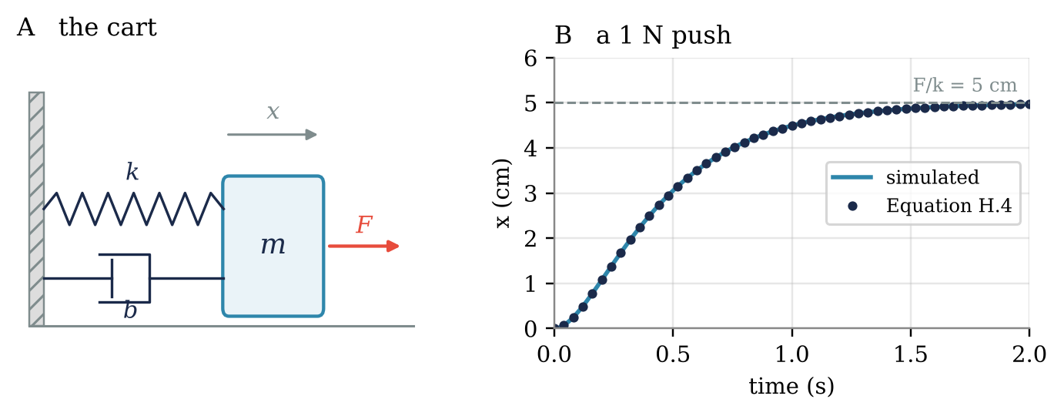
Figure 1. The CTMS cart. A: a mass m tied to a wall by a spring k and a damper b, pushed by a force F. B: the cart's position after a 1 N push at t = 0, simulated (line) and from Equation H.4 (dots); the dashed line is F/k.
Check 1. Without solving anything, where does the cart stop if the push is 2 N? If the spring is twice as stiff?
Board 2. The Laplace Transform
Board 1 needed a guess, e^{rt}, and a separate step to fit the starting conditions. The Laplace transform does both at once. It turns each derivative into a multiplication by a number s, so the differential equation becomes algebra. For a signal x(t) that starts at t = 0, the transform is
X(s) = ∫₀∞ x(t) e^{−st} dt (H.5)
s is a complex number with units of 1/s. The transform replaces a function of time with a function of s (Franklin et al., 2019, §3.1; Åström & Murray, 2008, §8.5). A transform is written with the capital of its signal's letter. The cart's position x(t) becomes X(s), and the push F(t) becomes F(s).
Two transforms follow directly from Equation H.5. A step, x(t) = 1 for t ≥ 0, gives ∫ e^{−st} dt = 1/s. An exponential, x(t) = e^{−at}, gives ∫ e^{−(s+a)t} dt = 1/(s + a).
Four rules do most of the work. Each follows from Equation H.5 in a line or two (Franklin et al., 2019, §3.1.4).
Derivatives become products. Integrating by parts gives the transform of a derivative:
ẋ(t) → s X(s) − x(0) (H.6)
Applied twice, ẍ becomes s²X(s) − s x(0) − ẋ(0). For a system that starts at rest, every d/dt becomes a multiplication by s.
Integrals become quotients. The transform of ∫₀^{t} x(τ) dτ is X(s)/s. The PI and PID controllers of Boards 8 and 9 use this rule.
A delay becomes a factor. If x is zero before t = 0, substituting τ = t − Δ in Equation H.5 gives
x(t − Δ) → e^{−sΔ} X(s) (H.7)
Board 11 uses this rule for the delay of vision.
The final value can be read without solving. Let s → 0 in Equation H.6. The left side becomes ∫₀∞ ẋ dt = x(∞) − x(0), so (Franklin et al., 2019, §3.1.6)
x(∞) = lim_{s→0} s X(s) (H.8)
Equation H.8 holds only if x(t) settles. Board 3 gives the test: every pole of sX(s) must have a negative real part. Table 2 collects the transforms used below.
Table 2. The transforms used in this handout. Each can be checked with Equation H.5.
x(t), for t ≥ 0 | X(s)
1 (a step) | 1/s
t | 1/s²
e^{−at} | 1/(s + a)
e^{−σt} sin ωt | ω / ((s + σ)² + ω²)
e^{−σt} cos ωt | (s + σ) / ((s + σ)² + ω²)
ẋ(t) | s X(s) − x(0)
∫₀^{t} x(τ) dτ | X(s)/s
x(t − Δ), with x = 0 before t = 0 | e^{−sΔ} X(s)

On the board
X(s) = ∫₀∞ x(t) e^{−st} dt (capitals are transforms: x(t) → X(s), F(t) → F(s))
step: ∫₀∞ e^{−st} dt = 1/s exponential: ∫₀∞ e^{−(s+a)t} dt = 1/(s + a)
derivative: ∫₀∞ ẋ e^{−st} dt = [x e^{−st}]₀∞ + s ∫₀∞ x e^{−st} dt = s X(s) − x(0)
delay: ∫_{Δ}∞ x(t − Δ) e^{−st} dt = e^{−sΔ} ∫₀∞ x(τ) e^{−sτ} dτ = e^{−sΔ} X(s)
final value: let s → 0 in the derivative line: x(∞) − x(0) = lim s X(s) − x(0)

Check 2. Use Equation H.5 to show that x(t) = t transforms to 1/s².
Board 3. Solving the Cart
Transform Equation H.1 with the cart at rest at t = 0. X(s) is the transform of the position x(t), and F(s) that of the push F(t). By Equation H.6, m s²X(s) + b s X(s) + k X(s) = F(s).
Dividing by the bracket gives the cart's transfer function G(s). It is the transform of the output, the position, divided by the transform of the input, the push:
G(s) = X(s) / F(s) = 1 / (m s² + b s + k) = 1 / (s² + 10 s + 20) (H.9)
G(s) depends only on the cart, through m, b and k, and not on the push. For any push, the position is X(s) = G(s) F(s).
The poles of G are the values of s that make its denominator zero. Here s² + 10 s + 20 = 0 gives s = −5 ± √5, so the poles are −2.76 and −7.24 per second. Each pole p contributes a term e^{pt} to the response.
A 1 N step is F(s) = 1/s (Table 2), so X(s) = G(s)/s = 1 / (s (s + 2.76) (s + 7.24)). Splitting it into partial fractions (Franklin et al., 2019, §3.1.5) gives
X(s) = 0.050/s − 0.081/(s + 2.76) + 0.031/(s + 7.24) (H.10)
Reading each term from Table 2 turns Equation H.10 into Equation H.4. The poles of G are the roots of Equation H.2, the characteristic equation, and the coefficients are Board 1's F/k, A and B. The transform needed no guess and no separate fit, because Equation H.6 carried the starting conditions into X(s).
Each coefficient comes from the cover-up rule: multiply X(s) by the factor of one pole, then set s to that pole. For the pole at 0, this gives 1/(2.76 × 7.24) = 1/20 = 0.050. Figure 2 draws the three terms and their sum.
Two checks. At t = 0 the three coefficients add to zero, so the cart starts where it was. As t grows, both exponentials vanish and x approaches 0.05 m. Equation H.8 gives the same final value without the partial fractions: s X(s) = 1/(s² + 10 s + 20), which is 1/20 at s = 0.
In Figure 2, the part from the pole at −7.24 is gone within a few tenths of a second, while the part from the pole at −2.76 lasts more than a second. Board 4 shows how to read this from the poles alone.
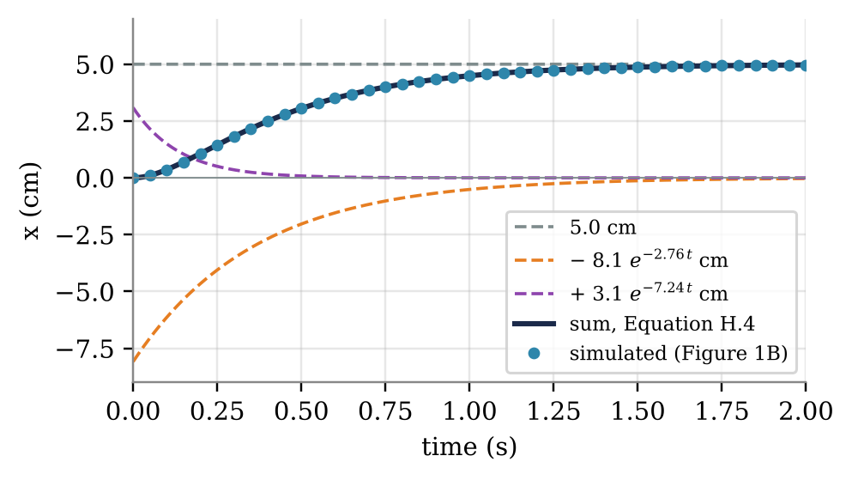
Figure 2. Equations H.4 and H.10, term by term. Dashed: the constant 5.0 cm from the pole at 0, and the two exponentials from the poles at −2.76 and −7.24 per second. Solid: their sum. Dots: the simulated response of Figure 1B.
On the board
(m s² + b s + k) X(s) = F(s) ⇒ G(s) = X/F = 1/(s² + 10 s + 20)
poles: s² + 10 s + 20 = 0 ⇒ s = −5 ± √5 = −2.76, −7.24
X(s) = G(s)/s = (F/k)/s + A/(s + 2.76) + B/(s + 7.24); F/k = 0.050, A = −0.081, B = 0.031 (Board 1)
Table 2, term by term: x(t) = 0.050 − 0.081 e^{−2.76 t} + 0.031 e^{−7.24 t}, as in Board 1; x(∞) = lim s X(s) = 1/20

Check 3. Remove the damper (b = 0). Where are the poles now, and what does the cart do after a 1 N push?
Board 4. What a Pole Tells You
A pole is a number that describes one part of a movement. In Board 1, the cart's motion was a constant plus two parts, e^{−2.76 t} and e^{−7.24 t}. Each part came from one root of the characteristic equation, and those roots are the poles of Board 3. Every pole p adds a part shaped like e^{pt}.
A pole can be a complex number, with a real part and an imaginary part. Each answers one question about the movement. Figure 3 shows the answers for six poles from this handout.
- The real part says whether that part of the movement dies away or grows, and how fast.
- The imaginary part says whether it swings back and forth, and how often.
Real poles: a smooth change
A negative pole, p = −a, gives a part e^{−at} that dies away smoothly. Its time constant, τ = 1/a, is the time it takes to shrink to 37% of its starting size. After four time constants only 2% is left, and that part of the movement is effectively over.
The cart's poles at −7.24 and −2.76 have time constants of 0.14 s and 0.36 s (Figure 3A and B). The pole nearer zero is the slower one, so it decides when the movement ends. Its part, −0.081 e^{−2.76 t} m, shrinks below 2% of the final 5 cm after 1.59 s: the settling time of Board 1.
A positive pole, p = +a, gives a part that grows without limit (Figure 3C). One positive pole makes the whole system unstable, whatever the other poles do. A pencil balanced on its tip behaves this way: left alone, it tips over faster and faster.
Complex poles: a swing
Complex poles come in pairs, p = −σ ± iω. Together they give a part e^{−σt} cos ωt (Table 2): a swing inside a shrinking envelope. The swing repeats ω/(2π) times per second. The envelope shrinks with the time constant 1/σ, as for a real pole at −σ.
Under P control (Board 6), the cart's poles are −5.00 ± 17.18i (Figure 3D). The cart swings 17.18/(2π) = 2.7 times per second, a period of 0.37 s. The swings shrink with a time constant of 1/5.00 = 0.20 s, so each peak is 0.16 times the one before. The simulated response swings with the same period and shrinks by the same factor.
What matters is how far a pair sits from the vertical axis, compared with how far it sits from the horizontal one. A pair close to the vertical axis, with σ small compared with ω, swings many times before it dies away (Figure 3E). A pair on the vertical axis, σ = 0, swings forever (Figure 3F); this is the cart without its damper, in Check 3. A pair to the right of the vertical axis swings with growing size.
When a system has several poles, the one closest to the vertical axis dies away last. It therefore decides how the end of a movement looks. Table 3 sums up how to read a pole.
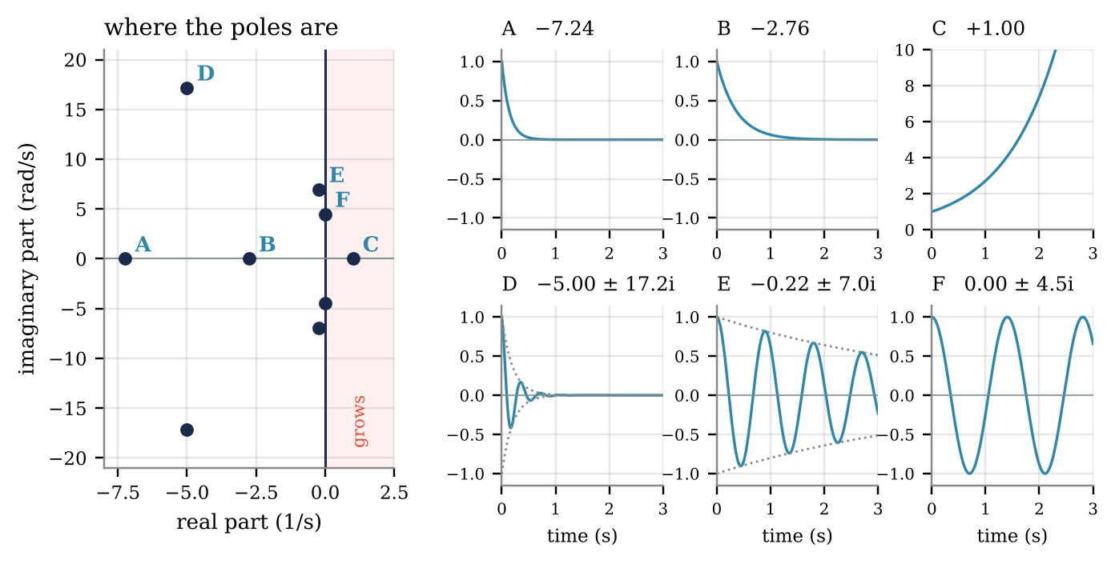
Figure 3. Six poles from this handout, and the part of a movement each one gives. Left: where the poles are; complex poles come in pairs, mirror images across the horizontal axis. Right: e^{pt} over 3 s, starting at 1; for a pair, the swing e^{−σt} cos ωt with its envelope dotted. A, B: the cart's two poles. C: a pole at +1. D: P control on the cart (Board 6). E: the delayed loop near its limit (Board 11). F: the cart without its damper (Check 3).
Table 3. Reading a pole p.
where the pole is | what that part of the movement does | how fast
on the horizontal axis, left of the vertical axis: p = −a | dies away smoothly | time constant 1/a; 2% left after 4/a
on the horizontal axis, right of the vertical axis: p = +a | grows; the system is unstable | doubles every 0.69/a
a pair left of the vertical axis: p = −σ ± iω | swings, and the swings die away | ω/(2π) swings per second; envelope time constant 1/σ
a pair on the vertical axis: p = ± iω | swings forever | ω/(2π) swings per second
a pair right of the vertical axis | swings that grow

On the board
each pole p adds a part e^{pt} to the movement
p = −a: dies away; time constant τ = 1/a; 2% left after 4τ
p = +a: grows; unstable
p = −σ ± iω: swings ω/(2π) times per second; the swings shrink with τ = 1/σ
the pole nearest the vertical axis is the slowest: it decides the end of the movement

In the pre-lab and Lab 08. Pre-lab Task P.1 finds the cart's poles and time constants in code. Lab 08's Task C.3 reads a root of the delayed loop the same way: its real part is the growth rate, and its imaginary part the frequency.
Check 4. A pair of poles sits at −2 ± 12.6i. How many times per second does that part of the movement swing, and after about how long are its swings down to 2%?
Board 5. Closing the Loop
Now let a controller choose the force. It measures the cart's position x, compares it with a target r, and sets the force u from the error e = r − x (Figure 4).
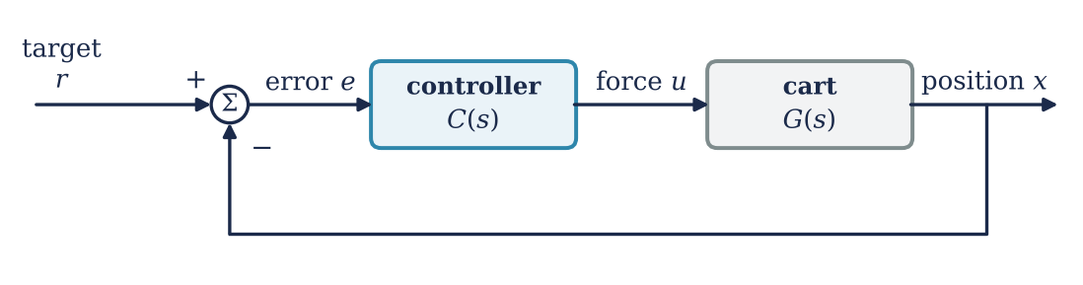
Figure 4. The feedback loop. The controller C(s) turns the error between target and position into a force on the cart G(s).
In s, with capitals for transforms as before, the loop is three equations: E = R − X, U = C(s) E and X = G(s) U. Eliminating E and U gives the closed-loop transfer function from target to position (Franklin et al., 2019, §4.1):
T(s) = X(s) / R(s) = C(s) G(s) / (1 + C(s) G(s)) (H.11)
The error is E = R / (1 + C G). For a step target, R = 1/s, and Equation H.8 gives the steady-state error:
e(∞) = 1 / (1 + C(0) G(0)) (H.12)
The cart has G(0) = 1/k. A controller removes the cart's steady-state error only if C(0) is infinite.
The PID controller sets the force from the present error, its accumulated past and its rate of change (Åström & Murray, 2008, Eq. 1.5):
u(t) = K_{p} e(t) + K_{i} ∫₀^{t} e(τ) dτ + K_{d} ė(t) (H.13)
By Equation H.6 and the rule for integrals, its transfer function is
C(s) = K_{p} + K_{i}/s + K_{d} s = (K_{d} s² + K_{p} s + K_{i}) / s (H.14)
Table 4 lists the three terms. P, PD and PI controllers set the missing gains to zero.
Table 4. The three terms of Equation H.13, for the cart.
gain | acts on | units | acts like
K_{p} | the error now | N/m | a spring pulling x toward r
K_{i} | the error summed over the past | N/(m s) | a push that grows while any error remains
K_{d} | the rate of change of the error | N s/m | a damper; a prediction of where the error is going

On the board
E = R − X, U = C E, X = G U ⇒ X = G C (R − X) ⇒ T = X/R = C G / (1 + C G)
E/R = 1/(1 + C G); step R = 1/s: e(∞) = lim s · (1/s) · 1/(1 + C G) = 1/(1 + C(0) G(0))
u = K_{p} e + K_{i} ∫ e dt + K_{d} ė ⇒ C(s) = K_{p} + K_{i}/s + K_{d} s

Check 5. With C = K_{p}, what is the cart's steady-state error? How large must K_{p} be to bring it under 1%?
Board 6. P Control
With C(s) = K_{p}, Equation H.11 gives
T(s) = K_{p} / (s² + 10 s + 20 + K_{p}) (H.15)
CTMS takes K_{p} = 300 N/m, so T(s) = 300/(s² + 10 s + 320). A denominator s² + 2ζω_{n} s + ω_{n}² describes a damped oscillation with natural frequency ω_{n} and damping ratio ζ (Franklin et al., 2019, §3.3). Here ω_{n} = √320 = 17.9 rad/s and ζ = 10/(2 × 17.9) = 0.28.
In the terms of Board 4, the poles are −5.00 ± 17.18i: the cart swings 2.7 times per second, and the swings shrink with a time constant of 0.20 s.
With a constant numerator, this form overshoots its final value by e^{−πζ/√(1−ζ²)} (Franklin et al., 2019, §3.4.2), which is 40% here. The simulated response overshoots by 40% (Figure 5A).
For comparison, Figure 5A also pushes the cart without feedback, with the steady 20 N that holds it at the target (k × 1 m). That response is Figure 1B scaled by 20. It reaches the target without overshoot, but takes 1.59 s to settle.
Under P control, the final value is T(0) = 300/320 = 0.9375, a steady-state error of 6.25%, as Equation H.12 gives. The response rises from 10% to 90% of its final value in 0.072 s, against 0.88 s for the push. It stays within 2% after 0.77 s.
Raising K_{p} raises ω_{n} but leaves the damping coefficient at 10, so ζ falls. The poles move away from the horizontal axis but stay at −5: the swings get faster and die away no sooner. A stiffer controller gives a faster response and a smaller steady-state error, with more overshoot.
On the board
C = K_{p}: T = K_{p}/(s² + 10 s + 20 + K_{p}); K_{p} = 300: T = 300/(s² + 10 s + 320)
match s² + 2ζω_{n} s + ω_{n}²: ω_{n} = √320 = 17.9 rad/s, ζ = 10/(2ω_{n}) = 0.28
overshoot = e^{−πζ/√(1−ζ²)} = 40%; T(0) = 300/320 = 0.9375 ⇒ e(∞) = 0.0625

Check 6. Which K_{p} gives the cart ζ = 0.7 under P control? What steady-state error goes with it?
Board 7. PD Control
With C(s) = K_{p} + K_{d} s,
T(s) = (K_{d} s + K_{p}) / (s² + (10 + K_{d}) s + (20 + K_{p})) (H.16)
The derivative gain adds to the damping coefficient: the controller acts as a second damper of K_{d} N s/m. With CTMS's K_{p} = 300 and K_{d} = 10, the denominator is s² + 20 s + 320. ω_{n} is unchanged, and ζ doubles to 0.56.
The poles move from −5.00 ± 17.18i to −10.00 ± 14.83i, twice as far from the vertical axis. The swings now shrink with a time constant of 0.10 s instead of 0.20 s.
The overshoot falls from 40% to 15%, and the response stays within 2% after 0.29 s instead of 0.77 s (Figure 5B). The formula of Board 6 predicts 12%. The numerator's zero, at s = −30, adds the rest (Franklin et al., 2019, §3.5).
The steady-state error stays at 6.25%, because K_{d} s vanishes at s = 0. The notes make the same point for the hand: damping needs velocity (§4).
On the board
C = K_{p} + K_{d} s: T = (K_{d} s + K_{p}) / (s² + (10 + K_{d}) s + 20 + K_{p})
K_{p} = 300, K_{d} = 10: s² + 20 s + 320 ⇒ ω_{n} = 17.9 rad/s, ζ = 20/(2ω_{n}) = 0.56
the D term adds K_{d} to the damping; at s = 0 it vanishes, so e(∞) is unchanged

In the pre-lab and Lab 08. Pre-lab Task P.2 builds the P and PD loops of Boards 6 and 7, and the PI and PID loops of Boards 8 and 9. Lab 08's Task B.3 shows why the D term is the hard part for vision: the velocity has to be differenced from noisy samples.
Check 7. With K_{p} = 300, which K_{d} makes the denominator of Equation H.16 critically damped (ζ = 1)?
Board 8. PI Control
With C(s) = K_{p} + K_{i}/s = (K_{p} s + K_{i})/s,
T(s) = (K_{p} s + K_{i}) / (s³ + 10 s² + (20 + K_{p}) s + K_{i}) (H.17)
At s = 0 the numerator and the denominator both equal K_{i}, so T(0) = 1: there is no steady-state error. The integral keeps adding force while any error remains, so the loop can come to rest only at zero error.
CTMS lowers K_{p} to 30 and takes K_{i} = 70, because the integral term also speeds the rise and adds overshoot. The response rises in 0.41 s, overshoots by 1.3% and stays within 2% after 0.62 s (Figure 5C). The denominator is now a cubic, with three poles.
The real pole at −2.09 gives a smooth part with a time constant of 0.48 s. The pair at −3.95 ± 4.22i swings 0.67 times per second, but its swings die away with a time constant of 0.25 s, before they show much. The real pole is nearest the vertical axis, so the response ends smoothly.
Figure 5C sets the PI loop against the 20 N push of Figure 5A. Both end at the target, and the PI loop gets there within 2% after 0.62 s, against 1.59 s for the push. They end at the target for different reasons.
The push was computed from k. On a cart whose spring is 10% stiffer, the same push would stop at 0.91, and P control at 0.93. The PI loop would still end at the target, because T(0) = K_{i}/K_{i} whatever k is.
On the board
C = K_{p} + K_{i}/s = (K_{p} s + K_{i})/s
T = (K_{p} s + K_{i}) / (s³ + 10 s² + (20 + K_{p}) s + K_{i}); T(0) = K_{i}/K_{i} = 1 ⇒ e(∞) = 0
K_{p} = 30, K_{i} = 70: T = (30 s + 70)/(s³ + 10 s² + 50 s + 70)

Check 8. Why does a PI controller remove the steady-state error for a step target, when a P controller cannot with any finite K_{p}?
Board 9. PID Control
With all three terms and CTMS's gains, K_{p} = 350, K_{i} = 300 and K_{d} = 50,
T(s) = (50 s² + 350 s + 300) / (s³ + 60 s² + 370 s + 300) (H.18)
The response rises in 0.055 s, with no overshoot and no steady-state error (Figure 5D). Its last percent is slow: x is 0.9935 at 2 s, because one pole sits at −0.96 per second, with a time constant of 1.04 s (Board 4).
Figure 5 sets the four controllers side by side. P control (A) is fast but overshoots and stops short, where the push without feedback is slow but exact. Adding D (B) damps the swing; adding I (C) removes the shortfall; all three (D) do both.
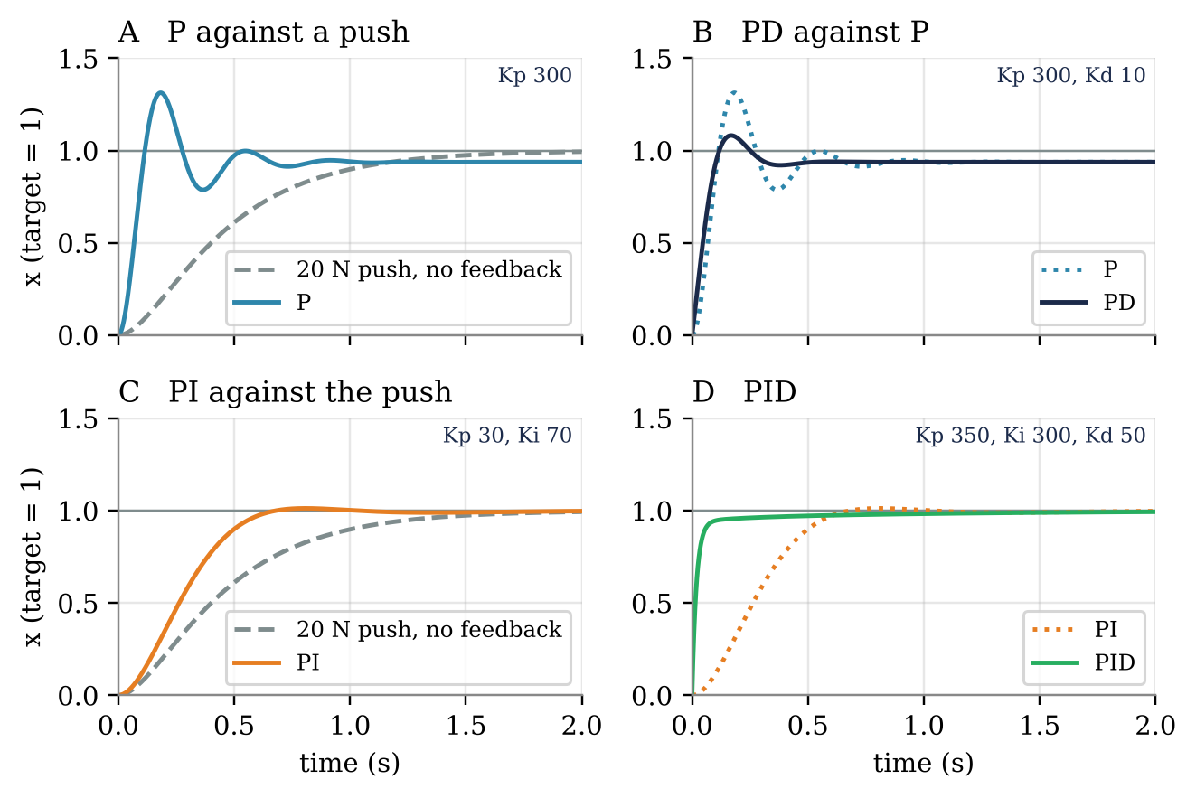
Figure 5. Step responses of the cart, target = 1 (gains in N/m, N/(m s) and N s/m). Dashed: the cart without feedback, pushed with the steady 20 N that holds it at the target (Figure 1B scaled by 20). A: P control against the push. B: PD against P. C: PI against the push. D: PID against PI.
Figure 6 shows where each controller puts the poles.
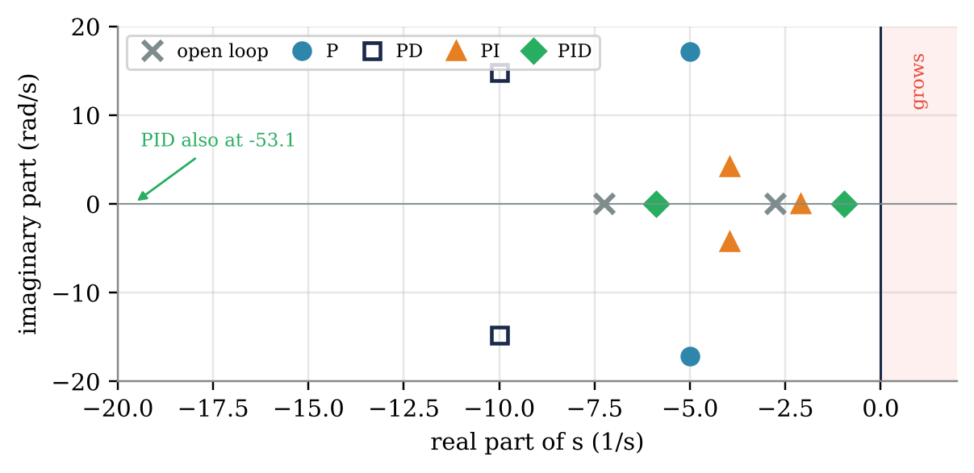
Figure 6. The poles of the cart alone and of the four closed loops, in the complex plane. A pole to the right of the vertical line would grow. The PID loop has a third pole at −53.1, off the left edge.
Table 5 reads the poles as in Board 4. P control swings fast, 2.7 times per second. D moves its poles further left, so the swings die out twice as fast. I adds a slow, smooth part. The PID controller's pole at −0.96 is the slowest part of any loop here, which is why its last percent takes seconds.
Table 5. The poles of Figure 6, read as in Board 4: the time constant of each smooth part, and the rate and time constant of each swing.
loop | poles (1/s) | smooth parts: time constants | swings: per second; time constant
the cart alone | −2.76, −7.24 | 0.36 s, 0.14 s | none
P | −5.00 ± 17.18i | none | 2.73 per s; 0.20 s
PD | −10.00 ± 14.83i | none | 2.36 per s; 0.10 s
PI | −2.09, −3.95 ± 4.22i | 0.48 s | 0.67 per s; 0.25 s
PID | −53.14, −5.90, −0.96 | 0.02 s, 0.17 s, 1.04 s | none

CTMS summarizes each gain's effect in a table, and warns that the effects are approximate because the gains interact. Table 6 tests each entry on the cart. Each gain is doubled in the example where CTMS introduced it.
Table 6. The rules of thumb that CTMS tabulates, and the same changes on the cart: K_{p} doubled in P control, K_{i} in PI control and K_{d} in PD control.
raise | rise time | overshoot | settling time | steady-state error
K_{p}, rule of thumb | decrease | increase | small change | decrease
K_{p}: 300 → 600 | 0.072 s → 0.048 s | 40.1% → 52.5% | 0.77 s → 0.79 s | 6.3% → 3.2%
K_{i}, rule of thumb | decrease | increase | increase | removes it
K_{i}: 70 → 140 | 0.408 s → 0.281 s | 1.3% → 24.9% | 0.62 s → 1.65 s | 0.0% → 0.0%
K_{d}, rule of thumb | small change | decrease | decrease | little or none
K_{d}: 10 → 20 | 0.078 s → 0.070 s | 15.3% → 5.8% | 0.29 s → 0.27 s | 6.3% → 6.3%

On the cart, every entry holds. CTMS also gives a design procedure:
- Find the open-loop response and decide what needs to improve.
- Add a proportional term to shorten the rise time.
- Add a derivative term to reduce the overshoot.
- Add an integral term to remove the steady-state error.
- Adjust the gains until the response is acceptable, and use only the terms the task needs.
For the cart, CTMS notes that PI control alone already met their goals.
On the board
C = (K_{d} s² + K_{p} s + K_{i})/s; T = (K_{d} s² + K_{p} s + K_{i}) / (s³ + (10 + K_{d}) s² + (20 + K_{p}) s + K_{i})
K_{p} = 350, K_{i} = 300, K_{d} = 50: T = (50 s² + 350 s + 300)/(s³ + 60 s² + 370 s + 300)
P: faster, smaller error, more overshoot. D: less overshoot. I: no steady-state error, slower settling.

In the pre-lab. Task P.2 runs all four controllers of Figure 5 and reads their poles as in Table 5. Lab 08's loop is PD only, for the reason Board 10 gives.
Check 9. The PD response of Board 7 overshoots by about 15%. Which gain would you raise to cut the overshoot, and what would it do to the steady-state error?
Board 10. The Hand
This week's model has no muscles (notes §1.3), so the hand has no spring and no damper of its own. Near the start posture it is a mass. Week 6 found that this mass depends on the direction of the push: 0.30 kg along the hand's light axis and 2.09 kg along its heavy axis (Week 6 §2.1).
Along either axis, Equation H.1 with b = k = 0 gives G(s) = 1/(m s²). A PD controller that commands a force, F = K e + D ė, gives the denominator m s² + D s + K. Dividing by m and matching Board 6's form gives
ω_{n} = √(K/m), ζ = D / (2√(K m)) (H.19)
The same gains act on two different masses. With K = 10 N/m and D = 2 N s/m, the light axis has ζ = 0.58 and overshoots by 11%. The heavy axis has ζ = 0.22 and overshoots by 49% (Figure 7A). The two damping ratios differ by √(2.09/0.30) = 2.6.
Week 6's inverse dynamics removes the difference. The controller commands a hand acceleration a, and τ = M(q) J(q)⁻¹ a turns it into torque (notes Figure 3). The hand then accelerates as commanded in every direction, so G(s) = 1/s². A PD command a = K_{p} e + K_{d} ė gives the denominator s² + K_{d} s + K_{p} on every axis.
This PD command is the gains box of the notes' Figure 3. K_{p} multiplies the position error e_{k}, between the plan and the latest sample, and K_{d} multiplies its rate ė_{k}. The PD term only corrects the reach; Week 6's feedforward torque still drives it, along the top row of that figure.
Two differences from the cart. The output is an acceleration, so the gains are per unit mass: K_{p} in 1/s² and K_{d} in 1/s, where the cart's were in N/m and N s/m. And vision reports only positions, so ė_{k} is not a true derivative: it is the difference of two samples divided by T_{S} (notes Equation 8.8).
The hand needs no integral term to reach a still target. G(s) = 1/s² is infinite at s = 0, so Equation H.12 gives e(∞) = 0 with PD control alone. The cart needed the integral term because its spring holds it short of the target unless the controller keeps pushing.
On the board
hand = a mass, no spring, no damper: m ẍ = F ⇒ G(s) = 1/(m s²)
force PD: m s² + D s + K ⇒ ω_{n} = √(K/m), ζ = D/(2√(K m)); m = 0.30 or 2.09 kg
acceleration PD (Week 6, τ = M J⁻¹ a): s² + K_{d} s + K_{p} on every axis
G(0) = ∞ ⇒ e(∞) = 1/(1 + C(0) G(0)) = 0 without an integral term

In the pre-lab and Lab 08. Pre-lab Task P.3 gives the hand Lab 08's gains without the delay. Lab 08's Task C.1 builds the same controller on the two-joint arm, and Task C.6 turns its gains into a stiffness, m K_{p}.
Check 10. With the force command and K = 10 N/m, which D gives the heavy axis ζ = 0.7? What is ζ on the light axis then?
Board 11. The Hand With a Delay
Vision reports the hand Δ late (notes Equation 8.1), so the controller acts on e(t − Δ). By Equation H.7, the delay multiplies the correction by e^{−sΔ}, and the denominator of the loop becomes
s² + (K_{p} + K_{d} s) e^{−sΔ} = 0 (H.20)
This is the characteristic equation of the notes' Equation 8.4. For central vision the effective delay is Δ = 155 ms (notes §3.2). Equation H.20 is not a polynomial: e^{−sΔ} gives it infinitely many roots, and the quadratic formula no longer applies. The root that matters most is the one nearest the vertical axis, the slowest (Board 4). The notes find it with the Lambert W function (Equation 8.5) or numerically.
Take the gains of the notes' Figure 4, κ = K_{p}Δ² = 0.2 and δ = K_{d}Δ = 0.9, so K_{p} = 8.3 s⁻² and K_{d} = 5.8 s⁻¹. Without the delay, s² + 5.8 s + 8.3 has ζ = 1.01. From a 1 cm offset, the error falls smoothly to zero (Figure 7B).
With the delay, the root nearest the vertical axis is −1.86 ± 7.29i: 1.2 swings per second, with a time constant of 0.54 s. The error falls faster at first, because the braking from the velocity term arrives late. It then stalls once every 2π/7.29 = 0.86 s, and shrinks by a factor e every 1/1.86 = 0.54 s (Figure 7B). The same root sets the swings of the notes' Figure 4B.
Now raise the gains toward the edge of the notes' Equation 8.7, to κ = 0.5 and δ = 0.95. Without the delay, these gains give ζ = 0.67 and an overshoot of 6%. With the delay, the root moves to −0.22 ± 6.96i, close to the vertical axis (Figure 3E). Its time constant is 4.5 s, so the error swings across zero for about 18 s before the swings are down to 2% (Figure 7B).
On the cart, a larger K_{p} only added overshoot. Here the delay sets a limit, K_{p}Δ² < 0.55 (notes Equation 8.7): K_{p} < 22.9 s⁻² at 155 ms.
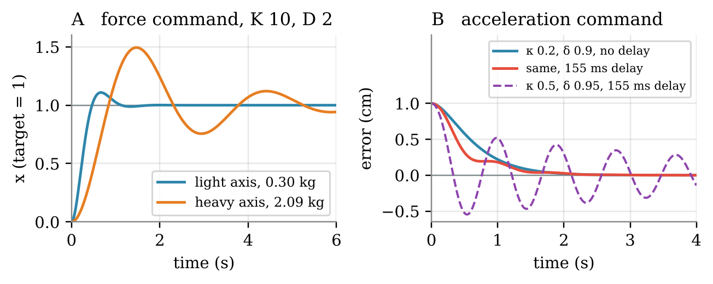
Figure 7. The hand, along one axis. A: a PD force command with K = 10 N/m and D = 2 N s/m, step to a target; the same gains act on the light and the heavy axis. B: a PD acceleration command (Week 6's inverse dynamics) from a 1 cm offset, with and without a 155 ms delay. κ = K_{p}Δ² and δ = K_{d}Δ, with Δ = 155 ms in both.
On the board
the controller sees e(t − Δ): e(t − Δ) → e^{−sΔ} E(s) ⇒ s² + (K_{p} + K_{d} s) e^{−sΔ} = 0
not a polynomial: infinitely many roots; the rightmost one decides (notes Eq. 8.5, 8.7)
κ = 0.2, δ = 0.9, Δ = 155 ms: no delay ζ = 1.01; with delay s = −1.86 ± 7.29i
limit: K_{p}Δ² < 0.55

In the pre-lab and Lab 08. Pre-lab Task P.4 steps Equation H.20 forward in time, with and without the D term. Lab 08's Tasks C.3 to C.5 measure the same growth on the arm and find the limit of Equation 8.7.
Check 11. Put s = iω in e^{−sΔ}. What are its size and its phase? What does the delay therefore do to a correction at frequency ω?
The Same Steps in Python
CTMS works in MATLAB. In Python, scipy.signal does the same steps. The code builds Equation H.18 from the cart and the PID gains, and computes its step response.
import numpy as np
from scipy import signal

m, b, k = 1.0, 10.0, 20.0 # the cart: kg, N s/m, N/m
Kp, Ki, Kd = 350.0, 300.0, 50.0 # CTMS's PID gains

# C(s) G(s) = (Kd s^2 + Kp s + Ki) / (s (m s^2 + b s + k))
CG_num = [Kd, Kp, Ki]
CG_den = np.polymul([1, 0], [m, b, k])

# T(s) = C G / (1 + C G), Equation H.11
T = signal.TransferFunction(CG_num, np.polyadd(CG_den, CG_num))
t, x = signal.step(T, T=np.linspace(0, 2, 2001))
print(T.poles) # three poles, all with negative real parts
print(x[-1]) # 0.99 at 2 s, still creeping toward 1

T.poles gives the three poles of Figure 6, and x[-1] is 0.9935, the value of Board 9 at 2 s. Changing the three gains reproduces Boards 6 to 8.
Answers to the Checks
- x = F/k: 10 cm for a 2 N push; 2.5 cm with the spring twice as stiff.
- Integrate by parts: ∫₀∞ t e^{−st} dt = [−t e^{−st}/s]₀∞ + (1/s) ∫₀∞ e^{−st} dt = 0 + 1/s².
- s² + 20 = 0 gives s = ±i√20 = ±4.47i, on the vertical axis (Figure 3F). The cart swings about 5 cm 0.71 times per second and never settles, so Equation H.8 does not apply.
- 12.6/(2π) = 2.0 swings per second. The time constant is 1/2 = 0.5 s, so the swings are down to 2% after about 4 × 0.5 = 2 s.
- e(∞) = 1/(1 + K_{p}/20) = 20/(20 + K_{p}). Under 1% needs K_{p} > 1980 N/m.
- ζ = 10/(2√(20 + K_{p})) = 0.7 gives 20 + K_{p} = 51, so K_{p} = 31 N/m. The steady-state error is then 20/51 = 39%.
- 10 + K_{d} = 2√320 = 35.8, so K_{d} = 25.8 N s/m.
- Equation H.12: e(∞) = 1/(1 + C(0)G(0)). For PI, C(0) = K_{p} + K_{i}/0 is infinite, so e(∞) = 0. For P, C(0) = K_{p} is finite and e(∞) = 20/(20 + K_{p}) > 0.
- K_{d}. In Table 6, doubling it cut the overshoot from 15% to 5.8% and left the steady-state error at 6.25%. Raising K_{p} would add overshoot.
- D = 2 × 0.7 × √(10 × 2.09) = 6.4 N s/m. On the light axis, ζ = 6.4/(2√(10 × 0.30)) = 1.8: overdamped, slow without overshoot.
- e^{−iωΔ} has size 1 and phase −ωΔ. The delay does not change the size of a correction; it shifts it later by ωΔ radians, so part of it pushes with the motion instead of against it (notes §3.2).
References
· Control Tutorials for MATLAB and Simulink. Introduction: PID controller design. University of Michigan, Carnegie Mellon University and University of Detroit Mercy. https://ctms.engin.umich.edu/CTMS/index.php?example=Introduction&section=ControlPID — The cart, the gains, the rules of thumb and the design procedure; Boards 1 and 6–8.
· Franklin, G. F., Powell, J. D., & Emami-Naeini, A. (2019). Feedback control of dynamic systems (8th ed.). Pearson. — The Laplace transform, partial fractions and the final value theorem (§3.1); poles, time-domain specifications and zeros (§3.3–3.5); the closed loop and PID control (§4.1–4.3).
· Åström, K. J., & Murray, R. M. (2008). Feedback systems: An introduction for scientists and engineers. Princeton University Press. — The PID controller (Eq. 1.5, p. 24); Laplace transforms (§8.5); PID control (Chapter 10). The authors make the book available online.
· Week 6 lecture notes, §2.1 (the hand's effective mass), and the Week 8 lecture notes, §2 (the PD controller, Figures 3–4) and §3 (the delayed loop).

