WEEK 8
Vision & Sensory Delay
The First Sense — and Why It’s Not Enough
Reading: Keele, S. W., & Posner, M. I. (1968). Processing of visual feedback in rapid movements. Journal of Experimental Psychology, 77(1), 155–158.
Reading: Elliott, D., Lyons, J., Hayes, S. J., Burkitt, J. J., Roberts, J. W., Grierson, L. E. M., Hansen, S., & Bennett, S. J. (2017). The multiple process model of goal-directed reaching revisited. Neuroscience and Biobehavioral Reviews, 72, 95–110.
Supplementary: Carrasco, M., McElree, B., Denisova, K., & Giordano, A. M. (2003). Speed of visual processing increases with eccentricity. Nature Neuroscience, 6(7), 699–700.
Supplementary: Woodworth, R. S. (1899). The accuracy of voluntary movement. The Psychological Review: Monograph Supplements, 3(3), i.
Supplementary: van Beers, R. J., Sittig, A. C., & Denier van der Gon, J. J. (1998). The precision of proprioceptive position sense. Experimental Brain Research, 122, 367–377.
Introduction
In Week 7, we established the feedforward frontier — the hard limit on endpoint accuracy imposed by signal-dependent noise. The inverse dynamics controller traced a descending curve through the speed-accuracy plane: faster movements require larger torques, which are noisier, which produce wider endpoint scatter. Below the frontier lies a region that no feedforward controller can reach without additional information about the state of the arm. The closing insight was: below the frontier lies a region accessible only to controllers that sense, estimate, and correct. This week we begin building the sensory pipeline that will let us enter that region.
We start with vision — the highest-acuity sense for spatial localization, but one burdened by substantial processing delay. The core tension of this week is that vision is both powerful and slow. By the time the brain has processed where the hand is, the hand has moved. Feedback corrections are always based on stale information, and naive correction strategies can be worse than no correction at all.
This week also introduces a richer framework for online correction than the simple “ballistic + corrective” model from Woodworth (1899). Elliott et al. (2010, 2017) argue that reaching involves two distinct types of online regulation — impulse control (early, continuous, driven by velocity and direction expectations) and limb-target control (late, discrete, driven by limb-target position comparison) — each served by different visual channels with different latencies and noise profiles. This distinction maps directly onto the anatomy of the retina: peripheral vision, with its fast temporal processing and motion sensitivity, serves impulse control; foveal vision, with its high spatial acuity, serves limb-target control.
The roadmap for Module 3: vision (this week) → proprioception and the Kalman filter (Week 9) → multisensory integration under degraded conditions (Week 10) → The Duel (Week 11).
1. When Does Vision Matter? Keele & Posner to the Multiple Process Model
Keele & Posner (1968): The Visual Processing Window
The most direct way to ask whether vision helps during a movement is to turn off the lights. Keele and Posner (1968) did exactly this: participants made discrete aiming movements to a target at varying speeds under two conditions — lights-on (full vision throughout the movement) and lights-off (the room was darkened at movement onset, eliminating visual feedback during the movement while preserving the initial target location in memory). Crucially, they used discrete, single movements rather than the repetitive back-and-forth tasks used in prior studies. Earlier estimates of visual processing time had been ~500 ms or longer, but those studies included the time required to reverse direction, inflating the estimate. By isolating the single movement, Keele and Posner obtained a much tighter bound.
At the fastest movement times (~190 ms), there was essentially no difference in the proportion of missed targets between the lights-on and lights-off conditions. Vision was present but had not yet been processed in time to influence the ongoing movement. At intended movement durations of 250 ms and beyond, the lights-on condition was progressively more accurate than lights-off. The divergence between the two curves marked the onset of visual feedback utilization. From these data, Keele and Posner estimated the minimum time required for the visual system to process feedback and issue an online correction: 190–260 ms.
Several additional findings from this study are important for what follows. First, accuracy improved with slower movements even in the dark — there was no visual feedback, yet slower movements were more precise. Keele and Posner suggested two explanations: (a) kinesthetic (proprioceptive) feedback, which has a reaction time of approximately 110–130 ms and is therefore ~50 ms faster than visual reaction time, could be driving corrections in the dark; or (b) slower movements allow more detailed initial motor commands. Either way, the improvement in the dark points to a second sensory channel operating alongside — or instead of — vision.
Second, the rate of accuracy improvement with movement time was steeper with vision than without. Vision adds a correction channel on top of whatever feedforward or kinesthetic mechanisms are already at work. Third, movement times were slightly longer with lights-on than lights-off, suggesting that participants may actively slow down to exploit the additional feedback — an early example of strategic behavior. Figure 1 illustrates these findings.

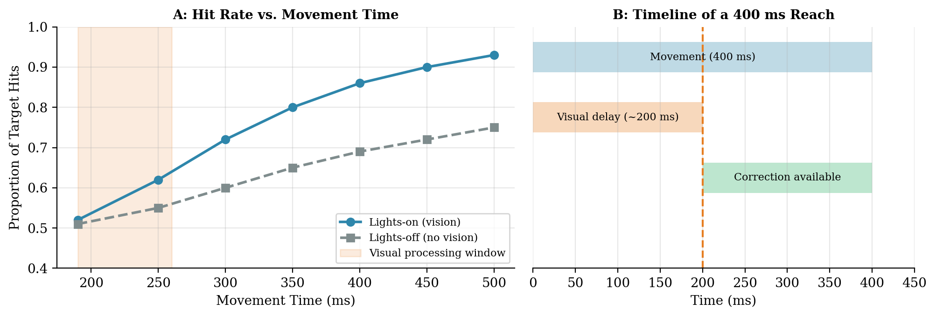
Figure 1. The Keele & Posner (1968) result, reproduced schematically. A: Hit rate vs. movement time under lights-on and lights-off conditions. The curves diverge at approximately 250 ms, establishing the minimum visual processing time for online correction at 190–260 ms. B: Timeline of a 400 ms reach showing when visual information becomes available relative to the movement.
Elliott et al. (2010, 2017): Two Types of Online Control
Keele and Posner’s 190–260 ms estimate captures the latency of one type of online correction. But subsequent work revealed that limb regulation begins much earlier — as fast as 70–100 ms after a perturbation (Bard, Hay, & Fleury, 1985; Cluff, Crevecoeur, & Scott, 2015). How can visual correction be operating 100 ms before the minimum visual processing time? The answer is that there are two distinct corrective processes, not one.
Elliott et al.’s multiple process model of goal-directed reaching resolves this apparent contradiction by distinguishing two forms of online regulation that operate in parallel on different timescales.
Impulse control (early, continuous): This process begins during the distance-covering phase of the movement. It does not compare the limb’s position to the target’s position. Instead, it compares the actual sensory consequences of the movement (the limb’s velocity and direction as detected primarily by peripheral vision and proprioception) to an internal model of the expected sensory consequences formed during movement planning. If the hand is moving faster or in a different direction than expected, impulse control makes graded, continuous adjustments to the trajectory. The latency of these adjustments is approximately 70–100 ms. Critically, impulse control incurs little or no additional movement time — it modulates the ongoing trajectory smoothly rather than appending discrete corrective submovements.
Limb-target control (late, discrete): This process operates during the deceleration phase and involves comparing the relative spatial positions of the limb and the target. It requires precise position information — typically provided by foveal (central) vision. The latency of limb-target control is approximately 180–260 ms, consistent with Keele and Posner’s estimate. When the limb falls short of the target at the end of the primary movement, limb-target control produces a discrete corrective submovement. This correction costs additional movement time.
The key insight for this week: these two control processes map onto different visual channels. Peripheral vision, with its fast temporal processing and superior motion sensitivity, serves impulse control. Foveal vision, with its high spatial acuity, serves limb-target control. This mapping is not a coincidence — the retina’s spatial inhomogeneity is matched to the temporal structure of the correction hierarchy.

From Woodworth to Elliott: Three Generations of Feedback Models
Elliott et al.’s multiple process model updates Woodworth’s two-component framework in three important ways. First, the “ballistic” phase is not truly ballistic — impulse control modulates it continuously based on a comparison between actual and expected sensory consequences. Second, the two corrective processes use different types of visual information: velocity and direction for impulse control, spatial position for limb-target control. Third, performers strategically adjust their planning based on prior knowledge of what feedback will be available.
Our simulations this week will focus on continuous online correction (§4), which captures elements of both impulse and limb-target control. The full separation of these processes — and the forward model that impulse control requires — is a direct bridge to the Kalman filter in Week 9.

Impulse control: Δ_peripheral ≈ 80 ms → correction at ~70–100 ms
Limb-target control: Δ_central ≈ 150 ms → correction at ~180–260 ms

For limb-target correction to help: T > ~250 ms (Keele & Posner)
For impulse correction to help: T > ~150 ms

Simulation: Stale Feedback Is Dangerous
To make the delay problem visceral, we build a feedback controller that combines feedforward inverse dynamics torques with a proportional-derivative (PD) correction based on delayed visual position (Kp = 5, Kd = 1.5, velocity error formulation). Sensor noise is σ = 0.3 mm — small enough that velocity estimation via differentiation is tolerable (velocity noise SD = 0.3 mm / 1 ms = 0.3 m/s ≈ peak hand velocity). We simulate a 10 cm center-out reach at T = 600 ms and run 15 trials for each delay.
At zero delay (Δ = 0 ms), the PD correction is synchronized with actual hand motion. Position errors are corrected immediately, and the velocity error term damps residual oscillation. The hand paths stay in a tight bundle around the desired trajectory. At Δ = 100 ms, the correction is based on where the hand was 100 ms ago. By the time the correction arrives, the hand has moved, and the correction overshoots — the paths fan out, and the single-trial traces in Figure 2B and 2C show the hand drifting beyond the target in both x and y. At Δ = 200 ms, the delayed correction actively destabilizes the trajectory: the hand overshoots far beyond the target. Figure 2C is particularly revealing — the desired y-position is constant (a horizontal reach), yet delayed feedback produces large y-deviations because the Jacobian-transpose correction couples the two joints: a delayed x-error drives a torque that also deflects the hand in y.

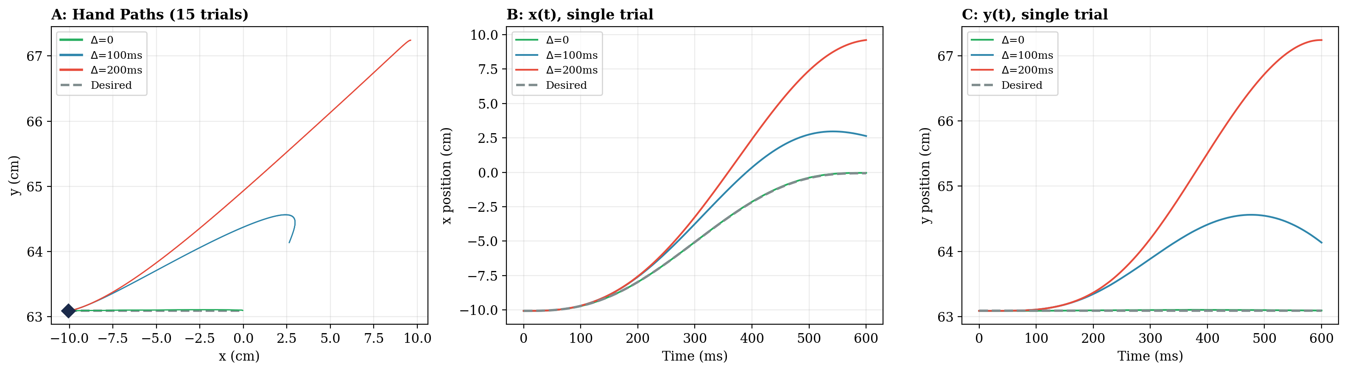
Figure 2. The stability cost of sensory delay. Feedforward ID + PD correction (Kp = 5, Kd = 1.5, velocity error) with σ = 0.3 mm sensor noise on a 10 cm center-out reach (T = 600 ms). A: 15 trials per condition. At zero delay (green), feedback is synchronized and keeps paths tight. At 100 ms delay (teal), stale correction causes overshoot — paths fan out. At 200 ms (red), delayed feedback actively destabilizes the trajectory. B: Single-trial x-position — the delayed curves overshoot the target in x. C: Single-trial y-position — the desired trajectory is a horizontal straight line (y is constant), but delayed feedback produces growing y-deviation because the Jacobian-transpose correction couples the two joints: a delayed x-error drives a torque that also deflects the hand in y.

The nervous system faces a dilemma: high gain corrects errors quickly, but high gain with long delay causes oscillation. The solution is not to crank up the gain — it is to reduce effective delay through prediction (forward models, Week 9) and to keep gain in a stable regime. This is why human corrections look smooth and gradual rather than sharp and jerky. Elliott et al.’s framework explains the mechanism: the nervous system runs two loops at different timescales, each with appropriate gain.

2. Foveated Vision: Two Sensors for Two Control Processes
Spatial Resolution — The Foveal Advantage
The fovea occupies only the central ~2° of the visual field, yet it contains the highest density of cone photoreceptors — approximately 200,000 cones per mm². This dense packing gives the fovea exceptional spatial resolution. How precise is foveal localization in motor-relevant terms? Van Beers, Sittig, and Denier van der Gon (1998) measured the precision of visual hand localization in a position-matching task and found standard deviations of 0.2–0.6° in the azimuthal direction (the precise axis for vision). At typical reaching distances (~35 cm), this corresponds to approximately 1–4 mm SD. For our simulations, we use σ_foveal ≈ 1 mm, representing the precise end of this range — appropriate for a well-lit, high-contrast target at the fovea.
Moving away from the fovea, cone density drops roughly 50-fold by 30° eccentricity. In the periphery, multiple photoreceptors converge onto single ganglion cells, pooling signals over larger retinal areas. The periphery also suffers from a “crowding bottleneck”: nearby stimuli interfere with recognition, and positional uncertainty is high. We model peripheral position noise as σ_peripheral ≈ 5 mm, capturing the ~5× acuity gradient at typical reaching eccentricities (~15–20°). These values are modeling simplifications — the actual noise depends on eccentricity, contrast, target size, and whether the object is stationary or moving — but they capture the essential order-of-magnitude tradeoff between the two channels.
Temporal Processing and Motion — The Peripheral Advantage
If the story ended with spatial resolution, peripheral vision would be nothing more than a degraded copy of foveal vision. But Carrasco, McElree, Denisova, and Giordano (2003) demonstrated that the speed of visual processing actually increases with eccentricity. Stimuli presented at 9° eccentricity reached discriminability approximately 87 ms faster than stimuli at 4°. The periphery processes visual onset faster than the fovea.
The periphery is also more sensitive to motion than the fovea for moderate to fast speeds (above 0.5°/s). Peripheral motion thresholds are often lower (better) than foveal thresholds. This seems paradoxical: how can the region with worse spatial resolution be better at detecting motion? The answer lies in surround suppression. The fovea exhibits stronger center-surround inhibitory interactions than the periphery. For a given stimulus size, foveal motion thresholds can actually be worse because the inhibitory surround is triggered more easily, suppressing the motion signal.
Mapping Retinal Anatomy to Control Processes
The foveal and peripheral channels are not simply “good” and “bad” versions of the same sensor. Each is optimized for a different computational role in the correction hierarchy described by Elliott et al. (2017).

Property | Foveal (Central) | Peripheral
Spatial acuity | Excellent (~1 mm SD) | Poor (~5–8 mm SD), crowding
Motion sensitivity | Moderate (surround suppression) | Superior for speeds > 0.5°/s
Processing speed | Slower (onset detection) | Faster (~87 ms advantage)
Delay (Δ) | ~150 ms | ~80 ms
Serves which control? | Limb-target control (spatial position) | Impulse control (velocity, direction)
Correction latency | ~180–260 ms | ~70–100 ms

The fovea provides precise spatial coordinates for limb-target control: where exactly is the target, and where exactly is the hand relative to it? The periphery provides fast motion and velocity information for impulse control: is the hand moving at the expected speed and in the expected direction?
Eye-Hand Coordination During Reaching
Elliott et al. (2017) describe the typical eye-hand coordination during a reach. The eyes saccade to the target before or at the onset of the hand movement. The hand then crosses from the peripheral visual field into the foveal field as it approaches the target. This coordination ensures that the right type of visual information is available at the right time: early in the movement, peripheral vision detects the hand’s motion for impulse control; late in the movement, foveal vision provides precise spatial information for limb-target control. Figure 3 illustrates this coordination at three timepoints during a reach.

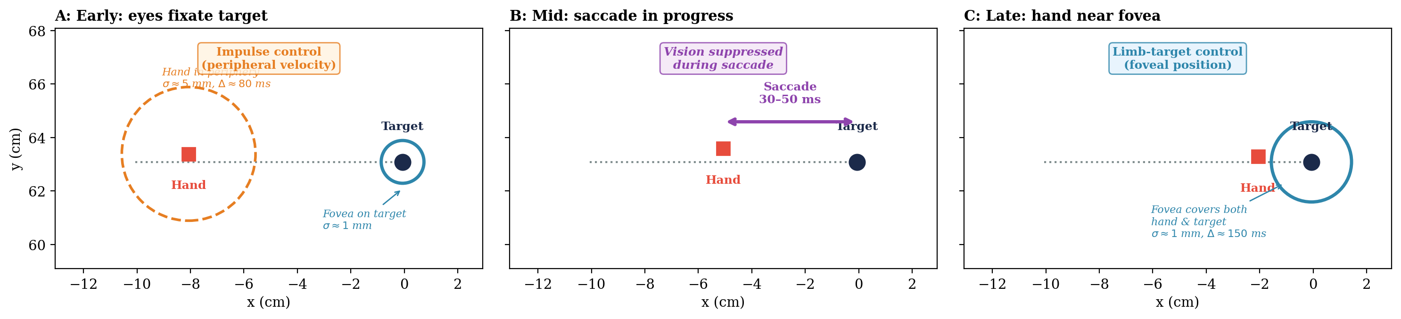
Figure 3. The visual field during a reaching movement. A: Early — the hand is in the periphery, where fast motion detection drives impulse control (Δ ≈ 80 ms, σ ≈ 5 mm). The target is at the fovea. B: Mid — a saccade is in progress; vision is suppressed for 30–50 ms. C: Late — the hand has entered the foveal region, enabling precise limb-target control (Δ ≈ 150 ms, σ ≈ 1 mm).

Modeling Two Visual Channels: Central and Peripheral
For the Sensor class (§3), we simplify the visual system into two discrete channels — a central (foveal) channel and a peripheral channel — each with different delay and noise parameters. This is a modeling simplification, not a claim about visual anatomy. In reality, retinal properties vary continuously with eccentricity: cone density, receptive field size, processing speed, and motion sensitivity all change gradually from the fovea outward. There is no sharp boundary between “central” and “peripheral.” Our two-channel model captures the essential tradeoff — one channel is fast but noisy, the other is slow but precise — while remaining simple enough to simulate and analyze. A further simplification: peripheral vision primarily contributes velocity and direction information, while foveal vision contributes spatial position. We model both as position sensors, deferring the velocity channel to Week 9’s forward model. Figure 4 demonstrates the output of both channels on a simulated reach.

Peripheral: y_p(t) = x_hand(t − Δ_p) + ε_p(t), ε_p ~ N(0, σ_p² · I₂), Δ_p = 80 ms, σ_p = 5 mm
Central: y_c(t) = x_target(t − Δ_c) + ε_c(t), ε_c ~ N(0, σ_c² · I₂), Δ_c = 150 ms, σ_c = 1 mm

Note: peripheral vision reports both hand position and, critically, its velocity and
direction of motion (Bard et al., 1985; Proteau & Masson, 1997). Central vision reports
the target position. Our Sensor class models both as position-only for simplicity.

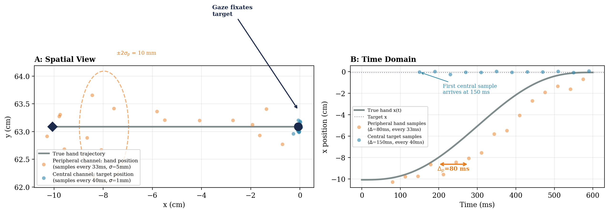
Figure 4. Discrete measurements from the two visual channels during a 10 cm center-out reach (T = 600 ms). Gaze fixates the target throughout. The central channel (teal dots) reports the target’s position with low noise (σ = 1 mm) at ~40 ms intervals, arriving after a 150 ms delay. The peripheral channel (orange dots) reports the hand’s position with higher noise (σ = 5 mm) at ~33 ms intervals, arriving after an 80 ms delay. A: Spatial view — the peripheral samples scatter along the trajectory while the central samples cluster tightly around the target. The dashed ellipse shows the ±2σ noise envelope for the peripheral channel. B: Time domain — the peripheral samples (orange) track the true hand x-position (gray) with visible scatter and 80 ms lag; the central samples (teal) cluster near the target x-position (dotted line). The first central sample does not arrive until 150 ms.

The Peripheral Advantage for Motion Detection
The peripheral advantage for motion detection explains a common experience: you notice a fly in your peripheral vision before you can identify it. For reaching, peripheral vision detects that the hand has deviated from the expected trajectory — even though it cannot say precisely where the hand is. This “alarm” function is exactly what impulse control needs: a fast signal that something is wrong with the velocity or direction, not a precise spatial coordinate.
Elliott et al. cite evidence that impulse control operates even when participants are unaware that a perturbation has occurred (Saunders & Knill, 2003; Proteau et al., 2009) — consistent with the periphery’s role as a rapid, pre-attentive motion detector.

3. The Sensor Class
We now formalize the concept of a sensory channel as a reusable software object: the Sensor class. A Sensor has three components: a delay buffer that stores recent states, a noise covariance matrix that defines measurement precision, and a sense() method that returns a delayed, noisy measurement. This class will be used throughout Module 3 — for central vision and peripheral vision this week, for proprioception in Week 9, and for multisensory fusion in Week 10.
The Delay Buffer
Sensory delay means the brain does not have access to the current state of the limb — only to a state from Δ ms in the past. We implement this with a ring buffer: a fixed-size array that stores the most recent N = ceil(Δ/dt) true states. At each simulation timestep, the current true state is pushed onto the buffer, and the state from Δ ms ago is popped out.
Noise Injection
The delayed state is corrupted by measurement noise drawn from a multivariate Gaussian: ε(t) ~ N(0, R), where R is the noise covariance matrix. For the visual sensors modeled this week, R is isotropic: R = σ² · I₂, where σ is the position noise standard deviation (1 mm for central, 5 mm for peripheral). In Week 10, we will introduce anisotropic covariance to model directional biases in sensory noise.
The API
The Sensor class exposes a single method: sensor.sense(true_state, t), which returns the delayed, noisy 2D position measurement y(t). The simulation loop becomes clean: at each timestep, compute the true state, pass it to each sensor, and collect the measurements.

y(t) = x(t − Δ) + ε(t), ε(t) ~ N(0, R)

Ring buffer length: N_buf = ceil(Δ / dt)

Central vision: Sensor(delay=0.150, R=np.eye(2) * 0.001**2)
Peripheral vision: Sensor(delay=0.080, R=np.eye(2) * 0.005**2)

The two visual sensors are instantiated with the parameters derived in §2. Central vision has a longer delay (150 ms) but lower noise (1 mm). Peripheral vision has a shorter delay (80 ms) but higher noise (5 mm). In Lab 08, students will implement the Sensor class and verify that its output matches the statistical properties specified above. Figure 5 confirms that the class produces the correct delay offsets and noise distributions.
An important design point: the Sensor class is a general-purpose delay-and-noise object. It does not know whether it is sensing the hand or the target — it simply takes whatever true state you pass in and returns a delayed, noisy version. What a sensor measures depends on where gaze is directed. When gaze fixates the target (the typical strategy), the peripheral channel senses the hand and the central channel senses the target. When gaze tracks the hand (§4), the central channel senses the hand instead. The simulation code determines what each Sensor object receives; the Sensor itself is agnostic.
This generality is deliberate, because in the natural gaze-on-target condition, the hand’s position is estimated by two independent channels: peripheral vision (Δ = 80 ms, σ = 5 mm) and proprioception (Δ ≈ 30 ms, σ depending on joint configuration). Both are Sensor objects with different parameters, both sensing the same true hand state. The target’s position is estimated by a third Sensor: foveal vision (Δ = 150 ms, σ = 1 mm). Fusing multiple noisy, delayed estimates of the same quantity — hand position from peripheral vision and proprioception — is the optimal estimation problem that the Kalman filter solves in Week 9. The architecture is three Sensor objects feeding into an estimator, and the controller then computes the error between the fused hand estimate and the foveal target estimate.

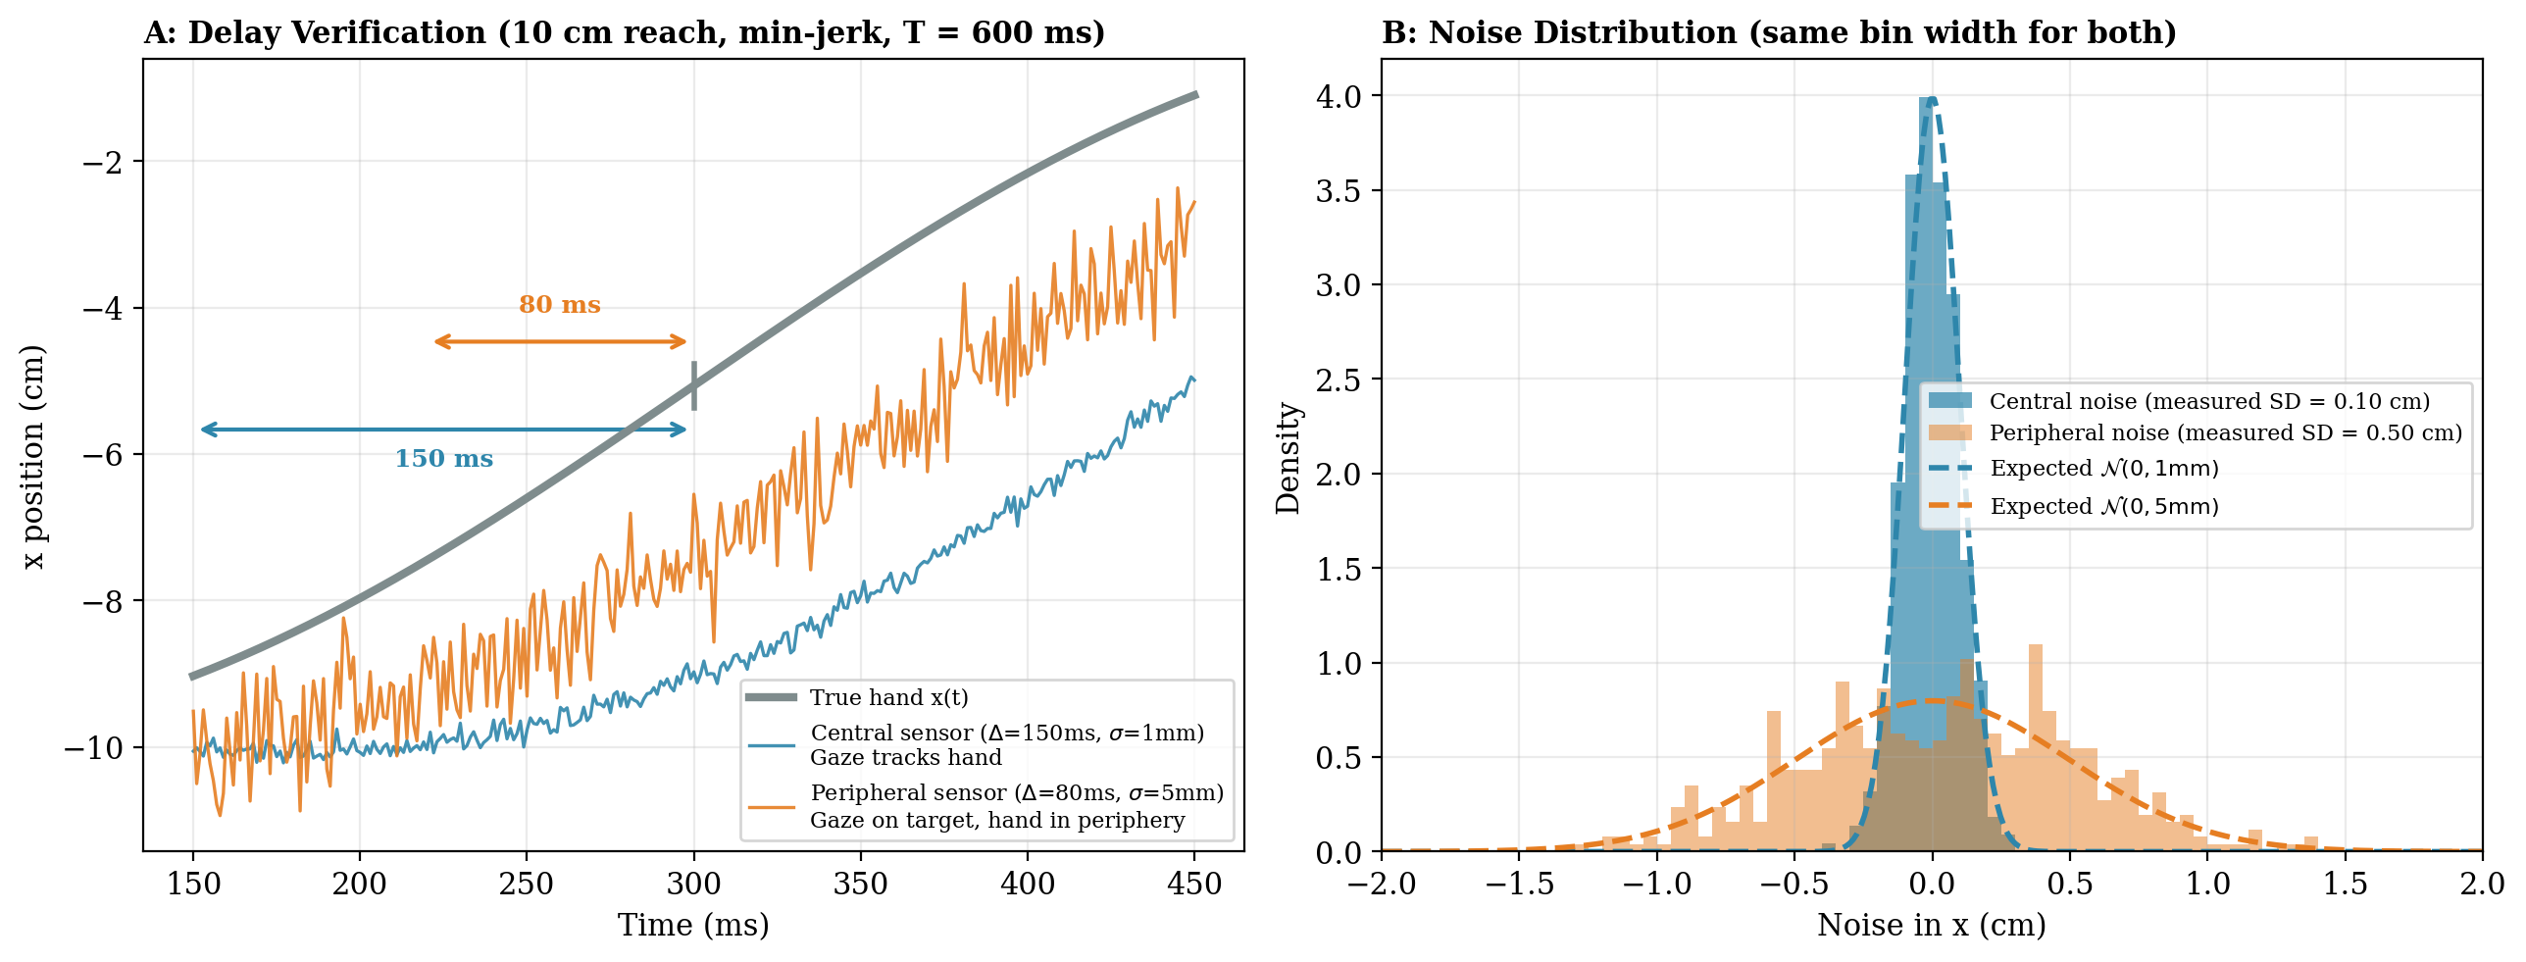
Figure 5. Sensor class verification on a 10 cm center-out reach (minimum-jerk trajectory, T = 600 ms). A: Delay verification (zoomed to 150–450 ms). The true hand trajectory (gray) is compared against the central sensor output (teal, Δ = 150 ms, σ = 1 mm) and the peripheral sensor output (orange, Δ = 80 ms, σ = 5 mm). The central sensor reflects a gaze-tracks-hand condition (hand at fovea); the peripheral sensor reflects a gaze-on-target condition (hand viewed in peripheral vision). Delay annotations confirm the temporal offsets. B: Noise distribution — histograms of the pure noise component (sensor output minus the delayed true state) for both sensors, plotted with the same bin width (0.5 mm). The central histogram occupies only a few bins near zero because σ = 1 mm; the peripheral histogram spreads wider because σ = 5 mm. Expected Gaussians (dashed curves) are overlaid. Measured SDs match the specified values: central = 0.10 cm, peripheral = 0.50 cm.

Why a Class, Not a Function?
The delay buffer is stateful — it must remember the recent history of true states across timesteps. A pure function would require the entire state history to be passed in at every call, cluttering the simulation loop with bookkeeping. The Sensor object encapsulates this state, making the simulation loop clean: y = sensor.sense(x_true, t). The class also makes it trivial to instantiate multiple sensors with different parameters and pass them to a controller, which is exactly what we will do in Weeks 9–10 when we fuse vision with proprioception.

4. Delayed Feedback on the Arc
We return to the 6 cm semicircular arc from Weeks 6–7. In Week 7, the inverse dynamics controller operating open-loop with signal-dependent noise (k = 0.15) produced an endpoint SD of 0.20 cm at T = 800 ms. Can visual feedback push the endpoint scatter below this feedforward frontier?
We build a continuous online correction controller: at each timestep, the controller compares a delayed, noisy measurement of the hand’s position to where the trajectory should have been at the time the measurement was taken, and applies a corrective torque proportional to the error through the Jacobian transpose. Signal-dependent noise is applied to the total torque (feedforward + correction), so the correction itself is subject to noise. The same gain (Kp = 8) is used for all feedback conditions so that the only difference between the central and peripheral channels is their delay and noise.

τ_total(t) = τ_ff(t) + J(q)ᵀ · K_p · (x_des(t − Δ) − y(t))
τ_executed(t) = τ_total(t) + k · |τ_total(t)| · ε(t)

where y(t) is the delayed, noisy measurement from the visual Sensor.
Proportional correction only (Kp = 8, no derivative term). See below for why.

Why Proportional Only — No Derivative Term?
A natural impulse is to add a derivative (velocity) correction: estimate the hand’s velocity from successive delayed measurements and damp residual motion. But differentiating a noisy signal amplifies the noise by 1/Δt_sample. With peripheral noise σ = 5 mm sampled at every simulation timestep (1 ms), the velocity estimate has a noise SD of 5 mm / 1 ms = 5.0 m/s — roughly 17× the peak hand velocity on this arc (~0.3 m/s). Even at a more realistic 33 ms sampling interval, the noise SD is still 0.15 m/s — half the peak velocity. Even a small derivative gain (Kd = 0.05) injects enough correction noise through the Jacobian transpose to make the controller worse than open-loop: endpoint SD jumps from 0.20 cm (open-loop) to 0.31 cm with peripheral PD and 0.23 cm with central PD. For central vision the problem is milder (σ = 1 mm gives velocity noise of ~0.03 m/s), but the derivative term still degrades performance relative to P-only.
The lesson: you cannot extract velocity by differentiating noisy delayed position. The nervous system faces the same problem, and its solution is not to differentiate raw sensory signals but to predict state forward in time using an internal model. This is the forward model that Elliott et al. invoke for impulse control, and it is the direct motivation for the Kalman filter in Week 9.

Central Vision Feedback (Gaze Tracks Hand)
With central vision (Δ = 150 ms, σ = 1 mm, Kp = 8), the online controller tightens the noise fan on the arc. This condition assumes gaze tracks the hand along the arc — the hand stays at the fovea, giving the controller a precise (but delayed) position estimate. The feedback corrections begin acting approximately 150 ms into the movement, leaving 650 ms for multiple correction cycles. The endpoint SD drops from 0.20 cm (open-loop) to 0.17 cm — a 15% improvement. The hand paths are noticeably less scattered than the open-loop case (Figure 6).

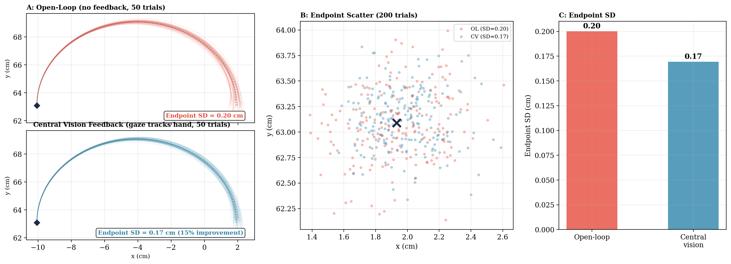
Figure 6. Visual feedback on the 6 cm arc with central vision (Δ = 150 ms, σ = 1 mm, Kp = 8, T = 800 ms). Gaze tracks the hand along the arc so that the hand remains at the fovea throughout. A (top): Open-loop — 50 hand paths with feedforward ID + SDN, no feedback. A (bottom): Central vision feedback — 50 hand paths with the same feedforward + proportional correction from the delayed, noisy hand-position measurement. The noise fan is visibly tighter. B: Endpoint scatter for 200 trials. C: Endpoint SD — central visual feedback reduces scatter from 0.20 to 0.17 cm (15% improvement).

Three-Way Comparison
Adding peripheral vision (Δ = 80 ms, σ = 5 mm, same Kp = 8) to the comparison produces a surprising result. The peripheral channel — gaze fixating the target, hand viewed in peripheral vision — reduces endpoint SD to 0.15 cm, a 25% improvement over open-loop. This outperforms the central channel (0.17 cm, 15% improvement) despite its 5× higher noise (Figure 7).
How can the noisier channel win? The answer is time. The peripheral channel’s 80 ms delay leaves 720 ms of the 800 ms movement for feedback corrections — roughly 9 correction cycles at 80 ms each. The central channel’s 150 ms delay leaves only 650 ms, allowing about 4 correction cycles. Each peripheral correction is individually less precise, but the controller gets nearly twice as many of them. For continuous trajectory correction, the speed advantage of peripheral vision outweighs its noise disadvantage.

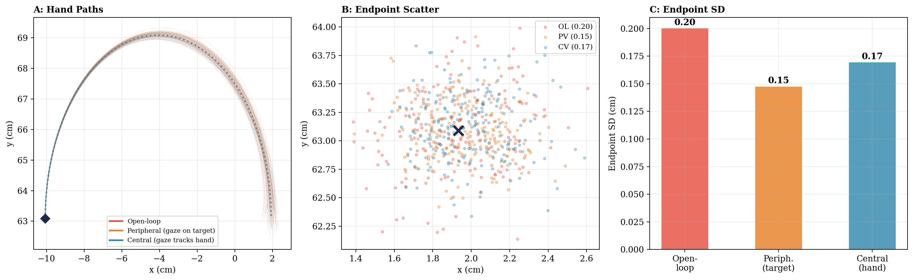
Figure 7. Three-way comparison on the 6 cm arc (Kp = 8, T = 800 ms). Open-loop (red, SD = 0.20 cm), peripheral vision with gaze on target (orange, Δ = 80 ms, σ = 5 mm, SD = 0.15 cm), and central vision with gaze tracking hand (teal, Δ = 150 ms, σ = 1 mm, SD = 0.17 cm). The faster peripheral channel outperforms the more precise central channel for continuous trajectory correction.

The peripheral channel (gaze on target, hand in periphery) outperforms the central channel (gaze tracking hand) for continuous trajectory correction: 25% vs. 15% improvement over open-loop. This result aligns with a basic ecological observation: coaches in ball sports tell athletes to “keep your eyes on the ball” or “eyes on the prize” — nobody instructs a tennis player to stare at their racket hand. The natural gaze strategy is to fixate the target and let peripheral vision monitor the limb. Elliott et al.’s multiple process model explains why: during the distance-covering phase, peripheral vision provides fast (if noisy) information about whether the limb is on course — impulse control. Foveal vision is reserved for the final approach, where precise limb-target comparison matters. Our simulation captures the first phase but not the second, because it uses continuous correction throughout the movement rather than separating the two control processes.

5. The Fixation Dilemma and Gaze Strategy
During a reaching movement, gaze must be allocated between the target and the hand. Each fixation strategy imposes different noise profiles on the two visual channels, and the choice of where to look has direct consequences for the quality of online correction. We simulate three strategies on a 10 cm center-out reach (T = 600 ms, Kp = 8, SDN k = 0.15) with 200 Monte Carlo trials each.
Fixate target (the typical strategy): The eyes land on the target before or at movement onset. This places the target at the fovea (σ ≈ 1 mm) and the hand in the periphery (σ ≈ 5 mm, Δ = 80 ms). The controller corrects using peripheral measurements of the hand against a precisely known target position. This is the natural coordination pattern documented by Elliott et al. (2017): the eyes saccade to the target and then “anchor” — holding fixation while the hand moves. Endpoint SD = 0.07 cm.
Track hand: The eyes follow the moving hand, placing it at the fovea (σ ≈ 1 mm, Δ = 150 ms) but pushing the target into the periphery (σ ≈ 5 mm). The controller has a precise hand-position estimate but a noisy target-position estimate — it knows where the hand is but not exactly where it should be going. Retinal slip from smooth pursuit adds additional noise. Endpoint SD = 0.08 cm — worse than fixate-target, because target uncertainty degrades the correction signal.
Saccade switch: The eyes fixate the target for the first half of the movement (peripheral correction, Δ = 80 ms, σ = 5 mm), then saccade to the hand at t = 300 ms. The saccade takes 40 ms (vision blanked during saccadic suppression), followed by 100 ms of fixation stabilization before the central channel becomes usable. Central correction (Δ = 150 ms, σ = 1 mm) then operates for the remainder of the movement. The timeline: peripheral correction 0–300 ms → blind 300–340 ms → stabilizing 340–440 ms → central from 440 ms. But the central channel’s first usable measurement does not arrive until 440 + 150 = 590 ms — leaving only 10 ms of central correction before the movement ends. Endpoint SD = 0.07 cm — tied with fixate-target, because the saccade buys almost no usable central correction time.
Empirical evidence strongly supports the fixate-target strategy, and our simulation shows why: it provides continuous peripheral correction for the entire movement, while the alternatives either degrade target knowledge (track hand) or sacrifice correction time to saccade costs (saccade switch). Performers who know vision will be available move faster and spend more time in the deceleration phase — maximizing the time available for limb-target control (Hansen et al., 2006). Figure 8 compares the three strategies.

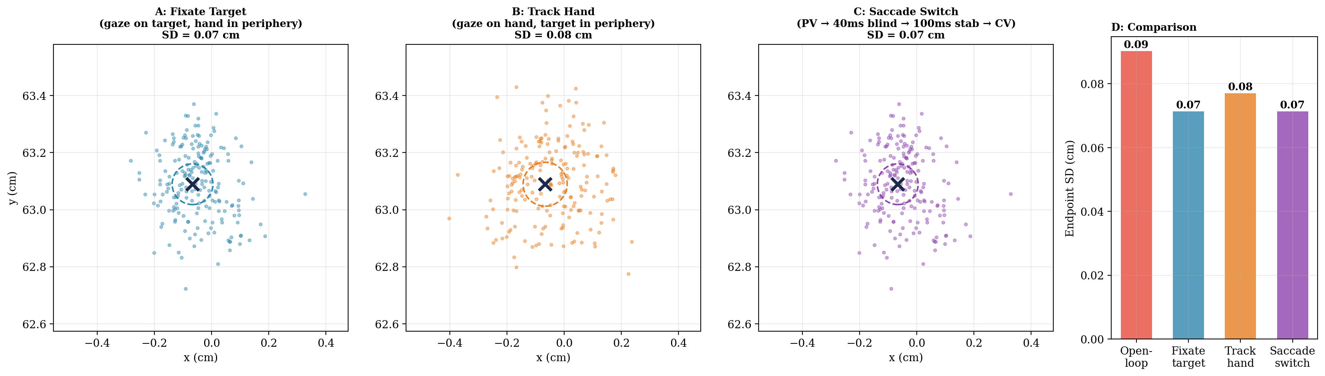
Figure 8. Gaze strategy comparison on a 10 cm center-out reach (Kp = 8, T = 600 ms, 200 trials). A: Fixate target — gaze on target, hand corrected via peripheral channel (Δ = 80 ms, σ = 5 mm). SD = 0.07 cm. B: Track hand — gaze follows hand, target in periphery. SD = 0.08 cm, the worst strategy because the target position is uncertain. C: Saccade switch at 300 ms — peripheral correction, then 40 ms saccadic suppression, 100 ms fixation stabilization, then central correction. SD = 0.07 cm, tied with fixate-target because the saccade costs leave almost no time for central correction. D: Bar chart comparison including open-loop (SD = 0.09 cm).

6. The Updated Frontier: Vision vs. Movement Speed
In Week 7 §3, we swept movement time from 400 to 1200 ms and mapped the feedforward frontier. We now repeat that sweep with visual feedback (Kp = 8, proportional correction), reproducing Keele and Posner’s finding computationally. Each channel uses the same gain; the only difference is delay and noise.
At T = 250 ms, the movement is so fast that neither feedback curve separates from the frontier: there is barely time for even a single correction cycle. By T = 300–400 ms, both channels begin to pull below the frontier. For medium-speed movements (T = 400–600 ms), the peripheral channel (gaze on target, Δ = 80 ms, σ = 5 mm) outperforms the central channel (gaze tracks hand, Δ = 150 ms, σ = 1 mm), just as in §4. But for slow movements (T > ~700 ms), the central channel overtakes the peripheral channel (Figure 9). With enough correction time, the 5× lower noise of the central channel dominates its 70 ms speed disadvantage.
This crossover is the computational complement to Keele and Posner’s result. Their estimated crossover at 190–260 ms marks when any visual correction begins to help. Our figure reveals a second crossover at ~700 ms, where the precise-but-slow channel overtakes the fast-but-noisy channel. Between these two crossovers, speed wins; beyond the second, precision wins. Elliott et al.’s model predicts exactly this: impulse control (fast peripheral) dominates early, limb-target control (precise foveal) dominates late.
One critical result from Keele and Posner that our simulation cannot yet reproduce: accuracy improves in the dark too. Our open-loop controller shows no improvement for slower movements beyond the torque-scaling effect already captured in Week 7. The missing ingredient is proprioception — a sensory channel with Δ ≈ 25–60 ms that provides joint-angle and velocity information even without vision. That channel is the subject of Week 9.

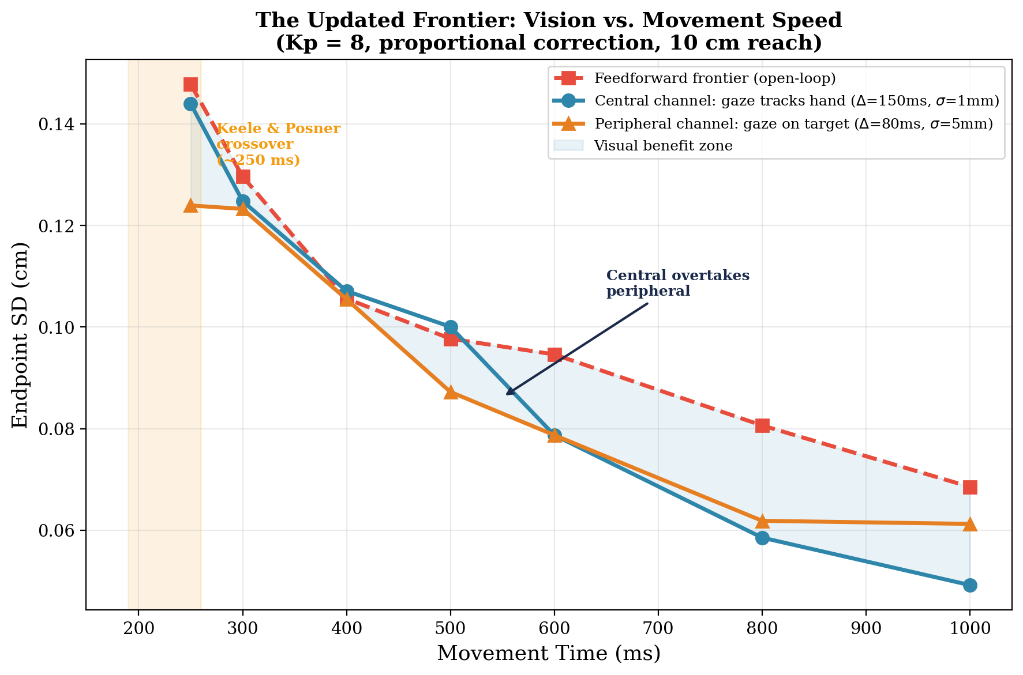
Figure 9. The updated frontier. Endpoint SD vs. movement time for open-loop feedforward (dashed red), online proportional feedback (Kp = 8) with central channel (gaze tracks hand: Δ = 150 ms, σ = 1 mm, teal) and peripheral channel (gaze on target: Δ = 80 ms, σ = 5 mm, orange). For medium-speed movements (300–600 ms), the faster peripheral channel outperforms the more precise central channel. At ~700 ms, the central channel overtakes the peripheral — with enough correction time, precision wins over speed.

Reproducing Keele & Posner Computationally
Keele and Posner estimated 190–260 ms for visual processing. Our simulation with Δ_central = 150 ms shows the crossover at roughly T ≈ 250 ms — because a single correction cycle requires time to both process the visual signal AND execute a corrective torque. The 150 ms sensory delay plus ~100 ms motor execution time gives a minimum loop time of ~250 ms, matching the empirical estimate.
A full model including impulse control (Δ_peripheral ≈ 80 ms) would show benefits starting earlier, around 150–200 ms. The two control processes have different onset times, explaining why Keele and Posner saw some evidence of online regulation at movement times as short as 190 ms, even though the full limb-target corrective process required 250+ ms.

7. Summary and Looking Ahead
Summary of Key Results

Property | Central Vision | Peripheral Vision
Spatial noise (σ) | ~1 mm | ~5 mm
Delay (Δ) | ~150 ms | ~80 ms
Strength | Spatial localization | Speed + motion detection
Limitation | Narrow field (~2°), slower processing | Crowding, positional uncertainty
Serves (Elliott et al.) | Limb-target control | Impulse control
Correction latency | ~180–260 ms | ~70–100 ms
Endpoint SD improvement (arc, 800 ms) | 15% below frontier | 25% below frontier

1. Keele and Posner (1968): the visual processing window. Visual feedback improves accuracy only for movements lasting longer than approximately 190–260 ms. This estimate reflects the minimum loop time for limb-target control (§1).
2. Elliott et al. (2010, 2017): two online control processes. The multiple process model distinguishes impulse control (early, continuous, velocity-based, ~70–100 ms latency, served by peripheral vision) from limb-target control (late, discrete, position-based, ~180–260 ms latency, served by foveal vision). The “ballistic” phase of movement is not truly ballistic (§1).
3. Foveal and peripheral vision are complementary, not hierarchical. Each channel is optimized for its respective control process. Peripheral processing is faster than foveal (Carrasco et al., 2003), matching the shorter latency of impulse control (§2).
4. The Sensor class formalizes a sensory channel as delay + noise covariance, encapsulated in a stateful object with a simple API (§3).
5. Both visual channels break the feedforward frontier for slow movements. Peripheral vision (gaze on target, 25% improvement at 800 ms) outperforms central vision (gaze tracking hand, 15%) for continuous trajectory correction because its 70 ms speed advantage allows nearly twice as many correction cycles. This matches the ecological observation that performers fixate the target, not the hand (§4–5).
6. Gaze strategy is a control problem. The typical fixate-target strategy delivers peripheral motion information for impulse control during the distance-covering phase and foveal spatial information for limb-target control during the final approach (§5).
Bridge to Week 9: Three Gaps Remain
This week established the visual sensory pipeline: two channels with complementary delay-noise profiles serving two control processes. But three critical gaps remain.
Gap 1: No proprioceptive channel. Keele and Posner found that accuracy improves in the dark. Our simulation cannot explain this. Proprioception provides joint-angle and velocity information with a delay of approximately 25–60 ms — faster than either visual channel.
Gap 2: No forward model. Our controller uses the raw delayed measurement. It does not predict where the hand is now from where it was 80 or 150 ms ago. As we showed in §4, even estimating velocity by differentiating noisy delayed position fails catastrophically — the noise is amplified by 1/Δt_sample. Elliott et al.’s impulse control depends on comparing actual sensory consequences to expected sensory consequences — an internal model that predicts both position and velocity from the motor command. The Kalman filter formalizes this prediction.
Gap 3: No sensory fusion. We have two visual sensors with different strengths. How should they be combined? The answer is Bayesian optimal estimation: weight each signal by the inverse of its variance. The Kalman filter does exactly this, and it extends naturally to fusing vision with proprioception.

Vision tells you where you were 80–150 ms ago. Proprioception tells you where you were 25–60 ms ago. Neither tells you where you are now — and as §4 showed, you cannot recover velocity by differentiating noisy delayed position. Elliott et al.’s model shows that the nervous system does not passively wait for feedback — it actively compares incoming signals to predictions from an internal model, catching errors before they grow. Building that predictive model is the work of Week 9.

