WEEK 4
The Equilibrium-Point Hypothesis
Threshold Control and the λ Model
Reading: Gribble, Ostry, Sanguineti & Laboissière (1998). Are complex control signals required for human arm movement? J. Neurophysiol., 79(3), 1409–1424.
Supplementary: Feldman, A. G. (1966). Functional tuning of the nervous system with control of movement or maintenance of a steady posture. Biophysics, 11(3), 565–578.
Supplementary: Kistemaker, D. A., Soest, A. K. J. V., & Bobbert, M. F. (2006). Is equilibrium point control feasible for fast goal-directed single-joint movements? J. Neurophysiol., 95(5), 2898–2912. — Full Hill-type model with series elastic element and Hatze activation dynamics.
Supplementary: Gomi, H., & Kawato, M. (1996). Equilibrium-point control hypothesis examined by measured arm stiffness during multijoint movement. Science, 272(5258), 117–120.

1. The Problem We Left Behind

In HW03, you tested a triphasic activation pattern on two versions of the arm. Model A included external joint damping (B = 3.0 N·m·s/rad) and did come to rest — though only after overshooting to 5.6 cm and recoiling back to 3.0 cm. Model B removed that damping (B = 0) and the same activation pattern produced overshoot and drift — the arm could not settle (Figure 1).
The force-velocity relationship in the Gribble muscle model does provide some velocity-dependent damping: during co-contraction, the shortening muscle loses force while the lengthening muscle gains force, creating a net torque that opposes motion. At the co-contraction hold level (a = 0.25), this force-velocity damping amounts to only about 30% of what B = 3.0 provides — and because the force-velocity relation saturates while B is linear, that fraction falls further as the joint speeds up, to roughly 15% at peak movement velocity.
Model A comes to rest. Model B, given exactly the same command, does not — it sails past the target and is still drifting when the trial ends. The only difference between them is a damping term in the equations of motion, and there is nothing in the arm that corresponds to it.
Before reading on, it is worth stopping to ask what you would do about that. You have the agonist burst, the antagonist burst, their timings, and the hold level to work with. Which would you change, and what do you expect would happen?
Three answers suggest themselves. Table 1 shows what each one does.
Brake harder. Raise the antagonist burst. The hand can be made to finish near the target — but it does not finish at rest; it passes through, still travelling. Raise the burst further and the endpoint lands somewhere else entirely. Nothing is converging.
Brake longer. Extend the burst instead. Now the arm is driven back past where it started, moving faster at the end of the trial than at any point during the reach. This is not stopping the arm. It is reversing it.
Squeeze. Hold both muscles on together once the movement is over, and read the last three rows of the table carefully. Quadrupling the hold barely moves the final position — while the final speed falls by nearly half.
attempt | what we changed | final position | final speed
(the pattern as tuned) | — | 19.2 cm | 3.7 cm/s
brake harder | antagonist 0.4 → 0.8 | 2.5 cm | 7.9 cm/s
brake harder | antagonist 0.4 → 1.0 | 10.5 cm | 9.3 cm/s
brake longer | burst extended to 600 ms | 1.1 cm | 24.3 cm/s
squeeze | hold both at 0.2 | 15.5 cm | 11.9 cm/s
squeeze | hold both at 0.4 | 15.6 cm | 9.1 cm/s
squeeze | hold both at 0.8 | 15.7 cm | 6.4 cm/s
Table 1. Three attempts to stop the undamped arm. The target is 5.5 cm; “stopped” would mean a final speed under 1 cm/s. No row achieves both.
That last result is the one to sit with. Something is plainly happening: the arm drifts more slowly the harder you squeeze. But it drifts to the same place. Co-contraction is taking energy out of the limb without taking the limb anywhere.
So ask what the three failures have in common. What would it take to stop an arm somewhere in particular?
You would need a force that grows the further the limb strays from where you want it, and disappears once it arrives. A spring. And now the question is concrete enough to answer: does anything in our model produce one?
Look at the force our muscle makes: M̃ = ρ[exp(c·G·a) − 1]. The muscle’s length does not appear in it. A given activation produces a given force, whatever the arm is doing and wherever it happens to be. Measure the shoulder stiffness and you get the same value at every activation level — and all of it comes from the passive springs, which are there whether the muscles are active or not.
There is no spring in the activation signal. It can pull, and while the limb is moving the force-velocity relation lets it resist motion. It cannot draw the arm toward a place and hold it there. That is why the three repairs failed, and why Model A needed B: the stabilising term had to come from outside the muscle, because the muscle we built does not have one.
So the question for this week is not how to tune the command better. It is whether the muscle itself can supply the restoring force — whether stability can come from the same signal that commands the movement, instead of being bolted on beside it. Anatol Feldman proposed an answer in 1966, and it requires rethinking what the nervous system controls.

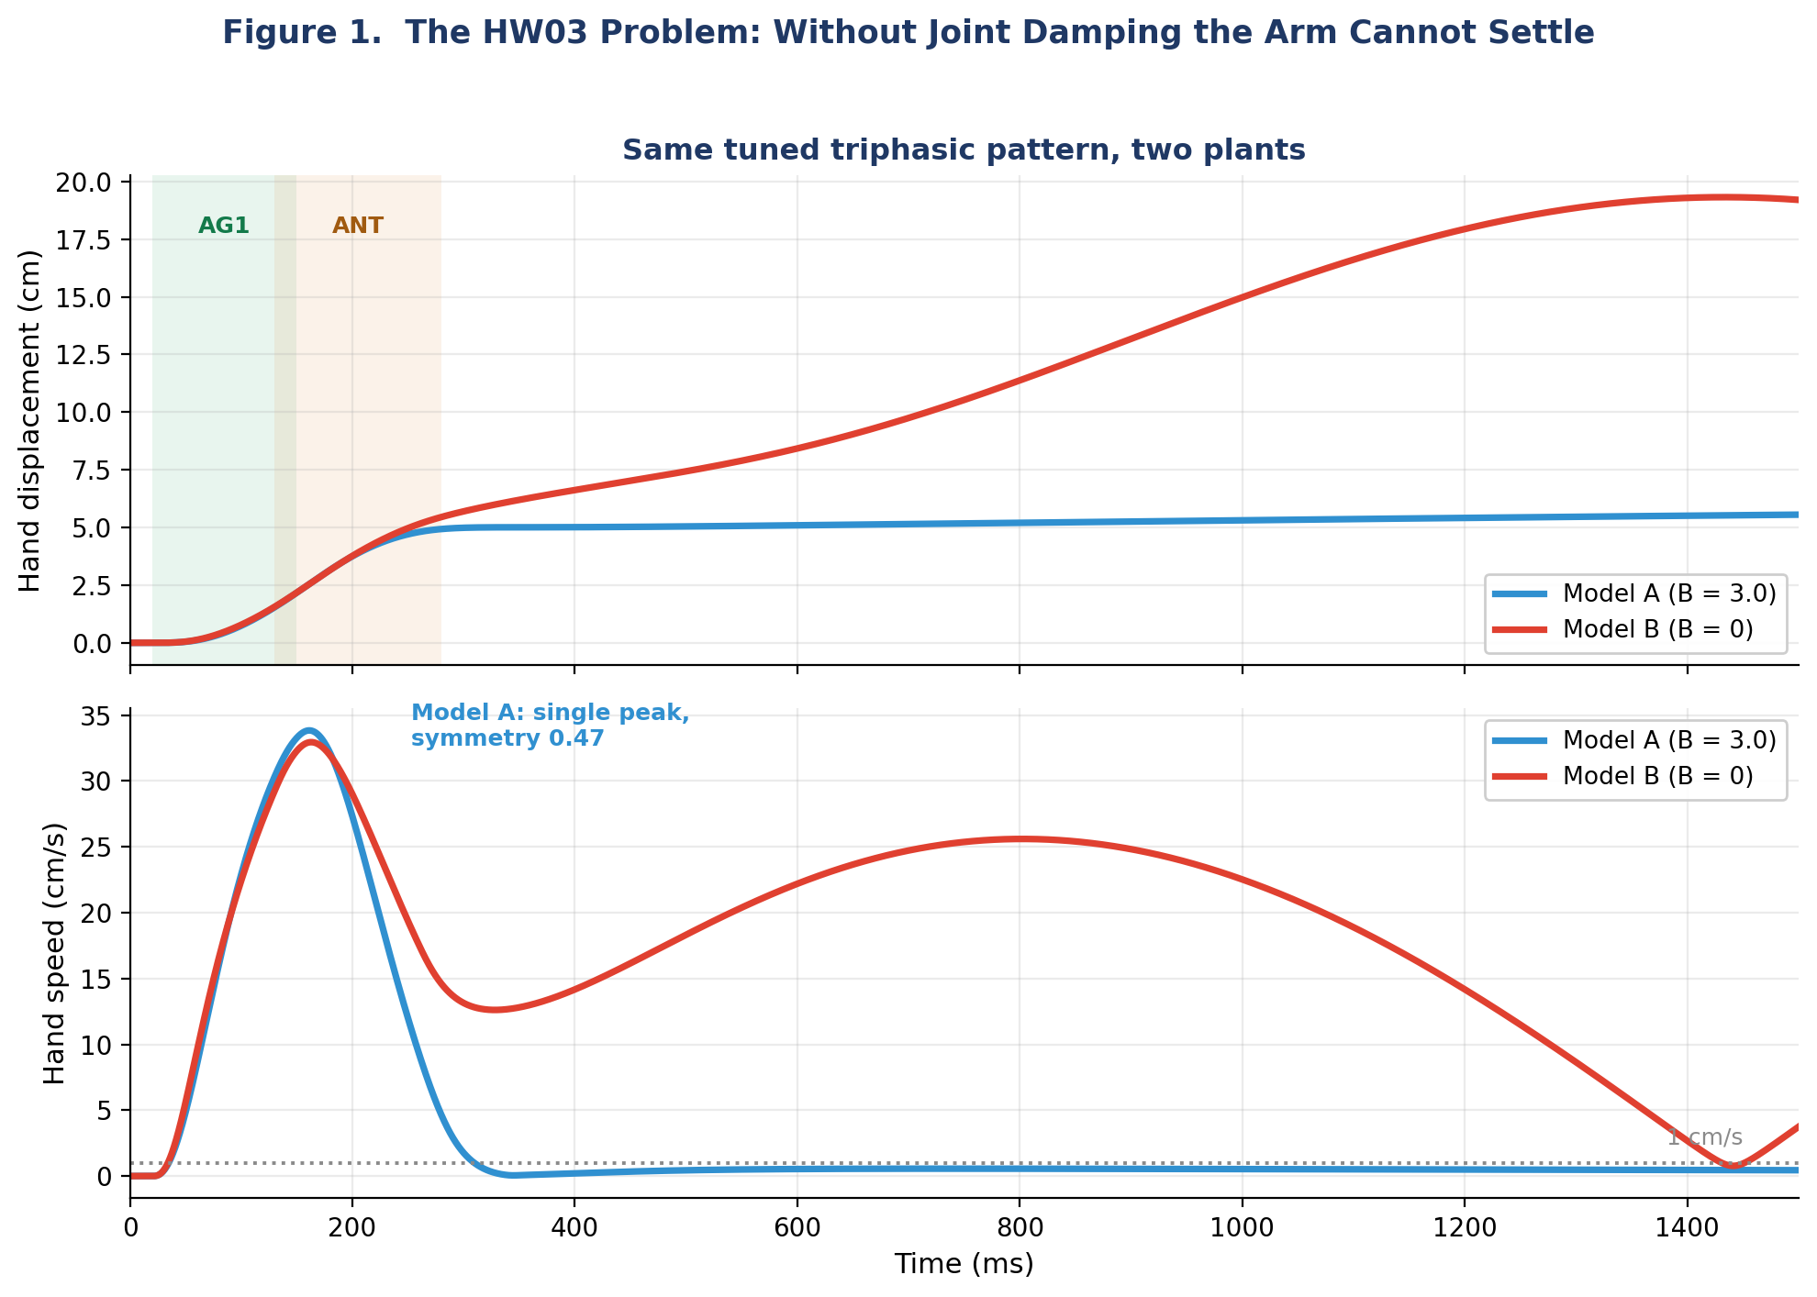
Figure 1. The HW03 problem. The tuned triphasic pattern you built in HW03, applied to two plants. Model A (B = 3.0) reaches 5.5 cm, holds it, and has a single-peaked velocity profile that spends almost equally long speeding up and slowing down (symmetry ratio 0.47, where 0.5 is perfectly even) — a bell. Model B (B = 0) is the same pattern with the joint damping removed: it overshoots and never settles. Green shading = agonist phase (pec + bic_s, 20–200 ms); orange shading = antagonist phase (delt + tri_lg, 180–300 ms). Co-contraction hold (a = 0.25) begins at 280 ms. Raising the hold to a = 0.8 does not rescue Model B: it adds force-velocity damping and roughly six times the isometric force, but no stiffness, and the arm settles no better (HW03 Part 4).

2. Threshold Control: The Core Idea

Feldman’s insight was radical: the nervous system does not command forces, activations, or trajectories. Instead, it sets thresholds — the muscle length at which a muscle begins to activate. This is the Equilibrium-Point Hypothesis (EPH), and the threshold parameter is called λ (lambda).
The biological basis is motoneuron recruitment. Every α-motoneuron has a recruitment threshold that depends on muscle length. Collectively, the spinal cord’s motoneuron pool acts like a threshold function: when the muscle is stretched beyond λ, motoneurons fire progressively and the muscle develops force. When the muscle is shorter than λ, no motoneurons are recruited and the muscle is silent.
The activation law that captures this is:
A = [ l − λ + μ · dl/dt ]⁺
where:
- l = current muscle length (already exposed as a property in Week 2)
- λ = threshold length — the only signal the brain needs to send
- μ = velocity sensitivity (provides damping; μ ≈ 0.06 s)
- dl/dt = muscle lengthening velocity (also exposed since Week 2)
- [·]⁺ = rectification — activation cannot be negative

The elegance is in what this gives you for free. When the muscle is stretched beyond λ (because the arm was perturbed, or because the limb moved during a reach), activation increases automatically — producing a restoring force. When the muscle shortens past λ, activation drops to zero. The muscle is its own sensor and its own controller. No computation of inverse dynamics, no trajectory planning, no error signal from the brain. Just a threshold.

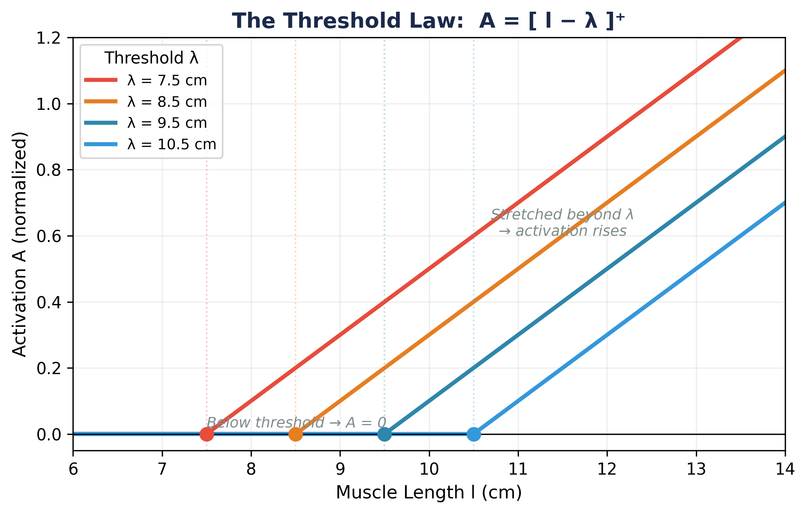
Figure 2. The threshold law. For a given λ value (colored dots), the muscle is silent when its length l is below λ. When l exceeds λ, the raw activation A = l − λ is a physical displacement (in cm) representing how far the muscle is stretched beyond its threshold. The y-axis normalizes this displacement to a 0–1 scale by dividing by a 5 cm reference; in the actual model, this displacement feeds directly into the Gribble exponential force-length curve (see Figure 3) to produce muscle force.

2.1 The full pipeline, as Gribble et al. implement it
The threshold law is the first step of six. It is worth seeing the whole chain at once, because the model is often described by its first equation alone — and it is in the later steps that several symbols which look alike turn out to be different quantities. Grey labels are Gribble et al.’s (1998) own equation numbers.
Step 1. The command λ sets a threshold, and activation is how far the muscle is past it. Gribble state this twice — once as the idea, once as the thing they actually integrate. The idea is
A = [ l − λ + μ·l̇ ]⁺ (their Eq. 1)
where [x]⁺ is rectification — equal to x when x is positive and zero otherwise, their Eq. 2 — so a muscle shorter than its threshold is silent rather than pulling backwards. But the muscle does not know its own length instantly. Length and velocity reach the motoneuron pool as afferent feedback, and that takes time. Their implemented form therefore carries a reflex delay:
A(t) = [ l(t−d) − λ(t) + μ(t)·l̇(t−d) ]⁺ (their Eq. 3)
Look at where the delay falls. It applies to l and l̇, the afferent terms, but not to λ. The descending command arrives when it arrives; it is the sensory report of muscle length and velocity that lags, by d = 25 ms — a value they take from the unloading responses of human arm muscles (Houk and Rymer 1981). This is what makes the λ model a reflex model rather than a feedforward one.
Our implementation uses Eq. 1, not Eq. 3. We set d = 0, so activation responds to the arm’s state instantaneously. That keeps the plant a plain system of ordinary differential equations rather than a delay-differential one, which is a considerable simplification of the numerics — but it removes a real feature of the biology. Lab 4 asks you to put the delay back and see what it costs. Sensory delay returns as a topic in its own right in Week 8, and the machinery for handling it properly — augmented state vectors — arrives in Week 13.
Step 2. That displacement drives force through the exponential force-length curve, with c = 0.112 mm⁻¹ and ρ proportional to cross-sectional area. This is the lecture’s Equation 2.2. M̃ is the force the contractile machinery is trying to produce.
M̃ = ρ [ exp(c·A) − 1 ] (their Eq. 4)
Step 3. Force does not appear instantly. Calcium kinetics low-pass filter it, with τ = 15 ms, reaching an asymptote in roughly 90 ms. M is the force the muscle is actually producing. This is the step that separates M from M̃ — they agree only once the filter has settled.
τ² M̈ + 2τ Ṁ + M = M̃ (their Eq. 5)
Step 4. The force-velocity relation scales the filtered force — a multiplier, not an addition — and the passive spring k(l − r) is added on.
F = M [ f₁ + f₂ arctan(f₃ + f₄·dl/dt) ] + k (l − r) (their Eq. 6)
The four coefficients are fitted rather than derived: Gribble take them from cat soleus muscle stimulated at different rates (Joyce and Rack 1969), giving f₁ = 0.82, f₂ = 0.50, f₃ = 0.43 and f₄ = 58 s/m. Each does a distinct job, and it is worth knowing which.
f₂ sets the range. An arctan spans ±π/2, so f₂ scales the swing to ±0.79. The multiplier therefore runs from about 0.04 when the muscle is shortening quickly to about 1.60 when it is being stretched quickly — a forty-six-fold difference between yielding and resisting. This asymmetry is the force-velocity relation’s whole contribution to damping.
f₃ fixes the isometric value. It shifts the curve horizontally so that at dl/dt = 0 the multiplier is 1.02 rather than something arbitrary. A muscle held still therefore produces very nearly the force the exponential of Step 2 asked for, which is what makes M̃ interpretable as “the force it is trying to make”. f₁ centres the curve vertically so that this comes out right.
f₄ sets the velocity scale, and it deserves attention. At 58 s/m the arctan is already saturating once the muscle moves at a couple of centimetres per second. In the reaches of this lecture the shoulder turns at roughly 1–2 rad/s, which across a 4 cm moment arm means muscle velocities of 4–8 cm/s. The muscle spends the movement out on the flat parts of the curve rather than in the responsive middle. That is worth remembering whenever we appeal to force-velocity damping: it bites hardest at low speeds, and becomes progressively less responsive as the limb moves faster — which is precisely the saturation we met in Section 3, where its share of the damping fell as the joint sped up.
Step 5. Each muscle’s force becomes joint torque through its moment arms, summed over all six.
τₘ = Σᵢ rᵢ Fᵢ
Step 6. And the limb obeys its own dynamics. Notice that τₘ depends on both q and q̇ — Steps 1 and 4 are where that dependence enters, and it is why the model needs no separate joint damping term.
I(q)q̈ + H(q,q̇) = −τₘ(q, q̇, u) + τₑₓₜ (their Eq. B1)
One further simplification. Gribble’s flexor moment arms vary with joint angle, ranging from 2.5 to 5 cm as the elbow rotates, where ours are held constant. Together with the dropped reflex delay of Step 1, these are the two places our plant departs from theirs. Neither changes the structure of the chain above, but both are worth knowing when comparing our figures with the paper’s.
But what does this activation produce? Panel A of Figure 3 shows the threshold activation A = [l − λ]⁺ for four different λ values. Panel B shows the resulting muscle force after passing this activation through the Gribble exponential force-length curve: F = ρ · [exp(c · A) − 1]. The key observation: shifting λ leftward does not just turn the muscle on earlier — it exponentially increases the force at every muscle length above threshold. This is why the λ model produces strong restoring forces with small threshold shifts.

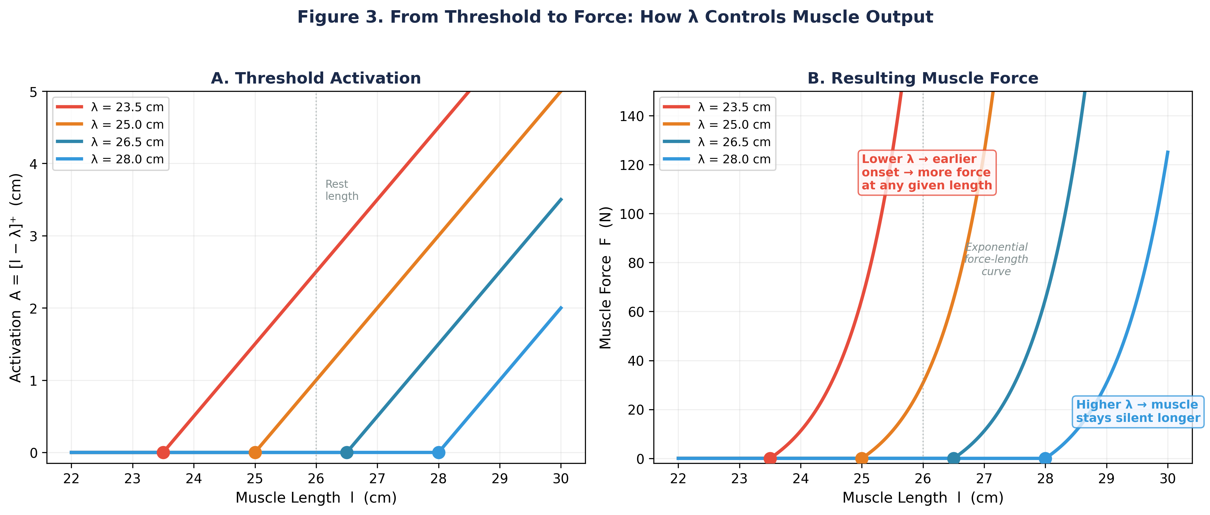
Figure 3. From threshold to force. A: Activation A = [l − λ]⁺ (in cm of stretch above threshold) for four λ values. B: The resulting muscle force after the exponential force-length transformation. Lower λ shifts the force curve leftward, producing force at shorter muscle lengths. The exponential steepness means small λ shifts create large force changes — this is how the nervous system controls movement with simple threshold signals.

3. From G and B to λ: What Disappears

In Weeks 2–3, we used two engineering crutches to make the muscle model work:
- G = 20 mm (neural drive gain): scaled the dimensionless activation a(t) ∈ [0,1] into physical units so the exponential force-length curve operated in its designed range. Implementation note: The Gribble paper specifies c = 0.112 mm⁻¹ (Week 2 §4). The smc library keeps that value as C_EXP = 0.112 and converts the threshold displacement to millimetres where it is used (a_mm = a_m * 1000.0, in Muscle.compute_force_lambda), so the exponential always receives its argument in the units Gribble specified. There is no separate SI-converted constant in the source.
- B = 3.0 N·m·s/rad (joint damping): added velocity-dependent resistance at each joint to prevent oscillation. Without it, Model B could not settle.
The λ model replaces both. The gain G is no longer needed because the threshold law operates directly in muscle-length units (meters) — the activation A = [l − λ]⁺ is already in the right range for the exponential force-length curve.
The damping B is replaced by two intrinsic mechanisms working together. The first is the force-velocity relationship — the same sigmoidal FV curve from Weeks 2–3 — which makes a muscle resist being stretched and yield when it shortens, and so opposes motion. Gribble et al. (1998) emphasise it. But it is not enough on its own: at the co-contraction hold it supplies only about 30% of what B = 3.0 provides, and because the FV curve saturates while B is linear, that share falls further as the joint speeds up.
Threshold control makes that damping stronger than it would otherwise be, and the reason is clearest in the equations. Gribble’s force expression (his Eq. 6) is
F = M · fv(l̇) + k(l − r), fv(l̇) = f₁ + f₂ arctan(f₃ + f₄ l̇)
Two symbols here are easy to confuse, and the distinction matters. M̃ is the raw output of the exponential force-length curve, M̃ = ρ[exp(c·A) − 1] — Equation 2.2, which is Gribble’s Eq. 4. M is that force after the second-order calcium filter of Week 2, τ²M̈ + 2τṀ + M = M̃ (his Eq. 5). It is the filtered force M, not the raw M̃, that the force-velocity term multiplies. The two coincide once the filter has settled, but during a movement they differ substantially — which is precisely when the force-velocity term is doing its work.
Notice how the force-velocity term enters: as a multiplier on M, not as something added to it. Differentiate with respect to velocity and you get the damping each muscle supplies:
∂F/∂l̇ = M · fv′(l̇), fv′(0) = f₂f₄ / (1 + f₃²) = 24.5 s/m
M sits in front. The damping a muscle provides is proportional to the force it is already making. Under direct activation that force traces back to M̃ = ρ[exp(c·G·a) − 1], set by the command alone, so the damping is whatever the command happens to specify. Under threshold control M̃ = ρ[exp(c·A) − 1] with A = [l − λ + μl̇]⁺: a muscle being stretched has a larger l, hence a larger A, hence a larger M̃ and in turn a larger M. The same multiplier now acts on a larger number.
The second mechanism is the μ·dl/dt term inside the activation law. When a muscle lengthens quickly, its activation rises directly — the muscle behaves as though it were already longer than it is — producing damping force beyond what FV alone gives. Together these two replace the external damping B, with no need for dedicated co-contraction.
3.1 Where the damping lives
A limb with mass and spring-like muscles, and nothing to dissipate energy, will not come to rest. Push it off its equilibrium and it oscillates. Drive it toward a new one and it overshoots and keeps going. Something has to take the kinetic energy out. The only real question is where you put that something.
There are two places available. You can put it in the equation of motion, as a torque proportional to joint velocity — that is Week 3’s B·q̇, with B = 3.0 N·m·s/rad. Or you can put it in the muscle, by making muscle force depend on how fast the muscle is changing length. Gribble et al. take the second route, and that is why their equation of motion has no damping term:
I(q)q̈ + H(q,q̇) = −τₘ(q, q̇, u) + τₑₓₜ (their Eq. B1)
Inertia, Coriolis, muscle torque, external torque. No B·q̇. But look at the arguments of τₘ: it is a function of q̇ as well as q. The velocity dependence has not been removed, it has been moved inside the muscle, where it enters twice — once through the μ·dl/dt term in the activation (Step 1) and once through the force-velocity multiplier (Step 4).
Both routes end up producing a joint torque that opposes motion. What differs is the kind of object it is. B is a parameter; the muscle’s viscosity is a consequence. B = 3.0 is a number chosen so that the simulation behaves, corresponding to no structure in the arm, and it is the same whatever the muscles are doing. The viscosity in the λ model is not chosen at all. It is whatever the six muscles happen to produce, and it changes with their force, with posture, and with co-contraction.
The numbers make the point. In our simulations the damping passed to the integrator is exactly zero, and the arm nonetheless behaves as though it had a joint viscosity of about 5.1 N·m·s/rad at the baseline hold — 1.4 of it from the reflex term μ and 3.7 from the force-velocity relation. None of it was put there by hand.
What about Eq. B2, then? Their Appendix B is full of viscosity, which can look like a contradiction. It is not, because B2 is not more physics. It is B1 differentiated — a linearisation, valid for small perturbations, written in the form Gomi and Kawato (1996) used to report their experiments. R and D there are the stiffness and viscosity you would measure by perturbing a real arm and watching it respond. Gribble computes what his model would give, so that the two can be compared on the same terms. D appears in B2 and not in B1 because B2 describes the model rather than constituting it.
So B and D occupy the same slot in the dynamics and are not the same kind of thing at all. One is postulated and fixed; the other is derived and varies. The B we remove in this section is the artificial crutch of Week 3. The equilibrium-point model does without it not because it switches B off, but because it never needed one.
Why the loop is what matters. Both mechanisms come from one fact, and it is worth stating on its own: under threshold control, activation reads the arm’s own state. The muscle is not told how hard to pull. It works that out from where it is and how fast it is moving.
Follow what happens when the arm is pushed off its equilibrium. The joint rotates by a small angle δq, so every muscle’s length changes by −r·δq, where r is that muscle’s moment arm. Since activation is A = [l − λ + μ·dl/dt]⁺ and λ has not changed, activation changes by exactly that same amount. More activation means more force, and differentiating the force-length curve of Equation 2.2 tells us how much: dM̃/dA = c(M̃ + ρ).
Chain those three steps — angle to length, length to activation, activation to force — multiply by the moment arm once more to get back to joint torque, and sum over the six muscles. What comes out is the joint stiffness:
K = Σ rᵢ² [ c(M̃ᵢ + ρᵢ)·fv(0) + kᵢ ]
That expression is evaluated at equilibrium, where the calcium filter has settled and M = M̃, which is why M̃ rather than M appears in it. We derived it above; Gribble et al. do not give this expression, but they do state the property it displays — that muscle stiffness is proportional to muscle force. You can see that in the M̃ sitting inside the bracket. Stiffness rises with the force the muscle is already making, which is precisely why the C-command buys stiffness, and why co-contraction under direct activation bought none.
Now ask the same question about velocity rather than position. Let the joint be rotating rather than merely displaced, and the same loop runs a second time, through the two velocity-dependent terms. The μ·dl/dt term contributes exactly μ times the stiffness we just computed — that is, a joint viscosity of
V ≈ μK
writing V for the joint viscosity and K for the joint stiffness derived above. This is Gribble’s Eq. 9. Their Appendix B calls these two quantities D and R respectively, so the same result appears in the paper as D ≈ μR — we have renamed the stiffness here because their R is not our R-command of Section 4, and the two would be easy to confuse.
The force-velocity relation then adds ∂F/∂l̇ = M̃·fv′(0) per muscle on top of that — which, as we saw above, is again proportional to the force each muscle is already making.
And now the contrast that matters. Under direct activation, activation is A = G·a(t). There is no l in it and no dl/dt. Whatever the arm does, activation does not respond: both ∂A/∂q and ∂A/∂q̇ are exactly zero. The loop is cut at its first step. What survives is the passive spring alone — the same flat value at every activation level that you measured in Section 1.

Key insight: The λ model does not add new machinery to the plant. The Muscle class from Week 2 and the dynamics engine from Week 3 run unchanged — only the drive into the exponential and the damping term differ. All six equations, side by side:
Weeks 2–3 (direct) Week 4 (λ)
Command a(t) ∈ [0, 1] λ(t), in metres
Drive u (mm) u = G · a, G = 20 mm u = [ l − λ + μ·dl/dt ]⁺
Active force M̃ = ρ[exp(c·u) − 1] M̃ = ρ[exp(c·u) − 1]
Muscle force F = Ca·fv(dl/dt) + k(l − l₀) F = Ca·fv(dl/dt) + k(l − l₀)
Joint dynamics M q̈ + C(q,q̇) + B q̇ = τ M q̈ + C(q,q̇) = τ
Joint damping B = 3.0 N·m·s/rad B = 0
Only two lines change. The gain G disappears because u is now a genuine length, already measured in millimetres; the damping B disappears because u depends on l and dl/dt, which makes every muscle a spring with its own damping. The middle two rows are identical — the same code executes in both modes (Figure 4).

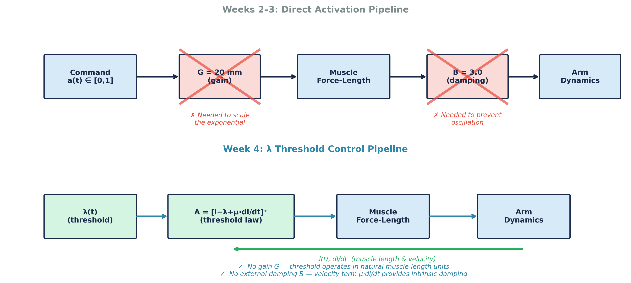
Figure 4. Pipeline comparison. Top: the Weeks 2–3 pipeline required an artificial gain G and external damping B (crossed out). Bottom: the Week 4 λ pipeline. The green arrow shows the intrinsic feedback loop: muscle length l(t) and velocity dl/dt are read back from the arm dynamics and fed into the threshold law A = [l − λ + μ·dl/dt]⁺. This closed loop — absent in the direct-activation pipeline — is what provides stiffness and damping automatically, with no need for the gain G or for any external damping term.
4. R-Command and C-Command

With six muscles and two joints, how does the brain organize λ shifts? The standard answer is a pair of commands introduced in earlier versions of the λ model (Feldman et al. 1990; Flanagan et al. 1990) and adopted by Gribble et al. (1998), who describe their own two signals as analogous to the “R” and “C” commands of that earlier work:
- R-command (Reciprocal): shift the agonist’s λ down (lower threshold → more activation) and the antagonist’s λ up (higher threshold → less activation). This produces a net torque in the desired direction and moves the equilibrium point to a new posture. The R-command controls where the arm goes.
- C-command (Co-contraction): shift all λ values in the same direction (lower all thresholds → more co-activation). Because the opposing shifts very largely cancel, the equilibrium position moves only slightly while the stiffness around it rises steeply. The C-command controls how stiff the arm is at its destination.
R and C are designed to act independently, and to a good approximation they do: you can place the arm at a chosen posture with a chosen stiffness by picking the right combination. The separation is not exact in our six-muscle plant, however. The bi-articular muscles pull on the shoulder with unequal moment arms (bic_s +0.025 m, tri_lg −0.040 m), so a pure C-command drags the shoulder equilibrium with it — by −0.6° at C = 0.05, and by −4.3° at C = 0.50. This is the control architecture that Gribble et al. (1998) used to generate reaching movements — the same arm model we built in Weeks 2–3. Two details of their implementation are worth noting, because ours is a simplification. Both come from p. 1412 of the paper, under “Organization of control signals”. Their R-command shifts λs between successive points of minimum total muscle force rather than simply offsetting an antagonist pair. They note there that because six muscles serve only two degrees of freedom, infinitely many λ-sets correspond to any given via-point, and they select the set that minimises total muscle force — one principled way to resolve that redundancy. And their C-command was defined in force space, in newtons, then converted into the equivalent λ shift; that is why their cocontraction levels are quoted as 3 N, 5 N, or 30 N, where ours is a scalar in radians. Figures 5 and 6 illustrate the R and C commands, respectively.
4.1 Six thresholds, two joints: the redundancy underneath
There is a question we have been stepping around. R and C take six thresholds and organise them into two knobs — but why should two be enough, and what became of the other four degrees of freedom?
Count them. At equilibrium, six λ values determine two joint angles. That map is six-to-two, so it cannot be one-to-one. Differentiate it and the Jacobian ∂q_eq/∂λ is a 2×6 matrix of rank 2, leaving a four-dimensional null space: a four-parameter family of threshold sets that hold the arm in exactly the same place, differing only in how hard the muscles pull against one another. Move λ along any of those four directions and the posture does not change. Lab 4 asks you to measure this for yourself.
This is the muscle redundancy problem, and it is not peculiar to threshold control. Gribble et al. meet it directly (p. 1412): because the number of muscles exceeds the kinematic degrees of freedom, “there are an infinite number of sets of λs associated with a given via-point, each set corresponding to different levels of muscle force”. They resolve it by choosing, at each via-point, the set that minimises total muscle force. Week 6 meets the same problem from the torque side, where it is the classical indeterminacy of inverse dynamics.
Seen this way, R and C are not a complete description of the command space. They are a two-dimensional slice through it, picked because those two directions do something interpretable: one moves the equilibrium, the other stiffens it. The remaining four directions are real, and the model simply does not use them.
One caution about what redundancy buys you. It is tempting to conclude that because infinitely many commands hold a posture, the model can be made to produce whatever movement one likes. It cannot, or not easily. The redundancy lives in the map from λ to equilibrium; the movement is produced by the limb’s dynamics acting on that equilibrium, and mass, force-velocity and calcium kinetics are not in the null space. Section 5 makes this concrete: several quite different λ time-courses give almost identical hand trajectories.

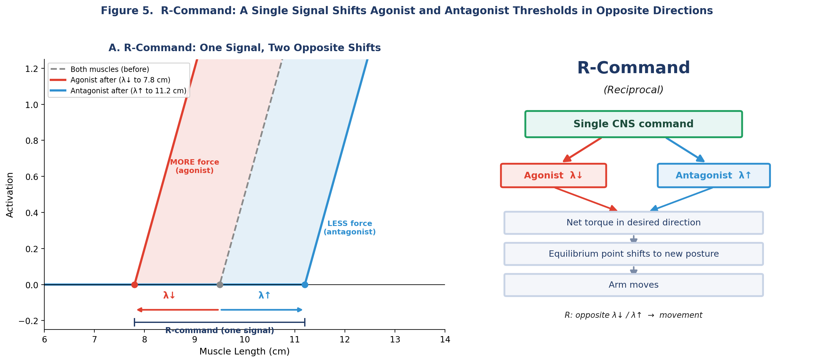
Figure 5. R-command (Reciprocal). Left panel: a single CNS command simultaneously shifts the agonist threshold leftward (λ↓, red — more activation at any given length) and the antagonist threshold rightward (λ↑, blue — less activation). The gray dashed line shows the shared threshold before the R-command; the red and blue shaded regions show the activation gained and lost, respectively, and the bracket emphasizes that both shifts are one coordinated signal, not two independent commands. Right panel: the same logic as a flow — one CNS command splits into opposite agonist (λ↓) and antagonist (λ↑) shifts, which together produce a net torque in the desired direction, shift the equilibrium point to a new posture, and move the arm. The R-command controls where the arm goes.
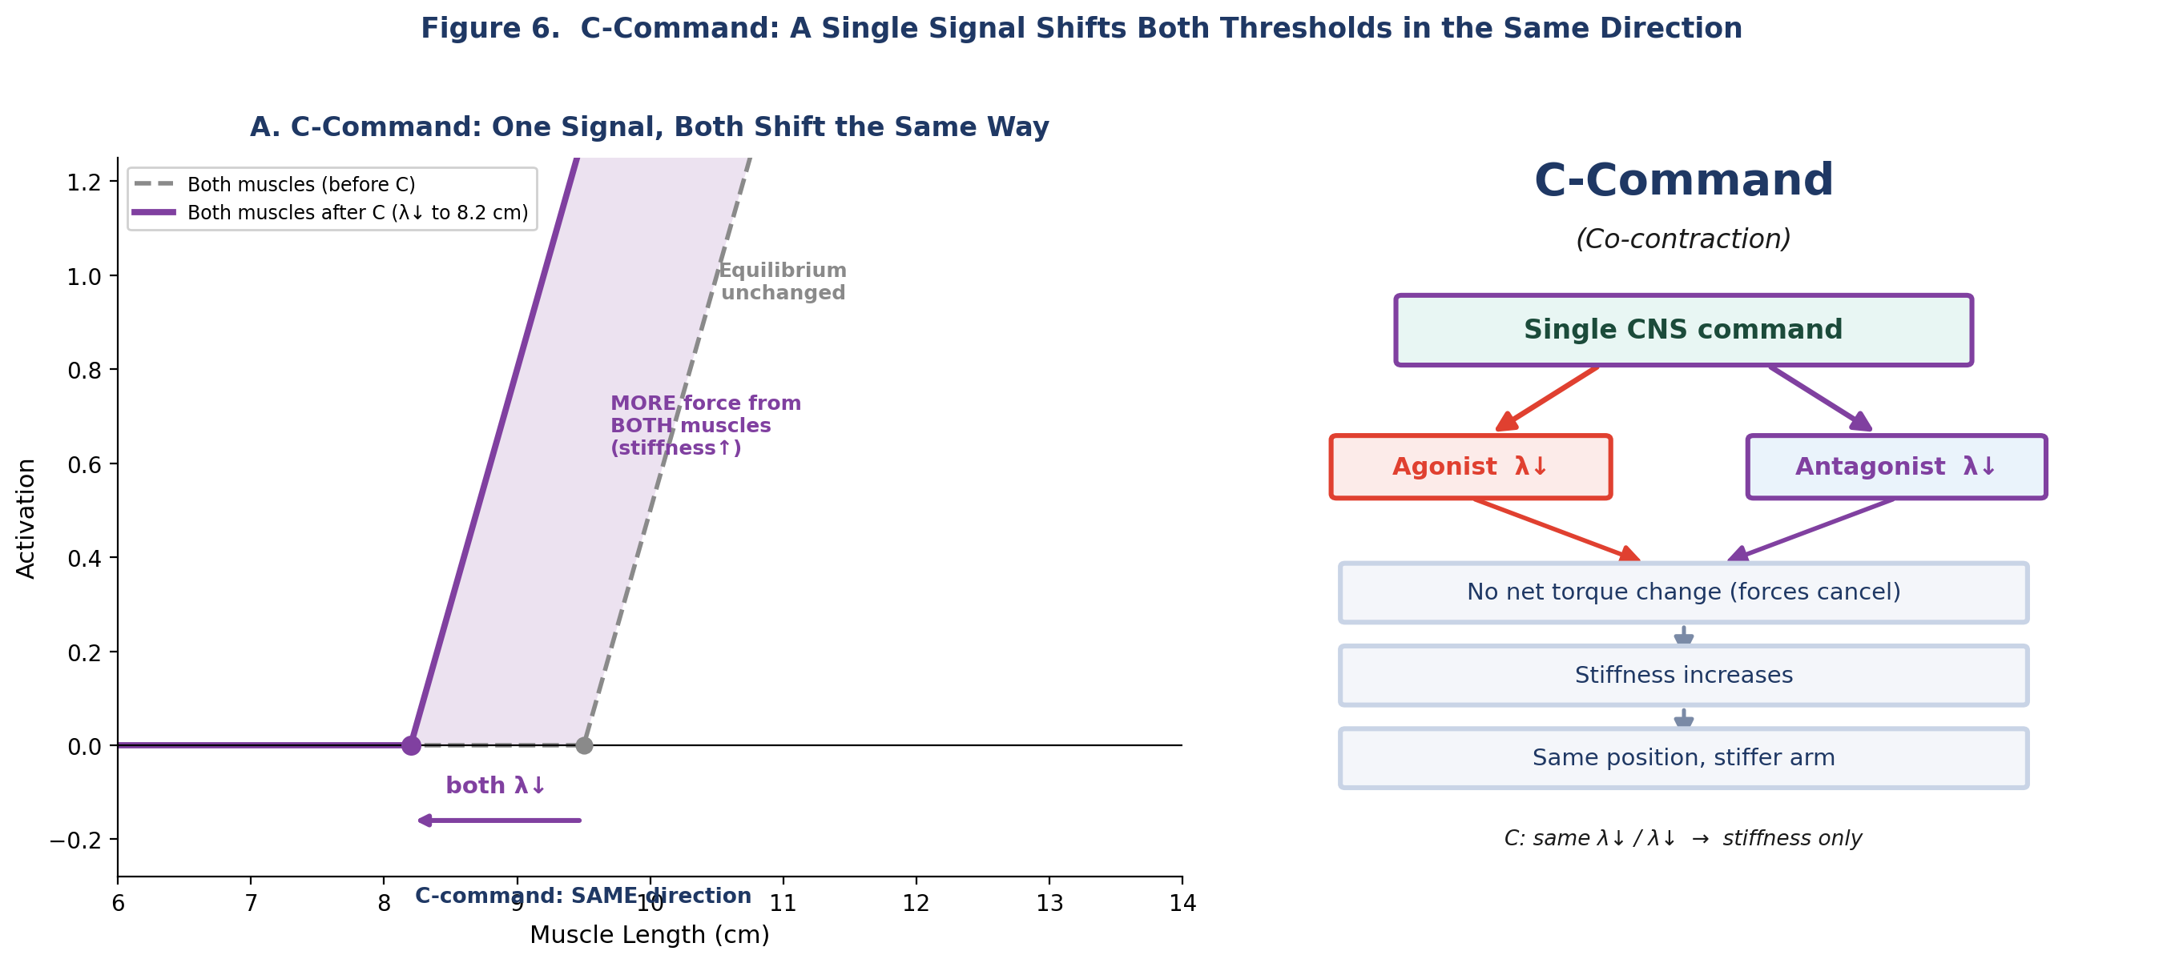
Figure 6. C-command (Co-contraction). Left panel: unlike the R-command, the C-command shifts both agonist and antagonist thresholds in the SAME direction (both λ↓), so they move together to a common threshold (purple). Because both muscles gain activation equally, their torques cancel and the equilibrium position does not change — but the added activation of both muscles raises the stiffness around that position. Right panel: the same logic as a flow — one CNS command drives both agonist and antagonist λ down together, producing no net torque change (the forces cancel) but increased stiffness, leaving the arm at the same position but stiffer. The C-command controls how stiff the arm is at its destination. Compare with Figure 5: R = opposite shifts → movement; C = same shifts → stiffness only.

5. Constant-Rate λ Shifts Produce Smooth Reaching

Here is the central result. To generate a reaching movement, we:
- 1. Set initial λ values so the arm is at rest in the start posture.
- 2. Ramp each λ at a constant rate toward target values (350 ms ramp, starting at 50 ms after the initial hold).
- 3. Hold the final λ values constant.
That’s it. No trajectory planning. No inverse dynamics. No computed torques. No optimization. Just a linear ramp in threshold space.
The result: the hand follows a reasonably straight path toward each target, and the velocity profile is approximately bell-shaped — the hallmark of natural reaching movements (Morasso, 1981). Neither is specified anywhere in the command; the shape of the movement is left to the nonlinear muscle properties and the arm’s inertial dynamics. Figure 7 shows what comes out of that: hand paths, velocity profiles, and joint angles for eight reach directions. Notice how smooth the velocity profiles are, and how smoothly the joint angles turn, given that the command driving them is a straight line.

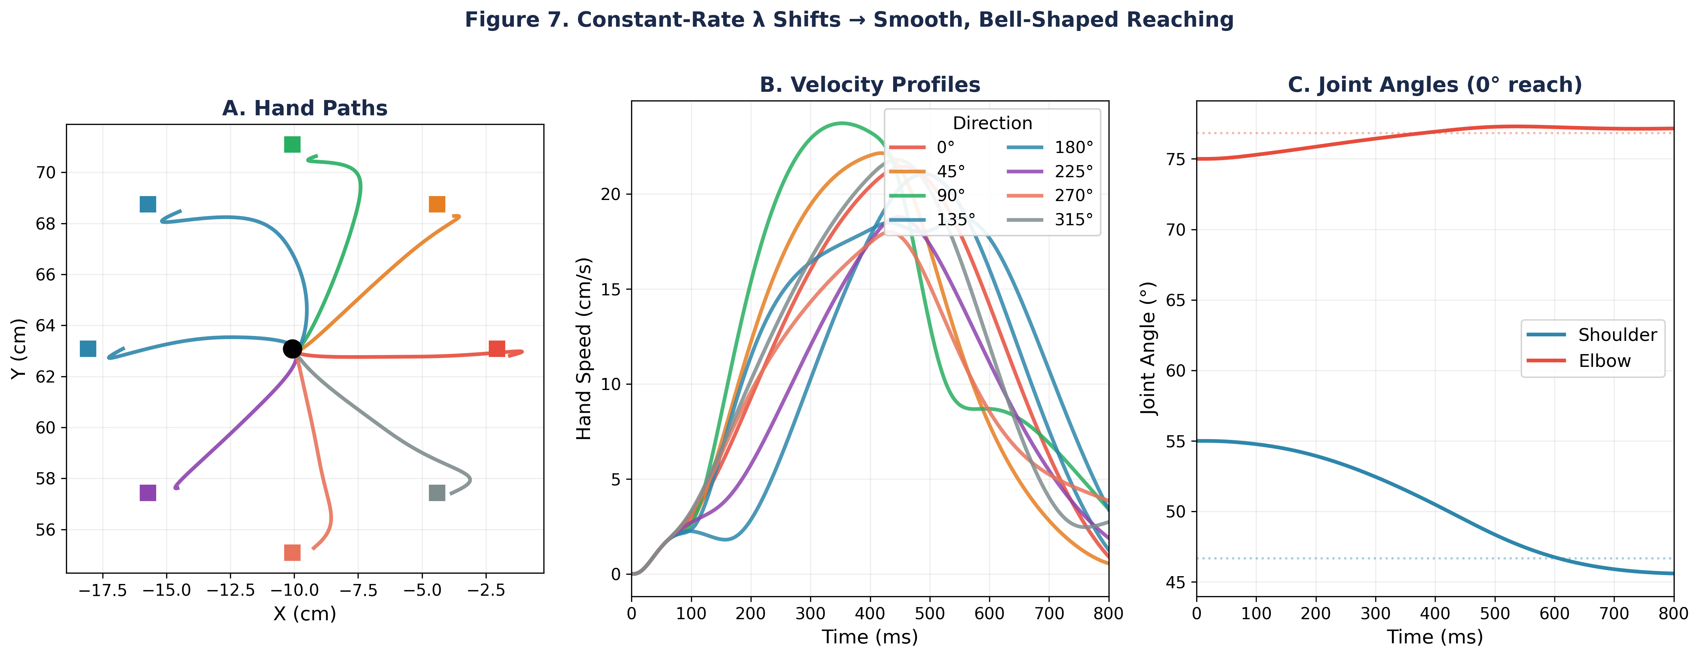
Figure 7. Center-out reaching with constant-rate λ shifts from the reference posture (55°, 75°) to 8 targets at 8 cm, spaced 45° apart. A: Hand paths. Some trajectories are noticeably curved because the λ model controls muscle thresholds, not hand position — the nonlinear Jacobian mapping (Week 1) and direction-dependent interaction torques distort the hand paths differently for each target (see Section 8). B: Velocity profiles are approximately bell-shaped, with direction-dependent amplitude and timing reflecting the arm’s anisotropic dynamics. C: Joint angles for the 0° reach show smooth monotonic transitions.
Figure 8 plots the two together — hand displacement above, hand speed below, with both conditions overlaid on each pair of axes. Section 1 showed this same arm driven by hand-designed activation patterns with no joint damping: it overshot the target and was still drifting at 4.4 cm/s when the trial ended a second later (the red trace in the lower panel of Figure 1). Here the plant is identical — the same six muscles, the same dynamics engine, still no joint damping — yet the arm reaches smoothly and stops. The only thing that changed is the control signal: λ thresholds instead of direct activations.
Bell-shaped movement, and what it costs to get one. A reaching movement is not just a displacement; it has a characteristic shape. Hand speed rises smoothly to a single peak and falls again, roughly as much time spent accelerating as decelerating — the bell-shaped profile Morasso (1981) reported and that has been found in reaching ever since. In HW03 you produced one by hand. It took a short agonist burst, a weaker and carefully timed antagonist brake, and — crucially — an asymmetric hold, because a symmetric co-contraction cannot keep the arm where you put it. Six numbers, tuned against the movement you wanted. The result was a genuine bell: a single velocity peak with a symmetry ratio of 0.47, and no overshoot.
Two numbers let us stop saying “bell-shaped” and start measuring it. The symmetry ratio is the time to peak speed divided by the total movement time: 0.5 means the limb spent exactly as long accelerating as decelerating, which is what a symmetric bell does. The second compares the whole profile to a template. We use the minimum-jerk velocity profile, 30τ²(1−τ)², and report the fraction of variance it explains (R²): 1.0 would be an exact match, and 0 would mean the template is no better than a flat line. Where that particular template comes from — and why it, of all shapes — is the subject of Week 5; for now treat it as a ruler.
Under threshold control the same shape comes out of a command with essentially nothing in it. The λ ramp is a straight line between two threshold sets, and its only free parameter is how long the ramp lasts. At 350 ms the resulting profile fits a bell with R² = 0.96 and a symmetry ratio of 0.49 — slightly closer to the ideal than the pattern you tuned by hand — while landing within 0.05 mm of the target. And the shape is not a knife-edge. Across ramp durations from 250 to 550 ms, spanning peak speeds from 18 down to 11 cm/s, the fit stays at R² ≥ 0.90 and the symmetry ratio between 0.44 and 0.56 (Figure 8C, D). If anything the shorter ramps fit slightly better; the 250 ms movement scores 0.92 against 0.76 for the 700 ms one, which spends longer creeping in at the end. A word on how that is measured: the movement window runs from the first rise above 5% of peak speed to the first drop below it after the peak. Taking the last crossing instead lets a small settling wobble hundreds of milliseconds later re-open the window and append a flat tail no bell can fit — which is a statement about the measurement, not about the movement. Nothing in the command specifies the bell. The target never moves. What moves is the equilibrium the arm is drawn toward: the λ ramp slides it smoothly from the start posture to the target and then holds it there. The bell is what a limb with mass does while it chases that shifting equilibrium and settles onto it.
Why the slowest ramp is the least bell-shaped. Look at Figure 8D and the two curves disagree: at 700 ms the symmetry ratio is 0.48, nearer to a perfect 0.5 than any other ramp, yet the fit is the worst of the set at 0.76. The measures are asking different questions. Symmetry asks only where the peak sits. The fit asks what shape surrounds it. A profile can be perfectly balanced about its peak and still be the wrong shape.
And the 700 ms profile is the wrong shape in a specific way: it is flat-topped. It spends 40% of the movement above 90% of peak speed, where a minimum-jerk bell spends 23%. It has a plateau rather than a peak — symmetric, but blunt.
The reason is worth following, because it says something about where the bell comes from. A constant-rate λ ramp moves the equilibrium at a constant speed. If the arm could track that equilibrium perfectly, the hand would move at constant speed too — a rectangle, not a bell. The bell exists because the limb has mass and lags its equilibrium: it accelerates to catch up, then decelerates as it arrives. Slow the ramp down and there is less to catch up with. With a 250 ms ramp, 78% of the movement happens after the command has stopped; with a 700 ms ramp, only 31%. The slow movement tracks its equilibrium closely, and inherits the ramp’s own flat velocity profile. Push this to the limit — an arbitrarily slow shift — and the bell would disappear entirely.

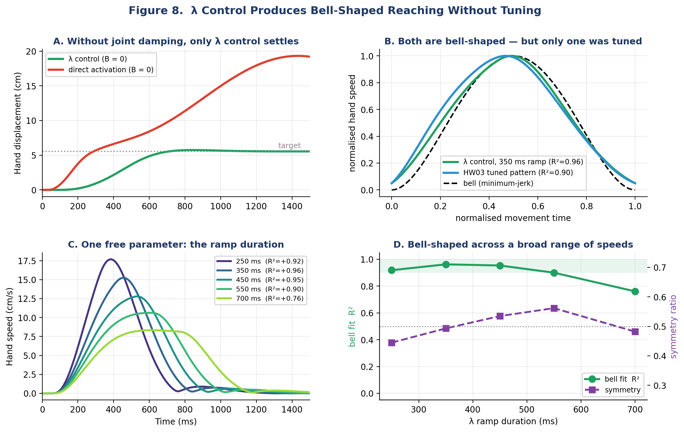
Figure 8. λ control produces bell-shaped reaching without tuning. A: with no joint damping, the λ controller converges on the target and stops while direct activation does not — same plant, same movement direction, only the control signal differs. B: hand speed for the two controllers — the λ ramp and the hand-tuned HW03 burst pattern — each normalised to its own movement time and peak speed, plotted against a minimum-jerk bell (dashed). The λ ramp fits it at R² = 0.96, the hand-tuned HW03 pattern at R² = 0.90 — but the HW03 pattern needed six tuned numbers and the λ ramp needed one. C: the same reach at five ramp durations. D: bell fit and symmetry against ramp duration. The fit holds above R² = 0.90 from 250 to 550 ms and falls away for slower ramps. Note that the two measures need not agree: at 700 ms the symmetry ratio is almost exactly 0.5 while the fit is the worst of the set, because symmetry only asks where the peak sits, not what shape surrounds it.

6. Emergent Muscle Activation Patterns

In HW03, you hand-designed a triphasic activation pattern: agonist burst, antagonist brake, co-contraction hold. With the λ model, you never program any activation pattern — instead, the threshold displacement A = [l − λ + μ·dl/dt]⁺ for each muscle evolves automatically as the arm moves (Figure 9).
The mechanism: as the λ ramp begins, muscles whose length exceeds the new (lower) threshold develop a positive displacement A > 0, which drives force production through the exponential force-length curve. As the arm accelerates, other muscles are stretched beyond their thresholds and begin to generate opposing forces. After the ramp ends, the displacements settle toward equilibrium values determined by the final λ configuration.
Note that Figure 9 shows the threshold displacement A (in mm) for each muscle — the input to the force-length curve — not EMG or force directly. The staggered pattern across muscles has a simple cause. As the arm moves, each muscle’s length changes at its own rate — set by its moment arms and the joints it spans — so each one crosses its own threshold at a different moment and by a different amount. The sequence of rising and falling activations is therefore a consequence of the movement, not a schedule imposed on it. One last thing about those traces: they are not the solution, but one of many. Section 4.1 showed a four-parameter family of threshold sets that hold any given posture, so the spatial pattern across the six muscles could have been distributed differently. The temporal shape is free as well — a raised-cosine ramp, or the minimum-jerk profile of Week 5, gives visibly different threshold traces while producing very nearly the same hand movement. Lab 4 asks you to build one and compare.
Two caveats about reading these traces too literally. They are one member of the four-parameter family described in Section 4.1: infinitely many other threshold sets would hold the same postures and drive the same movement, differing only in how hard the muscles pull against one another. And they reflect one particular choice of timing as well. A raised-cosine ramp, or the minimum-jerk profile we meet in Week 5, would give visibly different threshold traces — smoother ones, without the corners — while producing very nearly the same hand movement. What you are looking at is not the solution; it is a solution.

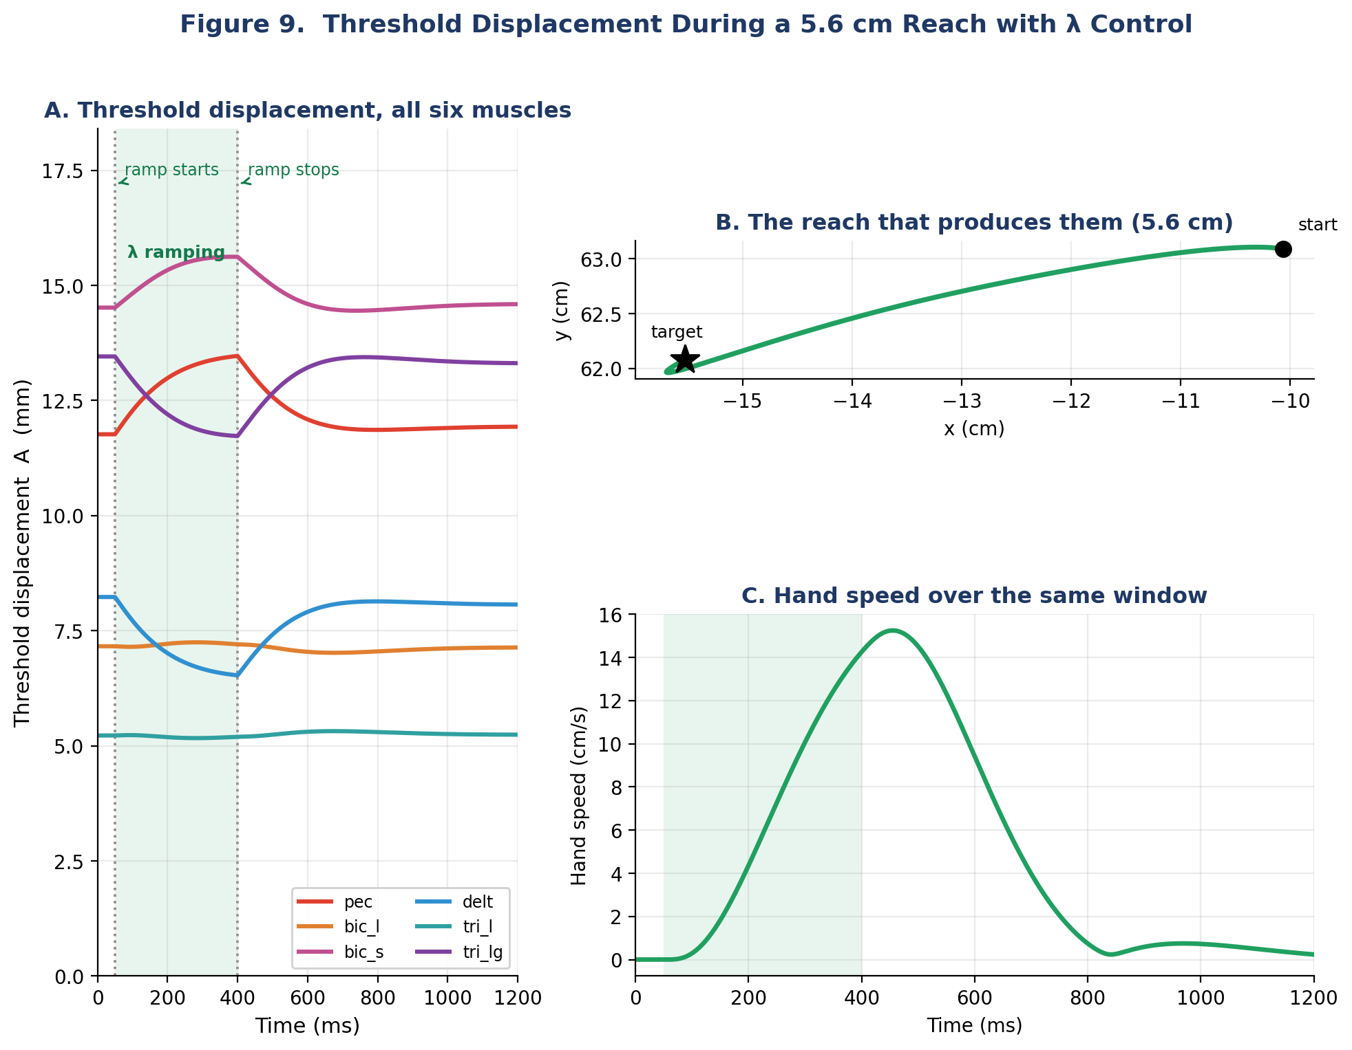
Figure 9. Threshold displacement A = [l − λ + μ·dl/dt]⁺ for each of the six muscles during the same 5.5 cm reach shown in Figures 8 and 10. These are not EMG traces and not forces: they are the model’s internal state, the stretch of each muscle past its own threshold, logged at every timestep as the simulation runs. Thresholds are solved so that the commanded equilibrium is the target (Section 3), and the hand arrives within 0.05 mm of it. Note the corners at 50 and 400 ms, marked by the dotted lines: those are the instants the λ ramp starts and stops. Because A depends on λ directly, and our ramp is piecewise linear, every muscle inherits a kink at both ends of it. The curves are continuous but not smooth there — an artefact of the command we chose, not of the muscle. This is the stretch of each muscle above its current threshold — the quantity that feeds into the exponential force-length curve to produce muscle force. It is not EMG or force directly. The teal shading marks the λ ramp period (50–400 ms): the time window during which λ values are shifted at a constant rate from start-posture values to target-posture values. Before 50 ms, all λ values are constant (holding the start); after 400 ms, all are constant (specifying the target).

To see how different these control strategies are at the muscle level, Figure 10 compares the calcium-filtered force output of two opposing muscles — the pectoralis (shoulder flexor) and deltoid (shoulder extensor) — during the same reach. With direct activation, forces follow the hand-designed triphasic timing: a sharp agonist burst (pec at 125 N), a braking antagonist pulse (delt at 74 N), then a symmetric hold. With λ control, the same muscles develop force smoothly and at much lower amplitudes (~35–40 N peak), with no prescribed timing. The pattern emerges entirely from the interaction of the λ ramp with the arm’s own motion.
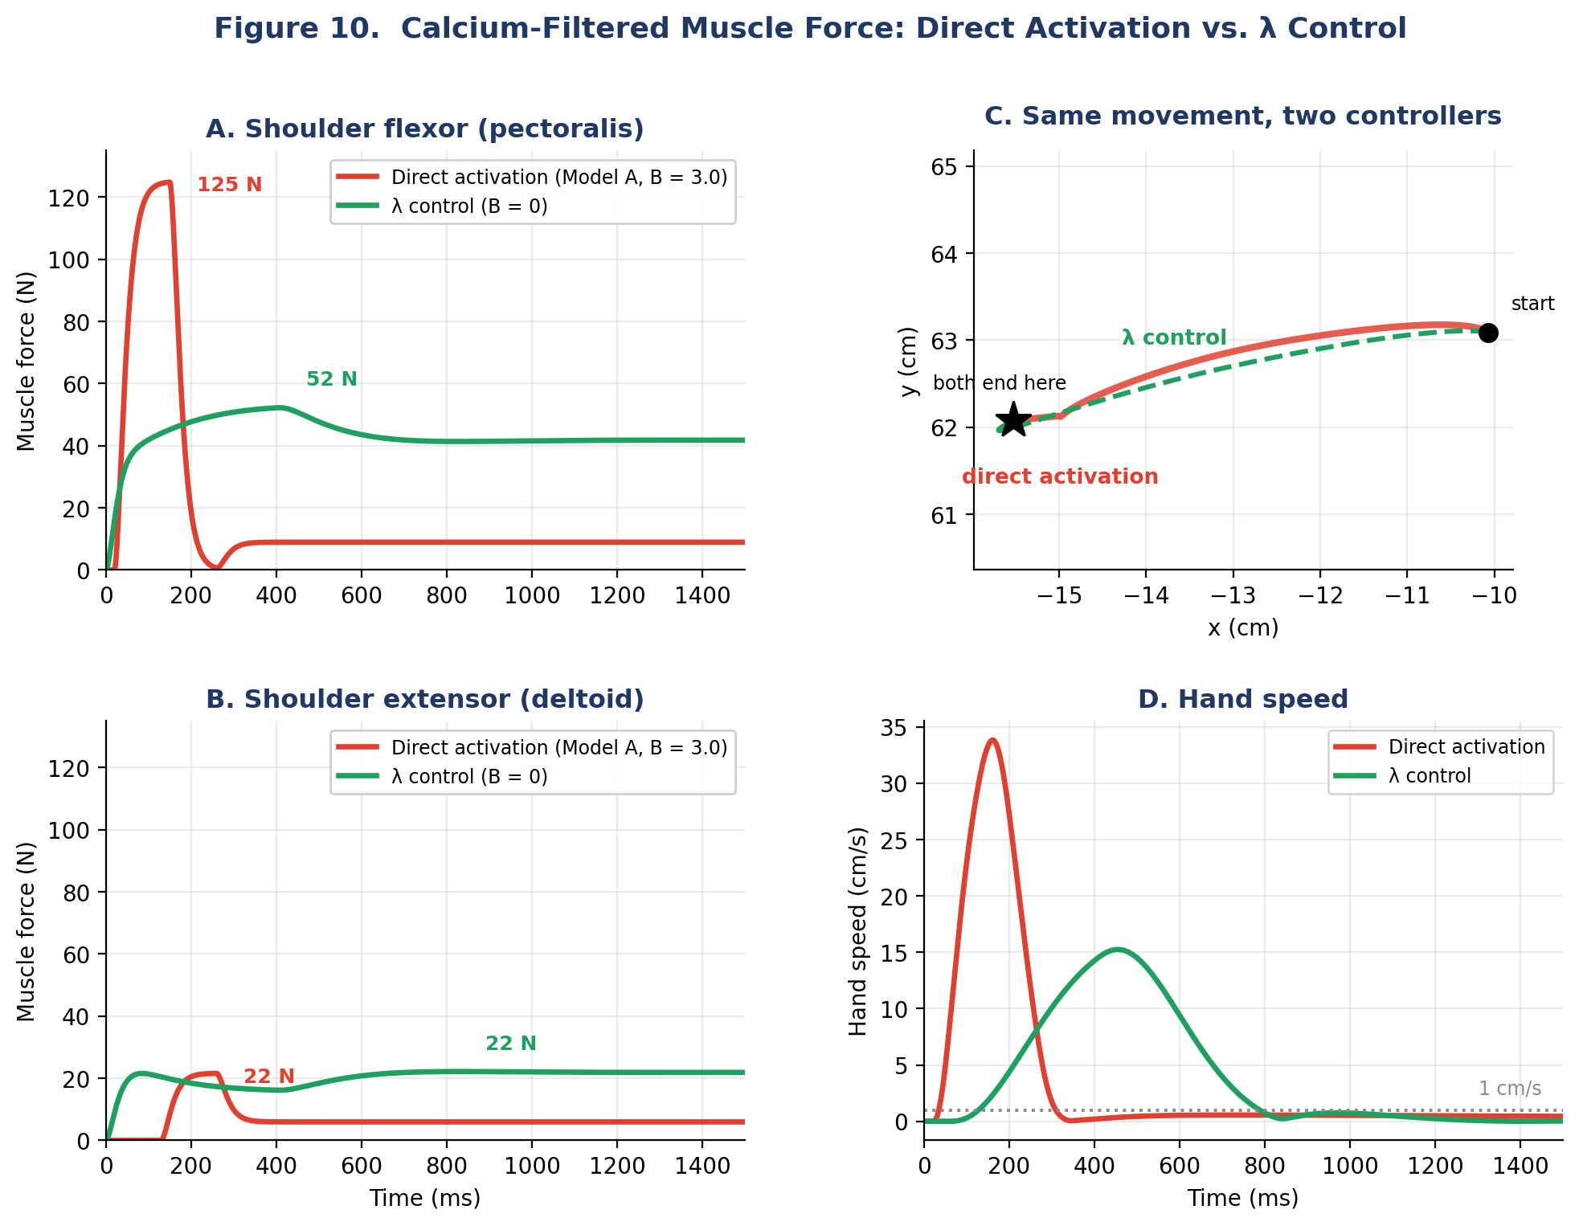
Figure 10. Calcium-filtered muscle force for the two opposing shoulder muscles. Both controllers perform the same 5.5 cm movement and finish in the same place, to within 0.05 mm, so the force traces can be compared directly. Note how they get there. Both settle at an equilibrium, but of very different quality. The burst pattern’s final hold is slightly more agonist than antagonist, and since active force under direct activation carries no length term, that hold is a constant torque; the arm settles where the passive springs balance it. Displace it and a restoring force does appear — but only about 1.0 N·m/rad of it, all passive. Under λ control the same measurement gives roughly 24 N·m/rad, because activation itself depends on muscle length. The difference is not target versus no target; it is a weak equilibrium against a stiff one. Reaching that same endpoint costs the burst pattern a peak of 125 N in pectoralis; the λ ramp needs 52 N. Red: direct activation (Model A, B = 3.0) driven by the tuned HW03 pattern — agonist burst (pec, 20–150 ms), antagonist brake (delt, 130–280 ms), and the asymmetric hold that keeps the hand where it arrives. Green: λ control (B = 0) — forces develop smoothly from threshold dynamics, at lower peak amplitudes and without prescribed timing. The λ model produces stable reaching with roughly one-third the peak muscle force.

7. Equifinality: The Spring-Like Signature
The λ model makes a strong, testable prediction: equifinality. If you perturb the arm during a reach — push it off course — it should return to the same endpoint (Figure 11). This is because the endpoint is determined by the final λ values, not by the trajectory. The muscles act like springs: they pull the arm back to the equilibrium defined by λ, regardless of the path.
This prediction distinguishes EPH from trajectory-based controllers. If the brain specifies a desired trajectory (as in inverse dynamics or VITE, Week 5), a perturbation would require replanning. In EPH, no replanning is needed — the final posture is an attractor.
Experimentally, equifinality has been demonstrated for slow movements and small perturbations (Bizzi et al., 1984; Feldman, 1986). For fast movements and large perturbations, the evidence is more nuanced. Lackner and DiZio (1994) found persistent endpoint errors when subjects made fast reaches under Coriolis perturbations, and Gomi and Kawato (1996) measured joint stiffness during fast multijoint movements that was too low to account for the observed trajectories through spring-like EP control alone. The debate centers on whether the nervous system supplements threshold control with additional feedforward or feedback mechanisms for fast movements — a question we revisit in Week 11 (The Duel).

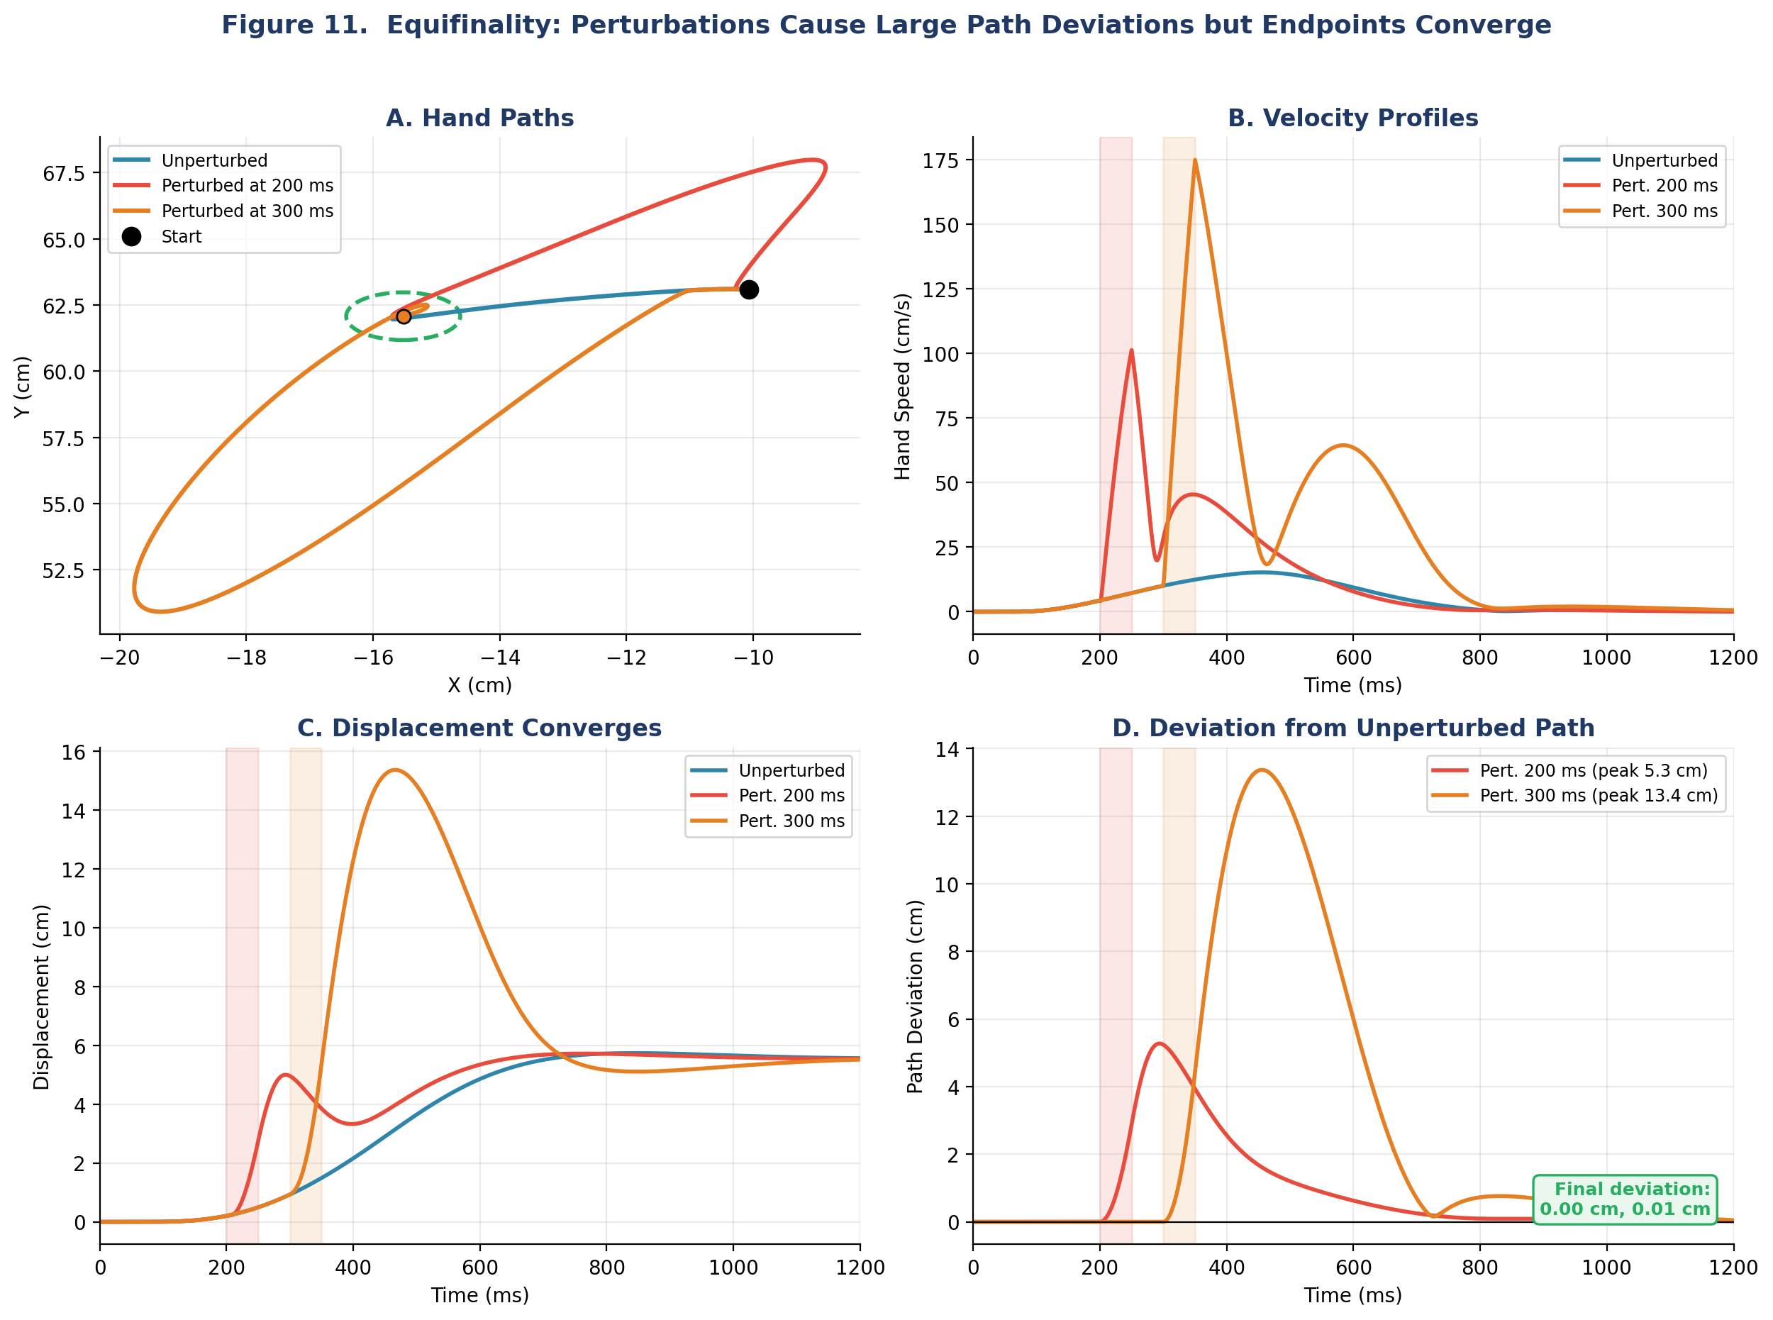
Figure 11. Equifinality test. Blue: unperturbed reach. Red and orange: the same reach disturbed by two brief torque pulses in different directions — (+5, −3) N·m at shoulder and elbow during 200–250 ms, and (−3, +5) N·m during 300–350 ms. The two pushes are not the same disturbance repeated at different times; they knock the arm off course in different ways, which makes the shared endpoint a stronger result. A: Hand paths diverge during perturbation but converge to the same endpoint (green dashed circle). B: Velocity profiles show transient disturbances. C: Displacement traces converge. D: Path deviation from the unperturbed trajectory peaks at 5.3 and 13.4 cm during the pulses but returns to under 0.02 cm at movement end — the spring-like attractor pulls the hand back to the λ-defined equilibrium regardless of the path taken.
8. Where Does EPH Struggle?

The λ model produces smooth reaching from simple control signals — but it has a limitation. Because the control is in muscle threshold space, not in task space, the same set of λ shifts can produce different hand-space trajectories depending on where in the workspace the movement starts.
This is workspace dependence. The arm’s Jacobian — the mapping from joint motion to hand motion — changes across configurations. A λ shift that produces a straight rightward reach from the center of the workspace may produce a curved path from the periphery (Figure 12).
How much of a problem is this? Human reaching is often described as straight, but the more careful statement is that hand paths are only approximately straight: they are gently curved, and the curvature varies systematically with movement direction and with where in the workspace the movement is made (Morasso 1981; Atkeson & Hollerbach 1985). So the λ model is not simply wrong here — it predicts workspace-dependent curvature, and workspace-dependent curvature is what people show. The open question is quantitative: whether the model produces the right amount of curvature, in the right places. (Gomi and Kawato’s 1996 critique is a separate argument, and it is about the equilibrium trajectory rather than about path curvature: they inferred that trajectory from measured arm stiffness and found it complex rather than a simple monotonic shift. Gribble et al. (1998) take this up as one of three such claims, and their answer is instructive. Applying Gomi and Kawato’s own algorithm to their simulations reproduces the same complex, nonmonotonic trajectory — even though the command driving those simulations was a simple constant-rate shift. The complexity, they argue, is an artefact of the simplified force-generation model the inference assumes, not a property of the command.) This is the question that motivates Week 5, which introduces the VITE model (Bullock & Grossberg, 1988) — planning movements in task space using difference vectors — and the Minimum-Jerk framework (Flash & Hogan, 1985), which derives optimal hand trajectories by minimizing jerk. Both produce straight paths and bell-shaped velocity profiles across the workspace, but they require the brain to compute a desired trajectory, which EPH avoids.

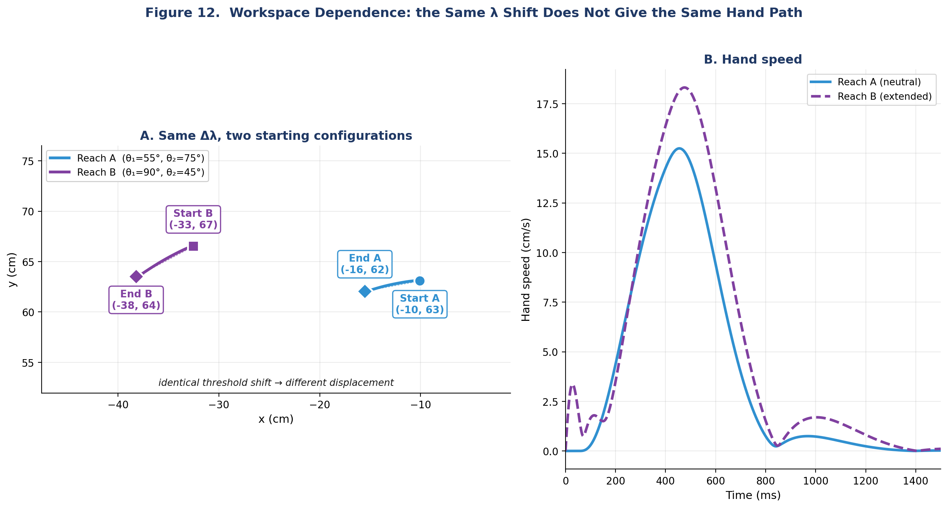
Figure 12. Workspace dependence. The same Δλ — the very shift that produced the reach in Figures 8 to 10 — is applied from two arm configurations. Reach A starts at the neutral posture (θ₁=55°, θ₂=75°; hand at −10, 63 cm) and ends at (−16, 62 cm), travelling 5.6 cm. Reach B starts from an extended posture (θ₁=90°, θ₂=45°; hand at −33, 67 cm) and ends at (−38, 64 cm), travelling 6.4 cm — 15% further, in a direction rotated by 17°. Start positions are marked with circles and squares, end positions with diamonds; dotted arrows show net displacement. The same threshold shifts produce dramatically different hand paths and velocity profiles because the Jacobian, moment arms, and interaction torques all change with configuration.

9. Summary & Looking Ahead

Week 4 Takeaway. The λ model replaces direct activation with threshold control. A constant-rate ramp in λ — the simplest possible control signal, with a single free parameter — produces bell-shaped reaching (R² = 0.96 against a minimum-jerk profile, symmetry 0.49, robust from 350 to 550 ms) with intrinsic stability and emergent EMG patterns. The same shape under direct activation had to be tuned by hand. The neural drive gain G and external damping B from Weeks 2–3 are no longer needed. Equifinality confirms the spring-like attractor dynamics. The cost: workspace-dependent kinematics, because control lives in muscle space, not task space.

Next week: We ask whether explicit trajectory planning can overcome EPH’s workspace dependence. Week 5 introduces the VITE model (Bullock & Grossberg, 1988) and the Minimum-Jerk framework (Flash & Hogan, 1985). These models plan in task space and generate kinematic invariants — but they pay for it with computational cost. The question becomes: does the brain compute trajectories, or does it just shift thresholds?
What Week 5 adds to this. We have been describing movements as “bell-shaped” and scoring them against a minimum-jerk profile without saying where that profile comes from. Next week we derive it. Flash and Hogan (1985) showed that if you ask which trajectory between two points minimises the integral of squared jerk — the rate of change of acceleration — the answer is a unique fifth-order polynomial whose velocity profile is exactly the symmetric bell we have been fitting. That gives a principled yardstick in place of an eyeball judgement, and it sharpens the question this week leaves open. The λ model was never asked to optimise anything, yet it lands within R² = 0.96 of the jerk-optimal profile. Either smoothness is something the nervous system computes, or it is something a limb with mass and spring-like muscles produces for free when it is pulled toward a moving equilibrium. Week 5 puts those two accounts side by side.

Comparison: Direct Activation vs. λ Control
Feature | Direct Activation (Wks 2–3) | λ Threshold Control (Wk 4)
Control signal | a(t) ∈ [0, 1] | λ(t) in meters
Needs gain G? | Yes (G = 20 mm) | No
Needs damping B? | Yes (B = 3.0 N·m·s/rad) | No (μ·dl/dt is intrinsic)
Stability (B = 0) | Overshoot and drift | Smooth settling
EMG pattern | Hand-designed triphasic | Emerges automatically
Equifinality | Not guaranteed | Built-in (spring attractor)
Workspace invariance | N/A (activations specified) | No — Jacobian-dependent
Computational cost | Must design activation profiles | Ramp λ at constant rate

References
Atkeson, C. G., & Hollerbach, J. M. (1985). Kinematic features of unrestrained vertical arm movements. Journal of Neuroscience, 5(9), 2318–2330.

Bizzi, E., Accornero, N., Chapple, W., & Hogan, N. (1984). Posture control and trajectory formation during arm movement. Journal of Neuroscience, 4(11), 2738–2744.
Bullock, D., & Grossberg, S. (1988). Neural dynamics of planned arm movements: Emergent invariants and speed-accuracy properties during trajectory formation. Psychological Review, 95(1), 49–90.
Feldman, A. G. (1966). Functional tuning of the nervous system with control of movement or maintenance of a steady posture. II. Controllable parameters of the muscles. Biophysics, 11(3), 565–578.
Feldman, A. G. (1986). Once more on the equilibrium-point hypothesis (λ model) for motor control. Journal of Motor Behavior, 18(1), 17–54.
Feldman, A. G., Adamovich, S. V., Ostry, D. J., & Flanagan, J. R. (1990). The origin of electromyograms — explanations based on the equilibrium point hypothesis. In J. Winters & S. Woo (Eds.), Multiple Muscle Systems: Biomechanics and Movement Organization (pp. 195–213). Springer-Verlag.
Flanagan, J. R., Ostry, D. J., & Feldman, A. G. (1990). Control of human jaw and multi-joint arm movements. In G. Hammond (Ed.), Cerebral Control of Speech and Limb Movements (pp. 29–58). Springer-Verlag.
Flash, T., & Hogan, N. (1985). The coordination of arm movements: An experimentally confirmed mathematical model. Journal of Neuroscience, 5(7), 1688–1703.
Gomi, H., & Kawato, M. (1996). Equilibrium-point control hypothesis examined by measured arm stiffness during multijoint movement. Science, 272(5258), 117–120.
Gribble, P. L., Ostry, D. J., Sanguineti, V., & Laboissière, R. (1998). Are complex control signals required for human arm movement? Journal of Neurophysiology, 79(3), 1409–1424.
Kistemaker, D. A., Van Soest, A. K. J., & Bobbert, M. F. (2006). Is equilibrium point control feasible for fast goal-directed single-joint movements? Journal of Neurophysiology, 95(5), 2898–2912.
Lackner, J. R., & DiZio, P. (1994). Rapid adaptation to Coriolis force perturbations of arm trajectory. Journal of Neurophysiology, 72(1), 299–313.
Morasso, P. (1981). Spatial control of arm movements. Experimental Brain Research, 42(2), 223–227.

