WEEK 14
Subcortical Learning in Sensorimotor Control
The Cerebellum, the Basal Ganglia, and Two Types of Motor Learning

Reading: Izawa, J. & Shadmehr, R. (2011). Learning from sensory and reward prediction errors during motor adaptation. PLoS Comput Biol, 7(3), e1002012.
Reading: Rezazadeh, A. & Berniker, M. (2019). Force field generalization and the internal representation of motor learning. PLoS ONE, 14(11), e0225002.
Supplementary: Kakei, S., Bostan, A. C., Ebner, T. J., et al. (2026). Consensus Paper: Models of Cerebellar Functions. The Cerebellum, 25(1), 15.
Supplementary: Smith, M. A. & Shadmehr, R. (2005). Intact ability to learn internal models of arm dynamics in Huntington’s disease but not cerebellar degeneration. J Neurophysiol, 93(5), 2809–2821.
Supplementary: Doya, K. (2000). Complementary roles of basal ganglia and cerebellum in learning and motor control. Curr Opin Neurobiol, 10(6), 732–739.
Supplementary: Mazzoni, P., Hristova, A., & Krakauer, J. W. (2007). Why don’t we move faster? Parkinson’s disease, movement vigor, and implicit motivation. Journal of Neuroscience, 27(27), 7105–7116.

Introduction
In Weeks 12–13, you built an optimal feedback controller: the Riccati equation computes gains L_t from a cost function (Q, R), and the Kalman filter estimates the arm’s state using a forward model (A, B). But where do these components come from? The brain doesn’t receive Q, R, A, and B as specifications. It must learn them from experience. This lecture asks: which brain structures learn which components, and what algorithms do they use?
The answer involves two subcortical systems that have traditionally been studied in isolation. The cerebellum learns the forward model — the A and B matrices that let the KF predict the arm’s state between delayed sensory measurements. It does so via error-based learning: climbing fiber signals carry sensory prediction errors that drive synaptic plasticity (§§1–4). The basal ganglia learn what to optimize — the cost function that shapes behavior. They do so via reinforcement learning: dopaminergic reward prediction errors adjust the value of actions (§5). Together, these two systems produce adaptive, goal-directed motor control.
1. The Cerebellum as Forward Model
In Week 12, you built a Kalman filter whose predict step runs at every timestep: x̂⁻ = A x̂ + B u. This predict step is the brain’s forward model. It takes the current state estimate and the efference copy of the motor command, and predicts the arm’s state at the next timestep — before any sensory feedback arrives. During fast reaching, when proprioception is 40 ms stale and vision is 100 ms stale, the controller relies almost entirely on this prediction.
The cerebellum is widely hypothesized to implement this forward model. It receives efference copy of motor commands via the pontine nuclei, and it has the computational architecture — the granule cell layer’s massive expansion recoding, the Purkinje cell’s dendritic integration — to learn complex input–output mappings like the dynamics matrix A. The quality of A determines how far the state estimate can drift before sensory feedback corrects it. For the 12 cm reach at Q_REF, the arm travels through its trajectory in 500 ms; the longest sensory delay is 100 ms. Without an accurate forward model, the controller would be steering with information that is 20–40% of the movement duration out of date.
Figure 1 shows the OFC/KF architecture from Week 12 with the cerebellar contributions highlighted in green: the KF predict step (which houses the forward model A) and the error-driven learning block (which updates A over time). For now, both blocks are intact.
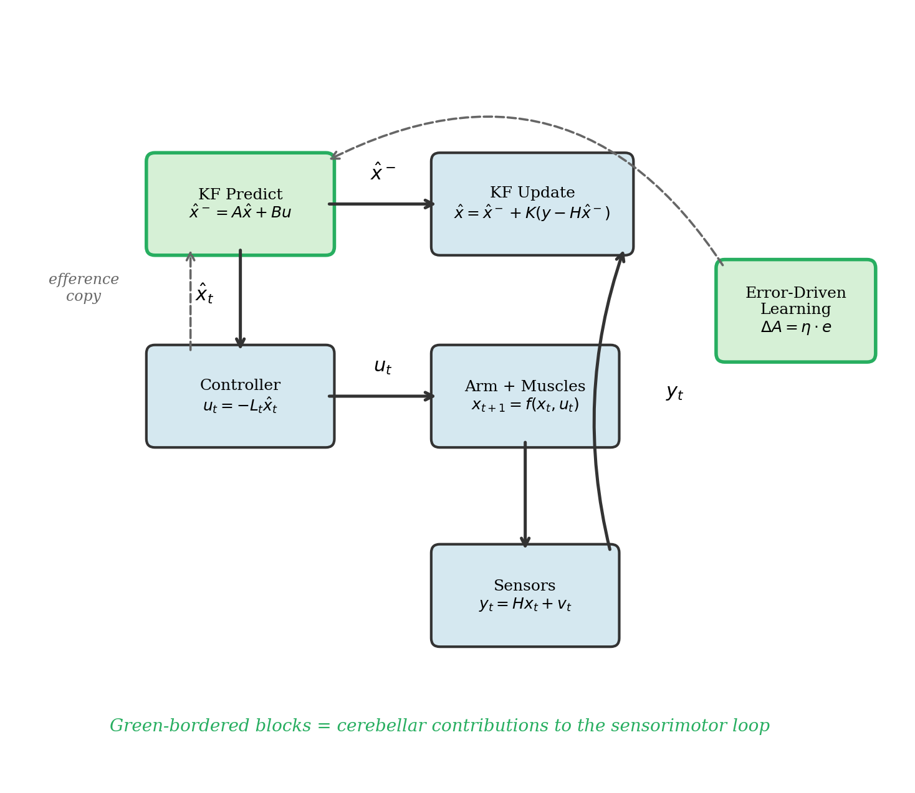
Figure 1. The OFC/KF architecture with cerebellar contributions highlighted in green. The KF predict step houses the forward model (the A matrix). The error-driven learning block updates A trial by trial. Both are cerebellar functions.
The forward model IS the predict step. The Kalman filter’s predict step x̂⁻ = A x̂ + B u is the computational implementation of the brain’s forward model. The cerebellum provides the accurate A. Without it, the controller must rely on delayed sensory feedback — a recipe for the instabilities that characterize cerebellar ataxia.

2. The Cerebellum as Learning Engine
The cerebellum does not just predict — it improves its predictions trial by trial. This is the second computational role: error-driven learning. Climbing fiber signals from the inferior olive carry sensory prediction errors — the discrepancy between what the forward model predicted and what the sensors actually reported. These error signals drive synaptic plasticity at the parallel fiber–Purkinje cell synapse (long-term depression, LTD), adjusting the cerebellar output to reduce the error on the next trial.
In our framework, this means the A and B matrices are not fixed — they are learned and refined through experience. When you first learn to throw a ball, your forward model is poor: you cannot predict where your arm will be 100 ms from now. With practice, the cerebellum refines A until the prediction error — the gap between x̂⁻ and the sensory measurement y — is minimized. This is why motor skill acquisition takes hundreds or even thousands of trials: the cerebellum is fitting a high-dimensional dynamics model from noisy data.
The learning engine also handles novel perturbations. When the dynamics change — because you pick up a heavy tool, or because an experimenter applies a force field to your arm — the old A matrix is wrong. The prediction errors spike. The cerebellum detects these errors and updates A to account for the new dynamics. This is motor adaptation, and it is one of the best-studied functions of the cerebellum. To understand what breaks in ataxia, we first need to understand what healthy adaptation looks like. That requires a concrete perturbation paradigm.
3. Force-Field Adaptation
A velocity-dependent curl force field is the standard tool for studying motor adaptation. The field applies a force perpendicular to the hand’s velocity: F = B_curl · v_hand, where B_curl is a 2×2 skew-symmetric matrix:
B_curl = [ 0 -b ] where b is the curl gain (N·s/m)
[ b 0 ]

F = B_curl · v_hand : Fx = -b · vy , Fy = b · vx

The gain b sets the perturbation strength. If the hand moves rightward (vx > 0), the force pushes downward (CW field) or upward (CCW field). The force is zero when the hand is stationary, and maximal at peak velocity. This converts to joint torques via the Jacobian transpose: τ_perturb = Jᵀ F — the same Jacobian from Week 1.
On first exposure, the reach curves dramatically (Figure 2A, red trace). The perpendicular error at peak velocity — the lateral displacement from the straight-line baseline measured at the moment of maximum hand speed — is the standard scalar metric for adaptation. Over repeated trials, the nervous system learns to produce anticipatory forces that cancel the perturbation, and the trajectory straightens (orange → green → purple traces). Figure 2B shows the trial-by-trial learning curve: perpendicular error drops exponentially over ~80 trials as the feedforward compensation â approaches the true field strength α.
This simulation uses the Rezazadeh & Berniker (2019) model framework: inverse dynamics feedforward + estimated field compensation (â) + PD feedback, applied to the nonlinear 2-link arm dynamics with a CW curl field (α = 15 N·s/m). The adaptation of â is driven by the two-stage model from §4.
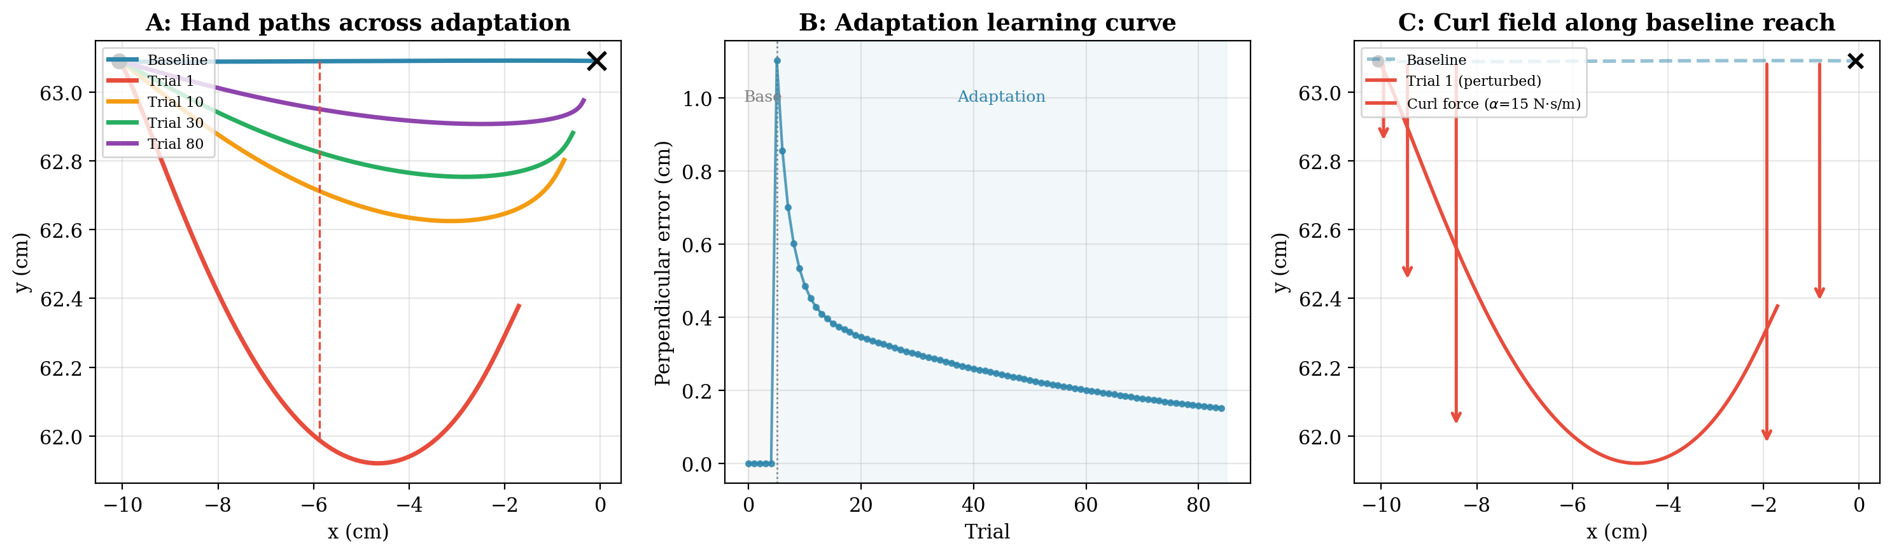
Figure 2. Force-field adaptation on the simulated arm. (A) Hand paths across adaptation: baseline (blue, straight), trial 1 (red, maximally curved), trial 10 (orange), trial 30 (green), and trial 80 (purple, nearly straight). (B) Perpendicular error learning curve across 80 adaptation trials, showing exponential decay. (C) Curl force vectors (red arrows) along the baseline reach direction — always perpendicular to velocity, largest at mid-reach.
Smith & Shadmehr (2005) studied this paradigm in patients with cerebellar degeneration, Huntington’s disease, and healthy controls. Their key finding: cerebellar patients’ motor commands do change from trial to trial — but the changes are random, uninformed by the error on the preceding trial. The cerebellum is needed not to change motor commands, but to change them in the right direction. This result directly supports the two-stage model’s prediction that the cerebellum drives the fast learning process.
The question for our framework is: what drives this adaptation in healthy subjects? The error on each trial provides a teaching signal. But a single learning rate cannot explain the full pattern of adaptation and its aftermath. For that, we need a model with two processes.
4. The Two-Stage State-Space Model
Smith, Ghazizadeh & Shadmehr (2006) proposed that motor adaptation is not a single process but the sum of two hidden processes with different time constants. On each trial n, the total adaptation x_total(n) is the sum of a fast process x_f(n) and a slow process x_s(n):
Fast process: x_f(n+1) = A_f · x_f(n) + η_f · e(n)
Slow process: x_s(n+1) = A_s · x_s(n) + η_s · e(n)
Total: x_total(n) = x_f(n) + x_s(n)
Error: e(n) = perturbation(n) − x_total(n)

The fast process has a high learning rate (η_f ≈ 0.15) but low retention (A_f ≈ 0.85): it learns quickly but forgets quickly between trials. The slow process has a low learning rate (η_s ≈ 0.03) but high retention (A_s ≈ 0.998): it learns slowly but remembers nearly everything. Together, they produce the rapid initial learning you see in adaptation (dominated by the fast process), followed by long-term retention (sustained by the slow process).
Why Two Processes?
A single process with one learning rate and one retention rate cannot explain three phenomena simultaneously:
Spontaneous recovery. After the perturbation is removed (washout), total adaptation decays to zero. But if you wait and then re-test, the error transiently reappears. Why? During washout, the fast process extinguishes quickly (A_f = 0.85, so it loses 15% per trial). The slow process, with A_s = 0.998, barely decays. Once the fast process is gone, the slow process “re-emerges” as a residual adaptation that the now-absent fast process was previously opposing. This is spontaneous recovery — and it proves two processes are at work.
Savings. Re-learning after washout is faster than initial learning because x_s retains from the first exposure. Even after the error has returned to zero, the slow process is still elevated.
Different time courses. Both initial learning and washout are fast (dominated by the fast process). Yet re-learning shows savings. A single process cannot produce fast learning, fast washout, and savings simultaneously.
Figure 3 shows the healthy two-stage model across 150 trials: 20 baseline, 80 adaptation with the curl field on, and 50 washout with the field removed. The spontaneous recovery during washout — the transient re-emergence of error after the fast process extinguishes — is annotated in Panel C.
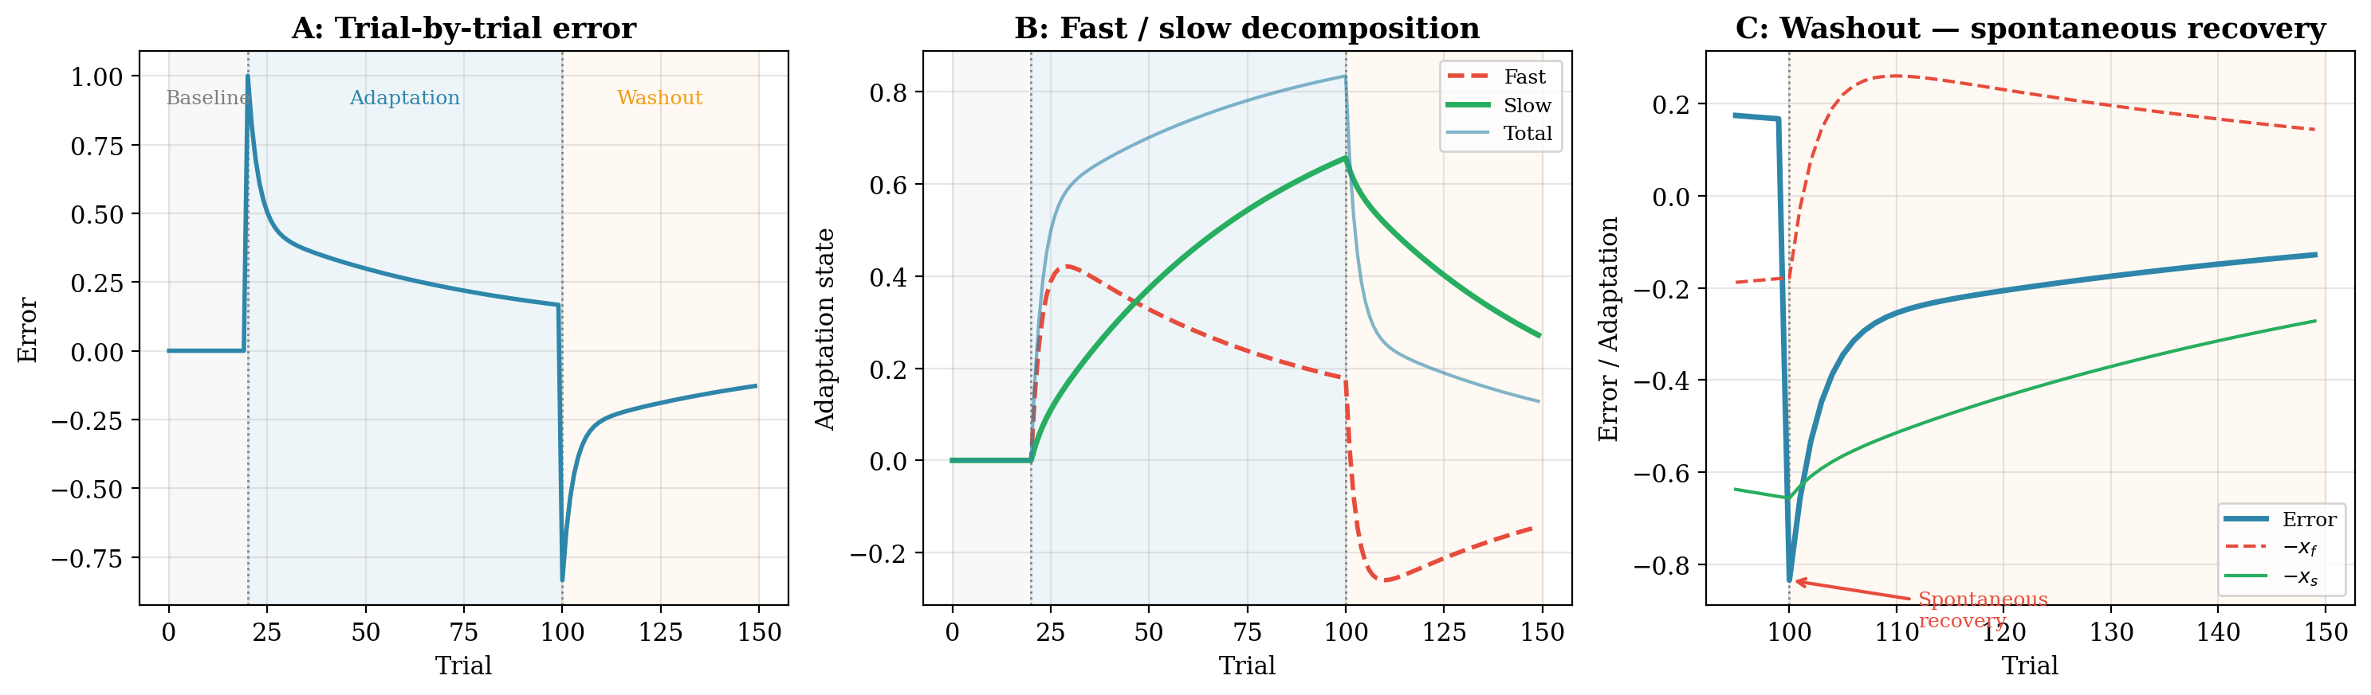
Figure 3. The two-stage model of healthy motor adaptation. (A) Trial-by-trial error across baseline, adaptation, and washout phases. (B) Decomposition: the fast process (dashed red) rises quickly and dominates early adaptation; the slow process (solid green) rises gradually and persists. (C) Washout phase zoomed: after the fast process extinguishes, the slow process persists, producing spontaneous recovery — the error transiently re-emerges before decaying.
Connecting Back to the Cerebellum
The fast process is hypothesized to depend on the cerebellum — rapid, trial-by-trial error correction driven by climbing fiber signals (§2). The slow process is thought to be mediated by motor cortex and other non-cerebellar structures. This hypothesis makes a testable prediction: if the cerebellum is damaged, the fast process should be selectively degraded while the slow process is spared.

5. Reinforcement Learning and the Basal Ganglia
Sections 1–4 addressed how the brain learns the model — the dynamics A, B that let the Kalman filter predict the arm’s state. But the OFC framework has a second learned component: the cost function Q, R that defines what the controller optimizes. Where does the cost function come from?
The Doya Framework
Doya (1999, 2000) proposed that three brain structures specialize in three types of learning. The cerebellum performs supervised (error-based) learning: it receives an explicit error signal (climbing fibers) and adjusts its output to reduce that error. The basal ganglia perform reinforcement learning: they receive a scalar reward signal (dopamine) and adjust behavior to maximize cumulative reward. The cerebral cortex performs unsupervised learning: it extracts statistical regularities from sensory input to build representations.
To see how Doya’s three systems map onto OFC, recall the two core computations from Weeks 12–13. The controller has a forward model (used in the KF predict step), an observation model (used in the KF update step), and a cost function (used in the Riccati backward pass):
Forward model: x̂⁻ₜ₊₁ = A · x̂ₜ + B · uₜ
Observation: yₜ = H · xₜ + vₜ
Cost function: J = ∑ₜ ( xₜᵀ Q xₜ + uₜᵀ R uₜ )
A = state dynamics (how the arm moves), B = control input (how motor commands affect the arm), H = observation matrix (how sensors read the state), Q = state cost (penalty for position/velocity errors), R = control cost (penalty for motor effort).
In the context of the OFC framework from Weeks 12–13, one natural interpretation is that each learning system maps onto a different component of the controller. The cerebellum’s role as a forward model learner (A, B) is well established in the literature (Wolpert, Miall & Kawato, 1998). The mapping of basal ganglia to the cost function (Q, R) is a conceptual bridge we are drawing here — a reasonable inference, since the basal ganglia learn what actions are valuable, which is what a cost function encodes — but it is not a direct claim from Doya’s work:
Cerebellum → forward model (A, B) → error-based / supervised
Basal ganglia → cost function (Q, R)? → reward-based / reinforcement
Cerebral cortex → representations (H)? → unsupervised

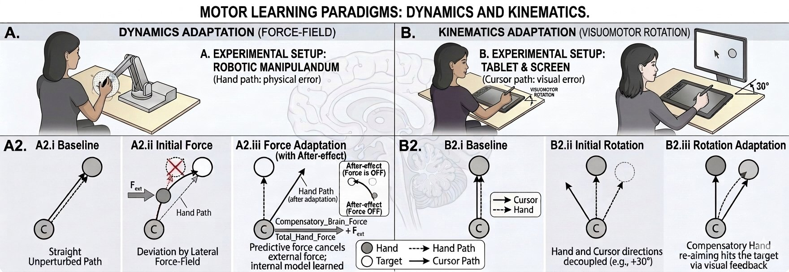
Figure 4. Experimental paradigm: A) Force-field adaptation (dynamics); B) Visuomotor rotation (kinematics).
The Visuomotor Rotation Paradigm
Figure 4 contrasts the two experimental paradigms used in this lecture. In §3, we used force-field adaptation (Figure 4A) to study cerebellar learning. To study reward-based learning, we switch to a different paradigm: the visuomotor rotation (VMR, Figure 4B). We make this switch because the key experiments dissociating error-based from reward-based learning (Izawa & Shadmehr, 2011) used VMR, and because VMR makes it easy to manipulate what feedback the subject receives.
In a VMR task, the subject reaches toward a target while watching a cursor on a screen. Unbeknownst to them, the cursor is rotated relative to their actual hand position — typically by 30°. If they reach straight to the target, the cursor lands 30° to the right. To hit the target, they must learn to aim 30° to the left of the target, so that the rotated cursor arrives at the correct location. The perturbation is purely visual (no forces on the hand), and the compensation is a change in reach direction rather than a change in force output (Figure 5A).
The Experiment: Error Feedback vs Reward Feedback
The power of the VMR paradigm for studying learning systems is that you can control exactly what feedback the subject receives. Izawa & Shadmehr (2011) compared two conditions:
Error-based condition. The subject sees the cursor throughout the reach. After each trial, they see exactly where the cursor went — the full trajectory and the endpoint relative to the target. The sensory prediction error (the angular difference between where the cursor was expected and where it appeared) is available at every moment. This signed error tells the learner both how much and in which direction to adjust: Δθ = η_f · e, where e is the rotation minus the current compensation.
Reward-based condition. The cursor is turned off. The subject reaches in the dark. After each trial, they receive only binary feedback: a tone indicating whether the (invisible) cursor landed within the target zone or missed. No information about where the cursor went, how far it missed, or in which direction to correct. The only feedback is a scalar: hit or miss.
Figure 5B–C shows the simulated result. The error-based learner adapts rapidly (~20 trials) with smooth convergence to the full 30° compensation. The reward-based learner adapts much more slowly (~200 trials), with noisy trial-to-trial variability, and reaches only partial compensation (~21°). The same perturbation, the same target — the only difference is the information available for learning.
A note on the simulations. The error-based learning curve uses the two-stage state-space model from Smith et al. (2006), with parameters (A_f = 0.85, A_s = 0.998, η_f = 0.15, η_s = 0.03) that are well established in the adaptation literature. The reward-based curve uses a REINFORCE policy-gradient algorithm with exploration noise σ = 6°, learning rate η = 0.15, and a graded reward zone of 10°. These RL parameters were chosen to produce the qualitative dissociation reported by Izawa & Shadmehr (2011) — fast and smooth for error-based, slow and noisy for reward-based — but they are not fit to their experimental data. The specific time courses, asymptotic compensation levels, and trial-to-trial variability in the simulation are predictions of our model; actual experimental learning curves will differ in detail.
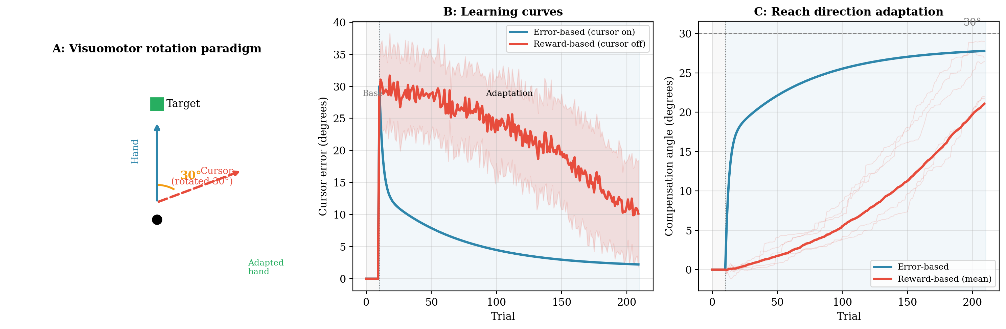
Figure 5. Visuomotor rotation adaptation: error-based vs reward-based. (A) The VMR paradigm: the cursor (red dashed) is rotated 30° from the hand’s actual direction (blue). To hit the target, the subject must learn to aim in the compensating direction (green). (B) Learning curves: error-based (blue, cursor on) converges to near zero in ~20 trials; reward-based (red, cursor off) is slower and noisier (±1 SD shaded, 30 runs). (C) Compensation angle: error-based rises smoothly toward 30°; reward-based individual traces (light) are noisy but the mean (bold) gradually increases.
Reward Prediction Error and Dopamine
Why is reward-based learning so much slower? The teaching signal for RL is the reward prediction error (RPE) — the difference between the reward you received and the reward you expected. Schultz, Dayan & Montague (1997) discovered that midbrain dopamine neurons encode exactly this quantity. When a reward is better than expected, dopamine neurons fire a burst (positive RPE). When a reward is worse than expected, they pause (negative RPE). When a reward matches expectations, they are silent (zero RPE). This is the biological implementation of the temporal difference (TD) error:
δ = r(t) + γ · V(s’) − V(s) where δ is the TD error, r is reward, γ is discount, V is value

Connecting the TD error to the OFC cost function
The OFC equations and the TD error operate at different timescales. Within a single reach, Q, R, A, and B are treated as fixed — the Riccati equation and KF run with these parameters to produce that movement. Across trials, both sets of parameters change: the cerebellum refines A and B using sensory prediction errors (§§1–4), and the basal ganglia adjust the effective cost function using reward prediction errors.
The connection is conceptual, not mathematical. The cost function Q, R determines what counts as a good movement — did the hand reach the target? Was the effort acceptable? At the end of each trial, the reward signal evaluates the outcome: success or failure. The TD error δ compares this outcome to what was expected. When δ > 0 (better than expected), the basal ganglia reinforce whatever balance of accuracy and effort produced that movement. When δ < 0 (worse than expected), they shift the effective cost function for future trials. Crucially, the basal ganglia do not compute the Riccati cost-to-go or monitor the arm’s moment-by-moment state — they receive a scalar “how did that go?” signal and use it to shape what the controller optimizes next time.
So the TD equation does not replace the OFC equations — it sits above them, tuning their parameters. The cerebellum’s sensory prediction error (a vector) tunes A, B from below. The basal ganglia’s RPE δ (a scalar) tunes Q, R from above. Both feed into the same Riccati/KF machinery that runs every reach.

The TD error δ plays the same role in the basal ganglia that the sensory prediction error plays in the cerebellum. But the two signals are fundamentally different. The cerebellar error is a signed vector — it tells you exactly what went wrong and in which direction (e.g., the cursor landed 15° clockwise of the target). The dopaminergic RPE is a scalar — it tells you only that something went wrong, not what (e.g., you missed). To convert a scalar reward into a directional update, the learner must correlate reward with its own exploration noise: Δθ = η · δ · ε, where ε is the exploration noise on that trial. This is the REINFORCE algorithm. It works, but it requires many trials because the correlation between exploration and reward is noisy.
Figure 6 illustrates what each learner actually experiences. The error-based learner sees the cursor and knows exactly which way to adjust (Panel B, top). The reward-based learner reaches in the dark and hears only a hit/miss tone (Panel B, bottom). Panel A shows the reward signal across all trials: reward is near perfect during baseline (no rotation), drops sharply when the 30° rotation is introduced, then gradually recovers over 200 adaptation trials — the only feedback the RL learner receives. Panel C summarizes the algorithmic contrast.
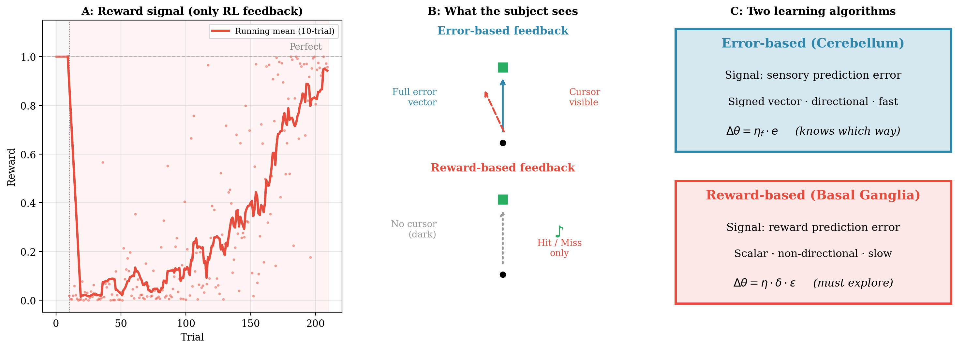
Figure 6. The two learning algorithms compared. (A) The scalar reward signal over 200 RL trials — the only feedback available to the reward-based learner. (B) What the subject actually sees: error-based (top) receives the full cursor trajectory; reward-based (bottom) reaches in the dark and hears only hit/miss. (C) Algorithmic summary: error-based learning uses a signed error vector and converges fast; reward-based learning uses a scalar RPE multiplied by exploration noise and converges slowly.

Mapping to OFC: Who Learns What?
Consider the Riccati backward pass from Week 12. It takes a cost function (Q, R) and a dynamics model (A, B) and produces optimal gains L_t. Neither Q, R nor A, B are given by the environment — both must be learned:
The cerebellum learns A, B. When you pick up a new tool, the arm’s effective dynamics change. The old A matrix is wrong. Sensory prediction errors spike. The cerebellum detects these errors and updates A via error-driven learning (§2). Force-field adaptation (§3) is the experimental paradigm that reveals this process. The result: the KF predict step becomes accurate again, and the controller can use its forward model to bridge sensory delays.
The basal ganglia learn Q, R. Should you reach fast or slow? Prioritize accuracy or energy? These are not questions the dynamics model can answer — they are questions about what you value. The cost function Q (how much you penalize error) and R (how much you penalize effort) encode these values. The basal ganglia, via dopaminergic RPE, adjust behavior to maximize cumulative reward. When the reward structure changes (e.g., speed–accuracy tradeoff shifts), the basal ganglia update the effective cost function.
The Mazzoni et al. (2007) insight. Parkinson’s disease patients are slow, not weak. Their muscles work fine. Mazzoni et al. showed that PD patients can move at normal speeds with preserved accuracy, but are reluctant to do so — they need more trials to produce fast movements. Bradykinesia, they argued, reflects a distortion in speed selection: the energetic cost of movement is weighted too heavily. In our OFC framework, one natural interpretation is that the basal ganglia, damaged by dopamine loss, produce an effective cost function where the motor effort penalty R is too large relative to the state cost Q. The controller becomes too “cautious” — it under-weights the benefit of reaching quickly. Note that this Q/R interpretation is our synthesis, not a claim from Mazzoni et al.

Two Systems, Two Failure Modes
This dual-system framework makes a clean clinical prediction. Cerebellar damage (→ broken model) produces ataxia: the movements are poorly calibrated (dysmetria, intention tremor) because the forward model can’t bridge sensory delays. Basal ganglia damage (→ broken cost) produces bradykinesia and akinesia: the movements are slow or absent because the cost function over-penalizes effort. Both patients can improve with practice, but through different mechanisms: cerebellar patients rely on the spared slow (cortical) adaptation process (§4), while Parkinson’s patients benefit from external cues that bypass the basal ganglia’s action selection.
Izawa & Shadmehr (2011) demonstrated the dissociation experimentally. When subjects adapted to a visuomotor rotation using error-based learning (seeing the cursor deviate), the cerebellum was engaged and proprioception was recalibrated. When the same adaptation was driven by binary reward feedback (success/failure, no cursor), learning still occurred but proprioception was not recalibrated — the cerebellum was not engaged. Reward-driven learning used a different neural substrate: the basal ganglia.

Takeaway: The OFC framework from Weeks 12–13 has two learned components: the model (A, B) and the cost function (Q, R). The cerebellum learns the model via error-based learning — climbing fiber signals carry sensory prediction errors that refine the forward model, enabling accurate state estimation between delayed measurements. The basal ganglia learn the cost function via reinforcement learning — dopaminergic reward prediction errors adjust the value of actions, shaping what the controller optimizes. Together, these subcortical systems produce a controller that is both well-calibrated (accurate model) and well-motivated (appropriate cost function). Damage to either system produces characteristic motor deficits: cerebellar ataxia (broken model) or parkinsonian bradykinesia (broken cost).

