WEEK 5
Movement Invariants & the VITE Model
Straight Paths, Bell-Shaped Speed, and What a Limb Does with a Plan
Reading: Bullock, D., & Grossberg, S. (1989). VITE and FLETE: Neural modules for trajectory formation and postural control. Advances in Psychology, 62, 253–297.
Supplementary: Bullock, D., & Grossberg, S. (1988). Neural dynamics of planned arm movements: Emergent invariants and speed–accuracy properties during trajectory formation. Psychological Review, 95(1), 49–90.
Supplementary: Flash, T., & Hogan, N. (1985). The coordination of arm movements: An experimentally confirmed mathematical model. Journal of Neuroscience, 5(7), 1688–1703. Referenced throughout these notes and promised in Week 4 §9; not an assigned reading.
Supplementary: Morasso, P. (1981). Spatial control of arm movements. Experimental Brain Research, 42(2), 223–227. The Week 1 paper, revisited here for the invariants themselves.
Supplementary: Uno, Y., Kawato, M., & Suzuki, R. (1989). Formation and control of optimal trajectory in human multijoint arm movement. Biological Cybernetics, 61(2), 89–101.
Figures are numbered by the section they illustrate, with letters where a section needs more than one. §7 is a table and has no figure.

1. Two Invariants, and What They Are Claims About
Week 4 ended with a limb that reached smoothly without being told to. A constant-rate shift in muscle thresholds produced a movement whose speed profile scored R² = 0.963 against the minimum-jerk bell, and nothing in the controller had been asked to optimize anything. That left a question sharp enough to organize this week: is smoothness computed, or is it what a limb with mass and spring-like muscles does for free?
This week builds the two models that take the “computed” side, minimum jerk and VITE, and then makes them drive real muscles, which is not usually asked of them.
The models exist because of two regularities in reaching, first described together by Morasso (1981). Reaching for a target, the hand traces a path that is approximately straight, and its tangential speed rises and falls in a single smooth peak. Both hold in hand coordinates. Neither holds in joint coordinates — shoulder and elbow angles follow whatever idiosyncratic paths the geometry demands.
That asymmetry is the argument. If the regularity appears in hand coordinates and not in joint coordinates, the reasoning goes, then the brain plans in hand coordinates. Figure 1 shows what one hand-coordinate model, minimum jerk, predicts for the reaches used throughout this week.
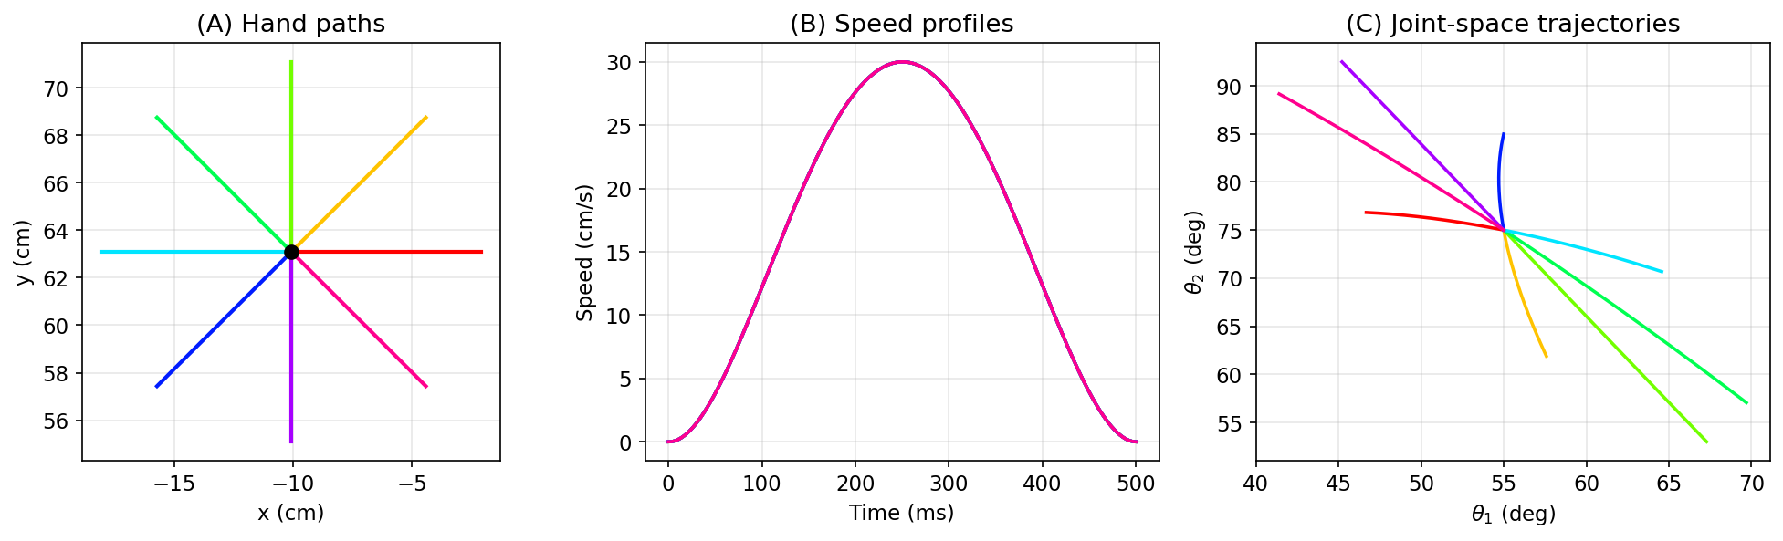
Figure 1. What the minimum-jerk model predicts for center-out reaching — these are model outputs, not data. (A) Eight 8 cm reaches from the reference posture. (B) Speed profiles, all peaking at 250 ms. (C) The same movements in joint space. Panels A and B are straight and bell-shaped because the model was constructed to make them so; you cannot demonstrate an empirical regularity by plotting a curve defined to have it. Panel C is the panel with content: producing a straight hand path demands qualitatively different shoulder–elbow coordination in every direction.
Figure 1 is not evidence that people reach in straight lines. Its hand paths are straight because the model defines them that way. Morasso reported paths that were only approximately straight, and later studies found systematic curvature that changes with reach direction and with where in the workspace the reach is made (Atkeson & Hollerbach 1985 in the vertical plane; Flash 1987 in the horizontal plane). Real reaches are close to straight, and their small deviations follow a pattern.
Keep those deviations in mind. In §3 and §6 they matter more than the straightness does.

2. Minimum Jerk: The Derivation Week 4 Promised
Week 4 scored every movement against a bell-shaped profile without saying where the bell came from. Here it is.
Flash and Hogan (1985) proposed that the nervous system selects, among all trajectories connecting two points in a given time, the one that is smoothest — where smoothness means minimal integrated squared jerk, jerk being the third derivative of position:
J = ∫₀ᵀ ‖ d³x/dt³ ‖² dt → minimize
Finding that trajectory is a different kind of problem from the optimization you are used to. Ordinary calculus finds the number that minimizes a function by setting the derivative to zero. Here the unknown is a whole function — the entire path x(t) — and the quantity being minimized is an integral over it. The calculus of variations supplies the analogous condition, and for a cost that depends on derivatives up to the third it takes the form
∂L/∂x − d/dt (∂L/∂x′) + d²/dt² (∂L/∂x″) − d³/dt³ (∂L/∂x‴) = 0
known as the Euler–Poisson equation. Writing x′, x″ and x‴ for the first three derivatives, our integrand is L = ‖x‴‖². It does not contain x, x′ or x″ at all, so the first three terms vanish and only the last survives. With ∂L/∂x‴ = 2x‴ the condition reduces to
x⁽⁶⁾(t) = 0
A function whose sixth derivative is everywhere zero is, by integrating six times, a polynomial of degree five. So on any interval without additional constraints the minimum-jerk trajectory is a fifth-order polynomial — six coefficients per dimension, and no more.
A rest-to-rest reach supplies exactly six conditions: position, velocity and acceleration at the start, and the same three at the end.
x(0) = x₀, ẋ(0) = 0, ẍ(0) = 0 x(T) = x₁, ẋ(T) = 0, ẍ(T) = 0
Six conditions, six unknowns, one solution. The only quantity the model does not supply for itself is the movement duration T, which has to be given. Writing τ = t/T, the trajectory is
x(τ) = x₀ + (x₁ − x₀)(10τ³ − 15τ⁴ + 6τ⁵)
and its velocity is the profile we have been fitting against since Week 4: ẋ = (D/T)·30τ²(1−τ)², symmetric about τ = 0.5, peaking at 1.875·D/T (Figure 2).
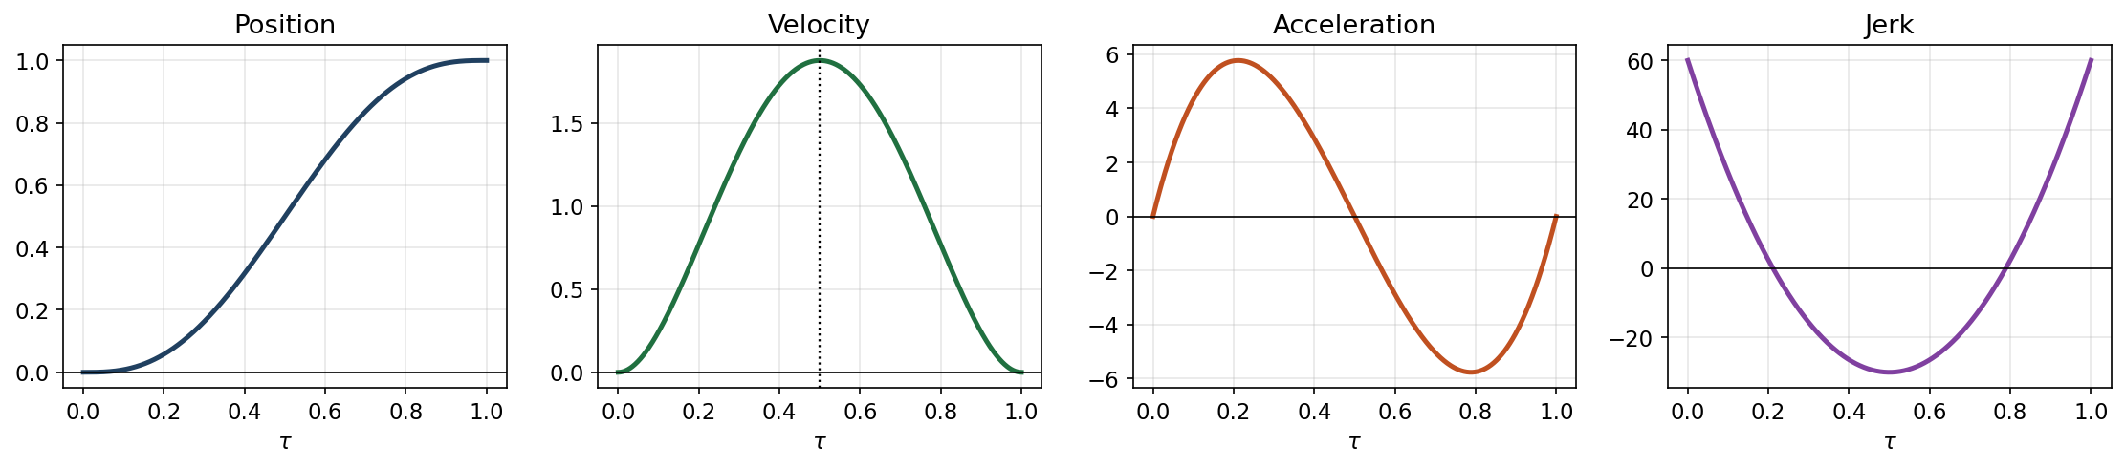
Figure 2. The unique minimum-jerk solution and its derivatives, in normalized time. Position runs 0 to 1; velocity and acceleration both vanish at each end, which is what the six boundary conditions enforce; velocity peaks at exactly τ = 0.5 with value 1.875. Jerk — the quantity being minimized — is non-zero at the endpoints and is not constrained there.
Note what the criterion does not contain: no mass, no muscle, no force, no gravity. Minimum jerk is purely kinematic and deliberately independent of the dynamics. That is what makes it a strong claim: the same path is predicted regardless of load, inertia or configuration. It also makes the model testable against its main competitor. Minimum torque-change (Uno, Kawato & Suzuki 1989) minimizes the rate of change of joint torque instead, so its predictions depend on the arm’s inertia and on anything the arm is carrying. The two criteria therefore come apart experimentally: strap a mass to the forearm, and minimum jerk predicts the hand path is unchanged while minimum torque-change predicts it deforms. Had minimum jerk been posed in terms of forces, the two would be near-restatements of each other and no such experiment would separate them.
Two further properties. First, the model produces straight paths by construction: x and y follow the same temporal profile, so the trajectory is a straight line traversed with a bell-shaped speed. Second, it is open-loop. The trajectory is computed once, in advance, and contains no mechanism for responding to anything. Perturb the arm and the plan does not notice.

3. Threshold Control Against the Minimum-Jerk Prediction
We now have two accounts of the same reach. Week 4's λ model shifts muscle thresholds and lets the limb find its way there. Minimum jerk specifies the hand path in advance. Put them on the same eight targets.
One methodological point first. Under threshold control, the controller does not tell the arm where to go. It sets a threshold for each of the six muscles, and the arm comes to rest wherever the torques of the six muscles cancel. Getting the arm to rest exactly on a target therefore takes some care.
The obvious recipe misses (Lab 04 Task B.2). It sets each muscle’s threshold from that muscle’s length when the arm is at the target, so the torques should cancel there. They do not quite. The two muscles that cross both joints pull on the shoulder with different leverage, 2.5 cm for one and 4.0 cm for the other, and some shoulder torque is left over. The arm rotates at the shoulder until the torques cancel, and the hand stops about 2.3 cm from the target.
The fix is to aim off-target, as an archer aims into a crosswind (Lab 04 Task B.3). The corrected method sets the thresholds for a slightly different posture, chosen so that the arm comes to rest exactly on the target. Every EPH reach in these notes uses the corrected method, and every reach ends within 0.023 cm of its target. Lab 05 Task B.2 runs the same reaches with the obvious recipe, so you can see how a method that misses its targets distorts the curvature measurements. With that settled, the two models can be put on the same eight targets (Figure 3).
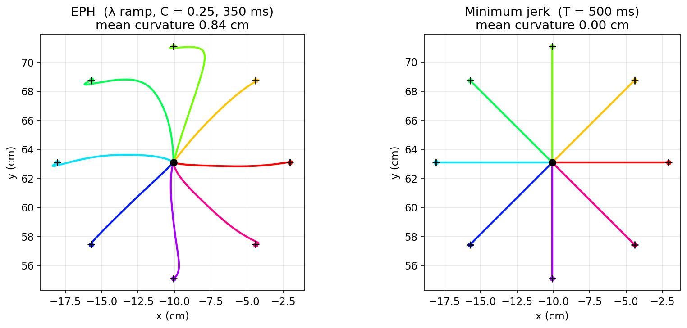
Figure 3. Eight center-out reaches under each model. Left: λ control, C = 0.25, 350 ms constant-rate ramp, thresholds set with the corrected method described above — mean curvature 0.84 cm, every endpoint within 0.023 cm of target (crosses). Right: minimum jerk, T = 500 ms, straight by construction. Colors identify direction; dots mark where each movement ended.
The result. EPH paths curve, and they curve unevenly: about 2.14 cm at 90° and 2.5 cm at 135°, but only 0.11 cm at 225°. Minimum jerk is straight everywhere, to numerical precision. Why EPH curves is taken up in §6. One candidate is geometric: Week 4 §8 showed that a straight line in threshold space need not map to a straight line in hand space. §6 measures how much of this curvature that explains.
Discussion: are EPH's curved paths actually wrong?
The obvious reading is that minimum jerk matches reality and EPH does not. That reading is too quick, for three reasons.
First, real reaching is not straight. Human hand paths show systematic, reproducible curvature that depends on movement direction and on where in the workspace the movement occurs (Atkeson & Hollerbach 1985; Flash 1987). A model that produced perfectly straight paths everywhere would be failing to reproduce a real feature of the data. Whether EPH's particular curvature pattern matches the human one is a quantitative question these figures do not settle — and it is exactly what HW05 asks you to test.
Second, the comparison is not yet like-for-like. The left panel is a simulation: six muscles pull on a two-link arm, the arm’s equations of motion carry it forward in time, and the hand path emerges. The right panel is a specification — a curve we wrote down. Of course the specification is straight. §6 fixes this by making the specification drive the muscles, and the fix changes the conclusion.
Third, the two models answer different questions. Minimum jerk says what the hand should do. EPH says what the muscles should do. Nothing forbids both: the nervous system might plan in task coordinates and execute through threshold control, in which case straight-ish paths and bell-shaped speed would be planning signatures while the deviations would be execution signatures. §6 builds exactly that hybrid and measures it.

4. VITE: Where the Bell Actually Comes From
Minimum jerk tells us what the optimal trajectory is, but not how a nervous system would find it. Look at what §2 actually required. You must know the start, the target and the total movement duration before the movement begins; you then solve a boundary-value problem that couples the beginning of the movement to its end, and only afterwards does anything move. It is a single global computation performed offline over the whole trajectory.
Nothing in the nervous system obviously does that. Neurons are local and continuous: a population reads its inputs now and updates its activity now. There is no known circuit that holds a whole future trajectory in suspension while it solves for polynomial coefficients, and it is not clear how a movement time would be committed to in advance of moving. The objection is not that the brain could not compute an optimum — later weeks build controllers that do — but that this particular formulation gives no account of the machinery.
Bullock and Grossberg (1988, 1989) proposed a circuit that sidesteps the problem: it produces the same invariants using only quantities available at the present instant, and never optimizes anything.
VITE has two state variables and one gate:
- Difference vector V — a neural population that tracks the gap between target and planned position: V̇ = α(−V + T − P). It is a low-pass filtered copy of T − P, not T − P itself. The integrator is P, which accumulates the gated difference vector until it reaches the target; that is what “Vector Integration To Endpoint” names.
Three symbols, all in hand coordinates. T is the target — where the hand is being sent, held fixed for a simple reach. P is the planned hand position: it begins wherever the hand starts and travels to T, and it is the model’s output. V is the population activity standing for the gap between them, and because it is filtered rather than copied, it lags T − P slightly and cannot jump when the target does. The rate constant α sets how fast that catching-up happens.
- Planned position P — integrates the gated difference vector: Ṗ = G(t)·V.
- The GO gate G(t) — a scalar that decides when the plan unrolls and how fast. It starts at zero when the movement is triggered and rises smoothly to a ceiling G₀:
G(t) = G₀ t² / (β + t²)
The t² makes the onset faster than linear. While t² is small next to β, the gate grows as G₀t²/β: it starts with zero slope and speeds up. It keeps accelerating until t = √(β/3), about 220 ms, and then levels off toward the ceiling G₀. The constant β sets the timing; the gate is half open at t = √β, about 390 ms. Bullock and Grossberg (1988, p. 71) compare gates of this form with different powers of t; these notes use the square. The values G₀ = 30 s⁻¹, β = 0.15 s² and α = 30 s⁻¹ were chosen for these notes so that an 8 cm reach takes about 370 ms. Figure 4c shows what the gradual onset does to the speed profile.
Notice where the gate sits. It multiplies the output, not the input. That placement is the entire model, and it is why the circuit produces a bell.
Ṗ = G(t) · V with G rising from zero and |V| shrinking toward zero
Speed is the product of a rising factor and a falling factor. Early in the movement the difference vector is large but the gate is nearly shut, so the hand barely moves. Late in the movement the gate is wide open but the difference vector has collapsed, so the hand barely moves. In between, both are appreciable, and speed peaks. Neither factor is bell-shaped. The bell belongs to neither of them.
This is what Bullock and Grossberg mean by emergent invariants — the invariant is not built into any component, it falls out of the architecture. Figure 4a separates the two factors and their product.
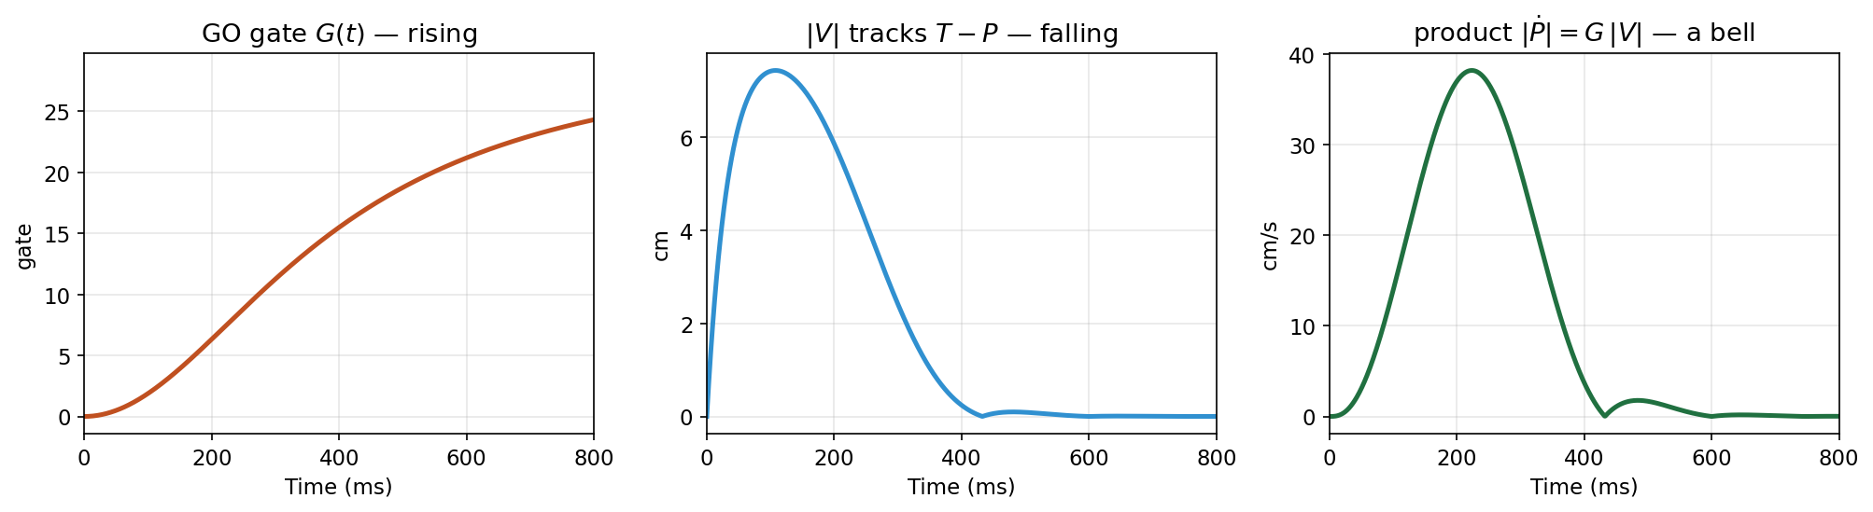
Figure 4a. Where the bell comes from. Left: the GO gate rises monotonically from zero. Center: the difference vector magnitude rises briefly, then falls monotonically as the plan approaches the target. Right: their product — the speed of the planned hand position — has a single interior peak. The bell is in neither factor.
Run the circuit against the minimum-jerk trajectory for a single 8 cm reach and the two are hard to tell apart (Figure 4b).
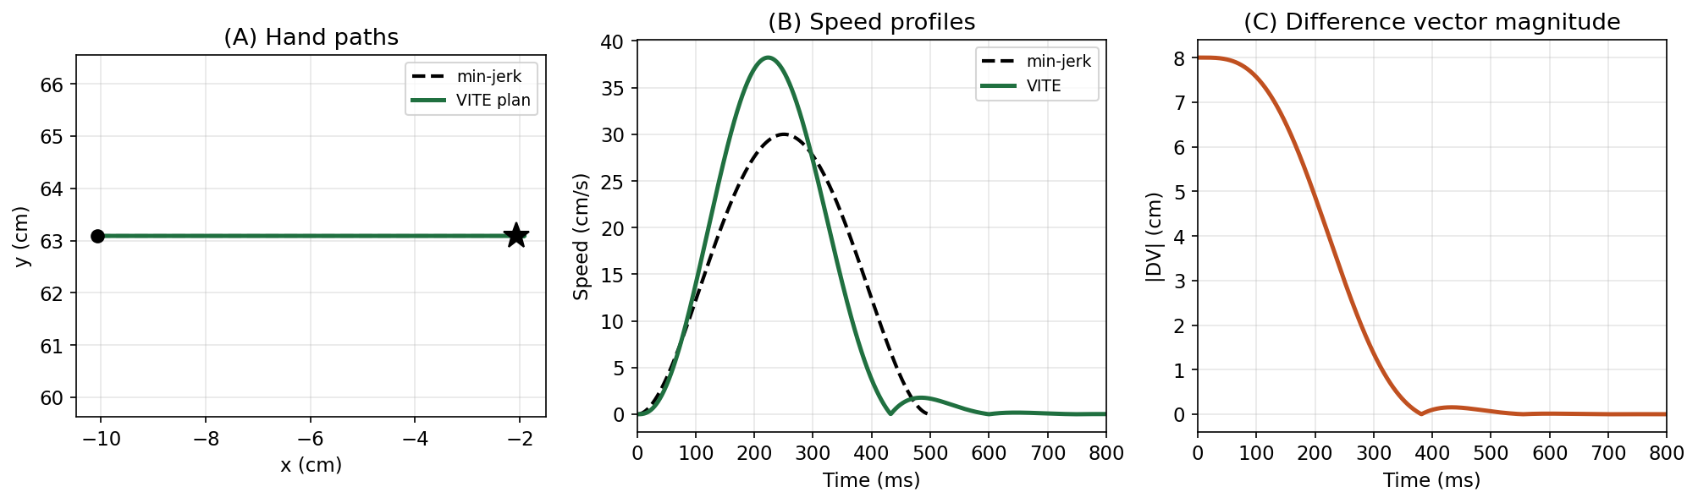
Figure 4b. A single VITE reach (α = 30, G₀ = 30, β = 0.15) against minimum jerk (T = 500 ms). (A) Hand paths, indistinguishable. (B) Speed profiles: VITE peaks at 38.2 cm/s at 224 ms. (C) The difference vector decays monotonically — the circuit's convergence criterion.
But the onset is doing the work, and it is easy to check. Hold the gate constant instead of letting it rise, change nothing else, and score both against the minimum-jerk bell using the Week 4 metric. Figure 4c puts the two gates side by side with the speed each produces.
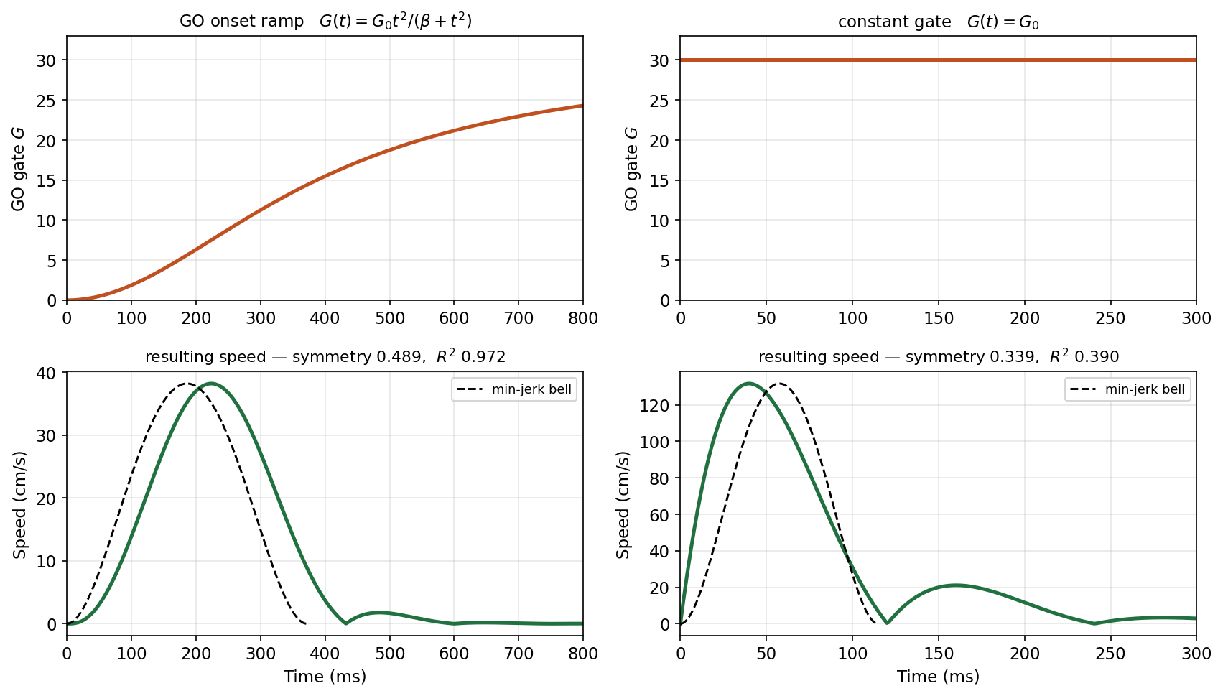
Figure 4c. The GO onset is not a detail. The top row shows the gate itself, the bottom row the speed profile it produces. Left: the onset ramp G(t) = G₀t²/(β + t²) rises from zero over roughly 400 ms, and the resulting speed tracks the minimum-jerk bell (dashed) with symmetry 0.489 and R² 0.972. Right: the identical circuit with the gate held constant at G₀ from t = 0 — symmetry 0.339, R² 0.39. Same equations, same target, same α, and only the shape of G(t) differs; remove the onset and the invariant the model exists to explain disappears. Note the x-axes differ: the constant gate finishes in under 150 ms.
For comparison, Week 4's λ ramp at 350 ms scored symmetry 0.49 and R² 0.963 on this same metric. VITE with its onset reaches R² = 0.972 — slightly better. VITE without it reaches R² = 0.39 — far worse than the controller it was supposed to improve on. Any implementation of this model that drops the onset has removed the phenomenon.
A note for readers of the paper. Two differences in notation, one of which is easy to get wrong. First, their DV is our filtered variable V, not the instantaneous difference T − P; if you see “DV” in the paper, it is our V.
Second, Bullock and Grossberg write the gated integration with a half-wave rectifier, Ṗ = G·[V]⁺. That does not mean you should clip our V at zero. Firing rates cannot go negative, so each degree of freedom in their model is carried by an opponent pair of populations — one coding movement in the + direction, one in the − — and the rectifier applies within each channel. Our V is the net of that pair.
The distinction has teeth. Apply [·]⁺ componentwise to a signed Cartesian V and reaches toward 180°, 225° and 270° do not move at all — the endpoint error equals the full 8 cm, because every component of the drive has been clipped away. Written properly as two rectified channels per axis, with V̇⁺ = α(−V⁺ + [T−P]⁺) and V̇⁻ = α(−V⁻ + [P−T]⁺) and Ṗ = G(V⁺ − V⁻), the model reproduces the signed version exactly: across all eight directions the two agree to better than 10⁻¹⁰ cm. The single signed equation is the compact form of the opponent pair, not an approximation to it.

5. The GO Signal as a Vigor Parameter
The architecture suggests a clean division of labor. The target T says where to go; the gate G says how fast. Change G alone and you should get the same movement at a different speed. It is an attractive claim, and Figure 5 shows it is approximately true. Table 1 gives the numbers.
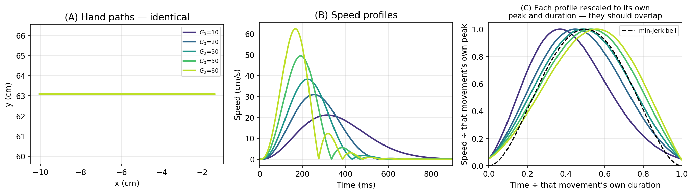
Figure 5. Speed scaling by gate amplitude, α = 30 fixed. (A) Hand paths for G₀ from 10 to 80 — identical, as linearity requires. (B) Speed profiles: duration falls from 717 ms to 237 ms and peak speed rises from 21.2 to 62.4 cm/s. (C) Each profile divided by its own peak speed and its own duration, so all five are placed on the same axes. If the gate were a pure speed knob these five curves would lie on top of one another, and on the minimum-jerk bell (dashed). They do not: the slow movements peak early and the fast ones peak late.
G₀ | duration (ms) | peak (cm/s) | symmetry | R² | peak × duration
10 | 717 | 21.2 | 0.370 | 0.586 | 15.18
20 | 465 | 30.9 | 0.447 | 0.920 | 14.38
30 | 372 | 38.2 | 0.489 | 0.972 | 14.22
50 | 290 | 49.5 | 0.531 | 0.942 | 14.36
80 | 237 | 62.4 | 0.561 | 0.871 | 14.80
min-jerk | 500 | 30.0 | 0.500 | 1.000 | 15.00
Table 1. VITE speed scaling. Shape is not preserved; the product of peak speed and duration nearly is.
The paths are identical, but the shape drifts. Symmetry runs from 0.370 at G₀ = 10 to 0.561 at G₀ = 80: slow movements front-load, fast ones back-load. The lecture-hall version of this claim — that VITE gives exact time-scaling — is too strong.
It is too strong for a specific reason. α is the difference-vector filter's rate constant, a property of the circuit; G₀ is the vigor command. Changing G₀ alone changes the ratio of the filter timescale to the movement timescale, so the shape must drift. You can force exact scaling by tying α to G₀ — but then α is no longer a fixed property of the circuit, and the invariance you have demonstrated is one you built in by hand.
What does survive is more interesting. Peak speed × duration stays between 14.22 and 15.18 across an eightfold range in G₀, against 15.00 for minimum jerk. So the model predicts approximate scaling with systematic deviation at the extremes — which is a testable claim, and a better one than perfect invariance would have been, since human speed profiles are also not perfectly scale-invariant.
One correction to a claim often made for VITE. It is sometimes said that only VITE separates “what” from “how fast.” EPH separates them too: the same final R-command with a different ramp duration gives the same target at a different speed, which is precisely what Lab 04 Task C.6 does across five durations. The distinctive property of VITE is not the separation but that G can be changed mid-movement without disturbing where the movement ends, because the endpoint is guaranteed by V → 0 rather than by the timing.

6. Handing the Plan to the Muscles
Everything so far compared a simulation against two specifications. EPH produced a hand path; minimum jerk and VITE were hand paths. The comparison so far has been unfair. This section makes the two plans drive the same six muscles and the same arm as EPH.
A plan executed without an internal model. A plan has to be executed by some controller, and the choice matters. Here the plans are executed by Week 4’s threshold controller, which has no model of the arm’s mass or inertia. It sets muscle thresholds and leaves the rest to the muscles and the limb. Week 6 executes the same kind of plan with a controller that has an exact model of the arm’s dynamics, so the two weeks together show what such a model buys. The numbers in this section describe this model arm at the co-contraction used throughout (C = 0.25). They illustrate a mechanism; they are not measurements of human reaching.
So give VITE's plan to the muscles. The plan is a hand trajectory P(t); the arm needs thresholds. Convert by inverse kinematics and then by the Week 4 solver:
P(t) →[ IK ]→ q(t) →[ λ solver ]→ λ(t) →[ plant ]→ hand(t)
Each arrow in that chain is a concrete object. Figure 6a shows all four at once, one panel per arrow, before we look at what came out.
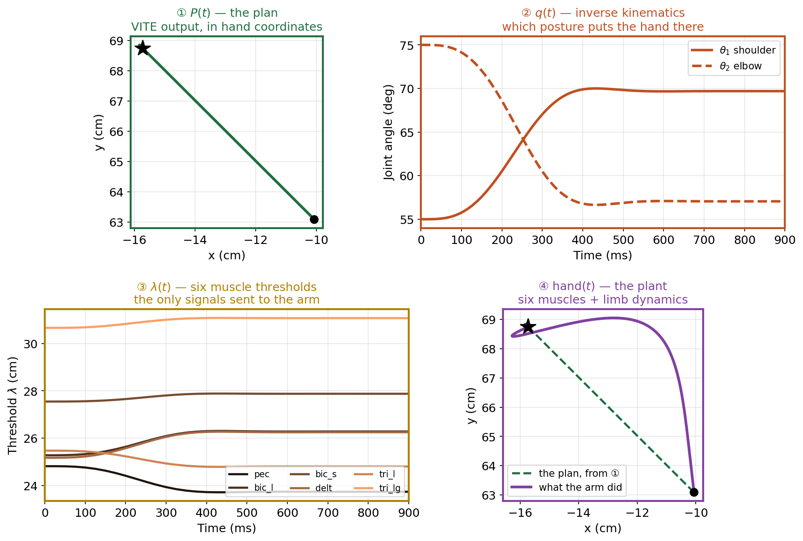
Figure 6a. The execution pipeline, one panel per arrow, for the 135° reach. ① VITE produces a planned hand path in Cartesian coordinates — perfectly straight. ② Inverse kinematics converts every point on it to the shoulder and elbow angles that would place the hand there; note that a straight hand path requires strongly nonlinear joint trajectories. ③ The Week 4 solver converts each posture to the six muscle thresholds whose equilibrium is that posture — these are the only signals actually sent to the arm. ④ The plant integrates six muscles and the limb dynamics from those thresholds, and the hand goes where the physics takes it. Nothing after panel ① knows what the plan was; the divergence in ④ is entirely the plant’s doing. Panels are ordered left to right, top to bottom, with borders colored by stage.
This is the hybrid §3 proposed — task-space planning executed through threshold control — made concrete. Start with the 135° target, which is the worst of the eight directions and so shows the effect most plainly (Figure 6b). It is not typical; the eight-direction mean is roughly a third of it.
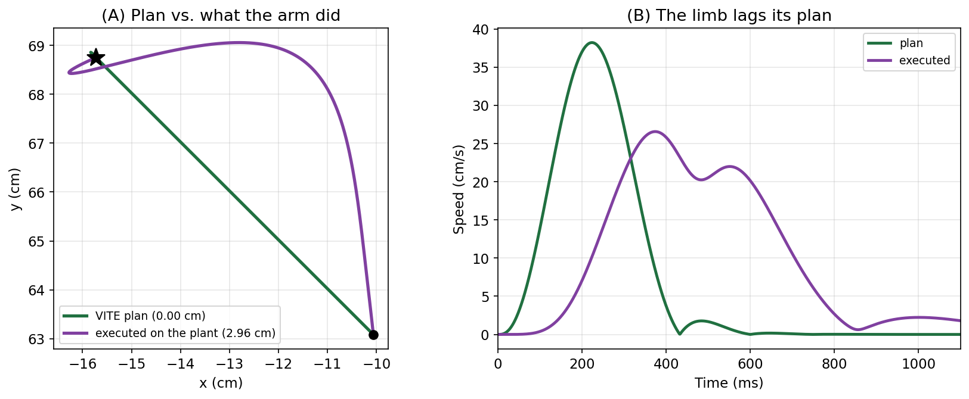
Figure 6b. A single VITE plan and what the arm did with it (135° target, 8 cm — the most curved of the eight directions, chosen to make the effect visible). (A) The plan is straight to numerical precision; the executed path deviates 2.96 cm. (B) The executed movement takes 696 ms against the plan's 372 ms — the limb lags its commanded equilibrium throughout. The endpoint is still reached, within 0.005 cm, because λ control has an attractor there.
Panel B of Figure 6b shows a second casualty: the executed speed profile is not a bell but has two peaks. Refining the threshold waypoints from 25 ms to 2 ms leaves both peaks in place, so this is the plant’s behavior, not a numerical artifact.
Why the detour is so pronounced. Start with what the plan asks of each joint. Inverse kinematics turns the straight hand path into two joint-angle trajectories: θ₁(t) for the shoulder and θ₂(t) for the elbow. Each point on the straight line needs one specific shoulder angle paired with one specific elbow angle. The hand stays on the line only while the two joints stay in step.
Now suppose the arm follows both trajectories correctly, but late. If both joints run 190 ms behind the plan, the arm always holds a posture that the plan reached 190 ms earlier. Each of those postures is a correct pairing, so the hand stays on the line. A delay shared equally by both joints changes when the hand reaches each point, not where it goes.
The arm does not delay its two joints equally. The elbow reaches the halfway point of its rotation 143 ms later than planned. The shoulder is 190 ms late. So at each instant the arm combines a shoulder angle from one moment of the plan with an elbow angle from a moment about 47 ms later. The plan does not contain that combination, so the hand leaves the line. Figure 6c tests this by rebuilding the hand path from the plan, with each joint delayed by its measured amount.
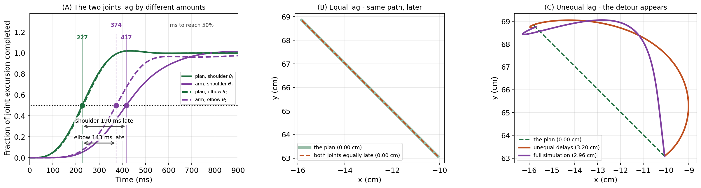
Figure 6c. Curvature comes from unequal lag, not from lag. (A) Each joint’s excursion as a fraction completed, for the plan (green) and for the arm (purple). The plan’s two joints cross the halfway mark at about 229 ms (shoulder 227 ms, elbow 231 ms). The arm’s elbow gets there at 374 ms and its shoulder at 417 ms: 143 ms and 190 ms behind their own planned crossings. (B) Rebuilding the hand path from the plan with the same 190 ms delay applied to both joints: the reconstruction lies exactly on the plan, 0.00 cm of curvature. A uniform delay changes when the arm is somewhere, never where it goes. (C) The same reconstruction with the two measured, unequal delays produces a 3.20 cm detour, close to the full simulation’s 2.96 cm and bowing the same way. Two delay constants, applied to a straight plan, account for nearly all of the curvature.
The asymmetry comes from the arm, not the controller. At the starting posture the shoulder’s effective inertia is 5.3 times the elbow’s (0.342 against 0.064), so the same class of muscle command moves the elbow toward its commanded equilibrium sooner. The elbow arrives early, the shoulder arrives late, and the hand swings wide in between. How wide depends on direction: it is near zero at 225°, where the shoulder barely rotates and there is no differential to express, and largest where both joints must travel comparable distances.
The minimum-jerk plan is also just a hand trajectory, so it can go through the same pipeline. Figure 6d runs all three on the plant.
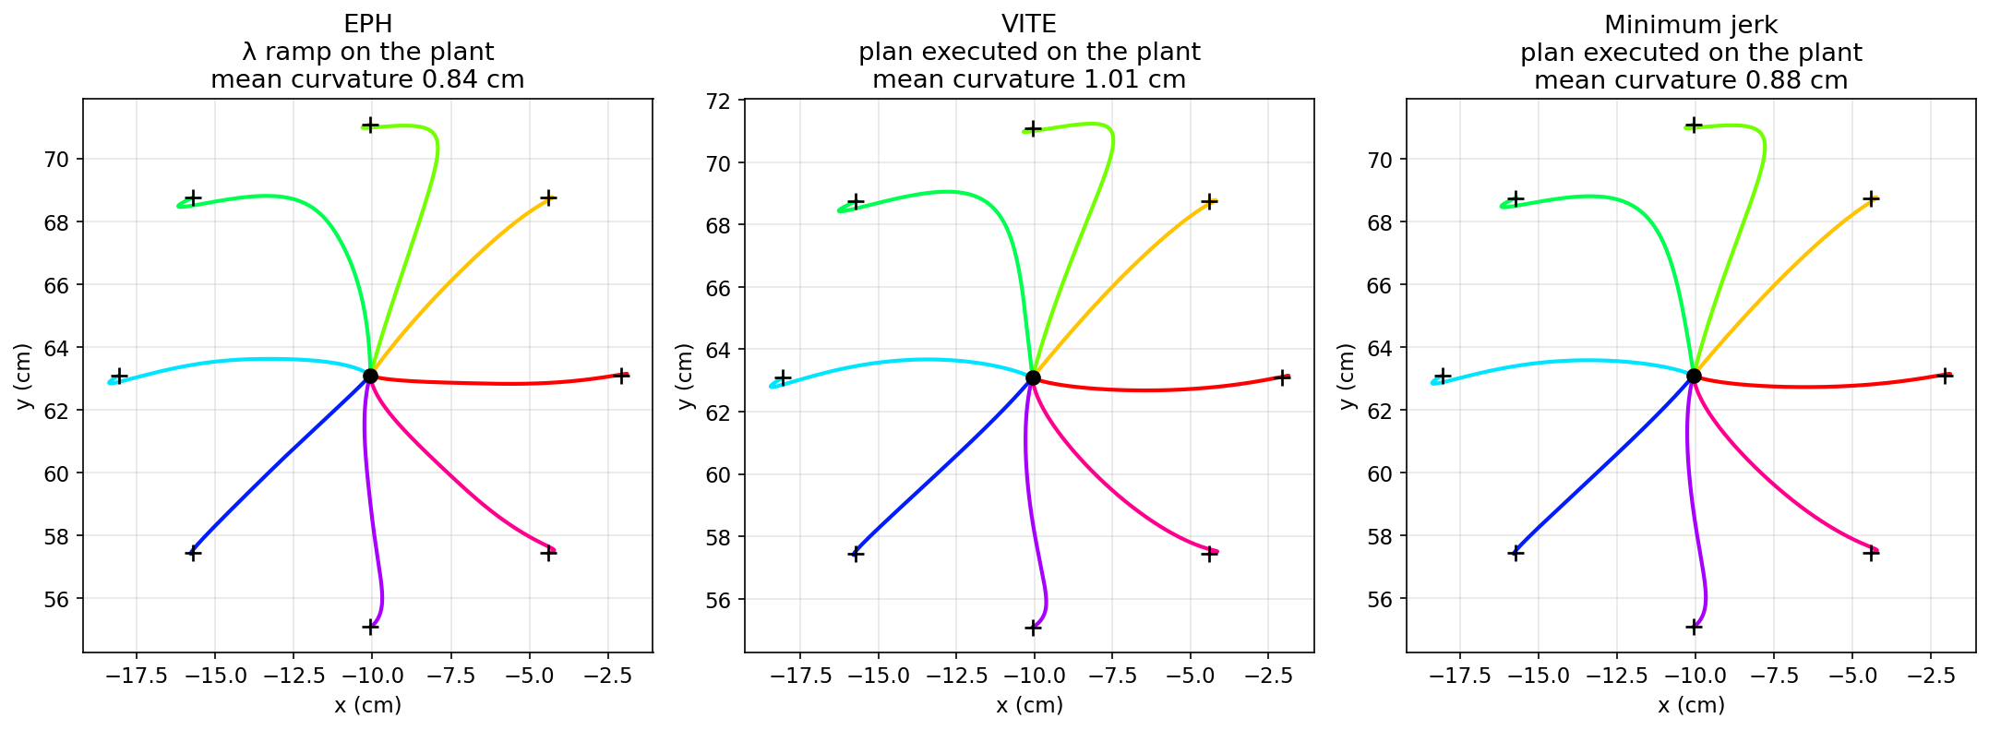
Figure 6d. Three controllers, eight targets, all three now driving the same six muscles. Left: EPH, mean curvature 0.84 cm. Center: the VITE plan executed through IK and the λ solver, 1.01 cm. Right: the minimum-jerk plan executed through the identical pipeline, 0.88 cm — compare Figure 3, where the same model was left as a specification and drew eight perfectly straight spokes. Both task-space plans were straight to numerical precision before execution; neither is straight after it. Crosses mark the targets.
All three curve, and they curve alike. Mean curvature is 0.84 cm for EPH, 1.01 cm for executed VITE and 0.88 cm for executed minimum jerk. All three are worst at 90° and 135° (2.14 / 2.60 / 2.28 and 2.50 / 2.96 / 2.52 cm) and near zero at 225° (0.11 / 0.09 / 0.07 cm).
The small gap between the two task-space planners is plan speed, not a difference between them. At a common 372 ms plan duration, minimum jerk executes to 1.03 cm against VITE’s 1.01 cm, direction by direction, to within 0.08 cm.
EPH curves for the same reason. In §3 it was natural to read EPH’s curvature as a product of planning in muscle coordinates. But EPH’s command is also nearly straight. If the arm could follow its moving equilibrium without any lag, EPH’s threshold ramp would trace a path within 0.27 cm of straight in every direction, 0.14 cm on average. Slowed from 350 ms to 2 s, the executed EPH reach curves only 0.19 cm on average. So the 0.84 cm of Figure 3 is almost all lag, like the curvature of the two executed plans.
The curvature was never a property of the planner. It is a property of the plant. A limb with inertia lags its commanded equilibrium, that lag lives in joint coordinates, and a straight line in hand space does not survive the trip.
If that diagnosis is right, it makes a prediction: slow the plan down and the lag should shrink. Figure 6e tests it by running the same plan at five speeds.
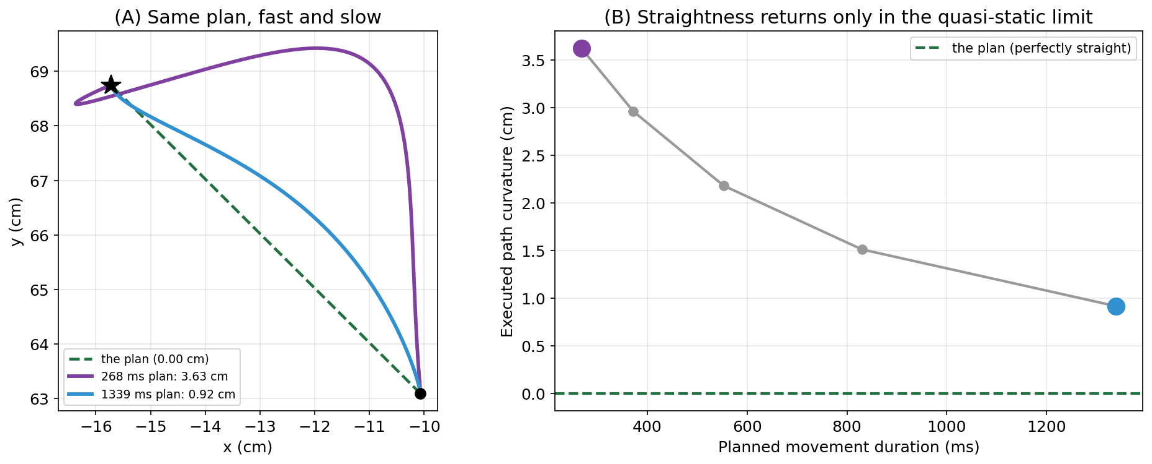
Figure 6e. The same 135° plan executed at five speeds. (A) Hand paths for the fastest and slowest plans against the plan itself (dashed). The 268 ms plan swings 3.63 cm wide of the plan and hooks past the target before settling. The 1339 ms plan stays closer, 0.92 cm, but still bows the same way. (B) Executed curvature against planned movement duration for all five plans; the two large points are the paths in (A). Curvature falls steadily with duration but never reaches the plan’s zero (dashed).
Straightness returns only in the quasi-static limit. At 268 ms the executed path deviates 3.63 cm; at 1339 ms — far slower than natural reaching — it is down to 0.92 cm and still not zero. Panel A of Figure 6e shows both paths. Planning in task space buys a straight intention. Whether it buys a straight movement depends on how fast you move.
This is Week 4's central finding seen from the other side. There, the bell existed because the limb lagged its equilibrium; the lag was the mechanism that turned a constant-rate command into a smooth reach. Here the same lag is what destroys the straight line. One mechanism, two consequences: the lag that makes the speed profile look right is the same lag that makes the path look wrong.
How could a controller produce a straight path?
Slowing down works, but natural reaches are much faster than 1339 ms. Two other fixes can be tested on this plant, both on the 135° reach, where the executed path curves 2.96 cm.
Stiffen the arm. Raising co-contraction from C = 0.25 to 0.40 makes every muscle spring stiffer, so both joints lag less and the curvature falls to 1.55 cm. The price is muscle force that produces no movement: holding the starting posture takes 307 N of combined muscle force instead of 121 N. People do co-contract more when a task demands accuracy (Gribble et al. 2003). Here, though, two and a half times the force only halves the curvature.
Correct the timing of the command. The elbow runs about 47 ms ahead of the shoulder (Figure 6c), so sending the elbow its command 47 ms late cuts the curvature to 0.61 cm. But the right delay changes with direction, from 92 ms at 0° to −29 ms at 45°, where the shoulder must be held back instead. It changes because the inertia each joint must move changes with direction. A single fixed delay lowers the mean curvature from 1.01 to 0.59 cm but makes some directions worse. Choosing the delay well means knowing the arm’s inertia in advance, which means carrying a model of the arm’s dynamics: an internal model. Week 6 gives the controller a complete one.
The corrected command is itself curved. Its equilibrium path bows about 3 cm to the other side of the plan, so that the arm’s unequal lags can bend it back. Gomi and Kawato (1996) argued from arm stiffness measured during movement that real equilibrium trajectories would need to be complex in this way; Week 12 returns to that claim. Feedback control (Week 13) and adaptation (Week 15) offer ways to straighten a path without working out the correction in advance.

7. What Survives the Comparison
All three models have now been measured on the same plant, so the differences can be stated precisely. Table 2 distinguishes what a model computes from what a limb does with it.
Property | EPH (λ model) | Minimum jerk | VITE
Planning space | muscle thresholds | hand coordinates | hand coordinates
Drives the plant here? | yes | yes, via IK + λ | yes, via IK + λ
Planned path | not specified | straight by construction | straight by linearity
Executed hand path | curved, 0.84 cm mean | curved, 0.88 cm mean | curved, 1.01 cm mean
Speed profile | bell (R² 0.963) | symmetric bell by definition | bell (R² 0.972) — requires the GO onset
Where the bell originates | limb lags its equilibrium | imposed by the cost functional | product of rising gate × falling DV
Speed control | ramp duration | movement time T | gate amplitude G₀ (approximate scaling)
Endpoint guaranteed by | mechanical attractor | construction | V → 0 in the planner
Response to a mechanical push | returns — spring-like | none — open loop | none — P has no sensory input
Response to a target jump | new equilibrium commanded | re-solve the whole trajectory | DV updates; movement redirects
Needs an inverse model? | no | yes, to reach muscles | yes, to reach muscles
Via-points | dwell duration set by hand | exact passage, at speed | switch time set by hand
Table 2. The three controllers compared. Note the two response rows: EPH resists a physical perturbation because the limb is held by muscle springs, whereas VITE's planned position P is an internal variable with no sensory input — a push cannot change it. Convergence of a differential equation and mechanical stability are different kinds of fact, and the table keeps them apart.

8. Via-Points, and Why Local Solutions Do Not Compose
Reaching rarely goes straight from A to B. Movements curve around obstacles and pass through intermediate points, and how each model handles that exposes its architecture.
Minimum jerk. The obvious approach is to solve two point-to-point problems and glue them together. Flash and Hogan showed that this is not the minimum-jerk answer. Getting the right one means returning to the optimization of §2 and adding the constraint properly, one step at a time.
If Lagrange multipliers are a distant memory, §4 of the Week 5 supplement reviews them with a worked example. The idea in one sentence: to minimize f subject to a constraint g = 0, you do not restrict the search to the surface where g vanishes. You minimize f + λg over everything, treating λ as one more unknown, fixed at the end by requiring that g = 0 actually comes out. The constraint stops being a restriction on where you may look and becomes an extra term in what you are minimizing.
Here f is the jerk integral from §2 and the constraint is that the hand be at the via-point at time t₁. To use the recipe, that constraint has to be written as an integral, like the objective. A Dirac delta does it — δ(t − t₁) is zero everywhere except at t₁ and integrates to one — so “pass through the via-point” becomes
∫₀ᵀ δ(t − t₁) x(t) dt = xᵥ (xᵥ = the via-point)
and the augmented functional, now unconstrained, is
J* = ∫₀ᵀ [ ‖x‴(t)‖² + λ · δ(t − t₁) · x(t) ] dt
This is the §2 problem with one extra term, so the same Euler–Poisson condition applies. The new term involves x but none of its derivatives, so it lands in the ∂L/∂x slot — the one that was empty last time:
λ·δ(t − t₁) − d³/dt³ (2x‴) = 0 ⟹ x⁽⁶⁾(t) = (λ/2)·δ(t − t₁)
Compare that with §2, where the right-hand side was zero and the answer was a fifth-order polynomial. The sixth derivative is still zero everywhere except at one instant. So the solution is that same quintic plus whatever function has a delta for its sixth derivative — and integrating a delta six times gives (t − t₁)⁵/5! after t₁ and nothing before it, the one-sided power written (t − t₁)⁵₊. Folding 5! and the ½ into a single constant c = λ/240, the complete solution is
x(t) = a₀ + a₁t + a₂t² + a₃t³ + a₄t⁴ + a₅t⁵ + c·(t − t₁)⁵₊
Seven unknowns per dimension; seven conditions — position, velocity and acceleration at each end, plus the via constraint. One linear solve, no optimizer, and c absorbs the multiplier so λ never has to be found explicitly. The truncated term is not a modeling choice someone made: a point constraint forces it. Note also what stays smooth. The added term vanishes along with its first four derivatives at t₁, so position, velocity, acceleration and jerk are all continuous there; only the fifth derivative jumps, which is as much roughness as a single point constraint can buy. Figure 8 compares that solution against the concatenated one.
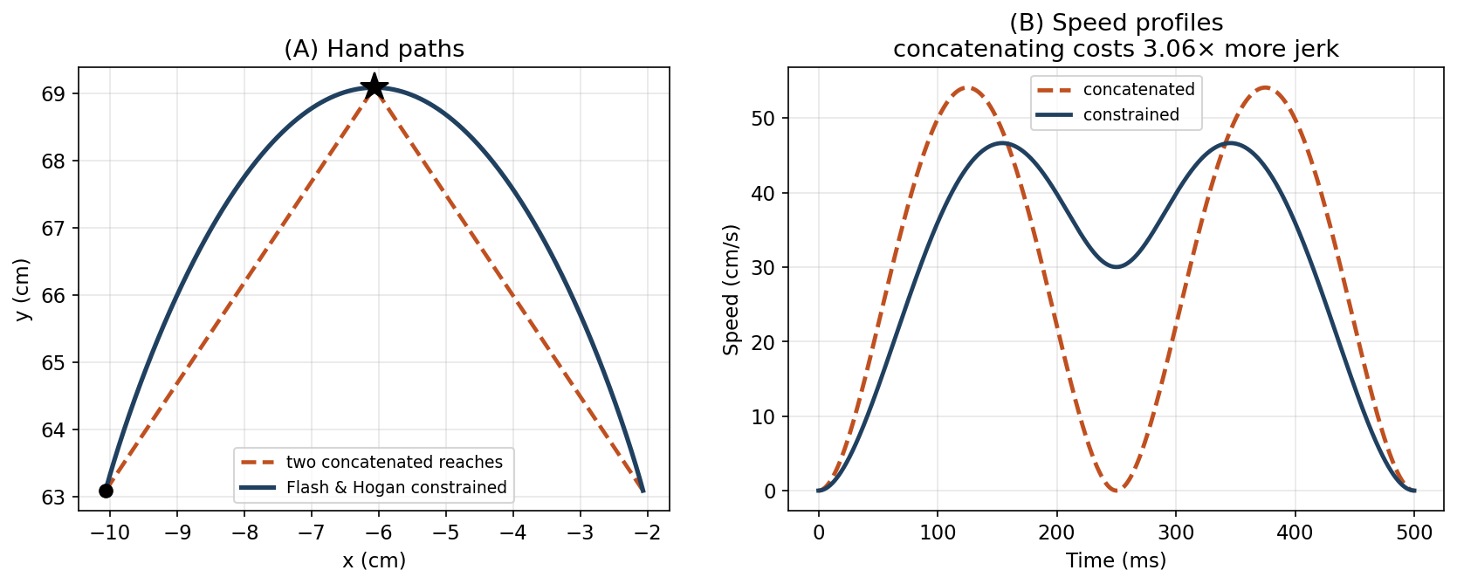
Figure 8. Two ways through a via-point (star), 8 cm total, T = 500 ms, passage at t₁ = 250 ms. (A) Both reach the via-point exactly. (B) The constrained solution passes through at 30 cm/s without stopping, while the concatenated pair comes to a complete halt. Integrated squared jerk is 2507 for the constrained solution against 7668 for the concatenation — 3.06× more expensive by the criterion the model is built on.
Where the factor of three comes from. The cost difference is not a simulation result to be taken on trust; it can be worked out in closed form. Substituting the §2 quintic into the jerk integral and rescaling by τ = t/T gives
J = ∫₀ᵀ ‖x‴‖² dt = (D²/T⁵) ∫₀¹ (60 − 360τ + 360τ²)² dτ = 720 D²/T⁵
for any rest-to-rest movement of distance D in time T. Our via-point sits off the straight line and the geometry is symmetric: both halves span √52 ≈ 7.21 cm. Concatenating two rest-to-rest reaches forces each of them into T/2, so
J = 720·D₁²/(T/2)⁵ + 720·D₂²/(T/2)⁵ = 2 × 720 × 0.0052 / 0.000977 ≈ 7668
The jerk cost of the constrained solution can also be worked out by hand. The jerk cost is a sum of an x part and a y part. The constraints separate the same way, so each direction can be solved on its own.
Along x, the hand starts at 0, must be at 4 cm when t = T/2, and finishes at 8 cm. An ordinary 8 cm reach already meets the middle condition, because the quintic is exactly halfway at τ = ½. So the x motion is a plain point-to-point reach, and its cost is
x part: 720 × (0.08)² / (0.5)⁵ ≈ 147
Along y, the hand starts and finishes at 0 but must reach h = 6 cm when t = T/2. This out-and-back motion is symmetric about the midpoint. On the first half it is a polynomial with the three rest conditions at τ = 0 already built in:
y(τ) = h · (a₃τ³ + a₄τ⁴ + a₅τ⁵), 0 ≤ τ ≤ ½
Symmetry supplies three conditions at τ = ½: the height is h, and the velocity and jerk are both zero. Solving gives a₃ = 160/3, a₄ = −400/3 and a₅ = 256/3. Squaring the jerk and integrating over both halves gives
y part: 20480 × h² / T⁵ = 20480 × (0.06)² / (0.5)⁵ ≈ 2359
Adding the two parts gives 147 + 2359 ≈ 2507 for the constrained solution, against 7668 for the concatenation. The ratio is 3.06.
The split also explains the 30 cm/s passage speed in Figure 8. At t = T/2 the y motion is at its peak and momentarily still. The x motion is at its own peak speed, 1.875 × 8 cm / 0.5 s = 30 cm/s.
The T⁻⁵ scaling does all the work here. Because (T/2)⁵ = T⁵/32, halving a segment’s duration multiplies its jerk cost thirty-twofold. Stopping at the via-point is costly not because stopping is inherently expensive, but because it forces both halves to be run in half the time, and this criterion punishes haste to the fifth power.
The optimal via-point trajectory does not stop. This is a real lesson about optimal control: two optimal halves glued together are not an optimal whole. Local optimality does not compose. It is also the empirically right answer — people do not stop at via-points either, which was among Flash and Hogan's reasons for taking the model seriously.
(A design note: t₁ was fixed at T/2 here. Flash and Hogan left the passage time free and fitted it, which turns the linear solve into a one-dimensional search and changes nothing conceptual.)
VITE. Nothing needs re-solving. Swap the target from via-point to final target partway through and the difference vector recomputes itself on the next timestep; the movement redirects smoothly because V is a filtered quantity and cannot jump. The rectification [V]⁺ in the original model matters here, preventing the plan from running backwards when the target changes behind the hand. But the switch time is a number someone has to choose.
EPH. The λ trajectory has to pass through the via-point’s equilibrium and pause there long enough for the limb to arrive — and the limb lags, so the pause must be chosen by the programmer. Too short and the hand cuts the corner; too long and the movement stalls.
Both of those are testable claims rather than settled ones, and testing them is what HW05 asks you to do: sweep the dwell, sweep the switch time, and see how much of a penalty a badly chosen number carries in each case. Go in without assuming the answer. A single switch looks more forgiving than a dwell that has to be timed to the limb, but nothing established so far requires that to be true.
The architectural difference is not really about via-points. It is about how much of a movement has to be settled before it starts. Minimum jerk must know the whole thing in advance, including when the via-point is passed, and any change means re-solving globally — but given that information it is the only one of the three that passes through at speed. VITE and EPH each need one timing number rather than the whole schedule, which is a weaker requirement, and neither theory says what that number should be. Week 13’s optimal feedback control answers the question a fourth way, by refusing the plan-then-execute split entirely.

9. Summary and Looking Ahead
Week 4 closed with a question, and this week was built to answer it: is smoothness computed, or does a limb with mass and spring-like muscles produce it for free?
The honest answer is that both accounts survive, and they survive for different reasons. VITE produces a bell (R² 0.972) without optimizing anything — but only because a rising gate multiplies a shrinking difference vector, and that product structure has to be in the circuit. Remove the onset and the score collapses to 0.39. Week 4's λ ramp produces a comparable bell (R² 0.963) with no such structure at all, purely because the limb lags its equilibrium. So smoothness is cheap in two different ways: cheap to arrange in a neural circuit, and free in a mechanical one. Nothing in these figures decides between them.
Straightness is a different story, and the week's clearest result. Both task-space planners generate perfectly straight paths, and neither delivers one. Executed on the plant, the VITE plan curved 1.01 cm against EPH's 0.84 cm, in the same directions. It came close to straight only when slowed far below natural speed, or when its elbow command was delayed to offset the arm’s unequal lags. That correction requires a model of the arm. Planning in task space buys a straight intention. The limb decides what happens.
That is a caution about a common inference. From “hand paths are approximately straight” it does not follow that the plan is straight, and from “the plan is straight” it does not follow that the hand path will be. The mapping between them runs through a nonlinear, inertial plant, and it is not close to the identity at reaching speeds.
What each model still needs
- Minimum jerk has no muscles in it and no way to reach them. It is a description of the hand, and getting from a hand trajectory to muscle commands is the whole of the next two weeks.
- VITE plans in hand coordinates and has the same debt, which §6 paid using Week 4's threshold controller. It also has no sensory input: the planned position cannot be perturbed, so the model has nothing to say about what happens when the limb is disturbed.
- EPH needs no inverse model and resists perturbation for free, but supplies no timing — the ramp duration and any via-point dwell are chosen by the modeler, not by the theory.
Where this goes
Week 6 executes the same kind of plan with a controller that has an exact model of the arm: inverse dynamics and computed torque, with static optimization to resolve muscle redundancy. §6 executed the plans without such a model. Comparing the two shows what an internal model buys. Make a prediction before you run it: how straight will the executed path be?
Week 7 adds signal-dependent noise, which turns the smoothness question into a different one: if commands are noisy in proportion to their size, smooth trajectories may be selected for accuracy rather than for smoothness (Harris & Wolpert 1998).
Week 13 drops the plan-then-execute architecture entirely. Optimal feedback control has no desired trajectory to track — only a cost and a feedback law — and the invariants of §1 come out as consequences rather than as things that were specified.

References
Atkeson, C. G., & Hollerbach, J. M. (1985). Kinematic features of unrestrained vertical arm movements. Journal of Neuroscience, 5(9), 2318–2330.
Bullock, D., & Grossberg, S. (1988). Neural dynamics of planned arm movements: Emergent invariants and speed–accuracy properties during trajectory formation. Psychological Review, 95(1), 49–90.
Bullock, D., & Grossberg, S. (1989). VITE and FLETE: Neural modules for trajectory formation and postural control. In Advances in Psychology (Vol. 62, pp. 253–297). Elsevier.
Feldman, A. G. (1966). Functional tuning of the nervous system with control of movement or maintenance of a steady posture. Biophysics, 11(3), 565–578.
Flash, T. (1987). The control of hand equilibrium trajectories in multi-joint arm movements. Biological Cybernetics, 57(4–5), 257–274.
Flash, T., & Hogan, N. (1985). The coordination of arm movements: An experimentally confirmed mathematical model. Journal of Neuroscience, 5(7), 1688–1703.
Gomi, H., & Kawato, M. (1996). Equilibrium-point control hypothesis examined by measured arm stiffness during multijoint movement. Science, 272(5258), 117–120.
Gribble, P. L., Mullin, L. I., Cothros, N., & Mattar, A. (2003). Role of cocontraction in arm movement accuracy. Journal of Neurophysiology, 89(5), 2396–2405.
Gribble, P. L., Ostry, D. J., Sanguineti, V., & Laboissière, R. (1998). Are complex control signals required for human arm movement? Journal of Neurophysiology, 79(3), 1409–1424.
Harris, C. M., & Wolpert, D. M. (1998). Signal-dependent noise determines motor planning. Nature, 394(6695), 780–784.
Hogan, N. (1984). An organizing principle for a class of voluntary movements. Journal of Neuroscience, 4(11), 2745–2754.
Morasso, P. (1981). Spatial control of arm movements. Experimental Brain Research, 42(2), 223–227.
Uno, Y., Kawato, M., & Suzuki, R. (1989). Formation and control of optimal trajectory in human multijoint arm movement. Biological Cybernetics, 61(2), 89–101.

