COMPUTATIONAL SENSORIMOTOR CONTROL

WEEK 2 LECTURE NOTES
Muscle Mechanics: The Actuators
Module 1: The Biological Plant | Fall 2026

Learning Objectives for This Week
By the end of this week, you should be able to:
- Describe the 6-muscle arrangement (Gribble et al. 1998): 4 mono-articular + 2 bi-articular muscles, their joint actions, and moment arm geometry.
- Implement the exponential force-length relationship: M̃ = ρ[exp(cA) − 1] and explain the role of the recruitment parameter c.
- Implement the sigmoidal force-velocity relationship and explain why lengthening contractions produce more force than shortening contractions.
- Implement the second-order calcium kinetics filter and explain why muscle force cannot change instantaneously.
- Describe passive elasticity and its role in stabilizing the limb at rest.
- Specify all parameter values from their empirical sources and explain the rationale for each.
Required Reading
- Zajac, F. E. (1989). Muscle and tendon: properties, models, scaling, and application to biomechanics and motor control. Critical Reviews in Biomedical Engineering, 17(4), 359–411.
Implementation Reference:
- Gribble, P. L., et al. (1998). Are complex control signals required for human arm movement? J. Neurophysiol., 79(3), 1409–1424. Sections: Arm Model and Muscle Model, pp. 1410–1411.
Supplementary (for context):
- Kistemaker, D. A., Van Soest, A. J., & Bobbert, M. F. (2006). Is equilibrium point control feasible for fast goal-directed single-joint movements? J. Neurophysiol., 95(5), 2898–2912. — A full Hill-type muscle model with series elastic element and Hatze activation dynamics. Read Fig. 3 for comparison with our pipeline.

1. From Kinematics to Dynamics: Why Muscles Matter
Last week we built the geometric skeleton—a 2-link arm that maps joint angles to hand positions. But the skeleton has no way to move. It has no actuators, no forces, no dynamics. This week we add the engines: muscles.
The distinction is fundamental. Kinematics asks “where is the hand?” Dynamics asks “what forces are required to move the hand there?” The answer depends on the properties of the muscles—their force-generating capacity, their dependence on length and velocity, and the time it takes for force to develop after a neural command.
Our muscle model follows Gribble et al. (1998), which is a variant of the Zajac (1989) framework. It has five components, arranged in a pipeline:
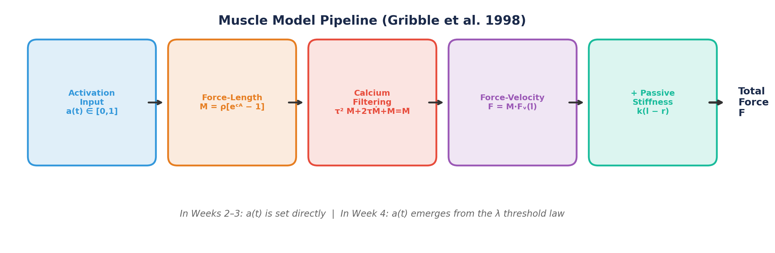
Figure 1. The muscle model pipeline. In Weeks 2–3, activation a(t) is set directly. In Week 4, it will emerge from the λ threshold law.
A key design decision: we build this muscle model to be λ-model compatible from the start. The exponential force-length relation, the reflex delay structure, and the sigmoidal force-velocity curve are all taken from Gribble et al. (1998). In Weeks 2–3, we drive the muscles with direct activation inputs a(t) ∈ [0, 1]. In Week 4, we will “turn on” the threshold control law and let activation emerge naturally from the difference between muscle length and the centrally specified threshold λ.
What Changes in Week 4 — And What Doesn’t
The muscle mechanics (force-length, force-velocity, calcium kinetics, passive stiffness) remain identical throughout the course. Only the source of the activation signal changes: direct input → λ threshold law → inverse dynamics → OFC. One plant, many controllers.

2. The 6-Muscle Arrangement
Gribble et al. (1998) model six muscle groups acting on the 2-joint arm in the horizontal plane. Each joint has a flexor-extensor pair, plus two bi-articular muscles that span both joints:
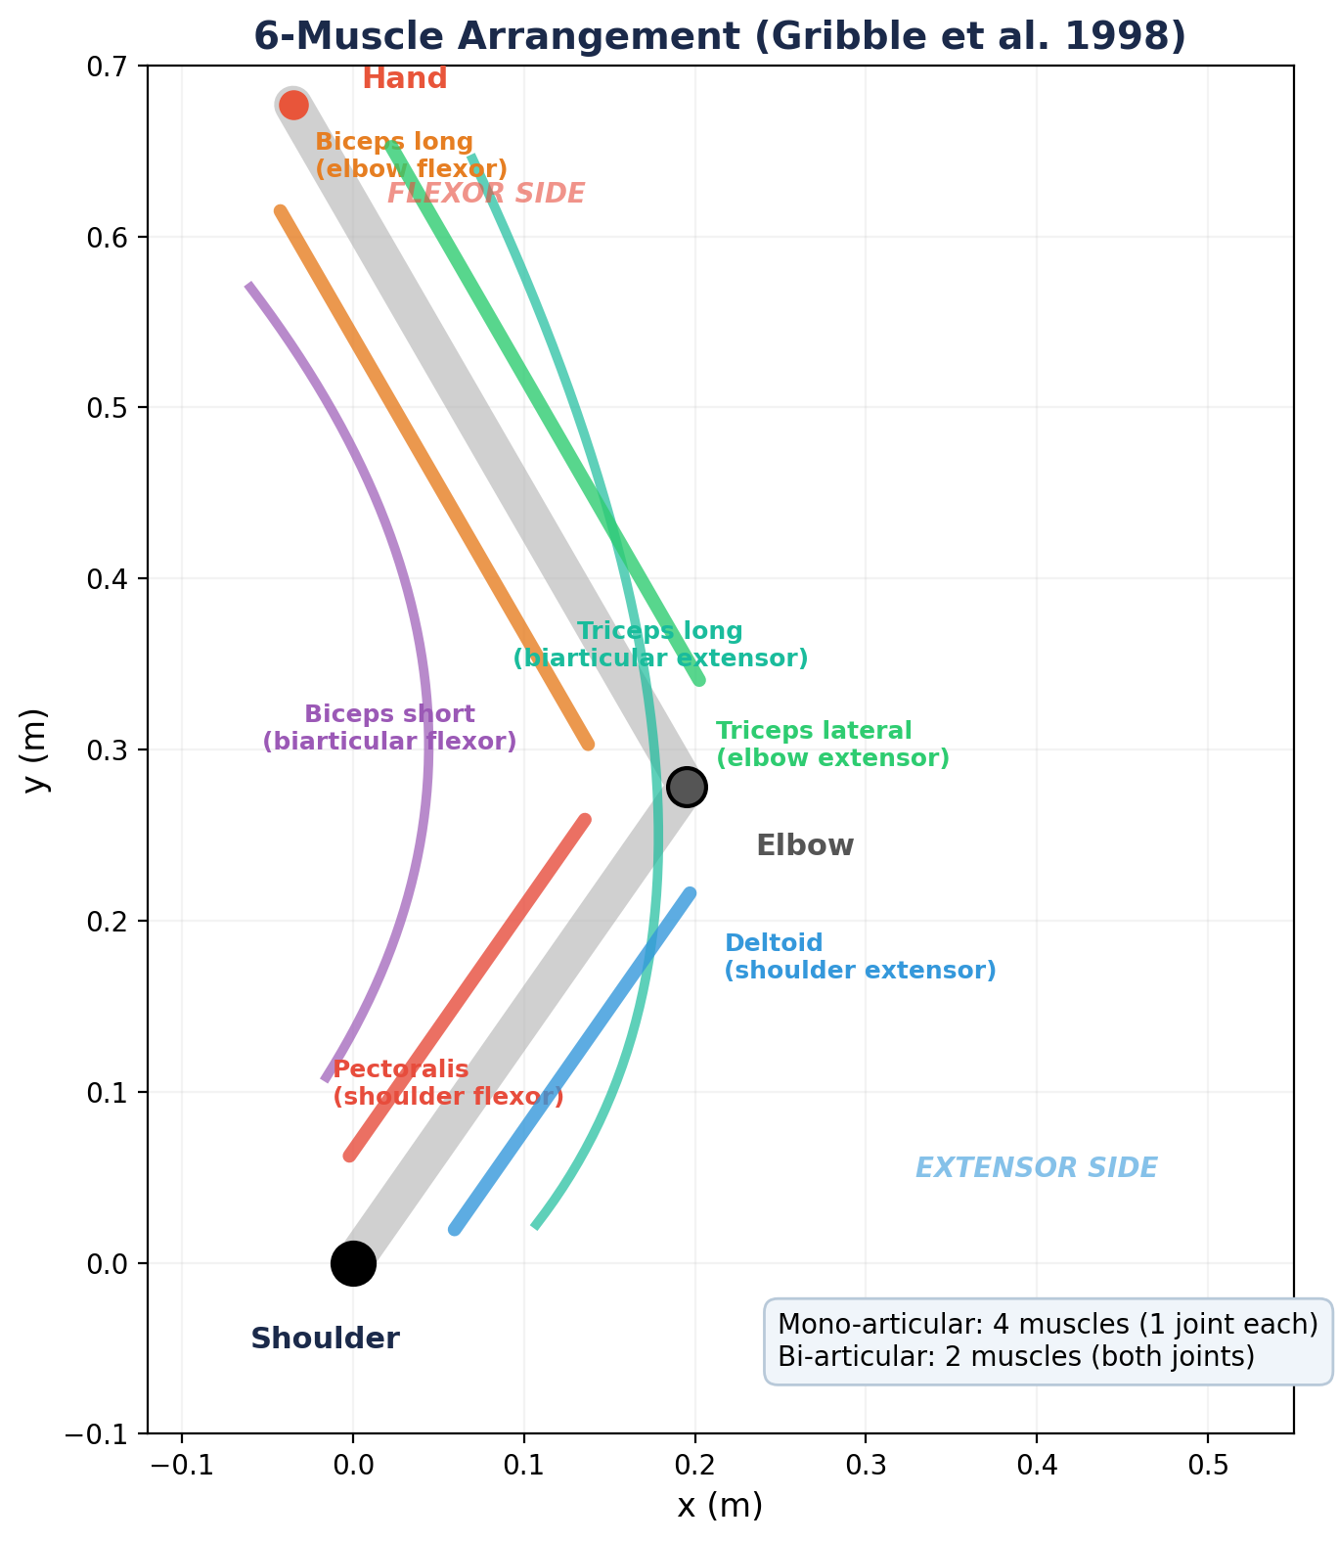
Figure 2. The 6-muscle arrangement. Four mono-articular muscles act on one joint each; two bi-articular muscles span both joints.

2.1 Muscle Groups
Shoulder muscles (mono-articular):
- Pectoralis — shoulder flexor (horizontal adduction). Produces positive torque at the shoulder, increasing θ₁.
- Deltoid (posterior fibers) — shoulder extensor (horizontal abduction). Produces negative torque at the shoulder, decreasing θ₁.
Elbow muscles (mono-articular):
- Biceps long head — elbow flexor. Produces positive torque at the elbow, increasing θ₂.
- Triceps lateral head — elbow extensor. Produces negative torque at the elbow, decreasing θ₂.
Bi-articular muscles:
- Biceps short head — flexor at both joints. When activated, it produces shoulder flexion and elbow flexion simultaneously.
- Triceps long head — extensor at both joints. When activated, it produces shoulder extension and elbow extension simultaneously.
Why Bi-Articular Muscles Matter
Bi-articular muscles create a mechanical coupling between the two joints. When biceps short head contracts, it flexes both the shoulder and elbow. This coupling is not a nuisance—it’s a feature. It means the nervous system can produce coordinated multi-joint movements with fewer independent commands. The Gribble et al. model shows that these couplings, combined with the λ control law, can explain complex movement patterns from simple control signals.

2.2 Force-Generating Capacity (PCSA)
Each muscle’s maximum force is proportional to its physiological cross-sectional area (PCSA). Gribble et al. use PCSA values from Winters & Woo (1990), scaled by ρ = 1 N/cm² to match empirical stiffness data:
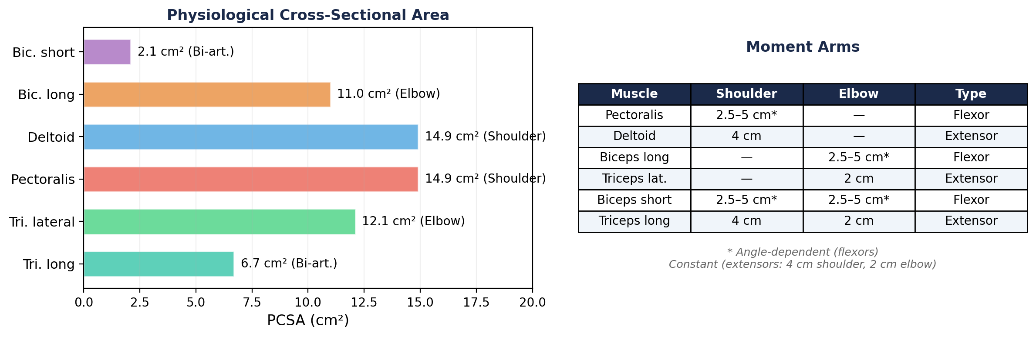
Figure 3. Left: PCSA values determine relative force-generating capacity. Right: Moment arm geometry — extensors are constant, flexors vary with joint angle.

3. Moment Arms: From Muscle Force to Joint Torque
A muscle’s moment arm determines how much torque it produces at a joint per unit of force. The relationship is:
τ = r(q) · F (3.1)
where τ is the joint torque, r(q) is the moment arm (which may depend on the joint angle q), and F is the muscle force.

3.1 Extensor Moment Arms (Constant)
The three extensor muscles (deltoid, triceps lateral, triceps long) have constant moment arms:
- Shoulder extensors: r = 4 cm (0.04 m)
- Elbow extensors: r = 2 cm (0.02 m)

3.2 Flexor Moment Arms (Angle-Dependent)
The three flexor muscles (pectoralis, biceps long, biceps short) have moment arms that vary with joint angle, computed from musculoskeletal geometry. Values range from 2.5 to 5 cm. This angle dependence arises because flexor tendons wrap around the joint differently at different angles—at high flexion, the tendon is further from the joint center, creating a larger moment arm.
For implementation, the moment arm at each joint is computed from the muscle’s origin and insertion points using the geometric relationship between muscle length and joint angle. The key implication: the same muscle activation produces different torques at different arm configurations. This is another source of the configuration dependence we first encountered in the Jacobian.
Moment Arms and Muscle Redundancy
With 6 muscles driving 2 joints, we have actuator redundancy: there are infinitely many combinations of muscle forces that produce the same net joint torques. For example, co-contracting the shoulder flexor and extensor produces no net torque but increases joint stiffness. This is distinct from the kinematic redundancy discussed in Week 1 (which our 2-DOF model does not have). We will encounter this actuator redundancy directly in Week 5 (Inverse Dynamics) and Week 6 (Static Optimization).

4. The Force-Length Relationship
The central equation of the Gribble et al. muscle model relates muscle activation to the force produced by the contractile apparatus:
M̃ = ρ [exp(cA) − 1] (4.1)
where:
- M̃ is the instantaneous muscle force (before calcium filtering)
- ρ is the force-magnitude parameter, specific to each muscle, proportional to PCSA
- c = 0.112 mm⁻¹ is the form parameter (same for all muscles)
- A is the muscle activation variable (see below)
Direct Activation and the Neural Drive Gain G
The parameter c has units of mm⁻¹ because Equation 4.1 was designed for the λ model (Week 4), where A = [l − λ]⁺ is a muscle length displacement in millimeters. In Weeks 2–3, we don’t have the λ model yet. Instead, we drive muscles with a dimensionless activation a ∈ [0, 1]. If we plug a directly into Equation 4.1, the product cA = 0.112 × 1.0 = 0.112 at maximum activation. The exponential barely rises: exp(0.112) − 1 ≈ 0.12. For the pectoralis (ρ = 14.9), this gives a maximum force of only 1.8 N — far too small to move the arm. To fix this, we introduce a neural drive gain G = 20 mm that converts the dimensionless activation to an effective displacement: A = G × a. Now at a = 1: cA = 0.112 × 20 = 2.24, producing ~125 N for the pectoralis — a physiologically realistic force. In Week 4, G disappears: the λ model computes A directly in millimeters, and the exponential operates in its designed range without any gain factor.

4.1 The Recruitment Gradient
The exponential form of Equation 4.1 reflects the size principle of motor unit recruitment (Henneman et al., 1965). As activation increases, progressively larger motor units are recruited, each contributing a larger increment of force. The parameter c captures this recruitment gradient.
The value c = 0.112 mm⁻¹ was estimated by Gribble et al. from the force-length data of Feldman & Orlovsky (1972), recorded from cat gastrocnemius muscle with intact dorsal and ventral roots under brainstem stimulation—ensuring physiologically realistic activation patterns.
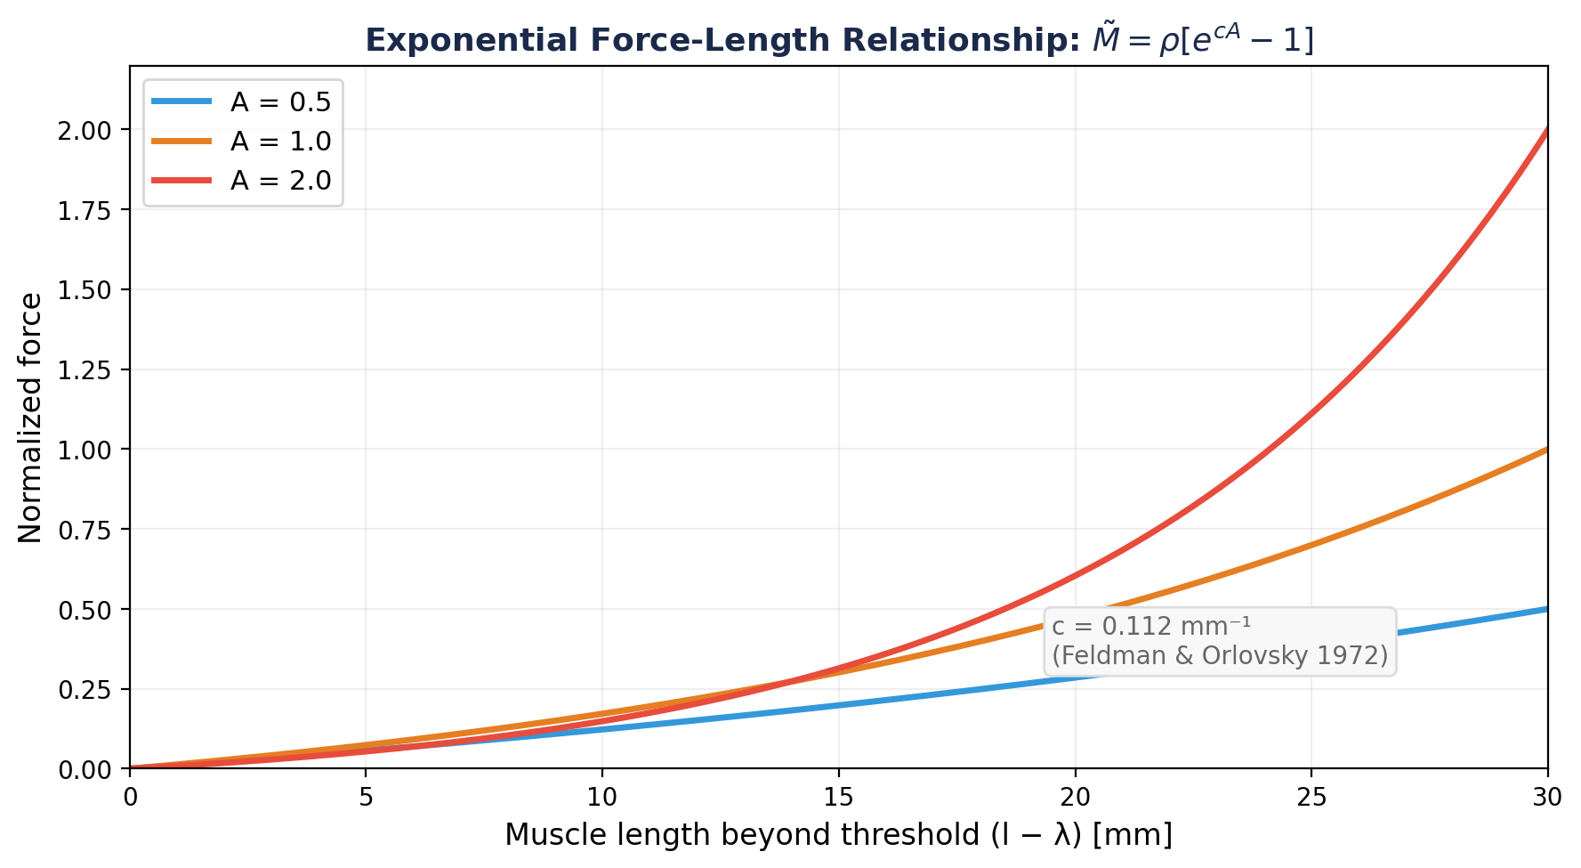
Figure 4. The exponential force-length relationship. Higher activation (larger A) produces exponentially more force. c = 0.112 mm⁻¹ from Feldman & Orlovsky (1972).

4.2 The ρ Parameter
The magnitude parameter ρ is specific to each muscle and proportional to its PCSA. Gribble et al. compute ρ by scaling PCSA values by 1 N/cm², chosen to match the predicted static stiffness of the model to empirical measurements (Gomi & Kawato 1995; Tsuji et al. 1995):
Muscle | PCSA (cm²) | ρ (N/cm² × PCSA) | Type
Biceps short head | 2.1 | 2.1 | Bi-articular flexor
Biceps long head | 11.0 | 11.0 | Elbow flexor
Deltoid | 14.9 | 14.9 | Shoulder extensor
Pectoralis | 14.9 | 14.9 | Shoulder flexor
Triceps lateral head | 12.1 | 12.1 | Elbow extensor
Triceps long head | 6.7 | 6.7 | Bi-articular extensor

Table 1. PCSA values and ρ parameters for all six muscles (Winters & Woo, 1990; scaled by 1 N/cm²).

5. Graded Force Development: Calcium Kinetics
Muscle force does not rise instantaneously when activation changes. The calcium kinetics of the contractile machinery impose a low-pass filter on force production. Gribble et al. model this as a second-order, critically damped system:
τ² M̈ + 2τ Ṁ + M = M̃ (5.1)
where M̃ is the instantaneous force from Equation 4.1 (the input), M is the actual muscle force (the output), and τ = 15 ms is the time constant.
This filter is critically damped (no oscillation) with a single parameter τ. A value of τ = 15 ms produces an asymptotic response to a step input in approximately 90 ms, matching empirically observed times from stimulus onset to maximum force in human adductor pollicis muscle (Hainaut et al., 1981).
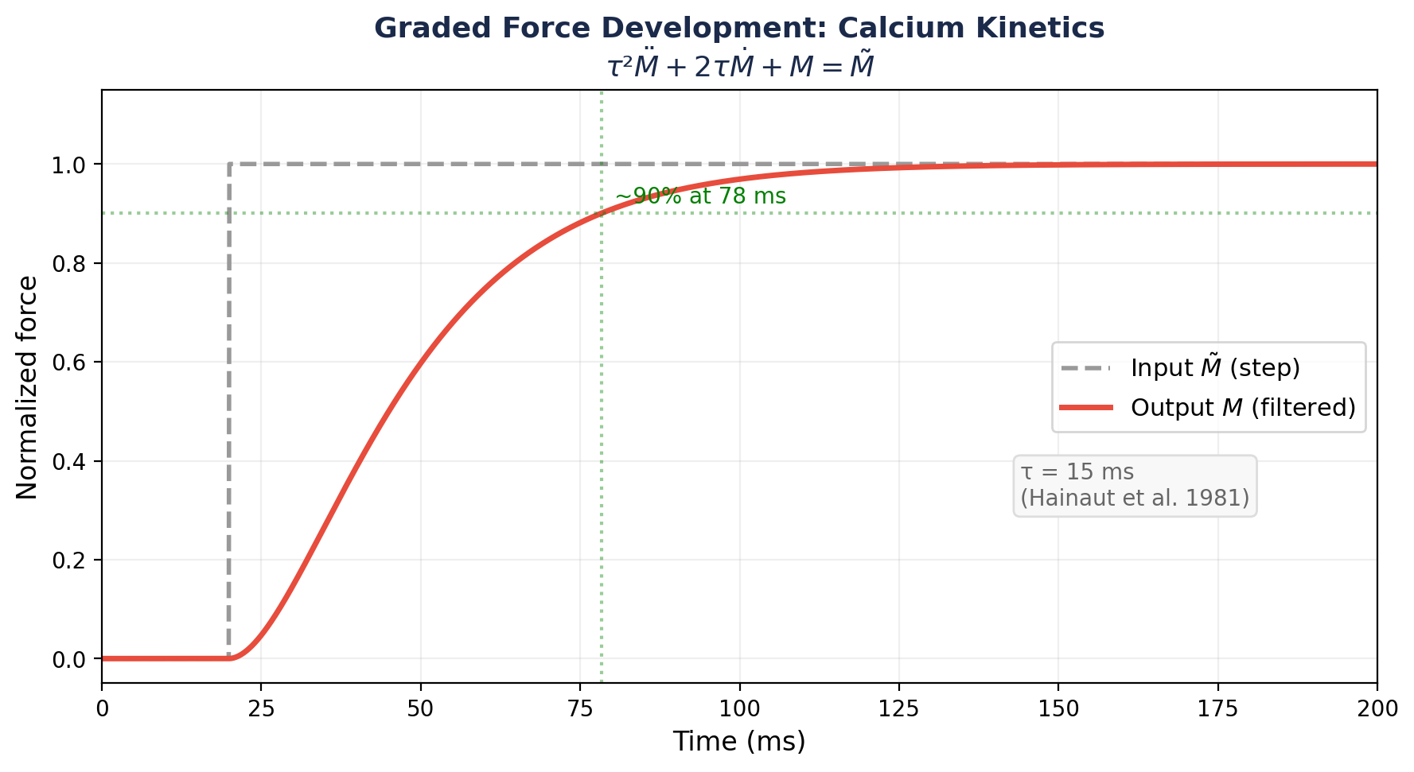
Figure 5. Graded force development. A step change in activation (dashed) produces a smooth, delayed rise in force (solid). The filter reaches ~90% of maximum in ~78 ms. τ = 15 ms.

5.1 Why This Matters for Control
The calcium filter has profound implications for motor control:
- Force cannot change instantaneously. The brain’s commands are filtered by muscle physiology. A sudden neural command produces a gradual force rise over ~90 ms.
- Deceleration is delayed. To stop a movement, the brain must send a deceleration command well before the hand reaches the target—because the resulting braking force will take ~90 ms to develop.
- Fast movements require anticipatory control. For rapid reaching, the entire force profile must be planned in advance, not computed online, because the muscle’s response is too slow to correct in real time. This is one reason feedforward control (Weeks 4–6) is essential.

5.2 Numerical Implementation
For numerical simulation, Equation 5.1 is converted to two first-order ODEs. Define M₁ = M and M₂ = Ṁ:
Ṁ₁ = M₂ (5.2a)
Ṁ₂ = (M̃ − M₁ − 2τ M₂) / τ² (5.2b)
These are integrated alongside the arm dynamics using Runge-Kutta (RK4). Each muscle adds two state variables (M, Ṁ) to the system, so the 6-muscle model adds 12 state variables to the dynamical system.
Why the Calcium Filter Sits Between Force-Length and Force-Velocity
The pipeline ordering reflects three distinct physiological processes. Force-length (Step 2) computes the force the contractile apparatus is commanded to produce—how many cross-bridges the neural drive requests. Calcium filtering (Step 3) represents the time required for calcium to bind troponin and expose actin sites—a biochemical rate limit on how fast bridges can actually form or dissolve. The output M is the number of bridges currently engaged. Force-velocity (Step 4) is a mechanical property of those engaged bridges: each produces more or less force depending on contraction speed, and this effect is nearly instantaneous. If the filter were placed after the velocity multiplier, the model would predict that muscles respond sluggishly to sudden perturbations—but empirically, the force increase from lengthening an active muscle is immediate. What is slow is recruiting new bridges, not modulating the force of existing ones.

6. The Force-Velocity Relationship
Muscle force depends not only on length but also on the velocity of contraction. A muscle that is shortening (concentric contraction) produces less force than one at rest, while a muscle that is being stretched (eccentric/lengthening contraction) produces more force. This is a fundamental property of the actin-myosin cross-bridge mechanism.
Gribble et al. model this using a sigmoidal function fit to data from cat soleus muscle (Joyce & Rack, 1969):
F = M · [f₁ + f₂ · arctan(f₃ + f₄ · dl/dt)] + k(l − r) (6.1)
where M is the calcium-filtered force (from Equation 5.1), dl/dt is the rate of change of muscle length (muscle velocity), and the coefficients are:
- f₁ = 0.82 — baseline force level
- f₂ = 0.50 — amplitude of velocity modulation
- f₃ = 0.43 — horizontal offset
- f₄ = 58 s/m — slope parameter (determines how steeply force varies with velocity)
The final term k(l − r) is the passive stiffness (Section 7). Note that Equation 6.1 gives the total muscle force: the product of the calcium-filtered active force M and the velocity-dependent multiplier, plus the passive component.
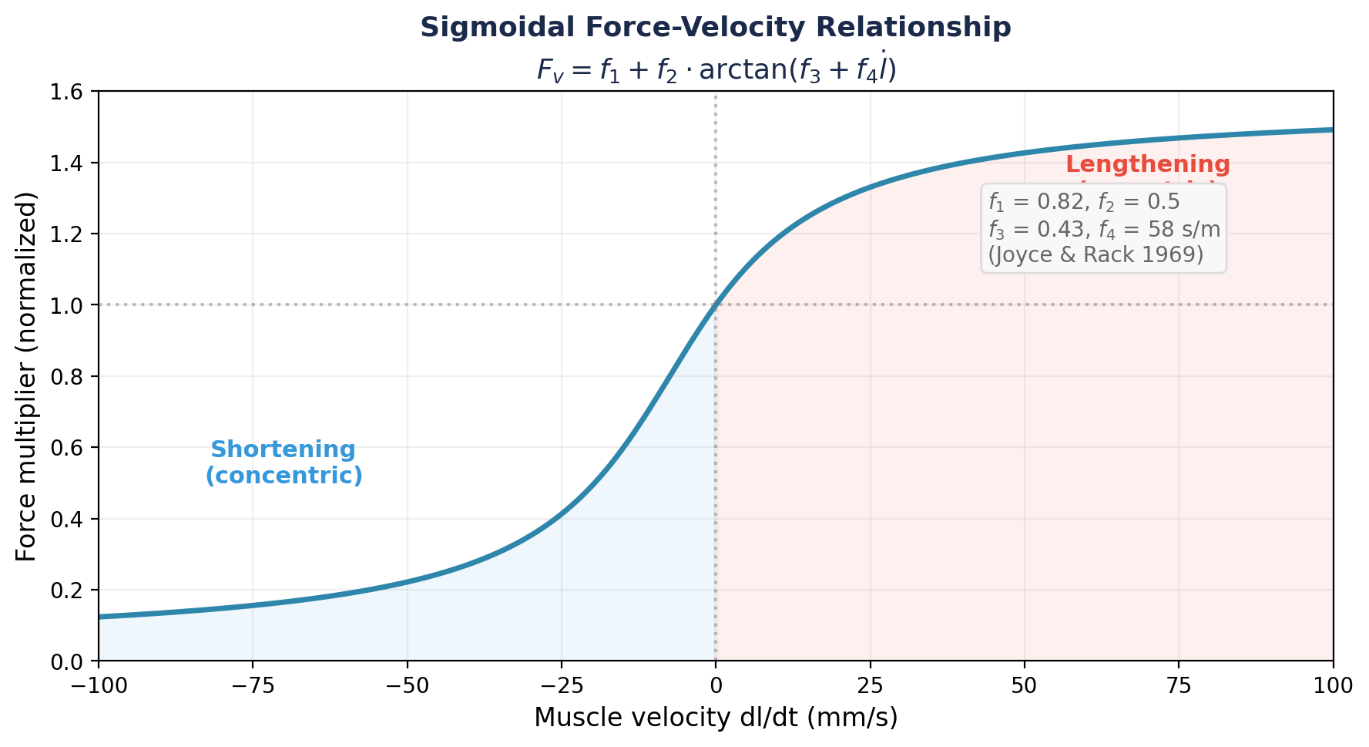
Figure 6. The sigmoidal force-velocity relationship. Lengthening (eccentric) contractions produce more force; shortening (concentric) contractions produce less. Parameters from Joyce & Rack (1969).

6.1 Interpretation
The force-velocity relationship acts as a natural velocity-dependent damping mechanism. When the arm is moving quickly (muscles shortening), the force multiplier drops below 1.0, reducing the net force and naturally decelerating the limb. When the arm is perturbed (muscles forcibly stretched), the multiplier rises above 1.0, providing a stabilizing resistive force.
This intrinsic damping is one of the reasons the Gribble et al. model can produce smooth movements from simple control signals: the muscle’s own mechanics provide “free” deceleration that doesn’t need to be explicitly commanded. We will see this dramatically in Week 4 when constant-rate λ shifts produce realistic reaching movements.

7. Passive Elasticity
Even without neural input (A = 0), muscles resist stretch due to their passive elastic properties—connective tissue, titin filaments, and the parallel elastic element of the sarcomere. Gribble et al. model passive force as linear in the departure from resting length:
F_passive = k · (l − r) (7.1)
where l is current muscle length, r is resting length, and k is passive stiffness. Resting lengths are computed as the muscle lengths at θ₁ = 45° and θ₂ = 90°. The stiffness values are proportional to PCSA, scaled to match the passive component of the force-length data from Feldman & Orlovsky (1972):
Muscle | Passive Stiffness k (N/m)
Biceps short head | 36.5
Biceps long head | 190.9
Deltoid | 258.5
Pectoralis | 258.5
Triceps lateral head | 209.9
Triceps long head | 116.3

Table 2. Passive stiffness values for all six muscles (Feldman & Orlovsky, 1972).
The linear passive stiffness approximation is valid for muscle stretches up to about 75% of maximum departure from resting length. All muscle length changes in our simulations will fall within this range.

8. The Complete Muscle Model
Assembling all components, the total force produced by a single muscle is:

8.1 The Complete Force Equation
Step 1: Activation.
A = a(t) [for Weeks 2–3; in Week 4 this becomes A = [l − λ + μ·(dl/dt)]⁺] (8.1)
Step 2: Instantaneous contractile force (exponential force-length).
M̃ = ρ [exp(cA) − 1] (8.2)
Step 3: Calcium-filtered force (graded development).
τ² M̈ + 2τ Ṁ + M = M̃ (8.3)
Step 4: Total force (velocity-dependent + passive).
F = M · [f₁ + f₂ · arctan(f₃ + f₄ · dl/dt)] + k(l − r) (8.4)
Step 5: Joint torque (via moment arm).
τ_joint = r(q) · F (8.5)

8.2 State Variables
Each muscle contributes the following to the simulation:
- 2 state variables: M (filtered force) and Ṁ (rate of force change)
- Inputs: activation a(t), muscle length l(q), muscle velocity dl/dt(q, dq/dt)
- Output: force F, which contributes to joint torque via the moment arm
With 6 muscles, the muscle subsystem adds 12 state variables to the dynamical system. In Week 3, these will be integrated alongside the 4 kinematic state variables (2 joint angles, 2 joint velocities), giving a 16-dimensional ODE system.

8.3 What the Muscle Class Must Expose
For future use by the proprioceptive system (Week 9), each muscle object must expose:
- l (muscle length) — computed from joint angles via musculoskeletal geometry
- dl/dt (muscle velocity) — computed from joint angles and joint velocities
In Week 9, we will build a Proprioceptor class that reads these signals as noisy, delayed estimates of the muscle’s mechanical state—mimicking muscle spindles and Golgi tendon organs. By exposing l and dl/dt now, we ensure that adding proprioception later requires no changes to the Muscle class itself: the sensory system simply reads data that the muscle already computes.
Our Model in Context: Gribble vs. Hill-Type Architecture
The Gribble et al. (1998) model we implement is a simplified member of the Hill-type muscle model family. A full Hill-type model (e.g., Kistemaker et al. 2006; Van Soest & Bobbert 1993) differs in three main ways. (1) Series elastic element (tendon compliance): In a full model, the muscle–tendon complex contains a contractile element (CE) in series with an elastic tendon (SE), so CE length ≠ total muscle length. Our model assumes a rigid tendon (CE length = muscle length), which is reasonable for slow-to-moderate movements but breaks down for fast or explosive actions. (2) Force–length shape: The classic Hill/Zajac force–length relationship is bell-shaped, peaking at an optimal sarcomere length. Gribble uses an exponential approximation that is monotonically increasing over the operating range—valid for our model’s joint limits but not a general description. (3) Activation dynamics: Kistemaker uses Hatze’s (1981) two-stage model: STIM → γ (free Ca²⁺) → q (Ca²⁺ bound to troponin), where q depends on both γ and CE length—capturing length-dependent Ca²⁺ sensitivity (LDCS). Our single second-order filter lumps these stages together. The Gribble model is the right choice for this course: fewer state variables, closed-form expressions, and λ-model compatibility. But when you read Zajac (1989) or Kistemaker et al. (2006), expect these differences.

9. Summary of Key Results
Component | Equation | Key Parameter
Force-length | M̃ = ρ[exp(c·G·a) − 1] | c = 0.112 mm⁻¹, G = 20 mm
Calcium kinetics | τ²M̈ + 2τṀ + M = M̃ | τ = 15 ms
Force-velocity | F_v = f₁+f₂·arctan(f₃+f₄·dl/dt) | f₄ = 58 s/m
Passive stiffness | F_p = k(l − r) | k from Table 2
Moment arms (ext.) | τ = r · F | 4 cm (shoulder), 2 cm (elbow)
Moment arms (flex.) | τ = r(q) · F | 2.5–5 cm (angle-dependent)
ρ parameter | ρ = PCSA × 1 N/cm² | See Table 1

Parameter Sources
- c = 0.112 mm⁻¹ — Feldman & Orlovsky (1972), cat gastrocnemius
- τ = 15 ms — Hainaut et al. (1981), human adductor pollicis
- f₁–f₄ — Joyce & Rack (1969), cat soleus
- PCSA values — Winters & Woo (1990)
- Passive stiffness — Feldman & Orlovsky (1972), scaled by PCSA
- Moment arms — An et al. (1981, 1989); Winters & Woo (1990)
- ρ scaling (1 N/cm²) — matched to Gomi & Kawato (1995) and Tsuji et al. (1995) static stiffness

Next week: We connect the muscles to the skeleton using Lagrangian dynamics. The kinematic arm from Week 1 and the muscles from this week will be integrated into a single dynamical system—the DynamicsEngine class.

