WEEK 5
Movement Invariants & Trajectory Planning
VITE, Minimum Jerk, and the Case for Task-Space Control
Reading: Flash, T., & Hogan, N. (1985). The coordination of arm movements. J. Neuroscience, 5(7), 1688–1703. [Required]
Bullock, D., & Grossberg, S. (1988). Neural dynamics of planned arm movements. Psychological Review, 95(1), 49. [Required]
Morasso, P. (1981). Spatial control of arm movements. Exp. Brain Research, 42(2), 223–227. [Supplementary]
Woodworth, R. S. (1899). The accuracy of voluntary movement. Psychological Review: Monograph Supplements, 3(3), 1–114. [Supplementary — origin of the two-component framework]

§1 Morasso’s Observation
In 1981, Pietro Morasso asked a deceptively simple question: when people reach to different targets, what is invariant? He recorded center-out reaching movements in the horizontal plane and found two remarkable regularities:
- Hand paths are approximately straight lines between start and target, regardless of direction.
- Velocity profiles are bell-shaped, with a single peak near the movement midpoint.
These invariances hold in task space (the x-y plane where the hand moves). In joint space (shoulder and elbow angles), the trajectories are complex and direction-dependent. The nervous system appears to plan in task coordinates, not joint coordinates.
Figure 1 reproduces Morasso’s key observation using our arm model. The left panel shows straight hand paths to 8 targets. The center panel shows bell-shaped velocity profiles. The right panel reveals the non-trivial joint-angle trajectories needed to produce those straight lines — different directions require qualitatively different patterns of shoulder and elbow rotation.
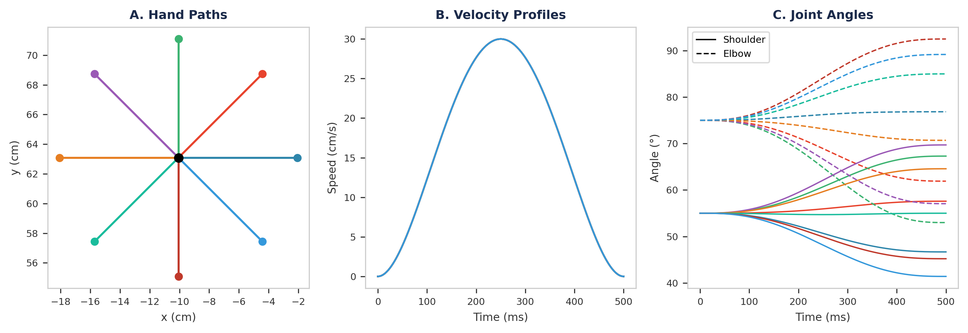
Figure 1. Morasso-style center-out reaching (min-jerk trajectories, 8 cm amplitude, T = 500 ms). (A) Straight hand paths to 8 targets from Q_REF. (B) Bell-shaped velocity profiles, all peaking near 250 ms. (C) Joint-angle trajectories corresponding to the hand paths in A — note the complex, direction-dependent patterns required to produce straight lines in task space.

§2 The Minimum-Jerk Model
Flash and Hogan (1985) proposed an elegant explanation: the brain minimizes the total squared jerk (rate of change of acceleration) over the movement:
min ∫₀ᵀ ‖d³x/dt³‖² dt
For a point-to-point reach from position x₀ to xf in time T, this optimization has a closed-form solution — a 5th-order polynomial:
x(τ) = x₀ + (xf − x₀) · (10τ³ − 15τ⁴ + 6τ⁵), τ = t/T
This formula produces straight-line hand paths by definition (both x and y components follow the same temporal profile), and the velocity profile is a perfectly symmetric bell shape. The acceleration reverses sign exactly at the midpoint, and the jerk is minimized.
Why jerk? Minimizing jerk penalizes abrupt changes in force, which would waste energy and destabilize the limb. The minimum-jerk trajectory is the smoothest possible movement between two points.

Open-Loop by Nature
A crucial property of minimum jerk: the trajectory is computed once, before movement begins. The 5th-order polynomial is a closed-form solution — no differential equation needs to be integrated, no feedback is required, and no online correction occurs. From a control theory standpoint, this is pure feedforward: a reference trajectory launched ballistically.
This has profound implications. If the arm is perturbed mid-reach, the minimum-jerk plan does not adapt — it has no mechanism to detect or correct errors. This is the purest expression of the course’s Initial Impulse phase — a ballistic, feedforward plan with no online correction (see Woodworth, 1899, in the supplementary reading). Contrast this with the EPH’s λ model from Week 4, which provided automatic perturbation resistance through equifinality. Minimum jerk explains the shape of movement better, but at the cost of abandoning the stability that made EPH attractive.
In practice, minimum jerk is best understood not as a controller but as a reference trajectory that some downstream controller must execute — using muscles, dealing with noise, and handling perturbations. This is exactly what Weeks 6 (inverse dynamics) and 12 (optimal feedback control) will address.
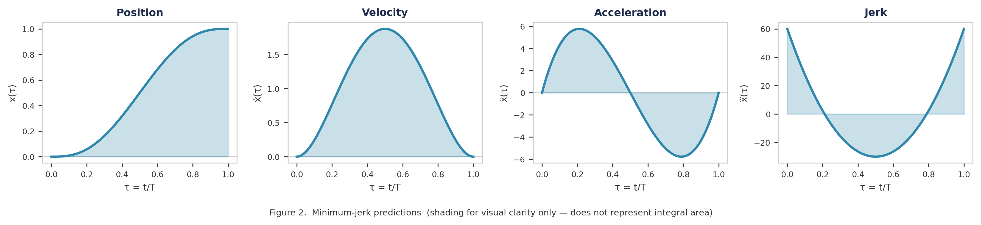
Figure 2. Minimum-jerk predictions (shading for visual clarity only — does not represent integral area).

§3 Minimum Jerk vs. EPH: Head to Head
Now the critical comparison. We run both controllers on the same center-out reaching task — 8 targets at 8 cm from the reference posture.
The EPH reaches (left panel) use the exact same λ ramp parameters from Week 4: constant-rate shifts with C = 0.25 rad. The minimum-jerk reaches (right panel) plan in task space — they specify the straight-line hand path and bell-shaped velocity analytically.
The difference is striking. EPH paths curve because the same Δλ maps through the nonlinear Jacobian differently at each arm configuration — this is the workspace dependence we demonstrated in Lab 4 (Part 9). Minimum-jerk paths are straight by construction: planning happens in the coordinate system where invariance is observed.
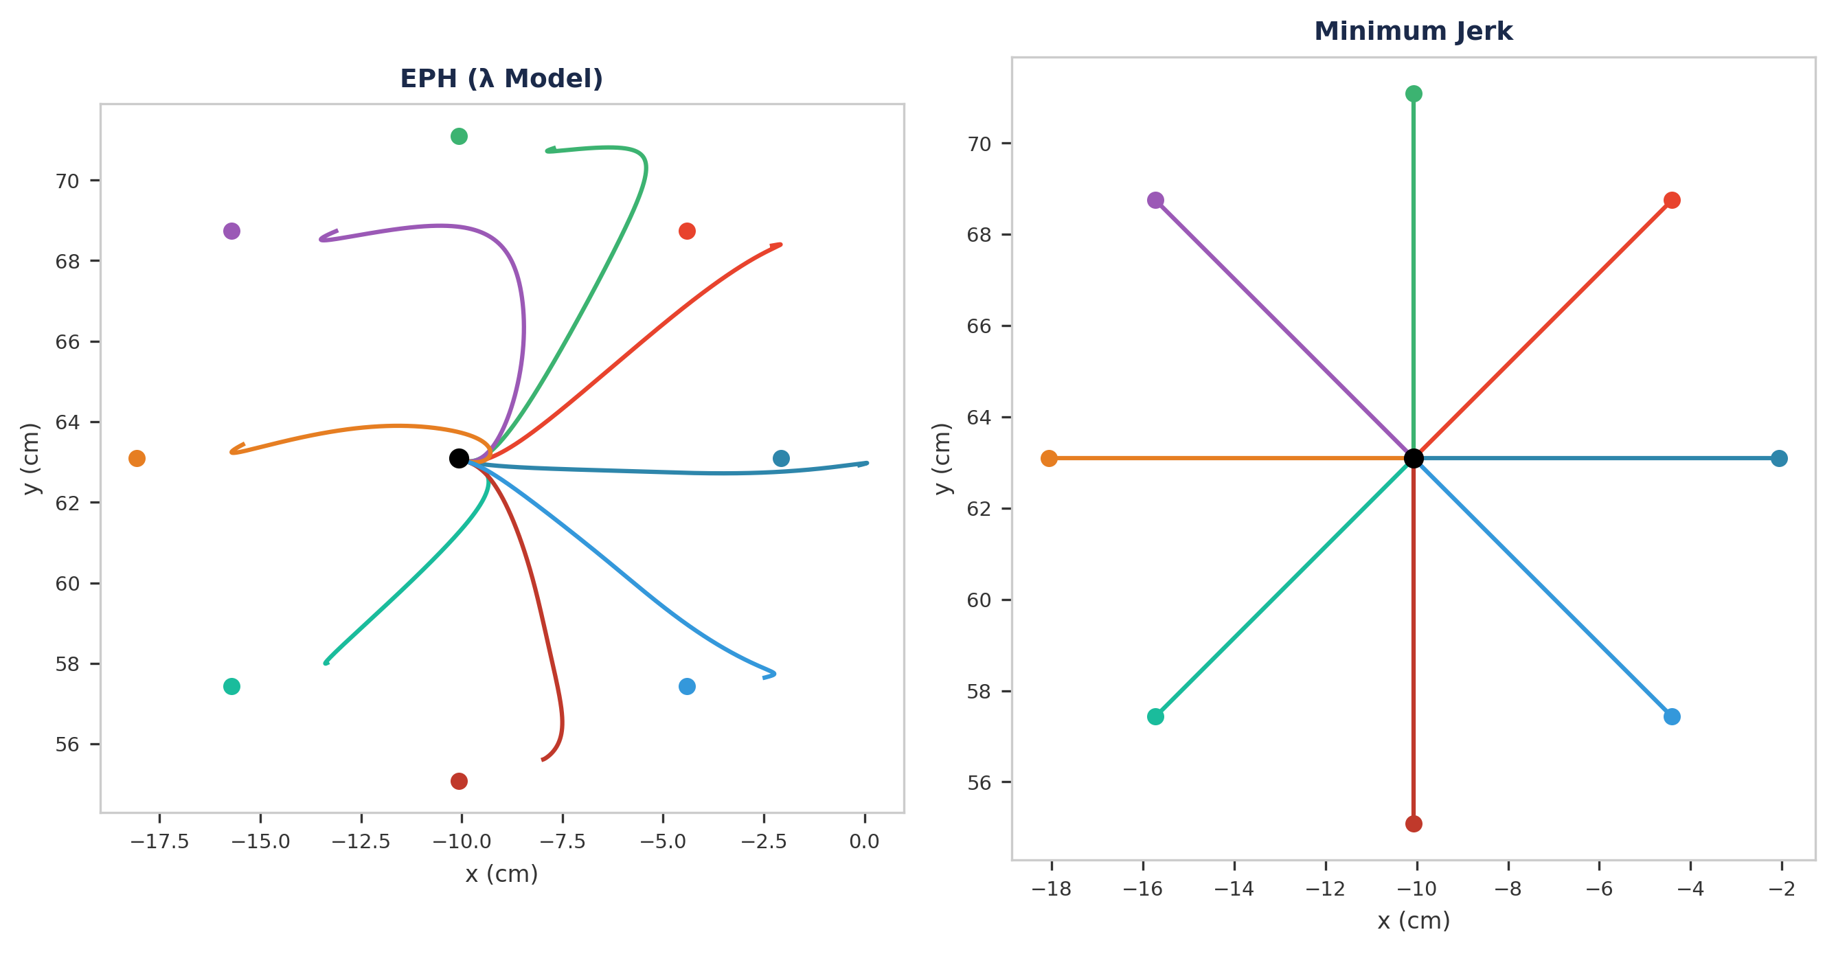
Figure 3. EPH vs. minimum-jerk center-out reaching (8 targets, 8 cm). Left: EPH with constant-rate λ ramps (C = 0.25 rad, ramp duration 300 ms) produces curved, direction-dependent paths. Right: minimum-jerk (T = 500 ms) produces straight paths by construction.
The key insight: EPH produces the right qualitative behavior (smooth, bell-shaped) but the wrong geometry (curved, direction-dependent). Minimum-jerk produces the right geometry (straight, invariant) but says nothing about how the muscles actually generate the movement.

Discussion: Are EPH’s Curved Paths Really Wrong?
The comparison above seems to indict the λ model — curved paths where Morasso found straight ones. But the story has three layers that make this a richer question than it first appears.
1. Real paths aren’t perfectly straight. Morasso’s 1981 data showed approximately straight paths, but subsequent work documented systematic, direction-dependent curvatures. Atkeson and Hollerbach (1985) and Flash (1987) found that movements toward the body curve differently than movements away — exactly the pattern our EPH simulations produce. The curvature reflects the arm’s anisotropic inertia and the nonlinear joint-to-task mapping. So EPH’s curved paths aren’t entirely wrong — they may capture a real feature of reaching that minimum-jerk, by enforcing perfect straightness, actually over-idealizes.
2. EPH can produce straight paths — but loses its simplicity. If you replace constant-rate λ ramps with carefully shaped, time-varying λ shifts that compensate for the Jacobian at each instant, you can steer the hand along a perfectly straight line using threshold control. But computing those shaped shifts requires knowledge of the arm’s geometry at every moment — which is essentially inverse kinematics. At that point, you have smuggled a trajectory planner inside the λ controller, and the “simple control signal” argument — the entire appeal of EPH — collapses. The simplicity of constant-rate ramps and the straightness of hand paths appear to be fundamentally incompatible.
3. The nervous system probably does both. The most likely picture, which the field has converged toward over the past two decades, is that the brain uses some form of task-space trajectory planning (Week 5) executed through threshold-like muscle activation (Week 4). The planning system specifies approximately where the hand should go; the muscle system provides the stability, compliance, and perturbation resistance that no feedforward plan can achieve alone. Neither EPH nor minimum-jerk is the whole story — but each captures something the other misses. This tension will drive the rest of the course: inverse dynamics (Week 6), noise analysis (Week 7), and ultimately optimal feedback control (Week 12), which attempts to unify both perspectives.
Class Discussion: If real hand paths are only approximately straight, how would you design an experiment to determine whether the curvatures are (a) noise, (b) biomechanical artifacts of the arm’s geometry (as EPH predicts), or (c) evidence of a task-space planner with imperfect inverse kinematics? What would you measure, and what pattern of results would distinguish these hypotheses?

§4 The VITE Model
Bullock and Grossberg (1988) proposed a neural circuit that produces minimum-jerk-like trajectories without solving an optimization problem. Their Vector Integration To Endpoint (VITE) model uses two variables:
- Difference Vector (DV): DV = T − P, the vector from the current planned position P to the target T.
- Go Signal G(t): A scalar that gates when and how fast the movement proceeds.
The velocity V is a low-pass filtered version of the Go-signal-scaled difference vector:
V̇ = α · [−V + G(t) · (T − P)], Ṗ = V
The parameter α controls the filter time constant. The difference vector (T − P) shrinks as P approaches T, which automatically drives V toward zero — the hand comes to rest on the target. This is guaranteed by the dynamics: there is no way for the system to overshoot and fail to converge, regardless of the Go signal amplitude.

State-Space Formulation
Define the state vector x = [Px, Py, Vx, Vy]ᵀ. The VITE dynamics are a linear time-varying ODE:
ẋ = A(t)·x + b(t)
A(t) = [ 0 I; −αG(t)I −αI ], b(t) = [ 0; αG(t)·T ]
This is the same form as the Week 3 arm dynamics (ẋ = f(x, u)), and the same RK4 integrator from the smc library can solve it. The only time-varying element is G(t) — the Go signal. We use α = 4G for critical damping (no overshoot). The key structural insight: VITE’s state space is a planning layer above the arm — its output P(t) is a desired hand trajectory, not a muscle command. Converting P(t) to actual movement requires an inverse model, which is Week 6’s problem.
Figure 4 compares VITE at two speeds (G = 3 slow, G = 10 fast) against minimum jerk (T = 500 ms). The min-jerk profile falls between the two VITE speeds in both peak velocity and movement duration — illustrating that the Go signal is a single scalar “vigor” parameter. Panel C tracks the difference vector magnitude |DV| = |T − P|. Note that DV is not an independent state variable — it is derived from the planned position P, which is a true state, and the fixed target T. The exponential decay of |DV| is a consequence of the V̇ dynamics, not a separately integrated quantity. Higher G drives faster decay because the velocity V (and hence Ṗ) is scaled by G.
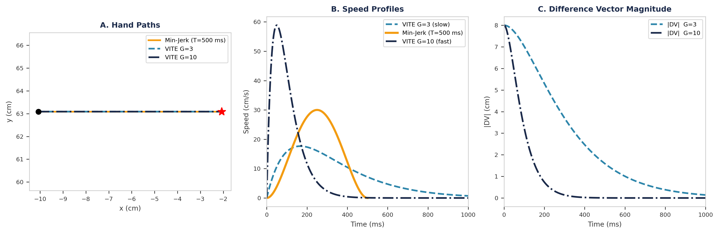
Figure 4. VITE single reach vs. minimum jerk (rightward, 8 cm). (A) Hand paths overlap — all three produce straight lines. (B) Speed profiles: VITE G = 3 (slow, peak ≈18 cm/s) and G = 10 (fast, peak ≈59 cm/s) bracket the min-jerk profile (T = 500 ms, peak 30 cm/s). (C) Difference vector magnitude |DV| = |T − P|. DV is not an independent state variable; it is derived from the planned position P (a true state) and the fixed target T. Its exponential decay is a consequence of the V̇ dynamics, not a separately governed quantity.

§5 VITE Properties: Speed Scaling
One of VITE’s most attractive features is speed scaling. By changing only the Go signal amplitude G, the model produces the same straight hand path at different speeds. Larger G → faster movement, smaller G → slower movement. The velocity profile shape is preserved — only the amplitude and duration change.
This matches a robust experimental finding: when people reach to the same target at different speeds, their velocity profiles are approximately time-scaled versions of each other. VITE explains this naturally — the Go signal acts as a single ‘vigor’ parameter that the brain can adjust without recomputing the trajectory.
In contrast, the EPH λ model would need to change the ramp rate to control speed — a faster ramp produces a faster reach, but this couples the ‘what’ and ‘how fast’ into a single signal. The minimum-jerk model would need to change the movement duration T in the cost function. Only VITE separates the ‘what’ (target T) from the ‘how fast’ (Go signal G) in its architecture. The rate constant α and the target T remain fixed — only G changes.
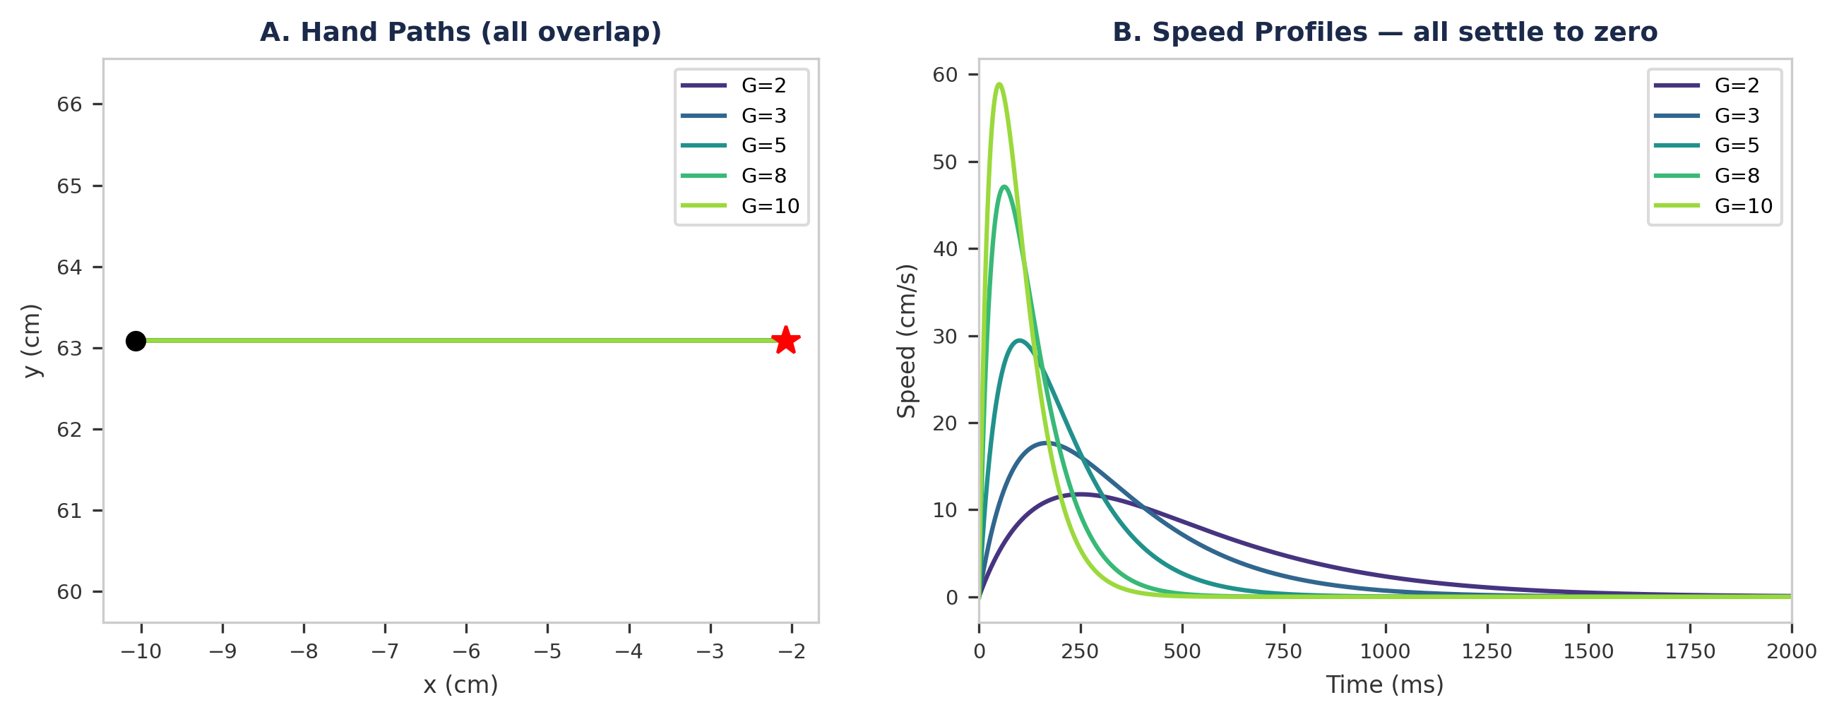
Figure 5. VITE speed scaling (rightward reach, 8 cm, α = 4G). (A) All five Go signal values produce the same straight hand path. (B) Velocity profiles scale with G: larger G → higher peak, shorter duration. All profiles settle to zero, confirming convergence to the target regardless of vigor.

§6 Three-Way Comparison: 8 Directions
Figure 6 puts all three controllers side by side on the same center-out task. The pedagogical point is immediate:
- EPH (left): Curved, direction-dependent paths. The workspace dependence from Week 4 is visible.
- Minimum Jerk (center): Perfectly straight paths. This is guaranteed by the optimization — it plans in task space.
- VITE (right): Nearly straight paths. The difference vector dynamics produce task-space planning without optimization.
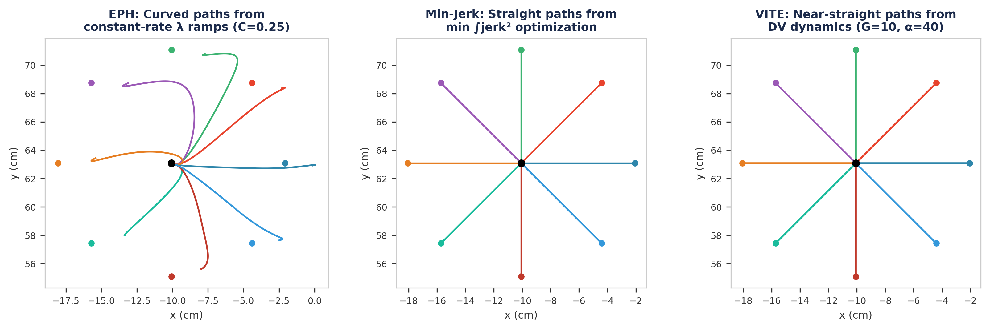
Figure 6. Three-way comparison on center-out reaching (8 targets, 8 cm from Q_REF). EPH plans in muscle space and produces curved paths; minimum jerk and VITE plan in task space and produce straight (or near-straight) paths. Subtitles state each controller’s parameters.
Both trajectory planners solve the workspace dependence problem. But they do so at a cost that EPH avoids entirely — they require a representation of the target in task space and (for execution on real muscles) an inverse model to convert desired trajectories to motor commands. Section 7 unpacks this trade-off.

§7 The Cost of Planning
The three controllers represent fundamentally different computational philosophies:
 | EPH (λ Model) | Minimum Jerk | VITE
Control signal | λ thresholds (6 values) | Desired trajectory x(t) | Target T + Go signal G(t)
Plans in | Muscle space | Task space | Task space
Hand paths | Curved | Straight | Straight
Velocity profile | Bell-shaped | Symmetric bell | Slightly asymmetric bell
Equifinality | Yes (spring-like) | No (open-loop) | Yes (DV → 0)
Requires target in task space | No | Yes | Yes
Requires inverse model | No | Yes (for muscles) | Yes (for muscles)
Speed control | Ramp rate | Duration T | Go signal G(t)
Perturbation response | Automatic (spring) | None (feedforward) | Partial (DV updates)

The table reveals a fundamental tension in motor control theory. Simplicity of control (EPH) trades off against kinematic invariance (Min-Jerk / VITE). Neither approach alone captures the full picture of human reaching. Week 6 will ask: what if we combine task-space planning with muscle-level execution by computing the inverse dynamics?

§8 Via-Point Movements
Real reaching is not always point-to-point. Everyday movements often pass through intermediate locations — reaching around an obstacle, touching a sequence of targets, or handing an object while moving. How do the planners handle via-points?
- Minimum Jerk: The optimization is extended with via-point constraints. The trajectory must pass through the via-point at a specified time with continuous velocity. This produces two concatenated polynomial segments with matched boundary conditions.
- VITE: The target is simply updated. When the hand approaches the via-point, the target switches to the final position. The difference vector recomputes automatically. No re-optimization needed.
- EPH: Requires sequential λ shifts — first ramp to a posture corresponding to the via-point, then immediately ramp to the final target. There is no internal mechanism to decide when to switch; the ramp schedule must be explicitly programmed.
Figure 8 shows a via-point reach with all three controllers on a comparable timescale. VITE produces a smooth curved path through the via-point because the target switch happens during movement — the difference vector recomputes automatically. Minimum jerk passes exactly through the via-point by construction (it is a boundary condition of the optimization). EPH undershoots the via-point by about 2 cm — the same workspace-dependent equilibrium offset we saw in §3 — because its λ ramps operate in joint space and the nonlinear Jacobian mapping distorts the hand path. The EPH controller requires an explicit dwell at the via-point to let the arm approach the intermediate equilibrium; how long to dwell must be chosen by the programmer, not by the controller. VITE has no such requirement: the target switch is instantaneous and the dynamics handle the transition.
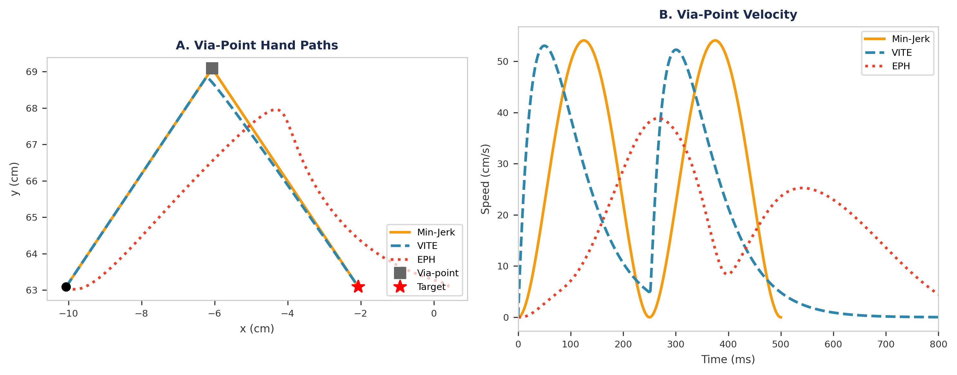
Figure 8. Via-point reaching — three-way comparison. Start at (−10.1, 63.1) cm (Q_REF), via-point at (−6.1, 69.1) cm, final target at (−2.1, 63.1) cm. (A) Hand paths: min-jerk concatenates two 250 ms segments and passes exactly through the via-point; VITE switches its target at 250 ms and curves smoothly past the via-point; EPH uses 150 ms λ ramps with a 100 ms dwell (50–200–300–450 ms) but undershoots the via-point by ∼2 cm due to workspace-dependent equilibrium offset (§3). (B) Velocity profiles: min-jerk shows a dip at the segment junction; VITE transitions smoothly; EPH produces two velocity peaks separated by the dwell period.

§8.5 Sensory Integration: Which Models Can Use Feedback?
Before summarizing, it is worth asking a question that will dominate the rest of the course: which of the models we have met so far can incorporate sensory feedback during movement? The answer is surprisingly asymmetric.
EPH (Week 4): No online sensory integration. The λ ramp is set before the movement begins and runs open-loop. Equifinality provides perturbation resistance through muscle spring-like properties, but this is a mechanical, not a sensory, phenomenon — the controller never “knows” the limb was perturbed. (Feldman’s Referent Configuration theory, which we will cover in Week 10, extends the threshold framework to incorporate sensory feedback.)
Minimum Jerk (§2): No. The trajectory is pre-computed from boundary conditions. Once the polynomial is set, there is no mechanism to update it mid-flight. It is the purest feedforward plan in our repertoire.
VITE (§4): Yes — via target update. If the target moves (a visual update), we simply change T. The difference vector DV = T − P recomputes automatically, and the ongoing integration smoothly redirects the movement without any trajectory replanning. This is why VITE handles via-points so elegantly (§8) and why it is often described as the first trajectory model with a natural sensory interface.
Looking ahead — Optimal Feedback Control (Week 12): OFC will integrate sensory feedback optimally, using a Kalman-filtered state estimate to compute time-varying feedback gains. It subsumes both the feedforward precision of minimum jerk and the feedback responsiveness of VITE within a single principled framework. Two related approaches — Model Predictive Control (MPC) and Active Inference (Friston) — extend these ideas further but are beyond the scope of this course.

§9 Where Does This Leave Us?
This week we confronted a core tension in motor control:
- EPH produces smooth, stable reaching from remarkably simple control signals — but cannot explain straight hand paths across the workspace.
- Minimum Jerk explains straight paths and symmetric velocity profiles perfectly — but it is a kinematic description with no account of forces, muscles, or stability.
- VITE offers a neural mechanism for generating minimum-jerk-like trajectories via simple dynamics — but still plans in task space and needs an inverse model for execution. Specifically, VITE outputs a desired hand trajectory P(t) in Cartesian coordinates, but the arm’s muscles operate in joint space. Converting P(t) to joint torques requires solving the inverse kinematics (P → q) and inverse dynamics (q̈ → τ) at every timestep — the exact computation that Week 6 introduces.
The velocity comparison (Figure 9) captures the situation: all three controllers produce bell-shaped velocity profiles, but for different reasons and with different trade-offs. VITE is shown at two speeds (G = 3 and G = 10) to illustrate that the Go signal scales movement vigor without changing the trajectory shape.
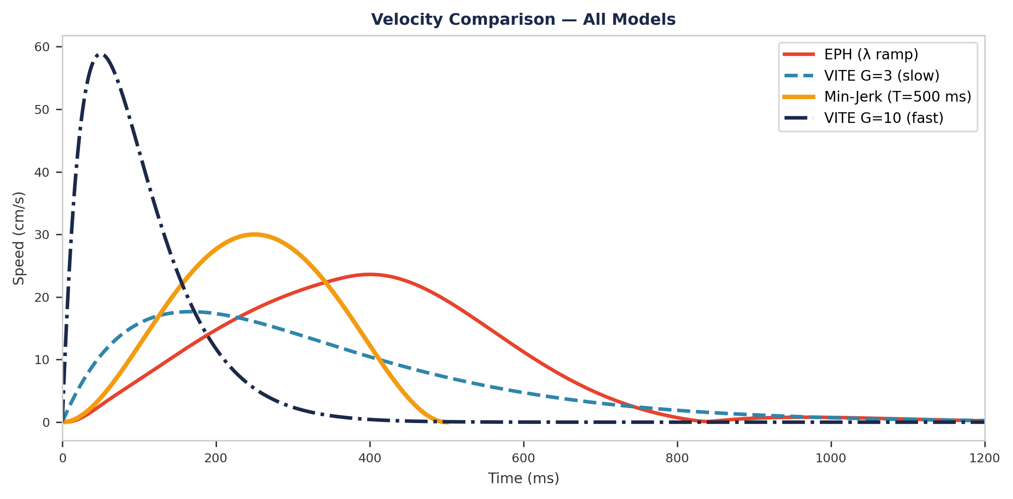
Figure 9. Velocity comparison for a single rightward reach (8 cm). All four traces produce bell-shaped profiles, but for different reasons: EPH from muscle-spring dynamics (λ ramp), min-jerk from jerk minimization (T = 500 ms), and VITE from difference-vector dynamics at two Go signal levels (G = 3 slow, G = 10 fast). The min-jerk peak falls between the two VITE speeds.
Next week: If we accept that the brain plans in task space (VITE / Min-Jerk), it must convert that plan into muscle commands. Week 6 introduces inverse dynamics — computing the torques needed to execute a desired trajectory. We will solve the muscle redundancy problem and compare the computed activations against the patterns that emerged naturally from λ control in Week 4.

References
1. Atkeson, C. G., & Hollerbach, J. M. (1985). Kinematic features of unrestrained vertical arm movements. Journal of Neuroscience, 5(9), 2318–2330.
2. Bullock, D., & Grossberg, S. (1988). Neural dynamics of planned arm movements: Emergent invariants and speed-accuracy properties during trajectory formation. Psychological Review, 95(1), 49.
3. Feldman, A. G. (1966). Functional tuning of the nervous system with control of movement or maintenance of a steady posture. Biophysics, 11(3), 565–578.
4. Flash, T. (1987). The control of hand equilibrium trajectories in multi-joint arm movements. Biological Cybernetics, 57(4–5), 257–274.
5. Flash, T., & Hogan, N. (1985). The coordination of arm movements: An experimentally confirmed mathematical model. Journal of Neuroscience, 5(7), 1688–1703.
6. Gribble, P. L., Ostry, D. J., Sanguineti, V., & Laboissière, R. (1998). Are complex control signals required for human arm movement? Journal of Neurophysiology, 79(3), 1409–1424.
7. Morasso, P. (1981). Spatial control of arm movements. Experimental Brain Research, 42(2), 223–227.
8. Woodworth, R. S. (1899). The accuracy of voluntary movement. Psychological Review: Monograph Supplements, 3(3), 1–114.

