COMPUTATIONAL SENSORIMOTOR CONTROL
WEEK 7 LECTURE NOTES
Motor Noise, Bits, and the Speed–Accuracy Tradeoff
Module 2: Control Architectures | Fall 2026
Learning Objectives for This Week
By the end of this week, you should be able to:
1. Explain where motor noise enters the model and why that choice matters, and implement the noise so that the results do not depend on the integration step.
2. Define a bit, explain how noise limits the number of positions a movement can distinguish, connect this to Shannon’s capacity of a noisy channel and Fitts’ index of difficulty, and explain why noise that grows with the command makes accuracy depend on the ratio of movement distance to target size.
3. Combine Week 1’s Jacobian and Week 3’s mass matrix into the map from joint torque to hand acceleration, and use it to predict the shape of the endpoint scatter, explain why reach direction has little effect on variability, and describe what happens near the Week 1 singularity.
4. Measure how endpoint variability depends on movement time, derive the exponent, and express the result in bits: doubling the movement time adds half a bit.
5. Derive the relationship between movement time and target width from the movement-time result.
6. Compare the model with Fitts’ law in shape, in slope and in bits per second, and show that changing the noise coefficient does not remove the difference.
7. Show that corrective submovements produce Fitts’ law, derive the slope, and explain why a correction that senses only the hand’s position does not help.
8. Distinguish the two numerical choices in a Monte Carlo simulation: the integration step and the number of trials.
Required Reading
· Harris, C. M., & Wolpert, D. M. (1998). Signal-dependent noise determines motor planning. Nature, 394, 780–784. — Tuesday’s discussion paper, and the source of the noise model in §1.
· Fitts, P. M. (1954). The information capacity of the human motor system in controlling the amplitude of movement. Journal of Experimental Psychology, 47, 381–391. — The Introduction, §2 and §6 are built on this paper.
· Jones, K. E., Hamilton, A. F. de C., & Wolpert, D. M. (2002). Sources of signal-dependent noise during isometric force production. Journal of Neurophysiology, 88, 1533–1544. — The measurements behind the noise model.
Supplementary
· van Beers, R. J., Haggard, P., & Wolpert, D. M. (2004). The role of execution noise in movement variability. Journal of Neurophysiology, 91, 1050–1063. — Measures endpoint variability in people on a task like ours and models it with the same kind of noise; §1 and §3.4 use it.
· Shannon, C. E. (1948). A mathematical theory of communication. Bell System Technical Journal, 27, 379–423 and 623–656. — The two-page introduction explains why information is measured with a logarithm and names the bit. The capacity formula used in the Introduction is Theorem 17, in the later part on continuous channels.
· Shannon, C. E. (1949). Communication in the presence of noise. Proceedings of the IRE, 37, 10–21. — A shorter route to the same capacity formula (Theorem 2). Its argument counts how many small spheres of noise fit inside the sphere of received signals, which is the many-dimensional version of counting targets on a line.
· Crossman, E. R. F. W., & Goodeve, P. J. (1983). Feedback control of hand-movement and Fitts’ law. Quarterly Journal of Experimental Psychology, 35A, 251–278. — The iterative-correction account that §7 reconstructs.
· Woodworth, R. S. (1899). The accuracy of voluntary movement. — The first description of corrective submovements.
· MacKenzie, I. S. (1992). Fitts’ law as a research and design tool in human-computer interaction. Human-Computer Interaction, 7, 91–139. — Discusses the different versions of the index of difficulty.
Introduction
When accuracy matters, people slow down. A quick reach for a light switch lands somewhere on the switch plate; a slow reach to press a small button lands on the button. Pointing with a mouse, threading a needle and signing your name show the same pattern: the faster the movement, the more its endpoint varies from one attempt to the next. Figure 1 shows the same pattern in the arm model this week builds: reaches that last 200 ms scatter far more widely around their targets (Figure 1B) than reaches that last 2 s (Figure 1C). This week asks where that tradeoff comes from, and how much accuracy a given amount of time can buy.
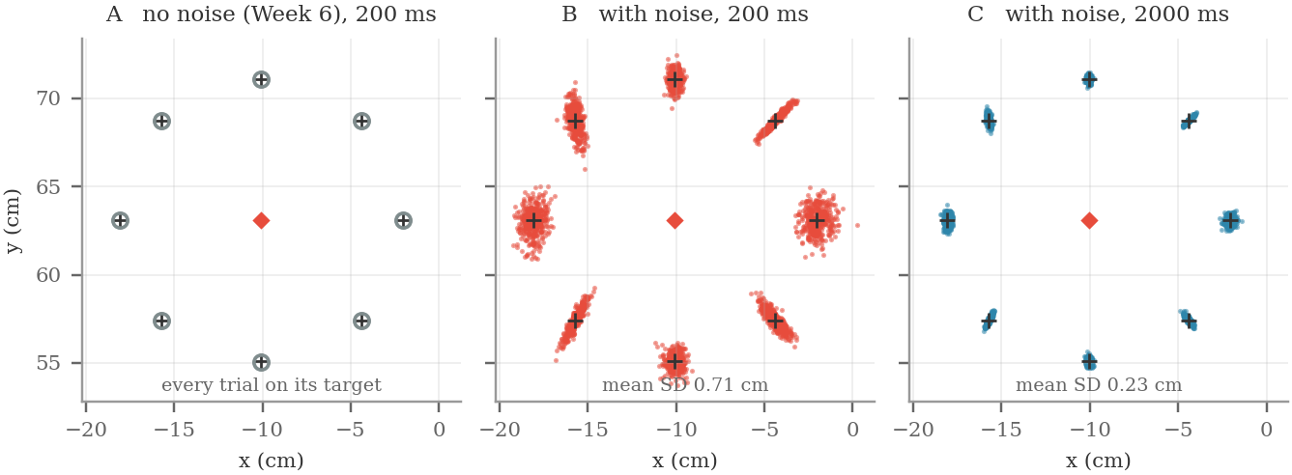
Figure 1. The speed–accuracy tradeoff in the model. Eight 8 cm reaches from the start posture (red diamond), 400 trials each; crosses mark the targets. A: Week 6’s pipeline without noise. Every trial lands on its target (circles). B: with signal-dependent noise, 200 ms reaches. C: the same noise, 2000 ms reaches. The SDs printed in B and C are averages over the eight directions, computed from 2000 trials per direction.
The model built so far cannot answer either question, because it has no tradeoff. Week 6’s pipeline computes the joint torques that move the hand along a planned path. When those torques are applied to the simulated arm, the hand lands within 0.0002 cm of the target on every trial, at any speed (Figure 1A). Biological systems cannot be that precise.
What the model is missing is noise in the motor command. In the simulation, the torque applied to the arm is exactly the torque the controller computed. In a real arm it is not. The force a muscle produces fluctuates from moment to moment even when the neural drive is held constant, and the size of the fluctuation grows with the size of the force (Jones, Hamilton & Wolpert, 2002). This is called signal-dependent noise.
Adding this one property to the model produces the tradeoff. A fast reach needs large torques: Week 3 §4.4 showed that the torque needed to move the arm grows as 1/T² as the movement time T gets shorter. Large torques come with large noise. Figures 1B and 1C were made with signal-dependent noise added to the model. At 200 ms the endpoints scatter with an average standard deviation of 0.71 cm, and the smallest target the hand hits on 95% of trials is about 26 mm wide. At 2 s the standard deviation falls to 0.23 cm, and the hand reliably hits a target about 8 mm wide. The arm, the plan and the noise level are the same in both cases; only the movement time differs.
Information, bits and noise
To say how much more accurate the slow reaches are, we need a unit. Fitts (1954) took one from information theory, which Shannon (1948) developed to describe communication over telephone lines. The week uses three ideas from that theory: the bit, the limit that noise places on how many positions can be told apart, and the capacity of a noisy channel.
Start with the bit. Number the eight targets in Figure 1 from 1 to 8, as in Figure 2A, and suppose one of them lights up. You can find out which one by asking yes-or-no questions, each of which rules out half of the targets that remain: Is it one of 1 to 4? Of the four that remain, is it one of the first two? Of the two that remain, is it the first? Figure 2B shows every possible sequence of answers, and each sequence ends at a different target. Two questions would give only four sequences, too few for eight targets, so three questions are needed and three are always enough. The event carries three bits of information. In general, picking one of N equally likely alternatives carries
H = log₂ N bits (7.1)
Eight alternatives carry 3 bits, sixteen carry 4, and each doubling of N adds one bit. The logarithm makes information from independent choices add. Choosing one of 8 targets and then one of 4 colors picks one of 32 combinations, and log₂ 8 + log₂ 4 = 3 + 2 = 5 = log₂ 32.
A reach can also be thought of as picking one alternative: the place where the hand stops. If the hand always stopped exactly where it was aimed, a reach could pick among infinitely many positions. In practice the endpoints of repeated attempts scatter over some width w, so two aim points closer than about w cannot be told apart from where the hand lands. Over a range R, the number of positions that can be told apart, and the information one reach carries, are approximately
N ≈ R / w, H ≈ log₂ ( R / w ) (7.2)
Without noise, N would be unlimited. Halving the scatter doubles N and adds one bit.
Apply this to Figure 1. The targets lie on a circle 16 cm across, so the line through the start and two opposite targets, such as 6 and 2, gives R = 16 cm. The smallest target a 200 ms reach hits on 95% of trials is about 26 mm wide, averaged over the eight directions. About 160/26 ≈ 6 targets of that width fit side by side on the line. Figure 2C puts six of them there and simulates 200 ms reaches to each. Every target is hit on at least 97% of trials, so a 200 ms reach can pick one of about 6 positions, which is log₂ 6 ≈ 2.6 bits. At 2 s the smallest target is about 8 mm wide and about 20 fit. Figure 2D shows that each of them is hit on at least 94% of trials, so the reach delivers about log₂ 20 ≈ 4.3 bits. Moving ten times more slowly gained 1.7 bits.
In Figure 2C and 2D the targets nearest the start are hit on every trial, because shorter reaches scatter less (§2.4 shows why). Narrower targets would work there, so the counts of 6 and 20 apply to targets of equal width.
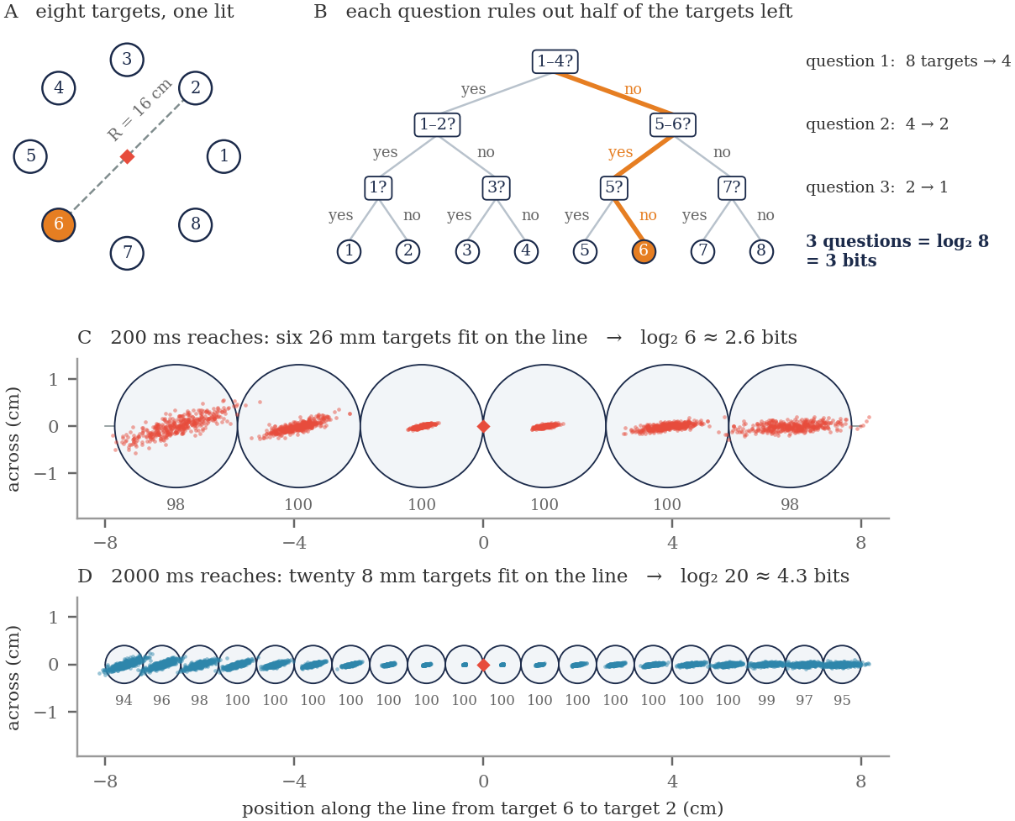
Figure 2. Counting bits. A: the eight targets of Figure 1, numbered; target 6 is lit. The dashed line through targets 6 and 2 is the 16 cm range used in C and D. B: three yes-or-no questions, each ruling out half of the targets that remain, identify any one of the eight. The highlighted answers (no, yes, no) lead to target 6. C: six 26 mm targets side by side on that line, with 400 simulated 200 ms reaches to each. D: twenty 8 mm targets with 2000 ms reaches, drawn at the same scale as C. The number under each target is the percentage of 2000 reaches that hit it.
Shannon’s main question was how much information can be sent through a noisy channel. A channel is anything that carries a signal from a sender to a receiver: a telephone line, a radio link or, in this week’s model, the arm, which carries a motor command to a position of the hand. When Gaussian noise of variance σ² is added to a signal of power S, Shannon showed that each use of the channel can deliver at most
C = ½ · log₂ ( 1 + S / σ² ) bits per use (7.3)
This is Theorem 17 of Shannon (1948) and Theorem 2 of Shannon (1949). Shannon stated the result per second: in our notation, a channel of bandwidth W can carry W log₂(1 + S/σ²) bits per second. Such a channel carries 2W independent values per second (Shannon, 1949, Theorem 1), so each value carries half as much, ½ log₂(1 + S/σ²) bits, which is Equation 7.3.
The ratio S/σ² is the signal-to-noise ratio. When it is large, each doubling of it adds half a bit. For a reach, the movement distance plays the role of the signal and the scatter of the endpoints plays the role of the noise. The signal power then grows as D² and the noise variance as SD², so for a large ratio Equation 7.3 becomes ½ log₂(D²/SD²) = log₂(D/SD), plus a constant. This has the same form as Equation 7.2. Halving the variance of the endpoints adds half a bit; halving their SD adds a whole bit.
Worked example: Equation 7.3 for the reaches in Figure 1
Treat one reach as one use of the channel. The signal is the point the hand is aimed at, and the noise is the scatter of the endpoints around it.
Signal: let the aim point be equally likely to be anywhere on the 16 cm line of Figure 2. A quantity spread evenly over a range R has variance R²/12, so S = 16²/12 ≈ 21.3 cm².
200 ms: σ = 0.71 cm, so σ² ≈ 0.50 cm² and S/σ² ≈ 43. C = ½ log₂(1 + 43) = ½ × 5.46 ≈ 2.7 bits.
2 s: σ = 0.23 cm, so σ² ≈ 0.053 cm² and S/σ² ≈ 400. C = ½ log₂(1 + 400) = ½ × 8.65 ≈ 4.3 bits.
Counting targets gave 2.6 and 4.3 bits. The two methods agree because they compare the same two spreads. A signal spread evenly over R has an SD of R/√12 ≈ R/3.5, and a round cloud of endpoints hits a circular target on 95% of trials when the target is about 3.5 SDs wide.
Equation 7.3 assumes the noise is the same for every aim point. Here it is smaller for shorter reaches (Figure 2C), so the result is an estimate.

Fitts (1954) treated the human motor system as a channel of this kind. He measured how many bits people’s movements delivered and how long the movements took. He found that the rate, in bits per second, was roughly constant for a given person and limb: harder targets took proportionally longer. He called this rate the information capacity of the motor system. For arm movements it is roughly 3 to 10 bits per second.
Figure 1 suggests that the model behaves differently. The 200 ms reaches deliver 2.6 bits in 0.2 s, a rate of 13 bits per second. The 2 s reaches deliver 4.3 bits in 2 s, a rate of about 2 bits per second. The rest of the week measures this change, explains where it comes from, and asks what the model needs in order to deliver bits at a steady rate, as people do.
The plan for the week
§1 defines the noise model and where it enters the pipeline.
§2 turns the ideas above into the measurements used all week: Fitts’ index of difficulty, the bits a reach delivers and the rate in bits per second. It also shows why noise that grows with the command makes accuracy depend on the ratio of movement distance to target size.
§3 treats the arm as a channel from joint torque to hand position, built from Week 1’s Jacobian and Week 3’s mass matrix, and uses it to predict the shape of the endpoint scatter without running a simulation.
§4 and §5 measure how accuracy depends on movement time and on target size.
§6 compares the result with Fitts’ law and finds that the model needs three to ten times too much time for each bit of accuracy.
§7 shows that adding corrective submovements removes the difference.
§8 covers two numerical choices in Monte Carlo simulation.

The task
The task is the same as in Weeks 5 and 6. From Q_REF = (55°, 75°) the hand starts at (−10.07, 63.09) cm and moves 8 cm along a minimum-jerk straight line in each of eight directions spaced 45° apart. Week 6 used a single movement time of 500 ms. This week varies two things: the movement time T, from 100 ms to 3 s, and the width W of the target.
Varying the target width does not require new simulations. A target of width W is hit whenever the endpoint lands within W/2 of the target center. Once we have recorded where the hand landed on every trial, we can compute the hit rate for any target width directly from those endpoints.
1. Where the Noise Enters
Jones, Hamilton and Wolpert (2002) asked people to hold a steady isometric force at several levels and measured how much the force fluctuated. The standard deviation of the force grew roughly in proportion to its mean: doubling the force roughly doubled the fluctuation, so the ratio of standard deviation to mean (the coefficient of variation) stayed about constant. Noise that grows with the signal like this is called signal-dependent, or multiplicative. Noise whose size does not depend on the signal is called additive.
Jones et al. measured force, but our pipeline has three places where such noise could enter: the joint torque, the muscle force and the muscle activation. These are not equivalent. Week 6 §6.3 showed that activation depends on force through a logarithm, a = ln(M̃/ρ + 1)/(cG), so noise that is proportional to force is not proportional to activation. We have to choose one level.
These notes add the noise to the joint torque, the quantity Week 6 computed. Harris and Wolpert (1998) added it to the neural control signal. In a two-joint arm model similar to ours, van Beers et al. (2004) added it to a motor command for each joint, which a model of the muscles smooths into joint torque over a few tens of milliseconds. We leave out that smoothing and give the noise a timescale of its own instead (see the box below). The executed torque is
τ_exec(t) = τ(t) + k · |⁠τ(t)| · ξ(t) (7.4)
Equation 7.4 has the form used by Harris and Wolpert (1998) and van Beers et al. (2004): noise with mean zero and a standard deviation proportional to the size of the command. This is the relationship Jones et al. (2002) measured between the mean and the SD of force. The table lists what each term means.
term | meaning | units and values
t | time since the movement began | s; from 0 to the movement time T
τ(t) | the commanded torque: what the controller computes from the planned path, with Week 6’s inverse dynamics | N·m; one value for the shoulder and one for the elbow; the same on every trial
τ_exec(t) | the executed torque: what actually acts at the joints and moves the arm | N·m; one value per joint; different on every trial
k | the noise coefficient: the SD of the noise as a fraction of the size of the command | no units; 0.15, so the SD is 15% of |⁠τ|
|⁠τ(t)| | the size of the command at each joint, ignoring its sign; −1.5 N·m gets the same noise as +1.5 N·m | N·m; zero wherever the command reverses
ξ(t) | a standard Gaussian random number | no units; mean 0, SD 1; drawn separately for each joint and each trial, and held for 10 ms (box below)
k · |⁠τ(t)| · ξ(t) | the noise: how far the executed torque is from the command on one trial | N·m; mean 0, SD k|⁠τ(t)|

Equation 7.4 applies to each joint separately: the shoulder and the elbow each have their own command, their own ξ and their own executed torque.
Commanded torque τ(t) and executed torque τ_exec(t)
τ(t) is computed once, before the movement starts. Week 6’s pipeline takes the planned minimum-jerk path, converts it to joint angles, and applies Equation 6.1: τ = M(q)q̈ + c(q, q̇), with q, q̇ and q̈ taken from the plan. The plan is the same on every trial, so τ(t) is too.
τ_exec(t) is what the arm receives. The simulation passes it to Week 3’s forward dynamics, q̈ = M(q)⁻¹[τ_exec(t) − c(q, q̇)], evaluated at the arm’s actual joint angles and velocities, and integrates the result. ξ(t) is drawn afresh on every trial, so τ_exec(t) and the path of the hand differ from trial to trial.
In Week 6 the noise term was zero, so τ_exec(t) = τ(t) and every trial landed on its target. The controller still computes τ(t) in advance and never measures τ_exec(t), so nothing corrects the difference until §7 adds corrective submovements.

If ξ(t) = 0, the noise term is zero and τ_exec(t) = τ(t): the arm receives exactly the commanded torque. If ξ were zero for the whole movement, or if k were zero, every trial would follow the plan and land on its target, as in Week 6. Figure 1A was made this way, with k = 0.
A draw of exactly zero almost never happens, but about two draws in three fall between −1 and +1. So at any moment, across trials, τ_exec(t) averages to τ(t), and on about two trials in three it lies within one noise SD of it. For the 135° reach at 500 ms, the shoulder command is largest at 400 ms, 1.51 N·m in size (Figure 3A). There the noise SD is k|⁠τ| = 0.15 × 1.51 ≈ 0.23 N·m, so on about two trials in three the executed shoulder torque is within 0.23 N·m of the command. At 258 ms the shoulder command crosses zero, and there the executed torque equals the command on every trial, whatever ξ is (Figure 3C).
Why ξ needs its own timescale
Equation 7.4 does not say how often ξ changes. If a new value is drawn at every integration step, the answer depends on the step size: halving the step halves the time each random value acts, so the accumulated variability shrinks. The result would then describe the solver rather than the arm.
To avoid this, ξ is held constant for a correlation time T_C = 10 ms and then redrawn, whatever the integration step (Figure 3B). This matches the fact that motor noise has limited bandwidth. In the model of van Beers et al. (2004), the muscle model does this job by smoothing the noisy command. With the noise held, the endpoint SD changes by 0.3% across an eightfold range of integration steps. With the noise redrawn at every step it changes by 95%. §8 and Figure 10A return to this.

The value of k is not taken directly from Jones et al. Their coefficient of variation describes a force held at a constant level; our k multiplies a torque that changes throughout the movement and acts through the dynamics of the arm. These are different quantities. What we take from Jones et al. is the form of Equation 7.4: noise proportional to the command. We then chose k so that the simulated endpoint scatter falls within the range reported for people reaching without seeing their hand. At k = 0.15 the standard 500 ms reach has an endpoint SD of 0.31 to 0.57 cm, depending on direction. §6.2 shows that the week’s main conclusions do not depend on this choice.
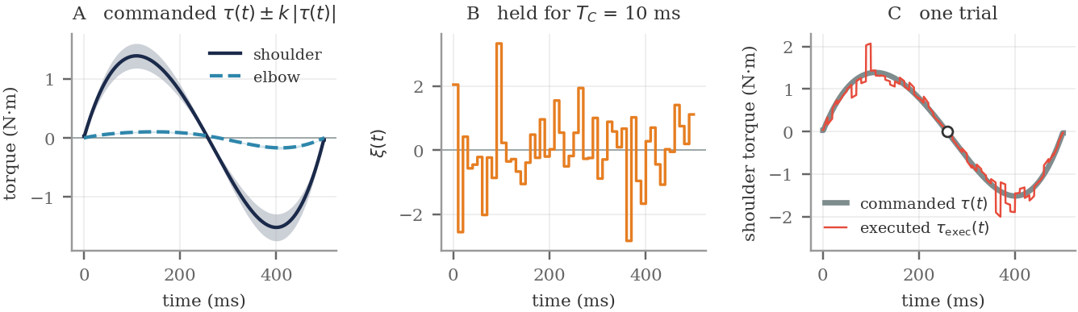
Figure 3. The noise model (Equation 7.4) for the 135° reach at 500 ms. A: the commanded torques τ(t) at the shoulder and elbow, each with the band τ(t) ± k|⁠τ(t)| shaded, which is one SD of the noise. The band narrows to zero where a command crosses zero. B: one sample of ξ(t), held for 10 ms and then redrawn. C: the commanded shoulder torque τ(t) and the executed torque τ_exec(t) on one trial. The difference is largest where the command is largest and vanishes where the command crosses zero, at 258 ms (circle).
2. Measuring Movements in Bits
The Introduction counted the bits a reach delivers by asking how many targets of the smallest width it can hit would fit side by side. This section turns that count into the three measurements used for the rest of the week: Fitts’ index of difficulty (§2.1), the bits a simulated reach delivers (§2.2) and the rate in bits per second (§2.3). §2.4 then shows why the type of noise matters.
2.1 Fitts’ index of difficulty
Fitts (1954) measured the difficulty of an aimed movement with a quantity of the same form as Equation 7.2. He took the range to be twice the movement distance, R = 2D, and the spread to be the width W of the target:
ID = log₂ ( 2D / W ) bits (7.5)
which he called the index of difficulty. It is the count we made for Figure 1 in the Introduction: for 8 cm reaches, 2D = 16 cm is the distance between opposite targets. A 20 mm target 8 cm away has ID = log₂(160/20) = 3 bits; halving the target to 10 mm raises it to 4 bits. Only the ratio D/W appears, so doubling both the distance and the target width leaves the difficulty unchanged. §2.4 asks what this requires of the noise.
Fitts described the index as analogous to Shannon’s capacity (Equation 7.3), with the movement distance in the role of the signal and the target width in the role of the noise. It is an analogy, not a derivation, and several versions are in use. MacKenzie (1992) recommends log₂(D/W + 1), which behaves better for easy targets. We use Fitts’ original version. The comparisons this week depend on slopes, which the choice hardly affects.
2.2 The bits a reach delivers
For a simulated reach we turn the question around. Instead of asking how difficult a given target is, we find the smallest target the reach hits on 95% of trials and report that target’s index of difficulty as the number of bits the reach delivers. This is how the bits in the Introduction were counted, and it is the measurement used for the rest of the week. Figure 2C and 2D show why it works: the narrower the smallest target the hand can hit, the more targets of that width fit in the same range, and halving the width adds one bit.
Worked example
The endpoint SD alone gives a quick estimate of the bits. In our model a 500 ms reach lands with an endpoint SD of about 0.45 cm. For a round cloud of endpoints, a circular target is hit on 95% of trials when its width is about 3.5 times the SD, so w ≈ 1.5 cm. With R = 16 cm, as in the Introduction, Equation 7.2 gives N ≈ 16 / 1.5 ≈ 10 positions, or about 3.4 bits.
Finding the smallest target the reach actually hits on 95% of trials gives 3.30 bits. The estimate is close; the small difference arises because the endpoint clouds are not round (§3.3).

2.3 Throughput
A number of bits says nothing about how long the movement took. If a movement delivers ID bits in a movement time MT, its rate is
throughput = ID / MT bits per second (7.6)
This is the rate Fitts found to be roughly constant for a given person and limb, and the rate computed for the two conditions of Figure 1 in the Introduction. §4 measures it at every movement time, and §6 compares it with people.
2.4 Why the type of noise matters
Equation 7.5 says that difficulty depends only on D/W. People behave this way, and that tells us something about the noise. Compare two possibilities.
If motor noise had a fixed size, a long reach would land no less precisely than a short one. The spread w would be the same for a 3 cm reach and a 12 cm reach, so the longer reach could distinguish more positions and would deliver more bits. Difficulty would then depend on D and W separately.
If the noise grows with the command, a reach four times longer needs a command about four times larger and lands with about four times the spread. R/w stays the same, so the number of bits stays the same, and only D/W matters. Figure 4A shows both cases.
We can check this in the model. To make the comparison fair, we set the size of the fixed noise so that both models give the same endpoint SD for the standard 8 cm reach, and then vary the distance:
reach distance | 3 cm | 4 cm | 6 cm | 8 cm | 12 cm
SD, signal-dependent (cm) | 0.168 | 0.225 | 0.336 | 0.448 | 0.669
SD, fixed-size (cm) | 0.446 | 0.446 | 0.446 | 0.445 | 0.444
bits, signal-dependent | 3.29 | 3.29 | 3.29 | 3.29 | 3.30
bits, fixed-size | 1.80 | 2.21 | 2.80 | 3.21 | 3.80

With signal-dependent noise the endpoint SD grows in proportion to the distance (SD ∝ D^0.99), and the number of bits changes by only 0.01 across a fourfold range of distances. With fixed noise the SD does not change with distance (D^−0.00), and the number of bits rises by 2.01, which is log₂ 4, as the argument predicts (Figure 4B).
So the type of noise Jones et al. measured in single muscles is also the type that makes movement difficulty depend on D/W, which is the form Fitts found in whole movements. This is why the week focuses on signal-dependent noise.
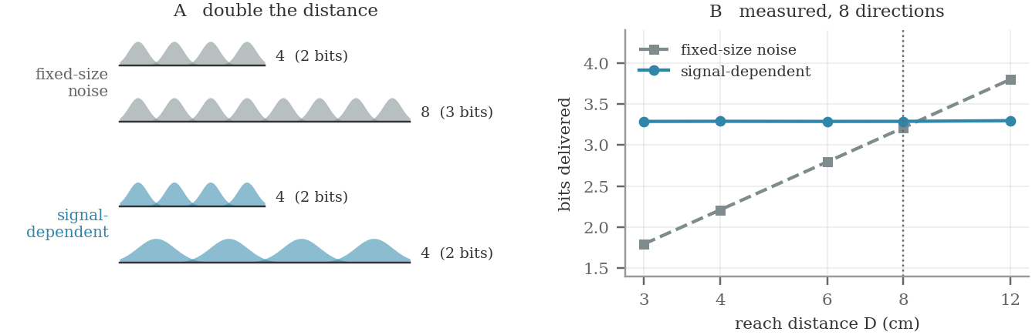
Figure 4. Why the type of noise matters. A: the effect of doubling the distance. With fixed noise the number of positions doubles, adding one bit. With signal-dependent noise the spread also doubles, so the number of positions stays the same. B: bits delivered in the model, averaged over the eight directions, with the two noise models set to agree at 8 cm. With signal-dependent noise the value stays between 3.29 and 3.30 bits from 3 to 12 cm.
3. From Joint Torque to Hand Position
The noise enters as a joint torque, but we measure its effect at the hand. Two matrices from earlier weeks convert one into the other: Week 3’s mass matrix and Week 1’s Jacobian. This section combines them and uses the result to predict the shape of the endpoint scatter without running a simulation.
3.1 The two matrices
Week 1 §4 derived the Jacobian J(q), which converts joint velocities into hand velocity: ṗ = J q̇. Week 1 §5 used it to draw the manipulability ellipsoid, the set of hand velocities produced by joint velocities of unit size. Its shape is set by JJᵀ. It is nearly circular at θ₂ = 90° and flattens into a line as θ₂ approaches 0, where det(J) = l₁l₂ sin θ₂ goes to zero.
Week 3 §3 derived the mass matrix M(q) from the kinetic energy of the arm. For a single joint, acceleration is torque divided by inertia. For the two-link arm the division becomes a matrix inverse, q̈ = M⁻¹τ. Week 3’s Figure 5 plotted this quantity.
3.2 Combining them
Follow a small torque perturbation δτ to the hand. The mass matrix turns it into a joint acceleration, and the Jacobian turns that into a hand acceleration:
δp̈ = J(q) · M(q)⁻¹ · δτ (7.7)
In the terms of the Introduction, the product G(q) = J M⁻¹ is the channel: it carries any joint torque, whether commanded or noise, to the hand as an acceleration. G is a 2 × 2 matrix that depends on the posture of the arm, and both of its factors were built in earlier weeks.
A perturbation that lasts a short time Δt changes the hand’s velocity by G δτ Δt. That velocity error then moves the hand off course for the rest of the movement, so an error made early grows for longer than one made late. Each 10 ms noise sample is independent, and the variances of independent errors add. The endpoint covariance is therefore
Cov(endpoint) = ∫₀ᵀ (T − t)² · G Σ(t) Gᵀ · T_C dt, Σ = k² diag(τ²) (7.8)
Every quantity on the right is known before any trials are run. Σ comes from Equation 7.4 and the torque profile computed in Week 6, G comes from Weeks 1 and 3, and the factor (T − t)² accounts for the time an early error has to grow.
3.3 Testing the prediction
Equation 7.8 predicts the endpoint scatter, so we can test it against the Monte Carlo simulation. For each direction at the standard 500 ms reach:
direction | SD (cm)  measured | SD (cm)  predicted | orientation  measured | orientation  predicted | aspect  measured | aspect  predicted
0° | 0.521 | 0.546 | 77° | 79° | 1.39 | 1.67
45° | 0.429 | 0.437 | 46° | 54° | 7.59 | 7.27
90° | 0.312 | 0.344 | 89° | 100° | 2.06 | 2.14
135° | 0.486 | 0.512 | 99° | 109° | 3.24 | 2.90
180° | 0.569 | 0.571 | 84° | 82° | 1.93 | 1.70
225° | 0.451 | 0.449 | 64° | 57° | 5.11 | 5.04
270° | 0.350 | 0.343 | 97° | 90° | 1.48 | 1.59
315° | 0.444 | 0.456 | 129° | 117° | 3.77 | 4.03

Figure 5A draws both sets of ellipses. The prediction gets the orientation of the scatter right to within 7.2° on average, the aspect ratio with r = 0.994 (Figure 5B), and the overall size to within 3%. The endpoint clouds are elongated, with aspect ratios (long axis divided by short axis) from 1.4 to 7.6. Equation 7.8 shows that this elongation comes from the geometry of the arm, through J M⁻¹.
3.4 Why reach direction has little effect
Week 6 §2 found that peak torque varies 6.08-fold across the eight directions: 0.25 N·m at 45° and 1.51 N·m at 135°, for reaches of the same length and duration. Since noise grows with torque, you might expect endpoint variability to vary about sixfold as well.
It does not. Endpoint SD varies only 1.82-fold across directions, and its correlation with peak torque is r = 0.30, which with eight points is not distinguishable from zero. The reach that needs the most torque (135°) is not the most variable; 180° is. The least variable reach, 90°, needs four times the torque of the 45° reach.
Why the torque differences do not reach the hand
Equation 7.7 explains this.
With signal-dependent noise, δτ is proportional to |⁠τ|. In a reach dominated by inertia the command itself is τ ≈ M q̈. Substituting into Equation 7.7 gives J M⁻¹ δτ ∝ J M⁻¹ M q̈ = J q̈ = p̈.
p̈ is the hand acceleration of the planned trajectory. For a minimum-jerk reach of fixed length and duration it is the same in every direction. The mass matrix makes some directions need more torque, and therefore more noise, but the same mass matrix makes the hand respond less to that noise. The two effects cancel.
The cancellation is not exact, because the argument ignores three things: the Coriolis term, which is not proportional to M q̈; the absolute value in Equation 7.4, which keeps the noise from vanishing exactly where the net torque does; and the change in M(q) along the path. These account for the remaining 1.82-fold variation.

So signal-dependent noise does not make movements that need more torque more variable at the hand. Whether the noise reaches the hand depends on the arm that lies between the command and the hand.
van Beers, Haggard and Wolpert (2004) measured this in people. Participants made short center-out reaches in 32 directions without seeing their hand, under conditions designed to minimize errors in locating the target and planning the movement. Endpoint variability depended systematically on direction, with some directions showing up to about twice the variability of others. Our model gives 1.82-fold variation on the same kind of task. The simple argument that noise follows torque would have predicted about sixfold.
3.5 Near the Week 1 singularity
Week 1 §4.2 noted that signal-dependent noise should matter near singularities. The channel lets us check what happens. We evaluate G = J M⁻¹ at postures with the elbow increasingly straight and apply torque noise of equal size at both joints. We then split the resulting hand acceleration into a radial component, along the line from shoulder to hand, and a tangential component across it:
elbow angle θ₂ | det(J) | radial gain | tangential gain | tangential / radial
90° | 0.1564 | 5.57 | 4.96 | 0.9
60° | 0.1354 | 6.07 | 6.59 | 1.1
40° | 0.1005 | 5.97 | 8.99 | 1.5
25° | 0.0661 | 4.94 | 11.50 | 2.3
15° | 0.0405 | 3.43 | 13.13 | 3.8
8° | 0.0218 | 1.95 | 13.95 | 7.1
4° | 0.0109 | 1.00 | 14.22 | 14.3
2° | 0.0055 | 0.50 | 14.29 | 28.5

The gains are hand acceleration per unit joint torque (m/s² per N·m). As the elbow straightens, the radial gain falls toward zero in proportion to det(J) = l₁l₂ sin θ₂ from Week 1. Below about 15° the ratio of radial gain to det(J) stays within 8% of constant. The tangential gain levels off near 14 (Figure 5C). At θ₂ = 2° the channel responds 29 times more strongly across the arm than along it.
Near full extension, then, the hand becomes less sensitive to noise along the arm, not more. Torque at the joints cannot move the hand radially there. For the same reason, commands cannot move it radially either: Week 1’s manipulability ellipsoid and this noise ellipse flatten together, because both are governed by det(J). Reduced noise in the radial direction therefore does not increase the number of positions the hand can distinguish along the arm, because the range of radial movement shrinks at the same rate.
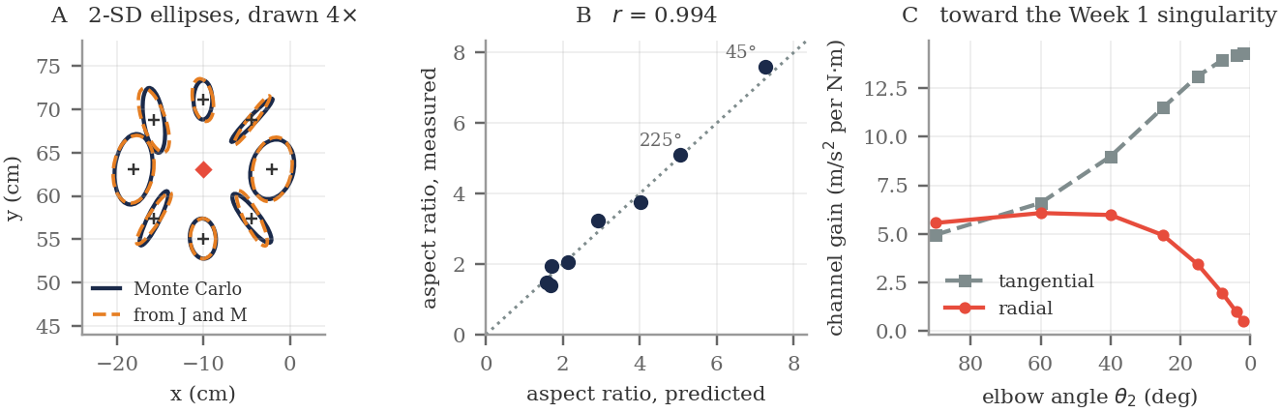
Figure 5. From joint torque to hand position. A: 2-SD endpoint ellipses at the standard reach, from the Monte Carlo simulation (solid) and from Equation 7.8 (dashed), drawn four times actual size around each target so that they are visible. B: predicted against measured aspect ratio, r = 0.994. C: channel gain as the elbow straightens toward the Week 1 singularity. The radial gain falls in proportion to det(J); the tangential gain levels off.
4. Accuracy and Movement Time
Fast movements need larger commands, and larger commands carry more noise, so faster movements are more variable. The question here is how quickly accuracy improves as the movement slows down, which is set by the exponent relating endpoint SD to movement time. Two values are commonly quoted, −1 and −2. Neither is correct for this model.
Week 3 §4.4 showed that every dynamic term in the equations of motion scales as 1/T²: halving the movement time quadruples the torque. Homework 6 confirmed this for peak torque on our task. We ran all eight directions at movement times from 200 ms to 2 s; Figure 6A shows the endpoints of the 135° reach at three of them. Averaged over the eight directions:
movement time | 200 ms | 300 ms | 500 ms | 1000 ms | 2000 ms
endpoint SD (cm) | 0.707 | 0.580 | 0.445 | 0.320 | 0.226
bits delivered | 2.63 | 2.92 | 3.30 | 3.78 | 4.29
throughput (bits/s) | 13.2 | 9.7 | 6.6 | 3.8 | 2.1

Fitting a power law separately for each direction gives SD ∝ T^{−0.495}, with all eight exponents between −0.503 and −0.487 (Figure 6B). The eight directions agree this closely because, as §3.4 showed, the torque differences between directions cancel before they reach the hand.
Where −1/2 comes from
The exponent can be derived in four steps.
1. Each 10 ms noise sample is a torque perturbation of size k|⁠τ|. Since |⁠τ| ∝ 1/T², the velocity error each sample causes is proportional to 1/T².
2. The samples are independent and there are T/T_C of them, so the variance of the accumulated velocity error grows as (1/T²)² × T.
3. A velocity error made during the movement moves the hand for the remaining time, which is proportional to T. This multiplies the position variance by T².
4. Combining: variance ∝ T⁻⁴ · T · T² = T⁻¹, so SD ∝ T⁻¹ᐟ².
The value −1 leaves out step 2: slowing down makes each perturbation smaller, but it also gives more time for perturbations to accumulate. The value −2 leaves out steps 2 and 3: it assumes that endpoint variability is simply proportional to peak torque.

4.1 The same result in bits
The number of bits is log₂(2D/W) for the smallest target the reach can hit, and that width is proportional to the endpoint SD. Substituting SD ∝ T⁻¹ᐟ² gives
bits(T) = constant + ½ · log₂ T (7.9)
so each doubling of the movement time should add half a bit. This is the half bit of Equation 7.3. Doubling the movement time halves the variance of the endpoints while the distance, which plays the role of the signal, stays the same, so the signal-to-noise ratio doubles. The measured value, averaged over the eight directions, is 0.50 bits per doubling. The table and Figure 6C show it directly: 3.30 bits at 500 ms, 3.78 at 1000 ms and 4.29 at 2000 ms.
This means that gaining one bit — halving the width of the target that can be hit reliably — requires moving four times more slowly. Gaining three bits requires moving 64 times more slowly. The last row of the table shows the effect on the rate: throughput falls from 13.2 bits per second at 200 ms to 2.1 at 2 s, a factor of 6.1. A person’s rate stays roughly constant as targets get harder; the model’s rate drops.
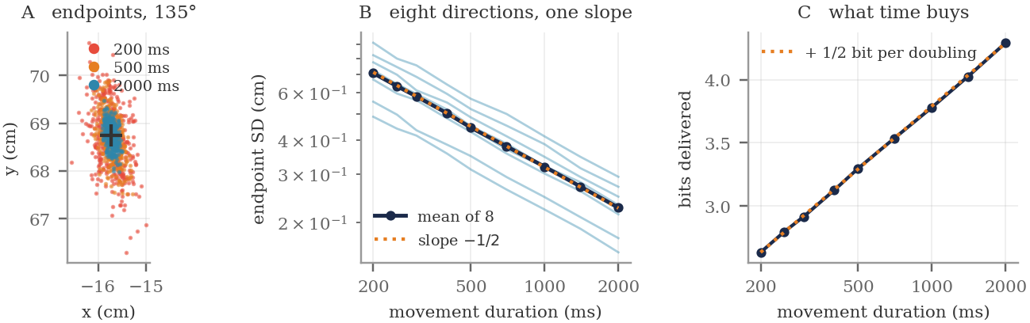
Figure 6. Accuracy and movement time. A: endpoints of the 135° reach at three movement times, with the target marked. B: endpoint SD against movement time on log axes, one light line per direction and their mean in navy, with a reference line of slope −1/2. The eight lines are parallel. C: the same data in bits. Each doubling of the movement time adds half a bit.
5. Accuracy and Target Width
So far we have measured how variable the hand is. Accuracy, however, is defined relative to a target, and the question usually asked in experiments is how long a movement needs to take to hit a target of a given size.
We can answer that from the endpoints already recorded in §4. For each target width from 4 to 40 mm and each direction, we find the shortest movement time that hits the target on 95% of trials (Figure 7A):
target width | index of difficulty | directions that can hit it | minimum movement time
4 mm | 5.32 bits | 0 of 8 | not hit at any time up to 3 s
6 mm | 4.74 bits | 2 of 8 | —
8 mm | 4.32 bits | 7 of 8 | —
10 mm | 4.00 bits | 8 of 8 | 1471 ms
12 mm | 3.74 bits | 8 of 8 | 1011 ms
16 mm | 3.32 bits | 8 of 8 | 578 ms
20 mm | 3.00 bits | 8 of 8 | 367 ms
24 mm | 2.74 bits | 8 of 8 | 249 ms

A minimum time is listed only where all eight directions could be measured. Below 10 mm, some directions cannot hit the target at any movement time we tested. Above 24 mm, some directions already hit the target on 95% of trials at the shortest time we tested.
Over the widths where all eight directions are measurable, MT ∝ W^{−2.02}, with r = 0.9999 on log axes (Figure 7B). This exponent follows from §4. If the endpoint SD falls as T^{−1/2} and hitting a target of width W requires an SD proportional to W, then MT ∝ W⁻². The reciprocal of the exponent measured in §4 is −2.02, and the exponent measured here is −2.02.
Figure 7C fits the same data with a straight line in the index of difficulty, which is the form of Fitts’ law. §6 explains why the residuals form a U.
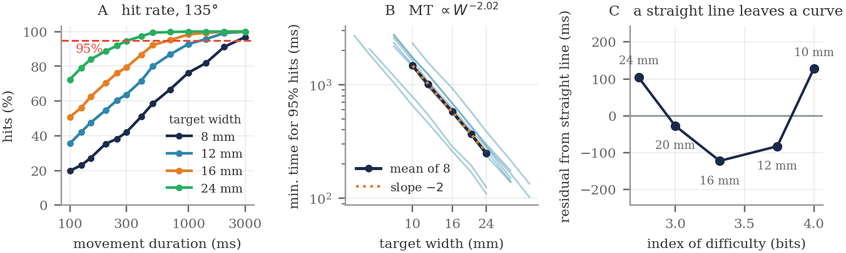
Figure 7. Accuracy and target width, computed from the endpoints recorded for Figure 6. A: hit rate against movement time for four target widths on the 135° reach, with the 95% criterion marked. The minimum movement time is where each curve crosses the line. B: minimum movement time against target width on log axes, one light line per direction and their mean in navy, with a reference line of slope −2. C: residuals when the mean is fitted with a straight line in the index of difficulty. The U shape shows that the relationship is curved.
6. Comparison with Fitts’ Law
Fitts (1954) asked people to tap back and forth between two targets of varying width and separation, and found that movement time increases linearly with the logarithm of D/W:
MT = a + b · log₂(2D / W) = a + b · ID (7.10)
This relationship is one of the most reliable findings in experimental psychology. It holds for the arm, the head and the foot, under water and with a computer mouse. For arm movements the slope b is typically 100 to 300 ms per bit, which by Equation 7.6 corresponds to a rate of roughly 3 to 10 bits per second.
The model disagrees with Equation 7.10 in three ways.
The first is the shape of the relationship. A power law in W is not a logarithm in W, and over the range tested the two can be told apart. Fitting the model’s results with a straight line in ID gives r = 0.9753, compared with r = 0.9999 for the power law. The residuals from the straight line are not random: they form a U, positive at both ends and negative in the middle (Figure 7C). That pattern is what remains when a straight line is fitted to a curve.
The second is the slope. Fitted with a straight line anyway, the model needs 949 ms per bit, compared with 100 to 300 ms per bit for people: three to ten times more time for each additional bit of accuracy (Figure 8A).
The third is that the model cannot hit small targets. A 4 mm target at 8 cm has an index of difficulty of 5.3 bits, a normal condition in Fitts experiments. The model does not hit it on 95% of trials in any of the eight directions at any movement time up to 3 s.
A derivation that does not work
A common shortcut goes: endpoint SD scales as a power of T; require SD < W/4; solve for T; conclude Fitts’ law. The conclusion does not follow, as §5 shows. Solving a power law for T gives another power law, here MT ∝ W⁻², and a power law is not a logarithm.
Over a narrow range of D/W the two curves can look similar, which is why the shortcut appears in summaries of the literature. Over the three bits tested here they are clearly different.

6.1 The comparison in bits per second
Figure 8B shows the same comparison as a rate. At short movement times the model’s rate is not lower than a person’s: at 200 ms it delivers 13.2 bits per second, above the human range. The difference is that the model’s rate does not stay constant. By 2 s it has fallen to 2.1 bits per second, 6.1 times lower.
This is what it means to say the model has no information capacity. When a person is given a harder target, the movement takes proportionally longer and the rate stays about the same. When the model is asked for one more bit, the movement has to take four times as long, and each further bit multiplies the time by four again.
6.2 Changing the noise coefficient
A smaller noise coefficient k would make every movement more accurate. Would it close the gap?
noise coefficient k | endpoint SD, standard reach | fitted width relationship | ms per bit
0.075 | 0.241 cm | MT ∝ W^−2.01 | 1074
0.15 | 0.482 cm | MT ∝ W^−2.03 | 1263
0.3 | 0.963 cm | MT ∝ W^−2.10 | 1778

Across a fourfold range of k the fitted exponent stays near −2. Changing k moves the curve up or down, because it changes how accurate the arm is at every speed, but it does not change the slope (Figure 8C). This follows from Equation 7.9: setting SD ∝ k T⁻¹ᐟ² proportional to W and solving gives MT ∝ k² W⁻², where k appears only as a constant factor. Even at k = 0.075, where the standard reach has an endpoint SD of 0.24 cm (more precise than people), the slope is far outside the human range. Adjusting k therefore cannot fix the disagreement with Fitts’ law.
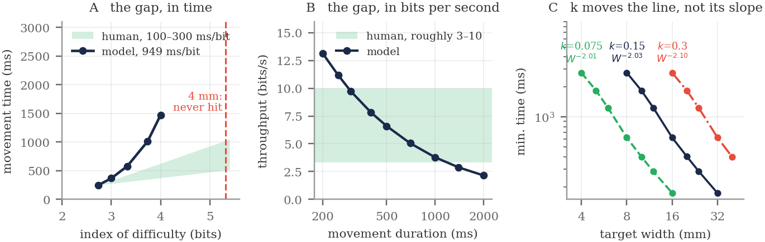
Figure 8. The model compared with Fitts’ law. A: minimum movement time against index of difficulty, with the range of human slopes shaded. The dashed line marks the 4 mm target, which the model cannot hit in any direction. B: the same comparison in bits per second. The model’s rate starts above the human range and falls through it. C: the relationship between movement time and target width at three values of k. The lines shift but stay parallel.
What this means for Module 2
The torque calculation, the arm model and the noise model are all correct. The noise model agrees with the force measurements it was based on, and §3.4 showed that it also reproduces the direction dependence that van Beers et al. measured in people.
What fails is the feedforward design. A controller that computes its commands in advance and never checks the arm can improve accuracy only by moving more slowly, and §4 showed that this gains half a bit for each doubling of movement time. People gain accuracy much more cheaply, so they must be doing something else.
Both results are needed for this conclusion. If the model had also failed the direction test, we could conclude only that the noise model was wrong.

7. Corrective Submovements
Woodworth (1899) had people draw lines to a target with and without seeing their hand. The accurate movements were not single smooth motions. They consisted of a fast initial movement that covered most of the distance, followed by one or more slower corrections. The speed profile of an accurate reach is a large bell followed by smaller bumps.
In the terms of the Introduction, each correction is another use of the channel. The controller of §4 gets one movement and must get all its accuracy by slowing that movement down. A controller that can correct gets as many movements as it has time for, and information from independent choices adds (Equation 7.1). If each correction adds a fixed number of bits and takes a fixed time, bits accumulate in proportion to time, which is Fitts’ law.
7.1 Why corrections are efficient
The argument uses one result from §2.4: endpoint SD is proportional to the distance moved. An 8 cm movement lands with a spread proportional to 8 cm. A correction that covers the remaining 0.6 cm lands with a spread proportional to 0.6 cm, more than ten times smaller. Each correction therefore reduces the remaining error by a constant factor r rather than by a fixed amount, so the error shrinks geometrically:
e_n = e₀ · rⁿ, bits gained = n · log₂(1 / r) (7.11)
The smallest possible r is set by how precise a movement of the correction’s duration can be. A 150 ms movement lands within 10.2% of the distance it covers, so r cannot be smaller than 0.102. A correction could reach this value only if it started from rest and knew exactly where the hand was.
7.2 A correction that senses only position does not help
Consider first the simplest correction. When the primary movement ends, the controller measures where the hand is, plans a new minimum-jerk movement from there to the target, and executes it. Averaged over the eight directions:
 | after primary | 1 correction | 2 corrections | 3 corrections
RMS error, position sensed only | 0.579 cm | 0.511 cm | 0.520 cm | 0.529 cm
RMS error, position and velocity | 0.579 cm | 0.084 cm | 0.015 cm | 0.003 cm

Correcting from position alone does not reduce the error. After three corrections the error is 0.529 cm, compared with 0.579 cm before the first: a ratio of 1.02 per correction, which is no improvement (Figure 9B).
The reason is that the hand is still moving when the primary movement ends. Noise leaves it with some leftover velocity (Figure 9A). A new movement planned as if the hand were at rest does not account for that velocity, so during the correction the hand drifts off course by about as much as the correction fixed.
If the controller also measures the hand’s velocity, it can plan a smooth path that starts where the hand is and moving the way it is actually moving. Each correction then reduces the error by a factor of 0.18, close to the limit of 0.102 from §7.1. The difference between the two rows of the table shows that a controller needs to know the arm’s full state — its velocity as well as its position. Week 9 covers how the nervous system can estimate it.
7.3 Corrections produce Fitts’ law
With velocity sensed, Equation 7.11 applies: each correction takes a fixed time and adds a fixed number of bits, so movement time increases linearly with bits. With a 100 ms sensory delay before each correction:
 | after primary | 1 correction | 2 corrections | 3 corrections
movement time | 300 ms | 550 ms | 800 ms | 1050 ms
RMS error | 0.579 cm | 0.115 cm | 0.032 cm | 0.009 cm
bits delivered | 2.93 | 5.09 | 6.89 | 8.82

A straight line fits movement time against bits with r = 0.9993, which is the form of Equation 7.10 (Figure 9C). The slope follows from Equation 7.11 without any fitting. Each correction takes T_c plus the delay and adds log₂(1/r) bits, so
b = ( T_c + delay ) / log₂(1 / r) ms per bit (7.12)
Varying the delay from 0 to 200 ms:
sensory delay | error ratio per correction | fitted slope | from Equation 7.12
0 ms | 0.183 | 60 ms/bit | 61 ms/bit
50 ms | 0.232 | 91 ms/bit | 95 ms/bit
100 ms | 0.283 | 128 ms/bit | 137 ms/bit
150 ms | 0.334 | 174 ms/bit | 190 ms/bit
200 ms | 0.387 | 229 ms/bit | 255 ms/bit

Compare the fitted slopes with the human range of 100 to 300 ms per bit. With no delay the model is faster than any person, at 60 ms per bit. With a 100 ms delay the slope is 128 ms per bit, with 150 ms it is 174, and with 200 ms it is 229. Delays of this size are typical of human sensorimotor feedback, and they place the model’s slope within the human range. The delay was not adjusted to produce this result.
Two limitations. First, the correcting controller senses position and velocity perfectly. Real proprioception and vision are noisy, which would make r larger and the slope steeper; Homework 7 measures how much. Second, a delay can do more than slow a controller down: Week 8 will show that acting on delayed information can make a controller unstable, which cannot happen in a model that corrects only between movements. The model therefore brackets human performance, but it does not yet explain it.
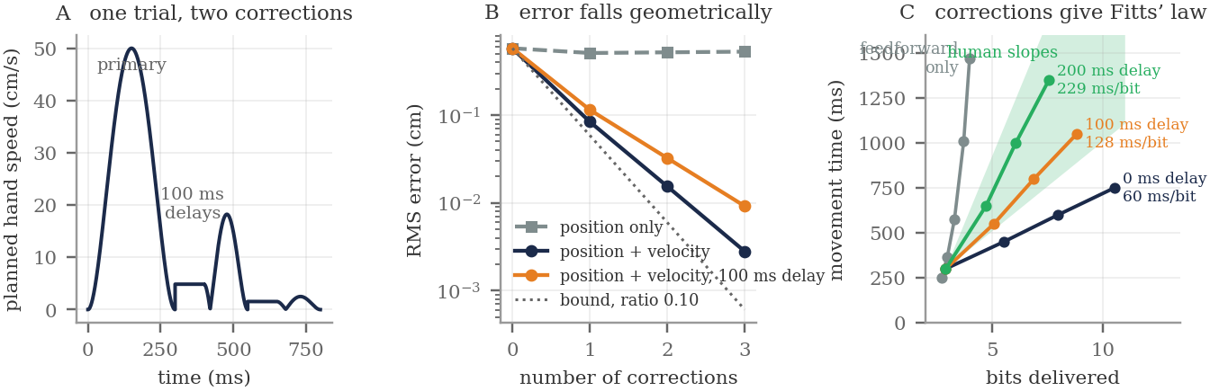
Figure 9. Corrective submovements. A: planned hand speed on one trial with two corrections and a 100 ms delay before each. The flat segments during the delays show the leftover velocity the hand carries while the controller waits. B: RMS error against number of corrections. Sensing position alone does not help; sensing position and velocity reduces the error by a constant factor each time. C: movement time against bits. The feedforward model curves upward; each correcting model is a straight line, and with 100 to 200 ms delays the slopes fall in the human range.
7.4 Two further points
This section also clarifies a common summary of Harris and Wolpert (1998). They did not claim that a fixed minimum-jerk trajectory explains Fitts’ law; §6 shows that it does not. They claimed that the trajectory with the smallest endpoint variance, chosen freely, is very similar to the smooth trajectories people produce. Their result depends on a detail that summaries often leave out: the variance is measured over a period after the movement ends, not only at the moment of arrival. If variance were measured only at arrival, the best trajectory would arrive with high velocity and a large command still active, because nothing after arrival would be penalized. Requiring the hand to stay near the target afterwards forces the command to zero at the end, and that is what makes the optimal trajectory smooth.
Homework 7 also covers one more limitation of feedforward control. All the reaches above are unloaded, so slowing down always helps, because the required torque shrinks toward zero. With the constant 3 N load from Week 6 §3, the required torque does not shrink, and slowing down makes endpoint variability larger instead of smaller.
8. Two Numerical Choices
Week 6 §9 distinguished the pipeline’s two step sizes. A Monte Carlo simulation has two numerical choices of its own: the integration step and the number of trials.
The integration step should not affect the answer. If making DT_SIM smaller changes the endpoint SD, the noise has been defined per step rather than per unit of time, and the reported variability depends on the solver. With ξ held for T_C = 10 ms, the endpoint SD changes by 0.3% across an eightfold range of DT_SIM. With ξ redrawn at every step it changes by 95%, from 0.214 cm at 2 ms to 0.081 cm at 0.25 ms, so the reported value would depend on which step the author chose (Figure 10A).
The number of trials sets the precision of the result. Earlier weeks computed exact values. This week’s results are estimates from random samples, and each estimate has an error. A standard deviation computed from n trials has a standard error of about SD/√(2n): 1.6% at n = 2000 and 7% at n = 100. Figure 10B shows how much an estimate still moves at n = 100. Two conditions whose SDs differ by 3% at n = 200 have not been shown to differ. The SDs in these notes are printed to three decimal places, but at n = 2000 the third digit is within the standard error and should not be read as a result.
Before comparing two estimates, compute their standard errors, and treat a difference smaller than about twice the standard error as no difference. Lab 07 Section A asks you to do this before any other results are reported.
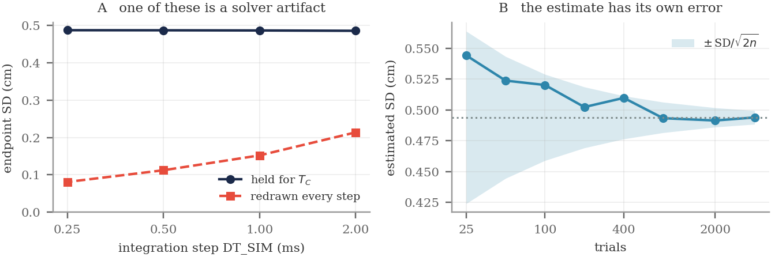
Figure 10. Two numerical choices. A: endpoint SD against integration step. With the noise held for T_C (navy) the result does not change; with the noise redrawn at every step (red) it falls as the step gets smaller. B: the estimated SD against the number of trials, with the ±SD/√(2n) band. The estimate still changes noticeably at n = 100.
Summary
 | model | people
bits vs reach distance | change by 0.01 bits over a 4× range | difficulty depends on D/W (Fitts 1954)
variability vs direction | 1.82× across a 6.08× range of torque | about 2× (van Beers 2004)
bits vs movement time | + 0.50 bits per doubling | —
movement time vs width | MT ∝ W^−2.02 | MT ∝ log₂(2D/W)
time per bit, feedforward | 949 ms | 100–300 ms
bits per second | falls 6.1× with movement time | roughly constant
time per bit, with corrections | 128 ms (100 ms delay) | 100–300 ms

Signal-dependent noise explains three results this week and fails on one. It is the type of noise that makes movement difficulty depend on the ratio of distance to target size, as Fitts found. It predicts that a sixfold difference in the torque needed for different reach directions produces less than a twofold difference in endpoint variability, which matches what van Beers et al. measured in people. And the endpoint scatter it produces can be computed directly from Week 1’s Jacobian and Week 3’s mass matrix.
It does not produce Fitts’ law. A controller that can improve accuracy only by moving more slowly has a speed–accuracy relationship of the wrong shape, needs three to ten times more time per bit than people, and cannot hit the smallest targets. Changing k does not help.
Adding corrective submovements fixes this, provided the corrections use the hand’s velocity as well as its position. With a realistic sensory delay, the model’s slope falls within the human range without any parameter being fitted. The drop from 949 to 128 ms per bit is what sensory feedback gains. Module 3 is about how the nervous system obtains that feedback.

