WEEK 10
From Reaching to Interception
Oculomotor Control, Target State Estimation, and Pursuit Efference Copy
Reading: Fooken, J., Kreyenmeier, P., & Spering, M. (2021). The role of eye movements in manual interception: A mini-review. Vision Research, 183, 81–90.
Supplementary: Van Donkelaar, P., & Lee, R. G. (1994). The role of vision and eye motion during reaching to intercept moving targets. Human Movement Science, 13(6), 765–783.
Supplementary: Lisberger, S. G. (2010). Visual guidance of smooth-pursuit eye movements: sensation, action, and what happens in between. Neuron, 66(4), 477–491.
Supplementary: Brostek, L., Eggert, T., & Glasauer, S. (2017). Gain control in predictive smooth pursuit eye movements. eNeuro, 4(3).
Supplementary: Andersen, R. A., Essick, G. K., & Siegel, R. M. (1985). Encoding of spatial location by posterior parietal neurons. Science, 230(4724), 456–458.
Introduction
Weeks 7–9 studied reaching to stationary targets. The target position was a constant — the only estimation problem was the hand’s state. The three-sensor architecture (proprioception, peripheral vision, and central vision) improved the speed–accuracy frontier beyond any single channel, and the inverse-variance weighting from Week 9 provided principled fusion. But the target itself was trivial: a known, fixed point that required no prediction.
This week introduces a moving target. Two new estimation problems arise that did not exist for reaching: the brain must estimate target velocity (not just position), and it must predict where the target will be when the hand arrives (not just where it is now). These problems demand the Kalman filter from Week 9 — but now operating on the target state rather than the hand state.
The key manipulation is gaze strategy. In one condition, the eyes actively track the target via smooth pursuit; in the other, the eyes remain fixated at the center of the target’s circular arc. The target moves at the same speed on the same arc in both conditions. The only difference is whether the oculomotor system is in pursuit mode — and therefore whether the brain has access to the pursuit efference copy for velocity estimation.
§1. From Reaching to Interception
The interception task: the participant sits with head fixed (chin rest) and hand at the start position. A target appears 15 cm to the right of the hand (on the workspace plane) and immediately begins to move counterclockwise along a circular arc of radius R = 15 cm centered on the hand’s start position. The target moves at a constant angular velocity ω = 60°/s (tangential speed ≈ 15.7 cm/s). The subject must intercept the target with a shooting action — the hand punches through the 15 cm circle without stopping. The hand cursor is 1 cm in diameter; the target is 1.5 cm in diameter.
At ω = 60°/s, the target begins moving at t = 0. During a 250 ms reaction phase (the subject observes the target; the saccade fires and lands) and a ~600 ms reach, the target moves ~51° along the arc (~13.4 cm). The hand must aim far ahead of the target’s current position. This lead angle depends critically on having a good estimate of target velocity: underestimate velocity by 50% and the hand misses by many centimeters.
Two gaze conditions (Figure 1): active pursuit — the eyes saccade to the target and then track it via smooth pursuit; and fixed gaze — the eyes remain fixated at the center of the arc (the hand’s start position), and the target moves at constant eccentricity (~15 cm) in peripheral vision. The circular arc design ensures that eccentricity is constant throughout the fixed-gaze condition, isolating the effect of gaze strategy from the effect of target distance from the fovea.
This connects directly to Elliott et al.’s (2017) two-phase model: for a moving target, the impulse phase must be launched toward a predicted location, not an observed one. The quality of that prediction depends on the oculomotor system.
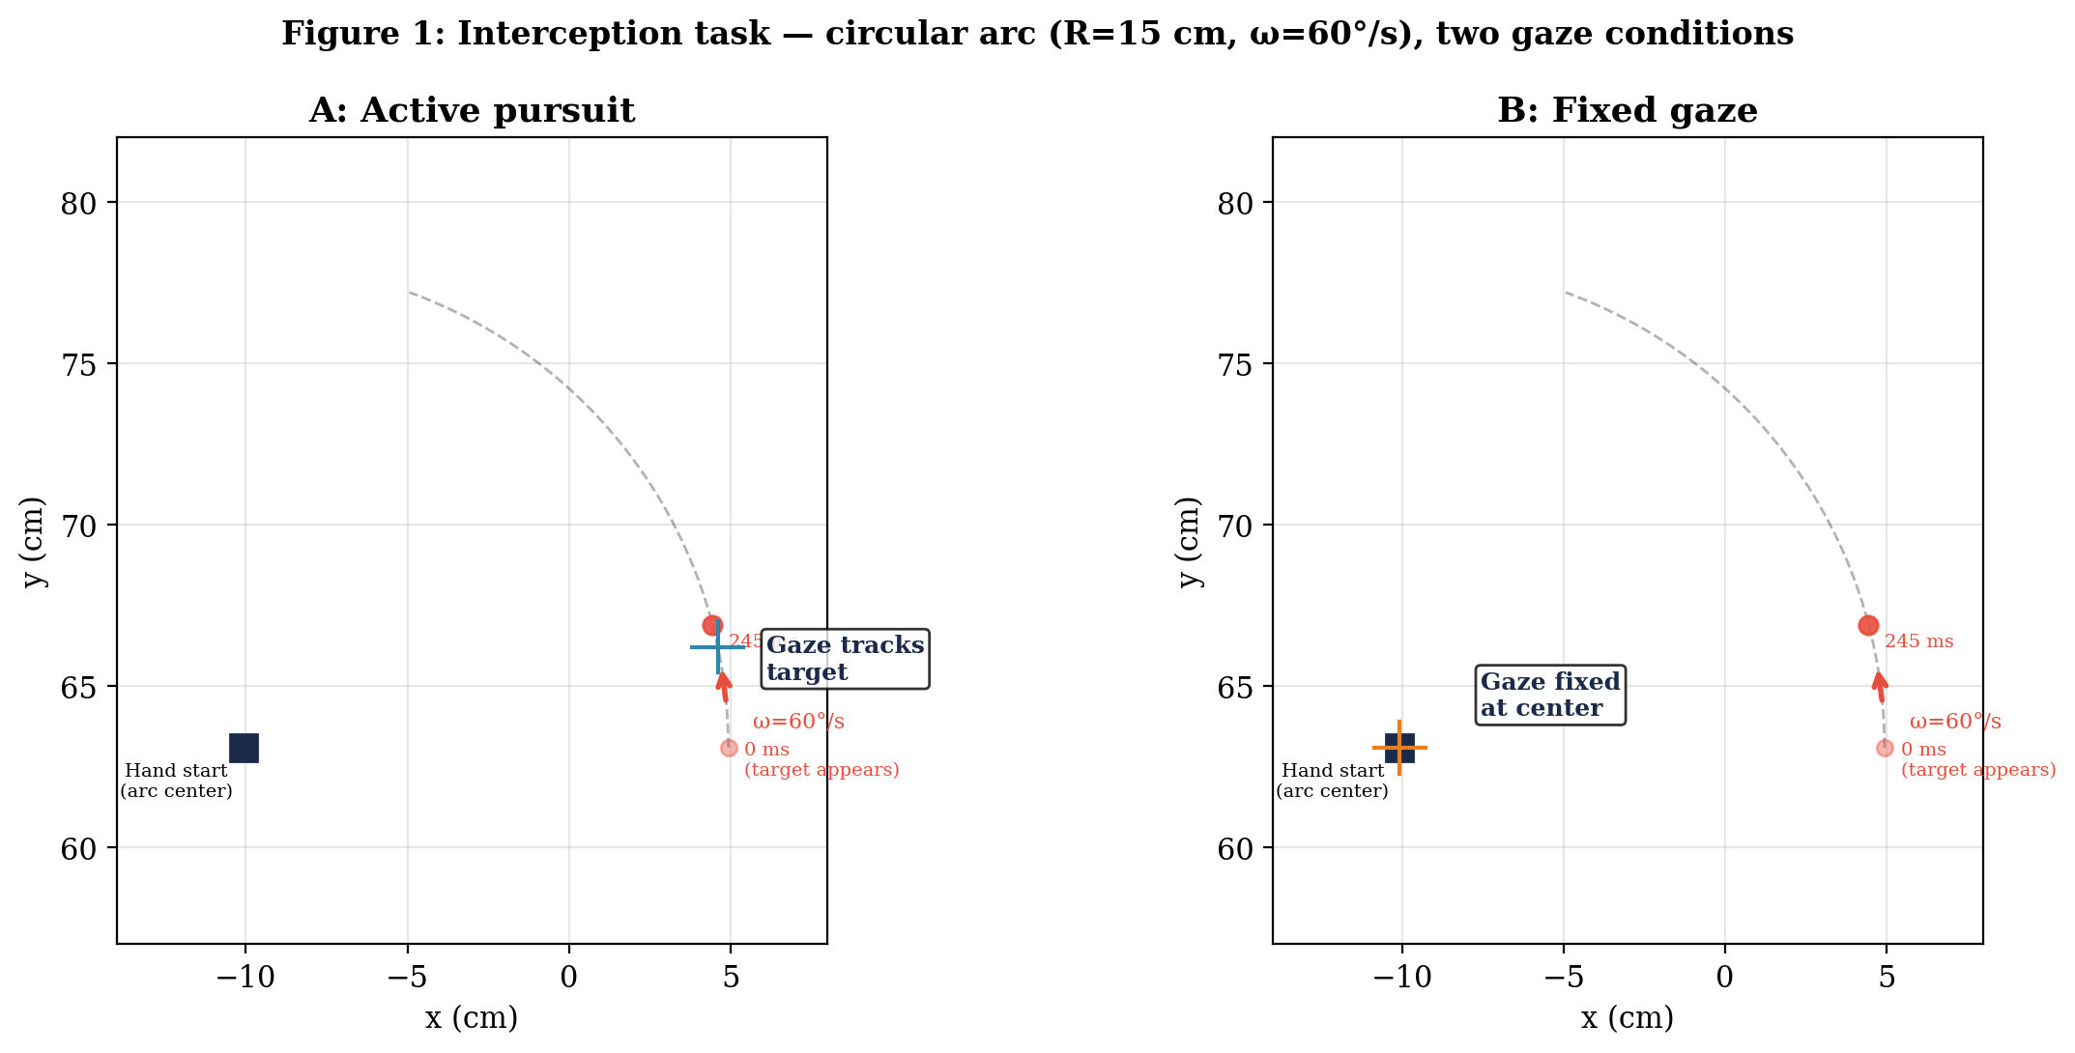
Figure 1. Interception task. A target appears 15 cm to the right of the hand and moves counterclockwise on a circular arc (R = 15 cm, ω = 60°/s) centered on the hand’s start position. Crosshair shows gaze position at the end of the fixation period (~200 ms). A: Active pursuit — gaze saccades to the target (crosshair near 12° on arc) then tracks via smooth pursuit. B: Fixed gaze — gaze remains fixated at the arc center throughout the trial.

§2. The Oculomotor Plant: Pursuit as a PD-Controller
The smooth pursuit system is a well-characterized sensory-motor circuit (Lisberger, 2010; Robinson, 1986; Brostek et al., 2017). Figure 2 shows the circuit operating in hand space (the same 2D workspace as Weeks 7–9), with four components:
1. Eye plant: a first-order low-pass filter with time constant T = 200 ms. Maps the motor command u (°/s) to eye velocity ev (°/s).
2. Visuomotor delay: The pursuit loop has a total delay of ~100–140 ms from retinal image motion to eye motor command, reflecting processing through MT, MST, FEFSEM, and pontine relay nuclei. This delay is internal to the pursuit system. Separately, visual observations reach the target KF with channel-specific delays: MT/MST velocity signals arrive ~60 ms after retinal stimulation; peripheral position signals arrive ~80 ms after; foveal position signals arrive ~50 ms after saccade landing.
3. Internal plant model + efference copy: a copy of the motor command (the efference copy) is fed through an internal model of the eye plant, producing the estimated eye velocity eev (°/s). This is the critical signal: eev represents what the brain knows about its own eye movement, independent of any sensory observation.
4. Gain control: the retinal image velocity signal is multiplied by (1 + GM × |eev|). Higher pursuit speed → higher gain → stronger visual–motor transmission. During fixation, eev = 0 and the gain factor = 1 (baseline). Lisberger (2010, Figure 8) demonstrated this directly: perturbation responses during fixation are dramatically smaller than during pursuit, even for identical retinal image motion. In our constant-velocity task, retinal slip during steady-state pursuit is small, so this gain modulation has little effect. However, if the target suddenly accelerated, decelerated, or changed direction, the gain-modulated slip signal would produce a faster corrective response during pursuit than during fixation — the pursuit system is pre-armed to respond to perturbations.
Pursuit circuit (Robinson 1986; Brostek et al. 2017, Fig. 7):

All signals in °/s unless noted:

iv = target_vel − eye_vel retinal image velocity (°/s)
etv = iv + G_P × eev estimated target velocity (°/s)
u = gain_control(iv) + PD(etv) motor command (°/s)
eev = internal_plant_model(u) estimated eye velocity (°/s)

Eye plant: d(ev)/dt = (u − ev) / T T = 200 ms
Gain control: iv × (1 + G_M × |eev|) G_M = 0.04 (s/°)
Pursuit gain: G_P = 0.9 dimensionless
PD-controller: d(etv)/dt, bounded at ±S G_D = 0.467 (s)
→ derivative adds phase lead to compensate visuomotor delay
The oculomotor response unfolds in four phases (Figure 3). Fixation (0–~200 ms): the target appears and begins to move; the eyes remain at the arc center while the saccade is planned. Saccade latency is variable (~200 ± 20 ms); we use 200 ms as a representative value for simulations. During this phase, the target KF receives two observation channels in parallel. MT/MST velocity observations arrive first (onset ~60 ms, then every ~10 ms): MT neurons in the dorsal stream are specialized for motion detection and respond with shorter latencies than spatial processing requires (Lisberger, 2010). They produce a new independent velocity estimate every ~10 ms because motion detection integrates over brief temporal windows. Peripheral position observations arrive slightly later (onset ~80 ms, then every ~50 ms): localizing the target in the periphery at 15° eccentricity requires spatial processing through larger receptive fields, and the coarse spatial resolution demands ~50 ms of temporal integration to produce a reliable position estimate (Osborne et al., 2004). Saccade (200–220 ms): ballistic jump to the predicted target location. The saccade is short (~15°) and completes in ~20 ms. Vision is suppressed during the saccade. Post-saccadic settling (220–250 ms): the eye is near the target; small oscillations damp out and the fovea acquires the target. The KF receives precise foveal position observations (σ = 1 mm), but the composite velocity signal is not yet available — pursuit has not been commanded, so eev = 0. This 30 ms window provides excellent position correction but no new velocity information beyond what the MT channel provided during fixation. Smooth pursuit (250 ms onward): the eye begins tracking the target with gain GP ≈ 0.9. The target velocity observation available to the KF is a composite: eev (efference copy of eye velocity) + retinal slip rate (how fast the target image moves on the retina). During early ramp-up, eev is low but retinal slip is high; at steady state, eev ≈ 0.9 × target velocity and slip ≈ 0.1 × target velocity. The composite is always close to 60°/s, providing a stable velocity observation even before pursuit reaches steady state. The hand also launches at ~250 ms, so pursuit and reaching begin simultaneously.
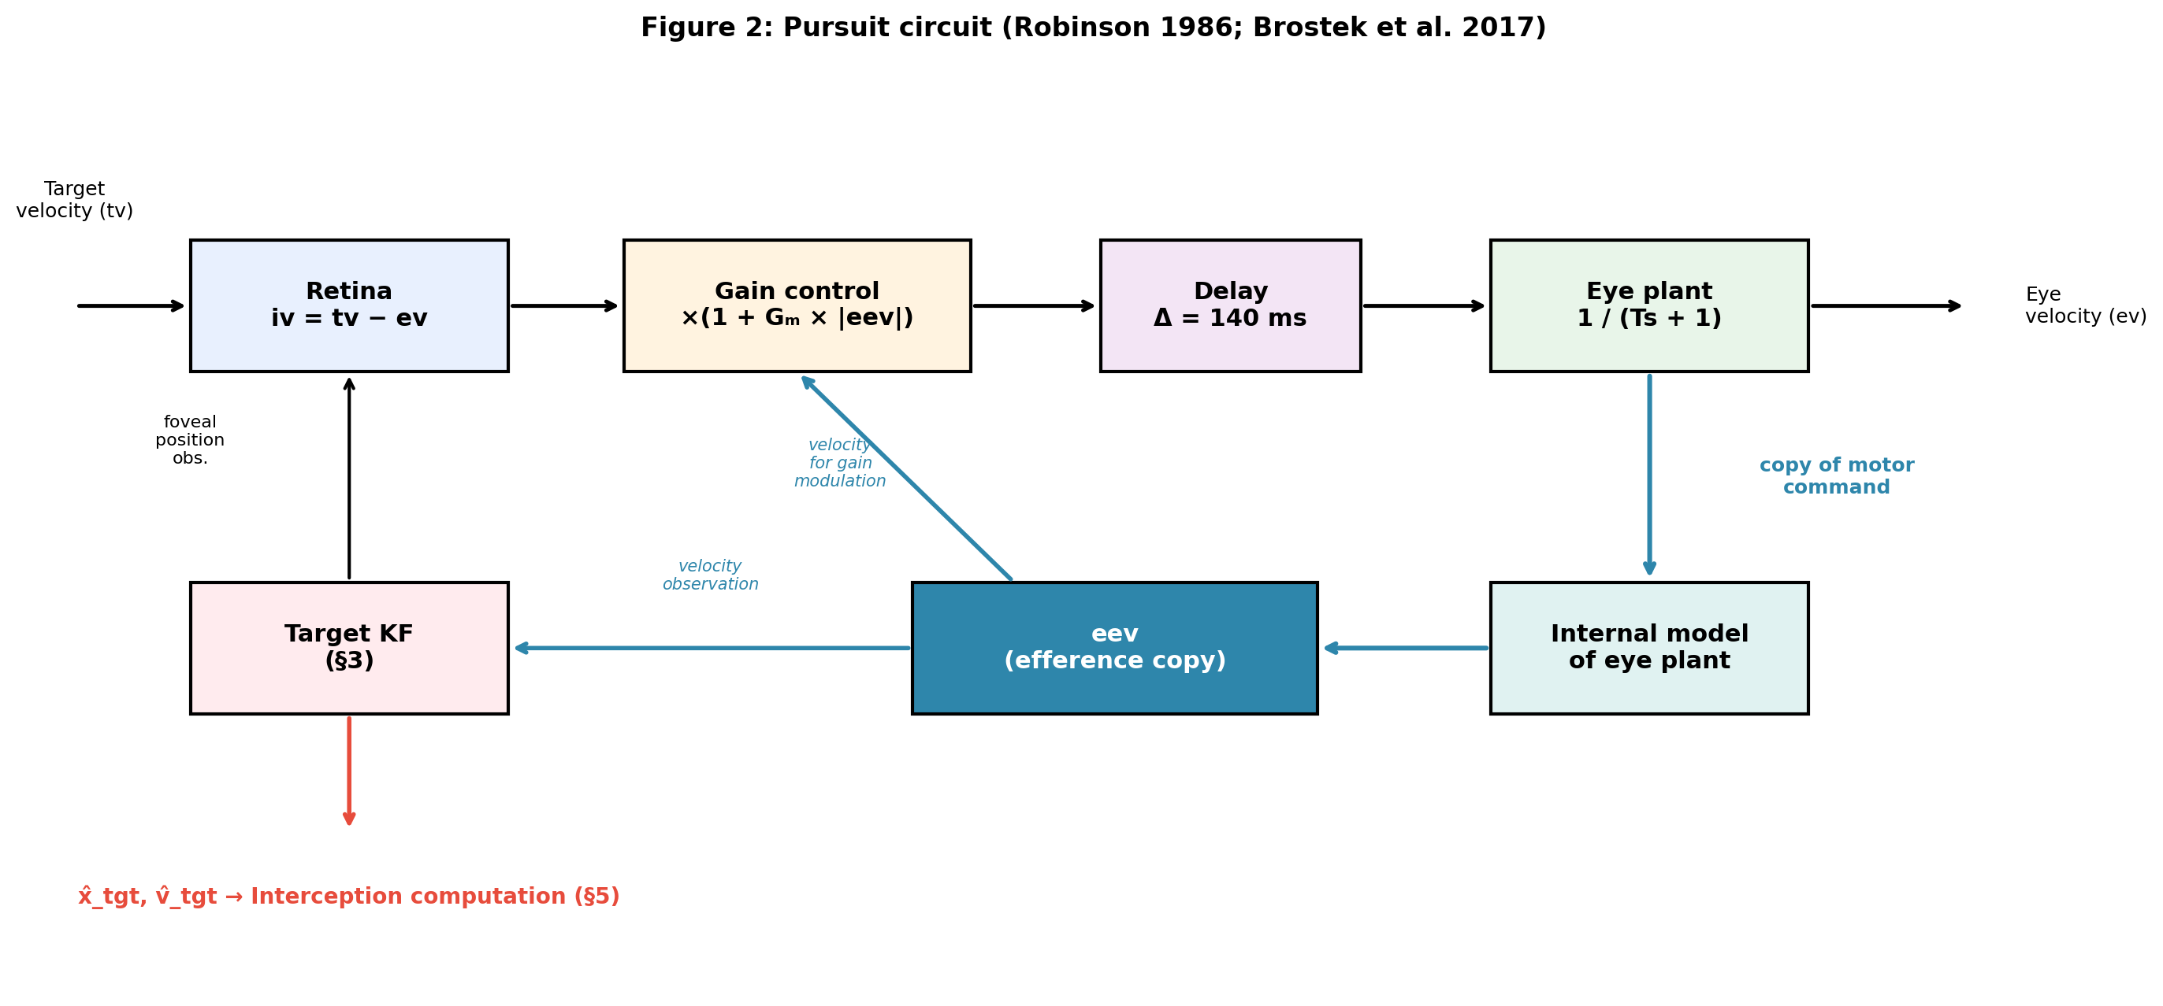
Figure 2. Simplified pursuit circuit (adapted from Brostek et al., 2017; Robinson, 1986). The efference copy (eev) from the internal plant model feeds into the target Kalman filter as a velocity observation (§3).
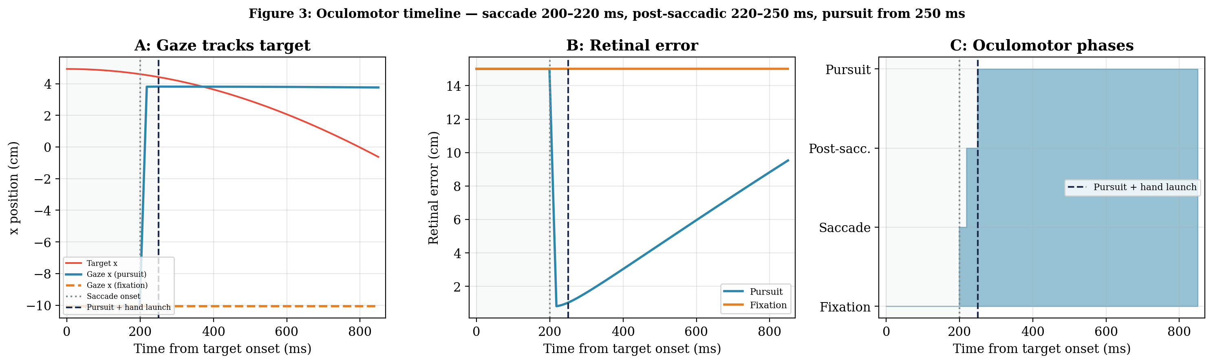
Figure 3. Oculomotor timeline during interception. Time axis starts at t = 0 (target onset). Gray shading = observation phase (0–250 ms). A: Gaze x-position is flat during fixation (0–200 ms); saccade fires at 200 ms and lands at ~220 ms; post-saccadic settling through 250 ms; pursuit then tracks the target. Fixation gaze (dashed orange) remains at the arc center. B: Retinal error drops to near zero after saccade landing (teal) but stays at ~15 cm for fixation (orange, constant eccentricity). C: Four oculomotor phases for the pursuit condition: fixation, saccade, post-saccadic settling, and pursuit.

§3. The Kalman Filter on Target State
The oculomotor system’s job is to provide the arm with a reliable estimate of where the target is and how fast it is moving. This section builds the estimator: a Kalman filter on the target’s state in polar arc coordinates. The arm controller (§5) will use this estimate to plan and correct the reach. Here, we focus on the estimator itself and how its performance differs between pursuit and fixation.
State and Process Model
Because the target moves on a circular arc, the natural state representation is polar: x_tgt = [θ, ω]ᵀ — the angular position on the arc (degrees) and the angular velocity (degrees per second). In this representation, the process model is exact: the target moves at constant ω, so θ increments by ω·dt each timestep and ω does not change. The fixed arc radius R eliminates two state variables: r = R (constant) and ṙ = 0. The remaining state [θ, ω] is 2D with exactly linear dynamics. In Cartesian coordinates, the same target would require a 4D state [x, y, v_x, v_y] with a nonlinear constraint x² + y² = R², making the KF nonlinear. The polar representation exploits the task geometry to keep the problem linear and low-dimensional.
State: x_tgt = [θ, ω]ᵀ 2×1 vector
θ: angular position on the arc (degrees)
ω: angular velocity (degrees per second, °/s)

Predict step (every dt = 0.001 s):

x̂_FM = A x̂ predicted state (2×1)
P_FM = A P Aᵀ + Q predicted covariance (2×2)

A = [1 dt] state transition matrix (2×2)
[0 1] θ += ω·dt (°); ω unchanged (°/s)

x̂ = [θ̂, ω̂]ᵀ current state estimate (2×1)
P = [P_θθ P_θω] covariance: P_θθ in °², P_ωω in (°/s)²
[P_ωθ P_ωω] off-diagonal P_θω in °·(°/s)

Q = diag(10⁻⁶, 10⁻⁶) process noise: Q_θθ in °², Q_ωω in (°/s)²
Tiny because ω is truly constant on the arc.

P₀ = diag(25, 900) initial: σ_θ = 5°, σ_ω = 30°/s
Observation Model: Two Operating Modes
Both conditions observe the target’s angular position θ on the arc. The observation is H = [1, 0] — position only. No sensor directly measures ω; the filter must infer it from how θ changes over time, unless the pursuit efference copy provides a direct velocity observation.
The angular noise on the position observation comes from the retinal noise projected onto the arc. Foveal vision has σ = 1 mm in hand space; at radius R = 150 mm, this maps to σ_fov = 1/150 = 0.38°. Peripheral vision has σ = 5 mm, mapping to σ_per = 5/150 = 1.91°.
Update step (when observation θ_obs available):

Innovation: θ_obs − H x̂_FM scalar (°)
θ_obs: observed angular position (°)
H = [1, 0]: observation matrix (1×2), selects θ from state
H x̂_FM: predicted θ (°)

Kalman gain:
S = H P_FM Hᵀ + R innovation variance (scalar, °²)
K_n = P_FM Hᵀ / S gain vector (2×1)
K_n[0]: °/° = dimensionless (position correction per ° error)
K_n[1]: (°/s)/° = 1/s (velocity correction per ° error)
R = σ²_obs (°²) observation noise variance
Pursuit: R = 0.38² = 0.14 °² (foveal)
Fixation: R = 1.91² = 3.65 °² (peripheral)

State update:
x̂ = x̂_FM + K_n × (θ_obs − H x̂_FM) (2×1) = (2×1) + (2×1)×(°)

Covariance update:
P = (I₂ − K_n H) P_FM (2×2)
I₂: 2×2 identity matrix
 | Active pursuit | Fixed gaze
θ observation | Foveal: σ = 0.38°, every dt (continuous) | Peripheral: σ = 1.91°, every 50 ms (Osborne et al., 2004)
ω observation | Composite: eev + retinal slip rate ≈ target velocity. σ = 5°/s. Stable during ramp-up. | None — filter infers ω from Δθ/Δt (noisy, slow)
Sampling | Every 1 ms (foveal) + velocity each ms | Every 50 ms (peripheral integration window)
Why This Kalman Filter Works
The process model (ω = constant) is exact for the circular arc, so the process noise covariance Q — how much the state is expected to change unpredictably between timesteps — can be tiny. The state is 2D, the dynamics are linear, and the noise is Gaussian. This is exactly the system the Kalman filter was designed for. The only difference between gaze conditions is what observations the filter receives and how often — the predict step is identical.
Note that the KF uses a forward model, not an inverse model. The predict step propagates the state forward: “if [θ, ω] is the current state, where will it be next timestep?” The update step compares the predicted observation (H x̂) to the actual observation — “if the target is at θ̂, what should the retina see?” The Kalman gain K weights the discrepancy by the relative uncertainties. No inversion is required. This contrasts with Week 7’s feedforward controller, which used an inverse dynamics model to compute torques from desired accelerations. Estimation needs forward models; control may need inverse models.
Results: Pursuit Tracks, Fixation Lags
Figure 4 shows the polar KF tracking the target under three conditions across the full 850 ms trial. During the observation phase (gray shading, 0–250 ms), all conditions receive identical peripheral observations every 50 ms. The conditions diverge after the saccade lands at ~220 ms.
Position (θ): Pursuit position uncertainty (Panel C, teal) collapses from ~2.5° to < 0.1° within 50 ms of saccade landing, as foveal observations flood the filter. Both fixation conditions (orange and purple) converge slowly toward ~1° — both receive the same peripheral position observations with σ = 1.91°.
Velocity (ω): This is where the three conditions separate most clearly. Pursuit velocity uncertainty (Panel D, teal) drops from 30°/s to < 1°/s once the efference copy ramps up (~350 ms). Fixation with MT velocity (purple) receives a direct but noisy velocity observation (σ_MT = 12°/s) from motion-sensitive neurons in MT/MST every ~10 ms (the MT temporal integration window). Velocity uncertainty drops to ~2°/s by 250 ms and ~1.5°/s by 500 ms — substantially better than position-only, but ultimately worse than pursuit at steady state. Fixation position-only (orange) has no velocity sensor; the KF must infer ω from discrete peripheral position samples arriving every 50 ms. This is the Kalman filter equivalent of differentiating noisy position: σ_ω remains ~4°/s even at 850 ms.
Note the crossover in Panel D near 250 ms: during the observation phase (0–200 ms), pursuit and fixation+MT share identical estimates — both receive peripheral position (50 ms) and MT velocity (10 ms). After the saccade lands (~220 ms), pursuit gains foveal position but the composite velocity observation (eev + retinal slip rate) does not become available until pursuit begins at 250 ms. By ~300 ms, the composite quickly surpasses the MT channel because it benefits from both the efference copy (which grows as pursuit ramps) and the foveal retinal slip measurement (which is precise). By 350 ms pursuit converges to σ_ω < 0.5°/s while MT remains at ~2°/s.
The MT/MST velocity condition (§4) models the biological reality that the peripheral visual system does not merely detect position — direction-selective neurons in MT/MST encode motion velocity directly, without requiring temporal differentiation of position (Lisberger, 2010). Their tuning curves are broader in the periphery (σ ≈ 12°/s at 15° eccentricity) than foveally, and each response reflects integration over ~10 ms, but the signal is a direct measurement of ω rather than an inference. By contrast, the position-only fixation model treats the peripheral visual system as a pure position sensor sampled every 50 ms — no direct velocity channel, velocity inferred entirely from the KF’s predict-update cycle on Δθ/Δt.
At hand launch (250 ms): pursuit and fixation+MT have identical estimates up to ~220 ms (shared pre-saccade phase) because both receive the same two observation channels — peripheral position every 50 ms and MT velocity every 10 ms. Fixation position-only diverges from the start because it lacks the MT velocity channel entirely: it receives only peripheral position observations, so it must infer velocity from Δθ/Δt through the KF predict-update cycle. After saccade landing, pursuit gains foveal position and the composite velocity signal. At 250 ms: pursuit has σ_θ ≈ 0.08° and σ_ω ≈ 2.2°/s (composite just starting). Fixation + MT has σ_θ ≈ 0.8° and σ_ω ≈ 2.3°/s (similar velocity, worse position). Fixation position-only has σ_θ ≈ 1.3° and σ_ω ≈ 8.5°/s (worst on both — no direct velocity observation at any point). All three conditions use these estimates to compute the initial reach direction (§5).
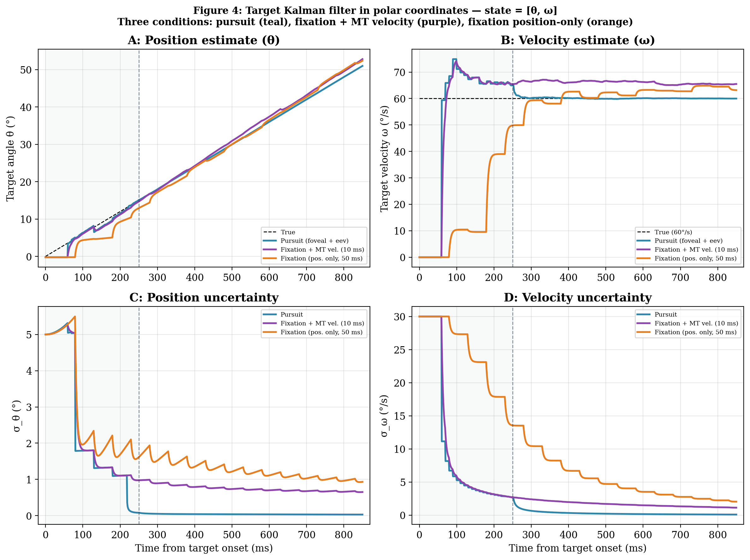
Figure 4. Target Kalman filter in polar coordinates — state = [θ, ω]. Three conditions: pursuit with foveal position + composite velocity (eev + retinal slip, teal); fixation with peripheral position (50 ms) + MT/MST velocity every 10 ms (purple); fixation with peripheral position only (orange). All three conditions share identical initial state (ω̂ = 0°/s, σ_ω = 30°/s); the apparent divergence at the left edge of Panels B and D occurs within the first 10 ms as the MT velocity channel provides its first observation. Pursuit and MT share identical trajectories during 0–200 ms (shared pre-saccade phase). A: Position estimate. B: Velocity estimate — no dip during pursuit ramp-up because the composite observation is stable. C: Position uncertainty. D: Velocity uncertainty — pursuit converges to < 0.5°/s by 350 ms; MT to ~1.5°/s; position-only remains ~4°/s.
The composite velocity observation (eev + retinal slip rate) is the key insight of the pursuit model. During ramp-up, the eye is slow but the image slips fast; at steady state, the eye is fast and the image barely slips. The sum is always close to the target velocity. This means the KF receives a stable velocity observation from the moment pursuit begins, with no transient dip. The MT/MST pathway provides a similar direct velocity channel in peripheral vision — noisier (σ = 12°/s vs 5°/s) but available before saccade onset.

§4. Reference Frames: From Retina to Shoulder
The arm controller needs the target’s position and velocity in shoulder-centered coordinates. The estimates from §3 are in polar arc coordinates (θ, ω). Getting them to the arm requires a chain of reference frame transformations: retinotopic → head-centered → shoulder-centered. Each transformation adds noise and introduces the possibility of systematic error. How this chain operates differs between pursuit and fixation.
Head-Centered to Shoulder-Centered
In our task, the head is fixed and the shoulder position is constant. The transformation from head-centered to shoulder-centered coordinates is therefore a fixed offset — the same in pursuit and fixation. This step adds no differential noise between conditions. The interesting differences arise in the retinotopic-to-head-centered stage.
Pursuit: Foveal Target on a Moving Eye
During pursuit, the target image falls on or near the fovea with minimal retinal slip. The brain must determine where the fovea is pointing relative to the head — that is, the eye-in-head position. Since the head is fixed, eye-in-head position directly gives target-in-head position. The brain has access to the eye’s motor command through the efference copy, so it can estimate eye position precisely.
Position: target position in head coordinates ≈ gaze position (from efference copy of eye position) + small retinal offset (foveal, σ = 0.38° ≈ 1 mm). The transformation adds almost no noise because the foveal offset is tiny and the eye position signal is precise.
Velocity: target velocity in head coordinates is estimated through the composite signal: efference copy of eye velocity (eev) plus retinal slip rate. During pursuit ramp-up, eev is low but retinal slip rate is high (the image moves fast across the fovea). At steady state, eev ≈ 0.9 × target velocity and slip rate ≈ 0.1 × target velocity. The composite is always close to 60°/s regardless of pursuit phase, providing a stable velocity observation to the KF (see Figure 4B, teal trace — no dip during ramp-up).
Fixation: Peripheral Target on a Stationary Eye
During fixation, the gaze is fixed at the arc center and the eye-in-head position is constant. The retinotopic-to-head-centered transformation is therefore fixed — unlike pursuit, no eye position update is needed. However, the target is now at ~15° eccentricity on the retina, and both position and velocity estimation are degraded by the spatial resolution limits of peripheral vision.
Position: the target’s retinotopic position must be mapped to head-centered coordinates. At 15° eccentricity, spatial acuity is approximately 5× worse than foveal (σ = 1.91° ≈ 5 mm). The fixed transformation itself adds no noise, but the input signal is noisier. Position observations are available only every ~50 ms due to the peripheral integration window (Osborne et al., 2004).
Velocity: this is the critical limitation. In the position-only model (Figure 4, orange), the brain must infer target velocity by differentiating discrete peripheral position signals sampled every 50 ms — exactly the bandwidth limitation from Week 8 §4. However, the peripheral visual system is not limited to position signals. Direction-selective neurons in areas MT and MST encode motion velocity directly: they respond to the speed and direction of image motion on the retina without requiring temporal differentiation of position (Lisberger, 2010). These neurons have broad tuning curves in the periphery (σ ≈ 12°/s at 15° eccentricity), and each response integrates over ~10 ms, so the velocity signal is noisy but it is a direct measurement of ω, not an inference from Δθ/Δt.
The fixation + MT condition (Figure 4, purple) models this direct peripheral velocity channel. The KF receives MT/MST velocity observations every 10 ms alongside peripheral position observations every 50 ms. The 5× faster velocity sampling is why the purple curve in Panel D drops much faster than orange during the observation phase. The MT channel also improves position estimation (Panel C) through the θ–ω cross-correlation in the KF covariance. Nevertheless, both fixation conditions remain substantially worse than pursuit for position estimation because peripheral spatial resolution (σ = 1.91°) cannot match foveal (σ = 0.38°).
Summary: Why Pursuit Wins
The reference frame transformation creates an asymmetry between gaze conditions that compounds with the sensory advantages from §3:
In pursuit, the transformation leverages the efference copy: the brain knows where the eye is and how fast it is moving, so converting retinal signals to head-centered coordinates adds minimal noise. Position and velocity estimates are dominated by the high-precision foveal and efference copy channels.
In fixation, the transformation itself is trivial (fixed gaze), but the input signals are degraded by peripheral spatial resolution. The best the brain can do is combine noisy peripheral position with MT/MST motion signals — a direct but coarse velocity channel. This is better than pure position differencing, but never approaches foveal precision.
This connects to gain fields (Andersen, Essick & Siegel, 1985): posterior parietal neurons encode target position in coordinates modulated by eye position — a multiplicative interaction that amplifies peripheral noise at large eccentricities.
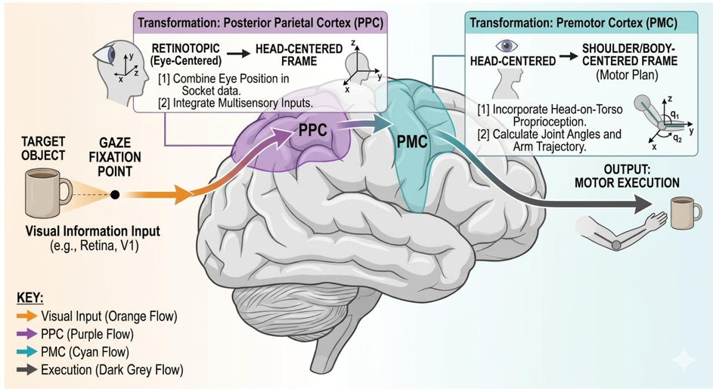
§5. Feedforward Planning: Woodworth’s Impulse Phase
The hand must be launched before the gaze system has settled into pursuit. At ~200 ms the motor plan is formed; at ~245 ms (±15 ms) the hand launches. The pursuit saccade lands at ~220 ms and pursuit begins at ~250 ms, but the efference copy velocity signal has not yet ramped up. The feedforward plan is therefore based entirely on the peripheral estimates from the observation phase — the same estimates available under fixation. This is Woodworth’s (1899) impulse phase: a pre-planned movement launched before visual feedback is available.
Inputs to the Plan
At 200 ms, the motor system has the Fixation + MT estimates from §3–4: θ̂ ≈ 11.9° (σ_θ = 1.0°) and ω̂ ≈ 65.6°/s (σ_ω = 2.6°/s). The velocity estimate is ~12% above the true value of 60°/s — this is not noise, it is a systematic bias from peripheral motion processing.
The Aubert-Fleischl Effect
The velocity overestimation reflects the Aubert-Fleischl phenomenon: objects moving across a stationary retina (fixation) appear to move faster than objects tracked by the eyes (pursuit). This is a well-established property of peripheral motion perception (Dichgans et al., 1969; Freeman & Banks, 1998). In our model, the MT/MST velocity observation carries a 12% positive bias, at the conservative end of the 10–50% range reported in the literature: ω_obs = 1.12 × ω_true + N(0, σ²). During the shared observation phase (0–200 ms), pursuit and fixation+MT both accumulate this biased velocity estimate through the KF because both receive MT velocity observations. Fixation position-only does not accumulate the bias — it has no MT channel, so its velocity estimate comes from differentiating unbiased position samples. However, its velocity estimate is so noisy (σ_ω ≈ 8.5°/s) that the absence of bias provides little comfort.
Van Donkelaar & Lee (1994) demonstrated exactly this effect in natural interception movements. When eye motion was restricted (analogous to our fixation condition), subjects aimed further ahead of the target than in the free-viewing condition. They attributed this to an overestimation of target velocity in the peripheral visual field. This is the Aubert-Fleischl bias operating through the feedforward plan: higher estimated velocity → longer extrapolation → aim point further along the arc.
Projecting the Interception Angle
The motor system projects where the target will be when the hand arrives:
Interception angle:
θ_intercept = θ̂ + ω̂_biased × T_cross

where T_cross = planned time from launch to arc crossing
= 550 ± 50 ms

Example: θ_intercept = 14.5 + 65.0 × 0.550 = 50.2°
True intercept (at 795 ms from target onset): 47.7°
Feedforward overshoot: +2.5° (≈ 0.65 cm on the arc)
→ hand aims PAST the true interception because of Aubert-Fleischl bias
The lead angle — the difference between the aim point and the target’s current position at launch — is ~36° (50° − 15°). The hand aims far ahead of where it currently sees the target (Figure 5A). Critically, the aim overshoots the true interception by ~2.5° because the velocity estimate is biased upward.
Both gaze conditions launch with nearly identical directions (Figure 5A, teal vs orange arrows). The pursuit subject has had ~30 ms of foveal position correction (post-saccade, 220–250 ms), which slightly corrects the velocity estimate from 65.6 to ~65.0°/s through KF cross-correlation. This produces a negligible 0.3° difference in aim. The feedforward plan is effectively identical across conditions. The van Donkelaar & Lee (1994) effect — fixation subjects aiming further ahead — arises during the movement, not at launch: pursuit corrects the bias through the unbiased composite velocity signal (§6), while fixation continues to extrapolate with the biased MT estimate.
Movement Parameterization
The movement is a shooting action through the arc, not a reach to a point on it (Figure 5B). The hand should be decelerating when it crosses the 15 cm circle, at approximately 65–75% of its peak velocity. For a min-jerk velocity profile, this corresponds to crossing at ~70% of the total movement duration:
Min-jerk position: s(x) = A × (10x³ − 15x⁴ + 6x⁵), x = t/T
→ minimizes ∫ₓ̈² dt (jerk = third derivative of position)

Min-jerk velocity (derivative): v(x) = (A/T) × 30x²(1−x)²
Peak at x = 0.5: v_peak = 1.875 × A/T

At 70% peak velocity (deceleration side): x_cross = 0.70
Position at crossing: s(0.70) = 0.84 × A
Total amplitude: A = 15 cm / 0.84 = 17.9 cm (overshoots arc by 2.9 cm)

With T_cross = 550 ms, total movement T = 550/0.70 = 783 ms
Peak velocity: 42.8 cm/s (at 392 ms into movement)
Velocity at arc crossing: 30 cm/s (70% of peak)
Uncertainty Budget
Three sources of noise contribute to the uncertainty in the planned interception angle:
σ²_intercept = σ²_θ + (T_cross × σ_ω)² + (ω̂ × σ_T)²

Position uncertainty: σ_θ = 1.0° (7% of total variance)
Velocity × time: T_cross × σ_ω = 1.43° (16%)
Timing × speed: ω̂ × σ_T = 3.30° (77%)

Total (RSS): σ_intercept = 3.69° ≈ 0.97 cm on the arc

σ_T = √(σ²_T_move + σ²_T_launch) = √(50² + 8²) ≈ 50.6 ms

Note: the Aubert-Fleischl bias adds a systematic overshoot (~2.5°)
on top of this random uncertainty. The bias does not appear in σ;
it shifts the mean aim point, not the spread.
The dominant source of feedforward error is timing noise (77% of variance), not velocity or position estimation. Even with a perfect velocity estimate, timing jitter (ω̂ × σ_T = 65°/s [biased MT estimate] × 0.051 s [combined movement duration + launch timing noise from the uncertainty budget above] = 3.3°) makes feedforward interception inherently imprecise. On top of this random error, the Aubert-Fleischl bias adds a systematic 2.5° overshoot. Both must be corrected online.
Motor execution noise (signal-dependent noise, Week 7) adds ~0.3° of additional variability from the smooth feedforward trajectory — about 7.5% of the 3.7° planning uncertainty. SDN is small here because the min-jerk trajectory is smooth with no abrupt torque changes. SDN becomes more important in §6, where correction torques introduce additional motor noise on top of the feedforward plan.
Connection to Woodworth and van Donkelaar & Lee
This feedforward plan is Woodworth’s (1899) impulse phase adapted for interception. Three properties match:
1. Pre-programmed: the plan is computed from pre-saccadic peripheral estimates at ~200 ms and launched at ~245 ms. No online visual feedback contributes to the initial trajectory.
2. Nearly identical across gaze conditions: because the plan uses estimates from the shared observation phase (before pursuit), the feedforward component is the same whether the subject will pursue or fixate. The 0.3° difference is negligible. The gaze-dependent divergence arises entirely in the feedback phase (§6).
3. The plan overshoots because of biased velocity: the hand aims at ~50°, past the true interception at 48°. This overshoot reflects the Aubert-Fleischl velocity bias in peripheral MT. Van Donkelaar & Lee (1994) observed exactly this: when eye motion was restricted, subjects aimed further ahead. Their finding is also consistent with a biased plan — but the bias is corrected during the movement in the pursuit condition, producing the observed difference in final hand direction, not initial direction.
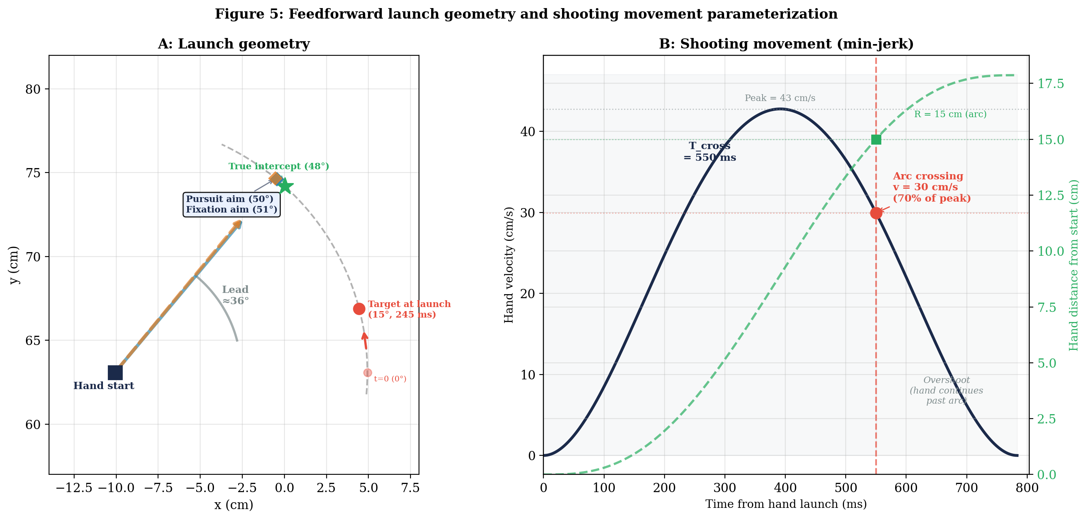
Figure 5. Feedforward launch geometry and shooting movement. A: Spatial geometry showing two launch vectors — pursuit (teal, solid) and fixation (orange, dashed). Both aim past the true intercept (green star, 48°) because of the Aubert-Fleischl velocity bias. Pursuit aims at 50°, fixation at 51° — nearly identical (0.4° difference). Lead angle ~36°. B: Min-jerk velocity profile of the shooting movement. Peak velocity 43 cm/s at ~390 ms. Hand crosses the 15 cm arc (green position curve) at 550 ms while decelerating at 70% of peak (30 cm/s, red dot). Total movement overshoots by ~3 cm. This figure will be updated in §6 to show how feedback control redirects the trajectory.

§6. Feedback Control: Woodworth’s Limb-Target Phase
The feedforward plan from §5 aims the hand at ~50° on the arc, overshooting the true intercept (48°) by ~2.5° because of the Aubert-Fleischl velocity bias. The feedforward σ_intercept is ~3.7° (≈ 1 cm). Without corrections, roughly 20% of trials would miss the target entirely. This section builds the feedback controller that corrects the feedforward error during the movement — Woodworth’s limb-target phase.
The Hit Window
The hand cursor is 1 cm in diameter; the target is 1.5 cm in diameter. The hand must cross the arc within 1.25 cm (cursor radius + target radius = 0.5 + 0.75 cm) of the target center to register a hit (Figure 6, green tick marks on arc). On the arc at R = 15 cm, this corresponds to ~4.8° of angular tolerance. The feedforward aim has two distinct error sources: a systematic +2.5° overshoot (Aubert-Fleischl bias) that shifts the distribution center past the true intercept, and a random spread of σ = 3.7° (from timing, velocity, and position noise) around that shifted center. Together, the far edge of the distribution (bias + 1σ = 6.2°) exceeds the hit window, meaning corrections are required on most trials.
When to Correct: The Predicted Miss
At each moment during the movement, the controller has access to: (1) the current KF estimate of target state [θ̂, ω̂] from §3, which is continuously updated as new observations arrive; (2) an estimate of where the hand is currently heading (from the feedforward plan + proprioception/vision of the hand); and (3) the time remaining until arc crossing. From these, it computes the predicted miss — the angular gap between where the hand will cross the arc and where the target will be at crossing time.
Predicted miss at time t:

θ_hand_at_cross(t) = current hand direction (from feedforward + corrections so far)
θ_target_at_cross(t) = θ̂(t) + ω̂(t) × t_remaining(t)

predicted_miss(t) = θ_hand_at_cross(t) − θ_target_at_cross(t)

Hit window: |predicted_miss| < 4.8° (≈ 1.25 cm)
The predicted miss changes over time for two reasons: the KF estimate updates (changing θ_target_at_cross), and the hand’s trajectory may be modified by prior corrections (changing θ_hand_at_cross). Crucially, the controller only sees its own estimate of the miss (dashed lines in Figure 7, top), not the actual miss (solid lines). If the estimate is biased, the controller may fail to correct a real error. The question is: what does the controller do when its estimated miss exceeds the hit window?
Model A: Intermittent Submovements (Elliott et al.)
The first model implements Elliott et al.’s (2017) discrete correction framework. The feedforward min-jerk trajectory runs until the predicted miss exceeds the hit window (1.25 cm). At that point, the controller terminates the current trajectory and overlays a new min-jerk submovement toward the updated interception point:
Correction trigger: |predicted_miss(t)| > 1.25 cm (4.8°)

When triggered at time t_c:
1. Current hand state (position, velocity) becomes the new initial condition
2. New aim: θ_target_at_cross = θ̂(t_c) + ω̂(t_c) × t_remaining(t_c)
3. New min-jerk overlay from current state to new aim
4. Time remaining must still produce 65–75% peak velocity at crossing

Each correction adds SDN from the torque change (τ_correction).
More corrections → more SDN → more endpoint variability.
Pursuit prediction: the KF estimate converges quickly after saccade landing (§3). The unbiased composite velocity signal corrects the Aubert-Fleischl bias within ~100 ms of pursuit onset. This shifts the predicted interception point backward, creating a large predicted miss that triggers one early correction. Figure 7 (top left) shows this clearly: the pursuit controller estimate (dashed teal) spikes above the hit window, triggering a correction at ~120 ms into the movement (~366 ms from target onset). After correction, the actual miss (solid teal) drops to < 2°. Early corrections are cheap (low hand speed, small torque, less SDN).
Fixation prediction: the KF estimate maintains the Aubert-Fleischl bias throughout because MT continues to feed biased velocity observations. The controller does not know it is wrong — both the aim and the ongoing estimate share the same bias, so the controller estimate of the miss (dashed orange in Figure 7, top left) stays within the hit window even though the actual miss (solid orange) remains ~8°. Model A rarely triggers corrections for fixation (mean 0.1 per trial). The miss distribution is shifted positive by ~4° (Figure 8, left), reflecting the systematic error that the controller cannot detect. This is a fundamental limitation of intermittent corrections: they can only correct errors the controller can see.
Model B: Continuous Time-to-Go Correction
The second model applies a continuous correction torque proportional to the predicted miss, weighted by how much time remains to make the correction:
Correction at each timestep:

τ_correction(t) = K_fb × predicted_miss(t) × g(t_remaining)

g(t_remaining) = (t_remaining / T_cross)²
→ full correction authority early, tapers to zero near crossing
→ preserves the shooting velocity profile (65–75% peak at crossing)

K_fb: feedback gain (N·m per degree of predicted miss)

No discrete trigger. Correction is always active but fades.
Less SDN per timestep (no abrupt torque changes).
But: never fully commits — always hedging against future updates.
This model maps onto optimal feedback control (Todorov & Jordan, 2002): corrections are applied continuously and weighted by cost-to-go. The time-to-go weighting preserves the velocity profile constraint — large corrections are only possible early when there is time to redirect without violating the 65–75% peak crossing requirement (Figure 7, bottom panels). The continuous model produces smoother trajectories than Model A (Figure 6, bottom row) because it avoids abrupt direction changes.
The Foveal Bonus on Hand Sensing
Both models require an estimate of hand position to compute the predicted miss. The hand is sensed through proprioception (σ = 12 mm, delay = 60 ms) and vision (σ depends on eccentricity, delay = 80 ms), fused through inverse-variance weighting (Week 9). The visual noise on the hand depends on where the hand is relative to gaze:
σ_hand_visual(t) = σ_foveal + (σ_periph − σ_foveal) × min(ecc(t) / r_fov, 1)

ecc(t) = distance(hand(t), gaze(t))
σ_foveal = 1 mm, σ_periph = 5 mm, r_fov = 2 cm (~2°)

Pursuit: gaze tracks target on arc. Hand approaches target/gaze.
→ ecc(t) shrinks in final 100–150 ms
→ σ_hand drops from 5 mm to ~1 mm
→ Final correction is precise (foveal hand sensing)

Fixation: gaze at arc center. Hand moves away from gaze toward arc.
→ ecc(t) = ~15 cm throughout (constant, large)
→ σ_hand = 5 mm always
→ Final correction is noisy (peripheral hand sensing)
This is the foveal bonus from Week 8, now applied to interception. During pursuit, the hand enters foveal vision in the final 100–150 ms of the reach (Figure 6, left column: the hand endpoint converges on the target/gaze). This is exactly when the final correction occurs — the moment that determines hit vs miss. The correction is based on a precise hand-target error (both hand and target in foveal vision), producing a well-aimed submovement with minimal SDN.
During fixation, the hand is always in peripheral vision (Figure 6, right column: the hand endpoint falls short of the target). The final correction is based on noisy hand position (5 mm vs 1 mm), producing a less accurate correction. This compounds with the noisier target estimate (§3–4) to make fixation corrections doubly imprecise.
Model Comparison: Predictions
Both models predict pursuit outperforms fixation. The mechanisms differ:
 | Model A (intermittent) | Model B (continuous)
Corrections | Pursuit: ~1 (early, cheap). Fixation: 0–1 (bias is invisible to controller). | Both: continuous, but pursuit signal smoother.
SDN source | Discrete torque changes at each submovement. | Continuous torque modulation, smaller per-step.
Velocity profile | Each submovement has its own min-jerk. Composite may deviate from planned. | Single min-jerk + smooth overlay. Profile preserved by g(t_remaining).
Foveal bonus | Final submovement benefits from foveal hand sensing. | Final corrections benefit from foveal hand sensing.
Van Donkelaar & Lee | Restricted eye motion: more submovements, each noisier. Restricted hand vision: final submovement noisier. | Restricted eye motion: noisier correction signal. Restricted hand vision: noisier hand estimate in final phase.
Both models are simulated with identical KF estimates, SDN, and hand sensing noise. Figure 6 shows single-trial hand trajectories in workspace — the gray dashed line is the feedforward-only path, and the colored line is the trajectory after feedback corrections. Figure 7 (top) shows the critical distinction between the actual miss and the controller’s estimate of the miss over time — the gap between solid and dashed lines reveals what the controller cannot see. Figure 7 (bottom) confirms the velocity profiles are identical across conditions. Figure 8 shows miss distributions across 100 Monte Carlo trials.
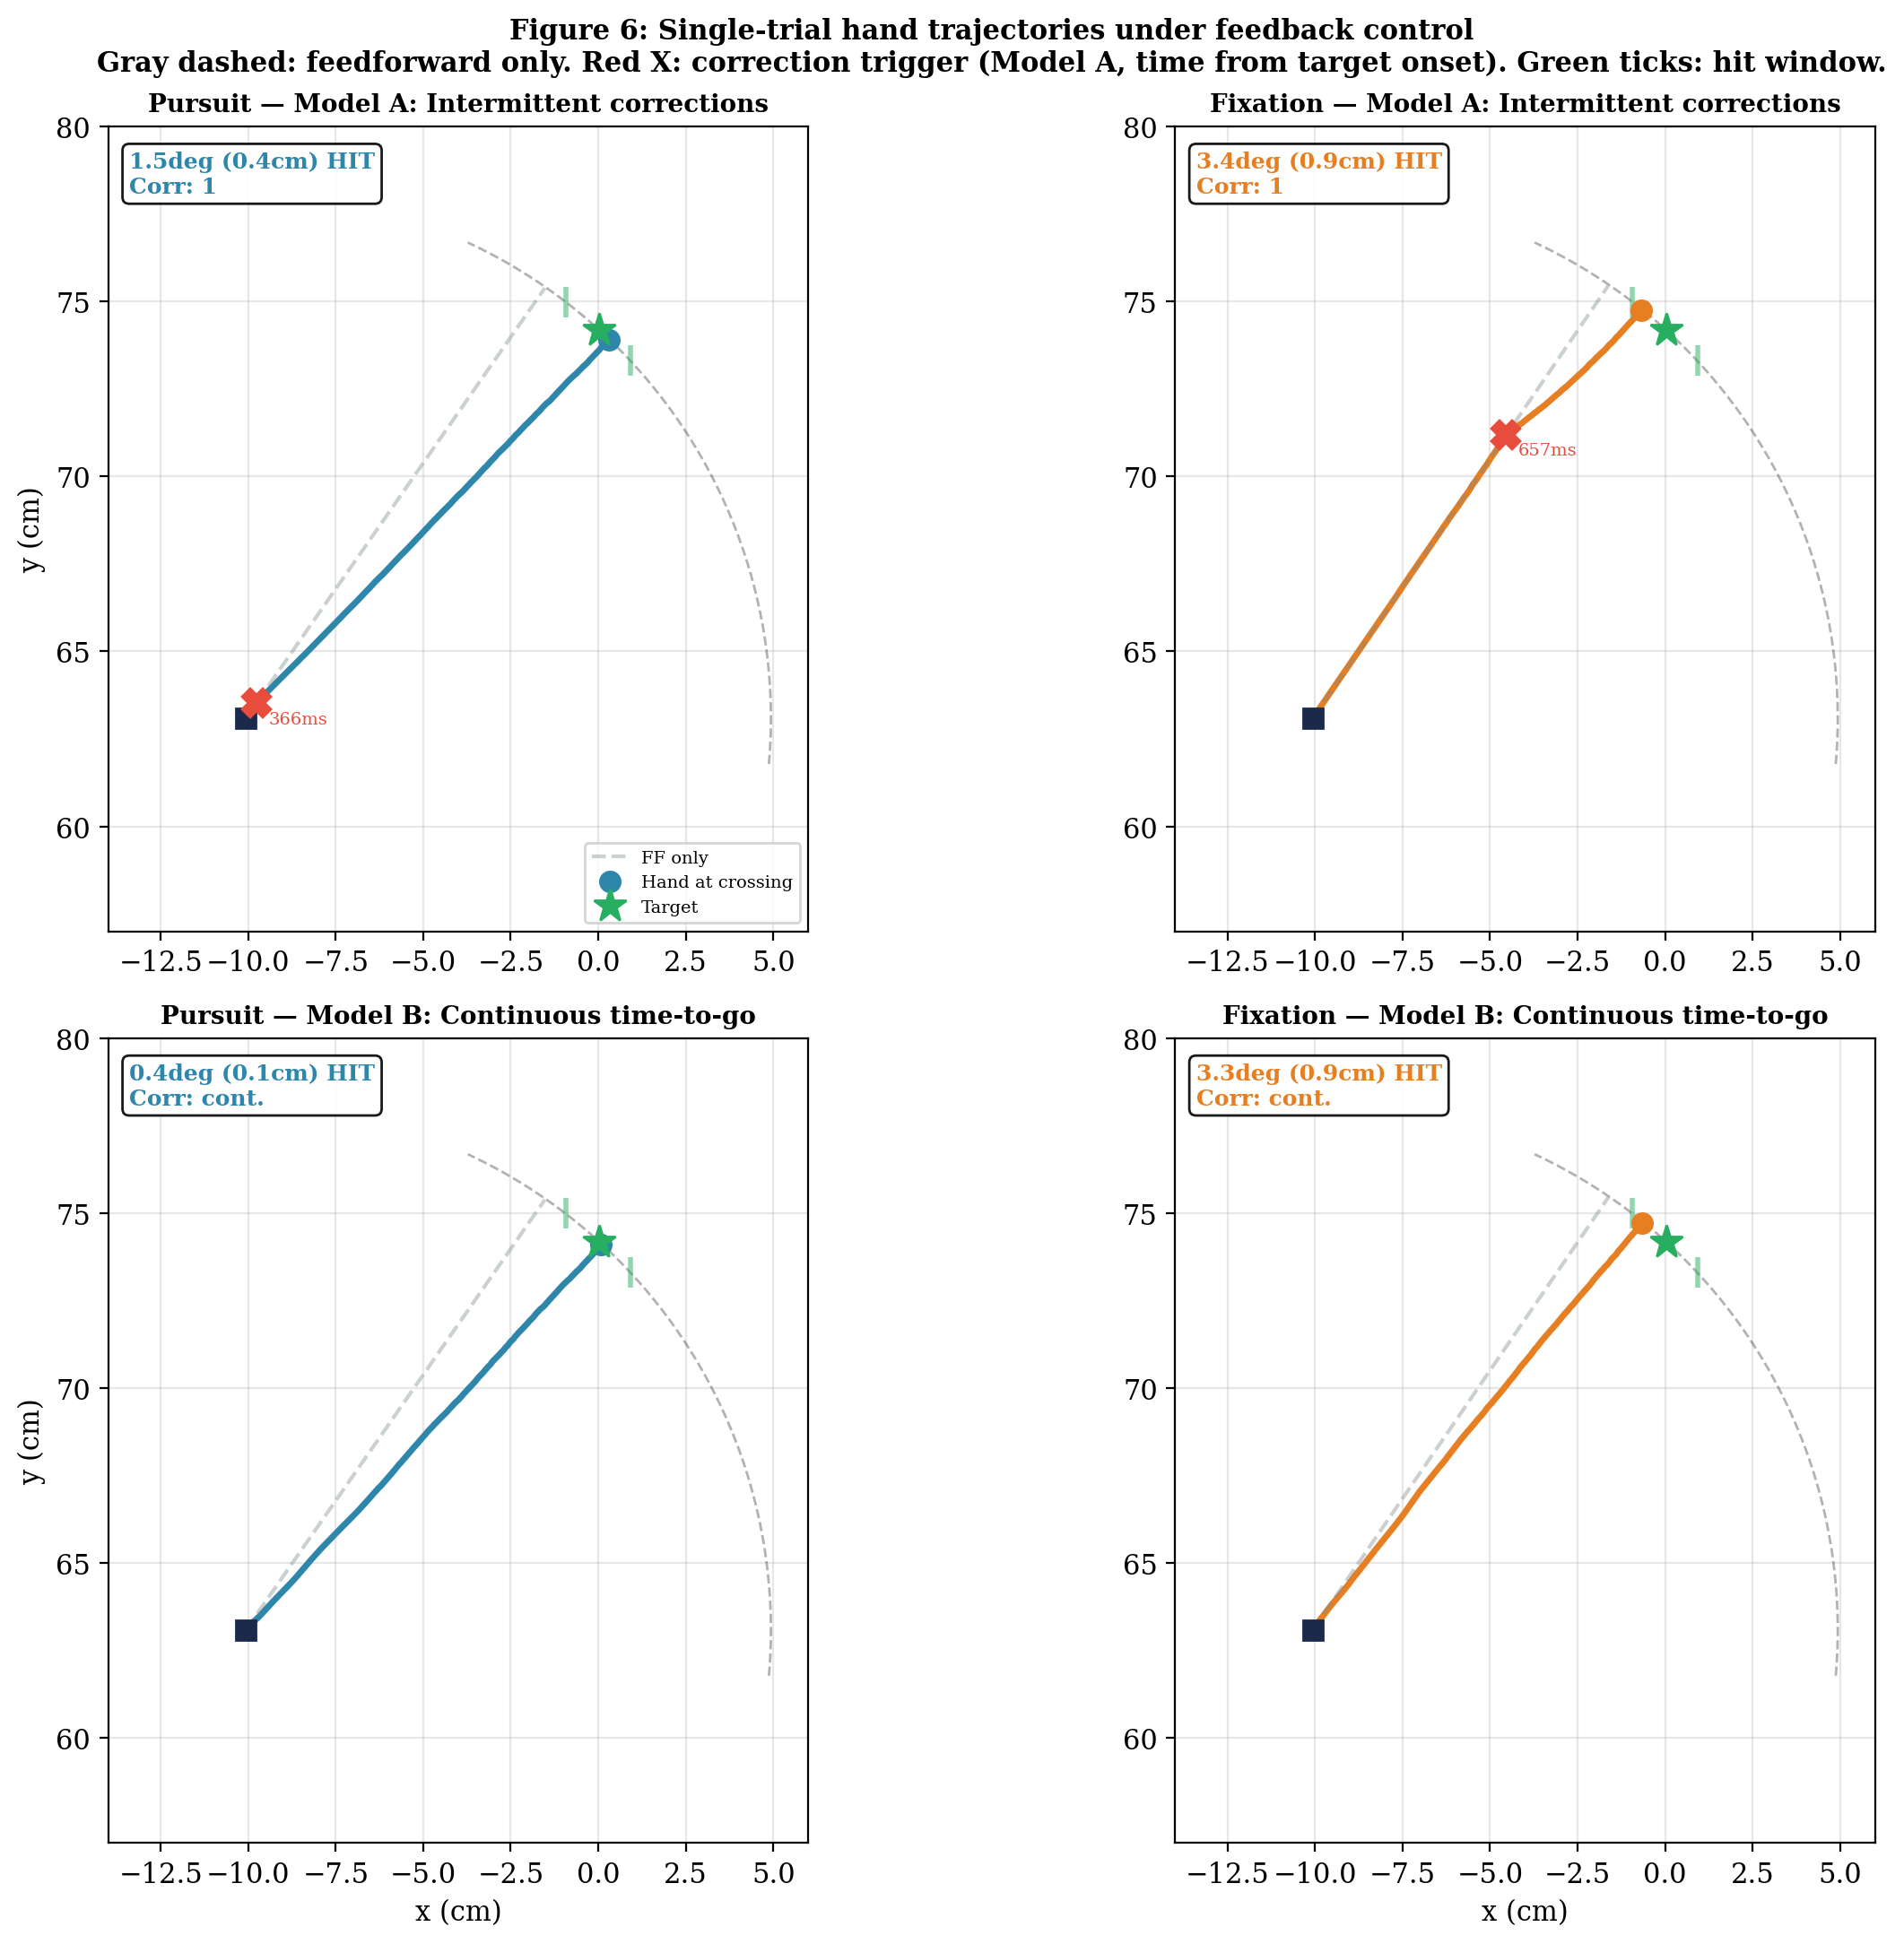
Figure 6. Single-trial hand trajectories under feedback control (seed = 13, ω = 60°/s). Gray dashed: feedforward-only trajectory (biased aim at ~50°). Colored: trajectory with feedback. Red ×: correction trigger (Model A); time labels are from target onset (hand launches at 245 ms, so 366 ms = 121 ms into the movement). Green star: target at crossing. Green ticks: hit window (±1.25 cm). Pursuit (left) corrects toward the target early; fixation (right) retains more of the bias. Both models show the pursuit advantage, but Model B produces smoother trajectories.
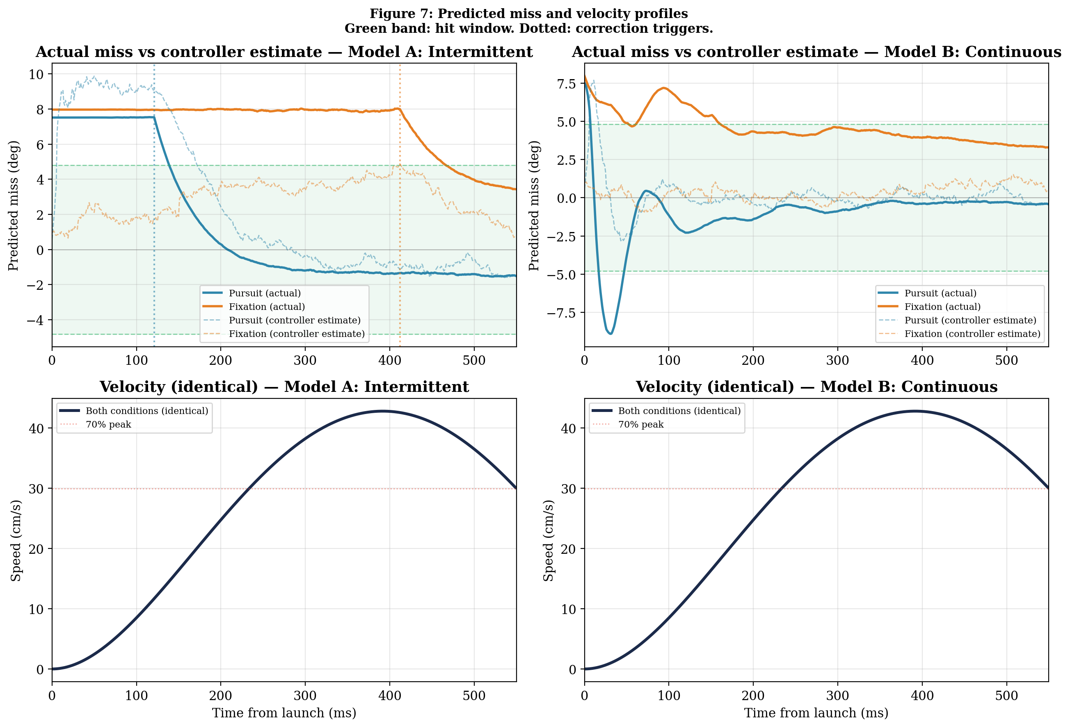
Figure 7. Actual miss vs controller estimate (top) and velocity profiles (bottom). Time axis is from hand launch (245 ms from target onset). Solid lines: actual miss (true hand angle − true target at crossing — what an omniscient observer would see). Dashed lines: controller’s estimated miss (computed from the KF target estimate and sensed hand angle — what the motor system uses to decide whether to correct). Top left (Model A): pursuit’s controller estimate (dashed teal) spikes when the composite velocity corrects the bias, triggering a correction at ~120 ms into the movement (~366 ms from target onset); actual miss (solid teal) drops to < 2°. Fixation’s controller estimate (dashed orange) stays within the hit window because the bias is self-consistent, so no correction fires — but the actual miss (solid orange) remains ~8°. Top right (Model B): continuous correction reduces both conditions, but fixation’s actual miss converges to ~3° (residual bias). Bottom: velocity profile is identical across conditions and models (single navy line) — corrections change direction, not speed.
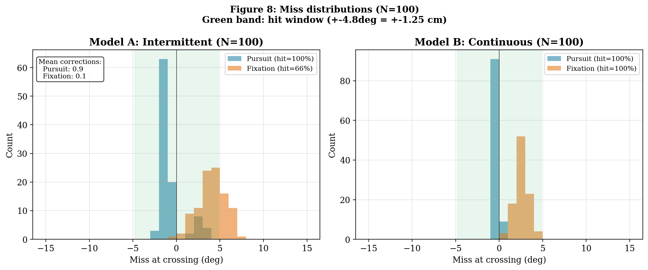
Figure 8. Miss distributions (N = 100 trials). Pursuit (teal) is centered near 0°; fixation (orange) is shifted positive by ~3–4° (Aubert-Fleischl overshoot). Model A: pursuit 100% hit rate, fixation 73%. Model B: both 100% (continuous correction keeps the miss within the window). The fixation distribution is wider and shifted, reflecting both the systematic bias and the noisier corrections.
Both models are consistent with van Donkelaar & Lee (1994). Their three conditions map directly (Figure 8 shows the resulting miss distributions):
Full vision + free gaze: pursuit KF corrects velocity bias + foveal bonus on hand. Best performance (Figure 8: teal distributions centered near 0°).
Restricted hand vision: pursuit KF corrects velocity bias, but no foveal bonus on hand. Intermediate — increased endpoint variability (their finding).
Restricted eye motion: fixation + biased velocity estimate persists throughout. No foveal bonus. Systematic overshoot + increased variability (Figure 8: orange distributions shifted positive). They found subjects aimed further ahead — consistent with the uncorrected Aubert-Fleischl bias.
The feedback phase is where pursuit and fixation diverge. The feedforward plan is nearly identical (§5). Three mechanisms compound during feedback: (1) pursuit corrects the Aubert-Fleischl velocity bias through the unbiased composite signal; fixation cannot. (2) Pursuit provides smoother target state updates → fewer/smaller corrections → less SDN. (3) The foveal bonus gives pursuit precise hand sensing for the final correction. §7 extends this framework by asking how prior expectations about target speed modulate the entire pipeline.

§7. Bayesian Priors on Target Speed
So far, the velocity estimation pipeline (§3) uses a wide, uninformative initial state (ω̂ = 0, σ_ω = 30°/s). The MT observations dominate the estimate within ~100 ms. But what if the participant has experience with the task? Across blocks of trials, they learn that certain speeds are more likely. This section develops a Bayesian framework for incorporating speed priors into the estimation pipeline and traces the consequences through feedforward planning (§5) and feedback corrections (§6).
The Thought Experiment
Consider a task with three possible target speeds: 60, 90, and 120°/s. On each trial, one speed is selected. We compare two prior conditions:
Flat prior: the participant has no strong expectation. We model this as a Gaussian with μ_prior = 90°/s (the mean of the three speeds) and σ_prior = 24.5°/s (the standard deviation of the uniform {60, 90, 120} distribution). With this width, the prior carries only ~1.7% of the total weight against 14 MT observations — the likelihood dominates.
Biased prior: 60°/s appears on 60% of trials, 90°/s on 20%, 120°/s on 20%. Through experience, the participant learns that the slow speed is the statistical mode and sets μ_prior = 60°/s. The prior width σ_prior reflects accumulated experience: the standard deviation of the speed distribution is ~24°/s, and after ~25 practice trials, σ_prior ≈ σ_distribution/√N ≈ 24/√25 ≈ 5°/s. This prior carries 29% of the total weight against the likelihood — enough to meaningfully shift the estimate.
Conjugate Bayesian Update
The brain’s velocity estimate combines prior knowledge with incoming MT observations. With Gaussian prior and Gaussian likelihood, the posterior is also Gaussian (conjugate update):
Prior: N(μ_prior, σ²_prior)
Likelihood: N(ω̂_MT, σ²_lik) where σ_lik = σ_MT / √n = 12 / √14 = 3.2°/s

Posterior: N(μ_post, σ²_post)
μ_post = w_prior × μ_prior + (1 − w_prior) × ω̂_MT
w_prior = (1/σ²_prior) / (1/σ²_prior + 1/σ²_lik)

Flat prior (μ=90, σ=24.5): w_prior = 0.017 → likelihood dominates
Biased prior (μ=60, σ=5): w_prior = 0.29 → prior pulls estimate toward 60°/s
The brain does not know about the Aubert-Fleischl bias — it interprets the biased MT observations (ω_true × 1.12) as veridical. The likelihood is therefore centered at the biased value. The prior either lets this through (flat) or fights it (biased toward 60).
Worked example: true ω = 90°/s

MT likelihood mean: 90 × 1.12 = 100.8°/s

Velocity estimate (μ_post):
Flat: 0.017 × 90 + 0.983 × 100.8 = 100.6°/s (≈ likelihood, prior too weak)
Biased: 0.29 × 60 + 0.71 × 100.8 = 88.9°/s (pulled toward 60)
True: 90°/s → biased prior accidentally corrects Aubert-Fleischl

Feedforward aim = θ(200ms) + μ_post × T_cross:
θ(200ms) = 90 × 0.200 = 18°
Flat: 18 + 100.6 × 0.550 = 73.3°
Biased: 18 + 88.9 × 0.550 = 66.9°

True intercept = 90 × (0.245 + 0.550) = 71.6°

Feedforward miss:
Flat: 73.3 − 71.6 = +1.7° (Aubert-Fleischl overshoot, within hit window)
Biased: 66.9 − 71.6 = −4.7° (prior pulls past true, at edge of hit window)
Impact on Velocity Estimation
Figure 9 shows the results across all three speeds. Panel A illustrates the conjugate update for ω = 90°/s: the likelihood (gray dotted) is centered at the biased MT mean (101°/s). The flat prior (teal) barely shifts the posterior — it sits at 101°/s. The biased prior (orange) pulls the posterior down to 89°/s, closer to the true 90°/s. In this case, the Aubert-Fleischl bias and the prior bias partially cancel.
Panel B shows the velocity estimate across speeds. With the flat prior (teal), all estimates sit near the MT biased line (×1.12 dashed red) — the prior is too weak to matter. With the biased prior (orange), the estimate is pulled toward 60°/s at all speeds:
At 60°/s: the biased prior pulls the estimate from 68 (MT biased) toward 65 — partially correcting the Aubert-Fleischl overshoot. The prior helps because it is centered near the true speed.
At 90°/s: the biased prior pulls the estimate from 101 down to 89 — now close to the true 90. Here the prior accidentally corrects the MT bias almost perfectly.
At 120°/s: the biased prior pulls the estimate from 134 down to 113 — a 21°/s underestimate. The prior fights the likelihood in the wrong direction, producing a large error.
Impact on Feedforward Planning
Panel C of Figure 9 shows the feedforward miss at launch. The flat prior (teal) produces a uniform positive miss of +1.6 to +2.3° across all speeds — the Aubert-Fleischl overshoot, barely affected by the weak prior. All misses are within the hit window (±4.8°).
The biased prior (orange) produces a speed-dependent pattern:
Feedforward miss (biased prior):
60°/s: +0.2° → prior partially corrects Aubert-Fleischl. Within hit window.
90°/s: −4.5° → prior pulls estimate too low. At edge of hit window.
120°/s: −9.3° → prior fights the likelihood badly. Well outside hit window.

Feedforward miss (flat prior):
60°/s: +1.6° → Aubert-Fleischl overshoot, uniform. All within hit window.
90°/s: +1.9°
120°/s: +2.3°
The biased prior helps at 60°/s and hurts at 120°/s. This is the Bayesian speed–accuracy tradeoff: the prior reduces feedforward error on frequent trials (60% at 60°/s) at the cost of large errors on rare trials (20% at 120°/s). Whether this tradeoff is worthwhile depends on the feedback controller’s ability to correct the large errors online (§6).
Impact on Feedback Corrections
The prior also affects the feedback phase (§6). With the biased prior on a 120°/s trial:
Model A (intermittent): the KF velocity estimate starts low and climbs slowly. The predicted interception point initially falls behind the target. If the pursuit composite corrects the bias, the controller detects the undershoot and triggers a correction. But the correction comes late because the KF was slow to converge from the biased prior. Late corrections at high hand speed inject more SDN.
Model B (continuous): the time-to-go weighting applies continuous corrections as the estimate converges. Because the prior started low, the corrections are larger and sustained throughout the early movement. This produces more SDN than on a 60°/s trial where the prior was closer.
The prediction: with a biased prior, miss variability increases for the rare speeds. The participant trades reduced average error (better on frequent 60°/s trials) for increased worst-case error (worse on rare 120°/s trials). This is optimal if the participant minimizes expected miss across trials:
Expected |miss| = Σ p_i × E[|miss| | ω = ω_i, prior]

Flat prior: 0.60×1.6 + 0.20×1.9 + 0.20×2.3 = 1.8° (uniform, all within window)
Biased prior: 0.60×0.2 + 0.20×4.5 + 0.20×9.3 = 2.9° (worse overall!)

But if we weight by hit probability:
Flat: all within hit window → ~100% hit rate
Biased: 120°/s miss = 9.3°, well outside 4.8° window → ~80% hit rate
The biased prior actually increases expected miss and decreases hit rate compared to the flat prior. This is because the Aubert-Fleischl bias and the speed prior interact: at 60°/s the prior partially corrects the MT bias (helpful), but at 120°/s the prior fights the already-biased likelihood in the wrong direction (doubly harmful). The flat prior, by staying out of the way, produces uniform and manageable errors that the feedback controller can handle (§6).
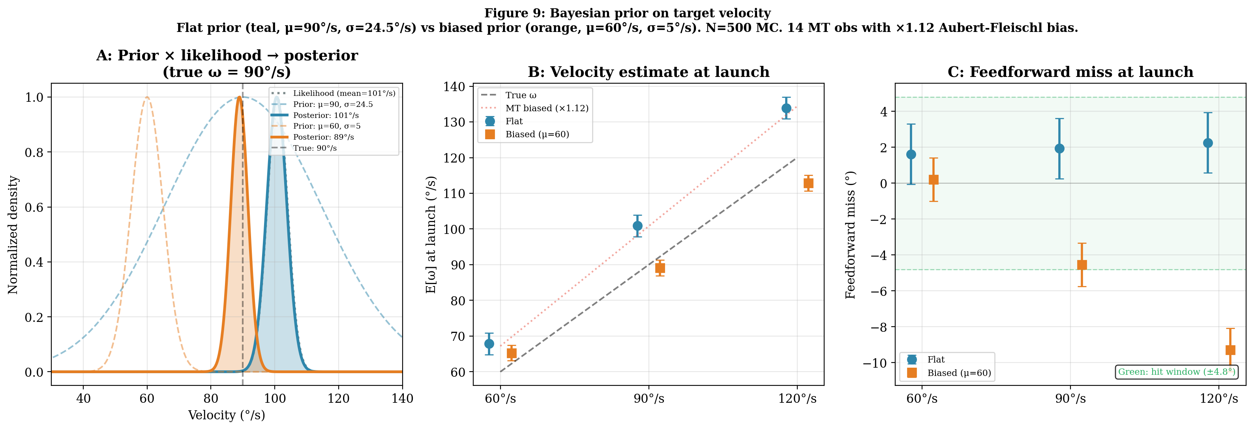
Figure 9. Bayesian prior on target velocity. Flat prior (teal, μ=90°/s, σ=24.5°/s, w=1.7%) vs biased prior (orange, μ=60°/s, σ=5°/s, w=29%). Speed distribution: 60% at 60°/s, 20% at 90, 20% at 120. A: Conjugate update for ω=90°/s — flat posterior sits at the biased MT mean (101°/s); biased posterior is pulled toward 60°/s, landing at 89°/s (close to true). B: Velocity estimate across speeds — flat tracks the MT bias line; biased prior pulls all estimates toward 60°/s (helps at 60, accidentally helps at 90, hurts at 120). C: Feedforward miss — flat produces uniform small positive miss (+1.6 to +2.3°); biased produces speed-dependent errors that exceed the hit window at 120°/s (−9.3°).
Connection to the Literature
This Bayesian framework connects to several established findings. Participants adapt their interception strategy to the statistics of the target speed distribution (Brenner & Smeets, 2015). Prior knowledge about target speed reduces saccade latency and improves pursuit initiation (Fooken et al., 2021). In our model, this is captured by the KF prior: a participant who knows the speed distribution can initialize the KF closer to the likely speed, reducing the observation time needed to converge and allowing earlier, more accurate feedforward planning.
The framework also predicts that block design matters. In a mixed block (all three speeds interleaved), the optimal prior is the mixture distribution. In a blocked design (one speed per block), the prior narrows to the block speed with very small σ_ω,0. The KF converges almost instantly because the prior is tight and accurate. This predicts faster reaction times and lower miss variability in blocked vs mixed designs — a standard finding in motor learning.
The Bayesian prior thought experiment reveals a counterintuitive result: a prior that matches the true speed distribution does not necessarily improve performance. The interaction between the Aubert-Fleischl bias and the speed prior can produce larger errors than the flat prior. The flat prior lets the (biased) MT likelihood dominate, producing uniform small overshoots that the feedback controller can correct. The biased prior fights the likelihood at high speeds, producing large undershoots that may exceed the hit window. The lesson: Bayesian optimality depends on the full generative model, including biases the brain may not know about.

§8. Reading: Fooken, Kreyenmeier & Spering (2021)
Fooken et al. (2021) review the role of eye movements in manual interception — the central topic of this lecture. Several of their key findings map onto our model:
Pursuit improves interception accuracy. Across studies, active pursuit of a moving target produces smaller miss distances than fixation. Our model provides the mechanism: pursuit delivers the unbiased composite velocity signal (§2–3) that corrects the Aubert-Fleischl bias (§5), enables better online corrections (§6), and provides the foveal bonus on hand sensing.
Eye velocity predicts hand accuracy. Fooken et al. highlight that the quality of smooth pursuit (measured by eye velocity gain) correlates with interception accuracy. In our model, pursuit gain directly determines the efference copy signal (eev = gain × target velocity). Higher gain → more accurate composite velocity → better KF estimate → better corrections. The gain control mechanism from §2 (Brostek et al., 2017) modulates this: higher pursuit speed increases the visual–motor gain, producing a positive feedback loop between pursuit quality and interception accuracy.
Timing of the saccade matters. The review discusses how saccade latency affects interception. In our model, the saccade timing determines how long the pre-saccadic (biased MT) phase lasts versus the post-saccadic (unbiased composite) phase. Earlier saccades give the KF more time to correct the velocity bias before and during the reach (§6).
Peripheral vision contributes to interception planning. Fooken et al. note that even in the fixation condition, subjects can intercept targets above chance. Our model explains this through the MT/MST velocity channel (§3): peripheral motion processing provides a direct but noisy and biased velocity signal. The fixation condition is not blind to velocity — it is biased and imprecise.

§9. Summary and Bridge to Week 11
Summary
1. Interception requires target velocity estimation — a fundamentally different problem from reaching that demands a state estimator on the target.
2. The polar Kalman filter on [θ, ω] exploits the circular arc geometry: constant-velocity process model is exact, observations arrive in the natural coordinate frame, and the state is only 2D.
3. Three observation channels produce three estimation conditions: pursuit (foveal position + composite velocity), fixation + MT (peripheral position + direct but noisy/biased MT velocity), and fixation position-only (peripheral position, velocity inferred from Δθ/Δt).
4. The Aubert-Fleischl effect biases peripheral velocity estimation by ~12%. This bias is shared across conditions at launch but corrected by the pursuit composite signal during the movement. Fixation retains the bias throughout (§5–6).
5. Feedforward planning is nearly identical across gaze conditions (§5). The pursuit advantage emerges in the feedback phase (§6), where three mechanisms compound: (1) velocity bias correction, (2) smoother target updates → fewer/smaller corrections → less SDN, (3) foveal bonus on hand sensing for the final correction.
6. Two feedback models make different predictions: Model A (intermittent, Elliott et al.) fails to detect the Aubert-Fleischl bias during fixation because the error is self-consistent. Model B (continuous, Todorov & Jordan) partially corrects it. Both predict pursuit outperforms fixation, consistent with van Donkelaar & Lee (1994) and Fooken et al. (2021).
7. Bayesian priors on target speed interact with the Aubert-Fleischl bias in surprising ways (§7). A prior that matches the speed distribution does not necessarily improve performance: at high speeds, the prior fights the already-biased likelihood, producing large undershoots. The flat (uninformative) prior produces uniform, manageable errors that the feedback controller can handle.
Controller/Estimator Summary
Week | Plant | Controller | Estimator
7 | Arm | Feedforward (inverse dynamics) | None (open-loop)
8 | Arm | P-controller, Kp=8 | Raw delayed measurement
9 | Arm | P-controller, sensor fusion | Inverse-variance fusion
10 eye | Eye | PD-controller + gain control | — (drives pursuit)
10 tgt | — | — | Polar KF on [θ, ω] + MT bias
10 arm | Arm | FF min-jerk + feedback (A: intermittent / B: continuous time-to-go) | Inv-var (hand) + KF (target) + foveal bonus
11 | Arm | EPH (λ-model) | Spinal reflex (25 ms)
Bridge to Week 11
The cortical feedback loop — from foveal observation through pursuit efference copy through the arm’s P-controller — handles interception when there is time. But look at the frontier at fast target speeds: even with the best possible target estimate, the cortical loop requires several hundred ms to converge on a reliable velocity estimate. The arm must launch toward a predicted interception point before the estimate is fully refined.
There is, however, a feedback loop that completes in time: the 25 ms spinal stretch reflex inside the λ model from Week 4. It does not estimate state — it acts directly on muscle length errors through the threshold law A = [l − λ + μ·dl/dt]⁺, providing intrinsic stiffness and damping entirely below the cortical pipeline. For interception, the λ thresholds must shift continuously as the interception point updates — the equilibrium is a moving target. Week 11 asks: does the Gribble et al. (1998) muscle model (no tendon compliance) track a continuously updating equilibrium, or does the system need Kistemaker et al.’s (2006) hybrid controller with realistic muscle-tendon mechanics?
Weeks 7–10 built the estimation pipeline: hand state from proprioception and vision, target state from the oculomotor efference copy. Week 11 asks what happens at the other end — when the motor command meets the muscle.

