Homework 12: Optimal Feedback Control
Computational Sensorimotor Control | Week 12 of 15
Due: One week from lab session

In this homework you build a complete OFC controller step by step and test it with a target-jump paradigm. Two target conditions run throughout:
Point target: the hand must reach a specific point. Both x and y position matter. A perpendicular target jump is task-relevant and must be corrected.
Bar target: the hand must reach a 5 cm vertical bar at the same x-distance. Only x matters. A perpendicular target jump moves the target along the bar — the hand is still heading toward the bar. The controller should ignore it.
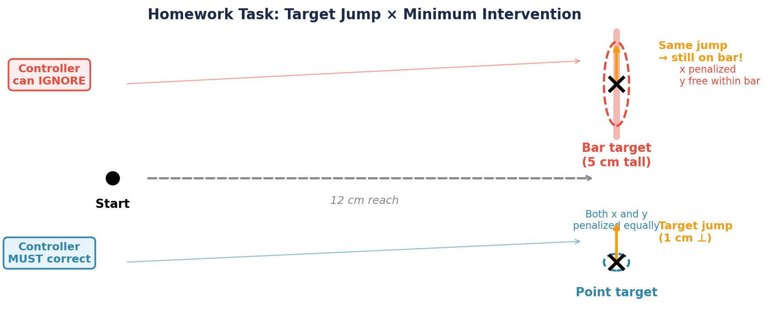
Figure 1. Task setup. The hand reaches 12 cm rightward to either a point target (blue) or a bar target (red). A 1 cm perpendicular target jump occurs mid-movement. For the point target, this jump is task-relevant (must correct). For the bar target, the jump is task-irrelevant (target is still the bar).
Deliverables: Submit HW12_OFC.ipynb with all cells executed and all questions answered.

Part 1: Linearize the Arm (2 lines)
Component: Plant model (A, B matrices)
Linearize the 2-link arm at the target posture. Compute the inverse mass matrix M⁻¹ and place it in the input matrix B_c. The A_c structure and discretization are provided.
What does M⁻¹ represent physically? Why does it appear in B_c but not A_c?

Part 2: Cost Function — Two Targets (2 lines)
Component: Q matrix design
The point target Q_N is provided. You build the bar target Q_N: penalize x errors heavily (w = 100) and y errors weakly (w = 5) using the row-decomposition of the output matrix C. This single change in Q is the only difference between the two controllers.
Q2: Why does changing Q_N change the controller’s behavior without changing the plant or the sensors?

Part 3: Backward Riccati Recursion (3 lines)
Component: Controller (optimal gains L_t)
Fill in three lines: the terminal condition S[N] = Q_N, the gain equation L[t], and the cost-to-go update S[t]. The loop structure is provided. You solve the Riccati equation for both point and bar targets, producing two different gain profiles.
Q3a: Why do the point and bar gain profiles differ?
Q3b: Why does ‖L_t‖ peak just before the endpoint and drop at the very last timestep?

Part 4: Kalman Filter (3 lines)
Component: Estimator (state estimate x̂_t)
The predict step is provided (forward model + efference copy). You fill in the update step: Kalman gain K, corrected estimate x̂_new, and updated covariance P_new. The observation model H is the same for both targets — the estimator does not know the task (separation principle).

Part 5: Baseline LQG — Point vs Bar (no fill-in)
Component: Full pipeline + minimum intervention
Run 200 LQG trials for both targets (no jump). The point target produces a compact endpoint distribution. The bar target produces an elongated distribution along y — the controller tolerates y-variability because Q_N barely penalizes it. This is the minimum intervention principle before any perturbation.
Q5a: Why is the bar ellipse elongated along y but tight in x?
Q5b: The Kalman filter is identical for both conditions. What differs, and why?

Part 6: Target Jump Implementation (2 lines)
Component: Online perturbation
A target jump of Δp in task space is equivalent to a state perturbation Δx = −J⁻¹Δp. You convert the 1 cm perpendicular jump from task space to joint space. The simulation function is provided.

Part 7: Jump at Three Times (no fill-in)
Component: Time-varying gains, control authority
Test the point-target controller with jumps at 100, 250, and 400 ms. Early jumps are fully corrected; late jumps produce endpoint errors because time runs out.
Q7a: Why does a late jump produce a larger error, even though L_t is largest near the end?
Q7b: What does the remaining control authority ΣL tell you?
Q7c: If the movement were 700 ms, how would errors change?

Part 8: Jump × MIP — Point vs Bar (no fill-in)
Component: Minimum intervention principle
The core test (see Figure 1 above): same perpendicular jump at 250 ms, two Q conditions. The point-target controller corrects aggressively. The bar-target controller ignores the jump. Identical physical event, different Q, different response.
Q8a: Why does the bar-target controller ignore the perpendicular jump?
Q8b: In the Riccati framework, Δv* = ΔxᵀS_tΔx. What is S_t in the perpendicular direction for the bar target?
Q8c: Would both controllers correct an along-reach jump? Why?

Part 9: Sensory Degradation (2 lines)
Component: Kalman filter, separation principle
Muscle vibration inflates proprioceptive noise 5× (variance 25×). The Riccati gains L_t are unchanged (separation principle). You create the degraded V matrices and compare jump correction under normal vs vibration conditions at all three jump times.
Q9a: Name the principle that explains why L_t is unchanged.
Q9b: Why is the late-jump correction preserved despite vibration?
Q9c: Why is the early-jump correction degraded?
Q9d: Vibrate the arm OR occlude foveal vision — which hurts the late-jump correction more?

Summary
By the end of this homework you have built every component of OFC and tested it:
Plant — linearized arm (Part 1)
Cost function — point vs bar Q_N (Part 2)
Controller — Riccati backward recursion (Part 3)
Estimator — Kalman filter predict-update (Part 4)
Minimum intervention — baseline variability (Part 5) + jump response (Part 8)
Online correction — target jump at three times (Parts 6–7)
Sensory reweighting — degraded proprioception (Part 9)

Total fill-in: 14 lines across 6 exercises (2–3 lines each). Focus on understanding the framework.

