WEEK 12
Optimal Feedback Control
The Minimum Intervention Principle
Reading: Todorov, E., & Jordan, M. I. (2002). Optimal feedback control as a theory of motor coordination. Nature Neuroscience, 5(11), 1226–1235.
Supplementary: Todorov, E. (2004). Optimality principles in sensorimotor control. Nature Neuroscience, 7(9), 907–915.
Supplementary: Scott, S. H. (2004). Optimal feedback control and the neural basis of volitional motor control. Nature Reviews Neuroscience, 5(7), 532–546.

Introduction
Think about what we have built so far. In Weeks 2–4, the muscles gave the arm a destination: shift the λ thresholds, and the arm’s intrinsic stiffness pulls it to a new equilibrium. In Weeks 8–10, we added eyes and proprioception so the brain could see where the hand actually went. In Week 11, we put these together and discovered a problem: the muscles can get the arm to roughly the right place, but they cannot guarantee a clean arrival. The tendon catapult in the Hill model produced 13% overshoot at fast speeds. KMHM’s velocity feedback tamed this to 8%, but required a hand-tuned gain (kd_ce = 0.30) and a hand-picked reference trajectory (min-jerk). Nobody told us why 0.30 and not 0.50, or why min-jerk and not some other shape.
The same arbitrariness haunted the estimation side. The P-controller from Week 8 used Kp = 8. Where did that number come from? Trial and error. It worked well enough, but a different task — a smaller target, a faster reach, a noisier sensor — would need a different Kp. We had no principled way to choose it.
This week we stop guessing. Optimal Feedback Control (OFC) replaces the trial-and-error approach with a simple but powerful idea: tell the mathematics what you care about, and let it compute the best possible controller for the job. You specify two things. First, a task cost: “I want the hand to land on the target, and I want it to arrive with low velocity.” Second, an effort cost: “Generating large torques is expensive.” Given these two specifications — and a forward model of the arm — the math returns a set of feedback gains that are optimal for this particular task. Not one fixed gain, but a different gain at every moment during the reach: gentle at the start, aggressive at the end when accuracy matters most.
Notice what kind of model this requires. In Week 7, inverse dynamics needed an inverse model: given a desired trajectory, what torques produce it? That required computing M(q)·q̈ + C(q,q̇) at every timestep — a complete description of the equations of motion running backward from desired movement to required force. OFC needs something simpler: a forward model. If I apply torque τ right now, what happens to the arm in the next instant? This is the same kind of prediction the Kalman filter already uses — and it is the kind of knowledge the cerebellum is thought to provide. The controller never needs to invert the dynamics.
How does OFC turn a forward model into optimal gains? The key idea is to work backward from the goal. At the very last moment of the reach, you know exactly what matters: hand on target, velocity near zero. The cost function tells you how much each error costs. So you can compute the best possible correction for that final instant. Now step back one timestep: knowing what the optimal strategy will be from that point on, you can compute the best correction for this instant. Repeat, stepping backward through the entire movement. This backward recursion is the Riccati equation. It is not an arbitrary choice of algorithm — it is what falls out of the principle of dynamic programming (Bellman, 1957): the optimal decision at any moment depends only on the current state and the optimal cost of everything that follows. For a system with linear dynamics and quadratic costs (our linearized arm), the Riccati recursion gives the exact, globally optimal solution. No other approach can do better.
Now consider the other half of the problem. The Riccati gains tell the controller how hard to push given the current state of the arm. But the controller does not know the current state of the arm. What it has are sensory signals that arrive late and corrupted by noise: proprioception tells you where the joints were 40 ms ago, plus some measurement error; peripheral vision tells you where the hand was 100 ms ago, plus a lot of measurement error. The problem of reconstructing the current arm state from these imperfect signals is state estimation — not sensing (that is the raw measurement), and not pure prediction (that would be ignoring the sensors). Estimation is the process of combining what you predicted would happen (using the forward model and a copy of your own motor command) with what you actually measured (the delayed, noisy sensory signals), to get the best possible guess of where the arm is right now.
This is exactly what the Kalman filter does, and it is the reason we use it here rather than some other estimation method. Recall from Week 9 that the KF has two steps. The predict step runs the forward model one timestep ahead and uses the efference copy (a copy of the motor command) to forecast where the arm should be. The update step compares this forecast with the actual sensory measurement and corrects the estimate, weighting the correction by how much it trusts the sensor relative to the prediction. For linear dynamics with Gaussian noise — the same assumptions that make the Riccati equation exact — the Kalman filter is provably the best possible estimator. No other filter can produce a more accurate state estimate from the same sensory data.
A remarkable mathematical fact, called the separation principle, ties these two halves together. You can solve the control problem (Riccati, working backward) and the estimation problem (Kalman filter, working forward) completely independently, and then just plug the estimated state into the optimal control law: u_t = −L_t · x̂_t. The Riccati gains do not need to know how noisy the sensors are; the Kalman gains do not need to know what the task demands are.
Why is this simple linear rule the best possible controller? In a world where you could observe the true state x_t directly, the Riccati gains L_t are already proven optimal — no other control law can achieve lower cost. But our system is partially observed: the controller cannot see the arm’s state directly. It only receives delayed, noisy sensory signals — a partial, corrupted view of reality. You might think that this limitation would require a completely different, more complicated control strategy. The separation principle says no: the best you can do is replace the unknown true state with the best possible estimate of it (the Kalman filter output x̂_t), and then apply the same Riccati gains as if you had perfect observation. Intuitively, the Kalman filter has already extracted every bit of useful information from the sensory signals; there is nothing left for the controller to gain by being clever about the uncertainty. This result holds exactly under our assumptions (linear dynamics, quadratic cost, Gaussian noise). The combined system is called LQG (Linear-Quadratic-Gaussian), and it is the formal backbone of Todorov and Jordan’s (2002) theory of motor coordination.
But the deepest insight is not the math itself — it is what the math predicts about behavior. When you tell the controller to care only about where the hand ends up (not the path it takes), a remarkable property emerges: the controller ignores deviations that don’t threaten the goal. If noise pushes the hand sideways during a forward reach, the controller barely corrects it — the hand can still arrive at the target from a shifted path. If noise pushes the hand short of the target, the controller corrects aggressively. This is the minimum intervention principle: correct only what matters.
It is important to understand what minimum intervention is not. It is not sensory gating — the brain filtering out irrelevant sensory information before it reaches the controller. In sensory gating, irrelevant signals are discarded: the controller never learns about the deviation. In minimum intervention, the controller knows the hand drifted sideways. The Kalman filter faithfully reports it. But the Riccati gains, shaped by the cost function, assign near-zero corrective effort to that deviation because acting on it would waste torque and — through signal-dependent noise — inject variability into the task-relevant direction. The controller sees the deviation and chooses not to act. This is a motor decision about resource allocation, not a sensory filter. It explains why human movements are variable in their details but reliable in their outcomes — a paradox that trajectory-tracking controllers and simple sensory gating cannot resolve.
The reach task for this week: start at Q_REF (the same 55°/75° reference posture from Week 1) and move the hand 12 cm to the right, to a static target in foveal vision. The only goal is to arrive at the target with low velocity — the path the hand takes to get there does not matter. The hand is sensed through proprioception (40 ms delay, moderate noise) and peripheral vision (100 ms delay, high noise, but including velocity via the magnocellular pathway). As the hand approaches the target and enters foveal range, visual feedback improves dramatically. The Kalman filter responds by trusting vision more (larger Kalman gains for the visual channel). The Riccati gains are already large at this point in the movement (endpoint urgency). The combination of better estimation and more aggressive control produces the corrective phase — and Woodworth’s two-component structure (ballistic launch, then corrective adjustment) falls out of the mathematics without anyone building it in.
How would all of this change if the task were different — say, tracing a straight path accurately from start to target, rather than just arriving at the target? The Kalman filter would be identical: estimation depends on the sensors and the plant, not on the task. But the Riccati gains would change dramatically. The cost matrix Q_t, which is zero at intermediate timesteps for endpoint-only reaching, would now penalize hand-position deviations at every timestep. The backward Riccati recursion would see large costs throughout the movement, not just at the end, and would produce gains that are large from the start — the controller would correct deviations immediately rather than tolerating them. Mid-trajectory variance would shrink (the controller is vigilant everywhere), but endpoint accuracy might actually suffer: the controller is spending effort on path fidelity that could have been saved for the final correction. This tradeoff — between constraining the trajectory and letting it wander — is the core of the minimum intervention principle, and we will see it play out in §5.
Figure 1 gives the big picture. The Riccati recursion (top, blue) runs backward from the endpoint before the movement begins, computing the optimal gains L_t at each timestep. The Kalman filter (bottom, red) runs forward during the movement, fusing sensory signals to produce the state estimate x̂_t. At every instant, the two meet in the control law u_t = −L_t · x̂_t: precomputed gains acting on a live estimate. The rest of this lecture derives each half and shows what happens when they work together.
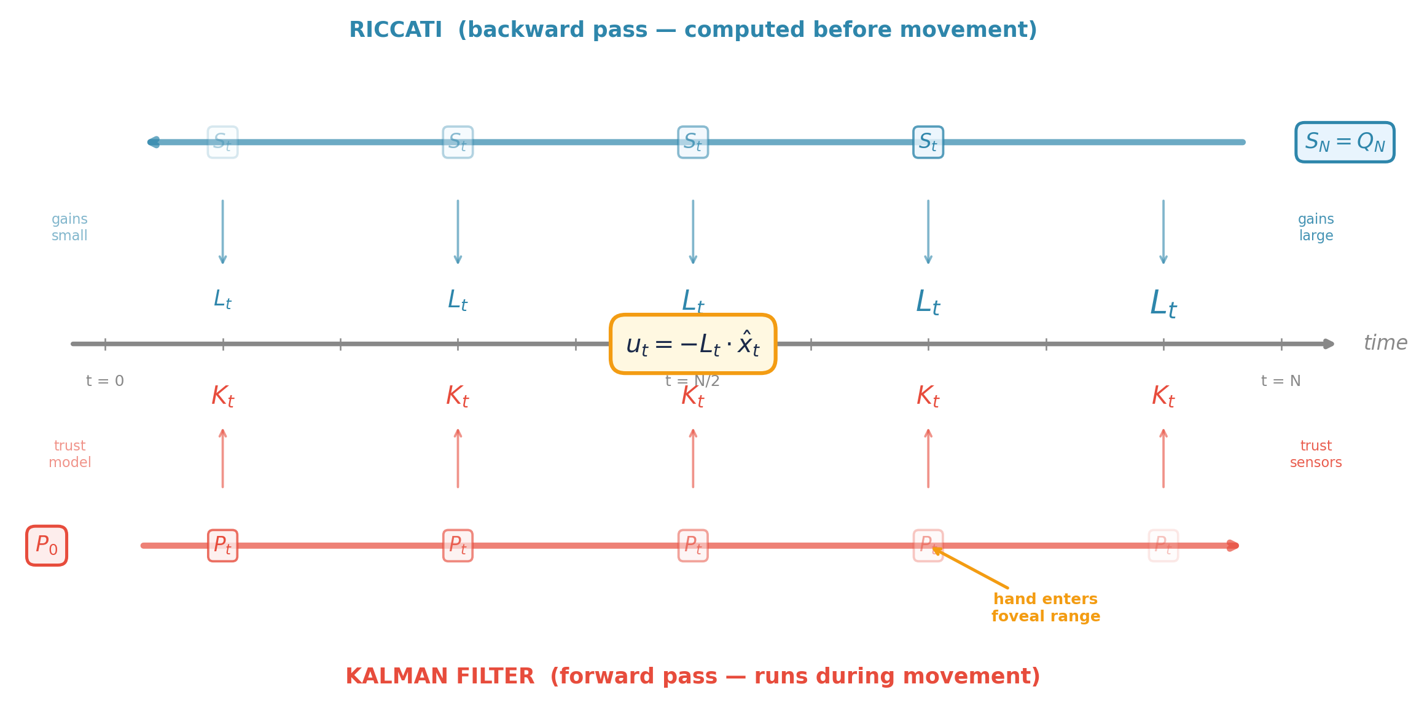
Figure 1. Two computations flowing in opposite directions. Top: the Riccati recursion starts at the endpoint (S_N = Q_N) and propagates backward, producing gains L_t that grow toward the end. Bottom: the Kalman filter starts with initial uncertainty P_0 and propagates forward, producing state estimates that improve as the hand approaches the target and enters foveal range. The control law u_t = −L_t · x̂_t couples them at every timestep.

1. The Problem with Desired Trajectories
The control architectures we have studied so far follow a serial logic: first, plan a trajectory (min-jerk, inverse dynamics), then execute it by correcting deviations from the plan. In Week 7, inverse dynamics computed the exact torques needed for a desired trajectory. In Week 8, the P-controller corrected errors from a min-jerk reference. Even KMHM in Week 11 tracked a desired CE velocity profile. In all these cases, the behavioral goal (reach the target) was replaced by a more specific instruction (follow this trajectory), and the execution mechanism attempted to minimize deviations from that instruction.
Todorov and Jordan (2002) identified a fundamental problem with this approach. If the motor system is executing a desired trajectory, then all deviations from that trajectory should be corrected equally — regardless of whether the deviation affects the task outcome. A perturbation that pushes the hand 1 cm to the left should be corrected with the same vigor as a perturbation that pushes the hand 1 cm short of the target, because both are equal-magnitude deviations from the desired trajectory.
But this is not what the motor system does. A large body of experimental evidence shows that trial-to-trial variability is structured: fluctuations in task-irrelevant dimensions are systematically larger than fluctuations in task-relevant dimensions. In pistol aiming, the final arm posture varies predominantly in the joint subspace that does not affect where the pistol points. In bimanual pointing tasks, the two hands compensate for each other’s errors to maintain the task constraint (Domkin et al., 2002). In multi-finger force production, individual finger forces are highly variable, but the total force is tightly controlled.
The Uncontrolled Manifold
Motor variability is not suppressed — it is constrained to a task-irrelevant subspace.
This pattern is observed across tasks: posture, locomotion, reaching, grasping, speech, writing.
The motor system distinguishes task-relevant from task-irrelevant errors online — impossible if the goal has been replaced with a specific trajectory.

Perturbation experiments tell the same story. When the hand is perturbed during reaching, the correction depends on the perturbation’s direction relative to the task. Perturbations along the reach direction (which would cause the hand to miss the target) are corrected aggressively. Perturbations perpendicular to the reach direction (which shift the path but not the endpoint) are corrected weakly or not at all. A trajectory-tracking controller cannot produce this pattern — it corrects all deviations equally.
These observations demand a controller that pursues the behavioral goal directly, not through the intermediary of a desired trajectory. OFC provides exactly this: the cost function specifies what matters (endpoint accuracy), and the optimal feedback law automatically corrects only the deviations that interfere with the goal.

2. From P-Controller to LQR
In Week 8, the feedback controller was u = −Kp · (x̂ − x_target). Fixed gain, position only, no velocity feedback. This was crude but effective: it steered the hand toward the target. Now we derive the optimal version of this controller.

Linearizing the Arm
LQR requires the dynamics to be linear. That means the relationship between the current state of the arm and the next state must take the form x_{t+1} = Ax_t + Bu_t, where:
x_t is the state of the arm at time t: how far the joints are from the target and how fast they are moving. Our state is the 4D vector [δq₁, δq₂, δq̇₁, δq̇₂] — deviations in joint angles and velocities from the target posture q_target. When x = 0, the arm is at the target with zero velocity.
u_t is the control signal: the joint torques [τ₁, τ₂] applied at the shoulder and elbow.
A is the drift matrix: what happens to the state in the next timestep if you do nothing (u = 0). The arm coasts under its own inertia.
B is the input matrix: how much each unit of torque changes the state. It depends on the arm’s inertia — the same mass matrix M(q) from Week 1.
In plain English: the next state equals what the arm would do on its own (Ax), plus the effect of the torques you apply (Bu). This is the forward model we discussed in the introduction — given the current state and a motor command, predict what happens next.
Why does LQR need this to be linear? The Riccati backward recursion works because, for a linear system with quadratic cost, the cost-to-go v*(t, x) is guaranteed to be a quadratic function of the state at every timestep. A quadratic function is fully described by a single matrix (S_t), and the recursion updates one matrix to get the next — exact, one backward pass, no iteration. The optimal control law falls out as a linear function of the state: u = −L_t · x.
With nonlinear dynamics — our actual arm with its Coriolis terms, and especially the Hill-type muscles from Week 11 — the cost-to-go is no longer quadratic. It becomes a complicated, curved surface over the state space that no single matrix can capture. The optimal control law is no longer a simple linear function of x, and the separation principle (which lets us solve estimation and control independently) no longer holds exactly. Solving for the true optimum would require discretizing the entire state space, which is computationally intractable even for our 4D system. The extension that handles this — iterative LQG, or iLQG — sidesteps the problem by linearizing the nonlinear dynamics around a nominal trajectory, solving the Riccati equation locally, updating the trajectory, and repeating. Each iteration reuses the same LQR machinery from this week. We will build iLQG in Week 13.
For now, we linearize the 2-link arm at the target posture q_target — the equilibrium the controller is driving toward, not Q_REF (the start posture). We choose q_target as the operating point because the arm spends most of the movement approaching this configuration, and the state x = 0 corresponds to “at the goal.” At this equilibrium, with zero velocity, the Coriolis terms vanish and the continuous-time dynamics simplify to (subscript c = continuous-time, before discretization):
dx/dt = A_c · x + B_c · u

A_c = [ 0 I ] B_c = [ 0 ]
[ 0 0 ] [ M⁻¹ ]

where M = mass_matrix(q_target) (from smc.dynamics)

Discretizing at dt = 10 ms gives the matrices the controller actually uses: A = I + A_c·dt, B = B_c·dt. This is the same arm from Week 1 — no muscles in the LQR plant. For our 12 cm reach, the joint angle difference between Q_REF and q_target is only a few degrees, so the arm stays close to the operating point throughout the movement and the linearization is accurate. A longer reach — say 20 cm — would push the arm further from q_target during the early phase, where the dropped Coriolis terms (which scale with sin(q₂)) are no longer negligible and the linear A becomes a poor approximation of the true dynamics. This is precisely the limitation that iLQG addresses by re-linearizing at each iteration rather than trusting a single linearization at the endpoint.

The Cost Function
We need to translate “I want the hand on the target with low velocity, and I don’t want to spend too much effort getting there” into a mathematical objective. The standard choice is a quadratic cost — meaning the penalty grows as the square of the error. This is a design choice, not a law of nature, but it has three properties that make it the right one here. First, squaring penalizes large deviations disproportionately: a 2 cm miss costs four times as much as a 1 cm miss, which matches the intuition that big errors matter more than small ones. Second, the squared function is smooth everywhere (unlike absolute value, which has a kink at zero), so the calculus of optimization works cleanly. Third — and this is the practical reason — it is the cost form that makes the Riccati recursion exact. Any other form and you lose the one-pass backward solution we just discussed; you would need iterative numerical methods with no guarantee of finding the global optimum.
The cost function has two terms:
J = Σ_{t=0}^{N} x_tᵀ Q_t x_t + Σ_{t=0}^{N-1} u_tᵀ R u_t

subject to: x_{t+1} = A x_t + B u_t

The first sum is the state cost: at each timestep, the matrix Q_t determines how much each component of the state deviation is penalized. The second sum is the control cost: the matrix R determines how expensive each unit of torque is. The tradeoff between Q and R is the single dial that replaces hand-tuning. Large Q relative to R says “accuracy matters more than effort” — the controller will push harder and faster. Large R relative to Q says “conserve effort” — the controller will be gentler and slower, producing a movement that takes longer but costs less energy. This is the principled replacement for choosing Kp = 8 by trial and error.
Critically, Q_t is defined in task space (hand position), not joint space. The Jacobian J maps joint deviations to hand-position deviations: δp = J·δq. So the joint-space cost is Q_joint = CᵀQ_taskC, where C = [J, 0₂ˣ₂] maps the 4D state to 2D hand position. This means the controller penalizes hand-position errors, not joint-angle errors — exactly what the reaching task demands. R, by contrast, operates directly in joint space: it penalizes the torques [τ₁, τ₂] that the controller applies at the shoulder and elbow, with no Jacobian transformation needed.

The Riccati Equation
The optimal feedback gains L_t come from solving the discrete-time Riccati equation backward from the endpoint:
S_N = Q_N (terminal cost)

L_t = (R + Bᵀ S_{t+1} B)⁻¹ Bᵀ S_{t+1} A (optimal gain)

S_t = Q_t + Aᵀ S_{t+1} (A − B L_t) (cost-to-go)

Control law: u_t = −L_t · x_t

The matrix S_t is the cost-to-go: the total expected cost from timestep t onward, assuming the controller behaves optimally from that point forward. Do not confuse it with Q_t. Q_t is what you choose — the instantaneous penalty you assign to being in state x at time t. S_t is what the math computes — the cumulative penalty from t through the endpoint. The recursion S_t = Q_t + Aᵀ S_{t+1} (A − B L_t) says: the cost from here onward equals the local penalty Q_t, plus the optimally-controlled future cost propagated one step backward. At the terminal step, S_N = Q_N because there is no future. At earlier steps, S_t ≥ Q_t because it includes everything ahead.
This is where the choice of Q_t determines the character of the controller. For endpoint-only reaching (our primary task this week), Q_t = 0 at all intermediate timesteps — the only penalty is Q_N at the end. The recursion propagates that terminal cost backward through the dynamics, but with each backward step it fades: S_t shrinks as t moves further from N, because there is more time to fix errors. The gains L_t (computed from S_{t+1}) inherit this pattern: small early, large late. The controller is permissive during mid-movement and aggressive near the endpoint.
For path tracking (the contrast we discussed in the introduction), Q_t is nonzero at every timestep. Now each backward step adds local cost on top of the propagated future cost, so S_t never fades — it stays large throughout the movement. The gains L_t are high from the start, and the controller corrects deviations immediately. This is why path tracking suppresses mid-trajectory variability but may sacrifice endpoint accuracy: the controller spends effort enforcing the path that could have been saved for the final correction.
Between these two extremes lies the ramped Q: Q_t = 0 during the first 70% of the movement, then increases quadratically over the last 30%. This is a rough approximation of the sensory transition during reaching — as the hand approaches the target and enters foveal range, the cost of being off-target ramps up. The gains L_t rise earlier than in the endpoint-only case but remain small during the initial ballistic phase.

Key insight: L_t is NOT constant. Compare this with the Week 8 P-controller: constant Kp = 8 throughout the movement. The LQR gains start small and rise, producing a smooth acceleration phase (when the controller is permissive) followed by an aggressive deceleration and correction phase (when endpoint accuracy dominates). This time-varying structure is a direct consequence of the optimization — no hand-tuning required.
Figure 2 shows these gain profiles. Panel A plots the overall gain magnitude ‖L_t‖ for endpoint-only Q (blue) and ramped Q (red). Both increase toward the endpoint, but the ramped condition rises earlier because its Q_t begins penalizing errors at 70% of the movement. Panel B decomposes the gains for the shoulder torque. The full gain matrix L_t is 2×4 (two torques × four state variables = eight gain components per timestep). Panel B shows the first row — the four components that map state deviations to shoulder torque τ₁: position feedback (δq₁ → τ₁, δq₂ → τ₁) and velocity feedback (δq̇₁ → τ₁, δq̇₂ → τ₁). The elbow row (not shown) has the same time-varying structure. Velocity feedback grows fastest near the end — the controller adds a braking term as the hand approaches the target, something the Week 8 P-controller (position only) could not do.
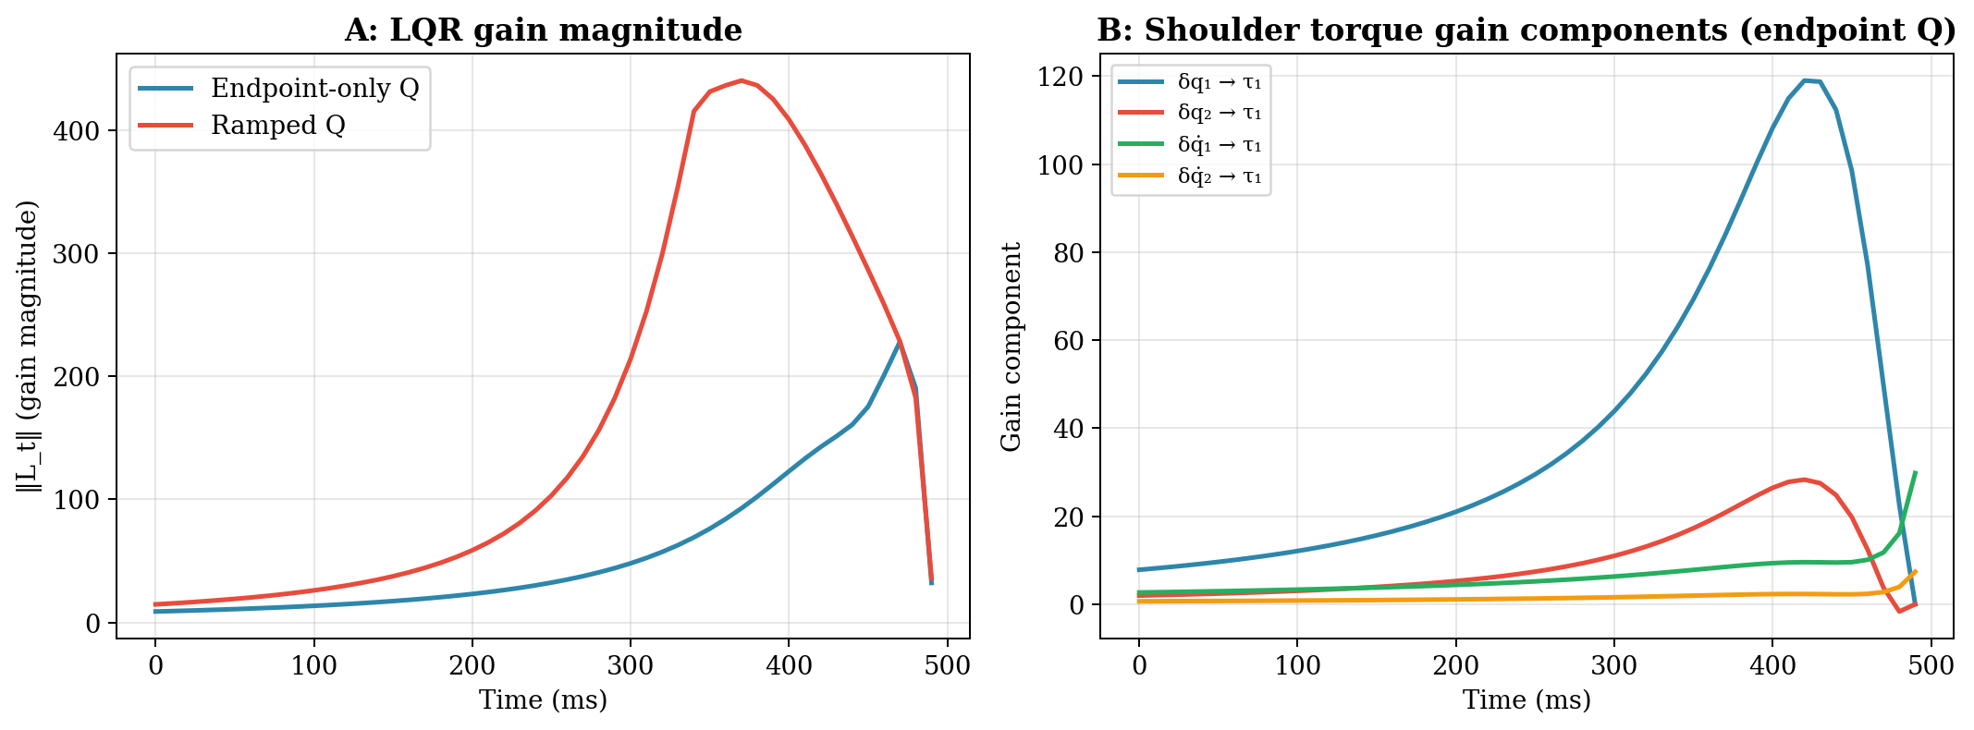
Figure 2. Time-varying LQR gains from the backward Riccati recursion. A: Gain magnitude ‖L_t‖ over time for two cost configurations: endpoint-only Q (blue) and ramped Q (red). B: Individual gain components mapping state deviations to shoulder torque.
What do these gains produce? Figure 3 shows the resulting hand trajectories in a deterministic simulation (no noise, full state feedback — the Kalman filter is not yet involved). Panel A: the hand paths for both Q configurations are nearly straight, closely following the min-jerk reference. Panel B: displacement traces show the hand arriving at 12 cm. Panel C: the velocity profiles are smooth and bell-shaped, resembling min-jerk, but they arise from optimality rather than a smoothness assumption. The endpoint-only controller (blue) is slightly more aggressive early on, reflecting its freedom to choose any path.
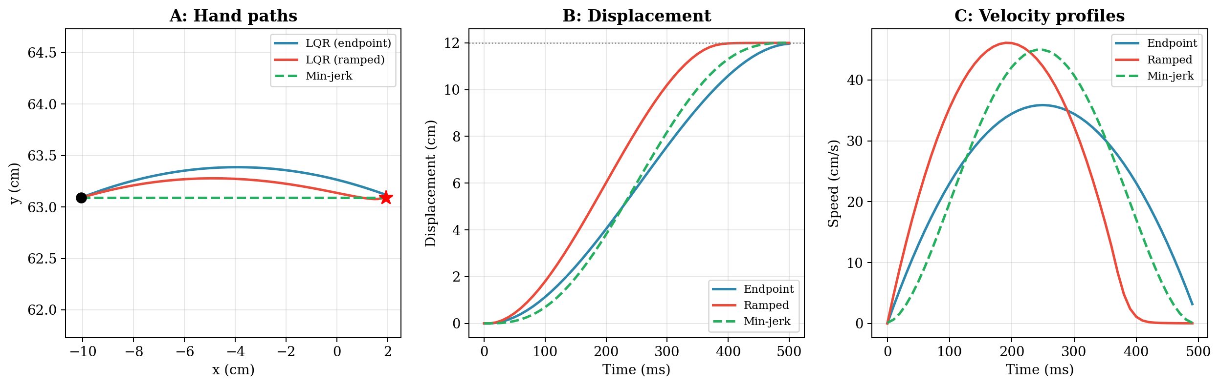
Figure 3. Deterministic LQR reaching (no noise, full state feedback). A: Hand paths. B: Displacement traces. C: Velocity profiles. The LQR trajectories are smooth and bell-shaped, resembling min-jerk, but arise from optimality rather than a smoothness assumption.
LQR vs the P-Controller
The Week 8 P-controller was u = −Kp(x̂ − x*) with fixed Kp = 8, position only.
LQR computes time-varying gains L_t with both position AND velocity feedback.
LQR gains increase near the endpoint (urgency); the P-controller is constant.
LQR is optimal for the specified Q and R; the P-controller is ad hoc.
LQR reduces to a constant-gain controller only if Q_t is the same at every timestep and the horizon is infinite — meaning the movement never ends, which makes no sense for reaching. Finite-horizon movements (with a defined duration) always produce time-varying gains.

But wait — why do we need a Kalman filter?
Figures 2 and 3 showed smooth, accurate reaching with just LQR. The hand arrived at the target, the velocity profile was bell-shaped, and no estimation was involved. So why add the complexity of a Kalman filter?
Because those simulations computed u_t = −L_t · x_t — plugging the true state directly into the control law. There was no observation step. Formally, this is equivalent to assuming the observation matrix H = I (you see the full state directly) and the sensory noise V = 0 (perfect measurement with no delay). Under those assumptions, x̂_t = x_t at all times and the Kalman filter is trivially an identity operation that can be skipped. In reality, H is an 8×4 sensory matrix (proprioception and vision each measure a partial, transformed view of the state), and V is far from zero. If you plug raw, delayed sensory signals into the finely tuned L_t gains, the result is a disaster: the controller applies large corrections based on stale, inaccurate information, producing jerky, oscillatory movements. The Kalman filter bridges this gap — it reconstructs the best possible estimate x̂_t from imperfect sensors, so that the Riccati gains have something trustworthy to act on.

3. From Raw Measurement to Kalman Filter
LQR assumes the controller knows the full state x_t. But the real motor system observes the arm through delayed, noisy sensors. In Weeks 8–10, we used raw delayed measurements and inverse-variance fusion. The Kalman filter from Week 9 tracked the target in polar coordinates. Now we apply the same framework to estimate the hand’s state — the state the LQR controller needs.

The Sensory Model
Three channels provide information about the hand during reaching:
Proprioception (delay ≈40 ms): Muscle spindles (Ia and group II afferents) sense muscle length and rate of stretch, providing joint angles [q₁, q₂] and angular velocities [q̇₁, q̇₂]. (Golgi tendon organs sense force, not position — they become relevant for force-field perturbation detection but are not part of the state estimation pipeline this week.) Position noise σ ≈ 1°, velocity noise σ ≈ 5°/s. This is the fastest channel — the same spinal proprioceptive pathway from Week 9.
Peripheral vision of hand (delay ≈100 ms): When gaze is on the target (the fixate-target strategy from Week 8), the hand falls in the visual periphery. Peripheral retina provides hand position [x, y] and velocity [ẋ, ẏ] in task space, via the motion-sensitive magnocellular pathway. Position noise σ ≈ 5 mm (eccentricity-dependent), velocity noise σ ≈ 1 cm/s (roughly twice foveal, reflecting degraded motion sensitivity in the periphery). Noisier than proprioception, but in task-space coordinates.
Foveal vision of hand (delay ≈100 ms, late phase only): When the hand approaches the target and enters the foveal field (∼3–5° visual angle), visual feedback improves dramatically: σ_pos ≈ 1 mm, σ_vel ≈ 5 mm/s.
The observation model maps the 4D joint state [δq₁, δq₂, δq̇₁, δq̇₂] — positions and velocities of both the shoulder and elbow — to an 8D measurement vector. The observation equation is:
y_t = H x_t + v_t, v_t ~ N(0, V_t)

In words: what you measure (y_t) equals the true state (x_t) transformed through the sensory mapping (H), plus random noise (v_t) drawn from a Gaussian distribution with covariance V_t. The matrix H encodes what each sensor physically measures:
H = [ I₄ ] (proprioception: 4 rows)
[ C_vel ] (vision: 4 rows)

The top block is I₄ (the 4×4 identity matrix) because proprioception measures joint angles and velocities directly — spindles sense the same variables [q₁, q₂, q̇₁, q̇₂] that make up the state vector, so the mapping from state to measurement is one-to-one. No coordinate transformation is needed. The bottom block is C_vel = [J, 0; 0, J] because vision measures the hand in Cartesian task space [x, y, ẋ, ẏ], not the joints. The Jacobian J converts joint deviations to hand-position deviations (δp = J·δq), applied separately to position and velocity. Both peripheral and foveal vision use the same H — both see the hand in the same task-space coordinates through the same geometric transformation. What changes between them is the noise V_t: peripheral vision has large noise, foveal vision has small noise.
The transition between peripheral and foveal noise is modeled as a smooth sigmoid blend:
V_t = (1 − α_t) V_periph + α_t V_foveal

α_t = sigmoid(t; transition at ~70% of movement)

Why a sigmoid, and not a hard switch? In reality, the hand does not jump from peripheral to foveal vision at a single instant. As the hand glides toward the target (where gaze is fixated), the visual angle between hand and gaze shrinks continuously. The foveal field spans about 2–3° of visual angle, and the hand passes through a transition zone where resolution improves gradually. A hard switch in V_t would produce a sudden jump in the Kalman gains, causing the controller to jerk as it abruptly reweights its sensory trust. The sigmoid blends the two noise regimes smoothly, producing a gradual shift in Kalman gains that matches the physical optics of the transition. The 70% onset point means the hand enters foveal range during the last ∼150 ms of a 500 ms reach — consistent with the hand being within a few centimeters of the target at that point.

Note on delays: The rigorous way to handle sensory delays is to augment the state vector with buffered past observations. For this week, we use the computationally simpler approximation of inflating sensory noise — a delayed sensor is roughly equivalent to a noisier instantaneous sensor (Todorov, 2002, Supplementary Notes). We will implement the full augmented-state formulation in Week 13 alongside iLQG.

The Kalman Filter
The Kalman filter from Week 9 generalizes directly. At each timestep:
Predict: x̂_pred = A x̂_t + B u_t (forward model + efference copy)
P_pred = A P_t Aᵀ + W (uncertainty grows)

Update: K_t = P_pred Hᵀ (H P_pred Hᵀ + V_t)⁻¹ (Kalman gain)
x̂_{t+1} = x̂_pred + K_t (y_t − H x̂_pred) (correct estimate)
P_{t+1} = (I − K_t H) P_pred (uncertainty shrinks)

Every symbol in these equations, with its dimensions:
x̂_t (4×1): current state estimate [δq₁, δq₂, δq̇₁, δq̇₂] — the filter’s best guess of the arm’s state right now.
A (4×4): state transition matrix — how the arm’s state drifts in one timestep if no torque is applied (the arm coasts). Same matrix from §2.
B (4×2): input matrix — how the two joint torques change the four state variables. Same matrix from §2.
u_t (2×1): control signal [τ₁, τ₂]. Arrives at the estimator via efference copy — an internal copy of the motor command, available with 0 ms delay because it never leaves the brain. This is why the predict step can run immediately: the estimator knows what the controller just commanded without waiting for any peripheral signal.
P_t (4×4): estimation uncertainty covariance — how confident the filter is about x̂_t. Large P means uncertain; small P means confident.
W (4×4): process noise covariance — how much the state drifts unpredictably between timesteps (neural noise, unmodeled dynamics).
H (8×4): observation matrix — maps the 4D joint state to 8D sensory measurements. Top 4 rows = I₄ (proprioception), bottom 4 rows = C_vel (vision via Jacobian). See above.
V_t (8×8): sensory noise covariance — how noisy each measurement channel is. Blended between V_periph and V_foveal by the sigmoid α_t.
K_t (4×8): Kalman gain — how much to correct the state estimate for each unit of measurement surprise (y_t − Hx̂_pred). Large K means trust the sensors; small K means trust the prediction.
y_t (8×1): sensory measurement vector — 4 proprioceptive signals + 4 visual signals.
I (4×4): identity matrix.
The predict step uses the same forward model (A, B) from §2 — the linearized arm dynamics. This is the internal forward model that Wolpert et al. (1995) proposed and that we formalized in Week 9, now applied to the hand rather than the target.
Figure 4 shows the Kalman filter in action during the reach. Panel A decomposes the Kalman gain for the position estimate by sensory source. Vision (red) provides the larger correction throughout — even during the peripheral phase — because it measures hand position directly in task-space coordinates. Proprioception (blue) measures joint angles, which must be mapped through the Jacobian to infer hand position; by the time this transformation propagates the σ ≈ 1° joint-angle noise to task space, the resulting hand-position uncertainty is comparable to peripheral vision’s σ ≈ 5 mm. When the hand enters foveal range at ~350 ms, the visual gain jumps further as measurement noise drops. Panel B shows the same decomposition for velocity: vision again dominates, and proprioception contributes a steady but smaller correction. Panel C shows the foveal blend α (gold) and the overall estimation uncertainty tr(P) (purple dashed). When α rises, tr(P) drops — the filter’s confidence improves, which will matter in §4 when these estimates drive the controller.
Important: The relative positions of these curves depend entirely on the σ values we chose for each sensor. If we had assumed noisier peripheral vision (σ_pos = 10 mm instead of 5 mm), proprioception would dominate the position estimate early on. If we had assumed quieter proprioception (σ = 0.5° instead of 1°), it would dominate even more. The Kalman filter automatically reweights according to whatever noise levels it is given — the structure of the curves (the foveal jump, the steady proprioceptive baseline) would remain, but which channel sits on top would change. This is both a strength and a limitation: the framework handles any noise profile, but the specific predictions depend on getting the noise parameters right.
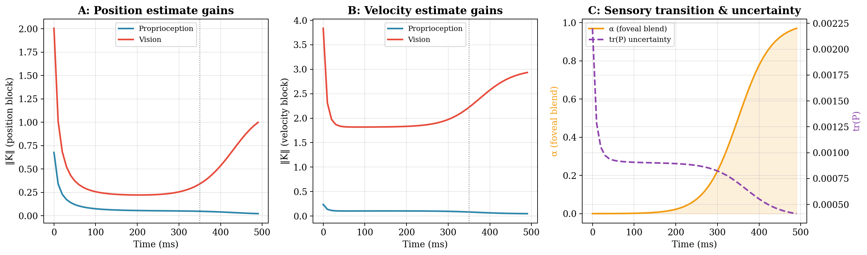
Figure 4. Kalman filter behavior during reaching. A: Kalman gains for the position estimate. Vision (red) dominates because it measures hand position directly in task space; proprioception (blue) contributes less after Jacobian transformation. B: Kalman gains for the velocity estimate — same pattern. C: Foveal blend α (gold) and estimation uncertainty tr(P) (purple dashed). Uncertainty drops when the hand enters foveal range.

4. LQG = LQR + Kalman Filter
The optimal controller for a system with noisy, partial observations combines LQR and the Kalman filter through the separation principle:
u_t = −L_t · x̂_t

where L_t comes from the backward Riccati (§2)
and x̂_t comes from the forward Kalman filter (§3)

Two computations, two roles: L_t is the controller — it determines how the arm responds to state errors. K_t is the estimator — it determines how sensory signals update the state estimate. The separation principle states that these two computations are independent: the optimal gains L_t do not depend on the sensory noise V_t, and the Kalman gains K_t do not depend on the task cost Q_t. The controller is computed as if the state were perfectly observed; the estimator is computed as if no control were applied. The two are then coupled by feeding the estimated state into the control law.

Two Gains, Two Jobs
LQG involves two sets of time-varying gain matrices that look superficially similar but solve opposite problems:
L_t (Riccati gains, §2): map estimated state → control signal. These answer: given that I believe the arm is in state x̂, how hard should I push? They come from the backward Riccati recursion. L_t depends on Q (task demands) and R (effort cost). Late in the movement, L_t grows because endpoint accuracy matters and time is running out.
K_t (Kalman gains, §3): map measurement surprise → state estimate update. These answer: given that I predicted one thing and measured another, how much should I revise my belief? They come from the forward Kalman recursion. K_t depends on W (process noise) and V_t (sensory noise). When peripheral vision is replaced by foveal vision, V_t drops and K_t for the visual channel increases — the filter trusts the measurement more.
The separation principle says L_t and K_t are computed independently. But the performance of the combined system depends on both. A controller with perfect gains (L_t) will still perform poorly if the state estimate (shaped by K_t) is bad. Conversely, a perfect state estimate is wasted if the control gains are wrong.
Figure 5 places the two gain profiles side by side. Panel A shows L_t (the controller) plotted forward in time (0 ms = movement onset, 500 ms = movement end), even though the Riccati recursion that computed these gains ran backward from the endpoint. The gains grow toward the endpoint — the rising profile we derived in §2 from the endpoint-only Q. Notice that the gain peaks just before the very last timestep and then drops sharply at the end. This is not a bug: at the penultimate step, the controller is most aggressive because it still has a few steps remaining to correct errors. At the very last step (t = N−1), there is only one control action left, and the arm’s dynamics limit what a single torque step can achieve — so the effective gain is smaller. The peak in L_t reflects the optimal tradeoff between urgency and mechanical feasibility. Recall from the Riccati discussion that if the task were path tracking (Q_t nonzero at every timestep), L_t would be large and roughly constant from the start rather than rising. The shape of L_t directly reflects what you told the cost function to care about.
Panel B shows ‖K_t‖, the Frobenius norm of the full 4×8 Kalman gain matrix — the combined contribution of all eight sensory channels (4 proprioceptive + 4 visual) to the state estimate. Figure 4 decomposed K_t by sensory source; Figure 5 shows the total. K_t is high at the start because the initial estimation uncertainty P_0 is large: the filter begins with a vague guess of the arm’s state and trusts early measurements heavily to rapidly reduce that uncertainty. After a few timesteps, P shrinks and K_t settles to a steady level governed by the balance between ongoing process noise W (which pushes uncertainty up each timestep) and sensory noise V_t (which determines how much each measurement pulls it back down). The late jump is the foveal transition — when the hand enters foveal range, V_t drops and K_t rises as the filter shifts trust toward the now-precise visual signal.
Both gains must converge for the corrective phase to work: large L_t near the endpoint (the controller is urgent) AND accurate x̂_t from improved K_t (the estimator is confident). If either is missing — large L_t acting on a poor estimate, or a good estimate feeding into small L_t — the correction phase fails.
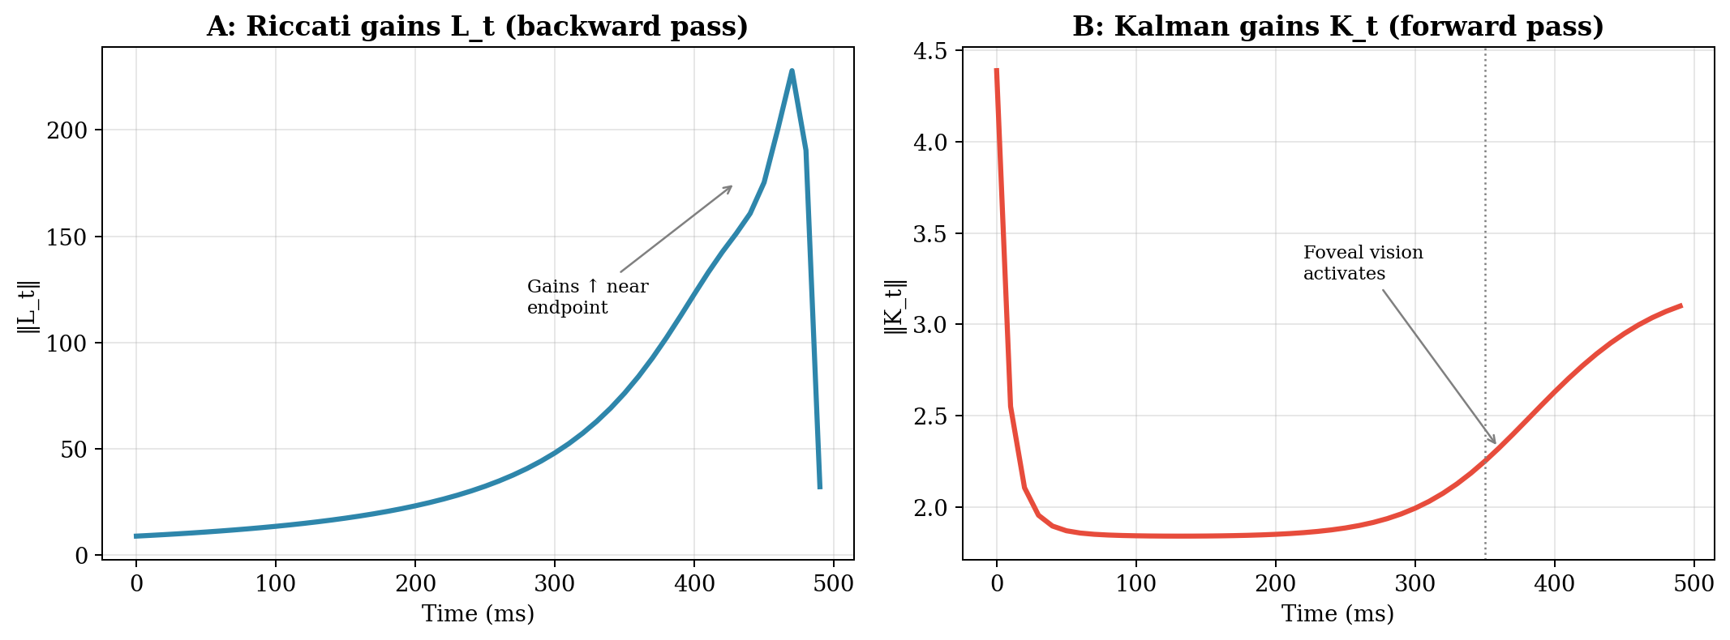
Figure 5. Two gains, two directions. A: Riccati gains L_t from the backward pass. B: Kalman gains K_t from the forward pass.
Figure 6 shows the result when both halves work together: 200 LQG trials of the 12 cm reach with process noise and sensory noise. Panel A: individual hand paths (light traces) fan out mid-movement but converge to the target — the signature of minimum intervention, which we will examine in §5. Panel B: the endpoint scatter, with a ±2 SD ellipse.
Panel C answers a question the student should be asking: how well does the Kalman filter actually track the true arm state? This matters because the controller acts on x̂_t, not x_t — if the estimate is wrong, the controller pushes in the wrong direction. The plot shows, for a single trial, the true displacement (blue) and the KF estimate (red dashed). Early in the movement, the estimate lags behind the truth: the filter starts uncertain (large P_0) and the sensory signals are delayed and noisy, so it takes time to lock on. By mid-movement, the estimate tracks the truth closely. After ~350 ms, when the hand enters foveal range, the two curves become nearly indistinguishable — the filter’s estimate is accurate enough for the large Riccati gains L_t to make precise corrective adjustments. The early lag is acceptable because L_t is small early on (the controller is permissive); the late accuracy is critical because L_t is large (the controller is aggressive). This is the L_t × K_t synergy at work.
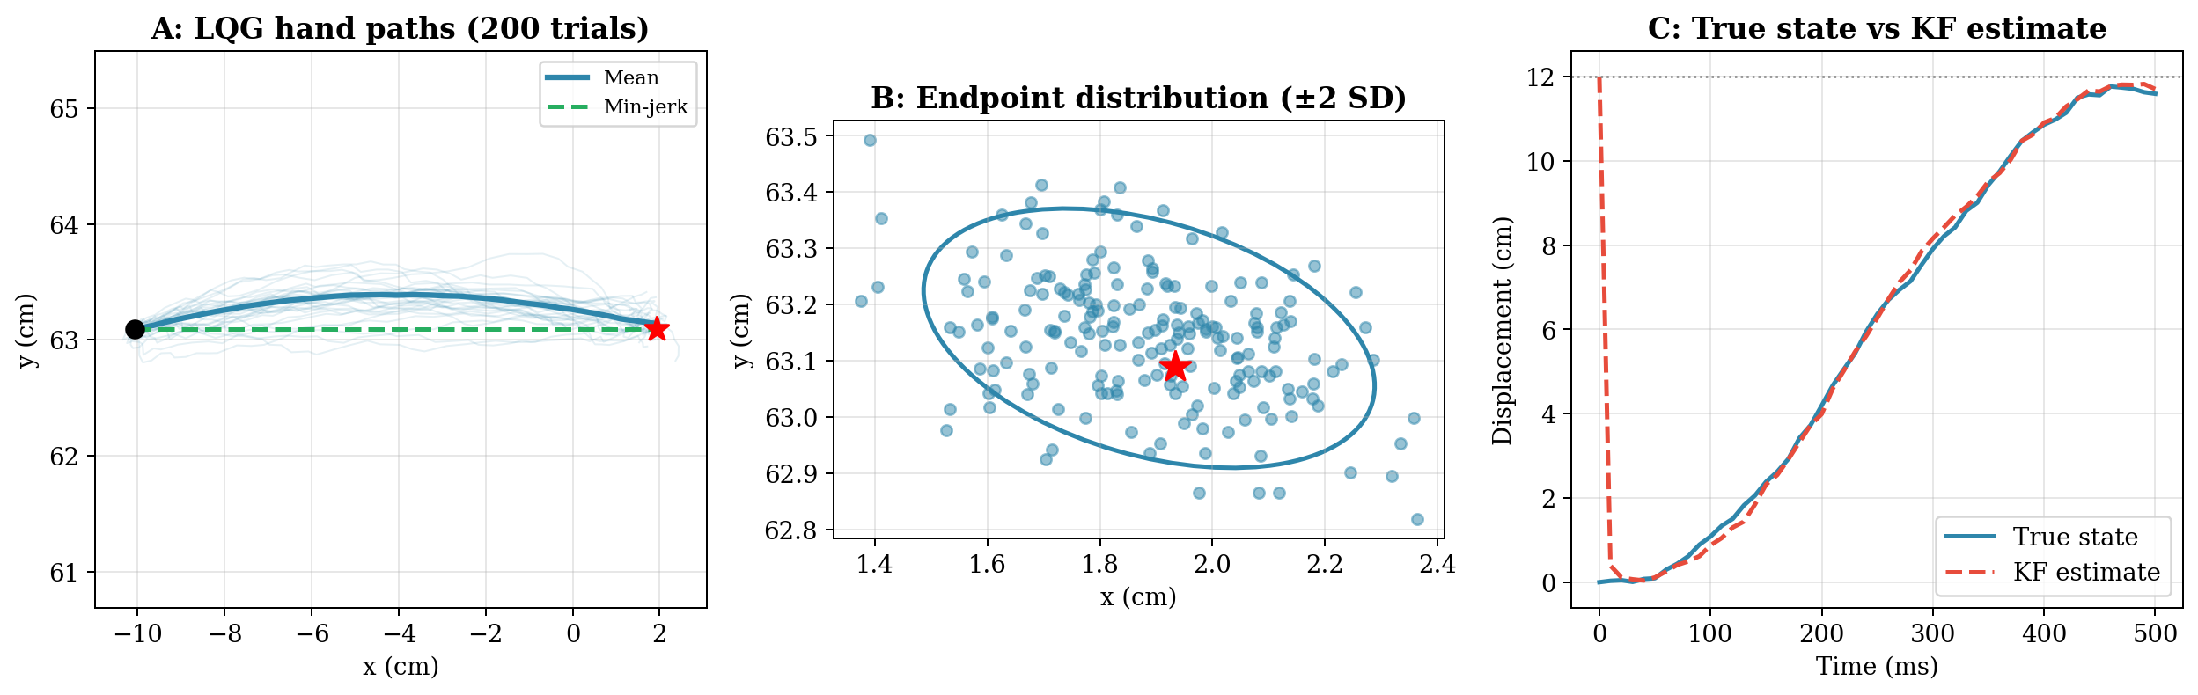
Figure 6. LQG reaching with process noise and sensory noise (200 trials). A: Individual hand paths and mean trajectory. B: Endpoint distribution with ±2 SD ellipse. C: True state vs KF estimate for a single trial.

5. The Minimum Intervention Principle
The central prediction of OFC (Todorov & Jordan, 2002): deviations from the average trajectory are corrected only when they interfere with task performance. This is the minimum intervention principle.

Why Does It Hold?
Recall the cost-to-go matrix S_t from the Riccati recursion (§2): S_t encodes the total cost from timestep t to the endpoint, assuming optimal control from that point forward. For our linear-quadratic system, the cost-to-go function is v*(t, x) = xᵀS_t x — a quadratic form in the state. This is the same S_t the backward Riccati computed. A deviation Δx is task-irrelevant if it lies in the null space of S_t — directions where S_t assigns zero cost. For endpoint-only Q, S_t is effectively low-rank at mid-movement (it only penalizes the task-relevant subspace projecting onto hand position at the endpoint), so many deviation directions have near-zero cost and trigger no correction.
The optimal controller has nothing to gain from correcting a deviation that does not change v*. Todorov and Jordan showed that the corrective action is proportional to the change in cost-to-go caused by the deviation:
corr(Δx) ∝ Δv*(Δx)

where Δv*(Δx) = v*(t, x̄ + Δx) − v*(t, x̄) = Δxᵀ S_t Δx

If Δx is in the null space of S_t: Δv* = 0, no correction
If Δx is in the range of S_t: Δv* > 0, vigorous correction

Moreover, generating a corrective control signal is actively harmful: larger control signals add more signal-dependent noise (the standard deviation of motor noise grows with the signal magnitude). Correcting a task-irrelevant deviation wastes effort AND introduces noise that could contaminate task-relevant dimensions. The optimal strategy is to leave the deviation alone.

Demonstration: Point Target vs Bar Target
The cleanest test of minimum intervention compares two tasks that share the same arm, the same noise, and the same reach direction — differing only in the shape of the target. In the first task, the hand must reach a point target — both x and y position matter. Q_N penalizes errors in both directions equally (the same endpoint-only Q from §2). In the second task, the hand must reach a vertical bar at the same x-distance — a 5 cm bar centered on the target. Now only x matters for success; y errors within ±2.5 cm are free. Q_N penalizes x errors heavily (w_x = 100) and y errors weakly (w_y = 5). The Kalman filter is identical in both conditions — estimation does not depend on the task. Only the Riccati gains change, because Q changed.
Figure 7 shows the result — 50 trials per condition, same noise seed. Panel A: the hand paths. Point target reaches (blue) are tightly clustered in both directions. Bar target reaches (red) fan out in the y-direction, with the hand arriving at different vertical positions along the bar. The controller tolerates this y-variability because Q_N barely penalizes it. Panel B: endpoint distributions. The point target ellipse (blue) is compact. The bar target ellipse (red) is elongated along the bar — the y-spread is dramatically larger. Both ellipses are tight in the x-direction (the reach distance), because Q_N penalizes x errors in both conditions. Panel C: endpoint variance decomposed into along-reach and perpendicular components. For the point target, both components are small (~0.04 and ~0.01 cm²). For the bar target, along-reach variance is comparable (~0.03 cm²), but perpendicular variance explodes (~0.16 cm²) — the controller has redirected its control authority away from the task-irrelevant direction.
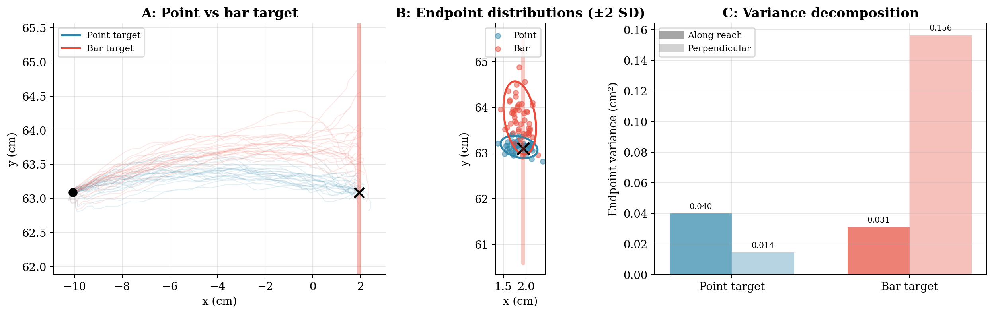
Figure 7. Minimum intervention principle: point target vs bar target. A: Hand paths (50 trials each). Bar target paths (red) fan out along the bar. B: Endpoint distributions with ±2 SD ellipses. Bar target ellipse is elongated along the task-irrelevant (y) direction. C: Endpoint variance decomposed into along-reach and perpendicular components.
This is the minimum intervention principle made visible: same arm, same noise, different Q → different variability structure. The controller does not suppress all variability — it suppresses only the variability that matters for the task. A trajectory-tracking controller would produce identical variability in both conditions (because the average trajectory is the same), which contradicts the data. This is exactly the pattern Todorov and Jordan documented across aiming, via-point, and manipulation tasks: variability is structured by the cost function, not by the trajectory.
Minimum Intervention = Maximum Performance
The minimum intervention principle is not laziness — it is optimal resource allocation.
Correcting task-irrelevant deviations wastes effort and adds noise via signal-dependent motor noise.
The controller exploits redundancy as a “noise buffer” (Todorov & Jordan, Figure 1).
Same arm + same noise + different Q = different variability structure. The task shapes the variability, not the trajectory.

6. Comparison: OFC vs EPH vs Inverse Dynamics
We run the linearized LQG on the same 12 cm rightward reach from Week 11, alongside the EPH model and the min-jerk reference. The EPH model here is the R-C Ca²⁺ λ (Gribble muscles, no tendon) from Week 4 — the simplest of the three muscle models from Week 11. Because the Ca²⁺ model overshoots its λ target by ~2%, the λ ramp aims at 10.2 cm rather than 12 cm, so the hand settles at approximately 12 cm after the overshoot decays. The ramp duration (300 ms) is chosen to match the OFC’s ~500 ms movement time.
Figure 8 places the three approaches side by side. Panel A: all three produce a roughly straight reach to the target. Panel B: OFC and min-jerk arrive at 12 cm within 500 ms. The EPH reaches 12 cm at a similar time but the muscle dynamics produce a small overshoot that takes an additional ~300 ms to settle. Panel C: the velocity profiles reveal the key difference between the two frameworks. OFC (blue) and min-jerk (green dashed) produce symmetric, bell-shaped profiles that return to zero by 500 ms. EPH (purple) is slower (peak ~29 cm/s vs ~35 cm/s for OFC) and has a long asymmetric tail extending to ~800 ms — the calcium filter and force-velocity curve impose their own temporal envelope on force production. The muscles take time to build and release force in a way that the torque-driven OFC model does not capture. This is an honest consequence of the plant: OFC commands torques directly and can stop instantly; EPH must work through the muscle’s activation and deactivation dynamics, which have inherent time constants. The small fluctuations visible in the OFC velocity profile are not numerical artifacts — they reflect the stochastic nature of closed-loop control: the controller continuously adjusts based on noisy state estimates from the Kalman filter, producing slight velocity corrections that persist even after averaging 200 trials. Week 13’s iLQG will close this gap by computing optimal feedback gains for the actual muscle dynamics rather than a linearized torque-driven approximation.
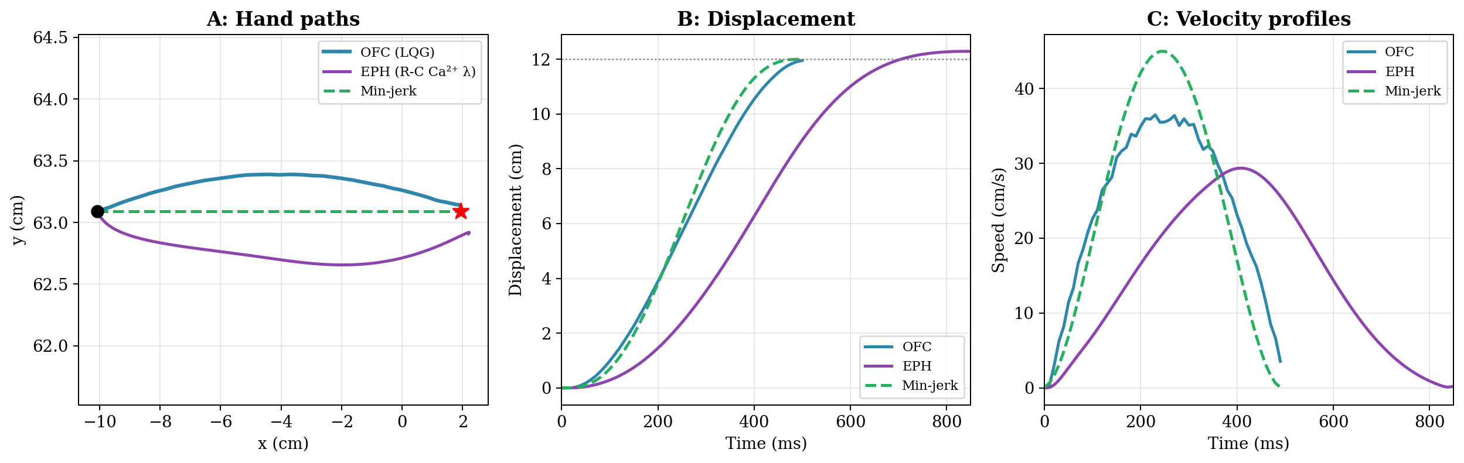
Figure 8. OFC vs EPH (R-C Ca²⁺ λ) on the 12 cm reach. A: Hand paths. B: Displacement — both reach ~12 cm with comparable movement times (~500 ms). The EPH λ ramp aims at 10.2 cm to compensate for the model’s ~2% overshoot. C: Velocity profiles. OFC produces a symmetric bell-shaped profile; EPH is slower and asymmetric due to calcium filter dynamics.
The comparison reveals complementary strengths:
Feature | Inverse Dynamics (Wk 7) | EPH / KMHM (Wk 11) | OFC / LQG (Wk 12)
Trajectory | Pre-specified (min-jerk) | Emergent from λ ramps | Emergent from cost function
Feedback gains | None (feedforward) | Intrinsic (muscle stiffness) | Optimal time-varying L_t
State estimation | None | Spinal reflex (25 ms) | Kalman filter (multi-sensor)
Handles noise? | No | Partially (stiffness damps) | Yes (designed for noise)
Variability structure | None (deterministic) | Unstructured | Structured (MIP)
Requires internal model? | Yes (full dynamics) | No (geometry only) | Yes (linearized dynamics)
Plant model this week | Torque-driven arm | Arm + 6 muscles | Torque-driven (linearized)

What OFC explains that EPH cannot: structured variability (the minimum intervention principle), task-dependent corrective responses, time-varying gains that increase near the endpoint, and the natural emergence of Woodworth’s two-component structure (ballistic launch + corrective phase).
What EPH explains that OFC (linear) cannot: intrinsic muscle stability without computation, equifinality, the tendon catapult, and the role of passive muscle mechanics in absorbing perturbations. Week 13 bridges this gap: iLQG computes OFC gains for the actual nonlinear Hill-type plant by iterating the same Riccati machinery around a nominal trajectory.

7. The Sensory Transition During Reaching
The full sensory story for reaching to a static target has two phases, corresponding to Woodworth’s (1899) two-component model. The transition is visible across several figures we have already examined: Figure 4 shows the Kalman gains shifting as the hand enters foveal range; Figure 5 shows L_t and K_t converging at the end of the movement; Figure 6C shows the KF estimate locking onto the true state after the foveal transition. Here we tie the story together.
Phase 1 — Launch (0–350 ms): The hand is far from the target. The target is in foveal vision (precise). The hand is sensed through proprioception (moderate noise, 40 ms delay) and peripheral vision (high noise, 100 ms delay). As Figure 4A shows, vision already dominates the position estimate during this phase, but the Kalman gains are at their steady-state level — the initial P_0 transient has decayed and the filter is in its cruising regime. The Riccati gains L_t are moderate (Figure 5A, left portion) — the controller launches the hand toward the target with a smooth acceleration, tolerating mid-trajectory variability.
Phase 2 — Correction (350–500 ms): The hand enters the foveal field near the target. Visual feedback improves dramatically (σ drops from 5 mm to 1 mm for position, from 1 cm/s to 5 mm/s for velocity). The Kalman gain for vision increases (Figure 4A, right portion) — the filter trusts visual feedback more, and the estimation uncertainty tr(P) drops sharply (Figure 4C). Simultaneously, the Riccati gains L_t are large because time is running out (Figure 5A, right portion). The combination of better estimation and more aggressive control produces the corrective phase: precise, feedback-driven adjustments that bring the hand to the target. Figure 6C shows this convergence for a single trial — the KF estimate (red dashed) tracks the true state (blue) almost exactly during this phase.
This two-phase structure is not programmed — no one told the controller to switch modes. It falls out of a single equation: u_t = −L_t · x̂_t. Two independently computed quantities multiply together:
L_t (from the backward Riccati) is small early because there is plenty of time to correct, and large late because time is running out. This pattern comes entirely from the endpoint-only Q propagating backward through the dynamics.
x̂_t (from the forward Kalman) is poor early because P_0 is large and only noisy peripheral vision is available, and accurate late because the hand has entered foveal range and tr(P) has dropped.
Neither computation knows about the other (separation principle). But their product naturally creates two phases. Early in the movement: small L_t × poor x̂_t = small, imprecise corrections — the ballistic launch. Late in the movement: large L_t × accurate x̂_t = large, precise corrections — the corrective approach. The two-phase structure falls out of multiplying two monotonically changing functions that both happen to favor late-movement correction — one because of the task (Q), the other because of the optics (foveal transition). This is exactly Woodworth’s (1899) two-component model and Elliott et al.’s (2017) formalization: the “initial impulse” is optimal control with poor estimation; the “current control” phase is optimal control with high-quality estimation.

Prediction: What Happens Under Degraded Proprioception?
The LQG framework makes a testable prediction about reaching under degraded sensory conditions. Suppose proprioceptive noise is increased — for example, by applying muscle vibration to the reaching arm (a standard technique that disrupts spindle signals by driving them at ~80 Hz, making them unreliable for position and velocity estimation). In our model, this corresponds to increasing the proprioceptive entries in V_t (the first four diagonal elements). The Kalman filter would automatically downweight proprioception and rely more heavily on vision for state estimation. Two consequences follow.
First, the launch phase degrades. During the first 350 ms, the hand is in peripheral vision (high noise) and the now-degraded proprioception is the only fast channel. The KF’s state estimate becomes less accurate throughout this phase — P_t stays larger, and the controller’s corrections are based on a noisier signal. The launch trajectory should become more variable.
Second, the corrective phase is relatively preserved. After ~350 ms, foveal vision takes over and provides high-precision feedback regardless of proprioceptive quality. The KF shifts its trust to the visual channel, and the state estimate recovers. The Riccati gains L_t are unchanged (they depend on Q and R, not on the sensors). So the corrective phase — driven primarily by foveal vision and large L_t — should remain effective even when proprioception is degraded.
The overall prediction: muscle vibration should increase endpoint variability by degrading the launch phase, but the effect should be smaller than you might expect because the corrective phase compensates. This is directly testable in the lab — and would make an excellent class project: simulate the vibration by inflating σ_prop in the model, compare the predicted endpoint distributions with and without vibration, and design an experiment to test the prediction.

Summary
Week 12 Takeaway
OFC unifies feedforward and feedback: the optimal policy IS the controller. No separate trajectory planner.
LQG = LQR + KF: optimal control (backward Riccati) + optimal estimation (forward Kalman), linked by the separation principle.
The Q matrix encodes the task; R encodes the cost of control. Together they determine the feedback policy.
The minimum intervention principle: correct only what matters for the task. Variability in task-irrelevant dimensions is tolerated — not because the controller is sloppy, but because correcting it would waste effort and add noise.
Woodworth’s two-component structure (ballistic launch + corrective phase) emerges naturally from time-varying Riccati gains and the sensory transition from peripheral to foveal vision.

Next week: Linearizing the biological plant (iLQG). This week’s LQR operated on a torque-driven arm — no muscles, no tendons. Week 13 extends OFC to the full nonlinear Hill-type plant by iteratively linearizing around a nominal trajectory and re-solving the Riccati equation at each iteration. We will also implement proper delay handling via the augmented-state formulation.

Controller/Estimator Summary (Updated)
Week | Plant | Controller | Estimator
7 | Arm | Feedforward (inverse dynamics) | None (open-loop)
8 | Arm | P-controller, Kp = 8 | Raw delayed measurement
9 | Arm | P-controller, sensor fusion | Inverse-variance fusion
10 | Arm | FF min-jerk + feedback | KF (target) + inv-var (hand)
11 | Arm + muscles | EPH (λ R-C) / KMHM | Spinal reflex (25 ms)
12 | Arm (linearized) | OFC (LQR) | Kalman filter (LQG)

References
Domkin, D., Laczko, J., Jaric, S., Johansson, H., & Latash, M. L. (2002). Structure of joint variability in bimanual pointing tasks. Experimental Brain Research, 143, 11–23.
Elliott, D., Lyons, J., Hayes, S. J., et al. (2017). The multiple process model of goal-directed reaching revisited. Neuroscience & Biobehavioral Reviews, 72, 95–110.
Todorov, E. (2004). Optimality principles in sensorimotor control. Nature Neuroscience, 7(9), 907–915.
Todorov, E., & Jordan, M. I. (2002). Optimal feedback control as a theory of motor coordination. Nature Neuroscience, 5(11), 1226–1235.
Scott, S. H. (2004). Optimal feedback control and the neural basis of volitional motor control. Nature Reviews Neuroscience, 5(7), 532–546.
Wolpert, D. M., Ghahramani, Z., & Jordan, M. I. (1995). An internal model for sensorimotor integration. Science, 269(5232), 1880–1882.
Woodworth, R. S. (1899). The accuracy of voluntary movement. Psychological Review: Monograph Supplements, 3(3), i–114.

