Computational Sensorimotor Control

WEEK 1 LECTURE NOTES
Kinematics & The Geometric Workspace
Module 1: The Biological Plant
Fall 2026

Learning Objectives for This Week
By the end of this week, you should be able to:
- Derive the forward kinematic equations for a 2-link planar arm using geometric and matrix methods.
- Solve the inverse kinematics problem and explain why multiple solutions arise.
- Compute the Jacobian matrix and interpret it as a linear mapping between joint-velocity space and task space.
- Construct and interpret manipulability ellipsoids to characterize the arm’s directional capabilities.
- Articulate the kinematic redundancy problem and its significance for motor control theory.
Required Reading
- Morasso, P. (1981). Spatial control of arm movements. Experimental Brain Research, 42(2), 223–227.
- Soechting, J. F., & Flanders, M. (1989). Sensorimotor representations for pointing to targets in three-dimensional space. Journal of Neurophysiology, 62(2), 582–594.
Optional Reading
- Soechting, J. F., & Flanders, M. (1989). Errors in pointing are due to approximations in sensorimotor transformations. Journal of Neurophysiology, 62(2), 595–608.
- Yoshikawa, T. (1985). Manipulability of robotic mechanisms. The International Journal of Robotics Research, 4(2), 3-9.

1. Introduction: The Arm as a Geometric Machine
Before we can understand how the brain controls movement, we must first understand the physical object being controlled. This week we focus exclusively on kinematics—the geometry of motion without regard to forces or masses. Think of it as building the “map” of what the arm can do before asking what it should do.
Our model system throughout this course is a 2-joint planar arm representing the human shoulder and elbow, constrained to move in the horizontal plane. This eliminates gravity from the equations of motion, allowing us to isolate the control-relevant dynamics: interaction torques, muscle forces, and nonlinear coordinate transforms. This is the same paradigm used by Gribble et al. (1998), Shadmehr & Mussa-Ivaldi (1994), and most of the empirical literature we will study.

1.1 Defining the Model
We define our arm with the following anatomical conventions for horizontal plane movement:
- Joint 1 (Shoulder — Horizontal Flexion): Angle θ₁ = 0° when the arm is abducted to the side, level with the shoulder. Positive θ₁ corresponds to horizontal flexion (sweeping the arm across the chest). The shoulder is fixed at the origin. Range: 0° to 140°.
- Joint 2 (Elbow — Flexion): Angle θ₂ = 0° when the elbow is fully extended (forearm collinear with upper arm). Positive θ₂ corresponds to elbow flexion (closing the angle between forearm and upper arm). Range: 0° to 145°.
- Link 1 (Upper Arm): Length l₁ = 0.34 m (Gribble et al., 1998).
- Link 2 (Forearm + Hand): Length l₂ = 0.46 m (Gribble et al., 1998).
Anatomical Conventions — Used Throughout the Course
These joint conventions match the anatomical definitions of horizontal shoulder flexion and elbow flexion. Both angles are non-negative: θ₁ ∈ [0°, 140°] and θ₂ ∈ [0°, 145°]. The workspace is therefore a semicircular crescent in front of the body—not a full annulus. These limits, along with the Gribble et al. (1998) limb parameters, remain constant for all 15 weeks.
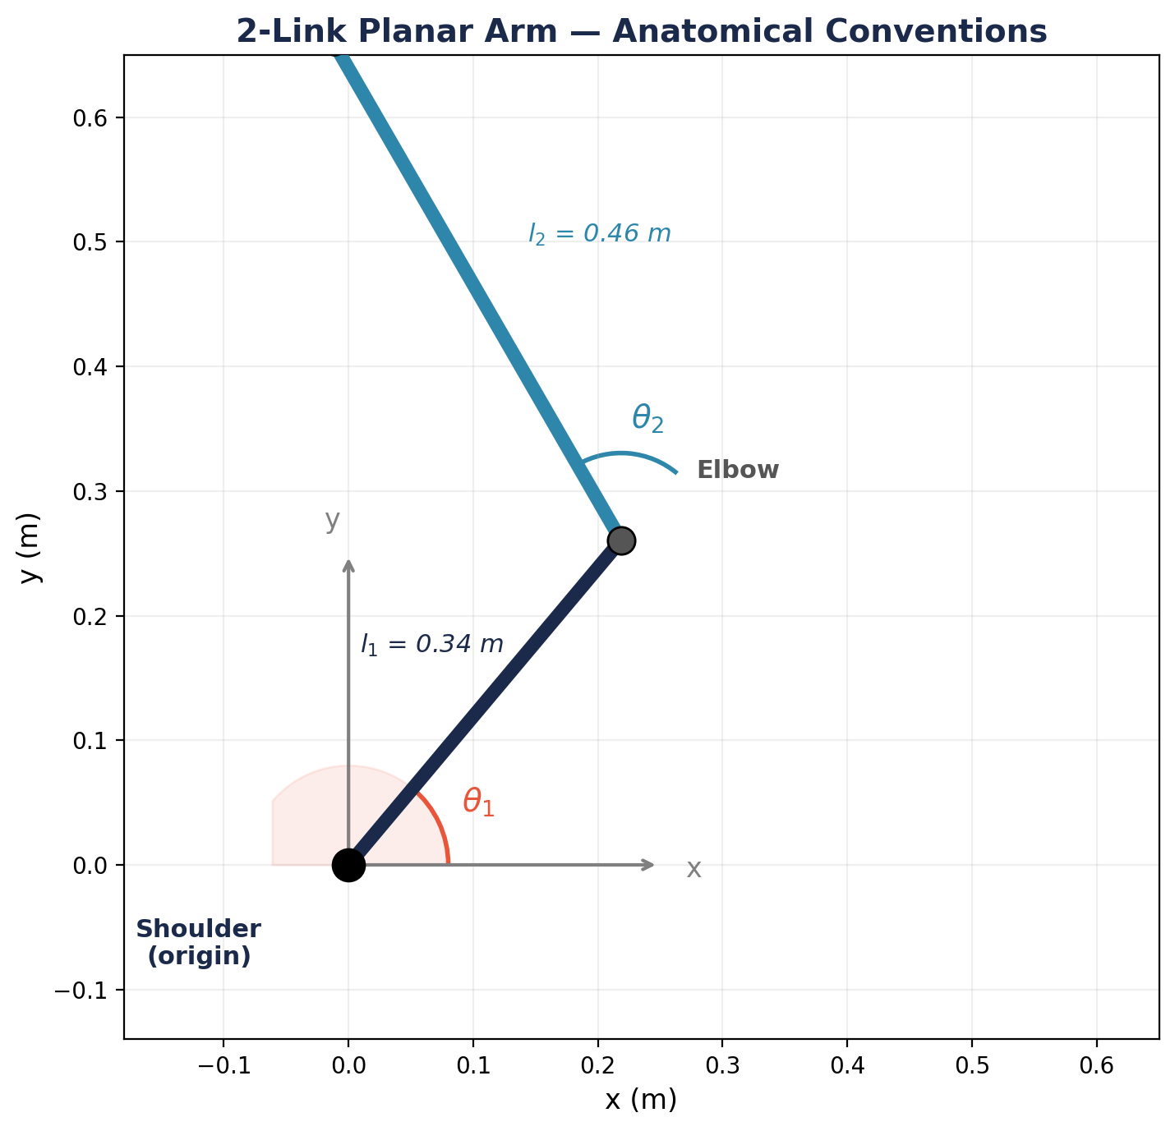
Figure 1. The 2-link planar arm with anatomical conventions. θ₁ (shoulder) and θ₂ (elbow) are both non-negative.
The configuration space (or joint space) is the set of all possible joint angle pairs q = (θ₁, θ₂). The task space (or workspace) is the set of all reachable endpoint positions p = (x, y) in the plane.
Key Distinction: Configuration Space vs. Task Space
Configuration space is where the controller lives—it specifies motor commands as joint angles. Task space is where the goal lives—the target is a point in Cartesian coordinates. Kinematics is the bridge between these two representations.

2. Forward Kinematics
Problem statement: Given the joint angles (θ₁, θ₂), compute the Cartesian position (x, y) of the endpoint (hand).
This is the “easy” direction—there is always a unique answer. We derive it two ways: geometrically and via rotation matrices.
Terminology: FK, DH, and Angle Conventions
Forward kinematics (FK) is the computation of endpoint position from joint angles—the map we derive in this section. The inverse problem (endpoint → joint angles) is inverse kinematics (IK), covered in Section 3. In robotics, a general method called the Denavit–Hartenberg (DH) convention systematically attaches coordinate frames to each link of a chain to derive FK for arbitrarily complex manipulators. Our 2-link planar arm is simple enough that basic trigonometry suffices, so DH parameters will not appear in this course.
Global vs. Body-Fixed Angles
Our two joint angles live in different reference frames. θ₁ is a global angle: it is measured from a fixed axis in the world (the positive x-axis) and describes the absolute orientation of the upper arm. θ₂ is a body-fixed (relative) angle: it is measured from the upper arm, not from the ground, and describes how much the forearm deviates from the upper arm’s axis. At θ₂ = 0° the forearm is collinear with the upper arm (full extension); at θ₂ = 90° the elbow is at a right angle. This is why the FK equations use (θ₁ + θ₂) as the absolute orientation of the forearm—adding the relative angle to the global one performs the frame transformation. It also explains the Jacobian’s structure (Section 4): differentiating with respect to θ₁ rotates the entire arm, while differentiating with respect to θ₂ moves only the forearm.

2.1 Geometric Derivation
Consider the arm in a general configuration. The elbow position is reached by traveling a distance l₁ from the origin at angle θ₁:
xₑ = l₁ cos(θ₁) (2.1a)
yₑ = l₁ sin(θ₁) (2.1b)
The hand is reached by traveling an additional distance l₂ from the elbow. The absolute angle of the second link is (θ₁ + θ₂), since θ₂ is measured relative to the first link. Therefore:
x = l₁ cos(θ₁) + l₂ cos(θ₁ + θ₂) (2.2a)
y = l₁ sin(θ₁) + l₂ sin(θ₁ + θ₂) (2.2b)
These two equations constitute the forward kinematic map, which we write compactly as:
p = f(q) (2.3)
where f : ℝ² → ℝ² is in general a nonlinear function. This nonlinearity is a fundamental source of complexity in motor control.

2.2 Rotation Matrix Derivation
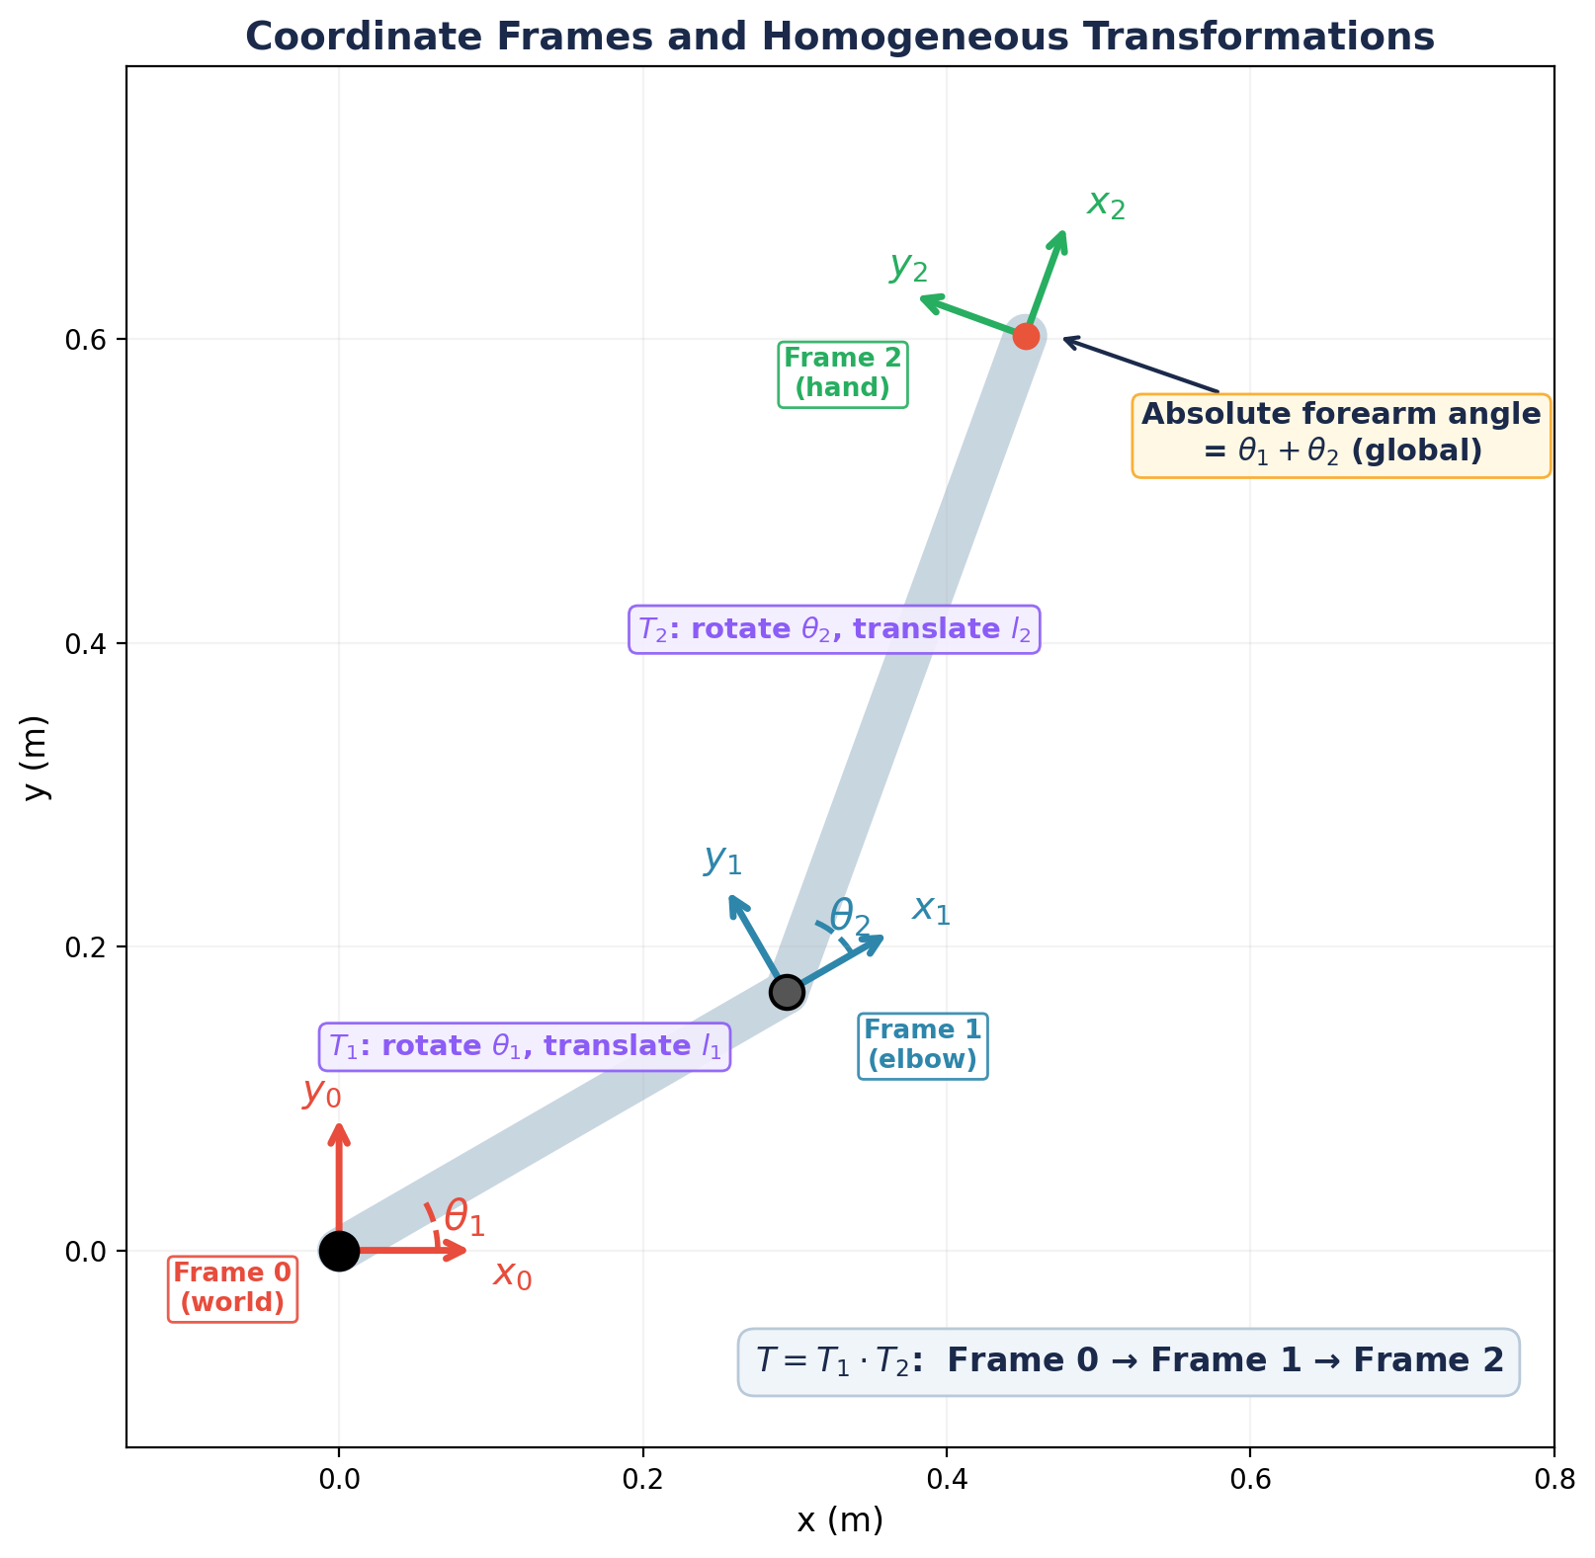
Figure 2. Coordinate frames attached to each link. T₁ rotates by θ₁ and translates by l₁; T₂ rotates by θ₂ (relative to link 1) and translates by l₂. The product T = T₁ · T₂ maps from the world frame to the hand frame.
A more systematic approach uses homogeneous rotation matrices. Each link applies a rotation and a translation. In 2D, a rotation by angle θ is:
R(θ) = [ cosθ −sinθ ; sinθ cosθ ] (2.4)
This 2×2 matrix can rotate a point, but it cannot translate it. To combine rotation and translation in a single matrix multiplication, we embed R in a 3×3 matrix and represent positions as [x, y, 1]ᵀ. The third coordinate is a dummy that rides along unchanged—its only purpose is to let the translation terms in the right column get added during multiplication. The bottom row [0 0 1] preserves this structure. For the first link:
T₁ = [ cosθ₁ −sinθ₁ l₁cosθ₁ ; sinθ₁ cosθ₁ l₁sinθ₁ ; 0 0 1 ] (2.5)
Similarly, for the second link (rotation by θ₂ and translation by l₂ in the local frame):
T₂ = [ cosθ₂ −sinθ₂ l₂cosθ₂ ; sinθ₂ cosθ₂ l₂sinθ₂ ; 0 0 1 ] (2.6)
The total transformation from the base frame to the endpoint is the product:
T = T₁ · T₂ (2.7)
Extracting the translation column from T recovers Equations 2.2a and 2.2b. This is verified by applying the angle addition identities:
cos(θ₁)·cos(θ₂) − sin(θ₁)·sin(θ₂) = cos(θ₁ + θ₂) (2.8)
The rotation matrix method may seem like overkill for two links, but it generalizes immediately to N-link chains and 3D, which is why roboticists prefer it.
Why This Matters for Motor Control
The forward kinematic map is what the brain must invert every time you reach for an object. The target is specified in a visual/gaze-referenced frame, while the motor command must ultimately be issued in joint coordinates. The precise coordinate system of the visual representation is itself debated — retinal coding is angular, and some evidence (Soechting & Flanders, 1989) favors a spherical distance/azimuth/elevation representation rather than a Cartesian one. Regardless of the exact frames, the map from visual target to joint command is nonlinear, which is what makes the inversion nontrivial. (In our simulation we adopt Cartesian task coordinates (x, y) as a modeling convenience.)

2.3 The Workspace
The reachable workspace is the set of all points (x, y) that the endpoint can reach for some configuration q within the joint limits. For our 2-link arm with physiological constraints:
- Outer boundary: The arm is fully extended (θ₂ = 0°), so the maximum reach is r_{ₘₐₓ} = l₁ + l₂ = 0.80 m. This arc sweeps through the 140° range of shoulder horizontal flexion.
- Inner boundary: The arm is maximally flexed (θ₂ = 145°), giving a minimum reach that depends on the elbow angle. The closest the hand can get to the shoulder is r_{ₘᵢₙ} = √(l₁² + l₂² + 2l₁l₂cos(145°)) ≈ 0.19 m.
Because both joint angles are non-negative and bounded, the workspace is not a full annulus but a semicircular crescent covering the space in front of and to the side of the body. The arm sweeps from fully abducted (arm out to the side) through to well across the midline of the chest.
The general reachability condition, before applying joint limits, is:
|l₁ − l₂| ≤ √(x² + y²) ≤ l₁ + l₂ (2.9)
However, with the joint limits θ₁ ∈ [0°, 140°] and θ₂ ∈ [0°, 145°], only a subset of this annulus is actually reachable. In the lab, you will visualize the true workspace by sweeping through all valid joint configurations.
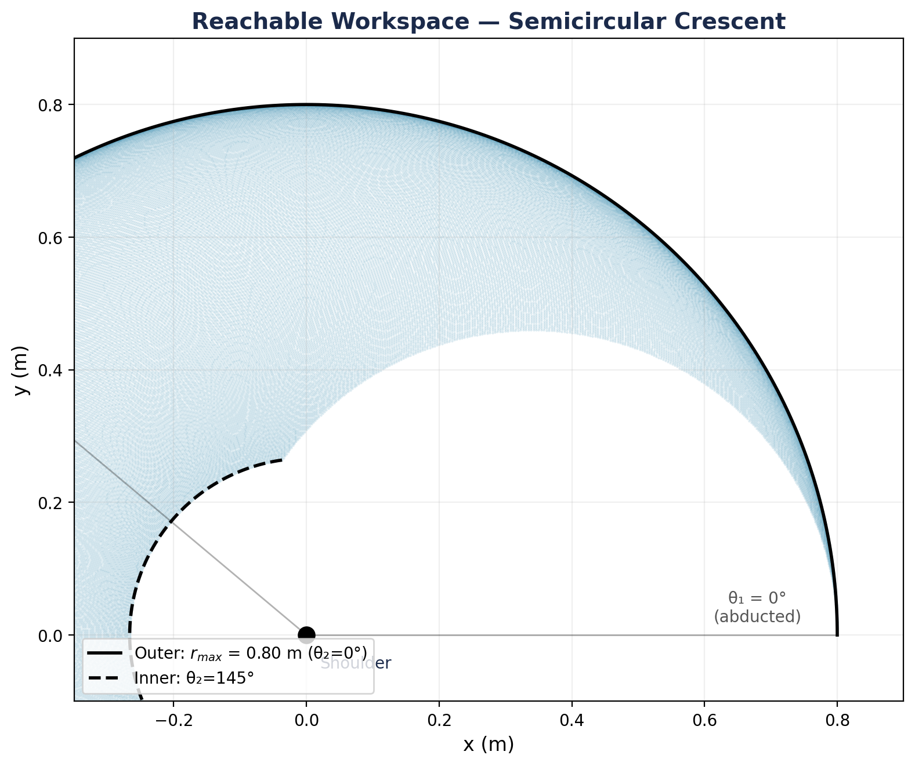
Figure 3. The reachable workspace is a semicircular crescent, bounded by the outer arc (elbow extended) and inner arc (elbow at 145°).

3. Inverse Kinematics
Problem statement: Given a desired endpoint position (x, y), compute the joint angles (θ₁, θ₂) that place the hand there.
This is the “hard” direction. Unlike forward kinematics, the inverse problem may have zero, one, or multiple solutions.

3.1 Solving for θ₂ (Elbow Angle)
We begin by computing the squared distance from the shoulder to the target:
r² = x² + y² (3.1)
Expanding the forward kinematic equations and using the identity cos² + sin² = 1:
x² + y² = l₁² + l₂² + 2l₁l₂ cos(θ₂) (3.2)
Step by step: square Equations 2.2a and 2.2b and add them:
x² = l₁²cos²θ₁ + l₂²cos²(θ₁+θ₂) + 2l₁l₂cosθ₁cos(θ₁+θ₂)
y² = l₁²sin²θ₁ + l₂²sin²(θ₁+θ₂) + 2l₁l₂sinθ₁sin(θ₁+θ₂)
Summing and applying the cosine difference identity to the cross-term:
cosθ₁cos(θ₁+θ₂) + sinθ₁sin(θ₁+θ₂) = cos(θ₂) (3.3)
This gives us the law of cosines result in Equation 3.2. Solving for cos(θ₂):
cos(θ₂) = (x² + y² − l₁² − l₂²) / (2l₁l₂) (3.4)
Define the right-hand side as c₂ for convenience. For a solution to exist, we require |c₂| ≤ 1, which is precisely the workspace condition (Equation 2.9). Taking the inverse cosine:
θ₂ = ± arccos(c₂) (3.5)
The ± sign reflects two possible geometric configurations. However, with our physiological joint limits (θ₂ ∈ [0°, 145°]), the elbow can only flex—it cannot hyperextend to negative angles. This means that in practice, only the positive solution (θ₂ > 0) is anatomically valid for our model. The negative solution would require the elbow to bend the wrong way.
Despite this constraint, the general two-solution structure is important to understand: in robotic systems with different joint limits, or in the full 3D human arm with shoulder rotation, multiple valid solutions do exist. The IK solver should compute both and then filter by joint limits.

3.2 Solving for θ₁ (Shoulder Angle)
With θ₂ known, we can compute θ₁. Define:
k₁ = l₁ + l₂ cos(θ₂) (3.6a)
k₂ = l₂ sin(θ₂) (3.6b)
What are k₁ and k₂?
These are not new physical quantities but abbreviations for the coefficients that appear when the forward-kinematic equations are regrouped by cos(θ₁) and sin(θ₁) (Equations 3.7a–b). Because θ₂ is already known at this stage, both are constants. Geometrically, (k₁, k₂) is the hand position expressed in a frame aligned with the upper arm: k₁ is the component along the upper-arm axis and k₂ the component perpendicular to it. Two useful checks follow — their magnitude recovers the shoulder-to-hand distance, k₁² + k₂² = r², and atan2(k₂, k₁) is the angular offset between the upper arm and the shoulder-to-hand line, which is exactly the quantity subtracted in Equation 3.8.

Expanding the FK equations (2.2a–b) using the angle addition identity (2.8) and grouping terms by cos(θ₁) and sin(θ₁):
x = k₁ cos(θ₁) − k₂ sin(θ₁) (3.7a)
y = k₁ sin(θ₁) + k₂ cos(θ₁) (3.7b)
This is a system of two equations in one unknown (θ₁). Using the atan2 function, which correctly handles all four quadrants:
θ₁ = atan2(y, x) − atan2(k₂, k₁) (3.8)
The full derivation: rewrite Equations 3.7a–3.7b in matrix form as a rotation applied to the vector (k₁, k₂). The angle of the target vector (x, y) is atan2(y, x), and the angle of (k₁, k₂) is atan2(k₂, k₁). The difference gives θ₁.
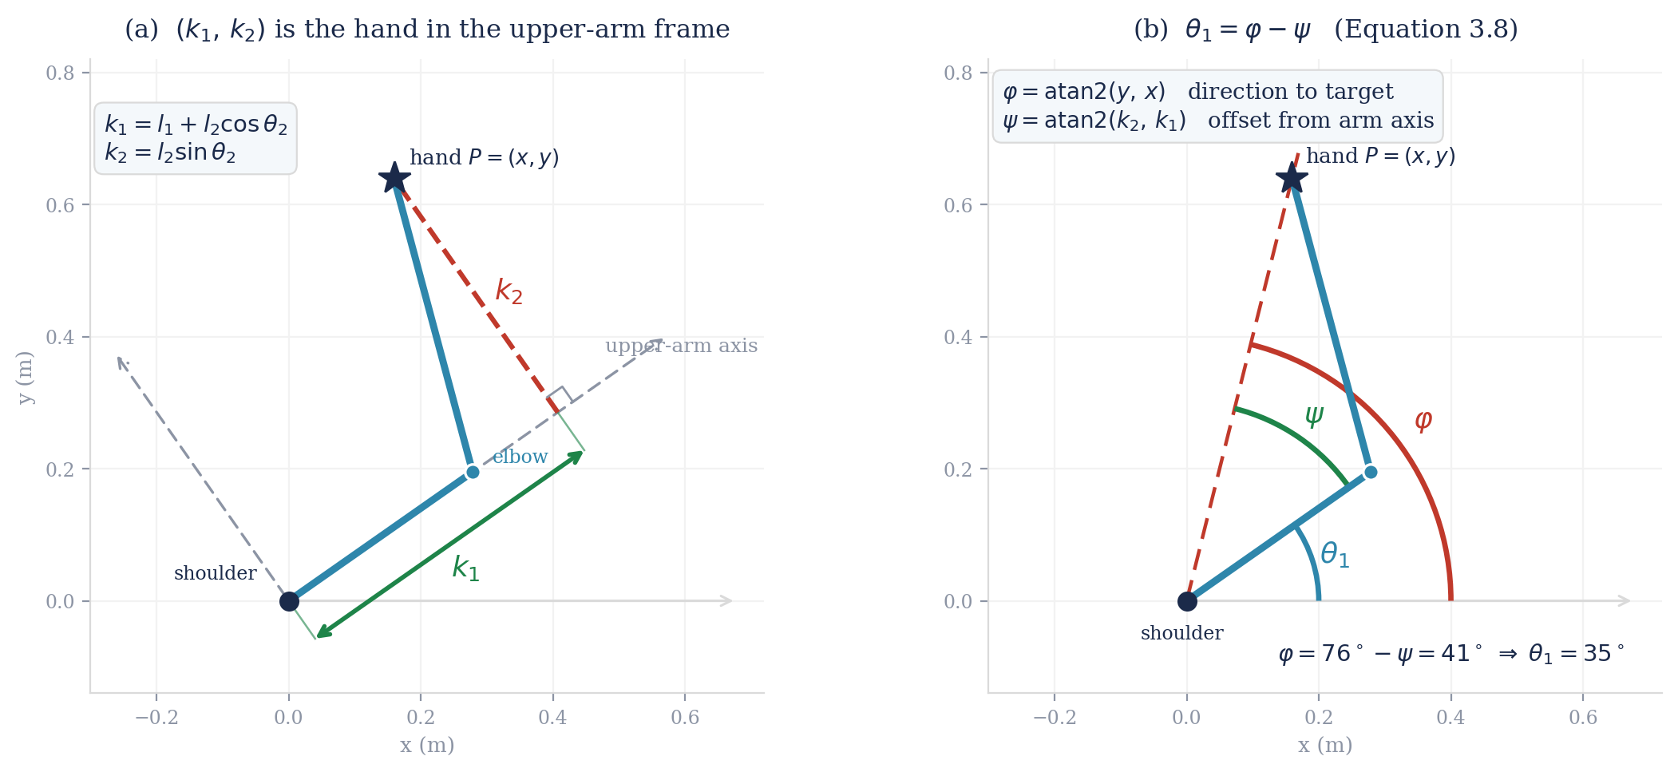
Figure 4. Constructing θ₁ (Equation 3.8). (a) The substitutions k₁ and k₂ are the hand’s coordinates in a frame aligned with the upper arm: k₁ is measured along the upper-arm axis and k₂ perpendicular to it, so √(k₁² + k₂²) recovers the shoulder-to-hand distance r. (b) The shoulder angle is then a difference of two angles: φ = atan2(y, x) is the direction from the shoulder to the target, and ψ = atan2(k₂, k₁) is the angle by which the forearm swings the hand off the upper-arm axis. Subtracting the second from the first leaves the absolute orientation of the upper arm, θ₁ = φ − ψ. Shown for θ₁ = 35°, θ₂ = 70°.
The Two-Solution Problem and Joint Limits
The unconstrained IK problem yields two solutions for every interior workspace point. With our anatomical joint limits, only the elbow-flexion solution (θ₂ > 0) is valid. On the workspace boundary (r = l₁ + l₂, where θ₂ = 0), there is exactly one solution—the arm is fully extended. The brain’s motor planning problem is simplified by joint limits, but not eliminated: even with a unique IK solution, the brain must still choose among infinitely many muscle activation patterns (the redundancy problem, Section 6).

3.3 Geometric Intuition
The two-solution nature of inverse kinematics has a beautiful geometric interpretation. Given a target endpoint P = (x, y), the elbow must lie at the intersection of two circles: one of radius l₁ centered at the shoulder, and one of radius l₂ centered at P. Two circles in general position intersect at either zero or two points (or one if tangent). Each intersection point defines a different arm configuration.
With our anatomical constraints, only the intersection point that yields θ₂ ∈ [0°, 145°] and θ₁ ∈ [0°, 140°] is valid. At the outer workspace boundary (arm fully extended), the two circles are tangent, producing a single solution. For targets beyond the boundary, the circles do not intersect and the target is unreachable.
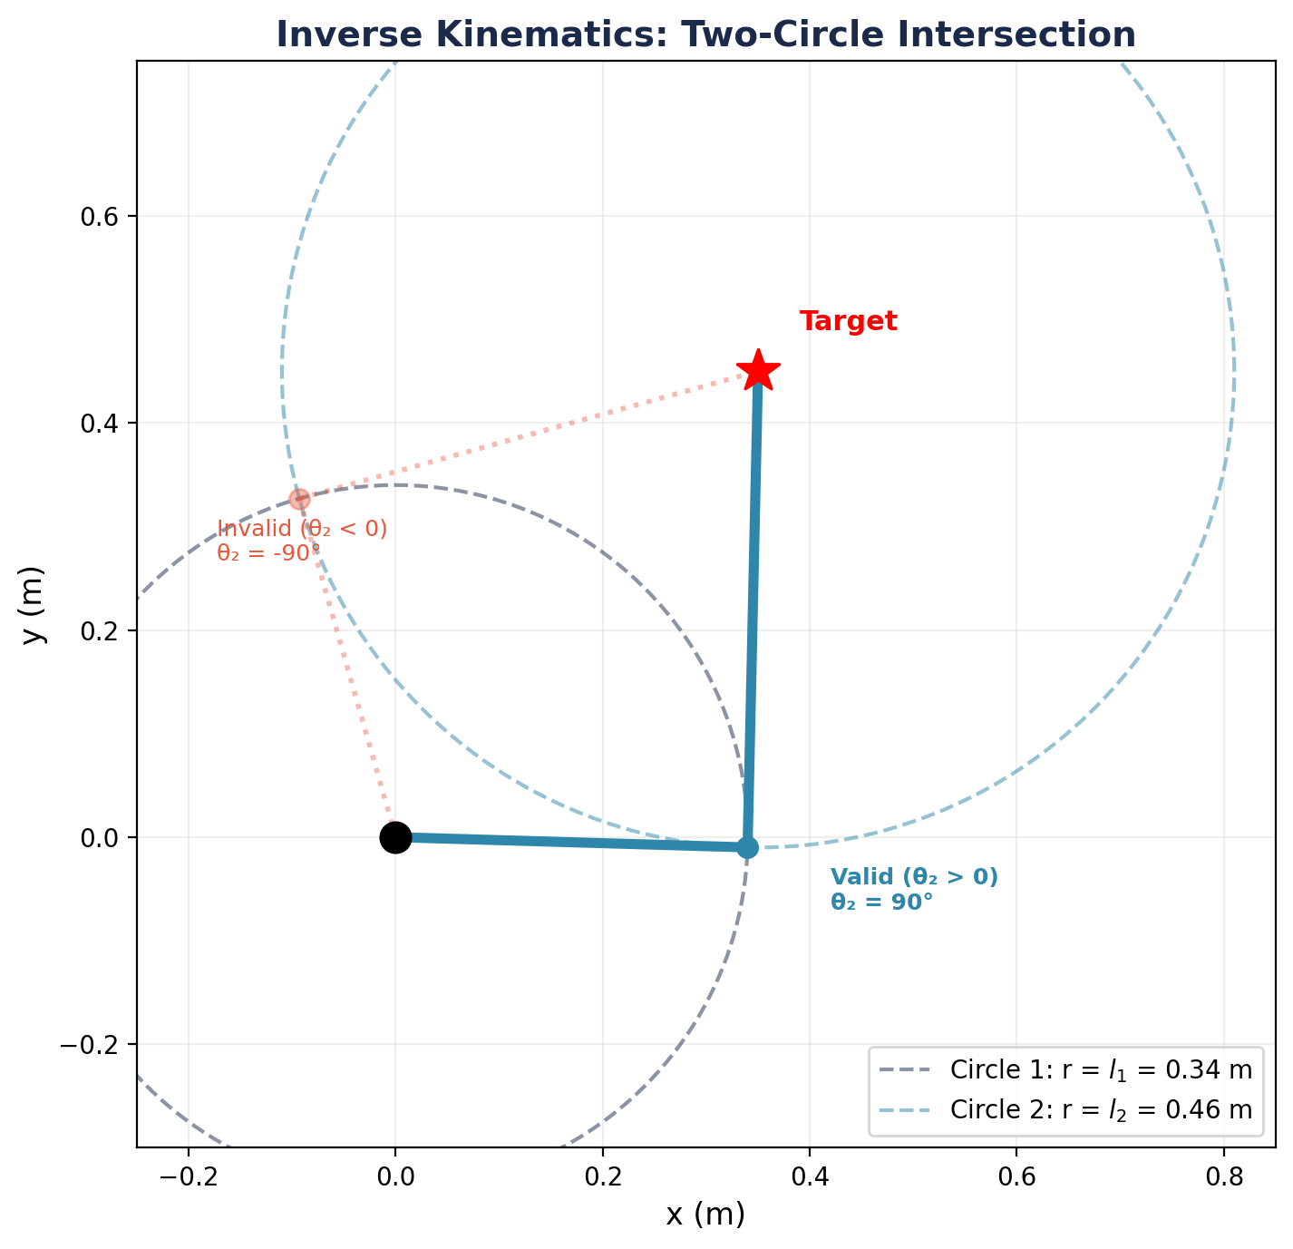
Figure 5. IK as circle intersection. The valid solution (blue, θ₂ > 0) and the invalid hyperextension solution (red, θ₂ < 0) are shown.
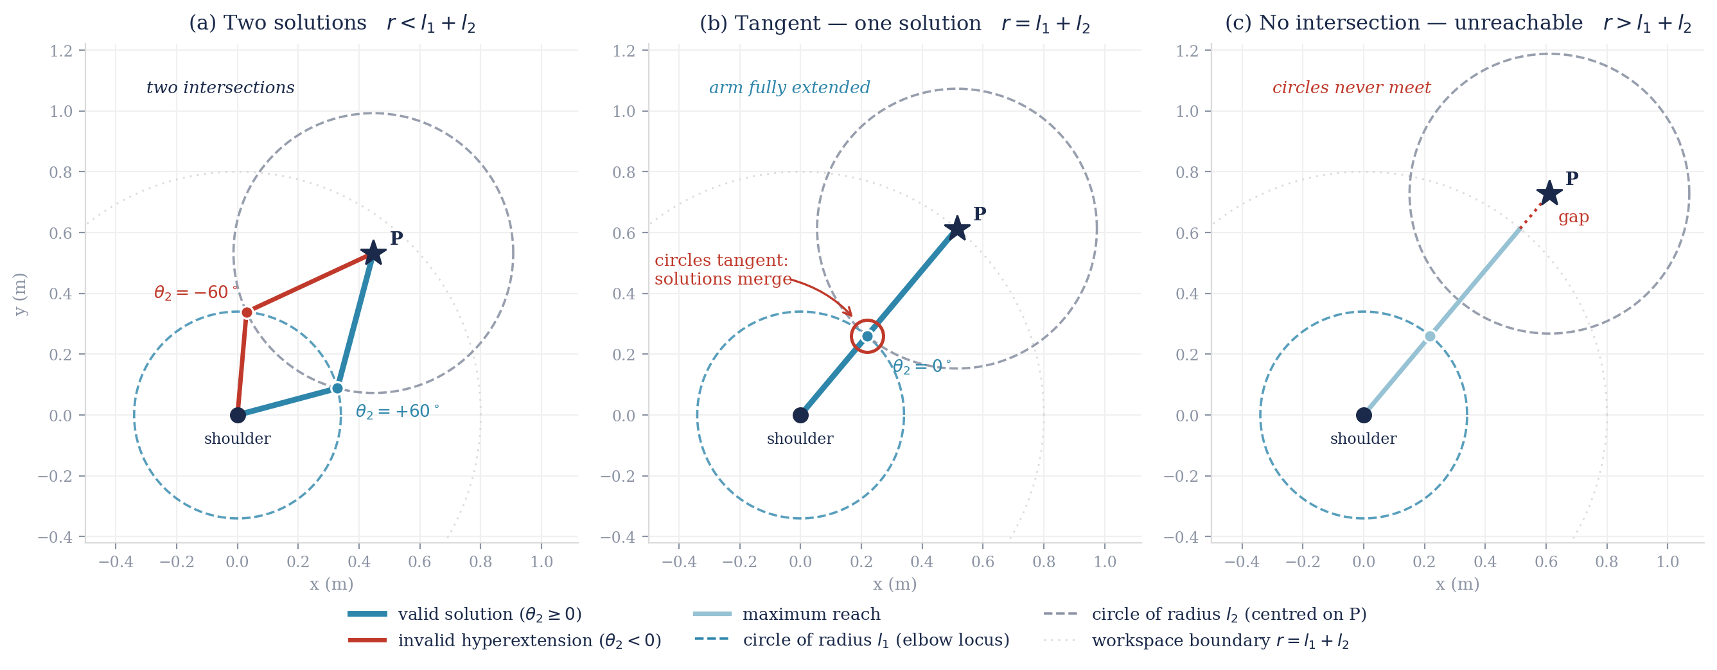
Figure 6. Inverse kinematics as circle intersection, shown for three targets along a fixed direction (50°). (a) Interior target (r < l₁ + l₂): the circles cross at two points, giving the valid elbow-flexion solution (blue, θ₂ = +60°) and the invalid hyperextension solution (red, θ₂ = −60°). (b) Target on the outer workspace boundary (r = l₁ + l₂ = 0.80 m): the circles are tangent, the two solutions merge into one, and the arm is fully extended (θ₂ = 0°) — precisely the configuration where det(J) = 0 (Section 4). (c) Target beyond the boundary (r > l₁ + l₂): the circles do not intersect and the target is unreachable.

4. The Jacobian Matrix
The forward kinematic map tells us where the hand is. The Jacobian tells us how fast and in what direction the hand moves when the joints rotate. It is the single most important construct in kinematic analysis.

4.1 Definition and Derivation
The Jacobian J is the matrix of partial derivatives of the forward kinematic map:
J = ∂f/∂q = [ ∂x/∂θ₁ ∂x/∂θ₂ ; ∂y/∂θ₁ ∂y/∂θ₂ ] (4.1)
It relates infinitesimal joint displacements to infinitesimal endpoint displacements:
dp = J · dq equivalently: ṗ = J · θ̇ (4.2)
where ṗ = (ẋ, ẏ) is the endpoint velocity and θ̇ = (θ̇₁, θ̇₂) is the joint angular velocity vector.
Now we compute each element by differentiating Equations 2.2a–2.2b:
Element J₁₁: ∂x/∂θ₁
∂x/∂θ₁ = −l₁ sin(θ₁) − l₂ sin(θ₁ + θ₂) (4.3a)
Element J₁₂: ∂x/∂θ₂
∂x/∂θ₂ = −l₂ sin(θ₁ + θ₂) (4.3b)
Element J₂₁: ∂y/∂θ₁
∂y/∂θ₁ = l₁ cos(θ₁) + l₂ cos(θ₁ + θ₂) (4.3c)
Element J₂₂: ∂y/∂θ₂
∂y/∂θ₂ = l₂ cos(θ₁ + θ₂) (4.3d)
Assembling into matrix form:
J = [ −l₁s₁ − l₂s₁₂ −l₂s₁₂ ; l₁c₁ + l₂c₁₂ l₂c₁₂ ] (4.4)
where we use the shorthand s₁ = sin(θ₁), c₁ = cos(θ₁), s₁₂ = sin(θ₁ + θ₂), c₁₂ = cos(θ₁ + θ₂).

4.2 The Determinant and Singularities
When det(J) = 0, the two columns of J become parallel, meaning both joint velocities produce endpoint motion in the same direction. The arm can still move along that direction, but motion in the perpendicular direction becomes impossible—the arm has lost one of its two task-space degrees of freedom. To see when this happens, we compute the determinant of the matrix in Equation 4.4. Expanding the 2×2 determinant:
det(J) = (−l₁s₁ − l₂s₁₂)(l₂c₁₂) − (−l₂s₁₂)(l₁c₁ + l₂c₁₂)
Expanding and simplifying:
= −l₁l₂s₁c₁₂ − l₂²s₁₂c₁₂ + l₁l₂s₁₂c₁ + l₂²s₁₂c₁₂
The l₂² terms cancel, leaving:
= l₁l₂(s₁₂c₁ − s₁c₁₂) = l₁l₂ sin(θ₁ + θ₂ − θ₁) = l₁l₂ sin(θ₂)
Therefore:
det(J) = l₁ l₂ sin(θ₂) (4.5)
The determinant is zero when sin(θ₂) = 0, i.e., when θ₂ = 0 or θ₂ = π. With our anatomical joint limits (θ₂ ∈ [0°, 145°]), only the θ₂ = 0 singularity is physiologically relevant:
- θ₂ = 0° (full extension): The arm is stretched to its maximum reach. The hand can only move perpendicular to the arm—it has lost the ability to move radially outward. This is the only singularity our model can actually reach.
- θ₂ = 180° (full flexion): The arm would be folded completely back on itself. This is outside our joint range (max 145°), so it is not encountered in practice. However, note that as θ₂ approaches 145°, the manipulability is already reduced—the arm is approaching a mechanically disadvantaged configuration.
Singularities and the Brain
Near singularities, the inverse Jacobian has very large entries, meaning tiny endpoint motions demand enormous joint velocities. The motor system appears to “know” about singularities: people naturally avoid fully extended arm configurations and slow down when approaching them. Signal-dependent noise (Week 7) further penalizes the large motor commands that singularities demand.
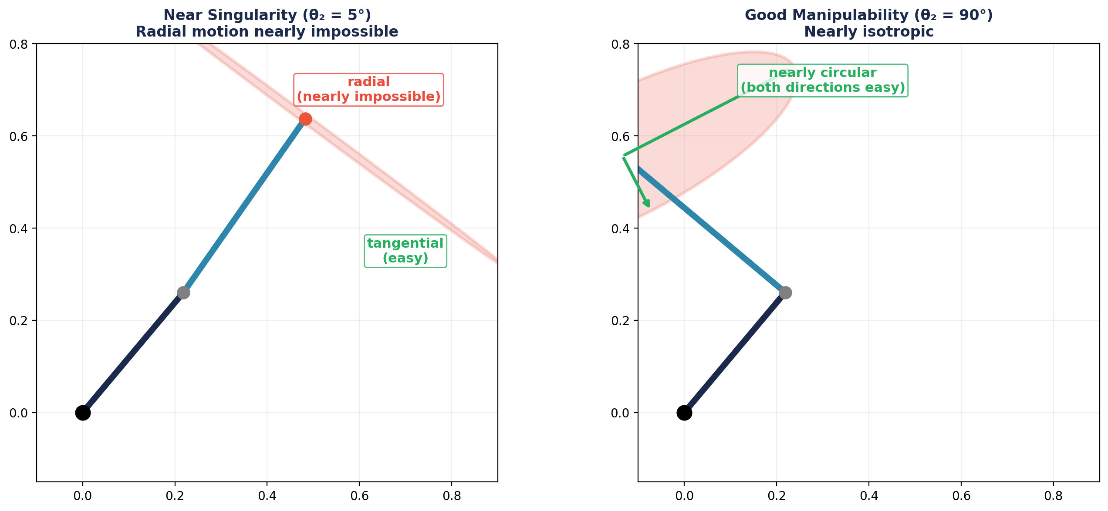
Figure 7. Left: near singularity (θ₂ = 5°), the velocity ellipsoid is highly elongated — radial motion is nearly impossible. Right: at θ₂ = 90°, the ellipsoid is nearly circular.

4.3 The Jacobian as a Velocity Transformer
The Jacobian’s fundamental role is converting between two representations of the same motion. Suppose the joints rotate with angular velocity θ̇ = (θ̇₁, θ̇₂). Then the endpoint moves with velocity:
ṗ = J(q) · $\dot{θ̇}$ (4.6)
Note that J depends on the current configuration q. The same joint velocities produce different endpoint velocities at different arm postures. This configuration dependence is a core challenge: the brain cannot use a fixed mapping from joint speeds to hand speeds.
Conversely, to achieve a desired endpoint velocity, we need:
$\dot{θ̇}$ = J⁻¹(q) · ṗ (4.7)
This exists whenever det(J) ≠ 0. At singularities, the inverse does not exist, and certain endpoint velocity directions become impossible to achieve.

5. Manipulability Ellipsoids
The Jacobian tells us how joint velocities map to endpoint velocities. But which endpoint directions are “easy” (achievable with small joint speeds) and which are “hard” (requiring large joint speeds)? The manipulability ellipsoid answers this question visually and quantitatively.

5.1 Construction
Consider the set of all joint velocities with unit norm:
||$\dot{θ̇}$||² = $\dot{θ̇}$ᵀ$\dot{θ̇}$ = 1 (5.1)
This defines a unit circle in joint-velocity space. Under the linear mapping ṗ = Jθ̇, this circle maps to an ellipse in endpoint-velocity space. To characterize this ellipse, substitute θ̇ = J⁻¹ṗ into the unit-norm constraint:
(J⁻¹ṗ)ᵀ(J⁻¹ṗ) = 1 (5.2)
ṗᵀ (J⁻ᵀ J⁻¹) ṗ = 1 (5.3)
ṗᵀ (JJᵀ)⁻¹ ṗ = 1 (5.4)
Equation 5.4 is the standard form of an ellipse. The matrix A = JJᵀ defines the ellipsoid. Its eigenvectors give the principal axes of the ellipse, and its eigenvalues give the squared semi-axis lengths.

5.2 Eigenvalue Analysis
Compute A = JJᵀ. Since A is a 2×2 symmetric positive semi-definite matrix, it has two real non-negative eigenvalues λ₁ ≥ λ₂ ≥ 0. The interpretation:
- Eigenvector v₁ (for λ₁): The direction in which the hand can move fastest for a given joint effort. The semi-axis length is √λ₁.
- Eigenvector v₂ (for λ₂): The direction in which the hand moves slowest. The semi-axis length is √λ₂.
When the ellipsoid is nearly circular (λ₁ ≈ λ₂), the arm is equally capable in all directions—this is isotropy. When it is highly elongated (λ₁ ≫ λ₂), the arm strongly favors one direction—this is anisotropy.

5.3 Yoshikawa’s Manipulability Measure
Yoshikawa (1985) proposed a scalar summary of the ellipsoid’s “quality”:
w(q) = √( det(JJᵀ) ) = |det(J)| = |l₁ l₂ sin(θ₂)| (5.5)
This equals the area of the manipulability ellipsoid (up to a factor of π). The derivation follows from the fact that det(JJᵀ) = λ₁λ₂, and the area of an ellipse with semi-axes √λ₁ and √λ₂ is π√(λ₁λ₂).
Key observations:
- w is maximized when θ₂ = 90° (elbow at a right angle)—this is the most dexterous configuration, and it falls comfortably within our joint range.
- w = 0 at the full-extension singularity (θ₂ = 0°)—the ellipsoid collapses to a line. As θ₂ approaches 0°, the hand loses the ability to move radially.
- w depends only on θ₂, not θ₁—for our 2-link arm, manipulability is determined entirely by elbow flexion, regardless of shoulder posture.
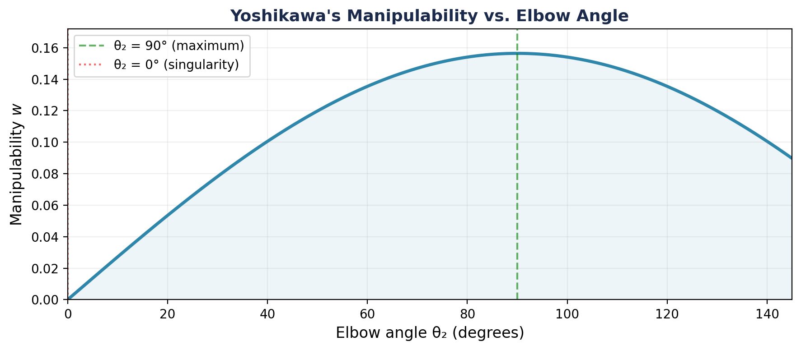
Figure 8. Yoshikawa's manipulability w over the anatomical elbow range [0°, 145°]. Maximum at θ₂ = 90°; singularity at θ₂ = 0°.
Motor Control Implications
Human reaching movements show higher endpoint variability in the direction predicted by the minor axis of the manipulability ellipsoid. This was demonstrated by Gordon et al. (1994): when reaching to the same target from different starting postures, the pattern of errors rotated with the arm’s Jacobian. The brain does not (or cannot) fully compensate for the arm’s anisotropic mechanics.
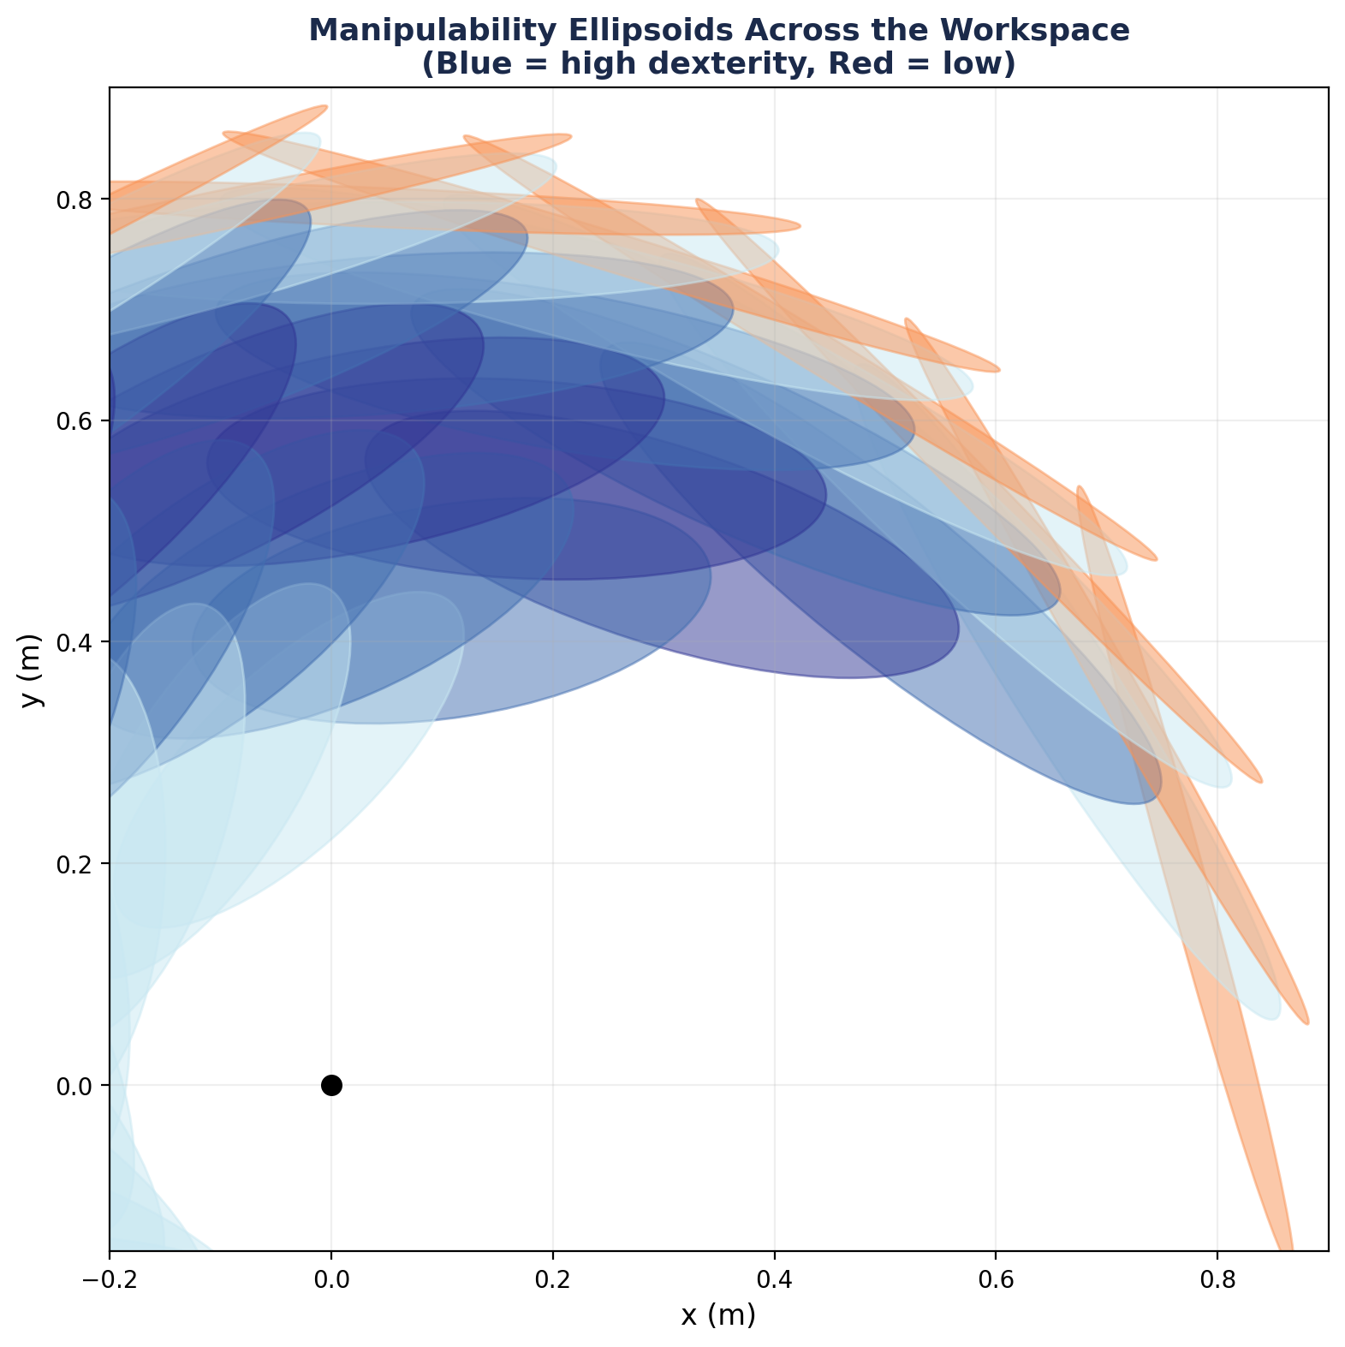
Figure 9. Manipulability ellipsoids sampled across the workspace. Blue = high dexterity (θ₂ near 90°); red = low dexterity (θ₂ near 0°).

5.4 The Force Ellipsoid
There is a dual ellipsoid for force. In static equilibrium — the arm holding a fixed posture and pushing isometrically against a rigid constraint — the principle of virtual work (τᵀδq = Fᵀδp, with δp = Jδq) gives τ = JᵀF, and therefore:
F = J⁻ᵀ τ (5.6)
Why Equation 5.6 Is a Statics Result
Equation 5.6 assumes the arm is not accelerating. Because our arm is confined to the horizontal plane, gravity drops out of the equations of motion, but the inertial terms do not. The full dynamics are M(q)θ̈ + C(q,θ̇)θ̇ + JᵀF = τ, so in general F = J⁻ᵀ[τ − M(q)θ̈ − C(q,θ̇)θ̇]. During movement, part of the joint torque accelerates the limb and balances Coriolis and centrifugal loads, and never appears at the hand. Note that the duality itself is not restricted to statics: a force applied at the hand always contributes JᵀF to the joint torques, whatever the arm's velocity. What requires equilibrium is identifying the net joint torque with the endpoint force. The force ellipsoid is therefore a statement about isometric force production in a fixed posture; its moving-arm counterpart is the endpoint-inertia (mobility) ellipsoid built from Λ(q) = (J M⁻¹ Jᵀ)⁻¹.

The force ellipsoid (constructed from JJᵀ) is the inverse of the velocity ellipsoid: substituting τ = JᵀF into the unit-norm torque constraint ||τ||² ≤ 1 gives Fᵀ(JJᵀ)F ≤ 1, an ellipsoid whose semi-axes are the reciprocals 1/σᵢ of the velocity ellipsoid's. Directions in which the hand moves easily are directions in which it exerts force poorly, and vice versa. This is a kinematic version of the classical speed–force tradeoff in mechanics.
Thought Exercise: What Does It Mean for the Two Ellipsoids to Be Perpendicular?
At any non-singular posture the velocity and force ellipsoids share the same principal axes, but the major axis of one is the minor axis of the other — the two elongations are 90° apart. Before reading on, work out for yourself:
(a) Why must the axes be perpendicular at all, and why are the semi-axes exact reciprocals (σᵢ and 1/σᵢ) rather than merely different?
(b) What is the physical reason that a direction of easy motion must be a direction of weak force? (Hint: the Jacobian stores no energy.)
(c) Yoshikawa’s w is maximal at θ₂ = 90°. Does that mean the hand is equally capable in every direction at that posture?

Answer
(a) Geometry. Both ellipsoids are built from the same symmetric, positive-definite matrix: the velocity ellipsoid from JJᵀ and the force ellipsoid from its inverse. The spectral theorem guarantees that a symmetric matrix has mutually orthogonal eigenvectors, and a matrix and its inverse have the same eigenvectors with reciprocal eigenvalues. The two ellipsoids are therefore locked to one orthogonal frame, with semi-axes σᵢ and 1/σᵢ. This is not a peculiarity of our arm — it holds at every non-singular posture of every manipulator.
(b) Power. The Jacobian is a massless, rigid, instantaneous transmission: it stores no energy, so the power delivered at the hand equals the power supplied at the joints, Fᵀṗ = τᵀθ̇, for every possible motion. Along a principal direction where J amplifies joint velocity into hand velocity by σ, it must therefore attenuate hand force into joint torque by that same σ — so with unit torque available, the achievable force is 1/σ. This is exactly the lever, or gear-ratio, principle: gearing up for speed gears down for force, and σ × (1/σ) = 1 is the statement that no transmission grants you both. Posture is the arm’s gearbox.
Practical corollary. To push hard in a given direction, orient the arm so that direction lies along the minor axis of the velocity ellipsoid. The limiting case is the singularity of §4.2: at θ₂ = 0° the arm is fully extended, σ₂ = 0, and radial motion is impossible — while radial force capability grows without bound, because the arm acts as a strut and the load passes through the skeleton rather than being carried by joint torque. This is why you lock your elbow to push a stalled car.
(c) No — and this is a common misreading of w. Yoshikawa’s measure is the product of the semi-axes (w = σ₁σ₂ = |det J|), so it tracks the ellipsoid’s area, not its roundness. At θ₂ = 90° our arm has σ = (0.699, 0.224) m: the area is maximal, w = l₁l₂ = 0.156, yet the ellipsoid is still elongated more than 3:1. The hand is over three times faster along one direction than the other — and, by the reciprocal relation, over three times weaker along that same direction. Uniformity is a different criterion, measured by the condition number σ₁/σ₂, and for our link lengths it is best near θ₂ ≈ 125° (ratio 2.39), where w has fallen to 0.127. Maximum manipulability and maximum uniformity are different postures — worth remembering whenever it is claimed that the motor system ‘optimises manipulability’.

6. Kinematic Redundancy & the Degrees of Freedom Problem
A Note on Scope
This section is included for pedagogical context. Our 2-DOF arm operating in a 2D task space is not redundant—it has exactly as many degrees of freedom as task dimensions, so each reachable target has a finite number of IK solutions (typically one, given our joint limits). You will never encounter null spaces, pseudoinverses, or infinite solution sets in the labs. However, kinematic redundancy is one of the central problems in motor control theory, and understanding it is essential for reading the literature. The concepts introduced here—Bernstein’s problem, cost-function resolution, the Uncontrolled Manifold Hypothesis—will help you appreciate the theoretical significance of the controllers we build in Modules 2–4, even though our simplified model sidesteps the redundancy problem itself.
Our 2-link arm has 2 degrees of freedom (DOFs) and operates in a 2D task space, so it is not redundant: each reachable target has a finite number of inverse kinematic solutions. But the real human arm has approximately 7 DOFs (3 at the shoulder, 1 at the elbow, 1 forearm rotation, 2 at the wrist) for a task space of 3 translational + 3 rotational = 6 dimensions. This means the arm has at least one extra degree of freedom.

6.1 The Ill-Posed Problem
When the number of joints exceeds the dimension of task space (n > m), the system ṗ = J$\dot{θ̇}$ is underdetermined: infinitely many joint velocity vectors θ̇ can produce the same endpoint velocity ṗ. Mathematically, the null space of J is non-empty:
null(J) = {θ̇ : J$\dot{θ̇ }$= 0 } (6.1)
Any vector in null(J) can be added to a solution without changing the endpoint motion—the joints “swirl” internally while the hand stays on the same trajectory. This is Bernstein’s degrees of freedom problem (1967): how does the nervous system choose among infinitely many equivalent motor solutions?
Figure 10 makes this concrete under our joint limits: the 2-DOF arm’s two IK solutions collapse to a single valid posture once hyperextension is excluded, while a redundant 3-DOF arm still reaches the same target through a continuous but bounded family of postures.
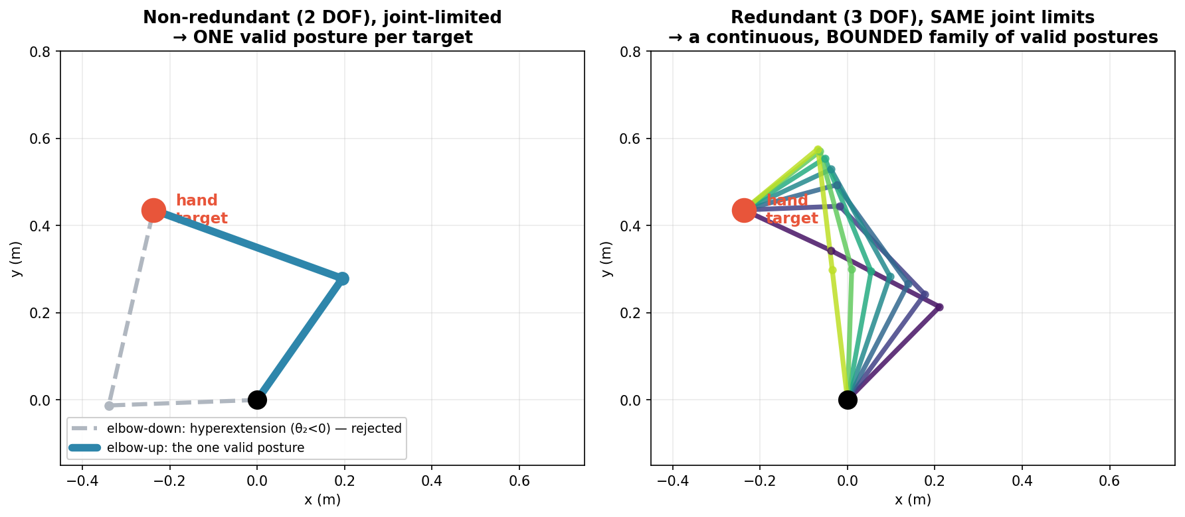
Figure 10. Kinematic redundancy under anatomical joint limits. Left: our non-redundant 2-DOF arm — the elbow-up solution (blue) is the only valid posture, while the elbow-down solution (grey, dashed) requires hyperextension (θ₂ < 0) and is rejected by the joint limits. Right: a redundant 3-DOF arm subject to the same limits reaches the same target through a continuous but bounded family of postures (self-motion through the null space of J). Redundancy persists under constraints; our 2-link model simply never has it.

6.2 Resolution Strategies
Several approaches have been proposed to resolve redundancy. These will recur throughout the course:
- Pseudoinverse solution: Choose the joint velocities with minimum norm: θ̇ = J⁺ṗ, where J⁺ = Jᵀ(JJᵀ)⁻¹ is the Moore–Penrose pseudoinverse. This minimizes instantaneous joint speed but has no physiological justification.
- Cost function optimization: Minimize a biologically motivated cost (e.g., energy, jerk, torque change) subject to the task constraint. This is the approach of Optimal Feedback Control (Module 4).
- Equilibrium Point Hypothesis: Avoid the redundancy problem entirely by specifying control in terms of equilibrium positions rather than trajectories (Week 4 in our course).
- Uncontrolled Manifold Hypothesis: Scholz & Schöner (1999) proposed that the brain does not resolve redundancy at all. Instead, it only stabilizes task-relevant combinations of DOFs, allowing variability to accumulate freely in the null space.

6.3 Preview: Why This Matters
The redundancy problem is not merely a mathematical curiosity. It sits at the heart of motor control theory. Although our 2-DOF model does not encounter redundancy at the kinematic level, the conceptual framework still applies.
All four resolution strategies above share a common structure: the brain must generate a motor plan before the movement begins, then monitor and correct during execution. This two-phase architecture is one of the oldest ideas in motor control. In 1899, R. S. Woodworth showed that rapid aimed movements consist of an initial impulse—a pre-planned, ballistic phase that gets the hand into the vicinity of the target—followed by current control—a slower, feedback-driven phase that homes in on the target using sensory information. This two-component framework maps directly onto the modules of this course:
Initial Impulse (Module 2): The brain computes a feedforward command by picking one solution to the motor planning problem, whether via threshold shifts (EPH) or a cost function (inverse dynamics). This gets the hand close to the target.
- Current Control (Modules 3–4): Feedback corrections handle the residual error using sensory information. Optimal Feedback Control, in redundant systems, can exploit the null space for robustness—a property we will appreciate conceptually even though our 2-DOF model does not possess a kinematic null space.
This week’s kinematic analysis provides the mathematical substrate for everything that follows. The forward map, the Jacobian, and the workspace structure will reappear in every module.

7. Summary of Key Results
Concept | Key Equation / Result
Forward Kinematics | x = l₁cosθ₁ + l₂cos(θ₁+θ₂), y = l₁sinθ₁ + l₂sin(θ₁+θ₂)
Inverse Kinematics (θ₂) | θ₂ = ±arccos[(x²+y²−l₁²−l₂²) / (2l₁l₂)]
Inverse Kinematics (θ₁) | θ₁ = atan2(y,x) − atan2(k₂, k₁)
Jacobian Determinant | det(J) = l₁l₂ sin(θ₂)
Singularities | θ₂ = 0° (extended); θ₂ = 180° outside joint range
Manipulability | w = |l₁l₂ sin(θ₂)|, max at θ₂ = 90°
Workspace | Semicircular crescent: θ₁ ∈ [0°,140°], θ₂ ∈ [0°,145°]

Notation Reference
- q = (θ₁, θ₂) — joint angle vector (configuration)
- p = (x, y) — endpoint position (task space)
- l₁, l₂ — link lengths (upper arm, forearm)
- J — Jacobian matrix (∂p/∂q)
- J⁺ — Moore–Penrose pseudoinverse of J
- w — Yoshikawa’s manipulability measure
- s₁, c₁ — shorthand for sin(θ₁), cos(θ₁)
- s₁₂, c₁₂ — shorthand for sin(θ₁+θ₂), cos(θ₁+θ₂)

Next week: We add muscles to this skeleton, introducing Hill-type actuators with force-length and force-velocity properties. The kinematic arm becomes a dynamic system.

