COMPUTATIONAL SENSORIMOTOR CONTROL

WEEK 6 LECTURE NOTES
Inverse Dynamics and the Muscle Redundancy Problem
Module 2: Control Architectures | Fall 2026
Learning Objectives for This Week
By the end of this week, you should be able to:
1. Run the inverse dynamics pipeline: convert a desired hand path into the joint torques that produce it, using inverse kinematics, numerical differentiation, and the equations of motion from Week 3.
2. Explain why the same 8 cm reach requires six times more peak torque in one direction than another, in terms of the Jacobian and the configuration-dependence of M(q).
3. Add an external load to the equations of motion through the term −J(q)ᵀF, and explain why the Jacobian must be evaluated at the current configuration.
4. State the muscle redundancy problem precisely, and explain why the non-negativity constraint F ≥ 0 makes the usable redundancy far smaller than the dimension of the null space.
5. Solve the redundancy problem by static optimization using the Crowninshield & Brand criterion, and explain what the choice of cost exponent does and does not control.
6. Distinguish the two numerical choices in the pipeline — the differentiation step and the integration step — and explain why they are separate decisions.
Required Reading
· Crowninshield, R. D., & Brand, R. A. (1981). A physiologically based criterion of muscle force prediction in locomotion. Journal of Biomechanics, 14(11), 793–801. — The origin of the cubic cost criterion we use in §4.
Supplementary
· Hollerbach, J. M. (1982). Computers, brains, and the control of movement. Trends in Neurosciences, 5, 189–192. — Why the inverse problem is hard, written before it was fashionable.
· Zajac, F. E. (1989). Muscle and tendon: properties, models, scaling, and application to biomechanics and motor control. Critical Reviews in Biomedical Engineering, 17(4), 359–411. — Background on the force-scaling parameter ρ.
Introduction
Week 3 solved the forward problem. Given joint torques, the Lagrangian formulation told us how the arm moves: apply Euler–Lagrange once per joint, collect the terms, and read off
M(q) · q̈ + C(q, q̇) · q̇ = τ (6.1)
This week we run that equation backwards. A movement is specified — a hand path through space — and we ask what torques would produce it. That is the inverse dynamics problem, and it is the computational alternative to letting the periphery sort things out.
Nothing about Equation 6.1 is re-derived here. M(q) and C(q, q̇) are exactly the objects built in Week 3 §3 and §4, with the same inertial parameters from Gribble et al. (1998), and the derivation is not repeated. Two things are new. First, we add an external force acting at the hand, which Week 3 had no occasion for: its arm moves in the horizontal plane with constant potential energy, so no external force ever entered the Lagrangian. Second — and this is where the week actually goes — solving Equation 6.1 gives joint torques, but joints are not what the nervous system commands. Muscles are. Converting two torques into six muscle forces turns out to be a different kind of problem entirely, and one with no unique answer.
The shape of the week
§1–2 solve the inverse problem at the joint level, where the answer is unique. §3 shows what an external load adds. §4 moves down one level of description, to muscles, where the same problem becomes underdetermined and stays that way until we commit to a cost function. The pivot between the two halves — uniqueness at one level, redundancy at the next — is the point of the week.
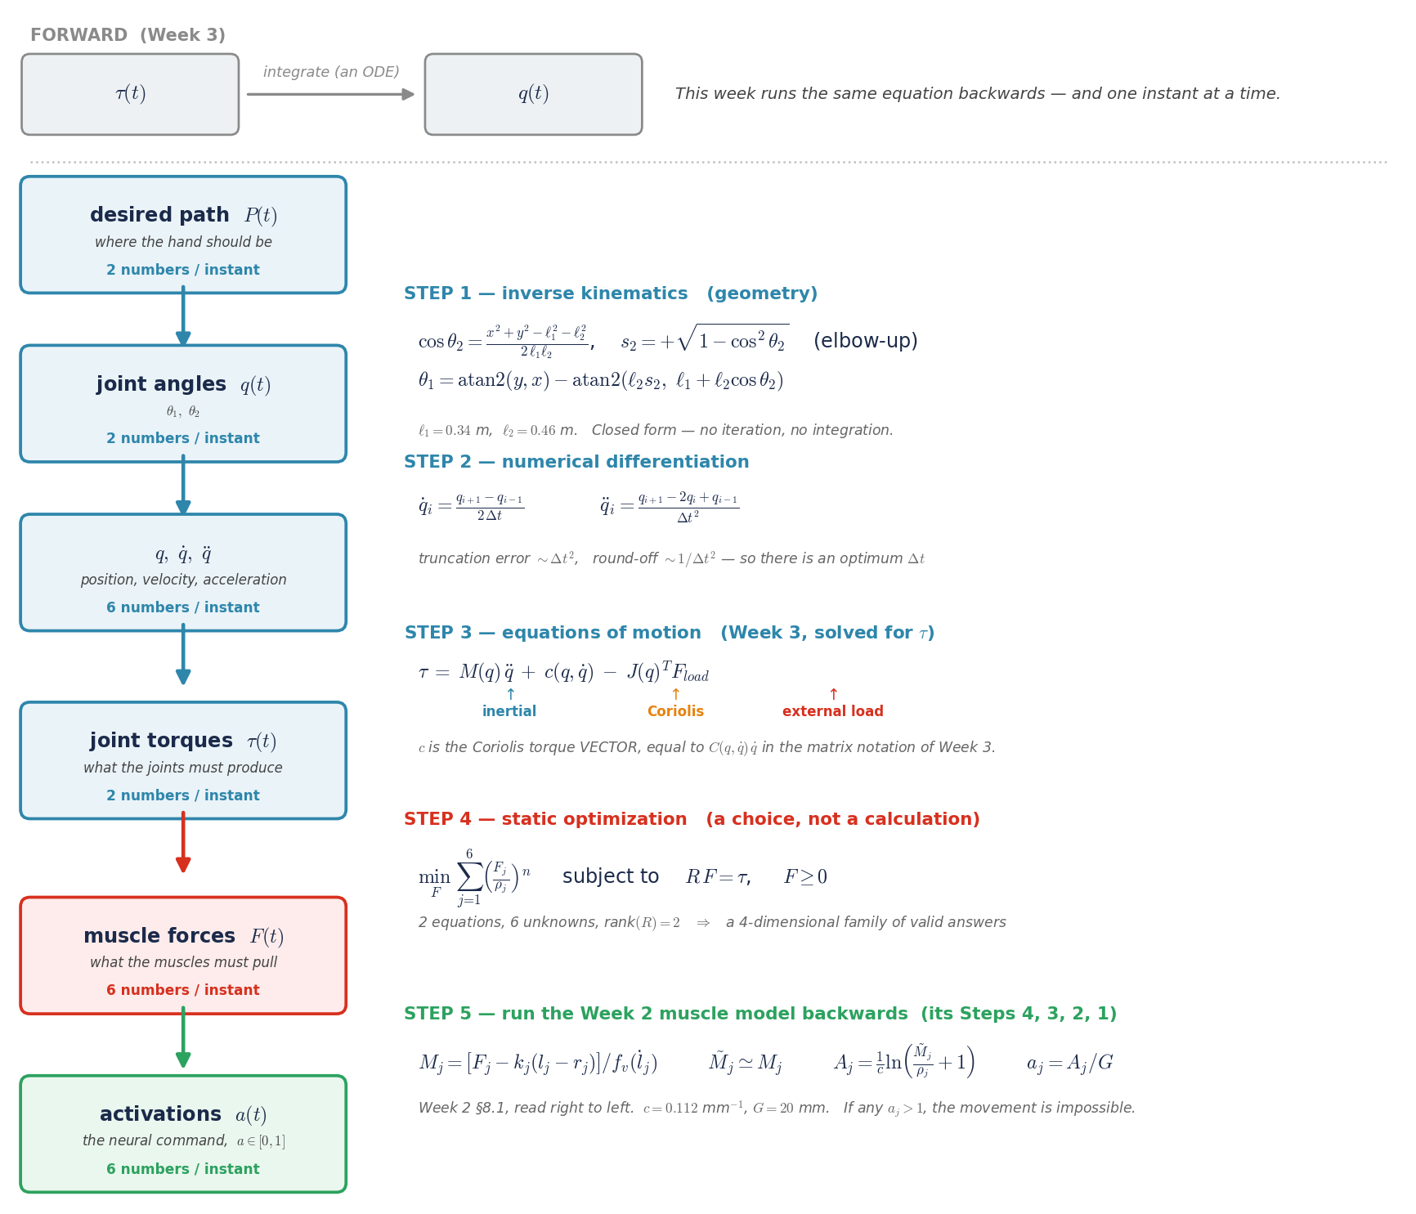
Figure 1. The inverse dynamics pipeline, step by step. Week 3 ran left to right along the top strip: given torques, integrate to find the movement. This week runs the same equation backwards, and pointwise in time rather than by integration. Steps 1 to 3 each have a closed form and each has exactly one answer. Step 4 does not: two equations in six unknowns admit a four-dimensional family of solutions, and choosing among them takes a cost function rather than more mechanics. Step 5 returns to the Week 2 muscle model, converting the chosen forces into the activations that would produce them.
The task
We keep Week 5’s reaching task unchanged, so that everything you already know about it carries over. From the reference posture Q_REF = (55°, 75°), the hand starts at (−10.07, 63.09) cm and reaches 8 cm in each of eight directions spaced 45° apart, in 500 ms, following a minimum-jerk straight line. In §3 a constant 3 N downward force is added at the hand.
1. The Inverse Dynamics Pipeline
The plan is a Cartesian path P(t). The plant accepts joint torques. Getting from one to the other is a fixed sequence of steps, and each is worth naming because each introduces its own error.
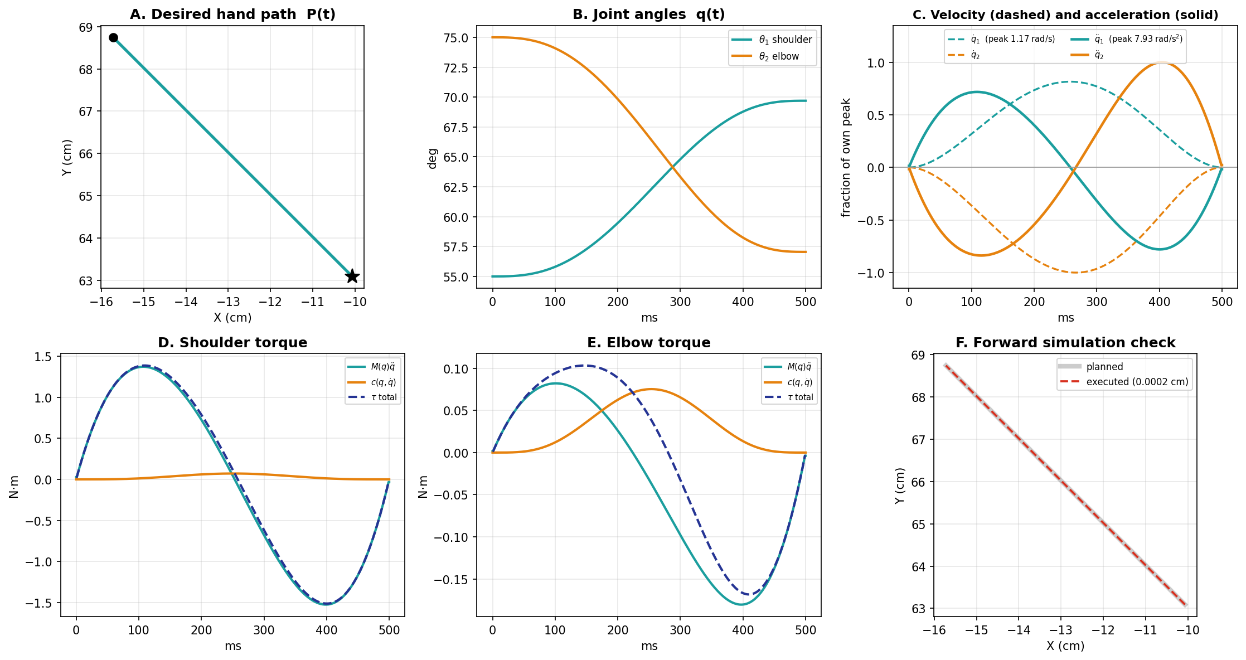
Figure 2. The inverse dynamics pipeline for the 135° reach, no load. A: the minimum-jerk plan in hand space. B: joint angles after inverse kinematics — the shoulder extends while the elbow flexes. C: joint velocity (dashed) and acceleration (solid) from central differences. Each is divided by its own peak so both fit one axis — the shapes are comparable, the magnitudes are in the legend. Velocity peaks where acceleration crosses zero. D–E: the torque at each joint, decomposed into its inertial and Coriolis parts. F: the executed path from forward simulation, overlaid on the plan.
Step 1 — The plan. A minimum-jerk straight line, P(t), sampled every 1 ms. It exists only in hand coordinates and knows nothing about the arm.
Step 2 — Inverse kinematics. Apply the Week 1 inverse kinematics at every sample to get q(t). Note what happens to the shape of the trajectory: the hand path is a straight line with a symmetric bell-shaped speed profile, but the joint trajectory is its image under a nonlinear map and inherits neither property exactly.
Step 3 — Differentiation. Central differences give q̇(t) and q̈(t) (Figure 2C). Because the minimum-jerk polynomial is smooth, no filtering is needed — but the step size is a real choice, and §5 returns to it.
A note on the Coriolis term, which these notes write as lowercase c(q, q̇). Week 3 presented it in the textbook form C(q, q̇)·q̇, a matrix multiplying joint velocity. That matrix is not unique — many different C matrices produce the identical product, because they differ by terms that vanish against q̇. Only the product is well defined, so that is what the library returns and what c denotes here. In code, coriolis(q, qd) is already the torque; multiplying it by qd again is a silent error that yields a plausible wrong number.
Steps 4 and 5 — Torques. Evaluate M(q)·q̈ and C(q, q̇)·q̇ at every sample using the Week 3 expressions and add them. This is the answer: at the joint level the inverse problem has exactly one solution, because M(q) is invertible everywhere in the workspace.
Step 6 — Verification. Feed the computed torques into the forward simulator from Week 3 and check that the arm actually goes where it was supposed to. On the 135° reach the executed path deviates from the plan by 0.0002 cm — for practical purposes, exact. This step is not optional. An inverse dynamics pipeline that is silently wrong produces torques that look plausible and movements that are not, and forward simulation is the only thing that catches it.
Why the verification step matters
Every stage above can fail quietly. Inverse kinematics can return the wrong elbow configuration; differentiation can be applied with the wrong step; the mass matrix can be evaluated at the desired rather than the actual configuration. None of these produce an error message. Forward simulation closes the loop, and it is the reason Lab 06 asserts on the executed path rather than on the torques.
2. The Same Reach Is Not the Same Problem
Run the pipeline for all eight directions and one number stands out. Peak inertial torque ranges from 0.25 N·m at 45° to 1.53 N·m at 135° — a factor of 6.1 — for movements of identical distance and identical duration.
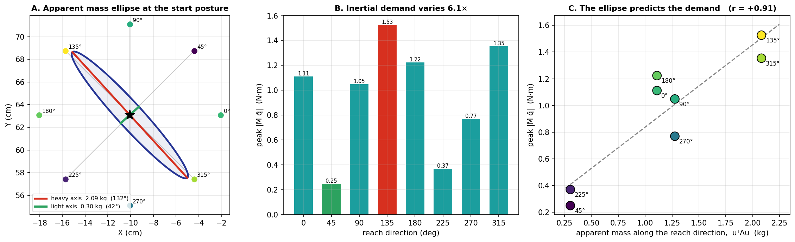
Figure 3. Why reach direction changes the problem. A: the apparent mass ellipse Λ(q) at the start posture, drawn in hand space with the eight targets; its long axis points at 132° and its short axis at 42°. B: peak inertial torque by direction. C: apparent mass along each reach direction against the torque that reach requires.
2.1 How much mass does the hand feel?
M(q) is the inertia the joints feel, and the task is specified at the hand, so the two are not directly comparable. The quantity we want is the hand-space analogue: push the hand in some direction and ask how much it accelerates. Three facts we already have are enough to derive it.
First, a force F applied at the hand produces joint torques τ = J(q)ᵀF — the Jacobian-transpose duality from §3. Second, those torques produce joint acceleration through Equation 6.1, and if the arm starts from rest the Coriolis term vanishes, leaving q̈ = M(q)⁻¹τ. Third, hand and joint acceleration are related by differentiating ṗ = J q̇, which gives p̈ = J q̈ + J̇ q̇, and at rest the second term is zero as well. Chaining the three:
p̈ = J q̈ = J M⁻¹ τ = J M⁻¹ Jᵀ F (6.2)
Inverting gives F = Λ(q) · p̈, with
Λ(q) = ( J(q) M(q)⁻¹ J(q)ᵀ )⁻¹ (6.3)
which is F = ma written for a two-link arm, with Λ playing the part of m. It is a 2 × 2 matrix with units of kilograms, and it is called the apparent mass, or in the robotics literature the operational-space inertia matrix (Khatib, 1987). Because it is built from both M(q) and J(q), it folds the two direction-dependent effects into one object rather than leaving them as separate influences to be traded off.
The number that matters for a reach along a unit direction u is the apparent mass in that direction, uᵀΛu. Concretely: a 1 N push along 42° accelerates the hand at 3.33 m/s², while the same push along 132° produces only 0.48 m/s². Same arm, same posture, same force — seven times the acceleration.
At the start posture Λ has eigenvalues of 0.30 kg and 2.09 kg, an anisotropy of 6.9, with the light axis pointing along 42° and the heavy axis along 132°. Figure 3A draws it. The ellipse is nearly a needle, and it is aimed almost exactly at the 135° and 315° targets while its narrow direction points at 45° and 225°.
Those are precisely the expensive and cheap reaches. Figure 3C plots apparent mass along each reach direction against the peak torque that reach requires: the correlation is 0.91, and the ranges nearly coincide — apparent mass varies 6.8-fold, peak torque 6.1-fold. Reaching along the needle means accelerating 2.09 kg of apparent mass; reaching across it means accelerating 0.30 kg. The task is the same and the limb is the same. Only the direction differs.
This is the same anisotropy Week 5 reported in its §6, from a different angle. There the comparison was between the two joints at the starting posture, where the shoulder’s effective inertia is 5.3 times the elbow’s (0.342 against 0.064 kg·m²), and the consequence was unequal lag — the elbow reaching its commanded equilibrium sooner than the shoulder, which is what bent the executed path. Here we are asking about directions in hand space rather than about joints, and the consequence is unequal torque demand. Both are readings of the same M(q): Week 5 took its diagonal, Equation 6.3 takes it through the Jacobian.
The ellipse is a property of posture, not of the arm
Λ depends on q, so the ellipse rotates and changes shape as the arm moves. Everything above is computed at the start posture, which is a reasonable summary for an 8 cm reach but would not be for a large movement. That posture-dependence has been measured in humans: the apparent mass ellipse and its orientation are what Hogan and colleagues characterized experimentally, and any account of reaching has to live with the fact that the limb presents a different mechanical load in every direction and at every configuration.
2.2 Coriolis: small, but not uniformly
Across the eight directions, peak Coriolis torque runs between 2.3% and 14.9% of peak inertial torque. That range is the interesting part. It is not a fixed small fraction that can be neglected once and forgotten — it is largest exactly where inertial demand is smallest, because the two have different geometric origins.
Figure 2D and 2E show the same point within a single reach. At the shoulder, the Coriolis term is nearly flat at about 0.05 N·m while the inertial term swings through ±1.5, so the total torque and the inertial torque are visually indistinguishable. At the elbow of the same movement, Coriolis peaks at 0.075 N·m against an inertial peak of 0.18 — comparable in size. Whether Coriolis can be neglected depends on which joint you ask about.
Interaction torques, revisited
Week 3 introduced interaction torques as the reason multi-joint control is harder than single-joint control. Inverse dynamics does not make that difficulty go away — it pays for it, by computing C(q, q̇) explicitly at every timestep. That is the deal this architecture offers throughout: the difficulty is not removed, it is converted into a computation, and the computation requires knowing M and C exactly.
3. Adding an External Load
A force acting at the hand does not enter Equation 6.1 as a joint torque. It has to be mapped through the geometry, and the mapping is the transpose of the same Jacobian used for velocities in Week 1:
M(q) · q̈ + C(q, q̇) · q̇ − J(q)ᵀ · F = τ (6.4)
The transpose is not an accident of notation. J maps joint velocities to hand velocity; Jᵀ maps hand forces to joint torques. The same matrix does both jobs, and that duality is one of the more useful facts in the subject.
The practical consequence is that J must be evaluated at the current configuration, because the arm rotates as it moves and the same 3 N force therefore produces different joint torques along the way. Freezing J at the starting posture is a tempting simplification and a wrong one: over a reach of this size the shoulder component of the load torque changes by enough to matter, and over larger movements it can change sign.
3.1 Load and inertia are differently anisotropic
Across the eight directions, peak load torque varies only from 0.89 to 1.06 N·m — a factor of 1.2 — because all eight reaches begin from the same posture and none travels far. Peak inertial torque, as we saw, varies by 6.1. So the ratio between them swings from 0.58 at 135° to 3.56 at 45°, and that swing is almost entirely the inertial term’s doing.
Five of the eight reaches are inertia-dominated and three are load-dominated. The 45° reach, which was the cheapest of all under no load, becomes the most load-dominated once 3 N is applied — the same movement, reclassified by adding a constant force.

4. Six Muscles, Two Torques
Everything so far has been unique. Given the plan, the joint torques follow with no choices to make. That ends here.
Torque is produced by muscles pulling on bones, and each muscle contributes through its moment arms. Collecting the six muscles from Week 2 gives
τ = R · F, F ≥ 0 (6.5)
where R is a 2 × 6 matrix of moment arms and F is the vector of muscle forces. Two equations, six unknowns. The system is underdetermined, and rank(R) = 2 means the set of solutions is four-dimensional.
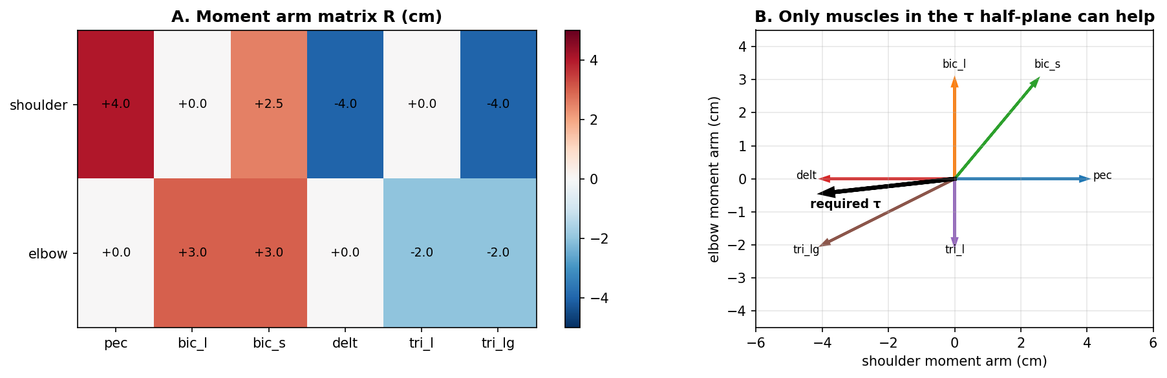
Figure 4. The redundancy problem. A: the moment arm matrix R in centimeters; positive is flexor, and bic_s and tri_lg are biarticular, contributing at both joints. B: each column of R drawn as a vector, with a required torque overlaid. Only muscles whose vector lies in the same half-plane as τ can contribute to it, because muscle force can only be positive — a muscle pulls but never pushes, so its contribution cannot be reversed in sign to help.
4.1 The null space is smaller than it looks
Four dimensions of freedom sounds like a great deal, and the standard statement of the redundancy problem stops there. But muscles pull; they do not push. The constraint F ≥ 0 is not a technicality, and Figure 4B shows what it costs.
For the torque drawn there — pointing down and to the left, as required midway through the 135° reach — only delt, tri_l and tri_lg have moment arm vectors on the correct side. Activating pec, bic_l or bic_s moves the torque in the wrong direction, and since their forces cannot go negative to compensate, they simply cannot help. Half the muscles are unavailable, and the usable freedom is far less than four-dimensional.
This is why the optimal solutions in §5 recruit two or three muscles rather than spreading across all six. It is not the optimizer being lazy. It is the geometry.
4.2 What lives in the null space
The null space is not an abstraction. Consider adding equal force to pec and delt. Their shoulder moment arms are +4.0 cm and −4.0 cm, so the two contributions cancel exactly and the joint torque is unchanged. The arm cannot tell the difference; the muscles are working harder for no mechanical effect.
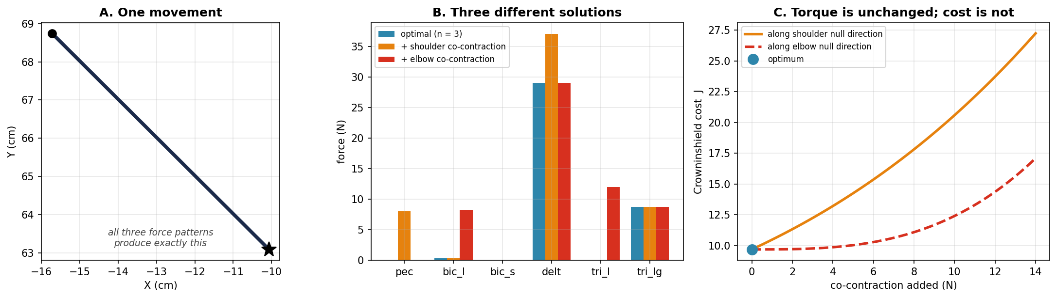
Figure 5. Redundancy made concrete. All three muscle force patterns in B produce exactly the torque required midway through the 135° reach, and therefore exactly the movement in A. They differ only in how much co-contraction they carry. C sweeps along both null-space directions: the torque never changes, the cost climbs steadily, and the optimum sits where no co-contraction is added.
Figure 5 makes this concrete: three force patterns that produce the identical torque, and therefore the identical movement, differing only in how much co-contraction they carry.
Co-contraction is often taken to mean that the joint carries no net torque. It does not, and the two force vectors from the in-class exercise show why. Both list forces in the order (pec, bic_l, bic_s, delt, tri_l, tri_lg): F_{A} = (0, 0, 0, 30, 0, 10) N and F_{B} = (10, 0, 0, 40, 0, 10) N. The table below multiplies each force by the muscle’s shoulder moment arm to get its shoulder torque. Only pec, delt and tri_lg appear, because the other three contribute nothing: bic_l and tri_l do not cross the shoulder, and bic_s carries no force in either vector.
Muscle | Shoulder moment arm (m) | Force in F_{A} (N) | Torque from F_{A} (N·m) | Force in F_{B} (N) | Torque from F_{B} (N·m)
pec | +0.04 | 0 | 0.00 | 10 | +0.40
delt | −0.04 | 30 | −1.20 | 40 | −1.60
tri_lg | −0.04 | 10 | −0.40 | 10 | −0.40
Flexor total (+) |  |  | 0.00 |  | +0.40
Extensor total (−) |  |  | −1.60 |  | −2.00
Net shoulder torque |  |  | −1.60 |  | −1.60
Co-contraction (canceled torque) |  |  | 0.00 |  | 0.40
Total muscle force |  | 40 |  | 60
Read each torque column from top to bottom. In F_{A}, delt and tri_lg both pull toward extension and nothing pulls the other way, so the whole −1.60 N·m moves the arm. In F_{B}, pec adds +0.40 N·m of flexion, and the extra 10 N in delt adds −0.40 N·m of extension. The extensors now produce −2.00 N·m. Of that, 0.40 N·m only cancels pec, and the remaining −1.60 N·m moves the arm.
Co-contraction is the torque canceled in this way. It equals the smaller of the flexor and extensor totals, ignoring sign: 0 in F_{A} and 0.40 N·m in F_{B}. The net shoulder torque is −1.60 N·m in both. At the elbow, only tri_lg contributes in either vector (10 N × −0.02 m = −0.20 N·m). Both joints receive the same net torque, so the arm makes the same movement.
The difference between the two vectors, F_{B} − F_{A} = (10, 0, 0, 10, 0, 0) N, is the equal pec and delt pair from the start of this section. It adds +0.40 N·m and −0.40 N·m at the shoulder and nothing at the elbow, so it lies in the null space of R. Adding it left the net torque unchanged. It raised the co-contraction from 0 to 0.40 N·m and the total muscle force from 40 N to 60 N.
So the joint carries a large net torque and co-contracts at the same time. The two are independent. You can have net torque with or without co-contraction, and you can have co-contraction with zero net torque, which is what holding a posture stiffly amounts to. Co-contraction measures the torque produced and then thrown away, and that is precisely what any cost increasing in each muscle force will refuse to pay for.
That is co-contraction — the C-command from Week 4, arrived at from the opposite direction. In Week 4 it was a control variable that set joint stiffness. Here it appears as a direction in the null space of R. Both descriptions are correct, and holding them together is worth the effort: co-contraction is precisely the freedom that torque alone cannot determine.
5. Static Optimization
To choose one solution from the family, we minimize a cost. Crowninshield and Brand (1981) proposed one on physiological rather than mathematical grounds:
minimize J = Σⱼ ( Fⱼ / ρⱼ )ⁿ subject to R·F = τ, F ≥ 0 (6.6)
5.1 What the paper actually did
It is worth knowing that this is a locomotion paper. Crowninshield and Brand were predicting muscle forces during human gait, not reaching, and their argument was about endurance: a muscle’s force capacity and its fatigue resistance both scale with physiological cross-sectional area, so the quantity worth conserving is force relative to capacity. Dividing by ρⱼ does that. They validated the predictions against EMG recorded during walking and argued that a cubic exponent reproduced observed recruitment better than linear or quadratic alternatives.
We are transplanting that criterion onto an 800-millisecond reach, solving it independently at every timestep with no coupling between instants. Whether a criterion validated on slow cyclic locomotion should govern a fast discrete movement is a fair question, and one worth pressing on Tuesday.
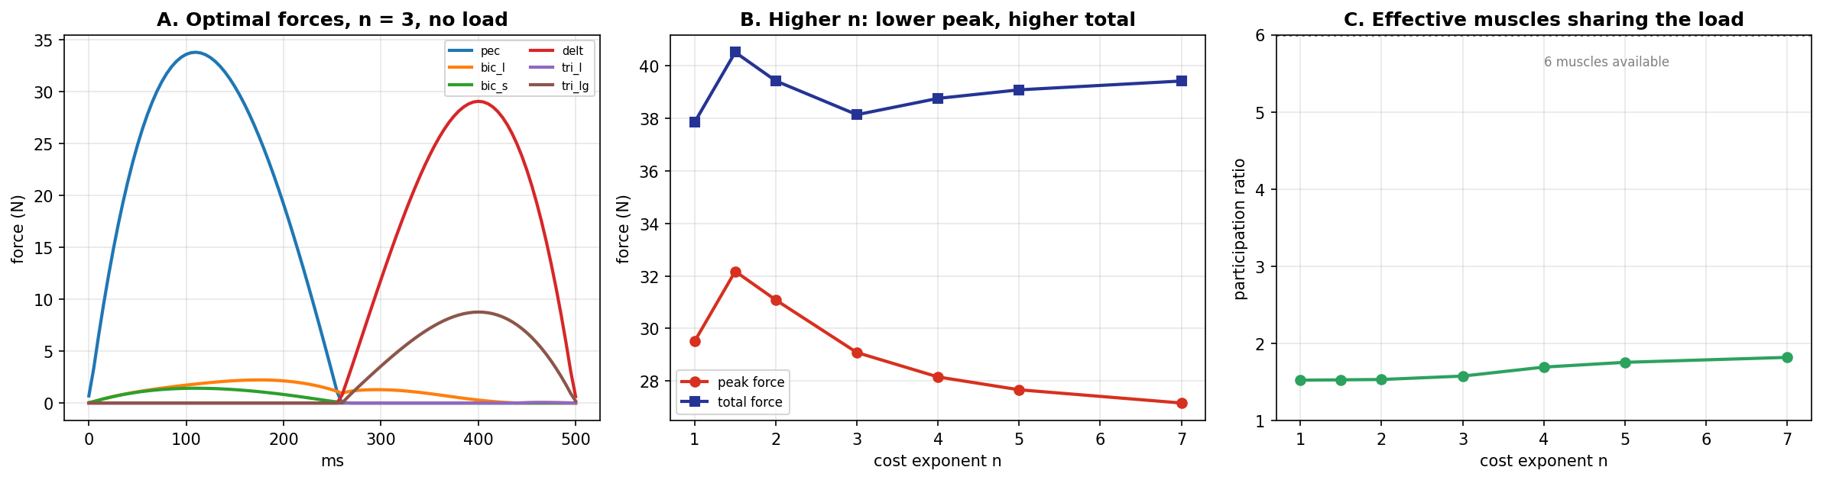
Figure 6. Static optimization on the 135° reach. A: optimal muscle forces over time with n = 3, no load. B: peak and total force as the cost exponent varies. C: the participation ratio, an effective count of how many muscles share the load.
5.2 What the exponent controls — and what it does not
Raising n from 1 to 7 lowers peak muscle force from 29.5 N to 27.2 N while raising total force from 37.9 N to 39.4 N, and raises the participation ratio from 1.52 to 1.82. That is the endurance argument made quantitative: a higher exponent buys a lower peak by paying more in total.
It is equally important to see what the exponent does not do. It is not what suppresses co-contraction. Any cost that increases with each muscle force rejects a null-space addition, because that addition is strictly positive force bought for no torque — and a linear cost rejects it just as firmly as a cubic one. The exponent governs distribution among the muscles that can help, not whether wasted force is admitted at all.
Note also how modest the distribution effect is: a participation ratio of 1.82 out of six available muscles. That is §4.1 again — most of the six cannot contribute to a given torque direction at any exponent.
5.3 The agonist–antagonist transition
Figure 6A shows pec carrying the movement for the first half and delt taking over for the second, with a rapid changeover around 258 ms. This is not a numerical artifact and it is not a discontinuity — at fine time resolution the forces are continuous, with the outgoing muscle’s force falling to zero as the incoming one rises.
What drives it is the torque reversing direction. Near the changeover the required torque does not pass through zero; its magnitude dips to roughly 2% of peak while its direction rotates by nearly 180°. By the half-plane argument of §4.1, that reversal swaps which muscles are able to contribute at all.
The result is the agonist–antagonist alternation familiar from EMG, produced here with no neural assumptions whatever — only mechanics and a cost function. Two caveats belong with it. Real EMG is triphasic, with a second agonist burst near the end that this model has no source for, since minimum jerk plans no correction. And the changeover here is sharper than any real muscle could achieve, because solving each instant independently allows the solution to turn over as fast as the torque does, whereas real activation dynamics would smear it over tens of milliseconds. That is the price of the word "static" in static optimization.
One further detail worth noticing: the changeover is at 258 ms, not at the 250 ms midpoint. The hand path is minimum-jerk, but the joint path is its image under inverse kinematics, and joint acceleration does not reverse at the same instant Cartesian acceleration does.
6. From Force to Activation
Week 2 §8.1 set out the complete muscle model as five numbered steps, running from a neural command down to a joint torque. Inverse dynamics hands us the last of those quantities and asks for the first, so this section runs the same five steps backwards. Nothing new is introduced; the equations below are Week 2’s, solved the other way round.
Week 2 step | Forward (Week 2 §8.1) | Backwards (this week)
1. Activation | A = G · a | a = A / G
2. Force–length | M̃ = ρ · [ exp(c·A) − 1 ] | A = (1/c) · ln( M̃/ρ + 1 )
3. Calcium filter | τ² M̈ + 2τ Ṁ + M = M̃ | M̃ = τ² M̈ + 2τ Ṁ + M
4. Total force | F = M · f_v(dl/dt) + k(l − r) | M = [ F − k(l − r) ] / f_v(dl/dt)
5. Joint torque | τ = R · F | F: underdetermined — see §4 and §5
Read the right-hand column from the bottom up and the shape of the week appears. Step 5 is the one that does not invert: two torques, six forces, and the whole of §4 and §5 spent choosing among the solutions. Steps 4 through 1 each invert exactly, in closed form, with no choices at all.
6.1 Step 4 backwards: what the contractile machinery must generate
Static optimization gave F, the force each muscle delivers to the bone — that is the quantity that has to satisfy R·F = τ, because that is what produces torque. Week 2’s Step 4 says F is not what the contractile machinery generates. Two other things contribute. The passive spring k(l − r) supplies force whether or not any command has been sent, since muscle is elastic tissue that resists stretch. And the force–velocity multiplier scales contractile force on its way out, because a shortening muscle delivers less than the same muscle held static. Solving Step 4 for M:
M = [ F − k ( l − r ) ] / f_v( dl/dt ) (6.7)
The correction is not cosmetic. At peak torque on the 135° reach the passive terms reach 2.5 N and contribute −0.21 N·m at the shoulder — about 14% of the required torque, supplied by the tissue for free — while f_v ranges from 0.57 to 1.30 across the six muscles at that same instant, because some are lengthening while others shorten.
6.2 Step 3 backwards: the one that fights back
Week 2’s calcium filter is a second-order differential equation, and inverting it is algebraically trivial — simply read it right to left:
M̃ = τ² M̈ + 2τ Ṁ + M (6.8)
Numerically it is not trivial at all, and the reason is worth understanding. Equation 6.8 needs the second time derivative of M, and M comes from static optimization, which solves each instant independently and therefore produces a force trajectory with corners in it — the agonist–antagonist changeover of §5.3 is one. Differentiating a corner twice does not converge. Refining the timestep from 2 ms to 0.25 ms drives the peak of M̃ from 126 N to 919 N and the implied activation from 1.00 to 1.85, with no sign of settling.
That divergence is not telling us the arm is incapable of the movement. It is telling us that the force profile static optimization asked for is not one any muscle could produce, because calcium kinetics cannot turn force over as sharply as an instant-by-instant optimizer can. It is the same limitation §5.3 identified from the other side, arriving here as a number that will not converge.
For everything that follows we therefore use the quasi-static reading, M̃ ≈ M. Week 2 puts the filter’s 90% rise at about 58 ms against our 500 ms movement, so away from the transitions the filter has time to settle and the approximation is a good one. At the transitions it is not, and that is a property of the solution rather than of the arm.
6.3 Steps 2 and 1 backwards: the neural command
Week 2’s Step 2 is the exponential force–length relation. Nothing in it depends on muscle length — that is the point Week 2 made about the name — so it inverts in one line:
A = (1/c) · ln( M̃ / ρ + 1 ) (6.9)
Step 1 then converts the effective displacement A back into the dimensionless activation that a controller would actually send, using Week 2’s neural drive gain G = 20 mm:
a = A / G (6.10)
With c = 0.112 mm⁻¹ the recruitment gradient, the product cG = 2.24, which is the number Week 2 chose so that full activation produces about 125 N in the pectoralis. The chain is now closed: a desired hand path at one end, a neural command at the other, and the same plant in between.
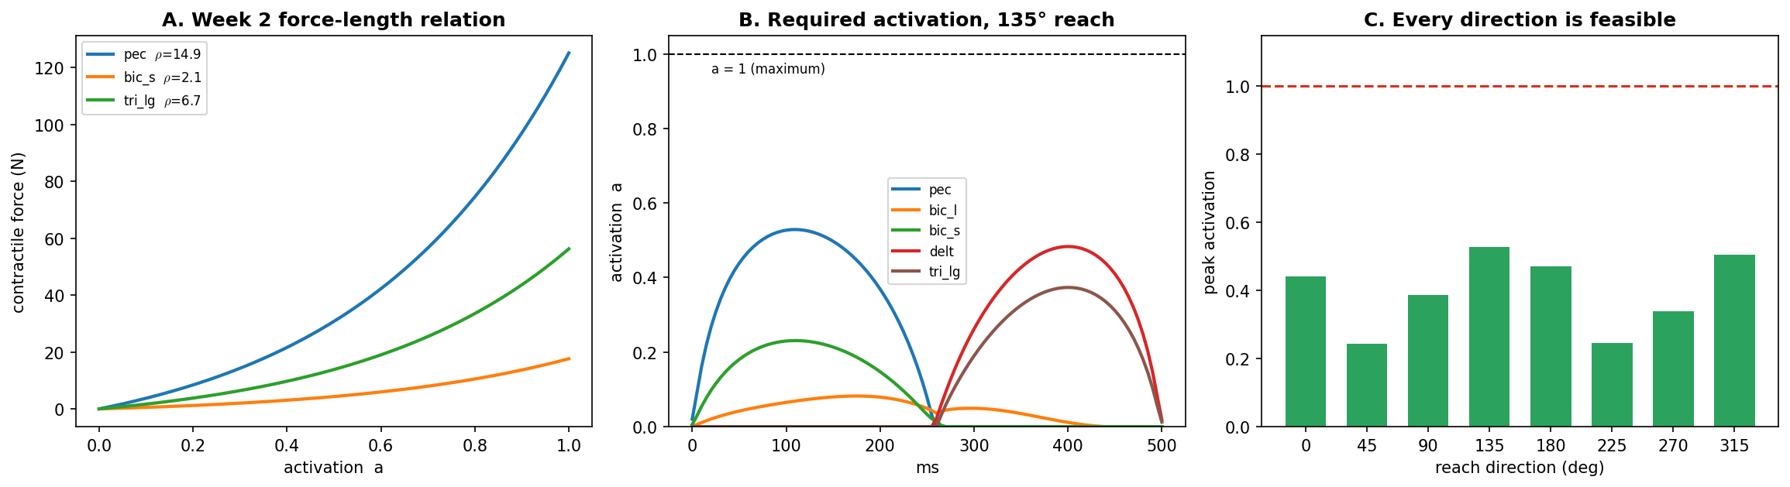
Figure 7. Running Week 2’s Step 2 backwards. A: the force–length relation for three muscles, showing how ρ sets the force available at a given activation. B: the activation required through the 135° reach, from Equations 6.7, 6.9 and 6.10. C: peak activation for each of the eight directions, against the ceiling at a = 1.
6.4 A feasibility test that the torques alone cannot give you
Activation is bounded above by 1, so the chain supplies something the torque calculation cannot: a check on whether the movement is possible at all. If any aⱼ exceeds 1, the required force is beyond what that muscle can produce, and no controller can rescue the plan.
Our task passes, though with less margin than the torques alone would suggest. The largest activation anywhere in the eight reaches is 0.81, at 135° — the direction §2 identified as the most demanding, which is the consistency check you would want. The 45° reach needs only 0.29. Figure 7C shows the full set.
So an 8 cm reach in 500 ms uses about four fifths of the available activation of its hardest-working muscle in the worst direction, and under a third in the easiest. Homework 6 asks what happens to that margin when the movement gets faster, and the answer is not comfortable.
One plant, many controllers
Week 2 said it plainly: the muscle mechanics stay fixed for the whole course, and only the source of the activation changes — direct input in Weeks 2 and 3, the threshold law in Week 4, inverse dynamics here, optimal feedback control in Weeks 12 and 13. This section is that promise being kept. Not one line of the muscle model was rewritten to accommodate inverse dynamics; the five steps were simply read in the other direction.
7. What the Load Does to Muscle Recruitment
Adding the 3 N load changes the required torque, and static optimization responds by changing which muscles it uses — not by scaling the ones it was already using.
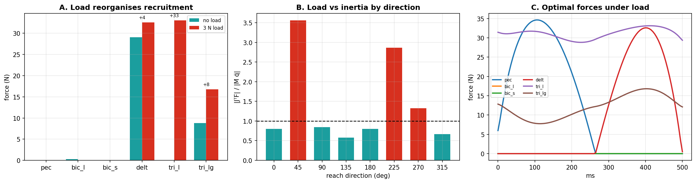
Figure 8. Effect of the 3 N load. A: optimal forces at peak torque, with and without load. B: the ratio of peak load torque to peak inertial torque by reach direction; the dashed line marks equality. C: optimal forces over time under load.
Figure 8A gives the comparison at peak torque, 8B the direction dependence, and 8C the full time course under load.
At peak torque on the 135° reach, tri_l goes from completely silent to 33.1 N — from unused to the largest force in the set, co-equal with delt. Meanwhile bic_l drops to zero. The active set changes membership.
That is a real prediction and a testable one. A model that merely scaled activation with load would predict the same muscles working harder; this one predicts a different muscle switching on. EMG can distinguish those.
Where this leaves us
At the joint level the inverse problem is exactly determined and inverse dynamics solves it outright. At the muscle level it is underdetermined, and no amount of mechanics will settle it — the answer depends on a cost function we chose, on grounds imported from a study of walking. That gap between "the mechanics are solved" and "the biology is decided" is where the rest of Module 2 lives.
Note also what this whole architecture assumes. Every torque in these notes was computed from an exact M(q), an exact C(q, q̇), and exact knowledge of the load. Where a nervous system would obtain those, and how well it would need to know them, is taken up in Week 12.
8. Each Muscle Has a Preferred Direction
Run the pipeline and the optimizer for all eight directions, and each muscle turns out to be recruited most heavily for some reaches and barely at all for others. That is a direction tuning curve, and it is the same kind of object Georgopoulos et al. (1982) reported for motor cortex neurons — except that here nothing neural produced it. It falls out of moment arm geometry and a cost function.
Getting it right, however, depends on a choice that is easy to make without noticing. The six muscles produce very different absolute forces — deltoid peaks near 30 N, biceps short barely reaches 1 N — so the curves have to be put on a common scale before they can be compared at all. The natural way to do that is to divide each muscle by its own largest value across the eight directions. That is what Figure 9A does, and it gives the wrong answer.
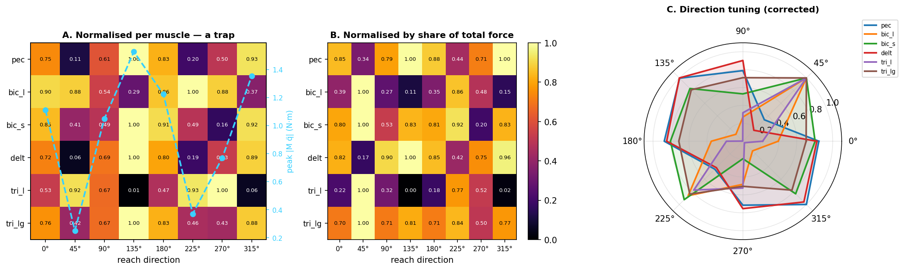
Figure 9. Direction tuning of the six muscles. A: each muscle normalized by its own maximum across directions, with peak inertial torque overlaid in blue. The apparent tuning tracks the torque curve — four of six muscles peak at 135°, including pec and delt, which are shoulder antagonists. B: the same data normalized by each muscle’s share of the total force in that direction. C: the corrected tuning as polar curves.
8.1 A normalization that measures the wrong thing
Dividing each muscle by its own maximum seems natural and produces Figure 9A. But §2 established that peak torque varies 6.1-fold across directions and is largest at 135°, so any muscle that is recruited at all will show its largest force there. The correlation between the mean normalized force and the torque magnitude is 0.86. What the panel is mostly displaying is which reach is hardest.
Here is how to read the panel. Each row is one muscle and each column one reach direction, so a bright cell means that muscle worked hard for that reach. Because every row has been divided by its own largest value, each row necessarily contains exactly one cell at 1.00 — the brightest cell in a row is that muscle’s preferred direction, and the row tells you nothing about how that muscle compares to any other.
Now read down the columns instead. The 135° column is bright almost all the way down, and the 45° column is dark almost all the way down. Compare that against the peak torques from §2, where 135° was the most demanding reach at 1.53 N·m and 45° the least at 0.25 N·m. The column pattern is tracking the difficulty of the reach, not the preferences of the muscles. The confound is in the raw data before any normalizing: mean peak force across the six muscles tracks peak torque at r = 0.98. Dividing each muscle by its own maximum does not remove that, it only rescales the rows, and the mean normalized force still tracks torque at r = 0.86.
There is a sharper check available, and it does not require the correlation. Look up pec and delt in the moment arm matrix of Figure 4: their shoulder moment arms are +4.0 cm and −4.0 cm. They are antagonists, pulling the shoulder in opposite directions. Two muscles that oppose each other cannot both be maximally recruited for the same reach, so if they share a preferred direction the analysis has gone wrong somewhere. In panel A both are brightest at 135°, along with bic_s and tri_lg — four of six muscles agreeing on one direction, which no arrangement of moment arms could produce.
The fault is in the normalization rather than in the model. Dividing each muscle by its own maximum leaves the across-direction variation in torque magnitude untouched, so the panel is showing which reach is hardest with a muscle-by-muscle scaling laid over the top.
8.2 The corrected picture
Normalizing instead by each muscle’s share of the total force generated in that direction removes the magnitude effect, and the count is the cleanest way to see it: under the naive scaling four of the six muscles peak at 135°, under the share scaling only one does. The tuning also becomes sensible — delt now prefers 135° while pec prefers 315°, which are opposite, as antagonists should be. The remaining muscles arrange themselves according to where their moment arm vectors point.
What the tuning does and does not show
It is worth being careful about the parallel with motor cortex. Direction tuning here is a consequence of mechanics: a muscle is recruited when its moment arm vector aligns with the required torque, and the cost function decides how strongly. No neural population, no encoding, no computation of movement direction is involved. That the shapes resemble cortical tuning curves is a reason to be cautious about inferring representation from tuning, not a reason to conclude the cortex is doing inverse dynamics.
9. Two Numerical Choices
The pipeline has two step sizes, and conflating them is a common and costly mistake.
The differentiation step sets how finely the plan is sampled before central differences are applied. Its error has two competing parts: truncation error falls as the square of the step, while round-off error in a second difference grows as the inverse square. There is an optimum, and it is not simply "as small as possible."
The integration step sets how finely the forward simulation advances. Here smaller is straightforwardly better, and RK4 error falls monotonically until it reaches the floor set by everything else.
These notes use 1 ms for the plan and 0.25 ms for the integration. One consequence is worth stating because it is easy to trip over: if the torque profile is held constant between plan samples rather than interpolated, refining the integration step converges to the exact solution of the held profile, not of the true one — and the error stops improving at a floor set by the plan sampling. Interpolating removes it. You will meet this directly in Section A of the lab.
Summary
 | Joint level (§1–3) | Muscle level (§4–6)
Unknowns | 2 torques | 6 forces
Equations | 2 | 2
Solution | unique | 4-dimensional family
Determined by | mechanics alone | mechanics + a chosen cost
Constraint | none | F ≥ 0, which removes most of the freedom
Verification | forward simulation | R·F = τ residual
Open question | none | which cost, and on what evidence
Week 7 adds motor noise, and the pipeline built here meets its limit: a torque profile computed in advance has no mechanism to notice that anything went wrong. That motivates the sensing and estimation of Module 3.

