WEEK 11
When Motor Commands Meet Muscle
Threshold Control with Real Tendons
Reading: Gribble, P. L., Ostry, D. J., Sanguineti, V., & Laboissiere, R. (1998). Are complex control signals required for human arm movement? Journal of Neurophysiology, 79(3), 1409–1424.
Reading: Kistemaker, D. A., Van Soest, A. K. J., & Bobbert, M. F. (2006). Is equilibrium point control feasible for fast goal-directed single-joint movements? Journal of Neurophysiology, 95(5), 2898–2912.
Supplementary: Feldman, A. G. (1986). Once more on the equilibrium-point hypothesis (λ model) for motor control. Journal of Motor Behavior, 18(1), 17–54.
Supplementary: Zajac, F. E. (1989). Muscle and tendon: properties, models, scaling, and application to biomechanics and motor control. CRC Critical Reviews in Biomedical Engineering, 17(4), 359–411.
Supplementary: McIntyre, J., & Bizzi, E. (1993). Servo hypotheses for the biological control of movement. Journal of Motor Behavior, 25(3), 193–202.
Introduction
Weeks 8–10 built the estimation pipeline: foveal and peripheral vision, proprioception, the Kalman filter, and pursuit efference copy. But look at how the hand actually moved: it followed a min-jerk trajectory with no muscles, no torques, and no dynamics. The 6-muscle plant from Weeks 2–4 was absent from execution.
This week closes that gap. We take the same reaching task — a 12 cm point-to-point movement from Q_REF — and execute it through real muscles. We compare three models that share the same λ-based control architecture (R-command + C-command from Week 4) but differ in what lies downstream: the R-C Ca²⁺ λ (no tendon, from Weeks 2–4), R-C on Hill muscles (same R-C commands, but with tendon compliance added), and the Kistemaker Model with Hill-type Muscle Mechanics (KMHM) (same Hill muscles, but with an additional CE velocity reference feedback). The comparison isolates two questions: what does the tendon change? And what does a smarter controller buy you when the tendon is present?
We run each model at two speeds — a slow reach (500 ms λ ramp, ~950 ms total movement time) and a fast reach (150 ms λ ramp, ~600–850 ms total movement time depending on the model). At slow speed, all three models perform nearly identically. At fast speed, the tendon catapult in R-C on Hill produces 13% overshoot; KMHM’s velocity reference feedback reduces this to 8% without sacrificing speed. The R-C Ca²⁺ λ model, without a tendon, is slower but stable.
The roadmap for Module 4: muscle mechanics and the tendon problem (this week) → optimal feedback control (Week 12) → motor adaptation (Week 13) → clinical motor control (Week 14).
1. The Debate: Simple Signals, Complex Movements
You built the Gribble muscle model in Week 2 and controlled it with λ thresholds in Week 4. The central result: constant-rate λ ramps produced smooth, bell-shaped reaching with intrinsic stability. No inverse dynamics, no trajectory planning. Gribble et al. (1998) argued that this simplicity was not a deficiency — the complex stiffness patterns measured by Gomi and Kawato (1996) during multijoint movement could be reproduced using simple λ ramps, because the complexity resided in the muscle’s nonlinear force-length and force-velocity properties, not in the control signal.
The Gribble Argument in One Sentence
Simple control signals (constant-rate λ ramps) + a realistic muscle model (nonlinear force-length, sigmoidal force-velocity, 25 ms reflex, calcium filter) = smooth movements with complex-looking stiffness patterns. The complexity that Gomi and Kawato attributed to the brain was actually in the muscles.
The Gribble Pipeline (Review from Weeks 2–4)
Threshold law: A = [l − λ + μ·dl/dt]⁺ (meters of stretch above threshold)
Exponential force: M̃ = ρ · [exp(c · A_mm) − 1] (c = 0.112 mm⁻¹)
Calcium filter: τ²M̈ + 2τṀ + M = M̃ (τ = 15 ms, ~90 ms to peak)
Force-velocity: F = M · [f1 + f2·atan(f3 + f4·dl/dt)]
Total force: F_total = F + k·(l − r) (passive spring)
The R-command (reciprocal λ shifts) controls where the arm goes; the C-command (cocontraction) controls stiffness. In code: lambda_for_posture(q_target, C=0.25) computes the six λ values. The key simplification: there is no tendon. Muscle length = MTC length = CE length. Spindle feedback maps one-to-one onto joint angle.
2. The Tendon Problem
Kistemaker, Van Soest, and Bobbert (2006) tested whether standard equilibrium-point controllers could produce fast goal-directed movements when the muscle model includes realistic tendon compliance. Using a Hill-type muscle with explicit CE, SE, and PE, they found that conventional α- and λ-controllers were insufficient for fast movements, while a hybrid controller combining open-loop and feedback components succeeded. In this section, we adopt the same Hill-type muscle architecture to ask a related question: what happens to our Gribble R-C control strategy when the plant has tendons?
Series Elastic Element: CE + SE + PE
In the Hill-type muscle model, each muscle consists of three elements (Figure 1): a contractile element (CE) that produces active force through cross-bridge cycling, a series elastic element (SE) representing the tendon and aponeurosis arranged in series with the CE, and a parallel elastic element (PE) arranged in parallel with the CE. The PE represents the passive elastic properties of the muscle tissue itself — the connective tissue layers surrounding the muscle fibers (endomysium, perimysium, epimysium) and the giant protein titin within each sarcomere. It produces force based on CE length regardless of activation: when the CE is stretched beyond about 1.4× its optimal length, the PE generates a passive restoring force. This is the resistance you feel when stretching a relaxed muscle. For most reaching movements the CE stays near optimal length and PE contributes little; the SE is the compliance that dominates the dynamics.
l_MTC = l_CE + l_SE

SE force: F_SE = k_SE · max(0, l_SE − l_SE_0)² (quadratic, ~4% strain at F_max)
PE force: F_PE = k_PE · max(0, l_CE/l_CE_opt − 1.4)²

At equilibrium (v_CE = 0): F_SE = F_CE_isometric + F_PE
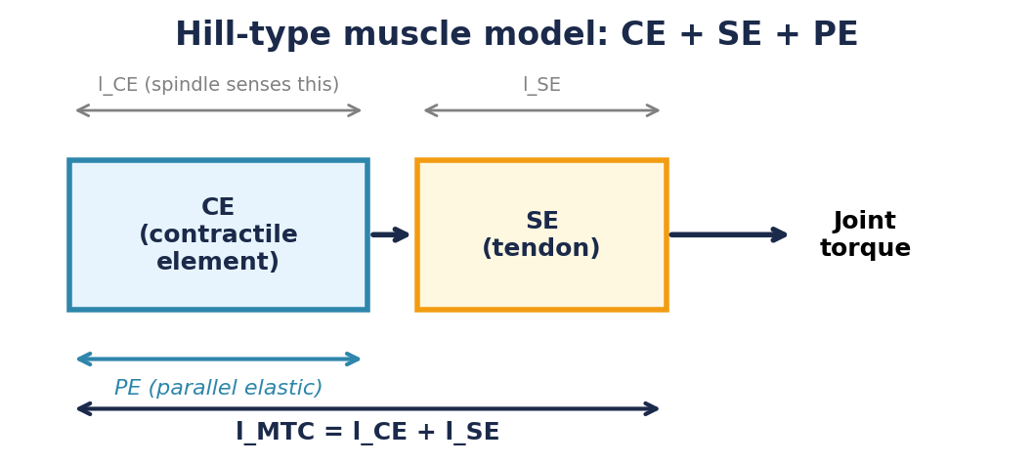
Figure 1. Hill-type muscle model. The contractile element (CE) produces active force via cross-bridge cycling. The series elastic element (SE, tendon) transmits CE force to the joint. The parallel elastic element (PE) represents passive connective tissue and titin within the muscle, producing a restoring force when the CE is stretched beyond ~1.4× optimal length. Muscle spindles sense l_CE, not l_MTC — because l_SE depends on force, the mapping from λ to equilibrium joint angle is no longer one-to-one.
The critical consequence: muscle spindles sense CE length, not MTC length. With a compliant tendon, CE length depends on both joint angle and muscle force. The one-to-one mapping between λ and equilibrium angle breaks. The C-command can no longer change stiffness without shifting the equilibrium. Kistemaker et al. (2006) demonstrated that when a controller ignores tendon compliance, static positioning errors can reach 8°.
The tendon breaks three things:
1. The mapping from λ to equilibrium joint angle now depends on activation level.
2. The C-command shifts the equilibrium position, not just stiffness.
3. CE velocity ≠ MTC velocity, so the μ·dl/dt damping acts on a different signal.
Activation Dynamics: Gribble vs Hatze
Both muscle models must convert a neural signal into active muscle force, but they do so through different activation pipelines. Understanding this difference is important because the activation dynamics shape the velocity profiles and perturbation responses we will see later.
Gribble activation (Weeks 2–4): The threshold displacement A = [l − λ + μ·dl/dt]⁺ is converted to a raw force command through an exponential curve, then passed through a second-order calcium filter:
Raw force: M̃ = ρ · [exp(c · A_mm) − 1]
Ca²⁺ filter: τ²M̈ + 2τṀ + M = M̃ (τ = 15 ms, ~90 ms to peak)
Active force: F = M · FV(dl/dt) (atan force-velocity curve)
This filter is fixed: it smooths force onset with the same time constant regardless of muscle length, velocity, or activation level. The force-length relationship is embedded in the exponential curve and does not change with activation.
Hatze activation (Kistemaker, 2006): The stimulation signal STIM is converted to active state through a two-stage process that depends on CE length:
Stage 1: STIM → γ (free calcium) dγ/dt = m · (STIM − γ)
Stage 2: γ → q (active state) q = (q₀ + (ρ·γ)³) / (1 + (ρ·γ)³)

where ρ depends on l_CE: ρ = c·η·(K−1) / ((K − l_CE/l_opt) · l_CE/l_opt)

Active force: F = q · f_iso(l_CE) · FV(v_CE) · F_max (Hill hyperbolic FV)
This model is length-dependent: the sensitivity parameter ρ increases at longer CE lengths, meaning less calcium (γ) is needed to achieve the same active state (q). Physically, stretched sarcomeres have more exposed binding sites and require less calcium for cross-bridge formation. The force-length curve effectively shifts with activation level.
The key differences for our simulations:
1. Filter order and shape. Gribble’s second-order filter produces a smooth, delayed force onset (~90 ms to peak) that naturally damps oscillations. Hatze’s first-order γ dynamics are faster, and the sigmoidal γ → q mapping can produce sharper force transients.
2. Length dependence. Gribble’s activation does not depend on muscle state. Hatze’s does — the same STIM produces different active states at different CE lengths, which interacts with the SE compliance to create coupled dynamics that the Gribble model avoids.
3. Force-velocity curve. Gribble uses an atan curve; the Hill model uses the classic hyperbolic relationship (concentric) with a linear eccentric extension. These produce different damping properties, as we will see in §7.
3. Three Models, One Reach
We compare three models on the same 12 cm point-to-point reach from Q_REF (Figure 2). All use the same R-C λ ramp; they differ only in the muscle plant and the feedback architecture.
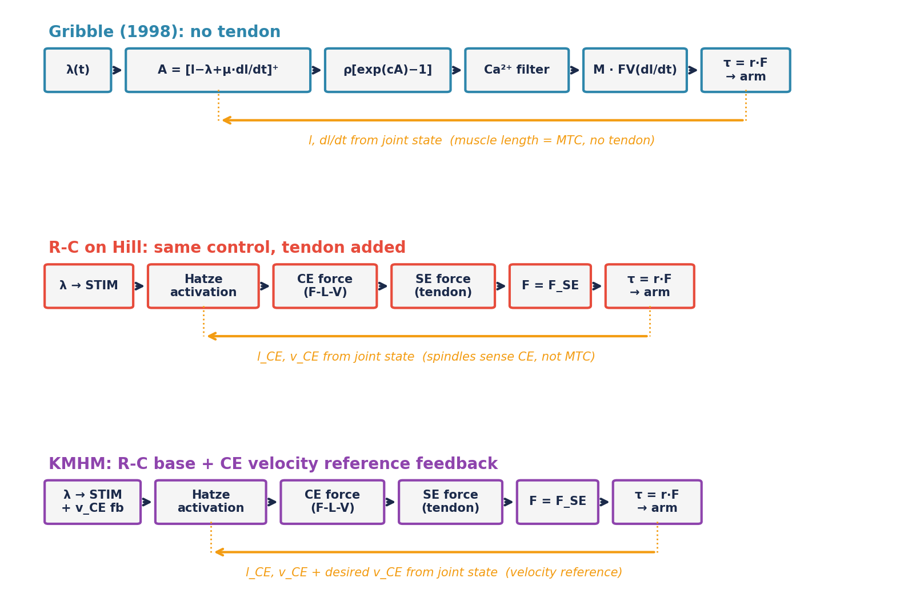
Figure 2. Force production pipelines. Top: Gribble (1998) — threshold displacement drives force directly; no tendon. Middle: R-C on Hill — same λ-to-STIM conversion, but muscles have CE + SE + PE; spindles sense l_CE. Bottom: KMHM — same Hill muscles, but feedback includes a CE velocity reference signal (desired v_CE from a min-jerk trajectory).
R-C Ca²⁺ λ (Week 4 model): R-C commands drive six muscles with no tendon compliance. This is simulate_lambda in the smc package — the same function you have been calling since Lab 4. Movement emerges from the interaction of threshold shifts with muscle mechanics.
R-C on Hill: The same λ ramp is converted to a STIM signal (STIM = gain × [l − λ + μ·dl/dt]⁺) and applied to Hill-type muscles with CE + SE + PE. No additional feedback beyond what the threshold law provides. This isolates the effect of adding a tendon.
KMHM: Same Hill muscles, same base STIM, but with an additional feedback loop that tracks a desired CE velocity profile. The rationale comes from McIntyre and Bizzi (1993), who proposed that feeding back the difference between desired and actual contraction velocity — rather than damping actual velocity alone — would improve EP controller performance. Their reasoning: pure velocity damping opposes the intended movement along with any perturbation, whereas a velocity reference signal lets the controller distinguish “moving as planned” from “moving off-plan.” Kistemaker et al. (2006) adopted this idea for their hybrid controller and found it was necessary for fast movements. The neurophysiological basis would be the fusimotor system’s ability to set muscle spindle sensitivity during planned movements, though direct evidence for this mechanism remains limited (Kistemaker et al. 2006). Our KMHM uses the same principle: a min-jerk CE velocity profile serves as the reference, and the feedback (delayed 25 ms) acts as a brake on the SE catapult effect.
Note: our three-way comparison is not a reproduction of Kistemaker et al. (2006). Their paper compared three different controller architectures (α, λ, and hybrid) on a single muscle model. We hold the control architecture fixed (Gribble’s R-C commands) and vary the muscle model, asking what tendon compliance does to a control strategy that was designed for a tendon-free plant. KMHM adds a velocity reference feedback inspired by Kistemaker’s hybrid, but is not identical to it.
4. Slow Reach: The Tendon Doesn’t Matter
With a 500 ms λ ramp (moderate speed), all three models reach the target with comparable accuracy and dynamics (Figure 3). The tendon is not stressed, and the KMHM velocity feedback has little to correct.
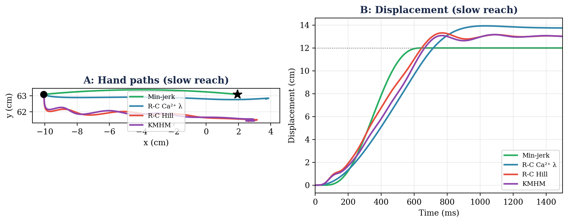
Figure 3. Slow reach (500 ms λ ramp). A: Hand paths are nearly identical across all three muscle models. B: Displacement traces show R-C Ca²⁺ λ (blue) settling slightly earlier, while R-C Hill (red) and KMHM (purple) are virtually indistinguishable.
Feature | Min-jerk | R-C Ca²⁺ λ | R-C Hill | KMHM
Peak velocity | 38 cm/s | 23 cm/s | 31 cm/s | 28 cm/s
Movement time (5–95%) | 529 ms | 940 ms | 1165 ms | 1170 ms
Endpoint error | 0.00 cm | 1.77 cm | 1.88 cm | 1.88 cm
Overshoot | 0.0% | 1.3% | 2.3% | 1.1%
Vel. asymmetry | 0.50 | 0.56 | 0.23 | 0.23

At this speed, R-C on Hill and KMHM are essentially identical. The tendon’s elastic energy storage and release are modest, and the CE velocity feedback has nothing to correct. R-C Ca²⁺ λ is slower (23 vs 31 cm/s peak) because it lacks the SE catapult, but it settles cleanly with only 1.3% overshoot.
5. Fast Reach: The Tendon Catapult and Its Cost
With a 150 ms λ ramp (fast), the tendon makes a dramatic difference (Figure 4). To understand why, consider what happens in the first 50–100 ms after the λ ramp begins.
When the CE begins contracting, it does not immediately move the joint. Instead, the CE shortens while the SE stretches to accommodate — the tendon absorbs the early contraction like a compressed spring. During this phase, elastic potential energy accumulates in the SE. The joint barely moves because the CE’s shortening is taken up by SE elongation rather than by joint rotation.
Then, when the SE force exceeds the load at the joint, the stored elastic energy is released rapidly. The SE recoils, accelerating the joint faster than the CE alone could produce. This is the SE catapult — a well-documented feature of muscle-tendon mechanics that insects like locusts and fleas exploit for jumping, achieving accelerations far beyond what their muscles could generate through contractile shortening alone. In human reaching, the effect is subtler but measurable: the Hill models produce 69–74 cm/s peak velocities, 60% faster than R-C Ca²⁺ λ’s 43 cm/s with the same λ command. But this speed comes at a cost.
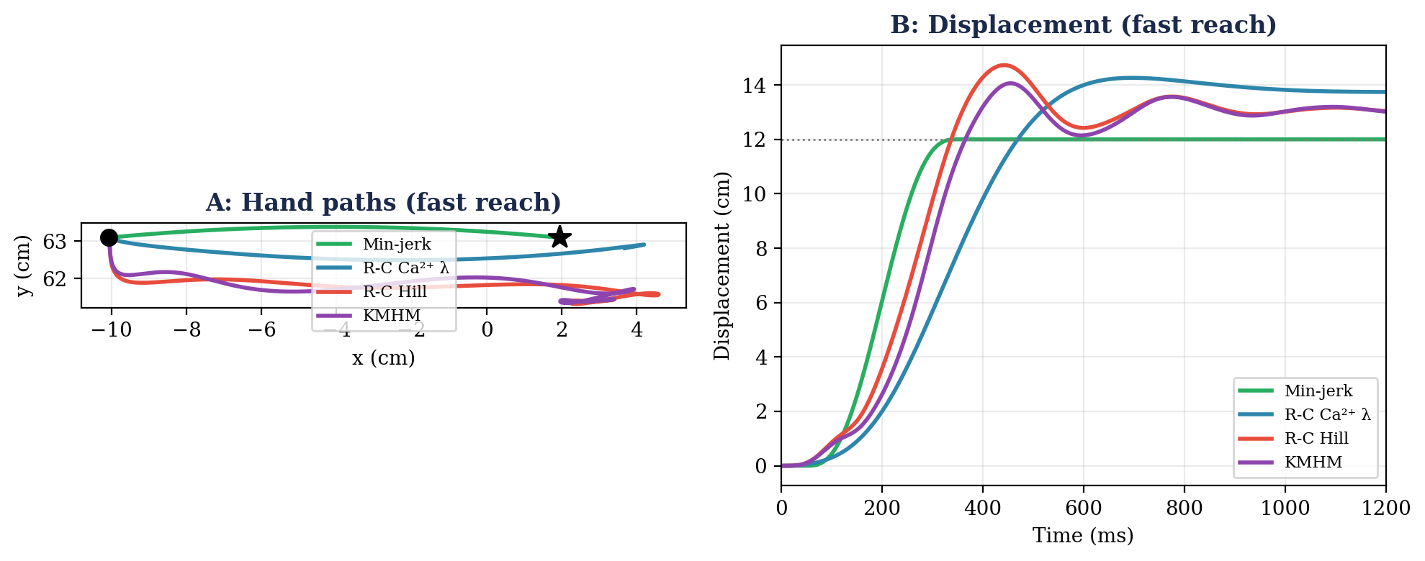
Figure 4. Fast reach (150 ms λ ramp). A: Hand paths. B: Displacement traces. R-C Hill (red) overshoots the target by 13% before settling back. KMHM (purple) reduces overshoot to 8% through CE velocity feedback. R-C Ca²⁺ λ (blue) is slower but stable (3.7% overshoot).
Feature | Min-jerk | R-C Ca²⁺ λ | R-C Hill | KMHM
Peak velocity | 75 cm/s | 43 cm/s | 69 cm/s | 74 cm/s
Movement time (5–95%) | 264 ms | 611 ms | 866 ms | 863 ms
Endpoint error | 0.00 cm | 1.77 cm | 1.88 cm | 1.88 cm
Overshoot | 0.0% | 3.7% | 13.2% | 8.0%
Vel. asymmetry | 0.50 | 0.45 | 0.28 | 0.29

R-C on Hill overshoots by 13%. The tendon catapult accelerates the hand so rapidly that the μ·dl/dt damping (which acts on MTC velocity, not CE velocity) cannot brake in time. The hand flies past the target and must oscillate back.
KMHM reduces overshoot to 8% without sacrificing peak velocity (slightly faster at 74 cm/s). The CE velocity reference feedback acts as a brake: when actual CE velocity deviates from the desired min-jerk profile, the feedback modulates STIM to counteract the deviation. In our simulations, this feedback reduces the SE catapult overshoot while preserving the speed advantage of tendon compliance.
R-C Ca²⁺ λ produces only 43 cm/s — limited by the force-velocity curve acting on the full MTC. Without a tendon to store and release elastic energy, the muscle must produce all the acceleration through contractile shortening alone. The benefit: only 3.7% overshoot.
Speed–stability tradeoff: the tendon’s dilemma
No tendon (R-C Ca²⁺ λ): slow but stable. The force-velocity curve limits peak speed but also prevents overshoot.
Tendon + R-C control: fast but unstable. The SE catapult boosts speed but the controller cannot brake in time.
Tendon + KMHM: fast AND more stable. The velocity reference feedback tames the catapult without giving up the speed advantage.
6. Velocity Profiles: Fingerprints of Muscle Mechanics
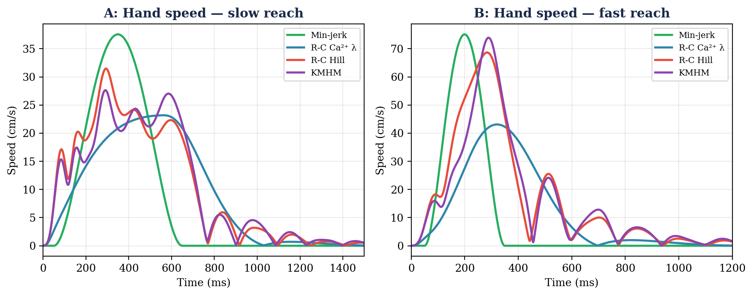
Figure 5. Hand speed for slow (A) and fast (B) reaches. Slow: all models produce clean single-peaked profiles. Fast: R-C Ca²⁺ λ (blue) peaks at ~320 ms with a near-symmetric bell; Hill models (red, purple) peak earlier at ~285 ms due to the SE catapult. The fast Hill profiles show a rapid early burst followed by a longer deceleration tail.
The velocity asymmetry tells the muscle mechanics story (Figure 5). Min-jerk is symmetric by construction (asymmetry = 0.50). R-C Ca²⁺ λ peaks slightly late (0.56 slow, 0.45 fast) because the calcium filter delays force onset by ~90 ms. The Hill models peak early (0.23–0.29) because the SE releases stored energy in a burst.
Velocity asymmetry as a fingerprint of muscle mechanics
Min-jerk: peak at 50% — symmetric bell (no muscles)
R-C Ca²⁺ λ: peak at 45–56% — slightly late (calcium filter delays force onset)
R-C Hill / KMHM: peak at 23–29% — early (SE catapult releases stored energy)

Same λ command, different velocity shapes. The difference is entirely in the muscle model.
7. Equifinality and Stability
In Week 4 §7, we tested equifinality and promised to revisit it with a more realistic muscle model. We now apply a 5 N·m torque perturbation (50 ms duration) at 300 ms into the slow reach — mid-ramp, when all three models are actively moving — and ask two questions: does the hand return to the same endpoint? And how does it get there? Figure 6 shows the results.
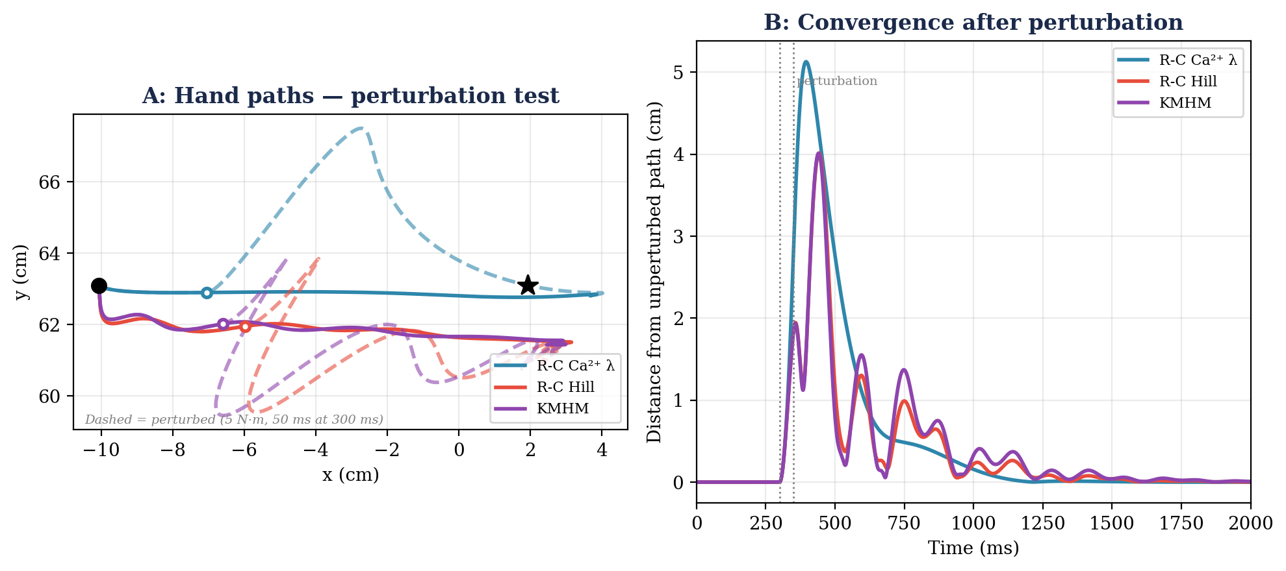
Figure 6. Equifinality test. A 5 N·m perturbation is applied at 300 ms during the slow reach (solid = unperturbed, dashed = perturbed). A: Hand paths. All three models are deflected but converge back to the same endpoint. B: Distance between perturbed and unperturbed paths over time. R-C Ca²⁺ λ (blue) shows the largest initial deflection (~5 cm) but the smoothest recovery. R-C Hill (red) and KMHM (purple) deflect less but oscillate before settling.
All three models converge to within 0.02 cm of their unperturbed endpoints — equifinality holds for slow reaches across all three architectures. But the dynamics of recovery tell a more important story than the final position.
R-C Ca²⁺ λ shows the largest initial deflection (~5 cm) because there is no tendon to absorb the impulse. But the recovery is smooth and monotonic. Why? Not because of the calcium filter alone — the Hill models also have activation dynamics (Hatze). The smooth recovery comes from the Gribble force production pipeline as a whole: the exponential force curve, the atan force-velocity relationship, and the second-order calcium filter together create a strongly damped attractor.
R-C Hill and KMHM deflect less initially (~4 cm) because the tendon’s series compliance absorbs part of the impulse — the SE stretches, buffering the joint. However, the recovery shows damped oscillation: the CE and SE form a spring-mass system with natural resonant modes. Elastic energy stored in the SE during the perturbation is released and reabsorbed over several cycles before settling.
Can Velocity Feedback Fix the Oscillations?
KMHM adds CE velocity feedback (kd = 0.30) to damp these oscillations. After the λ ramp ends, the desired velocity is zero, so the feedback becomes pure viscous damping: STIM += kd × (−v_CE). This is essentially Kistemaker et al.’s (2006) damping strategy. Does it work? Figure 7 tests this by comparing KMHM at its physiological delay (25 ms) against a hypothetical instantaneous version (1 ms delay).
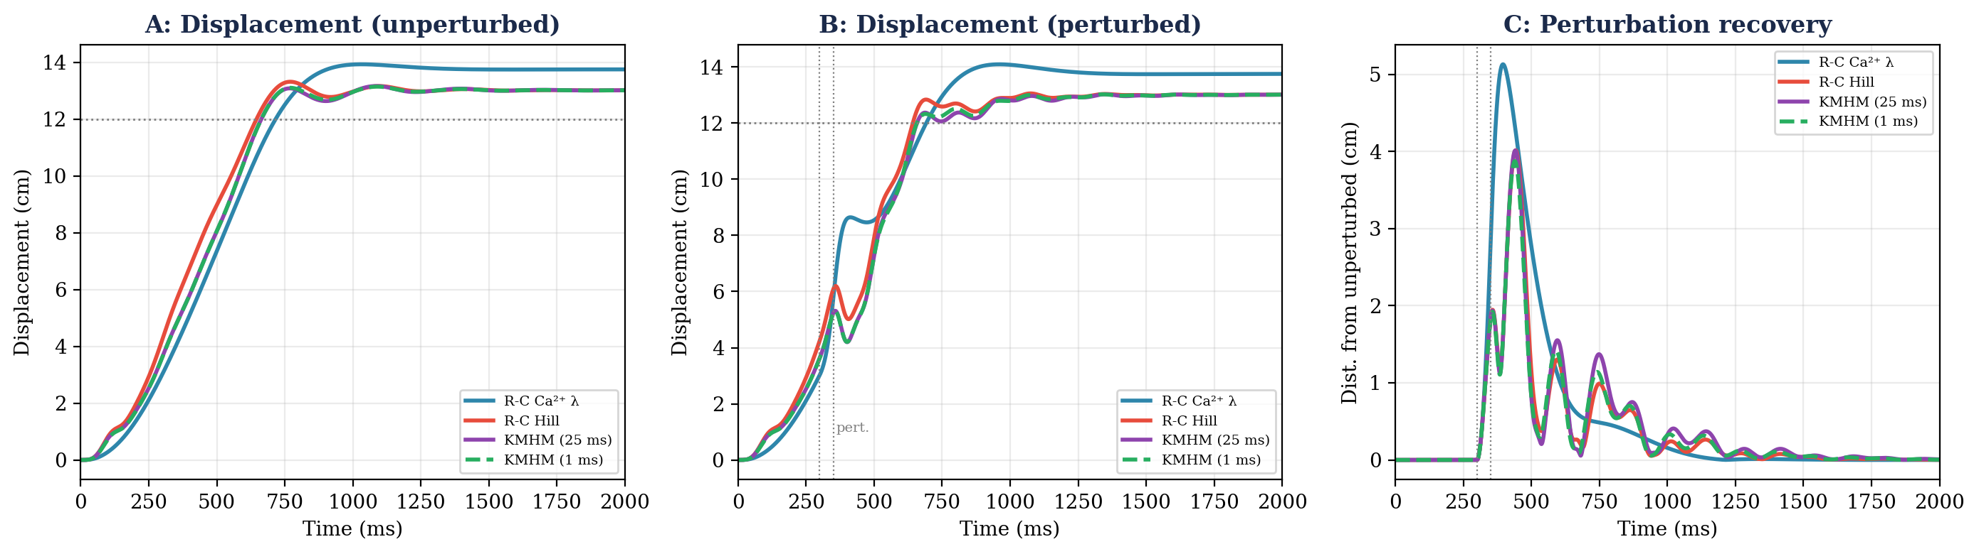
Figure 7. Effect of velocity feedback on oscillations. A: Displacement (unperturbed). B: Displacement with 5 N·m perturbation at 300 ms. C: Perturbation recovery (distance between perturbed and unperturbed). Even with near-instantaneous feedback (1 ms delay, green dashed — physiologically impossible but informative), the Hill models oscillate identically to R-C Hill (red). Only R-C Ca²⁺ λ (blue, no tendon) recovers smoothly. KMHM reduces overshoot (panel A: 2.3% → 1.0%) but cannot eliminate the SE-induced oscillations.
The result is striking: reducing the feedback delay from 25 ms to 1 ms (though physiologically impossible!) makes almost no difference. The oscillations persist at every delay. KMHM’s velocity feedback reduces overshoot (2.3% for R-C Hill → 1.0% for KMHM) but cannot suppress the SE-induced ringing. The oscillations are intrinsic to the CE+SE spring-mass dynamics, not a consequence of feedback delay.
This leads to three conclusions:
1. The oscillations come from the tendon, but not only the tendon. The Hill force-velocity curve (concentric hyperbola + eccentric linear) and the Hatze activation dynamics interact with the SE compliance to produce resonant modes. The Gribble pipeline’s specific combination of exponential force, atan force-velocity, and second-order calcium filter avoids these modes — but this is a property of that particular model, not a general feature of tendon-free muscles.
2. Simple velocity damping is insufficient. Even with zero delay and strong gain, proportional velocity feedback on individual CE velocities cannot fully damp a multi-muscle, multi-joint system. The feedback acts on each muscle independently and does not account for the coupled dynamics of the full limb.
3. The system needs a controller that knows the plant dynamics. To properly damp the CE+SE resonant modes, the controller must compute gains based on the full state of the system — joint angles, velocities, CE lengths, and SE forces — not just individual muscle velocities. This is exactly what optimal feedback control (Week 12) provides.
The case for optimal feedback control
EPH tells the arm WHERE to go (set the equilibrium via λ).
But EPH alone cannot guarantee HOW the arm gets there — the Hill muscle’s SE creates oscillations that simple velocity damping cannot suppress.
OFC (Week 12) computes feedback gains that account for the full plant dynamics, including the SE resonant modes. It answers: given this plant, what is the best feedback strategy to reach the target accurately and smoothly?
8. Two Feedback Loops: Spinal and Cortical
The perturbation results highlight a hierarchy of feedback. The spinal stretch reflex (μ·dl/dt, 25 ms delay) provides fast local correction: it resists perturbations by increasing activation when the muscle lengthens. The KMHM velocity feedback adds CE-level damping. But neither loop knows where the target is.
The cortical P-controller from Weeks 8–10 (Kp = 8, 100–260 ms delay) provides task-level correction: steering the hand toward the target in workspace. These are complementary loops operating at different timescales on different signals. The spinal reflex provides intrinsic stiffness (fast, local, task-agnostic). The cortical loop provides task-level accuracy (slow, global, task-aware). Neither alone is sufficient.
Spinal reflex (25 ms): fast, local, corrects muscle length errors via μ·dl/dt
CE velocity feedback: reduces overshoot but cannot eliminate SE oscillations
Cortical loop (100–260 ms): slow, global, corrects hand position errors via Kp·(target − hand)

Week 12 replaces these ad hoc gains with LQR: optimal feedback gains computed from the plant dynamics. Combined with the Kalman filter from Week 9, this gives LQG — the full sensorimotor control loop.
9. From Straight Lines to Curved Paths
Why EPH Needs Via-Points
The λ controller specifies where the arm should be, not how it should get there. A single endpoint λ ramp produces the workspace-dependent hand path that connects start to target — for our task, a roughly straight line. The controller has no representation of the desired path shape; it only knows the current λ values and the final λ values. To follow a curved path like the arc from Weeks 8–9, we must give the controller intermediate targets.
Via-points solve this: we place intermediate targets along the arc, compute the λ values that hold the arm at each via-point using lambda_for_posture(ik(via_point), C) from the smc package, and chain them together using make_ramp to linearly interpolate between successive λ vectors. The controller still does not know the path shape — it simply shifts through a sequence of postures. The path emerges from chaining these posture-to-posture transitions.
The arc task from Weeks 8–9: the hand traces a 6 cm semicircular arc from Q_REF to 12 cm right. With a single endpoint λ ramp, all three muscle models cut straight across the chord (6 cm max deviation). With 6 via-points equally spaced along the arc (160 ms per segment, 800 ms total), the hand curves upward to track the arc. Figure 8 shows the results for all three muscle models alongside the min-jerk arc reference.
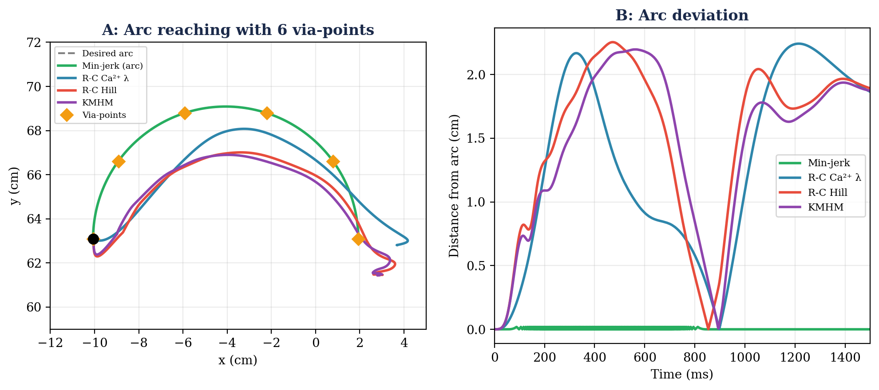
Figure 8. Arc reaching with via-points. A: Hand paths. Min-jerk (green) follows the arc by construction. With 6 via-points (orange diamonds), all three muscle models curve upward to track the arc, with R-C Ca²⁺ λ (blue) tracking slightly better than R-C Hill (red) and KMHM (purple). B: Arc deviation over time. Min-jerk stays on the arc; the muscle models deviate by ~2 cm at midpoint.
All three muscle models benefit equally from via-points, reaching max heights of 68 cm (R-C Ca²⁺ λ), 67 cm (R-C Hill), and 67 cm (KMHM) versus the true arc peak of 69 cm.
The Via-Point Tradeoff: How Many?
Via-points introduce a tradeoff. Fewer via-points (e.g., 3) produce smoother λ transitions but larger path deviations — the hand cuts corners between widely spaced targets. More via-points (e.g., 12) reduce path deviation but create more frequent λ transitions, each of which produces a small velocity transient as the muscles adjust to the new equilibrium target. At the limit of very many via-points, the λ signal approaches a continuously varying trajectory — which begins to resemble trajectory tracking rather than posture-to-posture control, and raises the question of what computational machinery the nervous system would need to generate such a signal.
Our choice of 6 via-points is a practical compromise: the mean arc deviation is ~1.5 cm (compared to 6 cm with no via-points), the velocity profiles remain clean single-peaked curves, and the λ signal is simple enough to be computed from a small number of stored postures. The via-point strategy works identically across all three muscle architectures — the differences from the point-to-point analysis (velocity profiles, overshoot) carry through but the path-following accuracy is comparable.
How Would the Nervous System Handle This?
The via-point approach raises a deeper question about motor planning. Would the nervous system precompute 6 via-points? Or 30, for a smoother path? And would it execute the entire sequence open-loop, or correct the trajectory online?
Precomputing many via-points approaches trajectory planning — the controller must know the desired path in advance and compute λ values at each point. This requires internal representations of both the workspace geometry (the arc shape) and the musculoskeletal mapping (which λ values produce which postures). At 30 via-points, the distinction between posture-to-posture EPH control and explicit trajectory tracking becomes blurred.
The alternative is online correction: the controller starts with a rough plan (perhaps just the endpoint, or a few coarse via-points) and adjusts the λ trajectory during movement based on sensory feedback about hand position errors. This is exactly the cortical feedback loop from Weeks 8–10 — the P-controller that steered the hand toward the target. Under this view, via-points are not precomputed waypoints but emergent consequences of continuous feedback correction.
This distinction — open-loop trajectory planning versus online feedback correction — is precisely what Week 12 formalizes. Optimal feedback control does not precompute a trajectory to follow; it computes a feedback policy (a mapping from state to control) that automatically generates the appropriate corrections at every moment. The via-point question dissolves: the controller does not need via-points because it continuously adjusts based on the current state of the arm.
10. The Verdict: What Tendons Cost and Buy
What Tendons Cost
1. The λ–angle mapping breaks. The same λ values produce different postures at different cocontraction levels. Kistemaker et al. (2006) showed that their hybrid controller required three internal “maps” of the static musculoskeletal system: angle → open-loop stimulation, stimulation → stiffness, and stimulation → steady-state CE length. Our KMHM addresses this in a simpler way by adding velocity feedback on top of the existing R-C architecture.
2. Overshoot at speed. The SE catapult produces 13% overshoot for fast reaches under pure R-C control. The KMHM velocity feedback reduces this to 8%.
3. Equifinality is approximate. The spring-like attractor is softened by tendon compliance.
What Tendons Buy
1. Faster peak velocity. 60–70% faster than R-C Ca²⁺ λ for the same λ command (69–74 vs 43 cm/s).
2. More realistic muscle mechanics. Real muscles have tendons. The stretch-shortening cycle and length-dependent calcium sensitivity depend on the CE–SE interaction.
Is KMHM Inverse Dynamics?
No. KMHM adds a velocity reference feedback to the existing R-C architecture, but it does not compute M(q)·q̈ + C(q,q̇) = τ. It does require a desired CE velocity trajectory (derived from a min-jerk profile), which means the controller has some knowledge of the intended movement — more than pure λ control, but far less than full inverse dynamics. Kistemaker et al. (2006) made a similar observation about their hybrid controller: it required knowledge of static muscle properties but not the equations of motion.
Recall from Week 6 that full inverse dynamics requires computing the mass matrix M(q), the Coriolis and centripetal terms C(q,q̇), and the gravitational torques at every timestep to determine the exact torques needed for a desired trajectory. KMHM avoids all of this — it uses the same λ-based feedforward as R-C Hill, and adds only a single scalar feedback term per muscle (the CE velocity error). The computational cost lies on a spectrum: pure λ control (geometry only) < KMHM (geometry + desired CE trajectory) < full inverse dynamics (complete equations of motion).
Summary
Feature | R-C Ca\u00B2\u207A \u03BB | R-C Hill | KMHM
Muscle model | No tendon | CE + SE + PE | CE + SE + PE
Control | R-C λ ramps | Same λ → STIM | Same + v_CE feedback
Slow overshoot | 1.3% | 2.2% | 1.2%
Fast overshoot | 3.7% | 13.1% | 8.0%
Fast peak vel. | 43 cm/s | 69 cm/s | 74 cm/s
Equifinality | Exact | Approximate | Approximate
Internal repr. | Geometry only | Geometry only | Geometry + trajectory

Week 11 Takeaway
Threshold control works — even with tendons, even at speed. But the tendon catapult creates a speed–stability tradeoff that pure R-C control cannot resolve. KMHM’s velocity reference feedback tames the catapult without giving up speed. The remaining gap between muscle-driven reaching (~1.9 cm error) and ideal reaching (0 cm) requires better control, not better muscles. Week 12 formalizes this as Optimal Feedback Control.

Next week: OFC (Todorov & Jordan, 2002). The cortical loop from Weeks 8–10 becomes LQR; the Kalman filter from Week 9 becomes the estimator in LQG. The minimum intervention principle: only correct task-relevant errors.
Controller/Estimator Summary (Updated)
Week | Plant | Controller | Estimator
7 | Arm | Feedforward (inverse dynamics) | None (open-loop)
8 | Arm | P-controller, Kp=8 | Raw delayed measurement
9 | Arm | P-controller, sensor fusion | Inverse-variance fusion
10 | Arm | FF min-jerk + feedback | KF (target) + inv-var (hand)
11 | Arm + muscles | EPH (λ R-C) / KMHM | Spinal reflex (25 ms)
12 | Arm + muscles | OFC (LQR) | Kalman filter (LQG)

References
Feldman, A. G. (1986). Once more on the equilibrium-point hypothesis (λ model) for motor control. Journal of Motor Behavior, 18(1), 17–54.
Gomi, H., & Kawato, M. (1996). Equilibrium-point control hypothesis examined by measured arm stiffness during multijoint movement. Science, 272(5258), 117–120.
Gribble, P. L., Ostry, D. J., Sanguineti, V., & Laboissiere, R. (1998). Are complex control signals required for human arm movement? Journal of Neurophysiology, 79(3), 1409–1424.
Hatze, H. (1981). Myocybernetic Control Models of Skeletal Muscle. University of South Africa.
Kistemaker, D. A., Van Soest, A. K. J., & Bobbert, M. F. (2006). Is equilibrium point control feasible for fast goal-directed single-joint movements? Journal of Neurophysiology, 95(5), 2898–2912.
Lackner, J. R., & DiZio, P. (1994). Rapid adaptation to Coriolis force perturbations of arm trajectory. Journal of Neurophysiology, 72(1), 299–313.
Latash, M. L., & Gottlieb, G. L. (1991). Reconstruction of shifting elbow joint compliant characteristics during fast and slow movements. Neuroscience, 43(2–3), 697–712.
McIntyre, J., & Bizzi, E. (1993). Servo hypotheses for the biological control of movement. Journal of Motor Behavior, 25(3), 193–202.
Todorov, E., & Jordan, M. I. (2002). Optimal feedback control as a theory of motor coordination. Nature Neuroscience, 5(11), 1226–1235.
Zajac, F. E. (1989). Muscle and tendon: properties, models, scaling, and application to biomechanics and motor control. CRC Critical Reviews in Biomedical Engineering, 17(4), 359–411.

