COMPUTATIONAL SENSORIMOTOR CONTROL

WEEK 3 LECTURE NOTES
Forward Dynamics: Connecting Muscles to Movement
Module 1: The Biological Plant | Fall 2026

Learning Objectives for This Week
By the end of this week, you should be able to:
- Write the Lagrangian equations of motion for a 2-link planar arm: M(q)d²q/dt² = τ − C(q,dq/dt)dq/dt.
- Derive each element of the mass-inertia matrix M(q) from the kinetic energy of the system.
- Explain why interaction torques arise from the off-diagonal elements of M and why they make multi-joint control fundamentally harder than single-joint control.
- Identify the Coriolis and centrifugal terms in C(q,dq/dt) and explain their physical meaning.
- Implement 4th-order Runge–Kutta (RK4) integration to simulate the arm forward in time.
- Connect the 6 muscles from Week 2 to the skeleton and simulate muscle-driven movement.

Required Reading
- Hollerbach, J. M., & Flash, T. (1982). Dynamic interactions between limb segments during planar arm movement. Biological Cybernetics, 44(1), 67–77. — The foundational paper on interaction torques in multi-joint arm movement.
Optional Reading
- Hirashima, M., Kudo, K., & Ohtsuki, T. (2003). Utilization and compensation of interaction torques during ball-throwing movements. Journal of Neurophysiology, 89(4), 1784–1796. — How skilled throwers exploit interaction torques rather than cancel them (see §4.4).
- Bastian, A. J., Martin, T. A., Keating, J. G., & Thach, W. T. (1996). Cerebellar ataxia: abnormal control of interaction torques across multiple joints. Journal of Neurophysiology, 76(1), 492–509. — What goes wrong when the cerebellum cannot predict interaction torques (see §4.4).
Implementation Reference:
- Gribble, P. L., et al. (1998). Are complex control signals required for human arm movement? J. Neurophysiol., 79(3), 1409–1424. — Appendix: equations of motion, all parameter values.

1. The Lagrangian Formulation

1.1 From Muscle Commands to Movement
In Weeks 1–2 we built two of the three parts of the plant. The kinematics gave us geometry — where the hand sits for a given set of joint angles, and how the Jacobian relates joint motion to hand motion. The muscle model gave us force — how much pull each of the six muscles produces from a given activation. Put the two together and the most basic question in motor control still has no answer: if I send this pattern of activations, where does the hand actually go?
Geometry cannot answer it, because geometry knows nothing about mass. Force cannot answer it directly either, because a force does not move a limb to a new place — it produces an acceleration. To turn a muscle command into a movement we need the missing law that maps torque to acceleration, and then we integrate that acceleration forward in time to get the trajectory. Supplying that law — the equations of motion — is the entire business of this week, and it is the third and last part of the plant.
For a single joint, the law is the one line everyone remembers from introductory physics:
I · d²θ/dt² = τ → d²θ/dt² = τ / I (1.1)
Torque divided by inertia gives acceleration. If the elbow were a lone hinge with the forearm bolted to it, we would be finished before we began. But an arm is not a lone hinge — it is a chain, and the moment two joints share a moving structure the simple picture collapses. Accelerating the shoulder flings the forearm outward; the forearm's own motion tugs back on the shoulder. These interaction torques — forces felt at one joint that are produced by motion at another — are the central theme of the week, and no single-joint equation can express them. We need a principled way to write the equations of motion for the whole coupled system at once. That method is the Lagrangian formulation.

1.2 Two Routes to the Equations of Motion
There are two classical ways to derive equations of motion, and choosing the right one saves an enormous amount of labor.
The first is Newton's, the one you already know: draw every body, mark every force acting on it, and write F = ma — with its rotational partner τ = Iα — for each. For a single mass this is trivial. For a two-link arm it is a bookkeeping nightmare. The upper arm pushes on the forearm at the elbow; by Newton's third law the forearm pushes back with an equal and opposite reaction; the shoulder exerts its own constraint force to keep the arm attached to the body. None of these internal forces are things you care about — they never appear in the final answer — yet Newton's method makes you introduce every one of them, resolve each into x- and y-components, and then watch them cancel. Each extra joint multiplies the bookkeeping.
The second route is Lagrange's, and its trick is to never write down a force at all. Instead of vectors it works with a single scalar — the energy of the system. Energy is a scalar, so no forces ever need resolving into components; and because internal constraint forces do no net work, they contribute nothing to the energy and so are absent from the start. (Vectors have not vanished — you still need segment velocities to write the kinetic energy down. What you never write is a force.) You describe the entire arm with one number, turn a mechanical crank, and the equations of motion emerge from the other side — interaction torques included, constraint forces already gone.

1.3 The Euler–Lagrange Equation
The one number is the Lagrangian L, defined as the system's kinetic energy minus its potential energy:
L = T − V (1.2)
That single scalar contains all the dynamics. To extract the equation of motion for any joint coordinate qᵢ, you apply the Euler–Lagrange equation:
d/dt ( ∂L/∂(dqᵢ/dt) ) − ∂L/∂qᵢ = τᵢ (1.3)
Read it as a recipe, not a mystery. Take the Lagrangian; differentiate it with respect to the joint's velocity; take the time derivative of that; subtract the derivative of the Lagrangian with respect to the joint's angle; the result equals the torque applied at that joint. Do this once per joint and the complete equations of motion fall out. For our arm we apply it twice — once for the shoulder, once for the elbow — and the two results assemble into the compact matrix form we will use all week:
M(q) · d²q/dt² + C(q, dq/dt) · dq/dt = τ (1.4)
Here M(q) is the mass–inertia matrix — the multi-joint generalization of the scalar I in Equation 1.1 — which we derive in Section 3. C(q, dq/dt) collects the velocity-dependent Coriolis and centrifugal terms, derived in Section 4. Everything else in these notes is either building these two objects or simulating what they do.
The Whole Recipe on One Line
Write the kinetic energy → form L = T − V → apply Euler–Lagrange once per joint → read off M(q)·d²q/dt² + C(q,dq/dt)·dq/dt = τ. Sections 3 and 4 are simply the two halves of the last step: Section 3 collects the terms that survive into M, Section 4 the terms that survive into C.

1.4 Why the Interaction Torques Come for Free
The reason to prefer this machinery is not elegance for its own sake — it is that the physics we most care about appears automatically. We never sit down and decide to add an interaction torque. We write the kinetic energy of a chain, turn the crank, and the interaction torques are simply there in the output, correctly signed and complete. Had we tried to add them by hand with Newton's method, we would first have had to know they existed and then get every sign right; the Lagrangian approach makes it impossible to forget one. This is exactly why, in Section 4, the Coriolis and centrifugal forces will seem to emerge from a time derivative rather than being posited by hand — they were hiding in the energy all along. It is worth seeing exactly where they enter. The forearm hangs off the upper arm, so its center of mass depends on both angles; differentiating and squaring its velocity therefore produces an unavoidable cross-term, 2l₁s₂cosθ₂ · (dθ₁/dt)(dθ₂/dt). That cross-term is the entire source of the coupling: its coefficient m₂l₁s₂ is the constant we will name a₃, and it is what puts the off-diagonal a₃cosθ₂ into M. One term in the kinetic energy then yields both families of interaction torque — the coupling M₁₂·d²θ₂/dt² directly, and, because it carries cosθ₂, the Coriolis and centrifugal terms once the time derivative differentiates it. “Free” does not mean effortless: you still have to write the kinetic energy correctly. It means no extra insight is required — you need not suspect these effects exist in order to obtain them.
One feature of our arm makes the general recipe simpler still. Because the movement is confined to the horizontal plane, no segment ever changes height, so the gravitational potential energy V is constant — and a constant contributes nothing to the derivatives in the Euler–Lagrange equation. It drops out entirely, leaving L = T. This is why every derivation from here on begins and ends with kinetic energy alone, and why gravity never appears when you build the DynamicsEngine.

2. Inertial Parameters of the Arm
The joint angles follow the same conventions as Week 1: θ₁ is measured in the global frame (0° = arm abducted, positive = horizontal flexion), and θ₂ is body-fixed relative to the upper arm (0° = fully extended, positive = flexion). The absolute forearm angle in the global frame is (θ₁ + θ₂) — this is why the forearm’s COM position (Equation 3.2) uses cos(θ₁ + θ₂) and sin(θ₁ + θ₂).
The 2-link arm model requires the following parameters for each segment:
- m — segment mass (kg)
- l — segment length (m)
- s (written sᵢ) — distance from joint i to segment i's center of mass: s₁ for the upper arm, s₂ for the forearm (m)
- I — moment of inertia about the center of mass (kg·m²)
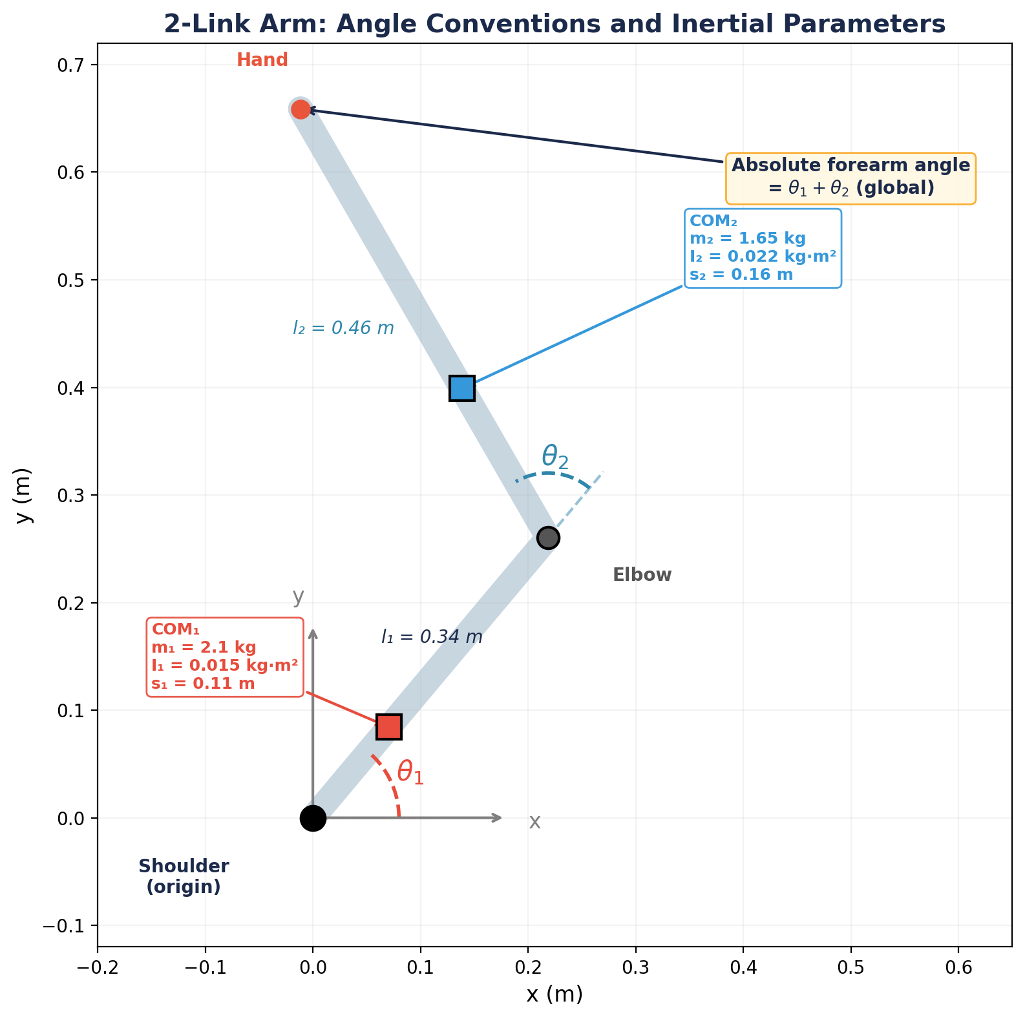
Figure 1. The 2-link arm with angle conventions (same as Week 1) and inertial parameters. θ₁ is global; θ₂ is body-fixed. Squares mark each segment’s center of mass. All parameters from Gribble et al. (1998).
Parameter | Upper Arm | Forearm | Notes
Mass m | 2.10 kg | 1.65 kg
Length l | 0.34 m | 0.46 m
COM distance s | 0.11 m | 0.16 m | from proximal joint
Inertia I (about COM) | 0.015 kg·m² | 0.022 kg·m²

Source: Gribble et al. (1998), p. 1411. The COM distances s₁ = 0.11 m and s₂ = 0.16 m are taken from the same source (Gribble et al. 1998); they correspond to center-of-mass fractions of roughly 0.32 and 0.35 of each segment's length, slightly proximal to the classic cadaver-based values of Winter (1990).

3. Deriving the Mass-Inertia Matrix
We now carry out the recipe of Section 1 for our specific arm. The Euler–Lagrange equation needs the kinetic energy T, and for a rigid two-link chain T can always be written as ½(dq/dt)ᵀM(q)(dq/dt). Our goal is therefore to express the total kinetic energy in terms of the joint velocities dθ₁/dt and dθ₂/dt, then read the mass–inertia matrix M(q) straight off the result. We build T one segment at a time.

3.1 Kinetic Energy of Segment 1
The upper arm rotates about the shoulder. Its center of mass is at distance s₁ from the origin, with velocity v₁ = s₁dθ₁/dt. The kinetic energy of segment 1 is:
T₁ = ½ m₁ s₁² dθ₁/dt² + ½ I₁ dθ₁/dt² = ½ (m₁ s₁² + I₁) dθ₁/dt² (3.1)
This is straightforward: a single rotating body with effective inertia (m₁s₁² + I₁) about the shoulder.

3.2 Kinetic Energy of Segment 2
The forearm’s center of mass has position:
p₂ = (l₁ cosθ₁ + s₂ cos(θ₁+θ₂), l₁ sinθ₁ + s₂ sin(θ₁+θ₂)) (3.2)
Differentiating to get the velocity components:
dx₂/dt = −l₁ sinθ₁ · dθ₁/dt − s₂ sin(θ₁+θ₂) · (dθ₁/dt+dθ₂/dt) (3.3a)
dy₂/dt = l₁ cosθ₁ · dθ₁/dt + s₂ cos(θ₁+θ₂) · (dθ₁/dt+dθ₂/dt) (3.3b)
The translational kinetic energy of segment 2 is ½m₂(dx₂² + dy₂²). Squaring and using cos² + sin² = 1:
v₂² = l₁²dθ₁/dt² + s₂²(dθ₁/dt+dθ₂/dt)² + 2l₁ s₂ cosθ₂ · dθ₁/dt(dθ₁/dt+dθ₂/dt) (3.4)
Note the key term: 2l₁s₂ cosθ₂ — this is the coupling between the two joints. It depends on the elbow angle θ₂, which is why the inertia is configuration-dependent.
Why This Term Couples the Two Joints
The forearm's center of mass moves for two reasons at once, so its velocity is a sum of two pieces: one from the shoulder carrying the whole forearm around (magnitude ∝ l₁·dθ₁/dt), and one from the elbow spinning the forearm about itself (∝ s₂·(dθ₁/dt+dθ₂/dt)). Kinetic energy needs the square of the total speed, |u + w|² = |u|² + |w|² + 2(u·w), and expanding that square is where the term is born.
The first two pieces are clean — one belongs to the shoulder alone, one to the elbow's rotation alone. The 2l₁s₂cosθ₂ term is the cross term 2(u·w): the part of the energy that exists only because both motions happen together. A product of a shoulder quantity and an elbow quantity, it belongs to neither joint by itself — which is exactly what “coupling” means. Because it survives into the mass matrix, a torque at one joint ends up accelerating both (Section 4).
Why cosθ₂ specifically? The carry velocity u points perpendicular to link 1 and the spin velocity w perpendicular to link 2, so the angle between the two velocity vectors is the angle between the links — θ₂ itself. A dot product goes as the cosine of that angle, so the coupling is the alignment of the two motions: maximal when the arm is straight (θ₂ = 0°, cos = +1, the motions reinforce), exactly zero at a right angle (θ₂ = 90°, cos = 0, the joints momentarily decouple), and maximal with opposite sign when fully folded (θ₂ = 180°, cos = −1). This single factor is also the only place posture enters the inertia — which is why M(q) is configuration-dependent at all.
Adding the rotational kinetic energy I₂(dθ₁/dt+dθ₂/dt)²/2, the total kinetic energy becomes T = ½dq/dtᵀM(q)dq/dt with:
M₁₁ = I₁ + I₂ + m₁s₁² + m₂(l₁² + s₂² + 2l₁s₂cosθ₂) (3.5a)
M₁₂ = M₂₁ = I₂ + m₂(s₂² + l₁s₂cosθ₂) (3.5b)
M₂₂ = I₂ + m₂s₂² (3.5c)
Each entry is nothing more than a coefficient of the velocity products in T: M₁₁ gathers the dθ₁/dt² terms, M₂₂ the dθ₂/dt² terms, and M₁₂ the cross term dθ₁/dt·dθ₂/dt. Two features are already visible. First, of the two joint angles only θ₂ appears anywhere — the shoulder angle θ₁ is absent from all three entries. The arm's inertia therefore depends on how far the elbow is bent, but not at all on where the arm is pointing: swinging the whole arm about the shoulder carries both segments around with it and leaves the mass distribution about the joint axes unchanged. Second, θ₂ is itself absent from M₂₂: the forearm's inertia about the elbow cannot change, because everything distal to the elbow is a single rigid body. In this two-joint model the forearm and hand are lumped into one segment with no wrist joint, so there is no distal degree of freedom that could redistribute mass about the elbow — the moment a wrist were added, M₂₂ would depend on its angle too.

3.3 The Mass-Inertia Matrix M(q)
Collecting terms by dθ₁/dt², dθ₂/dt², and dθ₁/dtdθ₂/dt, we define three inertial constants:
a₁ = I₁ + I₂ + m₁ s₁² + m₂(l₁² + s₂²) (3.6a)
a₂ = I₂ + m₂ s₂² (3.6b)
a₃ = m₂ l₁ s₂ (3.6c)
Then the mass-inertia matrix is:
M(q) = [ [a₁ + 2a₃ cosθ₂, a₂ + a₃ cosθ₂], [a₂ + a₃ cosθ₂, a₂] ] (3.7)
Why M Depends on θ₂
The cosθ₂ terms arise from the forearm’s position relative to the upper arm. When the arm is extended (θ₂ ≈ 0°), the forearm is far from the shoulder, maximizing the shoulder’s effective inertia (M₁₁ is largest). When the arm is flexed (θ₂ ≈ 90°), the forearm is closer, reducing shoulder inertia. This is why it’s easier to rotate your arm quickly with a bent elbow.
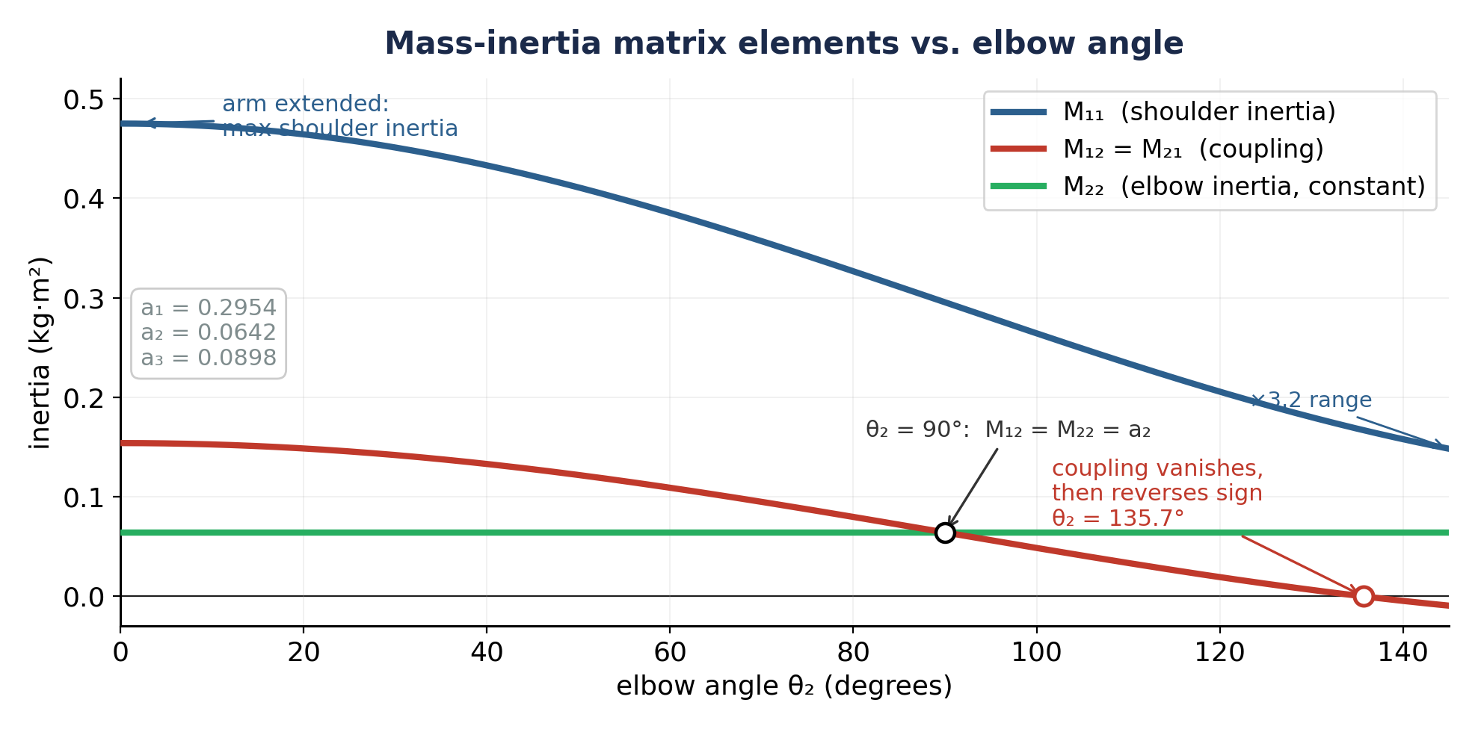
Figure 2. Elements of M(q) vs. elbow angle. M₁₁ (shoulder inertia) varies with configuration; M₂₂ (elbow inertia) is constant; M₁₂ = M₂₁ (coupling) connects the two joints.

3.4 Numerical Values
With the Gribble et al. parameters:
- a₁ = 0.015 + 0.022 + 2.1×0.11² + 1.65×(0.34² + 0.16²) = 0.2954 kg·m²
- a₂ = 0.022 + 1.65×0.16² = 0.0642 kg·m²
- a₃ = 1.65×0.34×0.16 = 0.0897 kg·m²
These three numbers define the entire inertial behavior of the arm. Students will use them directly in the DynamicsEngine class.

4. Coriolis and Centrifugal Terms
So far we have used only the inertial part of the kinetic energy. But the same Euler–Lagrange machine of Section 1 (Equation 1.3) has more to give: because M(q) itself depends on the configuration, the time derivative d/dt(∂T/∂(dq/dt)) produces terms beyond M(q)d²q/dt². These extra, velocity-dependent terms are the Coriolis and centrifugal forces — the second half of the same derivation, not a new one.
Where C Comes From
The Coriolis and centrifugal terms arise from the fact that M(q) changes as the arm moves. Differentiating M(q)dq/dt in time gives two pieces, M(q)d²q/dt² + (dM/dt)dq/dt. The first is the familiar mass-times-acceleration. The second is the velocity-dependent force — and not merely because of the dq/dt it carries: since M changes only with θ₂, the chain rule gives dM/dt = (dM/dθ₂)(dθ₂/dt), so this piece hides a second velocity factor. It is therefore quadratic in joint velocity — zero when the arm is still, growing with the square of speed — which is exactly the hallmark of Coriolis and centrifugal forces. Computing it is easy here because M depends on the configuration through one quantity only, cosθ₂, whose derivative is d(cosθ₂)/dθ₂ = −sinθ₂. Every velocity-dependent term therefore carries that same factor, and we bundle it into a single function: h = −a₃ sinθ₂, literally the θ₂-derivative of the coupling term a₃cosθ₂. Because M's entire configuration-dependence is this one cosine, this single function h captures all of the Coriolis and centrifugal behavior: dM₁₁/dθ₂ = 2h, dM₁₂/dθ₂ = h, and dM₂₂/dθ₂ = 0.

4.1 The Complete Equations of Motion
The equations of motion for the 2-link arm in the horizontal plane (no gravity) are:
M₁₁ d²θ₁/dt² + M₁₂ d²θ₂/dt² + hdθ₂/dt² + 2hdθ₁/dtdθ₂/dt = τ₁ (4.1a)
M₂₁ d²θ₁/dt² + M₂₂ d²θ₂/dt² − hdθ₁/dt² = τ₂ (4.1b)
where h = −a₃ sinθ₂ and the Mᵢⱼ are the elements of M(q) from Equation 3.7.

4.2 Physical Interpretation
Each velocity-dependent term has a physical meaning:
- hdθ₂/dt² — centrifugal torque at the shoulder due to elbow rotation. The forearm’s angular velocity creates a force that pushes the upper arm outward.
- 2hdθ₁/dtdθ₂/dt — Coriolis torque at the shoulder from the interaction of both joint velocities.
- −hdθ₁/dt² — centrifugal torque at the elbow due to shoulder rotation. When the shoulder rotates, it flings the forearm outward.
The magnitude of all three terms depends on h = −a₃ sinθ₂, which is zero when θ₂ = 0° (arm extended, singularity) and maximal at θ₂ = 90°.
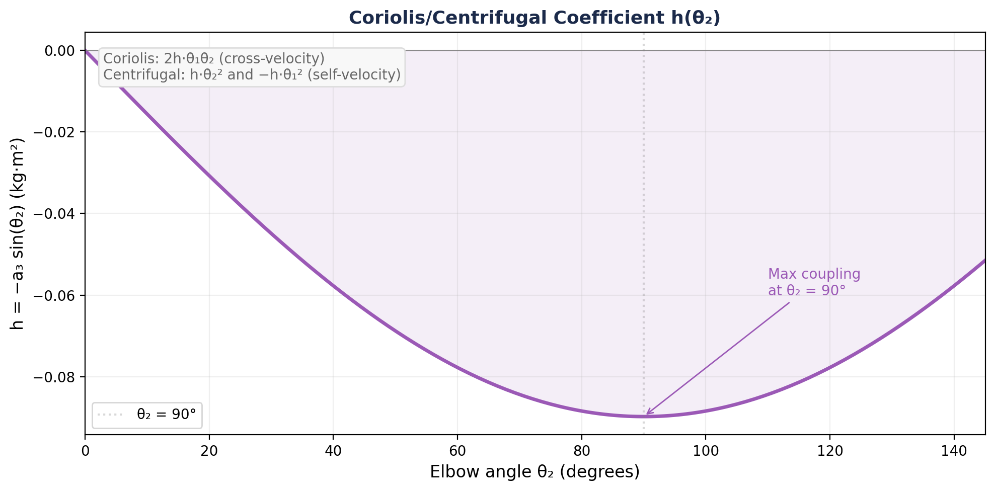
Figure 3. The Coriolis/centrifugal coefficient h(θ₂) = −a₃ sinθ₂. Interaction forces are strongest at θ₂ = 90° and vanish at θ₂ = 0°.

4.3 Compact Matrix Form
In matrix form, we write:
M(q) d²q/dt² = τ − C(q, dq/dt) dq/dt (4.2)
where C encodes the Coriolis and centrifugal terms. Two velocity-dependent effects sit on the left side of this equation, and it is worth keeping them distinct. The Coriolis and centrifugal terms C(q,dq/dt)dq/dt are internal — they arise from the arm's own geometry and vanish when the arm is straight or still. Real joints also carry external viscous friction, a torque that simply opposes joint velocity. Including it adds one more term:
M(q) d²q/dt² + C(q,dq/dt) dq/dt + B dq/dt = τ (4.3)
where B is a diagonal joint-damping matrix (units N·m·s/rad). Throughout these notes we take B = 0 — the horizontal-plane arm is modeled as frictionless, and every result above is the B = 0 case. But B matters: even a small positive B dissipates kinetic energy and helps a reach settle instead of oscillating. Homework 3 makes exactly this comparison, contrasting a damped plant (B = 3.0 N·m·s/rad) against the frictionless one (B = 0), and finds that direct activation alone provides too little damping for a clean stop — a gap the λ model closes in Week 4.
Rearranging for the accelerations:
d²q/dt² = M(q)⁻¹ [ τ − C(q, dq/dt) dq/dt ] (4.4)
This is the equation we integrate numerically. At each timestep: given the current state (q, dq/dt) and the muscle torques τ, compute d²q/dt², then update dq/dt and q.

4.4 Coriolis and Centrifugal Forces in Real Movements
The terms in Equation 4.1 look like algebra. They are not — they are forces you have felt. This section connects each one to a movement you already know how to make, and then asks how big they really are in our own model.
Start with the distinction, because the two terms are often lumped together and they are not the same thing:
Centrifugal — one joint moving alone. Swing your upper arm quickly while letting the elbow go slack and the forearm flies outward into extension. Nobody extended it. The term −h(dθ₁/dt)² in Equation 4.1b delivers an elbow torque generated purely by shoulder speed. This is the same physics that flings water off your hand when you shake it, and it is what the flick experiment in Section 5.2 isolates.
Coriolis — both joints moving at once. The term 2h(dθ₁/dt)(dθ₂/dt) requires both velocities to be non-zero, so it vanishes in any single-joint movement and appears in essentially every real reach. Notice where it sits: Coriolis appears only in Equation 4.1a, at the shoulder. The elbow never receives a Coriolis term. The coupling is structurally asymmetric.
That asymmetry is worth dwelling on. The shoulder carries the forearm's weight; the elbow carries nothing but the hand. So the shoulder disturbs the elbow far more than the elbow disturbs the shoulder — which is exactly the mechanical basis of a whip.
How large are these forces? We can answer this on our own plant rather than taking it on faith. Figure 4 decomposes the elbow torque during a fast sweeping reach.
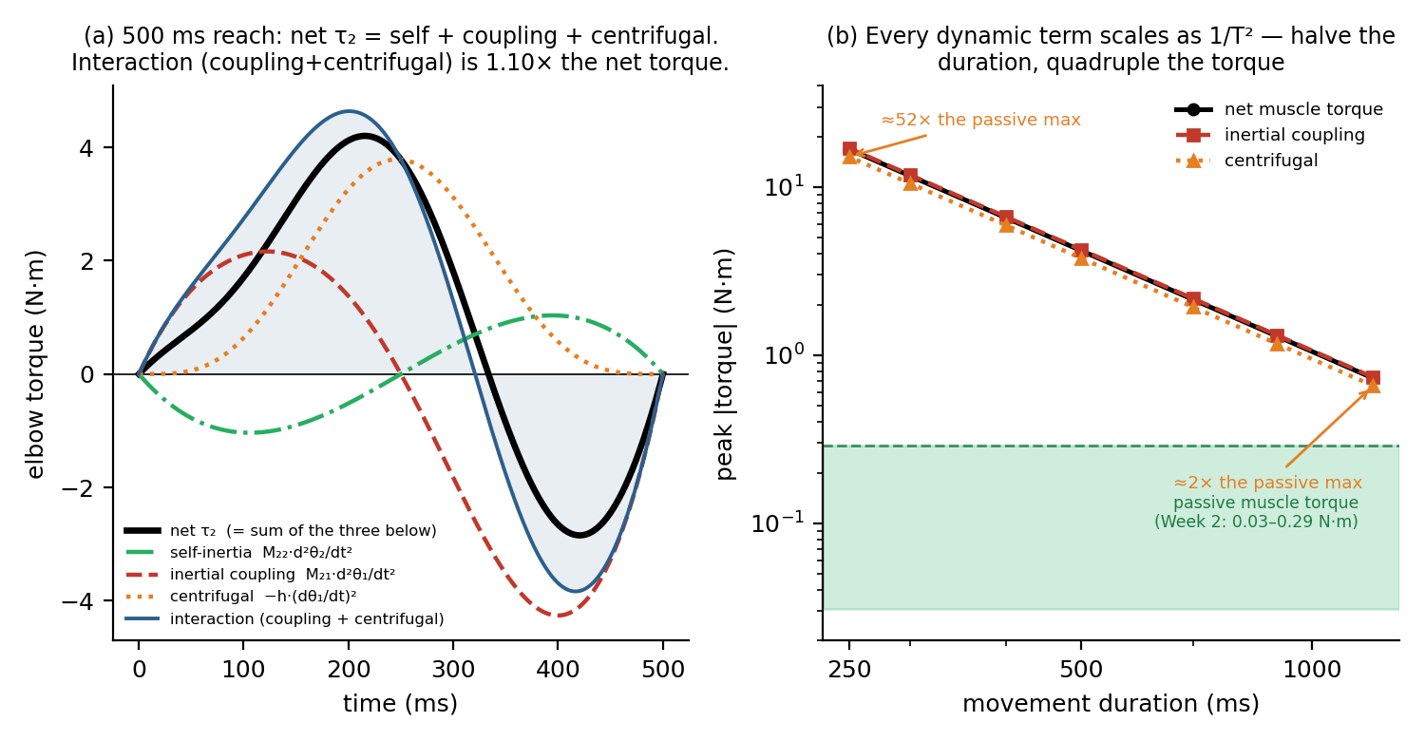
Figure 4. Coriolis and centrifugal forces during a fast sweeping reach (shoulder 20°→120°, elbow 100°→60°), computed with our own plant. (a) The net elbow torque decomposes exactly into three parts — its own self-inertia (M₂₂·d²θ₂/dt², green), the inertial coupling from shoulder acceleration (red), and the centrifugal term (orange) — which sum onto the black net curve. The interaction torque (coupling + centrifugal, shaded) peaks at 4.64 N·m against a net torque of 4.20 N·m: the elbow is driven more by the shoulder than by its own muscles (1.10×). (b) Every dynamic term scales as 1/T²: halving the duration quadruples the torque. Against the roughly fixed passive muscle torque of Week 2 (green band), these forces are minor at conversational speeds and overwhelming at fast ones.
The result is worth stating plainly. During the 500 ms reach, the interaction torque at the elbow peaks at 4.64 N·m while the net torque the elbow's own muscles supply peaks at 4.20 N·m. The elbow is being driven more by the shoulder than by itself. This is precisely the claim in your required reading: Hollerbach and Flash (1982) found interaction torques of the same order as net muscle torques during ordinary reaching, and our model reproduces it.
Panel (b) makes the speed dependence exact. Both the inertial coupling (∝ d²θ/dt²) and the centrifugal term (∝ (dθ/dt)²) scale as 1/T², so halving the movement duration quadruples them. A subtlety worth noticing: because every dynamic term scales the same way, their ratio to each other does not change with speed. What changes is their size relative to anything fixed — the passive muscle springs of Week 2 (0.03–0.29 N·m). At 1200 ms the centrifugal torque is roughly twice the largest passive torque; at 250 ms it is about fifty times larger. Slow movements are quasi-static and forgiving. Fast movements are not.
This is why the examples below all involve speed.
Throwing, and the art of exploiting them. Hirashima, Kudo and Ohtsuki (2003) analyzed the joint torques of ball-throwing and found that the shoulder's muscle torque does double duty: it accelerates the shoulder and produces an assistive interaction torque at the elbow, which skilled throwers use to generate large elbow extension velocity when throwing fast. The triceps is not the main engine of elbow extension in a hard throw — the shoulder is. Cracking a whip, snapping a towel and skipping a stone are the same trick: drive the proximal segment, let interaction torques whip the distal one. Interaction torques are not only a nuisance to be canceled; they are free power if you can time them.
Single-joint movements that are not single-joint. Gribble and Ostry (1999) — the same Gribble whose muscle model we are using — asked subjects to move one joint and recorded EMG at the other. During pure elbow movements, shoulder muscles fired anyway, before the movement began, scaled to the interaction torque about to arrive. Holding a joint still in a multi-joint limb is an active achievement, not the absence of one. Your Lab 3 flick simulation is the same experiment with the muscles removed.
What happens when prediction fails. Two clinical populations make the computational cost visible. Sainburg, Ghilardi, Poizner and Ghez (1995) studied patients without proprioception and traced their reaching errors to uncompensated interaction torques transferred to the elbow from shoulder acceleration — the very term plotted in red in Figure 4a. Their movements decompose into sequential single-joint rotations, as though the coupling had to be avoided rather than managed. Bastian, Martin, Keating and Thach (1996) found the same signature in cerebellar ataxia, and argued that predicting the interaction torques generated by other moving joints is a principal job of the cerebellum. Reaching looks effortless only because this computation usually succeeds.
A Warning About the Word "Coriolis"
Two different things share this name, and conflating them causes real confusion. The Coriolis term in Equation 4.1a is self-generated: it arises inside the limb from its own segments moving relative to one another, and it exists even in a perfectly stationary room. The Coriolis force of meteorology — and of Lackner and DiZio's (1994) famous experiment, in which subjects reach inside a slowly rotating room — is externally imposed by rotation of the reference frame. Both are inertial forces requiring no contact, and both scale with velocity, which is why they share a name. Only the first is in our equations of motion.
The distinction earns its keep in Week 4. Lackner and DiZio's subjects made curved, inaccurate reaches on first exposure and adapted over repeated trials — and the authors argued their endpoint errors fail to support equilibrium-point models, alpha and lambda alike, because the Coriolis force was absent at both the start and the end of the movement, so an equilibrium-based controller should not have been fooled. Keep that objection in your pocket. Next week we adopt the λ model precisely because it makes stability effortless; this is the sharpest published argument that effortless stability is not the whole story.

5. Interaction Torques: The Central Challenge
The off-diagonal elements M₁₂ = M₂₁ have a profound consequence: torque at one joint produces acceleration at both joints. Figure 5 shows this directly, computed from the plant's equations of motion; the full DynamicsEngine that lets the arm move is assembled in Section 8, and the numerical integration and two-phase muscle–skeleton loop behind it follow in Sections 6–7. (In the figure, the dashed curves hold the posture fixed to isolate the pure coupling, while the solid curves are the free simulation — see the caption.)
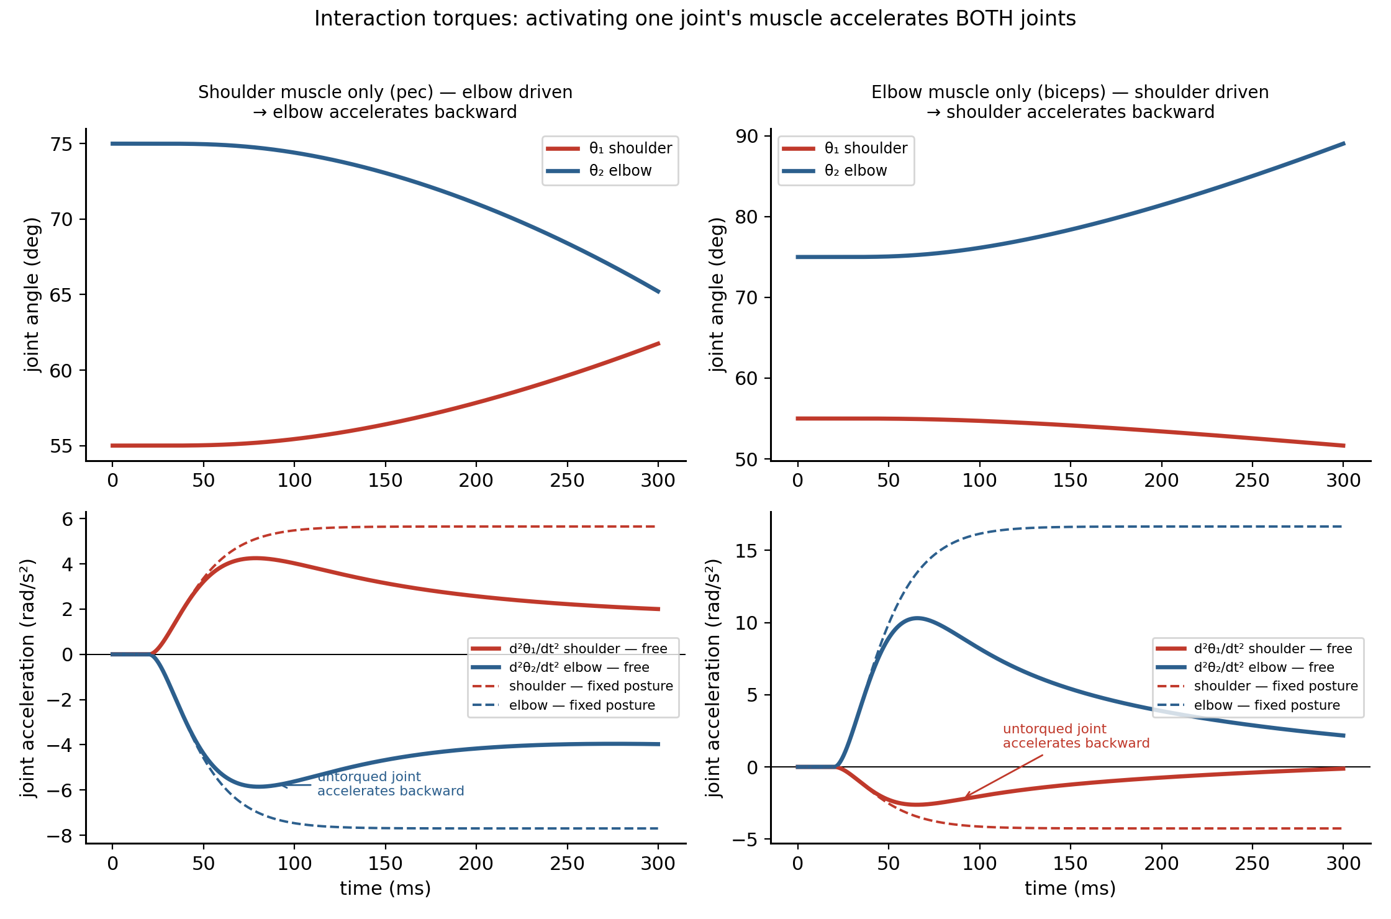
Figure 5. Interaction torques from muscle activation, both directions. Left column: activating only the shoulder muscle drives the elbow — it accelerates backward with no elbow muscle acting. Right column: activating only an elbow muscle drives the shoulder backward. Top row: joint angles. Bottom row: joint accelerations, shown two ways — the free simulation (solid), where the arm moves, and the same posture held fixed (dashed), which isolates the pure coupling M⁻¹τ. The dashed curves plateau with the muscle torque; the solid curves decay once the arm moves and the driving muscle shortens, so the force–velocity property cuts its force. The gap between them is that force–velocity effect.
Why must this be so? Look at what the matrix equation demands at the instant a movement begins. Starting from rest, all velocities are zero, so C(q, dq/dt)dq/dt vanishes and Equation 4.2 reduces to the purely inertial statement M(q)d²q/dt² = τ. (This simplification is exact only at movement onset. Once the limb is moving, the velocity terms of Section 4 return.)
Case 1: shoulder torque only (τ₂ = 0). Write the two rows out:
M₁₁ · d²θ₁/dt² + M₁₂ · d²θ₂/dt² = τ₁ (5.1a)
M₂₁ · d²θ₁/dt² + M₂₂ · d²θ₂/dt² = 0 (5.1b)
The second row has no torque on its right-hand side — and yet it cannot be satisfied by leaving the elbow still. Solving it for the elbow acceleration:
d²θ₂/dt² = −(M₂₁ / M₂₂) · d²θ₁/dt² ≠ 0 (5.2)
Case 2: elbow torque only (τ₁ = 0). The same argument runs in reverse:
M₁₁ · d²θ₁/dt² + M₁₂ · d²θ₂/dt² = 0 (5.3a)
M₂₁ · d²θ₁/dt² + M₂₂ · d²θ₂/dt² = τ₂ (5.3b)
d²θ₁/dt² = −(M₁₂ / M₁₁) · d²θ₂/dt² ≠ 0 (5.4)
Both results are non-zero for exactly one reason: M₁₂ = M₂₁ ≠ 0. Were the mass matrix diagonal, both right-hand sides would collapse to zero and the joints would be independent — a torque at one would move only that one. The off-diagonal term is the whole story. Note also what Equations 5.2 and 5.4 are not: they are not claims that the untorqued joint receives a force. It receives none. It accelerates because it is mechanically attached to a segment that is accelerating.
Putting Numbers on the Coupling
These ratios are concrete. At the reference posture q = (55°, 75°), the mass matrix is M₁₁ = 0.3419, M₁₂ = M₂₁ = 0.0875, M₂₂ = 0.0642 kg·m², so:
Case 1 (shoulder torque only): d²θ₂/dt² = −1.36 · d²θ₁/dt². The elbow accelerates 36% harder than the shoulder does, in the opposite direction, with no elbow muscle acting. The negative sign is the flick of Section 5.2 predicted algebraically: shoulder flexion drives elbow extension.
Case 2 (elbow torque only): d²θ₁/dt² = −0.26 · d²θ₂/dt². The shoulder barely stirs.
The coupling is therefore about 5.3× stronger from shoulder to elbow than from elbow to shoulder — the proximal-to-distal asymmetry of Section 4.4, now as a number. It is why throwers drive the shoulder to whip the forearm, and why the reverse would be a poor way to move the shoulder. One caution: because M₁₂ = a₂ + a₃cosθ₂ passes through zero at θ₂ = 135.7°, this coupling weakens, vanishes, and then reverses sign in deep flexion — beyond 135.7°, a shoulder torque drags the free elbow the same way rather than flinging it backward. The ratios above describe the reference posture, not the whole workspace.
This is the fundamental reason why multi-joint control is hard. If you want the shoulder to move while the elbow stays still, you cannot simply activate only shoulder muscles. You must also apply a compensatory torque at the elbow to cancel the interaction torque. This compensation requires knowledge of the arm’s dynamics — the mass matrix and the current velocities.
Hollerbach & Flash (1982): The Key Insight
Hollerbach and Flash showed that during normal reaching, the interaction torques at each joint are of the same order of magnitude as the net muscle torques. They are not small perturbations — they are a fundamental part of the dynamics. Any controller that ignores them will produce dramatically wrong movements. This is why the DynamicsEngine is essential: without it, the muscle model from Week 2 cannot predict where the hand actually goes.

5.1 Co-Contraction as a Brute-Force Solution
There is one simple strategy for resisting interaction torques: co-contraction. If you co-contract the muscles at the elbow, the force–velocity property makes the pair resist the motion the shoulder’s interaction torque would otherwise produce. The mechanism is the asymmetry of the force–velocity curve: a muscle produces more force while being stretched than while shortening. So when the joint starts to rotate, the muscle on one side is stretched — its force rises — while its antagonist shortens and its force falls. The two forces, equal and canceling at rest, become unbalanced the instant the joint moves, and the imbalance always favors the muscle pulling against the motion. That net opposing torque grows with joint speed, so the elbow resists being moved quickly — though, as the next paragraph shows, not being displaced. Figure 6 plots exactly this: the pair’s net torque is zero at rest and rises with rotation speed.
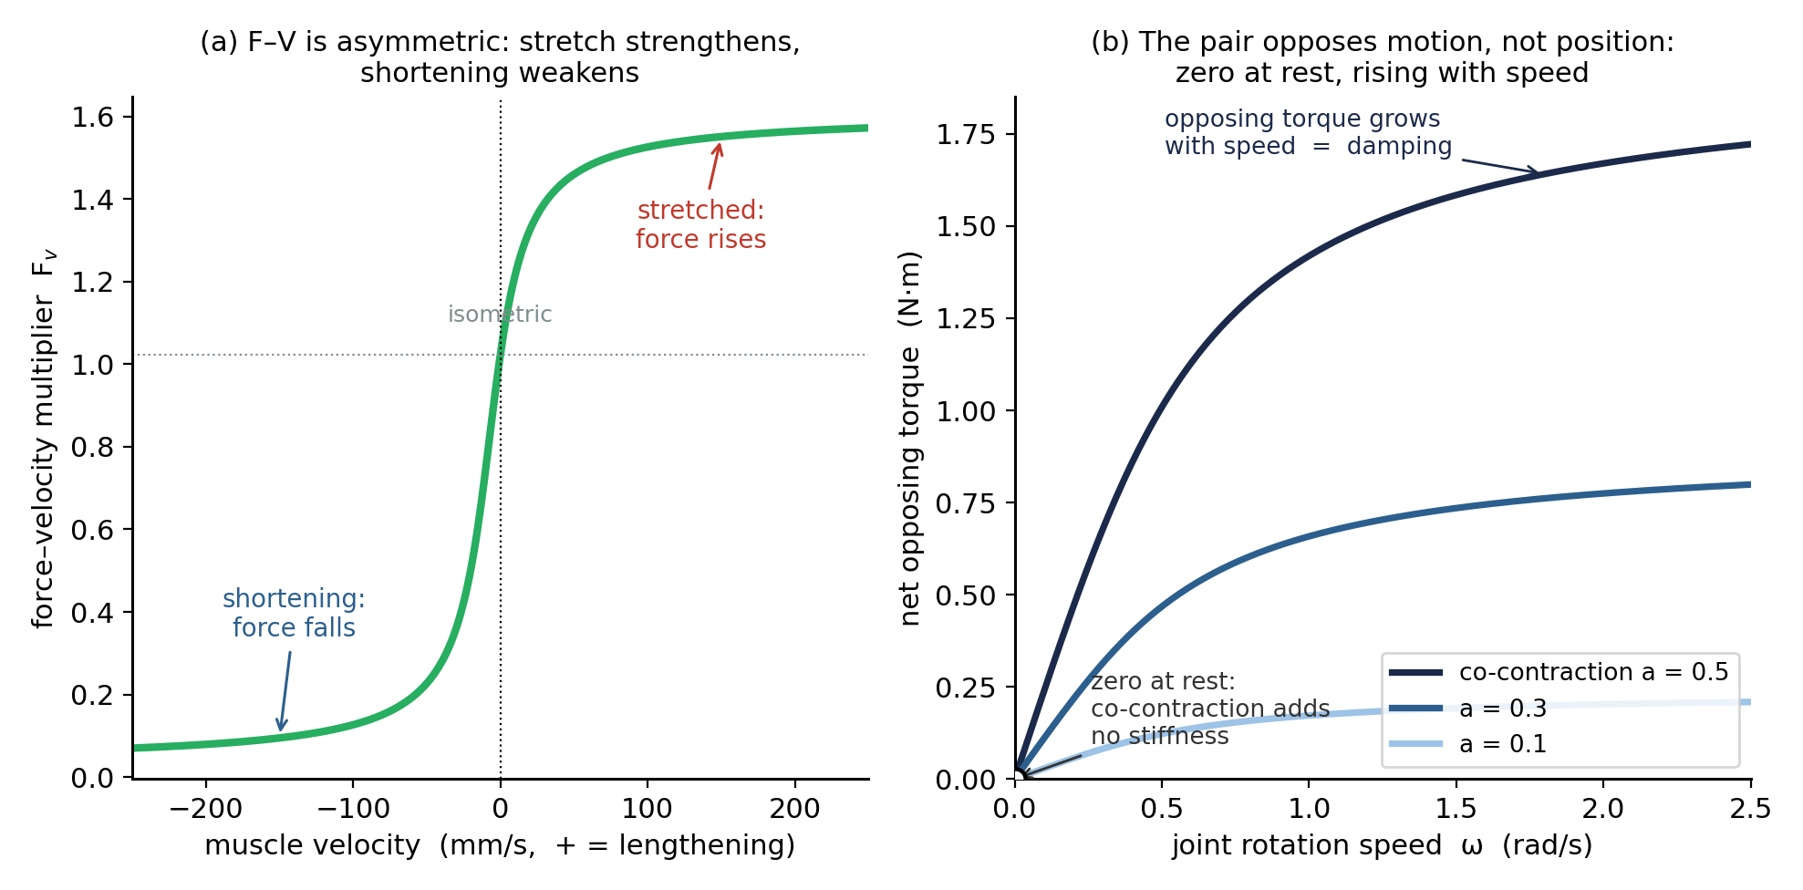
Figure 6. Co-contraction produces damping, not stiffness, through the force–velocity asymmetry. (a) The force–velocity multiplier is asymmetric about zero velocity: a stretched (lengthening) muscle produces more force than at rest, a shortening one less. (b) A co-contracted agonist–antagonist pair therefore nets zero torque at rest — adding no stiffness — but once the joint rotates, the stretched muscle outpulls the shortening one and the pair opposes the motion. That opposing torque grows with joint speed and with activation, which is damping.
This works, but at a cost. Co-contraction increases metabolic energy expenditure and reduces the speed of voluntary movement at the co-contracted joint. It is a brute-force solution: instead of precisely compensating the interaction torque with a targeted muscle command, the system opposes motion at the joint indiscriminately.
That picture needs one correction, and Lab 2 supplies it. Stiffness is a restoring force that depends on position — it requires a force that changes as the joint is displaced, that is, a force that depends on muscle length. But under direct activation the active force depends only on activation, never on length (the Week-2 result), so displacing the joint changes neither muscle's active force and no restoring force can arise. Co-contraction inherits this defect: in Weeks 2–3 it buys no stiffness at all. Two symbols need naming before we write this down. Here M is the muscle’s calcium-filtered active force from Week 2 — a force in newtons, not the mass matrix M(q) of §3 — and Fᵥ is the dimensionless force–velocity multiplier, the bracket [f₁ + f₂arctan(f₃ + f₄ dl/dt)], which sits near 1 (it is 1.02 at rest). Their product M·Fᵥ is therefore a force. Take the joint displaced by Δθ but held still, so ω = 0 and both muscles share the same Fᵥ; for a matched agonist–antagonist pair the active torques then cancel identically, leaving only the passive springs:
τ_net = (+r)(M·Fᵥ − k·r·Δθ) + (−r)(M·Fᵥ + k·r·Δθ) = −2r²k·Δθ
The cancellation simply confirms this: the two active terms are equal and enter with opposite moment-arm signs, so activation drops out entirely, leaving only the passive spring −2r²k·Δθ. Static stiffness for this pair is therefore 0.827 N·m/rad whether you tense at 10% or 50% — the same at any effort, because none of it comes from activation. It is the direct signature of active force being length-independent under direct activation: displacing the joint does not change either active force, so there is nothing to restore it.
What co-contraction does buy is damping. The force–velocity multiplier is asymmetric, and that — not velocity-dependence on its own — is what breaks the cancellation. Once the joint rotates at ω the two muscles no longer see the same conditions: their moment arms have opposite signs, so a single rotation shortens one at −rω while lengthening the other at +rω. Each is therefore evaluated at a different point on the same curve, and the active terms no longer cancel. Writing the pair at the reference posture (Δθ = 0, so the passive springs contribute nothing) isolates what the motion adds:
τ_net = r·M·[ Fᵥ(−rω) − Fᵥ(+rω) ] + −2r²k·Δθ
The bracket is nonzero only because Fᵥ is asymmetric: a symmetric curve would give Fᵥ(−rω) = Fᵥ(+rω), and the pair would produce no net torque at any speed. At ω = 0.5 rad/s the shortening muscle contributes a multiplier of 0.50 against the lengthening muscle’s 1.32 — a 2.6× imbalance, and that imbalance is the whole of the damping. Note also that at ω = 0 the bracket vanishes identically, which restates the point above: co-contraction resists motion, never displacement. Here M — and therefore activation — survives, multiplying the result instead of dropping out of it. At ω = 0.5 rad/s the pair yields −0.12 N·m at a = 0.1 but −1.01 N·m at a = 0.5: an 8.2× increase. So the elbow does resist the shoulder's interaction torque, but by damping motion rather than by holding position. The clean framing is worth carrying into Week 4: velocity-dependence is already in our model, through F–V; length-dependence arrives only with λ. That asymmetry is exactly why HW 3's Model B oscillates and drifts rather than simply going limp — and why its co-contraction hold only partially rescues it.
The two results above are the same expression evaluated in two regimes, and they simply add. Holding the pair at a displacement Δθ while it also rotates at ω gives
τ_net = −2r²k·Δθ + r·M·[ Fᵥ(−rω) − Fᵥ(+rω) ]
The first term depends on position, the second on velocity, and the division of labor is the whole point: the active state M multiplies only the velocity term. Turn co-contraction up and the damping grows in proportion, while the stiffness coefficient 2r²k never moves — M does not appear in it.
One number to reconcile: 0.827 N·m/rad is the pectoralis–deltoid pair alone. Lab 3 measures the whole shoulder and reports 1.05 N·m/rad, because two further muscles cross it — biceps-short and triceps-long — and each adds its own k·r²: 0.414 + 0.414 + 0.063 + 0.160 = 1.05.
In Week 4, the λ threshold law will provide a more elegant solution. Because activation depends on muscle length and velocity (A = [l − λ + μ·dl/dt]⁺), the λ model automatically generates length-dependent active stiffness that resists perturbations proportionally to their size — without the metabolic cost of full co-contraction. This is one of the key advantages of the equilibrium-point hypothesis over direct activation.

5.2 Demonstrating Interaction Torques: The “Flick” Experiment
In the horizontal plane with no gravity and no muscle activation, an arm at rest stays at rest — nothing drives it. But if someone gives your upper arm a brief push (an initial angular velocity at the shoulder), the interaction torques immediately cause the elbow to move, even though no force was applied there.
Consider the arm starting at rest at θ₁ = 55°, θ₂ = 75°, with an initial shoulder velocity of dθ₁/dt = 2 rad/s and dθ₂/dt = 0. From the equations of motion (Eq. 4.1b), the initial elbow acceleration is:
d²θ₂/dt² = −(M₂₁/M₂₂) · d²θ₁/dt² + h(dθ₁/dt)² / M₂₂ (5.5)
Both terms are nonzero: the coupling term M₂₁ drives the elbow from the shoulder’s acceleration, and the centrifugal term h(dθ₁/dt)² pushes the elbow outward. The result: the shoulder flick drags the elbow along and then the passive muscle springs bring both joints back to rest — a coupled oscillation driven purely by interaction torques.
The reverse experiment is equally revealing: an initial elbow velocity dθ₂/dt = 3 rad/s with dθ₁/dt = 0 causes the shoulder to be dragged along, even though it received no force. The coupling works in both directions because M₁₂ = M₂₁.
In Lab 03, you will simulate both flick experiments and observe the coupled trajectories. This is the most direct demonstration that multi-joint dynamics are fundamentally different from single-joint dynamics: you cannot move one joint without affecting the other.

6. Numerical Integration: RK4
Given d²q/dt² = f(q, dq/dt, τ), we need to integrate forward in time. We use the 4th-order Runge–Kutta (RK4) method, which is the standard workhorse for ODE integration in biomechanics.

6.1 The State Vector
We define the state vector as:
x = [q₁, q₂, dq₁/dt, dq₂/dt] = [θ₁, θ₂, dθ₁/dt, dθ₂/dt] (6.1)
The state derivative is:
dx/dt = [dθ₁/dt, dθ₂/dt, d²θ₁/dt², d²θ₂/dt²] (6.2)
where the accelerations come from Equation 4.4. With 6 muscles, the muscle subsystem adds 12 state variables (M and dM/dt for each muscle), giving a total 16-dimensional state vector.

6.2 RK4 Algorithm
Given state xₙ at time tₙ, the RK4 update is:
k₁ = dt · f(xₙ) (6.3a)
k₂ = dt · f(xₙ + k₁/2) (6.3b)
k₃ = dt · f(xₙ + k₂/2) (6.3c)
k₄ = dt · f(xₙ + k₃) (6.3d)
xₙ₊₁ = xₙ + (k₁ + 2k₂ + 2k₃ + k₄) / 6 (6.4)
For a timestep of dt = 0.0001 s (0.1 ms), RK4 provides excellent accuracy and stability for our system. In Labs 1–2 we used Euler integration for simplicity; from now on we use RK4.
Why Not Euler?
Euler integration (xₙ₊₁ = xₙ + dt·f(xₙ)) is first-order accurate: halving dt halves the error. RK4 is fourth-order: halving dt reduces error by 16×. For the stiff muscle dynamics (fast calcium kinetics τ = 15 ms combined with slow limb dynamics), Euler requires very small timesteps to remain stable. RK4 lets us use larger timesteps, making the simulation faster and more accurate.

7. Connecting the Muscles to the Skeleton
The torque vector τ = [τ₁, τ₂] is the sum of all muscle torques at each joint:
τ₁ = Σᵢ rᵢ,shoulder · Fᵢ (7.1a)
τ₂ = Σᵢ rᵢ,elbow · Fᵢ (7.1b)
where rᵢ is the signed moment arm (from Week 2, Table: +4 cm shoulder flexors, −4 cm extensors, etc.) and Fᵢ is the total force from each muscle’s compute_force method. The muscles use the neural drive gain G = 20 mm introduced in Week 2 to convert dimensionless activations a ∈ [0, 1] to physiologically realistic forces.
The simulation loop at each timestep has two phases:
Phase 1 — Muscle update (once, Euler): The calcium dynamics inside each muscle are integrated with a single Euler step. This is adequate because dt = 0.1 ms is much smaller than the calcium time constant τ = 15 ms.
- For each muscle, compute lᵢ(q) and dlᵢ/dt(q, dq/dt) from the current joint state
- Call compute_force(aᵢ, lᵢ, dlᵢ/dt, dt) to get Fᵢ (this advances the calcium state)
- Sum the torque contributions: τⱼ = Σ rᵢⱼ · Fᵢ
Phase 2 — Kinematic integration (RK4, with τ fixed): RK4 evaluates the derivative function four times per step. If the muscles were called inside that function, their calcium state would advance four times instead of once. Instead, the torque vector τ from Phase 1 is held constant, and RK4 integrates only the kinematic equation d²q/dt² = M(q)⁻¹[τ − C(q,dq/dt)dq/dt].
- Pass the fixed τ to the kinematic derivative function
- Advance [q, dq/dt] with one RK4 step
In short, the split follows from an asymmetry between the two states. The skeletal state demands accuracy — its errors compound over a full reach — and it can be safely re-evaluated at RK4's intermediate trial points, so it earns the fourth-order method. The muscle state needs little accuracy, because its 15 ms calcium dynamics are 150× slower than the 0.1 ms step and so barely change within one step; and it cannot be re-evaluated freely, because the calcium filter carries history — asking it about the hypothetical trial states RK4 probes would corrupt that history. So it takes a single Euler step, computed once, with its torque then held fixed while RK4 advances the skeleton.
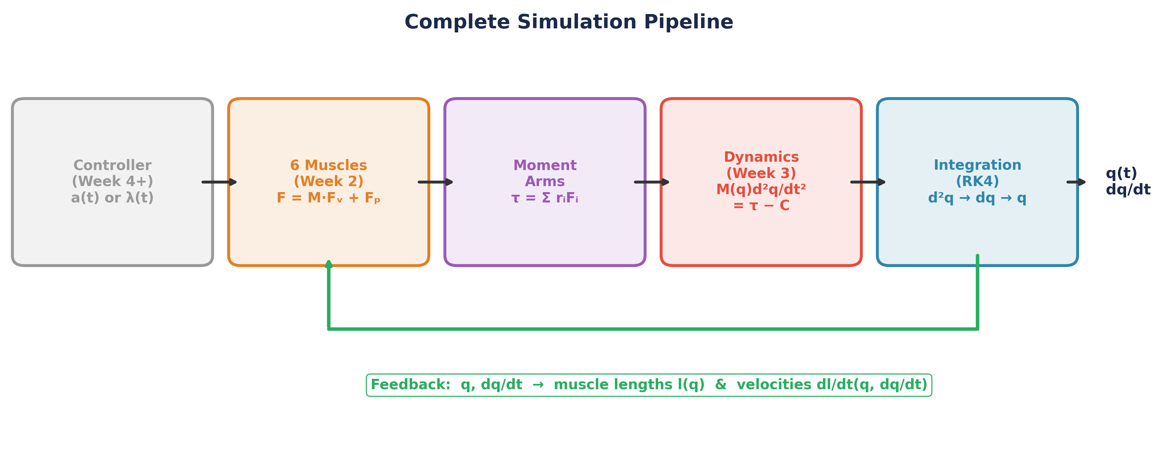
Figure 7. The complete simulation pipeline. The controller sets activations; muscles produce forces; moment arms convert to joint torques; dynamics compute accelerations; integration advances the state. Joint angles and velocities feed back to the muscles.

7.1 Muscle Length and Velocity from Joint State
Each muscle’s length l(q) and velocity dl/dt(q, dq/dt) are computed from the joint angles and velocities using the moment arms:
lᵢ ≈ lᵢ,rest − rᵢ,shoulder · (θ₁ − θ₁,ref) − rᵢ,elbow · (θ₂ − θ₂,ref) (7.2)
dlᵢ/dt = −rᵢ,shoulder · dθ₁/dt − rᵢ,elbow · dθ₂/dt (7.3)
This is a linear approximation using the moment arms. For extensors (constant moment arms), it is exact. For flexors (angle-dependent moment arms), it is accurate over the operating range of our model.

8. The DynamicsEngine Class
In Lab 03, students will build the DynamicsEngine class from scratch. It encapsulates:
- mass_matrix(q) — returns the 2×2 matrix M from Equation 3.7
- coriolis(q, qdot) — returns the 2-vector C(q,dq/dt)dq/dt
- compute_torques(q, qdot, activations) — updates all 6 muscles, sums torques
- derivatives(state, activations) — the dx/dt function for RK4
- step(activations, dt) — advances one RK4 timestep
- simulate(activations_fn, T, dt) — runs a full simulation
The DynamicsEngine holds references to the Arm (Week 1) and the 6 Muscle objects (Week 2). It does not own them — it coordinates them. This modularity means we can swap controllers (Weeks 4–14) without touching the dynamics.
Design Rationale: This is the last class students build from scratch. From Week 4 onward, the tested Arm, Muscle, and DynamicsEngine are provided via the smc package. Students can always read the source, but they don’t have to maintain it.

9. Summary of Key Results
Component | Expression | Reference
Mass-inertia matrix | M(q) [2×2, symmetric] | Eq. 3.7
Inertial constants | a₁=0.295, a₂=0.064, a₃=0.090 | Eq. 3.6
Coriolis/centrifugal | h = −a₃ sinθ₂ | Eq. 4.1
Equations of motion | M(q)d²q/dt² = τ − C(q,dq/dt)dq/dt | Eq. 4.2
Integration | RK4 (dt = 0.1 ms) | Eq. 6.4
State vector | 16D: 4 kinematic + 12 muscle | Eq. 6.1

Next week: We turn on the λ threshold law and let activation emerge from the difference between muscle length and the centrally specified threshold. The DynamicsEngine you build this week is the plant that all future controllers will drive.

