WEEK 13
Linearizing the Biological Plant
The Iterative LQG Framework

Reading: Li, W., & Todorov, E. (2004). Iterative linear quadratic regulator design for nonlinear biological movement systems. ICINCO, 1, 222–229.
Supplementary: Todorov, E. (2005). Stochastic optimal control and estimation methods adapted to the noise characteristics of the sensorimotor system. Neural Computation, 17, 1084–1108.
Introduction
Last week we built an optimal controller that was mathematically perfect but physically wrong. The LQG controller from Week 12 computed time-varying feedback gains by solving the Riccati equation backward and a Kalman filter forward. It produced clean, symmetric bell-shaped velocity profiles, corrected perturbations in the task-relevant direction, and ignored perturbations that did not matter. But it was controlling a torque-driven arm — an arm without muscles.
The torque-driven arm has a torque knob at each joint. Turn the knob, and the joint accelerates proportionally. This is a useful fiction for deriving the mathematics, but it is not how the body works. The real arm is driven by the same Hill-type muscle-tendon units we studied in Week 11. Between the brain’s motor command and the resulting joint torque lie calcium dynamics, the force-length relationship, the force-velocity curve, tendon elasticity, and posture-dependent moment arms. Every one of these introduces nonlinearity, and together they make the mapping from neural command to movement profoundly state-dependent.
The consequences are visible in the data. Human reaching movements are not perfectly symmetric: deceleration typically takes longer than acceleration, especially for fast reaches (Morasso, 1981; Nagasaki, 1989). EMG recordings show a triphasic burst pattern — agonist, antagonist, agonist — that no torque-driven model predicts. These are signatures of muscles, and a controller that ignores muscles cannot explain them. This week we show how to bring the Hill-type muscle plant into the optimal control framework, and demonstrate that linearizing the muscle dynamics substantially improves endpoint accuracy compared to both the EPH controller from Week 11 and single-point linearization from Week 12.
This week we replace the torque-driven arm with the Hill-type muscle model from Week 11 and compute optimal feedback gains for this actual musculoskeletal plant. The mathematical tool is iterative LQG (iLQG) — an extension of the LQR/LQG framework that handles nonlinear plants by re-linearizing at every timestep along a planned trajectory and iterating until the plan converges. The Riccati equation and Kalman filter you built in Lab 12 are reused unchanged inside iLQG. The only new ingredient is a loop that feeds updated linearizations into the same machinery.
Figure 1 shows the iLQG loop at a glance.
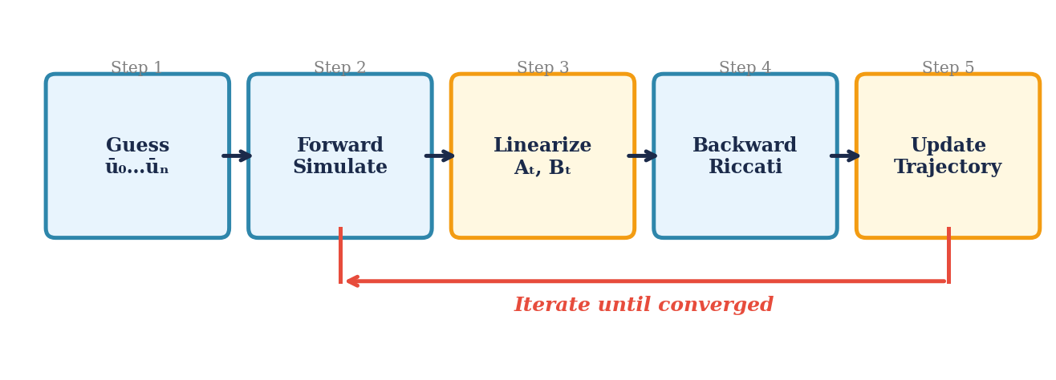
Figure 1. The iLQG iteration loop. A nominal control sequence is simulated forward through the nonlinear plant, linearized at every timestep, solved via the Riccati backward pass, and updated. Typically 6–8 iterations suffice.
1. The Muscle Problem: Why Week 12’s Controller Can’t Drive Muscles
Start with a concrete thought experiment. Take the LQR gains L_t from Week 12 and try to apply them to the Hill-type arm from Week 11. The controller says: “apply 0.3 N·m at the elbow.” But there is no torque knob on the elbow. What you have are six muscle groups, each with its own stimulation signal. To produce 0.3 N·m, you need to know the current moment arms (which depend on joint angle), the current force-length state of each muscle (which depends on CE length), the current activation level (which depends on recent stimulation history), and whether the muscle is shortening or lengthening (which affects force through the force-velocity curve). The same 0.3 N·m request requires completely different stimulation patterns depending on where the arm is in the movement.
This is not a minor calibration issue. Recall from Week 11 the three nonlinearities that shape muscle force:
Force-length curve. The contractile element produces maximal isometric force at an optimal length l_CE_opt. Force drops toward zero when the CE is stretched or shortened beyond about ±0.56 of optimal length.
Force-velocity curve. A shortening muscle produces less force than an isometric one. A lengthening muscle can exceed the isometric maximum by 50% or more.
Series elastic element. The tendon stores energy during acceleration and releases it during deceleration — the “tendon catapult” from Week 11.
How much does the plant actually change along the reach? Figure 2 compares a 12 cm reach with a 20 cm reach, tracking the inertia matrix, moment arms, and force-length operating point along each trajectory.
For the 12 cm reach, the changes are modest: the shoulder inertia M₁₁ shifts by ~2%, the coupling term M₁₂ by ~3%, and the pectoralis force capacity by ~2%. For the 20 cm reach, these changes roughly double: M₁₂ shifts by ~5%, the pectoralis force capacity by ~5%, and the flexor moment arms by ~4%. These are conservative numbers from our simplified 6-muscle model; in the real musculoskeletal system with its complex geometry, moment arms can vary by 20–30% over the full range of motion (Li & Todorov, 2004, Fig. 1B). The force-velocity curve adds further nonlinearity on top of these static measures: the same stimulation produces up to 3× different forces depending on whether the muscle is shortening or lengthening, and this changes throughout every movement.
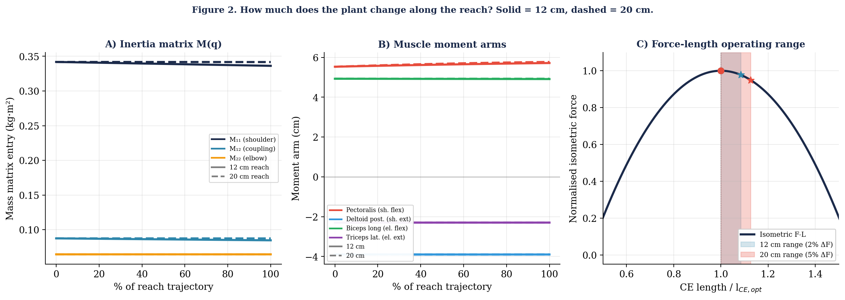
Figure 2. How much does the plant change along the reach? Solid = 12 cm, dashed = 20 cm. (A) Inertia matrix components: M₁₁ changes ~2% for 12 cm, because it depends on cos(θ₂) which varies with elbow angle. (B) Flexor moment arms vary with joint angle; extensors are roughly constant. (C) Force-length operating range of the pectoralis: the CE traverses a wider portion of the hill for 20 cm (~5% force capacity change) than for 12 cm (~2%). X-axis: CE length normalised by the optimal length l_CE_opt.
The core problem: Week 12’s linearization assumes the plant looks the same everywhere along the reach. For short movements this approximation is tolerable. For longer reaches, or for muscles with large moment arm variations, the plant at the start is substantially different from the plant at the end. A single set of A and B matrices cannot capture both.
2. Why Linearize at All?
If the muscle plant is nonlinear, why not solve the optimal control problem for the nonlinear system directly? We linearize because it gives us access to the Riccati equation, which provides three things that no general-purpose nonlinear optimizer can match:
1. Global optimality. For a linear system with quadratic cost, the Riccati equation returns the best possible controller — not approximately best, not locally best, but globally optimal. No other method can achieve lower cost. This is a mathematical proof, not an empirical observation.
2. Computational efficiency. The Riccati equation solves the problem in a single backward pass through time. It does not search, it does not iterate, it does not get stuck in local minima. For our 100-timestep, 16-state, 6-control problem, this takes a fraction of a second.
3. The separation principle. The optimal controller (Riccati) and the optimal estimator (Kalman filter) can be designed independently and simply plugged together. You do not need to jointly optimize the controller and estimator — each is optimal on its own, and their combination is optimal for the composite system.
These three properties hold only for linear dynamics with quadratic costs. For nonlinear dynamics like the Hill-type muscle plant, no equivalent closed-form solution exists. You could try to find the optimal stimulation pattern by searching over all possible combinations of six muscle stimulations at every timestep — 600 free parameters for a 500 ms reach at 5 ms control intervals. Optimizing a 600-dimensional landscape full of local minima is not just slow — it is unreliable.
But there is a circularity
Linearization sounds straightforward: approximate the nonlinear system as locally linear, then apply Riccati. But there is a problem. To linearize, you need to know the trajectory — the sequence of states the arm will pass through. To compute the trajectory, you need the controller. And to compute the controller, you need the linearization. This is circular: the linearization depends on the trajectory, which depends on the controller, which depends on the linearization.
iLQG resolves this circularity through iteration. Here is exactly what happens:
Step 1. Start with a guess for the nominal control sequence ū_0 … ū_{N-1}. This is just a starting point for the iteration — it does not need to be optimal, only physically plausible. Common choices: (a) a crude constant stimulation pulse (moves the arm roughly toward the target but with wrong timing — see Figure 4, iteration 0), (b) the EPH λ-ramp from Week 11 converted to stimulation signals (gives a trajectory with roughly the right shape — this is what we use in §6), or (c) a minimum-jerk trajectory converted to stimulations via inverse dynamics (more work, but a better starting point). The better the initial guess, the fewer iterations to converge, but the algorithm converges from any guess that does not blow up numerically. For interception tasks — where the target is moving — the initial guess must aim at the predicted interception point (using the Kalman-filtered target trajectory from Week 10), not the target’s current position.
Step 2. Linearize around the guessed trajectory. At each timestep, compute the Jacobians A_t and B_t of the nonlinear dynamics evaluated at the guessed state and control. This gives you a time-varying linear approximation of the muscle plant along that particular trajectory.
Step 3. Run the Riccati equation on the linearized system. The Riccati equation does not know or care that the A_t, B_t came from a nonlinear system — it just sees a time-varying linear problem and returns the optimal gains L_t for that problem. This is where the three guarantees above apply: for the linearized system, these gains are globally optimal.
Step 4. Simulate forward with the new gains. Apply the new controller to the full nonlinear plant (not the linear approximation) and see what trajectory the muscles actually produce. This trajectory will generally be different from the one you guessed in Step 1, because the linearized model was only an approximation.
Step 5. Check convergence. If the new trajectory is close to the previous one, stop — the linearization was accurate enough and the controller is (locally) optimal for the actual nonlinear plant. If not, go back to Step 2 and re-linearize around the new trajectory.
Each pass through this loop produces a better trajectory and a better controller. The linearization becomes more accurate because it is now centered on a trajectory that is closer to optimal. The controller becomes better because it is designed for a more accurate linearization. Typically, 6–8 passes suffice for convergence (Li & Todorov, 2004).
Where does the Kalman filter fit in?
The iLQR algorithm described above (Li & Todorov, 2004) assumes the controller can observe the full state of the arm directly. In reality, the state must be estimated from delayed, noisy sensors — which is where the Kalman filter enters. How the KF interacts with the iLQR iteration depends on the type of noise in the system.
Additive noise (this week). When the noise is additive — the same magnitude regardless of the control signal — the separation principle from Week 12 still holds after linearization. This means the controller gains L_t and the estimator gains K_t can be designed independently. In practice, you first run the iLQR iteration (Steps 1–5 above) to convergence, obtaining the final linearization A_t, B_t and the optimal controller gains L_t. Then, in a separate step, you compute the Kalman filter gains K_t using these same converged A_t, B_t matrices. The KF does not need to participate in the iteration loop — it is computed once at the end.
Signal-dependent noise. When motor noise scales with the control signal — larger activations produce larger force fluctuations — the separation principle breaks. The optimal controller depends on the estimator (because noisier controls degrade the state estimate), and the optimal estimator depends on the controller (because the control signals determine the noise level). Todorov (2005) handles this by alternating between optimizing the controller for a fixed estimator and optimizing the estimator for a fixed controller, iterating until both converge. This coordinate-descent algorithm is guaranteed to converge but requires jointly iterating the controller and estimator. The modification to our existing code is modest — the Riccati backward pass gains an extra term in the effective control cost (R becomes R + Σ Cᵢᵀ(Sˣ + Sᵉ)Cᵢ), and the Kalman filter’s process noise becomes control-dependent — but the conceptual shift is significant: the controller and estimator can no longer be designed in isolation.
For this week, we use the simpler additive-noise case. After iLQR converges, we compute the KF gains once using the converged linearization, combine them with the controller gains via u_t = −L_t · x̂_t, and simulate the full iLQG system. During execution, the feedback controller handles deviations from the nominal trajectory through δu_t = −L_t · δx_t, and the KF handles estimation errors through its predict-update cycle. The linearization remains valid as long as the actual trajectory stays close to the nominal — which the feedback controller helps ensure.
Why linearize: the Riccati equation gives globally optimal gains in a single backward pass — but only for linear systems. Linearization lets us apply this tool to the nonlinear muscle plant. The circularity (linearization needs a trajectory, trajectory needs a controller, controller needs a linearization) is resolved by iterating: guess, linearize, solve, simulate, repeat.
3. Re-Linearizing Along the Movement
To see concretely why a single linearization fails, consider the simplest question the controller faces: if I apply 1 N·m of torque at the shoulder, how does the hand accelerate?
The arm’s configuration is described by two joint angles: θ₁ (shoulder angle, measured from the horizontal) and θ₂ (elbow angle, measured from the upper arm). These angles determine where the hand is in (x, y) space through the forward kinematics equations from Week 1. The relationship between small changes in joint angles and small changes in hand position is captured by the Jacobian matrix J(q):
[Δx] [∂x/∂θ₁ ∂x/∂θ₂] [Δθ₁]
[Δy] = [∂y/∂θ₁ ∂y/∂θ₂] [Δθ₂]

Δp_hand = J(q) · Δq
The Jacobian J(q) depends on the current joint angles q = [θ₁, θ₂]. This is because the same 1° change in shoulder angle moves the hand by different amounts depending on where the elbow is. Similarly, the mass matrix M(q) — which determines how much torque is needed to produce a given joint acceleration — depends on q because the effective inertia changes with arm configuration (recall M₁₁ = I₁ + I₂ + m₂l₁² + 2m₂l₁s₂cos(θ₂) from Week 1).
Combining these two, the hand acceleration produced by a joint torque τ is:
ẍ_hand = J(q) · M(q)⁻¹ · τ

where:
J(q) = Jacobian (2×2), maps joint velocities → hand velocity
M(q)⁻¹ = inverse mass matrix (2×2), maps torque → joint acceleration
τ = joint torque [N·m]
ẍ_hand = hand acceleration in task space [m/s²]
Because both J(q) and M(q) depend on the joint angles, the product J(q) · M(q)⁻¹ — the mapping from torque to hand acceleration — changes with posture. The same 1 N·m at the shoulder produces a hand acceleration of 1.52 m/s² pointing at 117° when the arm is at the start posture (θ₁ = 55°, θ₂ = 75°), but 1.51 m/s² pointing at 108° at the target posture (θ₁ = 43°, θ₂ = 77°). The magnitude barely changes, but the direction shifts by 8.5°. A controller that assumes the target-posture mapping throughout the movement will push the hand in the wrong direction at the start.
Figure 3 makes this visible. Panel A shows the 2-link arm at three postures, with θ₁ and θ₂ labeled, and arrows indicating the hand acceleration from the same shoulder torque. The arrows differ in direction because J(q) and M(q) change. Panel B shows the consequence: linearizing at the target posture and applying those matrices at the start gives the wrong direction (dashed arrow) — 8.5° error compared to the actual response (solid arrow). Panel C shows the solution: iLQG computes a fresh linearization at each point along the trajectory.
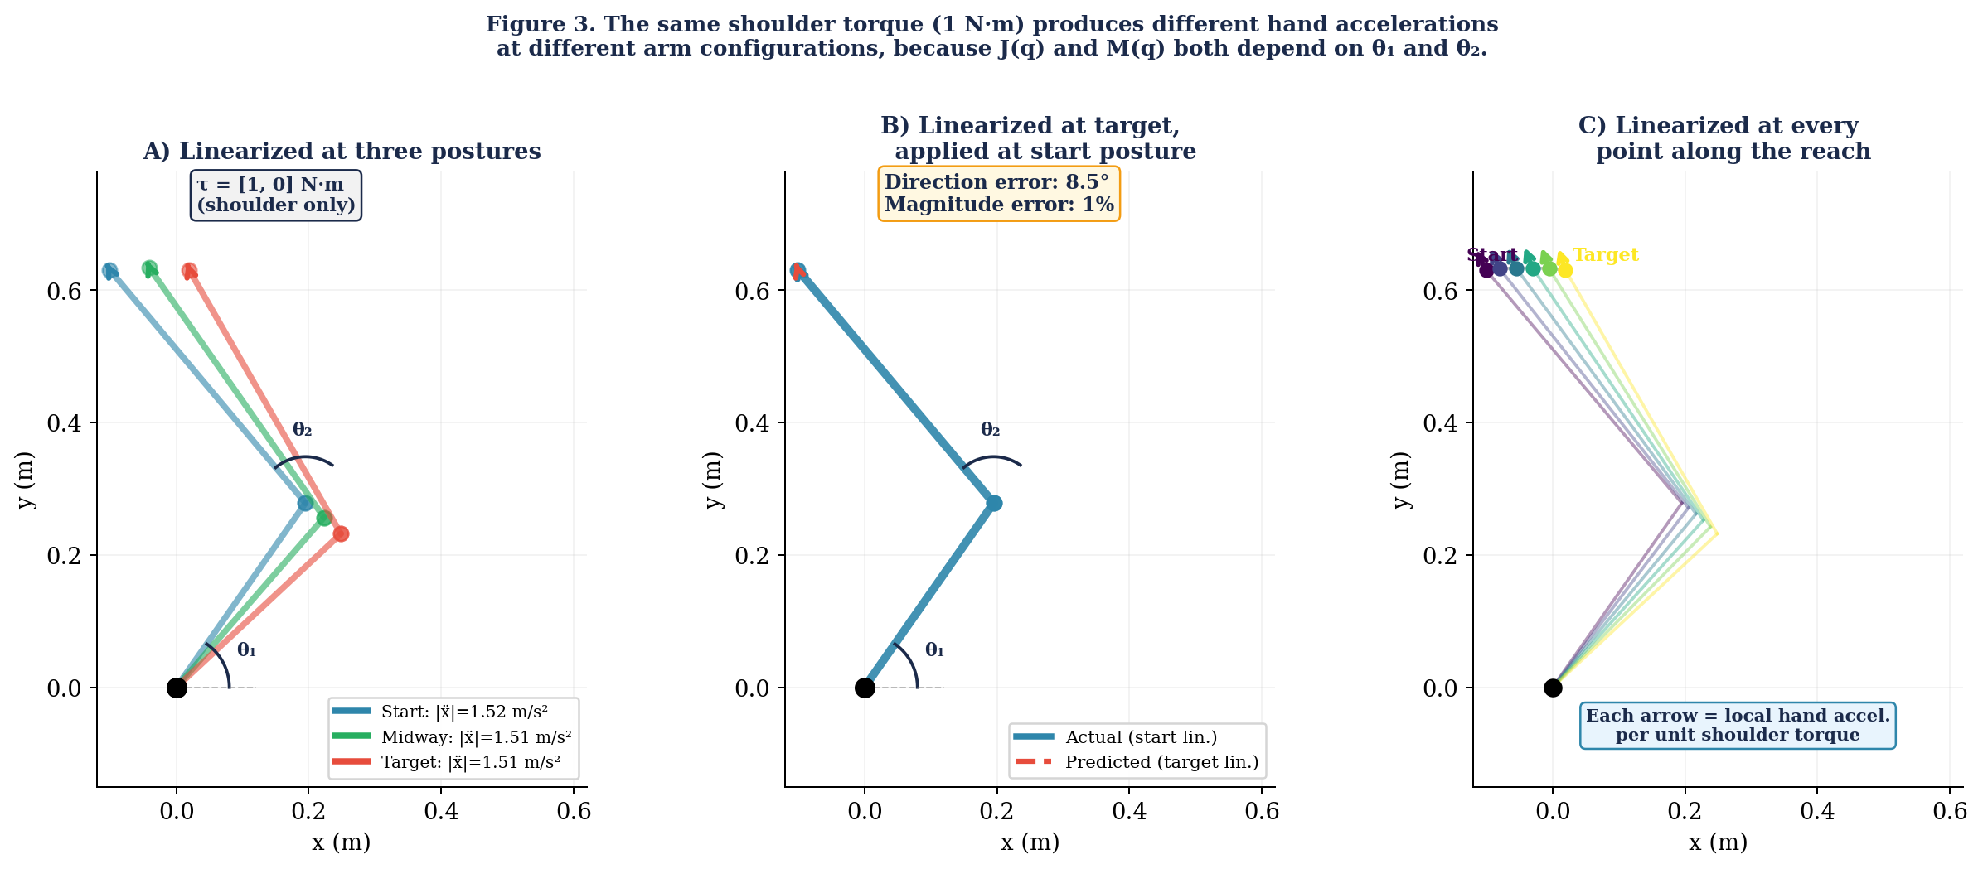
Figure 3. The same 1 N·m shoulder torque produces different hand accelerations at different configurations because J(q) and M(q) depend on θ₁ and θ₂. (A) Three postures along the reach: arrows show hand acceleration direction and magnitude. (B) Linearizing at the target and applying at the start gives 8.5° direction error. (C) iLQG re-linearizes at each point, so the local response always matches the current arm geometry.
From the torque-driven arm to the muscle plant
The equation above is for the torque-driven arm, where the control input is joint torque τ and the state is the 4-dimensional vector x = [θ₁, θ₂, θ̇₁, θ̇₂] (joint angles and velocities). For the Hill-type muscle plant, the control input is muscle stimulation u = [stim₁ … stim₆], and the mapping from stimulation to hand acceleration passes through the additional nonlinearities of force-length, force-velocity, and activation dynamics.
An important distinction: the control signal u (the neural stimulation the brain sends to the muscle) is not the same as the muscle’s activation state γ (the free calcium concentration that actually determines how much force the contractile element produces). The relationship between the two is a first-order low-pass filter — the Hatze activation dynamics from Week 11:
γ̇ = m · (u − γ)

m = 11.3 /s (Hatze rate constant)
This equation says that γ tracks u, but with a lag: the muscle cannot turn on or off instantly. When the brain commands a burst of stimulation (u jumps to 1), the calcium concentration γ rises exponentially toward 1 with a time constant of about 1/m ≈ 90 ms. When stimulation stops (u drops to 0), γ decays back toward zero. This lag is not direction-dependent — it does not depend on joint angle or velocity — but it is a temporal nonlinearity that matters for fast movements where the controller needs to plan ahead for the muscle’s delayed response.
Because γ changes according to its own differential equation and influences the force the muscle can produce at the next instant, it must be part of the state vector. The controller needs to know not just where the arm is (joint angles and velocities) but also how activated each muscle currently is, because that constrains what forces are available in the next timestep. This gives us 10 state variables: 4 mechanical + 6 activations.
But there is a second muscle variable that must be tracked. Recall from Week 11 that the contractile element length l_CE evolves according to the Hill force-velocity equation — it is not simply determined by the joint angle. The tendon stretches under load, so l_CE = l_MTC − l_SE where l_SE depends on force. This means l_CE has its own dynamics: it changes over time in a way that depends on the current force, activation, and joint velocity. If l_CE is not in the state vector, the linearization cannot capture how the CE length at one timestep affects the force at the next. Without this, the Jacobians miss the tendon dynamics entirely.
The full state vector is therefore 16-dimensional:
x = [θ₁, θ₂, θ̇₁, θ̇₂, γ₁..γ₆, l_CE₁..l_CE₆] (16-dimensional state)

u = [stim₁, stim₂, stim₃, stim₄, stim₅, stim₆] (6-dimensional control)
The first four elements are the joint angles and velocities — the same mechanical state from Week 12. The next six are the calcium activation levels γ of the six muscle groups. The final six are the contractile element lengths l_CE. Together, these 16 variables fully describe the instantaneous state of the musculoskeletal system: where the arm is, how fast it’s moving, how activated each muscle is, and how long each CE currently is.
This is the x and u that will appear in the linearized dynamics x_{t+1} = A_t x_t + B_t u_t. We use the same letters A and B as Week 12, because they play exactly the same role: the Riccati equation does not distinguish between a 4×4 A from the torque-driven arm and a 16×16 A from the muscle plant — it sees a linear system and returns the optimal gains. What has changed is the dimensions and content. Week 12’s B (4×2) mapped two joint torques directly to joint accelerations. This week’s B_t (16×6) maps six muscle stimulations through the entire chain of activation dynamics (γ̇), force generation (force-length and force-velocity), tendon mechanics, moment arms, and skeletal dynamics (M(q)⁻¹). The mathematical framework is the same; the plant it describes is not.
The A_t matrix (16×16) captures how each state variable at time t affects every state variable at time t+1 — including how joint angles affect muscle lengths (through moment arms), how muscle activations decay or persist (through the γ̇ equation), how CE lengths affect tendon forces, and how forces affect joint accelerations (through M(q)⁻¹). Note that A_t is also not the same as Week 12’s A (4×4), which only captured the mechanical coupling between joint angles and velocities. This week’s A_t additionally encodes all the muscle-tendon dynamics.
The posture-dependent direction error shown in Figure 3 is just the geometric component of the nonlinearity — the part due to J(q) and M(q) changing. The muscle nonlinearities (force-length, force-velocity, activation lag) add on top of this. Together, they make the time-varying linearization A_t, B_t essential rather than optional.
Time-varying Jacobians
We can write the full Hill-type dynamics compactly as a single function f that takes the current state and control and returns the next state:
x_{t+1} = f(x_t, u_t)
Here f is the entire forward simulation for one timestep: it takes in the 16D state (joint angles, velocities, muscle activations, and CE lengths) and the 6D stimulation, and computes the next state by running the Hatze activation dynamics (γ̇ = m(u − γ)), the Hill force-length and force-velocity curves (which update l_CE), the SE tendon force, the moment arm mapping from muscle forces to joint torques, and finally the equations of motion (M(q)⁻¹ · [τ − C(q,q̇)]). In the lab, this is what hill_step() does in a single function call.
To linearize around a nominal trajectory, we need to know how f responds to small perturbations. At each timestep t, we compute two Jacobian matrices:
A_t = ∂f/∂x at (x̄_t, ū_t) (16 x 16)
"If I perturb the state slightly, how does x_{t+1} change?"

B_t = ∂f/∂u at (x̄_t, ū_t) (16 x 6)
"If I perturb the stimulation slightly, how does x_{t+1} change?"
We compute these numerically via central finite differences — perturb each input by ±ε, call f twice, and measure the change:
A_t[:, j] ≈ [ f(x̄_t + ε e_j, ū_t) − f(x̄_t − ε e_j, ū_t) ] / (2ε)
B_t[:, j] ≈ [ f(x̄_t, ū_t + ε e_j) − f(x̄_t, ū_t − ε e_j) ] / (2ε)
For each of the 16 state dimensions, we perturb by +ε and −ε and simulate one step: 32 simulations for A_t. For each of the 6 controls: 12 more for B_t. At 100 control timesteps (with 5 ms control intervals), about 4,400 one-step simulations per iLQG iteration. We use a shorter control interval than Week 12’s 10 ms because the muscle dynamics — particularly the force-velocity curve and tendon force balance — are stiffer than the torque-driven arm and require finer temporal resolution. Each 5 ms control step is internally simulated with five 1 ms substeps to ensure numerical stability. The Riccati equation from Lab 12 works unchanged on these time-varying matrices — it receives A_t, B_t instead of a fixed A, B, and returns time-varying gains L_t as before.
Key insight: riccati_backward() from Lab 12 works unchanged. A and B are now lists (one pair per timestep) instead of a single pair. The Riccati equation receives the linearized dynamics at each timestep and returns the locally optimal gains.
4. From One Gain to Three: The iLQG Control Law
In §3 we computed a time-varying linearization A_t, B_t at every point along the nominal trajectory. Now we feed these into the Riccati backward pass. The recursion is the same one you built in Lab 12 — but the answer looks different, because the linearization is no longer centered on a stationary equilibrium.
In Week 12, the arm was linearized at the target posture: the nominal control was zero (no torque needed to hold the target) and the nominal state was already at the goal (zero miss distance). Under those conditions, the cost-to-go was purely quadratic in the deviation δx, and the optimal correction was a single gain: δu_t = −L_t δx_t.
Now the nominal trajectory is in motion — muscles are firing, the arm is moving — and the plan may not reach the target yet. This changes the cost-to-go in two ways, each of which produces an additional gain in the control law:
The nominal control is nonzero. The plan calls for specific stimulation patterns at each timestep. The Riccati equation optimizes the total control u_t = ū_t + δu_t. If the plan wastes energy or has bad timing, the controller needs to adjust the plan itself. This produces a gain L_u that acts on the nominal control ū_t. At equilibrium, ū_t = 0 and this correction vanishes.
The nominal trajectory misses the target. Early in the iteration, the plan does not land at x*. This miss distance — measured by v_N = Q_N(x̄_N − x*) — creates a linear term in the cost-to-go that was absent in Week 12’s purely quadratic formulation. This produces a gain L_v that steers the trajectory toward the target. At convergence, x̄_N → x* and this correction vanishes.
When the algorithm has converged and both corrections have vanished, the control law reduces to the familiar single-gain form δu_t = −L_t δx_t from Week 12. The three-term law is the general case; Week 12’s single-gain law is the special case where the plan is already perfect.
Reference: the iLQG equations
The full set of equations for the backward pass is given below for reference (Li & Todorov, 2004, eqs. 12–18). This lecture uses L_t, L_v, L_u to stay consistent with Week 12’s notation; Li and Todorov use K, K_v, K_u for the same quantities.
Control law (eq. 12):

δu_t = −L_t δx_t − L_v v_{t+1} − L_u ū_t

Gains (eqs. 13–15):

L_t = (Bᵀ S_{t+1} B + R)⁻¹ Bᵀ S_{t+1} A ← state feedback (= Week 12)
L_v = (Bᵀ S_{t+1} B + R)⁻¹ Bᵀ ← target-miss correction
L_u = (Bᵀ S_{t+1} B + R)⁻¹ R ← nominal-control correction

Backward recursions (eqs. 16–17):

S_t = Aᵀ S_{t+1} (A − BL_t) + Q ← cost-to-go (= Week 12)
v_t = (A − BL_t)ᵀ v_{t+1} − L_tᵀ R ū_t + Q x̄_t ← miss correction

Boundary conditions (eq. 18):

S_N = Q_N
v_N = Q_N (x̄_N − x*)
Every symbol in these equations:
x (16×1) = state vector [θ₁, θ₂, θ̇₁, θ̇₂, γ₁..γ₆, l_CE₁..l_CE₆]
u (6×1) = control vector [stim₁..stim₆]
A_t (16×16) = Jacobian of f w.r.t. state at timestep t (§3)
B_t (16×6) = Jacobian of f w.r.t. control at timestep t (§3)
S_t (16×16) = cost-to-go matrix (same role as Week 12)
R (6×6) = control cost matrix (diagonal, penalises effort)
Q (16×16) = running state cost (zero for endpoint-only tasks)
Q_N (16×16) = terminal state cost (penalises endpoint error)
x̄_t (16×1) = nominal state at timestep t (from the current plan)
ū_t (6×1) = nominal control at timestep t (from the current plan)
x* (16×1) = target state
v_t (16×1) = auxiliary vector: carries the target-miss correction backward
In the lab, you will implement this backward pass by adding the v_t recursion alongside the S_t recursion you already have from Lab 12. The key thing to remember: as the algorithm converges and the plan reaches the target, v_t → 0 everywhere, L_v and L_u contribute nothing, and the control law reduces to Week 12’s single-gain form.
Convergence
Figure 4 shows convergence data from running the iLQG algorithm on our torque-driven 2-link arm (the 4D state from Week 12, not the Hill muscle plant) using the smc package, for both the 12 cm reach from Week 12 and a longer 20 cm reach. Both start from a crude initial guess — a constant torque pulse that moves the arm roughly toward the target but overshoots and stops at the wrong place (gray line, iteration 0). The 12 cm reach converges in 1–2 iterations: iteration 1 (dashed) already nearly matches the converged solution (solid). This confirms that Week 12’s single-point linearization was nearly optimal for this reach distance. The 20 cm reach takes 3–4 iterations, with visible improvement from iteration 1 to iteration 2 before the solution settles. The hand-space view (top row) shows the reach as the hand moves through (x, y) space, while the joint-space view (bottom row) shows the same convergence in the (θ₁, θ₂) coordinates that the Riccati equation operates in.
For the 6-muscle Hill-type plant, with its additional nonlinearities from force-length, force-velocity, and activation dynamics, Li and Todorov (2004) report convergence in 6–8 iterations. This is still an order of magnitude faster than conjugate gradient (14 iterations) and 20× faster than differential dynamic programming (15 iterations), because the Riccati equation exploits the temporal structure of the problem rather than treating it as a generic optimization. The pattern in Figure 4E generalises: the more nonlinear the plant, the more iterations the linearization needs to catch up with the dynamics. Our 16D Hill iLQG in §6 converged in 6 iterations — consistent with Li and Todorov’s results on a similar plant.
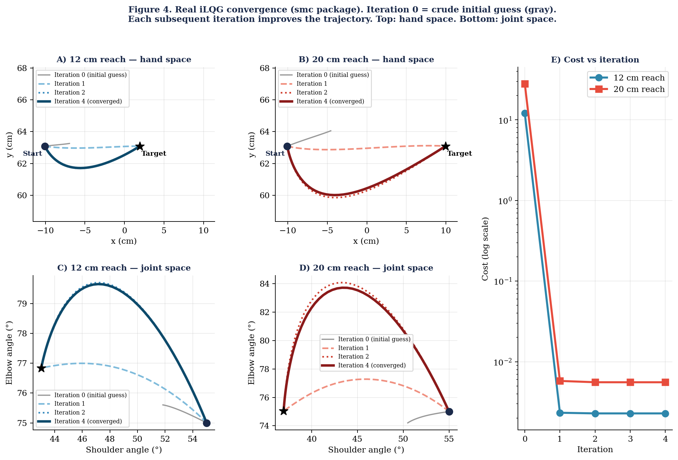
Figure 4. Real iLQG convergence (smc package). Gray = iteration 0 (crude initial guess), dashed = iteration 1, dotted = iteration 2, solid = converged. (A, B) Hand-space trajectories for 12 cm and 20 cm reaches. (C, D) The same trajectories in joint space. (E) Cost vs iteration on a log scale. All data from actual iLQG runs.
Biologically, each iteration resembles an internal rehearsal supported by the cerebellar forward model, occurring during the ~100–150 ms reaction time before movement onset.
5. What Re-Linearization Looks Like
In Sections 2 through 4, we described the iLQG framework in the abstract: compute A_t, B_t at every timestep, feed them into Riccati, iterate. Now let us look at what these time-varying matrices actually contain. Figure 5 shows the B_t matrices computed along the iLQG-converged trajectory for our 12 cm reach on the smc Hill-type arm.
Recall that each column of B_t answers the question: if I increase this muscle’s stimulation by a small amount at time t, how does the 16D state at time t+1 change? The most important part of this answer is the effect on joint accelerations — how much does the hand speed up or change direction? Panel A of Figure 5 plots the magnitude of this mechanical effect for each of the six muscles, across the entire 500 ms movement.
The variation is dramatic. The pectoralis (the primary agonist for this reach) changes its mechanical effect on the joints by more than 5× over the course of the movement. At the start, the CE is near its optimal length and the muscle can generate force efficiently; by mid-reach, the CE is shortening rapidly and the force-velocity curve reduces its output; near the end, the muscle is nearly isometric again. These changes are encoded in B_t at every timestep. A single B matrix — computed at any one posture — cannot capture this variation.
Panel B shows a different aspect of the same phenomenon: the direction in which each muscle pushes the hand. As the arm configuration changes (θ₁ and θ₂ evolve), the Jacobian J(q) rotates, and the same muscle force produces hand acceleration in a different direction. The pectoralis direction rotates by 38° over the 12 cm reach; the triceps lateral rotates by 11°. Both rotations are large enough that a single linearization — which assumes a fixed direction — will generate stimulation commands that push the hand the wrong way at some point during the movement.
Panel C shows why the state vector must be 16-dimensional: the joint angle, muscle activation γ, and CE length l_CE all change throughout the movement, and they all affect the B_t entries. If γ or l_CE were not in the state vector, the linearization could not capture how the current activation and CE length constrain the force available at the next timestep.
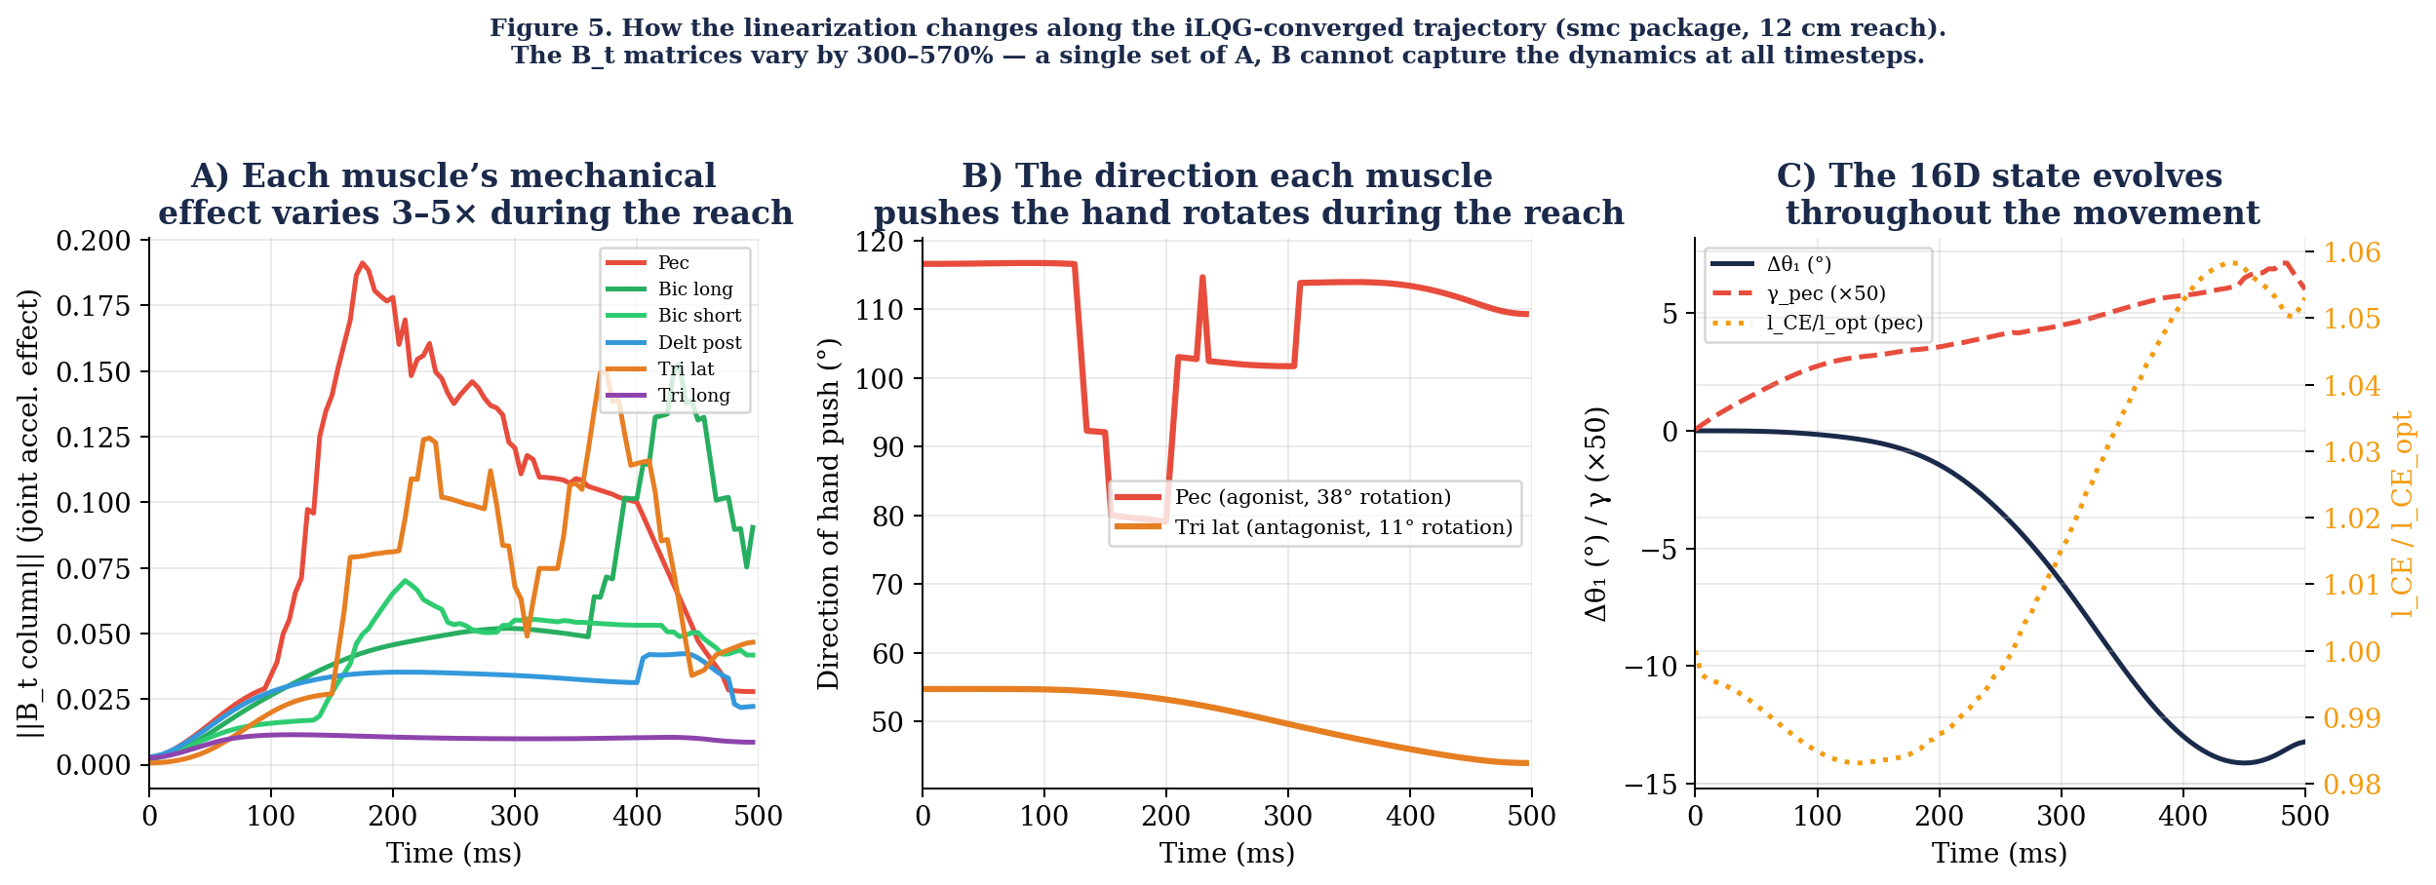
Figure 5. How the linearization changes along the iLQG-converged trajectory (smc package, 12 cm reach). (A) Magnitude of each muscle’s mechanical effect on joint accelerations (||B_t column||). The pectoralis varies by more than 5× across the movement. (B) Direction in which the pectoralis (38° rotation) and triceps lateral (11° rotation) push the hand — both change as the arm configuration evolves. (C) Key state variables (Δθ₁, γ_pec, l_CE/l_opt for the pec) showing why a 16D state is needed.
The B_t matrices vary by 300–570% along the trajectory. A single B computed at one posture misses most of this variation. This is why single-point linearization cannot match full re-linearization — the dynamics at the start, middle, and end of the movement are substantially different.
6. Single-Point vs Re-Linearized: What the Iteration Buys
The central claim of this lecture is that re-linearizing along the trajectory — not just linearizing once — is what makes iLQG work on the muscle plant. Figure 6 tests this claim with three control strategies on the same Hill-type arm, all simulated using the smc package.
The first strategy is EPH from Week 11: no linearization at all. The λ-ramp drives the muscles and the reflex system handles the rest. The hand overshoots the target by 2.4 cm.
The second strategy is single-point linearization: compute A, B at one operating point (the trajectory midpoint), use these fixed matrices for the Riccati backward pass, and iterate. This improves on EPH — the endpoint error drops to 1.2 cm — because at least one set of linearized dynamics is being used to compute gains. But the improvement is limited: the A, B at the midpoint describe the plant’s response when the arm is halfway through the reach. They are wrong for the start of the movement (where the arm is at a different posture with different muscle lengths) and wrong for the end (where the arm is decelerating against different force-velocity conditions). The single linearization captures some of the dynamics but not all of them.
The third strategy is full iLQG: re-linearize at every control timestep along the trajectory, compute new Riccati gains from the time-varying A_t, B_t, and iterate. After 6 iterations, the endpoint error drops to 0.9 cm — a 62% improvement over EPH and 25% better than single-point. The velocity profile remains asymmetric (the tendon mechanics are unchanged), but the stimulation timing is reshaped so the hand arrives at the target more accurately.
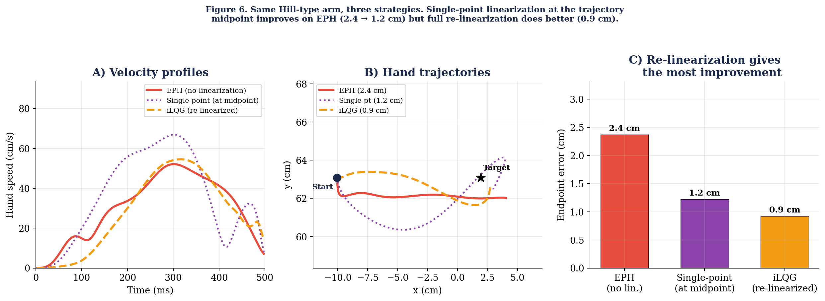
Figure 6. Same Hill-type arm, three strategies (smc package, 12 cm reach). Red = EPH (no linearization, 2.4 cm error). Purple = single-point linearization at the trajectory midpoint (1.2 cm). Orange = full iLQG with re-linearization at every timestep (0.9 cm). (A) Velocity profiles. (B) Hand trajectories with endpoint errors. (C) Endpoint error bars.
 | EPH | Single-point | iLQG (re-linearized)
Linearization | None | At midpoint only | Every timestep
Endpoint error | 2.4 cm | 1.2 cm (49% better) | 0.9 cm (62% better)
A, B matrices | N/A | Fixed (16×16, 16×6) | Time-varying (one per timestep)
Iterations | N/A | 2 | 6
Hand-tuned params | λ shape, kd_ce | None (cost only) | None (cost only)
This result validates the entire framework of Sections 2 through 4. A single linearization helps, but it cannot capture how the plant changes between the start, middle, and end of the movement. Re-linearizing at every timestep captures these changes, and the iteration loop (§2, Steps 1–5) resolves the circularity between the trajectory and the linearization. The improvement from single-point to full re-linearization is the direct payoff of the time-varying Jacobians A_t, B_t from §3.
Choosing the right state vector
All of the results above used the 16D state vector [θ₁, θ₂, θ̇₁, θ̇₂, γ₁..γ₆, l_CE₁..l_CE₆]. A natural question is whether the six l_CE variables are really necessary — after all, Week 11 ran the Hill plant without ever putting l_CE into a state vector. We tested this directly by running iLQG with a 10D state (dropping the l_CE entries) but keeping everything else identical: same plant, same EPH initial guess, same cost function, same algorithm.
The 10D iLQG did not merely fail to improve on EPH — it made things worse, increasing the endpoint error from 2.4 cm to 2.7 cm. The reason is that without l_CE in the state, the Jacobians cannot capture how the current CE length affects force at the next timestep through the force-length curve. The Riccati equation receives an incomplete picture of the dynamics, and the gains it computes push the arm in the wrong direction. This is a general lesson: the state vector for iLQG must include every variable whose current value affects the next state in a way that the controller needs to know about. Omitting a variable does not just reduce accuracy — it can make the linearization actively harmful.
State vector design rule: if a variable has its own dynamics and affects the next state, it must be in x. For the Hill muscle, l_CE evolves according to the force-velocity equation and determines force through the force-length curve. Omitting it from the state vector caused iLQG to perform worse than no linearization at all (2.7 cm vs 2.4 cm). Including it enabled a 62% improvement (0.9 cm).
7. Handling Sensory Delays Properly
In Week 12, we handled delays by inflating sensory noise. This is conceptually wrong: noise means “I measured inaccurately”; delay means “I measured accurately but what I measured is 40 ms old.” How much does this matter in practice?
Figure 7 answers this question using the iLQG trajectory from §6. During the 12 cm reach, proprioception (40 ms delay) reports a shoulder angle that is up to 3.4° stale — it sees the arm where it was 40 ms ago, not where it is now. Vision (100 ms delay) reports a hand position that is up to 5.3 cm stale. Both channels are most stale during peak velocity, which is precisely when accurate state information matters most for the controller. Treating these delays as noise would tell the Kalman filter that the measurements are inaccurate, when in fact they are accurate but old — a fundamentally different kind of uncertainty.
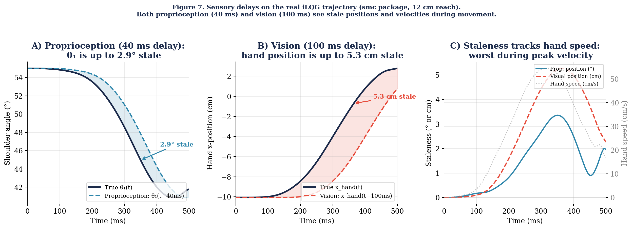
Figure 7. Sensory delays on the real iLQG trajectory (smc package, 12 cm reach). (A) True shoulder angle (solid) vs what proprioception reports 40 ms later (dashed, blue). The shaded gap reaches 3.4° during peak velocity. (B) True hand x-position (solid) vs what vision reports 100 ms later (dashed, red). The gap reaches 5.3 cm. (C) Both staleness signals peak when the hand moves fastest.
The proper treatment augments the state vector with a buffer of recent states spanning the longest delay. For our 16D state at dt = 5 ms, proprioceptive delay is 8 control steps and visual delay is 20 control steps. The augmented state concatenates the current state with the 20 most recent past states:
x_aug = [x_t, x_{t-1}, x_{t-2}, ..., x_{t-20}] (16 × 21 = 336-dimensional)
Proprioception reads joint angles and velocities [θ₁, θ₂, θ̇₁, θ̇₂] from the slot at t−8. Vision reads hand position and velocity [x_hand, y_hand, ẋ_hand, ẏ_hand] (computed from θ₁, θ₂ and θ̇₁, θ̇₂ via forward kinematics and the Jacobian) from the slot at t−20. At each timestep, the forward model advances the leftmost slot and the buffer shifts right. The Kalman filter uses these delayed observations to correct its estimate of the current state, propagating corrections forward through the buffer.
The cost is computational: the state dimension grows from 16 to 336, and the Riccati equation scales with the cube of the state dimension. For our arm, this is still tractable. The benefit is that the filter recognises a perturbation as soon as the delayed measurement arrives — 40 ms after a proprioceptive perturbation, 100 ms after a visual one — rather than treating it as additional noise that corrupts the estimate indefinitely.
8. What iLQG Buys and What It Costs
Buys: Principled muscle commands without hand-tuning. Unified framework spanning Weeks 11–12. Testable EMG and perturbation predictions.
Costs: ~20 s to converge on a laptop (fast offline, slow for real-time). Local optimality — the algorithm finds a local minimum, which may not be the global best. Not a neural circuit model — but a normative benchmark.
Still missing: Signal-dependent noise (Todorov, 2005) and online replanning. Signal-dependent noise is needed to explain the speed-accuracy tradeoff (Fitts’ law); the coordinate-descent extension described in §2 provides the framework.
9. The Full Picture
We began with a simple arm and a simple controller. This week, the same Riccati mathematics from Week 12 drives the actual musculoskeletal plant from Week 11.
The remaining gap in our framework is signal-dependent noise. When motor noise scales with the control signal, the controller faces a tradeoff that additive-noise iLQG cannot capture: large corrections reduce errors but also inject variability. This tradeoff is at the heart of Fitts’ law and the speed-accuracy tradeoff. The extension to signal-dependent noise, described in §2, requires replacing the independent controller-estimator design with the coordinate-descent procedure of Todorov (2005).
Takeaway
iLQG = “give the Riccati equation the real musculoskeletal plant.” The mathematics is the same as Week 12. The only new ingredient is iteration: plan, simulate, re-linearize, re-solve, repeat. On the Hill-type arm, full re-linearization reduces endpoint error by 62% compared to EPH and 25% compared to single-point linearization. The correct state vector (16D, including l_CE) is essential — without it, linearization makes things worse.

