The Impact of Fixed Broadband Access on Employment Levels
By Daniel Cavin

Contents
Executive Summary Page 3
Aims and objectives Page 4
Background Page 4
Data Sources Page 4
Analysis Pipeline Page 5
Findings Page 8
Conclusions Page 12
Reflections Page 13
References Page 14
Appendix 1: Notebooks Page 15
Appendix 2: Data Catalogue Page 16
Appendix 3: TMA02 Report Page 17

Executive Summary
Internet access is essential in today’s employment market offering opportunities to find work as well as being a vehicle for remote working and learning.
The purpose of this report is to investigate the link between access to good quality broadband and employment levels. The investigation aims to answer two questions:
- Is it possible to identify different employment profiles among local authorities?
- Can the broadband characteristics of an area predict that area’s employment profile?
Two datasets were used in this report, fixed broadband data from the Ofcom connected nations 2022 report, and employment data from the 2011 and 2021 UK censuses. The broadband data consists of figures showing availability of broadband speeds and infrastructure in local authorities in the UK whilst the employment data features the employment figures of authorities in England and Wales separated by age group.
Authorities were split into clusters based on employment figures using k-means data mining, two clusters were identified which were cohesive enough to represent viable groupings. The resulting cluster assignments were applied to the fixed broadband data and a k-NN classifier was trained by randomly selecting 80% of the broadband data for training with the other 20% used for testing. Test data was successfully classified at a rate of 85%.
The results of the investigation showed 307 of the 331 local authorities fell into the same groupings in 2011 and 2021, the lower profile included 18 and 16 of the 20 most employment deprived councils (Penney, B. 2019) in 2011 and 2021 respectively, although there was some overlap in the employment characteristics of affluent areas including Kensington and Chelsea. The main employment characteristic difference appears to be in figures relating to the 16-24 age group.
The 85% classification rate suggests some minor correlation between broadband availability and employment profile however, examination of the figures showed that areas with lower employment rates often had the highest rates of quality broadband availability.
The study was constrained by the broadband data covering only availability as information on internet use would have been beneficial. The form of the employment data in 2011 and 2021 was also inconsistent requiring the combination of datapoints for direct comparison, obfuscating details regarding part-time/full-time ratios.
In light of the availability of broadband in employment deprived areas I would recommend focusing on promoting effective use of broadband services to help those in deprived communities fully utilise the employment benefits provided.
Executive Summary Word Count: 400

Aims and Objectives
This study aims to investigate the link between good quality broadband access and employment levels in England and Wales using two datasets: census data detailing employment figures from 2011 and 2021, and fixed broadband availability data from 2021. The former covers local authorities in England and Wales while the latter covers local authorities in the UK as a whole.
The purpose of the study is to identify digital inequality issues in the UK but may also be useful in analysing employment deprivation. The focus of the study relates to the questions; is it possible to identify different employment profiles among local authorities, and can the broadband characteristics of an area predict that areas employment profile?
No specialised knowledge is required to understand this report.
Background
According to a study by Paul Lapointe on access to fibre optic broadband in the US between 2011 and 2013, of the 47 states that showed increased access, only one (Alaska) saw a drop in employment figures, Lapointe concluded that his study “showed a strong correlation” between the percentage of households with access to fibre optic broadband and employment levels (2015). The OECD includes access to high-speed internet and employment levels as two of the contributing factors to overall wellbeing (OECD, 2022). This investigation aims to explore whether there exists a link between levels of broadband availability and employment levels in England and Wales with a view to identifying digital inequalities.
Using UK employment data from the 2011 and 2021, this investigation attempts to identify potential employment profiles by which to stratify local authorities in England and Wales. The investigation then combines these profiles with 2021 fixed broadband data to ascertain whether it is possible to predict the employment profile of a given area using the areas broadband coverage.
A limitation of the employment data is that the 2021 figures do not contain details of the types of employment (part-time, full-time etc.) which limits the comparison of employment levels along these lines. The broadband data also has the limitation of containing no information on how broadband is typically used in each area which would better facilitate analysis of its effect on employment.
Data Sources
The employment and broadband datasets are available from the Office of National Statistics website and Ofcom website respectively. They are both made available under the Open Government Licence 3.0 under which I am permitted to “copy, publish and transmit the information” as well as “adapt the information” and “exploit the information commercially and non-commercially” including by combining the information with other data (2023).
Links to the Licences and Data sources are included in Appendix 2.
Employment Data
This data was supplied as part of the TM351 TMA02 datasets which were provided legally under the Open Government Licence. The data provides employment details from 2011 and 2021 separated by local authority and age group. The household response figure for 2011 was approximately 95% (ONS, 2013) while according to Ed Dunn the corresponding 2021 response rate was 97% meaning the figures are not a 100% accurate representation of the country’s employment figures, Dunn also noted that the 2011 census had over 300,000 duplicate responses detected which was due to the 2011 census being conducted on paper as opposed to digitally (2021).
The data was delivered via two excel files with sheets corresponding to each featured age group, the files contained several rows of metadata at the beginning and end of each sheet which required cleaning. There were no missing values in either file however, the youngest age group in the 2021 file (15 and under) was entirely comprised of 0 values and had no corresponding age group in the 2011 file therefore these figures omitted from the analysis.
Each file contained figures relating to the number of active and inactive persons as well as figures relating to various forms of employment. Summary details of the coverage of each file are contained in the table below.

Table 1 - Employment Data Characteristics
Census Year | Age Groups | Active Employment Categories | Inactive Employment Categories | Local Authorities
2011 | 12 | 5 | 5 | 348
2021 | 6 | 4 | 2 | 331

In order to allow direct comparison between the figures from each year, the various employment columns were combined to provide total employed, total active, and total residents figures for each age group and local authority. I considered calculating ratios of the 2011 employment figures and applying these to the 2021 figures for direct comparison of part-time and self-employed figures however, due to changes in the job market in that period particularly with regards to Brexit and covid-19 I assumed that these estimates may be unreliable.
The employment data is anonymised, being summarised by area makes it unlikely that individuals or households may be identified through the data, however where risk of identification was found to exist the Office for National Statistics employed “targeted record swapping” and “cell key perturbation”, swapping household records with nearby areas and making small changes to the figures that further ameliorate the risk of participants being identified (2021).
Fixed Broadband Data
The fixed broadband data was part of the Ofcom Connected Nations Report 2022 and was supplied by the Open University legally in accordance with the Open Government Licence 3.0 as part of TMA02. The data relates to broadband coverage from 2019 – 2023 and was prepared and stored in MongoDB, the details of this are provided in TMA02 (Cavin, D. 2023).
Analysis Pipeline
Employment Data Import and Preparation
The employment data was initially imported into Panda’s data frames and inspected. The frames contained several leading and trailing rows of metadata included among which was the appropriate column headings which had appeared initially as ‘unnamed’. The column headings were extracted and applied to the frames and the metadata was stripped away, the combined figures were calculated and added as columns.
Due to the inconsistencies in age groups, several of the 2011 age groups had to be combined to match the 2021 data, furthermore, due to the amalgamation of various local authorities in the late 2010’s rows from the 2011 frames had to be combined for comparison. Finally, columns denoting the year and age group of each row were added to each frame before the cleaned data was imported into a fresh collection in MongoDB alongside the fixed broadband data. All of the original column data was retained should later retrieval and analysis be required.
Clustering Employment Data
My first task was to define employment profiles, the first step was shaping the data from each year into a table containing a row for each local authority and a column value for each combination of age group/employment characteristic. The specific characteristics I used were the combined figures which I converted to percentages in order to make the data proportional for each area and not skewed towards the population size. Specifically, these figures represented percentages of Total Active, Total Employed and Total Active Employed.
With these figures I applied k-means clustering with k values 2,3 and 4 to define the clusters. The results showed the most cohesive clusters were produced using k = 2 with average silhouette coefficients of 0.42 and 0.44 for the 2011 and 2021 data respectively. The lower employment profile comprised of 123 local authorities with 208 in the higher profile in 2021 with a slight overlap of values from the lower end of the lower profile.
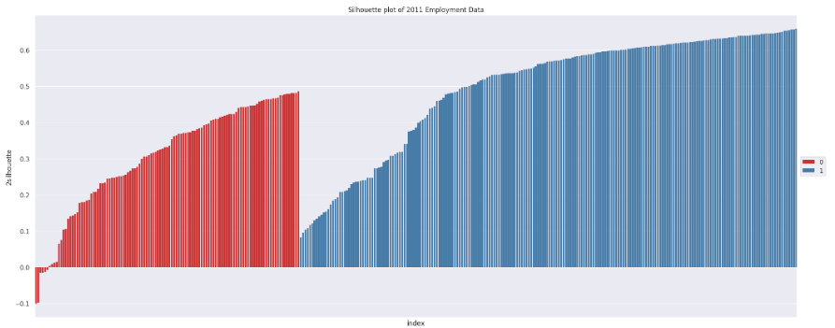
Figure 1 - 2011 Silhouette plot.

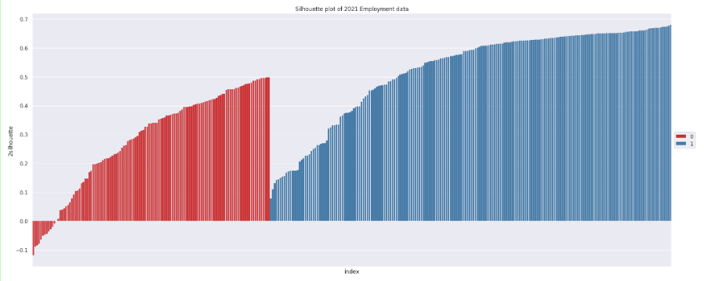

Figure 2 - 2021 Silhouette Plot

Classifying by Broadband Availability
Using the broadband data I trained a k-Nearest Neighbour classifier to predict the employment profile of each local authority. I used 5 columns from the broadband data which contained the number of premises with various broadband availability including full fibre and Ultra-Fast Broadband, 4 columns detailing the number of premises receiving a range of download speeds between 5 to 10 Mbit/s and over 300Mbit/s, and finally a column with the number of premises receiving speeds below the Universal Service Obligation. The clusters assigned to the employment data using the k-means clustering was added as the target variable.
The data was split randomly into training and test sets, with 80% used to train the classifier and 20% for testing.
I used a leave one out algorithm to optimise the value of k and tried numerous variations in order to produce the best result. The highest success rate was produced by scaling the broadband data before applying a 5-NN classifier weighted by distance, the results are shown in the table below.

Table 2 - Best results of k-NN Classifier
 | Prediction | Incorrect | Correct
Actual Value | Lower Cluster | 8 | 14
 | Upper Cluster | 2 | 43

This result showed an 85% classification success rate which is not particularly well performing especially considering the fact the classifier is dealing with only two clusters.

Findings
Employment Profiles
Having applied k-means clustering to the employment data I produced boxplots which showed among the defining characteristics of each profile, the 16-24 and 50-64 age groups and Total Active % figures showed the most significant differences.
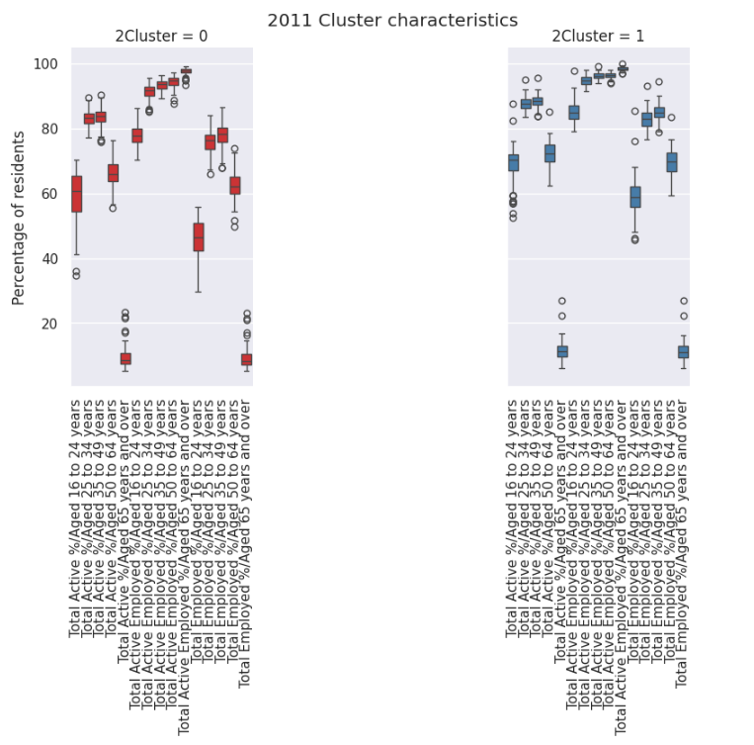
Figure 3 - 2011 Employment Characteristics
Figure 3 shows the figures across the range are lower in cluster 0 than in cluster 1 however, in the 16-24 age group the upper range of cluster 0 is around the median for cluster 1 in all three metrics, similar differences are observable in the 50-64 bracket. The 2021 figures show similar trends as evidenced in figure 4.
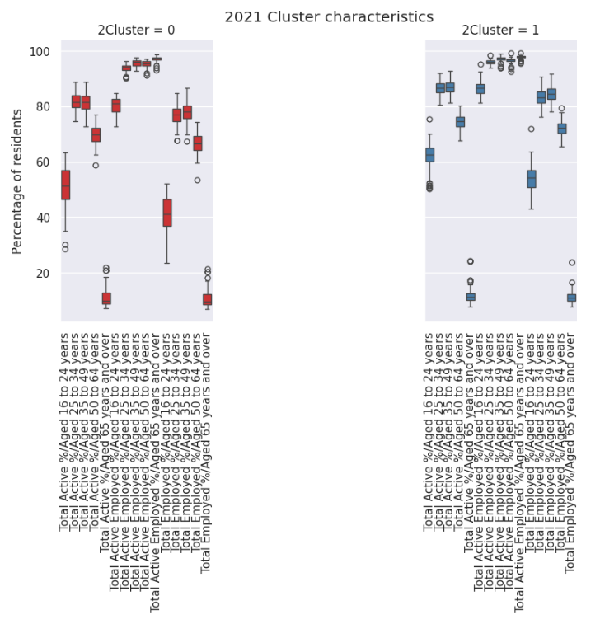
Figure 4 - 2021 Employment Characteristics
Figures 5 and 6 show the majority of areas conform to the same cluster in both 2011 and 2021 with Northwest England, Coastal Wales and London having the largest groupings of areas in Cluster 0.
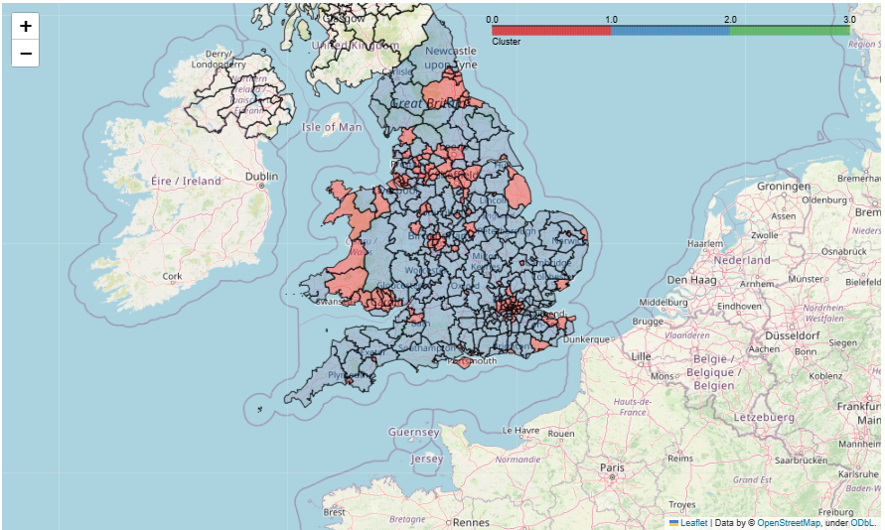
Figure 5 - 2011 Employment Map
I expected the lower employment cluster 0 to be comprised of the most deprived areas and it’s true that 18 and 16 of the 20 most employment deprived areas according to the Iod2019 report (Penney, B. 2019) were included in this cluster in 2011 and 2021 respectively. However, I was surprised to also find many affluent areas in the same cluster most notably, Kensington and Chelsea, Westminster and Hammersmith and Fulham, three of the 4 richest areas in the UK (Lloyd, M. 2019). 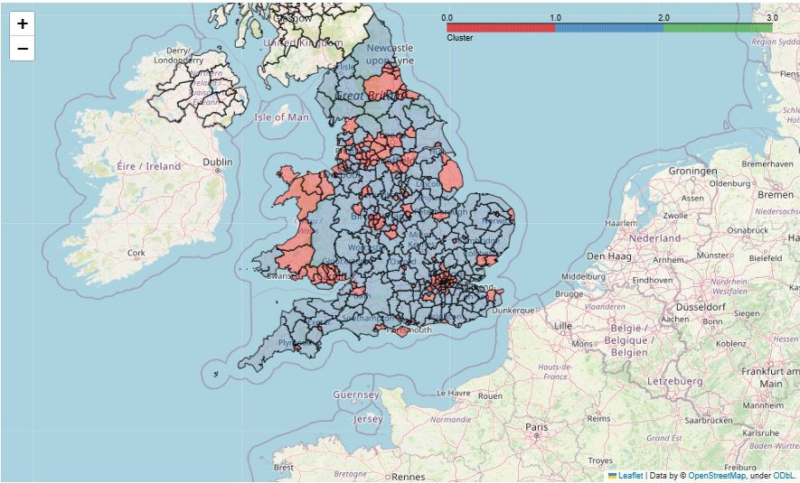
Figure 6 - 2021 Employment Map
My assumption is that generational wealth in these areas reduces the need to work especially in the key age groups due to the number of young people in higher education and higher levels of early retirement. More detailed 2021 employment figures including part-time and self-employed figures may have added further nuance to understand or avoid this feature of the clusters.
Broadband Classification
As previously mentioned, broadband classification using a 5-NN classifier was able to correctly classify areas by broadband provision at a rate of 85% at the highest.
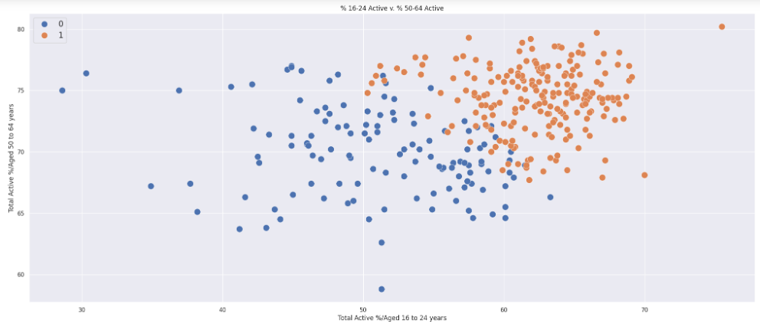
Figure 7 - Clustering Scatterplot
The scatterplot in figure 7 shows the juxtaposition of the most disparate age groups in the 2021 data, with the colour indicating the cluster of the data points. The values between 50 and 60 on the x-axis show a significant overlap of data points from each cluster.
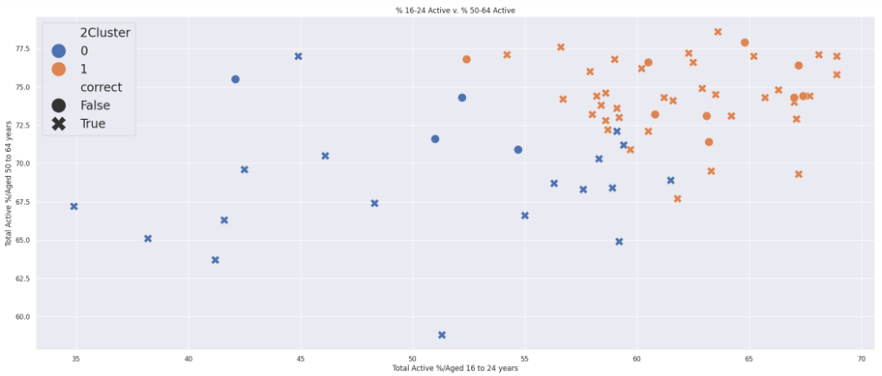
Figure 8 - Classification Scatterplot (81% success rate example)
I expected most of the misclassified data points to be at this point of overlap however, figure 8 shows this was only the case for cluster 0 and the majority of the misclassified cluster 1 were positioned above 60 on the x-axis. Taking account of this and having only two possible classifications diminishes the validity of the classifiers performance.
One interesting finding of my investigation is that the average percentage of premises receiving the highest speeds included in the classification training were higher in cluster 0 than in cluster1, additionally, the average was higher still in the 20 most employment deprived areas in the country. This would suggest that broadband characteristics may not be a good indicator of employment profile and that unequal access to quality broadband may not be a strong contributing factor in employment deprivation.
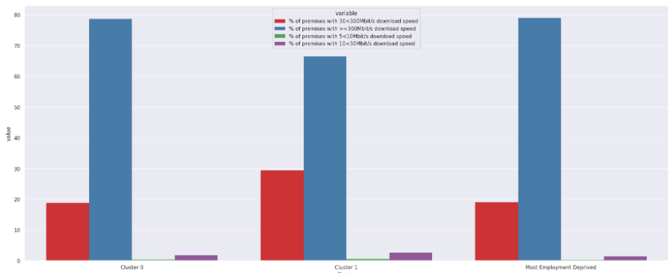
Figure 9 - Average Speeds by Cluster
Conclusions
Using census employment data and Ofcom broadband data this investigation set out to ascertain if it was possible to identify different employment profiles among local authorities and to predict the employment profile of an area using its broadband characteristics. I was able to define two profiles with similar characteristics using k-means data mining that were fairly consistent and classify authorities into these profiles using broadband data at a rate of up to 85% however this rate and the overlap in clusters limit this outcomes usefulness.
Finally, I found that on average broadband speeds in some instances are higher in areas with the highest employment deprivation suggesting a prevalence of ‘third level’ digital inequality defined by the British Academy as, “reduced ability to exploit digital resources and transform them into tangible outcomes” (2022). I therefore conclude that an effective method of tackling digital inequalities in these communities would be to focus on helping people fully utilise broadband services in achieving better economic outcomes.

Reflection
Both datasets were stored in the MongoDB database which had already contained the broadband data from TMA02, I added the census data to the database to allow me the option of using the MongoDB aggregation to combine the data however I found this too complicated and instead retrieved the data into data frames as I needed it.
The census data required significant cleaning and preparation, simply removing metadata, and assigning the column names was cumbersome and the discrepancies between the age groups, local authorities and column values were time consuming to rectify.
The most difficult problem I faced in my investigation was defining the employment profiles.
My initial attempts used single rows for each local authority figures with column values for each age group/employment characteristic using the combined figures, and then again using the original figures however I couldn’t produce anything particularly cohesive and I then noticed that the results were skewed towards the total population of the authorities. I then tried to scale the data to get around this but the boxplots from the scaled data showed significant outliers on at least one of the clusters in every value of k.
Using percentage figures helped and I decided to test 3 and 4 means clusters, the shape of the boxplots produced seemed sensible however there was too much overlap in the silhouettes and when I moved on to attempting to classify the broadband data, at best I was able to correctly classify around 50% of the time.
Using 2 means clustering produced only minimal overlap and showed clear difference in the boxplots that I was able to identify the 16 to 24 and 55 to 64 age groups as the most disparate characteristic of the profiles. Furthermore, I was able to train a k-NN classifier capable of correctly classifying 85% of the test data which was my best result.
The most disappointing part of my investigation was that although the most deprived areas were included in the lower employment profile as I had expected, so too were some of the most affluent areas. I also found that in some cases average broadband availability in the lower profile was higher than the higher profile. This exposed an obvious flaw in my initial logic guessed as of course metropolitan areas, famous for social deprivation, are likely to have the most up-to-date infrastructure. This forced me to rethink the premise of my investigation to allow me provide a suitable conclusion and recommendation in the context of digital inequalities.
Total Word Count:2978

References
- Cavin, D (2024) TM351 TMA 02, submitted to The Open University for assessment
- Dunn, E. (2021) ‘Census 2021 – the count is done, the data is in, so what happens next?’ Available at: https://blog.ons.gov.uk/2021/10/12/census-2021-the-count-is-done-the-data-is-in-so-what-happens-next/ (Accessed 3 June 2024)
- Lapointe, P. (2015) ‘Does speed matter? The employment impact of increasing access to fiber Internet’ Georgetown University.
- Lloyd, M. (2019) ‘Kensington and Chelsea is the richest local authority’ Available at: https://www.mpamag.com/uk/mortgage-types/residential/kensington-and-chelsea-is-the-richest-local-authority/382510 (Accessed 2 June 2024)
- Penney, B. (2019) ‘The English Indices of Deprivation 2019’ , Ministry of Housing, Communities and Local Government Available at: https://assets.publishing.service.gov.uk/government/uploads/system/uploads/attachment_data/file/835115/IoD2019_Statistical_Release.pdf (Accessed 3 June 2024)
- British Academy (2022) ‘Understanding Digital Poverty and Inequality in the UK’ Available at: https://www.thebritishacademy.ac.uk/publications/understanding-digital-poverty-and-inequality-in-the-uk/#:~:text=Disparities%20in%20levels%20and%20types%20of%20digital%20access%2C,transform%20them%20into%20tangible%20social%20benefits%20%28third%20level%29. (Accessed 1 June 2024)
- OECD (2023) ‘OECD How’s Life? Well-being Database Definitions and Metadata’ Available at: https://www.oecd.org/wise/oecd-well-being-database-2022-definitions.pdf (Accessed 31 May 2024)
- ONS (2023) ‘Economic activity status by sex by age’ Available at: https://www.ons.gov.uk/datasets/RM024/editions/2021/versions/3#get-data (Accessed 31 May 2024)
- Open Government License (2024) Available at: https://www.nationalarchives.gov.uk/doc/open-government-licence/version/3/ (Accessed 3 June 2024)

Appendix 1: Notebooks
Data processing and analysis used in this investigation are provided in the following notebooks:
Notebook | Contents
K4782084_q1_TMA02-Copy1 | Copy of the TMA02 question 1 notebook detailing cleaning and processing of Broadband data
K4782084_project_diary | Details of cleaning and processing of Census Employment data
Visualisation | Details on EMA investigation and visualisations

* Visualisation notebook contains cell which runs the project diary notebook and TMA02 question 1 notebook

Appendix 2: Data Catalogue
Data used for this report is licensed via the Open Government License 3.0 which is available at: https://www.nationalarchives.gov.uk/doc/open-government-licence/version/3/
The Fixed Broadband data used in this report formed part of the Ofcom Connected Nations Report 2022 and is available at: https://www.ofcom.org.uk/research-and-data/multi-sector-research/infrastructure-research/connected-nations-2022/data
The Census Employment data used in this report was part of the 2011 and 2021 UK censuses and is available at: https://www.nomisweb.co.uk/census/2011/dc6107ew and https://www.nomisweb.co.uk/datasets/c2021rm024

Appendix 3: TMA02 Report
Relationship Between Local Authority Premises and 300+Mbit/s Broadband Use
Daniel Cavin 14/03/2023
Aims and Objectives
This report examines the relationship between the size of local authorities in the UK, in terms of the number of premises registered, and the percentage of premises that receive the highest fixed broadband download speeds.
This report will attempt to answer the question of whether areas with greater numbers of premises show comparatively higher percentages of premises receiving the highest download speeds (300+Mbit/s).
Background
The availability of adequate fixed broadband service often varies geographically with some areas having far more consistent access than others. This is especially the case in rural areas, where, according to Phillip Cottrill et al. these “territorial inequalities” can cause negative social effects for individuals and businesses (2017).
This report assesses the prevalence of download speeds over 300 Mbit/s across local authority areas in the UK, beginning with the assumption that higher numbers of premises should produce higher service demand leading to better infrastructure.
Using Ofcom fixed broadband data from 2019 to 2023 I addressed whether the number of premises within each local authority is linked to the availability of the aforementioned speeds.
Data Sources
The Ofcom fixed broadband dataset was used in the Connected Nations 2022 report (2023a) and is available from the Ofcom website. It is licensed under the Open Government Licence v3.0.
Under the terms of this licence, I am free to “copy and redistribute” and “remix and transform” the data so as long as I “give appropriate credit” and include a link to the license (Creative Commons, 2024).
Analysis Pipeline
The Ofcom data was cleaned and imported into a MongoDB collection as part of my answer to question 1 of this assignment (Cavin, D. 2024), subsequently the data had already been prepared for analysis.
After importing the data, I investigated the average prevalence of 300+ Mbit/s download speeds from 2019-2023 in the UK before splitting the authorities into quartile ranges based on the number of premises in each authority, the ranges were based on the 2023 premises numbers.
Subsequently, I investigated the use of 300+ Mbit/s broadband in each local authority in 2019, taking account of the premises in each authority before applying the output of both investigations to visualisations.

Findings
My investigation into the data showed that on average the use of 300+ Mbit/s broadband increased from 2019-2023 with a large spike in 2021 which can be attributed to new Ofcom regulations (Ofcom, 2021), furthermore I found that on average the level of use was greater in each quartile of premises numbers.
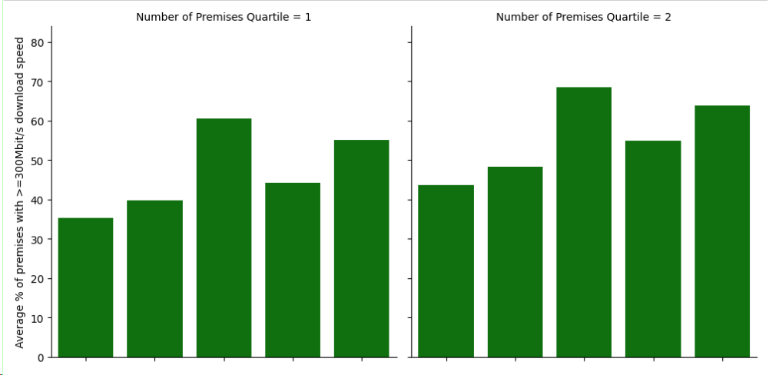
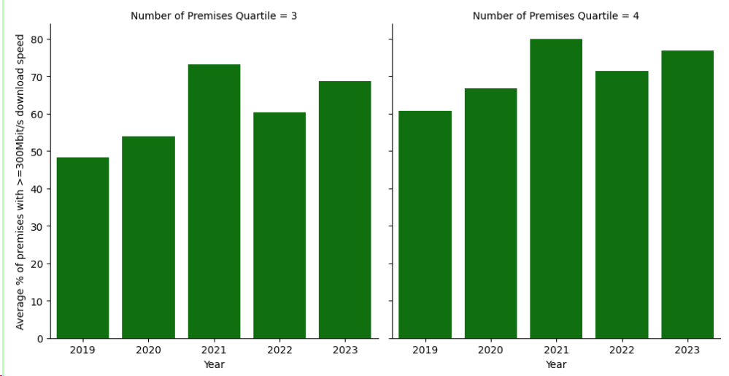
Figure 1- Average % of premises with >= 300 Mbit/s download speed in UK Local Authorites Divided on Number of Premises
I also found that the majority of areas with the highest percentage of 300+ Mbit/s in 2019 had premises numbers less than 150,000 as shown in the scatterplot below. This scatterplot also shows that the overwhelming majority of local authorities have premises numbers around 50,000-125,000 with the highest number of premises just short of 500,000.
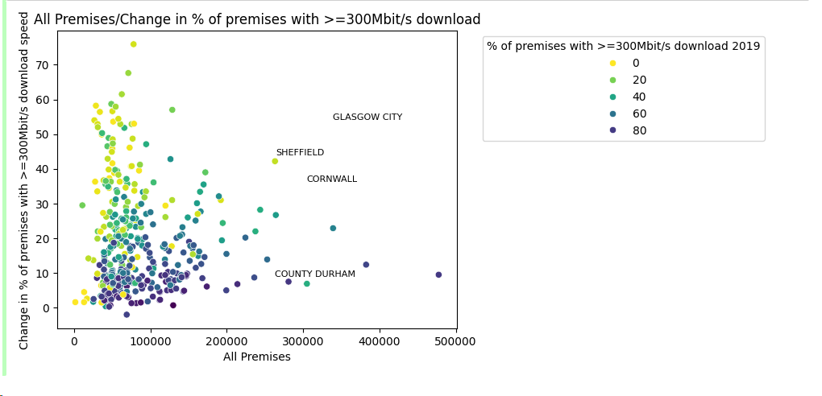
Figure 2 - Rate of change in 300+Mbit/s use / % of premises with 300+ Mbit/s / Number of premises per Local Authority
Lastly, using a choropleth to visualise the data I found some of the highest percentages were in geographically small areas clustered around London, Birmingham, Manchester and Scotland’s central belt.
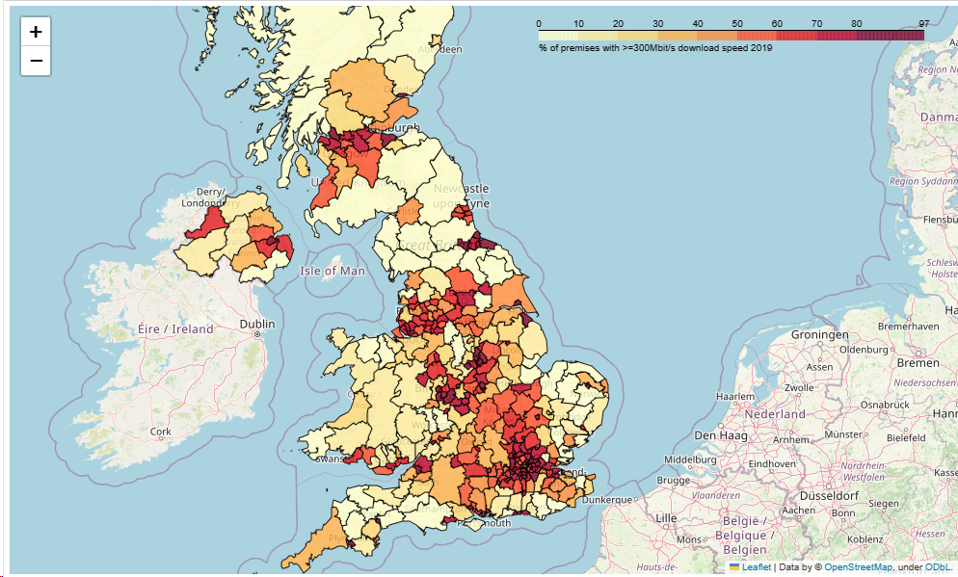
Figure 3 - Choropleth of % 300+ Mbit/s use.

Conclusions
This report concludes that although on average, the number of premises in a local authority seems to be correlated with the % of premises receiving 300+ Mbit/s download on closer inspection of the individual local authorities this appears to be false.
This is due to a concentration of premises numbers around the 100,000-figure skewing the method used to calculate the quartile ranges of property numbers in the local authorities assessed.
Looking at the map of local authorities, geographically small areas in major cities had the highest 300+ Mbit/s figures showing geographic positioning is a stronger factor than premises numbers.
Word count: 650

References
Philip, L., Cottrill, C., Farrington, J., Williams, F. and Ashmore, F., 2017. The digital divide: Patterns, policy and scenarios for connecting the ‘final few’in rural communities across Great Britain. Journal of rural studies, 54, pp.386-398.
Creative Commons(2024) CC By 3.0 Deed https://creativecommons.org/licenses/by/3.0/ (Accessed 14/03/2024)
Ofcom (2023a) Connected Nations 2022: Interactive report. Available at: https://www.ofcom.org.uk/research-and-data/multi-sector-research/infrastructure-research/connected-nations-2022/interactive-report (Accessed: 26 September 2023).
Cavin, D (2024) TM351 TMA02 submitted for assessment to The Open University

