AI Strategy Research Agent for PAC 2026-07-27 | 
Quick Guide to Copilot’s Prompt Coach & Researcher Agent
FIRST. Log in to copilot.cloud.microsoft with your Tarleton credentials
1. Quick checks
- Premium account: Should say “(Premium)” under your name in bottom-left

Your profile at the bottom-left should read “(Premium).”
- Work mode: If you see the Work/Web toggle, select Work (may not be present)
- WorkIQ: If you see a WorkIQ button in the top-left, make sure that it is NOT struck out.

2. Prompt Coach
- If left sidebar is collapsed, expand by clicking the icon in the top-left corner.
- Under “Agents”, click “Prompt Coach” if you see it otherwise, search and add it from “... More agents”
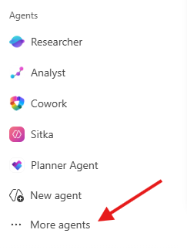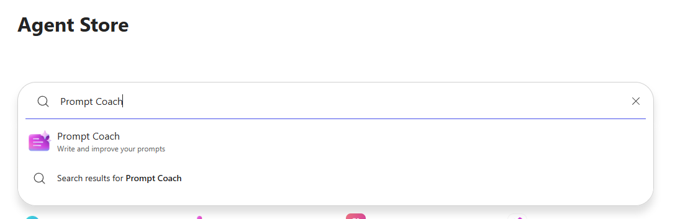
3. Attach AI Strategy Guidance
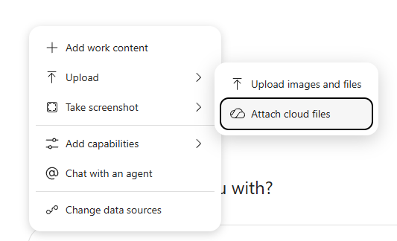
- Click “+” then “Attach cloud files”. You may need to click Upload first.
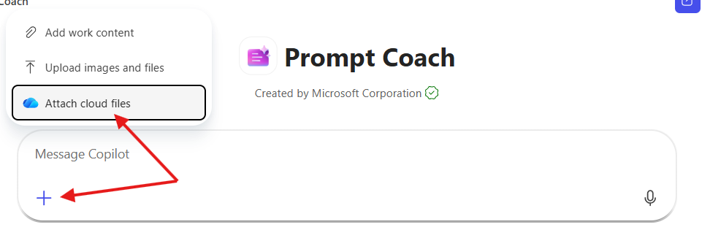
<-OR->
- Under “People” find Scott Cook (or “Shared”), attach Draft_a_OnePage_AI_Strategy (2)
- Type the following prompt (sub your assigned IHE’s name) - Prompt Coach expands your short prompt into a more detailed one perfectly suited for the Researcher agent. It may ask follow-up questions.
Can you help me create a prompt for the Researcher agent that will
utilize the steps outlined in this PowerPoint, to assess the AI strategy
of University of Michigan? Put the prompt in an easily copied framebox.
It may take a few rounds of back-and-forth questions. Once Prompt Coach produces a finished prompt, copy the entire prompt text.

4. Researcher Agent
- Under Agents, click or add it as before.
- Paste the prompt that Prompt Coach wrote. Run it!
- Wait a few minutes.
- Voila – your well-vetted, cited, and written report is ready!

Researcher doesn't just search the internet — it also searches your internal WorkIQ data (relevant emails, files, chats, etc), showing every source it found and highlighting the ones it used. From there, ask follow-ups, request changes, or export the result to OneDrive, SharePoint, or a document.

