https://wenku.baidu.com/view/940d3a234028915f814dc21c.html?from=search

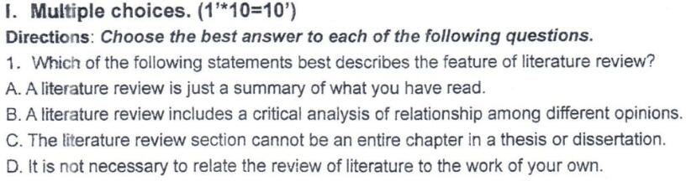
答案：B（P24）

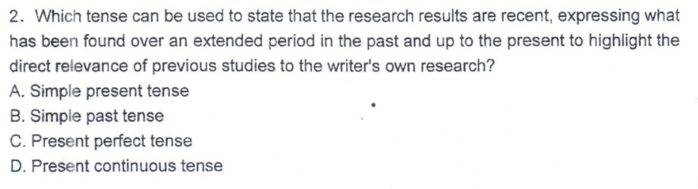
答案：C

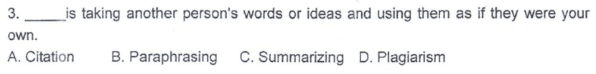
答案：D

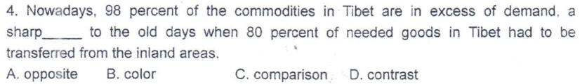
答案：D

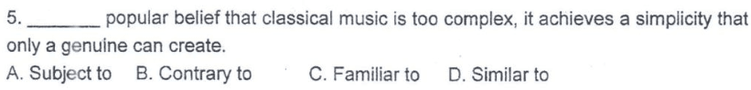
答案：D

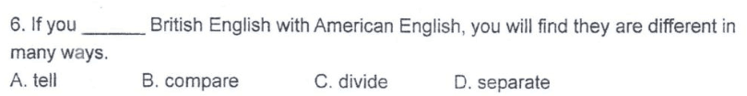
答案：B

答案：D

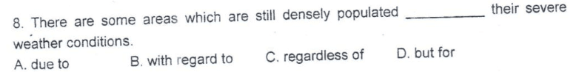

答案：C

答案：A

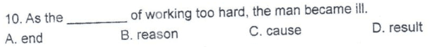
答案：D

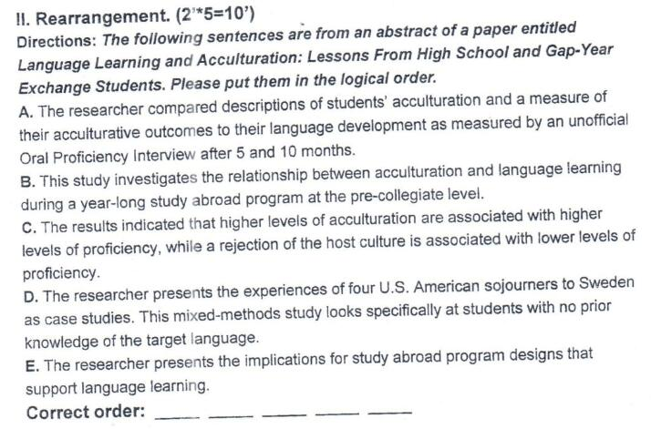

答案：BDACE
A:研究人员比较了学生的适应能力，并通过5个月和10个月的非正式口语能力访谈来衡量他们的语言发展水平。
B:摘要本研究探讨了在大学预科阶段的一项为期一年的留学计划中，文化适应与语言学习之间的关系。
C:结果表明，较高水平的适应能力与较高的熟练程度有关，而对宿主文化的排斥则与较低的熟练程度有关。
D:研究人员将四名美国旅居者的经历作为案例研究。这个混合方法的研究专门针对那些对目标语言没有事先了解的学生。
E: 研究人员提出了支持语言学习的海外学习计划的意义

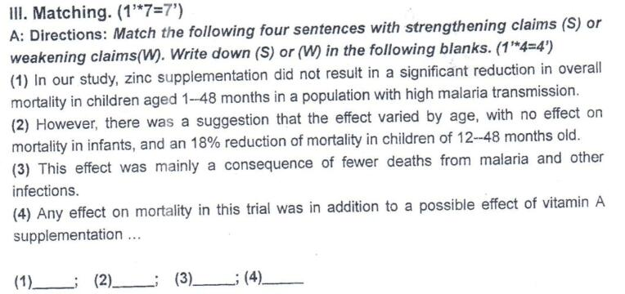

- S 2. W 3. W 4. W

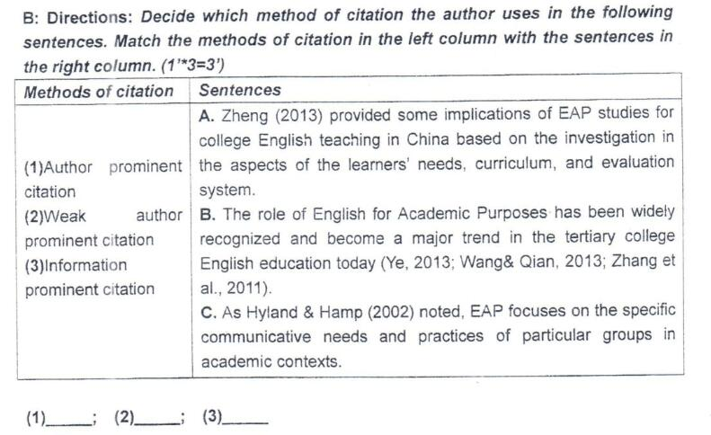

- A 2. C 3. B

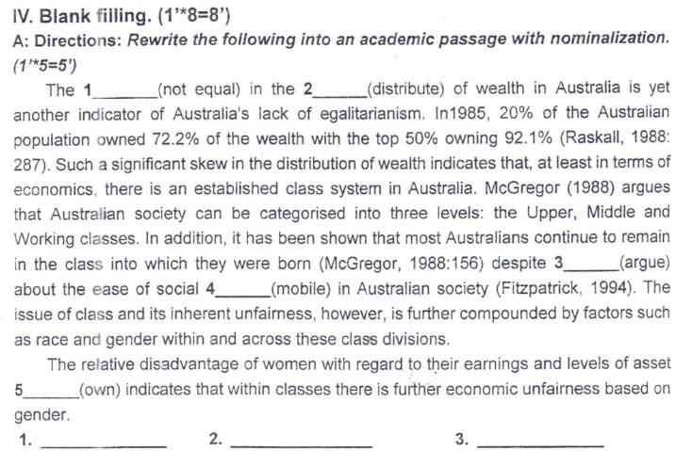
1.inequality 2. distribution 3. argument 4. mobility 5.ownership

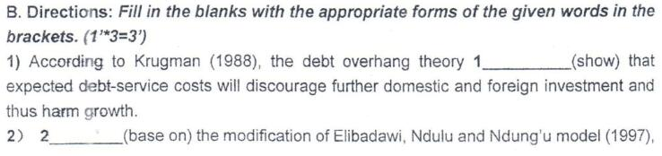
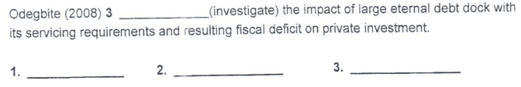
- shows 2. Based on 3. investigated
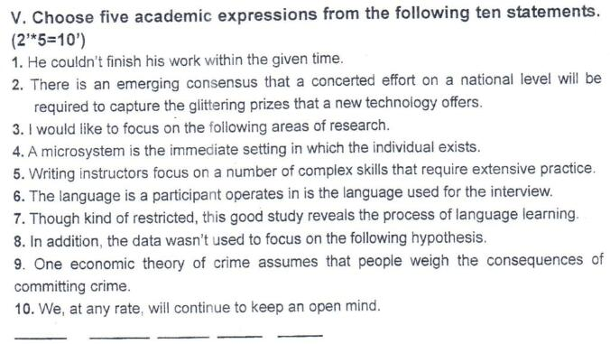
2 4 5 7 8
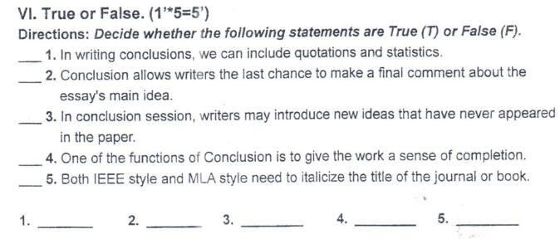
1.T 2. F 3.F 4. T 5. T

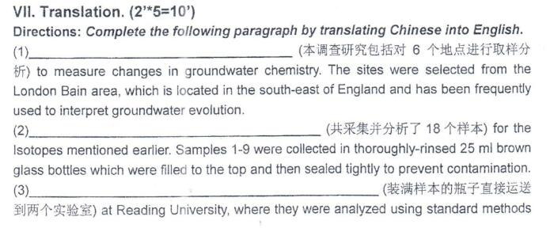
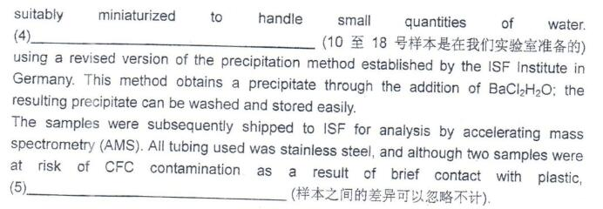
- Six locations were sampled to make analysis included in this research
This research included six locations were sampled to make analysis
- A toal of 18 samples were collected and analyzed.
- The two bottles filled with samples were directly sent to the two laboratories.
- The samples from number 10 to number 18 were prepared in our laboratory.
- The difference between samples can be ignored.

