VanTrade
Final Architecture Report

Course: Software Architecture
Date: April 13, 2026
Repository: vantrade (pnpm monorepo)

Table of Contents

1. Project Overview
VanTrade is a multi-tenant algorithmic trading strategy marketplace. Strategy Providers publish parameterized trading Blueprints (RSI mean-reversion or ICT/Smart Money Concepts strategies); Testers subscribe and execute them automatically against their personal Alpaca Paper Trading accounts, choosing which asset to run each strategy on; Admins verify Blueprints before they appear on the marketplace.
Scope is intentionally bounded to paper trading — no live money, no HFT, no ML model training.

1.1 System at a Glance
The monorepo contains three packages:
- apps/api — NestJS REST API (port 4000): owns all business logic, Prisma, Alpaca SDK
- apps/web — Next.js 14 frontend (port 3000): UI only, no business logic
- packages/types — Shared Zod schemas and TypeScript interfaces (@vantrade/types)

Build orchestration: pnpm workspaces + Turborepo
Database: PostgreSQL via Prisma 5
Broker: Alpaca Paper Trading API

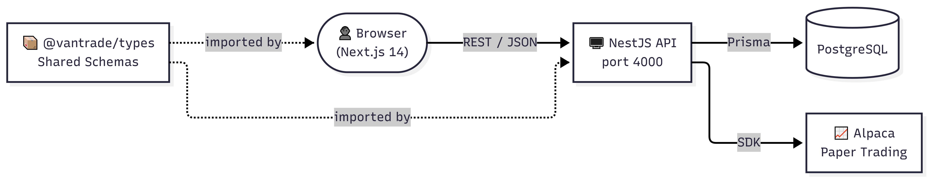
Figure 1 — System Overview

2. System Requirements

2.1 Functional Requirements

# | Requirement | Implementation
FR-1 | Three distinct user roles with own responsibilities, permissions, and access control | TESTER, PROVIDER, ADMIN enforced via RolesGuard + @Roles() on every protected endpoint
FR-2 | Each role performs at least one CRUD operation | TESTER: subscribe/unsubscribe/toggle; PROVIDER: blueprint create/read/update/delete; ADMIN: verify blueprint, list all users, assign user roles
FR-3 | Secure login/logout, user authentication | JWT via Passport.js; bcryptjs password hashing; JwtAuthGuard on all protected routes
FR-4 | Role-based authorization and access control | Server-side RolesGuard — client cannot escalate privileges regardless of what it sends
FR-5 | From-scratch development | Full custom implementation; no boilerplate app templates used

2.2 Non-Functional Requirements

Attribute | Requirement | Mechanism
Security | Broker credentials must never be stored in plaintext | AES-256-GCM encryption at rest; decryption in-memory only at order time
Security | API surface must be rate-limited | @nestjs/throttler — 10 req/s burst, 200 req/min sustained
Reliability | One subscription failure must not stop others | Promise.allSettled in HeartbeatService
Auditability | Trade history must be immutable | Append-only TradeLog — no update or delete paths exist
Maintainability | Broker swap must require zero domain changes | Ports & Adapters — new adapter + one DI rebinding
Testability | Trading calculations must be verifiable in isolation | Pure functions in trading.engine.ts — no mocks needed
Type Safety | No type drift between API and frontend | Shared Zod schemas in @vantrade/types

3. Architecture Characteristics
VanTrade's architecture was designed around several key quality attributes driven by the domain requirements of a financial trading platform.

3.1 Security
Broker API credentials are encrypted with AES-256-GCM before database storage. The encryption key is scrypt-derived from an environment variable. Decrypted values are computed in-memory at order time only and passed as function call arguments — never stored on adapter instances. The API surface is protected with rate limiting (10 req/s burst, 200 req/min sustained) and every endpoint enforces JWT authentication and role-based access control server-side.

3.2 Reliability
The heartbeat execution loop processes all active subscriptions using Promise.allSettled. This means a single subscription failure — such as invalid credentials, a revoked API key, or a network timeout — cannot halt execution for other users. Each subscription runs in its own isolated try/catch block.

3.3 Auditability
TradeLog rows are append-only. No update or delete methods exist in the repository. Every execution outcome — filled order, hold, or error — is persisted as a new row. This immutable ledger enables users to independently verify their trade history and P&L, and powers the heartbeat's trade-side alternation logic without requiring mutable state.

3.4 Maintainability
The Ports & Adapters pattern isolates broker-specific code in a single file (alpaca.adapter.ts). Swapping brokers requires writing one new adapter and changing one DI binding — zero changes to domain logic. The Repository pattern similarly isolates Prisma access; the ORM can be replaced without touching services. Ten feature modules enforce vertical separation.

3.5 Testability
All trading calculations are implemented as pure functions in trading.engine.ts. They take primitive inputs and return deterministic outputs with no side effects, making them testable without mocking any infrastructure. Service-level tests mock repositories; controller-level tests use supertest against the full NestJS app.

3.6 Type Safety
Shared Zod schemas in packages/types serve as the single source of truth for data contracts. The API validates incoming request bodies and query params with ZodValidationPipe; the web app validates API responses at runtime. TypeScript's z.infer derives static types from schemas, giving end-to-end type safety from the database model to React components.

4. Architecture Design

4.1 Hexagonal Architecture (Ports & Adapters)
The trading subsystem enforces strict three-layer separation across all broker-related logic.

Layer | Location | Responsibility
Domain | apps/api/src/trading/trading.engine.ts | Pure functions only — RSI, SMA, signal generation, P&L
Port | packages/types/src/interfaces/IBrokerAdapter.ts | Interface contract that HeartbeatService depends on
Adapter | apps/api/src/trading/broker/alpaca.adapter.ts | Concrete Alpaca SDK implementation — the only file allowed to import the SDK

Domain layer functions — RSI Strategy:

Function | Purpose
calculateRSI(prices, period) | Wilder's smoothing RSI
calculateSMA(prices, period) | Simple Moving Average
generateSignal(rsi, buyThreshold, sellThreshold) | Returns TradeSignal.BUY / SELL / HOLD
calculatePnL(entry, exit, qty, side) | Realised profit/loss for a closed position
calculateUnrealisedPnL(entry, current, qty) | Mark-to-market P&L for an open position

Domain layer functions — ICT / Smart Money Concepts Strategy:

Function | Purpose
aggregateBars(bars, n) | Resamples M5 bars into M15, H1, etc.
detectSwingPoints(bars, lookback) | Identifies local swing highs and lows
detectMarketStructure(bars, swings) | Derives BULLISH / BEARISH / NEUTRAL bias via BOS/CHoCH
detectOrderBlock(bars, type) | Finds the most recent valid OB entry zone
detectFairValueGap(bars, type) | Finds the most recent unmitigated FVG
classifyPriceZone(price, high, low) | Returns PREMIUM / DISCOUNT / AT_EQUILIBRIUM
hasLiquiditySweep(bars, level, type) | Detects stop-hunt wick past a swing level
checkLimitOrderFill(bar, position) | Simulates TP/SL fill in backtests
generateIctSignal(ctx) | Full A+ setup checklist — all five ICT conditions must pass

The DI binding is declared in apps/api/src/trading/trading.module.ts as: { provide: 'IBrokerAdapter', useClass: AlpacaAdapter }. To swap brokers, write a new adapter class and rebind the token — zero changes to domain logic or the heartbeat.

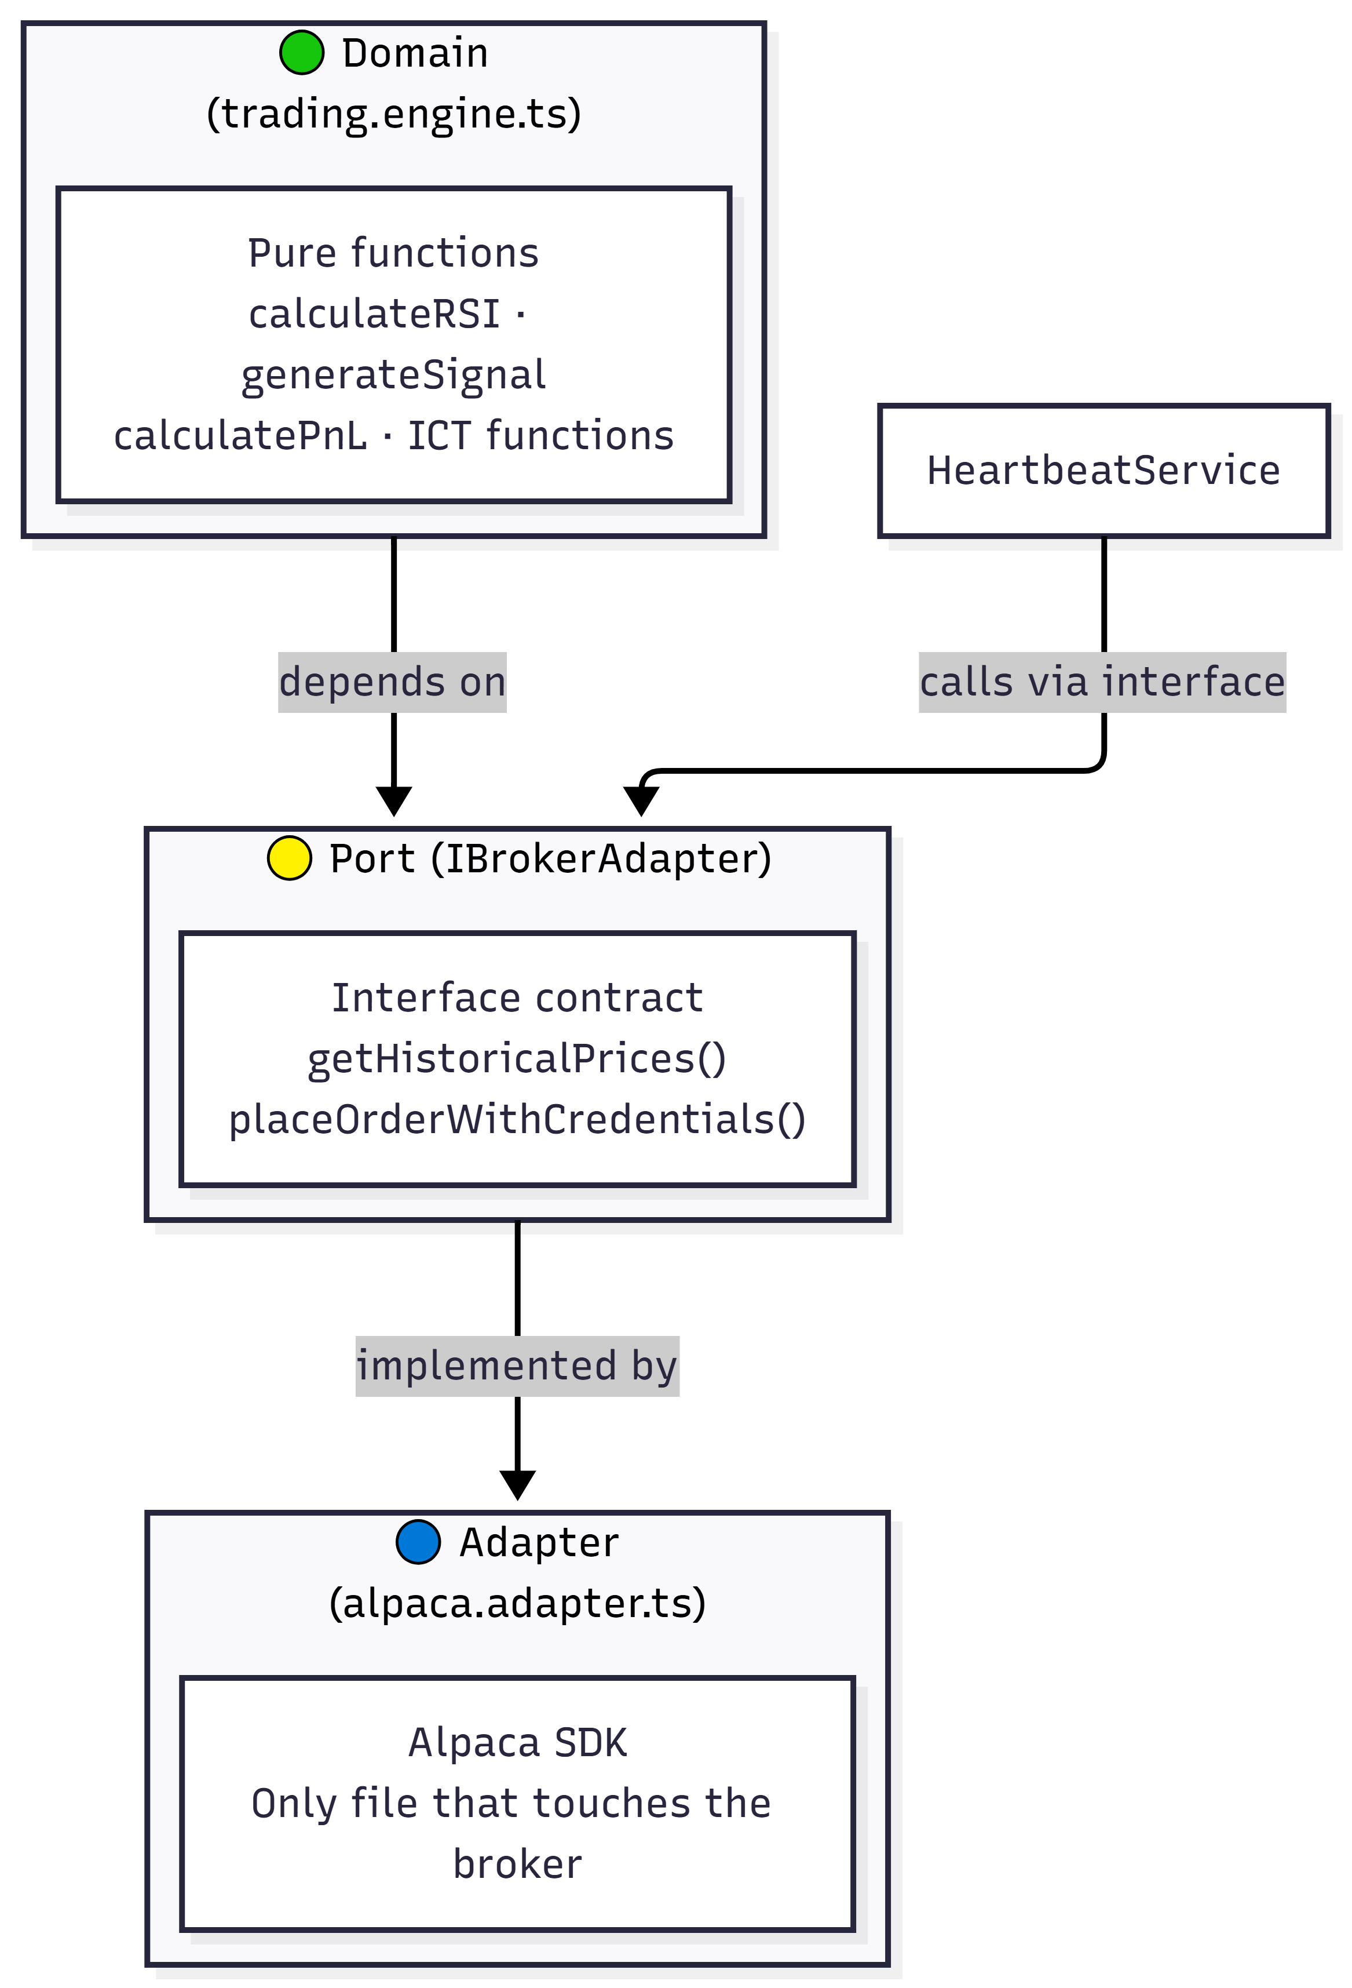
Figure 2 — Hexagonal Architecture (Ports & Adapters)

4.2 Repository Pattern
Every feature module has exactly one *.repository.ts that is the sole file permitted to import PrismaService. No controller or service touches the database directly. PrismaModule is declared @Global() so PrismaService is available to all repositories without explicit imports.

Repository | Key Methods
AuthRepository | findByEmail, findById, create
BlueprintsRepository | CRUD, setVerified, findAllVerified, findByAuthor
SubscriptionsRepository | findByUser, findAllActive, setActive, findExisting
ApiKeysRepository | upsert, findByUser, delete
TradeLogsRepository | create, findBySubscription, getStats, findLatestTradeSideBySubscription

4.3 NestJS Feature Modules (Thin Controller Pattern)
Ten feature modules each follow the same vertical slice structure:
- controller.ts — HTTP boundary: validate input, call service, return result
- service.ts — Business logic and orchestration
- repository.ts — Database access (Prisma only)
- module.ts — DI wiring

The Thin Controller Rule: controllers do exactly three things — validate with ZodValidationPipe, call one service method, return the result. No if/else, no Prisma, no SDK calls inside controllers.

Module | Role
AuthModule | JWT login/register, Passport strategy
BlueprintsModule | Marketplace CRUD, admin verification gate, backtest
SubscriptionsModule | Subscribe/unsubscribe, toggle active, stats
TradingModule | Exports IBrokerAdapter DI token
HeartbeatModule | Background cron execution engine
EncryptionModule | AES-256-GCM key encryption/decryption
ApiKeysModule | Broker credential management
MarketDataModule | Real-time price/bars endpoint for UI
TradeLogsModule | Exports TradeLogsRepository
PrismaModule | Global database connection

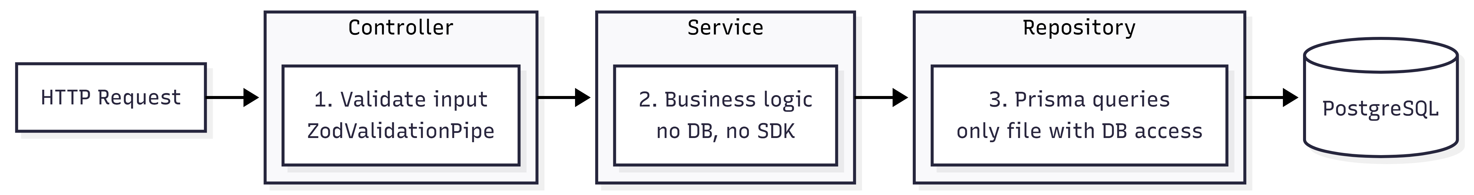
Figure 3 — Request Pipeline (Controller → Service → Repository)

4.4 Heartbeat Execution Loop
File: apps/api/src/heartbeat/heartbeat.service.ts | Schedule: @Cron('*/60 * * * * *') — every 60 seconds
The heartbeat is the core runtime engine. On each tick it processes all active subscriptions in parallel with Promise.allSettled, so a single failure does not block others.

Per-subscription processing pipeline:
- Validate blueprint parameters (Zod)
- Check market hours — Stocks: 9:30 AM–4:00 PM ET weekdays; Crypto: 24/7
- Check timeframe boundary alignment (5Min, 15Min, 1Hour, 1Day)
- Fetch (rsiPeriod + 1) OHLCV bars via IBrokerAdapter
- calculateRSI() — pure domain function
- generateSignal() — pure domain function
- Smart side resolution: read last executed side from TradeLog, enforce BUY→SELL→BUY alternation
- Decrypt user API key via EncryptionService (in-memory only)
- placeOrderWithCredentials() via IBrokerAdapter
- Persist TradeLog (append-only, including HOLDs)

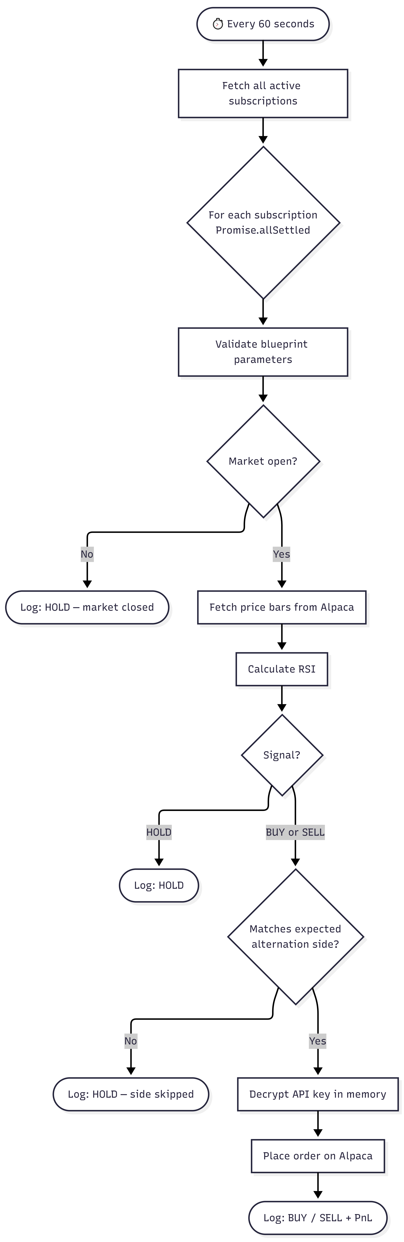
Figure 4 — Heartbeat Execution Flow

4.5 Shared Type Package (@vantrade/types)
All Zod schemas and TypeScript interfaces live in packages/types/src/. Both apps/api and apps/web import from this package. Zod schemas serve double duty:
- API layer: ZodValidationPipe validates incoming request bodies and query params
- Web layer: base.ts API client parses and validates API responses at runtime

A single schema change propagates to both apps at compile time. TypeScript's z.infer derives static types from schemas, giving end-to-end type safety from database model to React component.

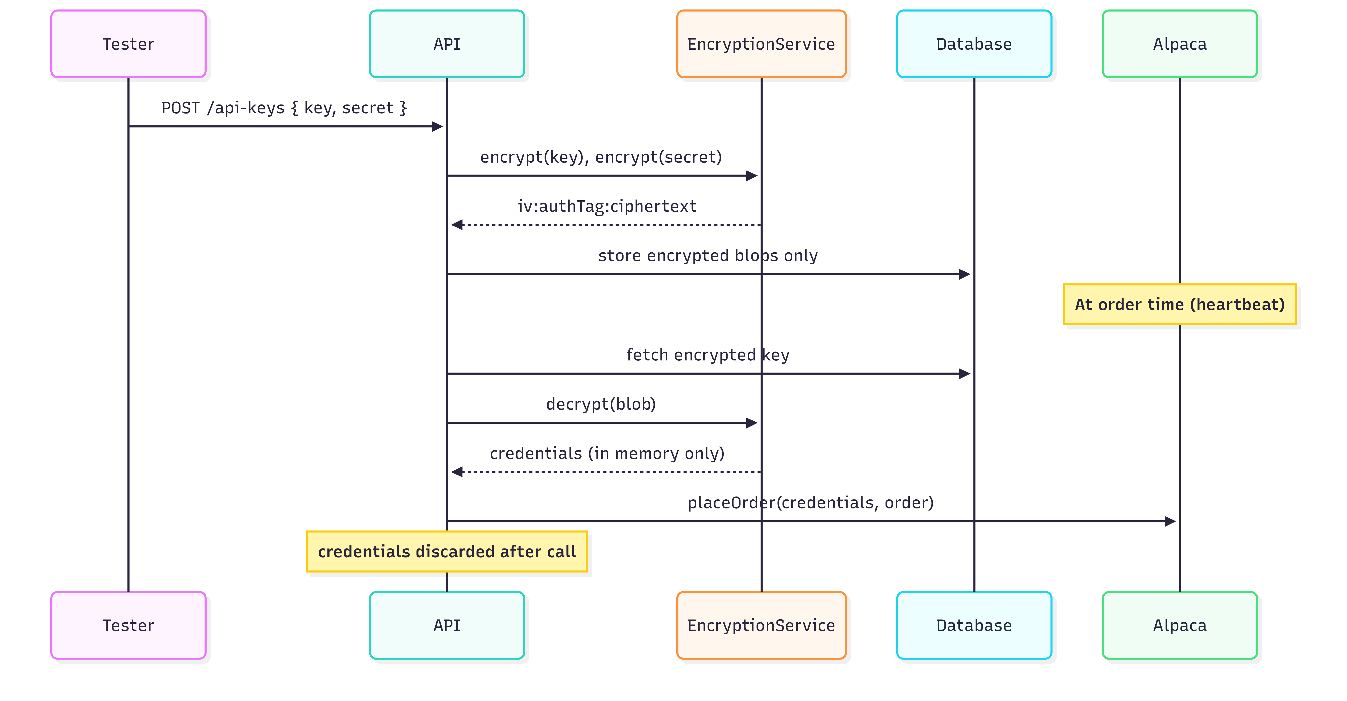
Figure 7 — Credential Encryption & In-Memory Decryption Flow

4.6 CodeCharta Static Analysis as a Fitness Function
CodeCharta v1.142.0 was used as a continuous architectural fitness function. Two metric sources are merged into a single map: rawtextparser produces rloc (real lines of code) showing file size/complexity, and gitlogparser produces number_of_commits showing churn. Files that are both large and frequently changed are the highest-risk architectural hotspots.

Hotspots identified and resolved:

File | Problem | Fix | LOC Before | LOC After
blueprints.service.ts | Single Responsibility Violation — CRUD + backtest engine in one class | Extracted BacktestService as separate NestJS provider | 471 | 139
alpaca.adapter.ts | God Class — HTTP fetching, SDK trading, and response mapping in one file | Extracted AlpacaMarketDataClient for pure HTTP fetching | 473 | 197
BacktestPanel.tsx / BacktestPreviewPanel.tsx | DRY Violation — shared components copy-pasted | Extracted EquityCurve, TradeRow, backtest-formatters.ts to shared location | 265 | 177
BlueprintReviewTable.tsx | High churn from inline state management in admin page | Extracted useAdmin hook to absorb state management and API calls | 64 (churn) | Stable

5. Database Design

5.1 Schema Overview
The database uses PostgreSQL managed through Prisma 5. The schema consists of five models: User, Blueprint, Subscription, ApiKey, and TradeLog.

User
- id, email, password (bcrypt hashed), role (TESTER | PROVIDER | ADMIN)
- Relations: apiKeys[], subscriptions[], blueprints[]

Blueprint
- id, title, description, parameters (Json), isVerified
- Relations: authorId → User, subscriptions[]

Subscription
- id, isActive
- symbolOverride String? — tester-chosen asset; overrides blueprint symbol
- Relations: userId → User, blueprintId → Blueprint, tradeLogs[]

ApiKey
- id, encryptedKey, encryptedSecret (AES-256-GCM)
- label String @default('default')
- Unique constraint: @@unique([userId, label])

TradeLog
- id, symbol, side (TradeSide enum: buy | sell | hold)
- price, quantity, pnl Float?, status String
- executedAt (append-only — no updatedAt)
- Relations: subscriptionId → Subscription

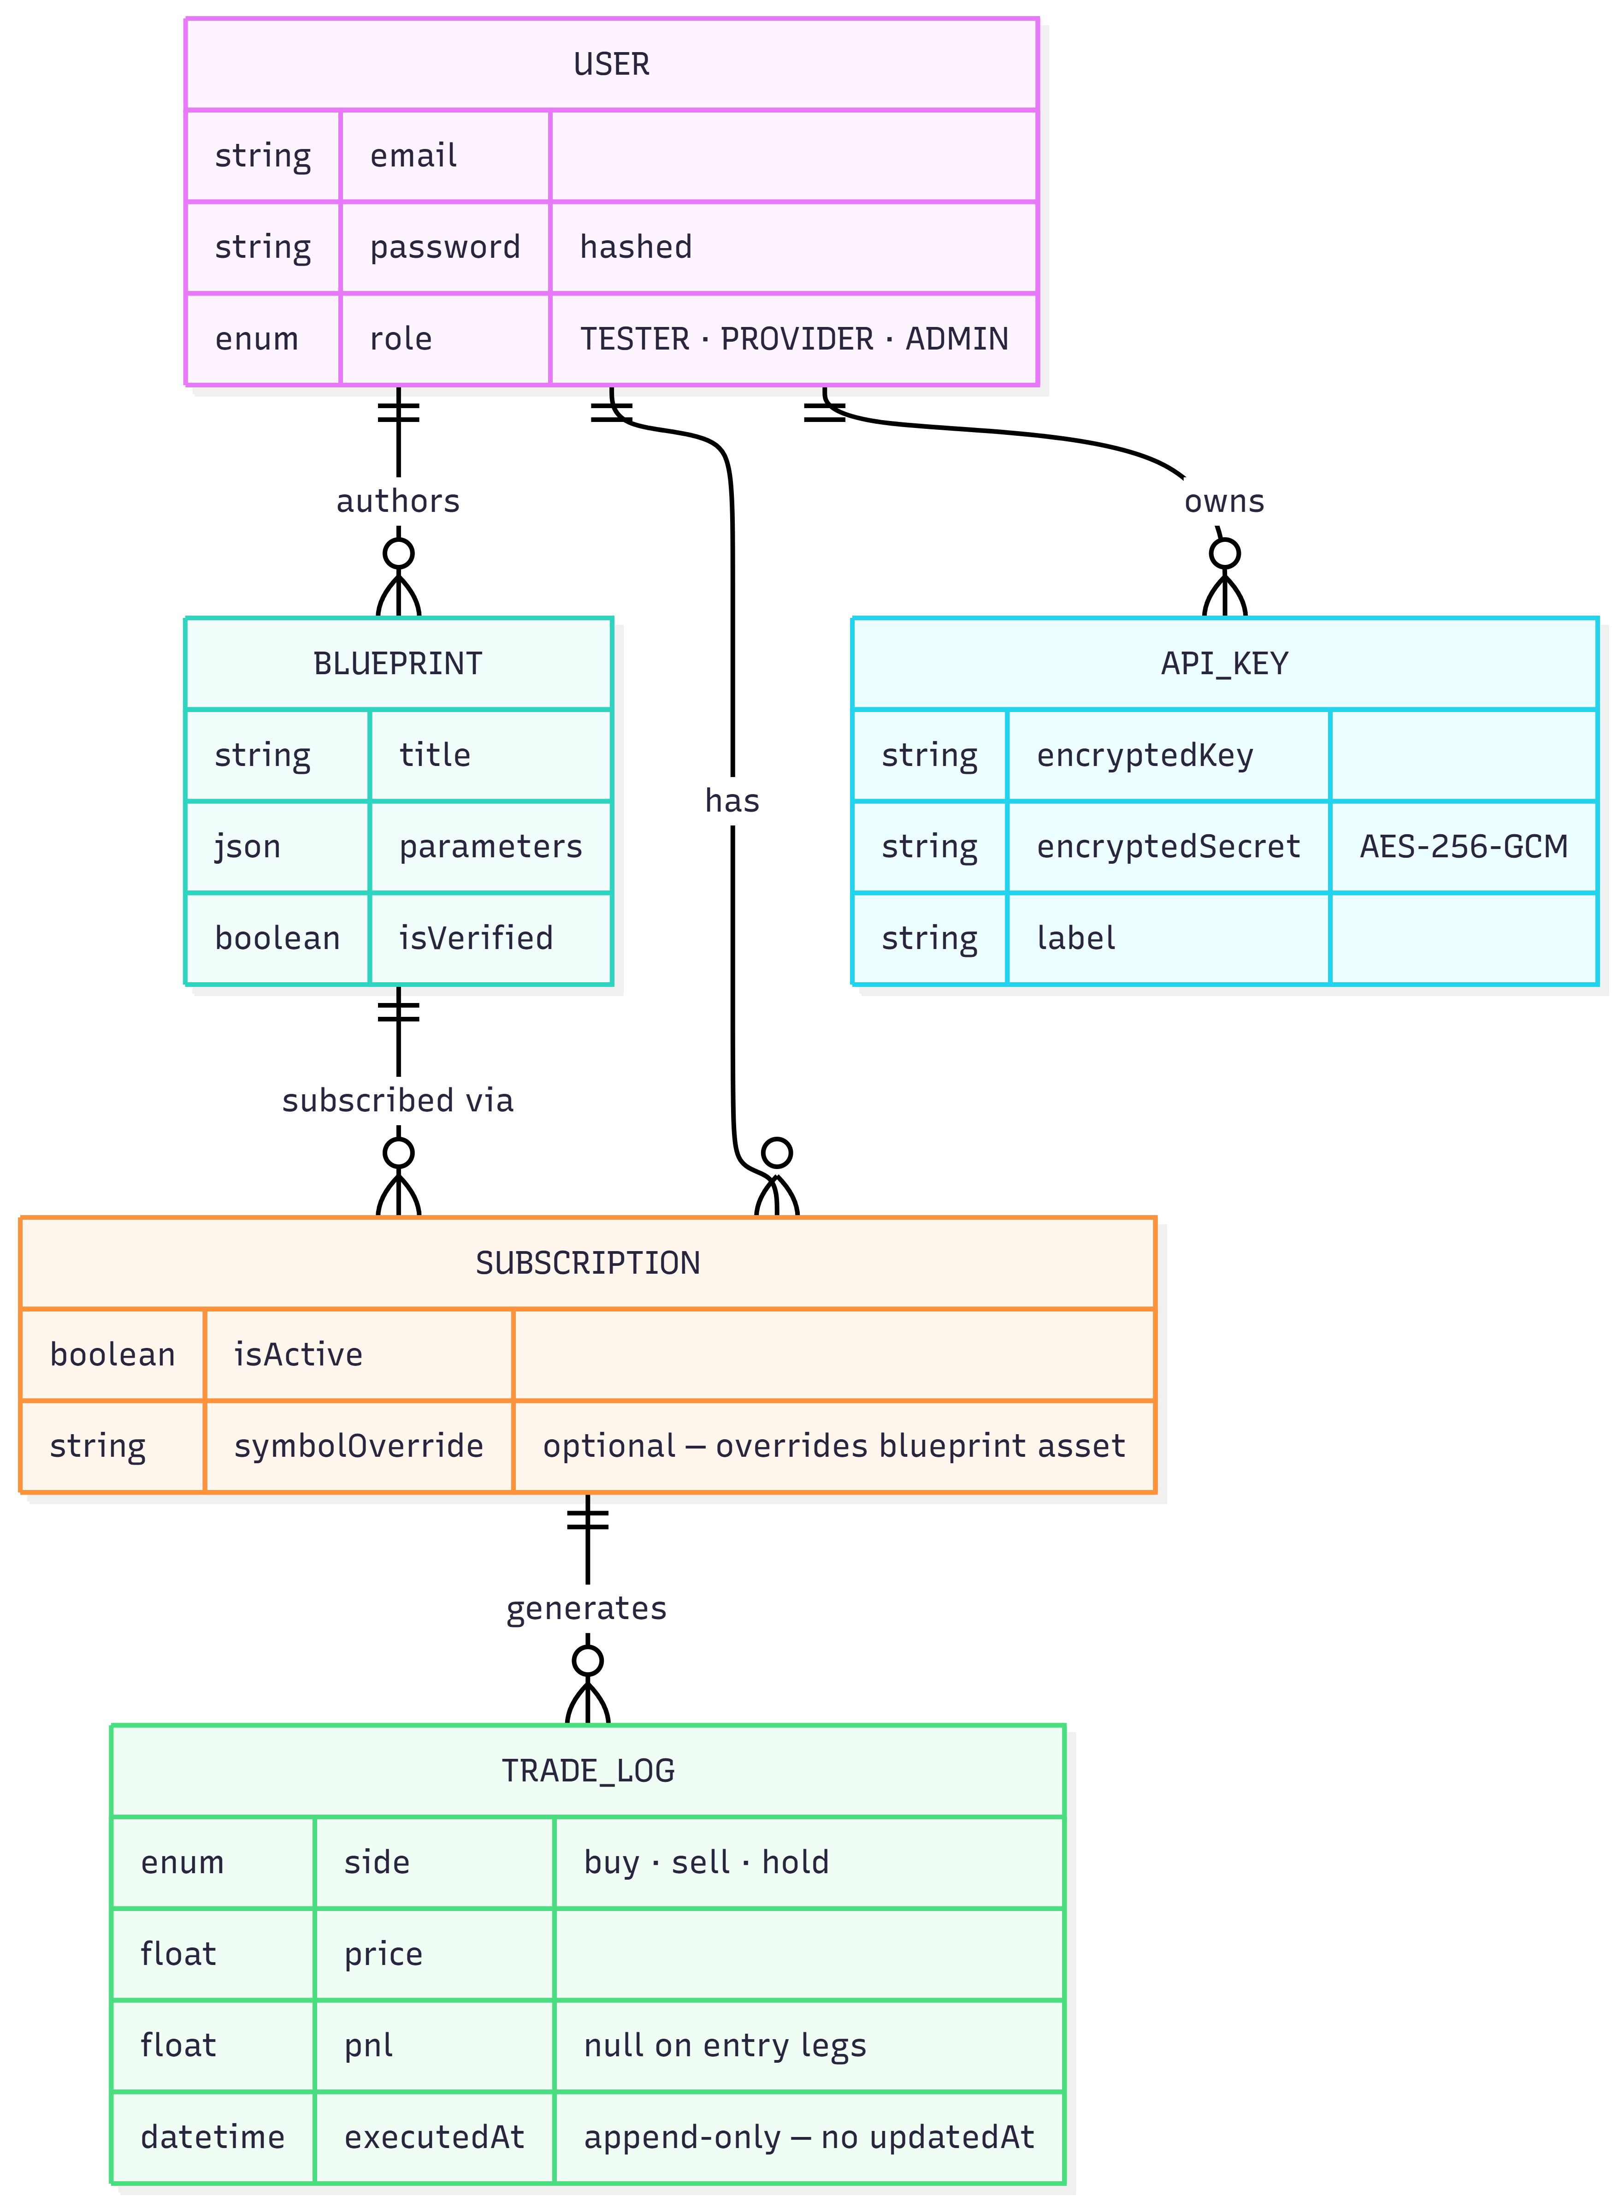
Figure 5 — Database ER Diagram

5.2 Key Design Decisions

Decision | Rationale
TradeSide as Prisma enum | Prevents casing inconsistencies ('BUY' vs 'buy') that break alternation logic
Blueprint.parameters as Json | Flexible enough for multiple strategy types (RSI, ICT); validated by Zod at application layer on every read
@@unique([userId, label]) on ApiKey | Allows multiple broker accounts per user, identified by label
Subscription.symbolOverride nullable | Lets testers target different assets per subscription without altering blueprint parameters; null means use blueprint default
No updatedAt on TradeLog | Enforces append-only semantics — schema itself prevents accidental updates
TradeLog.status as free-text String | Stores rich broker/engine state ('filled', 'bracket_entry:...', 'ict_hold:NO_H1_BIAS') without requiring enum migrations
PrismaModule declared @Global() | PrismaService available to all repositories without explicit imports in each module

6. Role & Permission Structure
Every protected endpoint uses @UseGuards(JwtAuthGuard, RolesGuard) and @Roles(Role.X). Role enforcement is entirely server-side — the client cannot influence its own role. Registration always assigns Role.TESTER; privileged roles are assigned by an admin only.

Role | Permissions
TESTER | Browse marketplace, subscribe to blueprints, manage API keys, view own trade logs
PROVIDER | All TESTER permissions + create, edit, delete own blueprints
ADMIN | All permissions + verify blueprints, view all users and blueprints, assign user roles

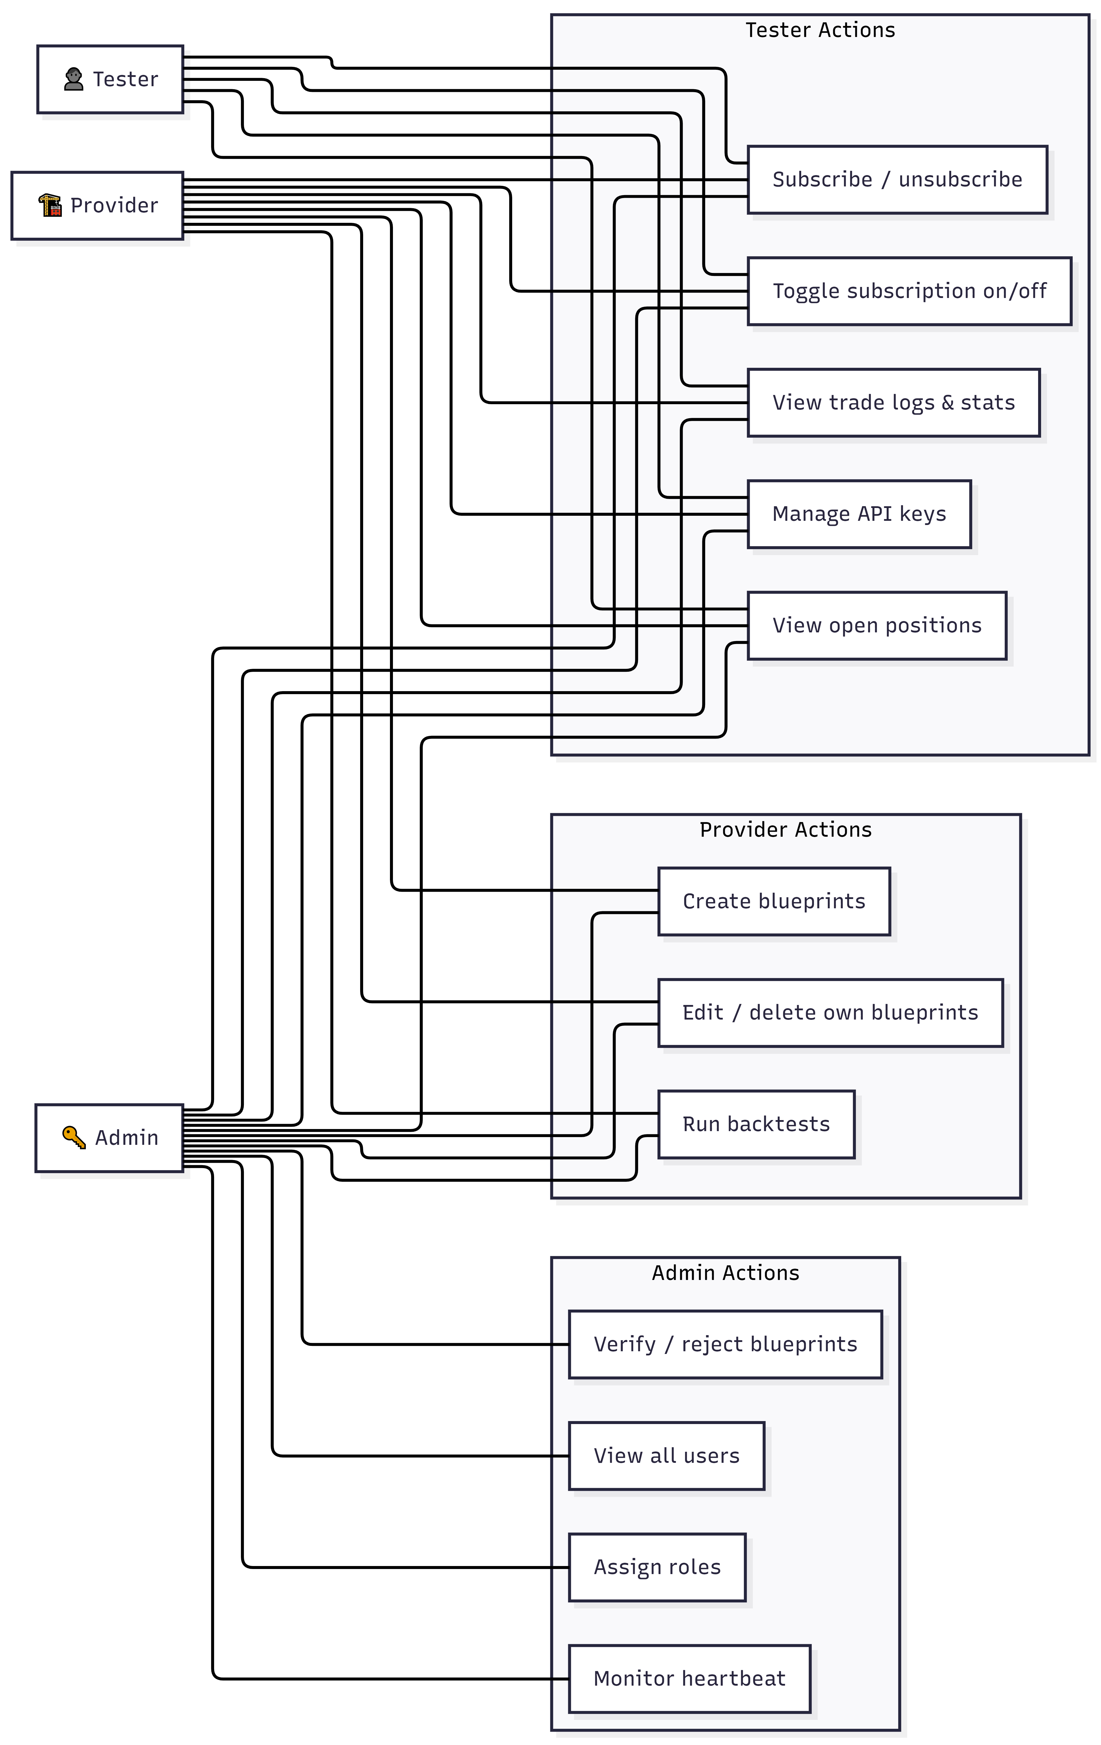
Figure 6 — Role & Permission Map

6.1 Tester API Endpoints
Testers interact with subscriptions, API key management, positions, and blueprint backtests. The Subscriptions, Positions, and API Keys controllers are restricted to Role.TESTER at the class level.

Method | Endpoint | Purpose
GET | /subscriptions | List all subscriptions for the authenticated user
POST | /subscriptions | Create a new subscription to a blueprint
PATCH | /subscriptions/:id/toggle | Toggle a subscription active/inactive
DELETE | /subscriptions/:id | Remove a subscription
GET | /subscriptions/:id/trade-logs | Fetch paginated trade logs for a subscription
GET | /subscriptions/:id/stats | Get statistics (win rate, PnL, trade counts)
GET | /positions | List open positions via the user's Alpaca credentials
GET | /api-keys/status | Check whether the user has an API key configured
GET | /api-keys | List all API keys (with labels) for the user
POST | /api-keys | Create or update an API key (upsert by label)
DELETE | /api-keys | Delete an API key by label
POST | /api-keys/verify | Verify that stored credentials are valid with Alpaca
GET | /blueprints/:id/backtest | Run a backtest against a saved blueprint's parameters
POST | /blueprints/backtest | Run an ad-hoc backtest with arbitrary parameters

6.2 Provider API Endpoints
Providers have all Tester permissions plus the ability to create and manage their own blueprints. Write operations check that the authenticated user is the blueprint author before allowing edits or deletes.

Method | Endpoint | Purpose
POST | /blueprints | Publish a new blueprint (pending admin verification)
GET | /blueprints/my/list | List all blueprints authored by the authenticated provider
PATCH | /blueprints/:id | Update an existing blueprint (author only)
DELETE | /blueprints/:id | Delete a blueprint (author only)
GET | /blueprints/:id/backtest | Run a backtest against a saved blueprint's parameters
POST | /blueprints/backtest | Run an ad-hoc backtest preview with arbitrary parameters

6.3 Admin-Only Endpoints

Method | Endpoint | Purpose
GET | /blueprints/admin/all | View all blueprints including unverified
PATCH | /blueprints/:id/verify | Approve or revoke a blueprint
GET | /auth/users | List all registered users
PATCH | /auth/users/:id/role | Promote or demote a user's role
GET | /heartbeat/status | Monitor system cron execution status

6.4 Public Endpoints (any authenticated user)

Method | Endpoint | Purpose
GET | /blueprints | Browse all verified blueprints (marketplace)
GET | /blueprints/:id | View blueprint details
GET | /blueprints/:id/signal | Get a dry-run signal for a blueprint
GET | /market-data/bars | Fetch OHLCV bars for a symbol
GET | /auth/me | Get the currently authenticated user's profile

RBAC implementation files: auth/roles.guard.ts, auth/roles.decorator.ts, auth/jwt-auth.guard.ts. The decorator pattern keeps role requirements co-located with each route definition, making the security posture auditable in a single file pass.

7. Implementation Details

7.1 Completed Capabilities

Capability | Status
Multi-role user system (PROVIDER / TESTER / ADMIN) | Complete
Admin user management — list users, assign roles | Complete
Blueprint CRUD with admin verification gate | Complete
RSI mean-reversion signal engine — pure functions, fully tested | Complete
ICT / Smart Money Concepts engine — multi-timeframe, 9 pure functions | Complete
Heartbeat auto-execution every 60 seconds | Complete
Per-user encrypted Alpaca API credentials | Complete
Backtest simulation with equity curve, slippage, commission, Sharpe, max drawdown | Complete
Live market bar fetching — stocks and crypto | Complete
Open positions viewer (per-user, credential-delegated) | Complete
Subscription stats with realized + unrealized PnL from live Alpaca positions | Complete
Paginated trade log with server-side fetch | Complete
Tester symbol override — choose which asset to run each strategy on | Complete
Immutable append-only TradeLog audit trail | Complete
Shared Zod contracts between API and Web | Complete
Role-enforced API surface | Complete
Symbol normalization (AAPL, BTC/USD, BTCUSD variants) | Complete
Market hours guard — ET hours for stocks, 24/7 for crypto | Complete
Timeframe boundary alignment (5Min, 15Min, 1Hour, 1Day) | Complete
Smart trade side alternation enforcement | Complete

7.2 Test Coverage
- trading.engine.ts — fully covered with a dedicated spec (RSI, SMA, signal, PnL, all ICT functions)
- heartbeat.service.spec.ts — 25 tests: status, tick behaviour, filledPrice fallback, PnL regression suite for both execution modes
- blueprints.service.ts — backtest and dry-run logic covered with a 332-line spec
- apps/web/src/lib/api-client/base.ts — fetch wrapper covered (Zod validation, error handling, 204 handling)

7.3 Known Issues & Resolutions

Blueprint Parameters as Untyped JSON (Partially Mitigated)
Blueprint.parameters is stored as Json. Out-of-band DB inserts can persist malformed parameters. Current mitigation: the heartbeat service runs BlueprintParametersSchema.safeParse() on every tick. A full fix (normalised BlueprintParameters table) was out of scope.

No Caching on Market Data Fetches (Resolved)
Fixed by adding a Map cache in heartbeat.service.ts keyed on 'symbol:timeframe:limit'. TTLs match the timeframe (1Min=60s, 5Min=5min, 15Min=15min, 1Hour=60min, 1Day=24h). Cache is wiped at the start of each tick.

No API Rate Limiting (Resolved)
Fixed by integrating @nestjs/throttler with two tiers: short (10 req/s burst) and medium (200 req/min sustained), applied globally via ThrottlerGuard.

Backtest Quality Was Optimistic (Resolved)
Fixed by adding slippagePct and commissionPerTrade as optional query parameters, and computing maxDrawdown and sharpeRatio as output fields.

Market Hours Timezone Hardcoded (Resolved)
Fixed by making the timezone configurable via MARKET_TIMEZONE environment variable with 'America/New_York' as the default.

One API Key Per User (Resolved)
Fixed by removing the unique constraint on ApiKey.userId and adding a labeled key system with @@unique([userId, label]). Users can now manage multiple broker accounts identified by label.

No Structured Logging (Resolved)
Fixed by implementing JsonLoggerService that emits newline-delimited JSON log records with timestamp, level, context, and message fields.

PnL Double-Counted on Entry Legs (Resolved)
Fixed by gating P&L recording on isExitLeg rather than lastTradeSide !== null. In BUY_LOW_SELL_HIGH mode, only SELL legs record P&L; in SELL_HIGH_BUY_LOW, only BUY legs do. Entry legs always receive pnl: null.

No User Notifications (Not Resolved)
Testers must poll the trade logs UI to learn about fills, errors, or deactivations. Implementing push notifications requires a new persistence model, a delivery channel (WebSockets, SSE, or email), and frontend integration — out of scope for this iteration.

7.4 Architecture Risk Assessment

Component | Risk Score | Highest Risk Factor
Heartbeat Execution | 39 ⚠ | Scalability — all subscriptions share one in-process cron loop
Auth / Registration | 18 | Security — JWT cannot be revoked before expiry
API Key Vault | 16 | Security — encryption key loss makes all credentials unrecoverable
Subscription Management | 15 | Data Integrity — subscription toggle state is the sole heartbeat gate
Blueprint Marketplace | 14 | Availability — unverified blueprint parameters can cause heartbeat skips

Top mitigations identified:
- P0 — Heartbeat scalability: Extract to a dedicated worker process if subscription count exceeds ~100 active
- P0 — External monitoring: Add health-check endpoint and alerting for missed heartbeat ticks
- P1 — JWT revocation: Introduce a short-lived token TTL (15 min) with a refresh token flow

7.5 Architecture Decision Summary

Decision | Pattern Applied | Location
Broker-agnostic trading logic | Hexagonal / Ports & Adapters | IBrokerAdapter + AlpacaAdapter + trading.engine.ts
Database access isolation | Repository Pattern | One *.repository.ts per feature module
HTTP request handling | Thin Controller (validate → service → return) | All *.controller.ts files
Feature separation | NestJS Feature Modules | 10 modules, vertical slice structure
Shared type contracts | Single source of truth | packages/types — Zod schemas + interfaces
Broker injection | Dependency Injection (string token) | 'IBrokerAdapter' in TradingModule
Role enforcement | RBAC via Guards | JwtAuthGuard + RolesGuard + @Roles()
Background execution | Cron + Promise.allSettled | HeartbeatService
Credential security | AES-256-GCM, in-memory decryption only | EncryptionService + ApiKeysService
Audit trail | Append-only ledger | TradeLog — no update/delete
End-to-end type safety | TypeScript + Zod | DB schema → API → React component
Build efficiency | Monorepo with cache | Turborepo + pnpm workspaces
Architectural health monitoring | CodeCharta fitness function | rawtextparser + gitlogparser → vantrade.cc.json
SRP enforcement | God-class decomposition | BacktestService extracted from BlueprintsService; AlpacaMarketDataClient extracted from AlpacaAdapter
DRY enforcement | Shared component extraction | EquityCurve, TradeRow, backtest-formatters.ts shared across backtest panels

