Health Care System
Software Requirements Document
V 1.0


 | Prepared By | Reviewed by | Approved By
Name
Role
Signature
Date

Contents
1 Introduction 3
1.1 About this document 3
1.1.1 Purpose & Scope of the document 3
1.1.2 Intended Audience 3
1.2 About the Software System 3
1.2.1 Scope of the system 3
1.2.2 Exclusions 4
1.2.3 System Perspective 4
1.2.4 Architecture diagram 4
1.2.5 Impact of the System 5
1.2.6 Assumptions, Risks / Constraints 5
1.2.7 Design Constraints – from the template 5
1.2.8 Source File Structure 5
1.2.9 Target Table Structure: 7
System Requirements 9
1.3 Functional Requirements 9
1.3.1 Group 9
1.3.2 Sub Group 9
1.3.3 Subscriber 10
1.3.4 Welcome Letter 10
1.3.5 SOURCE-TARGET MAPPING 11
2 Annexure 11
3 Terms & Conditions 12
4 Change Log 12

Introduction

About this document

Purpose & Scope of the document
The purpose of the software requirements document is to systematically capture requirements for the project and the system “Blue Care Health Plan Inc.” to be developed. Functional requirements of this system are captured in this document. It also serves as the input for the project scoping.
The scope of this document is limited to addressing the requirements from a user, quality, and non-functional perspective. It is recommended that design aspects are not added in this document

Intended Audience
Project Team

About the Software System
The primary objective of the project is to create a database with required data validations as mentioned. The database is in turn used for generating welcome letters in xml format for each subscriber.

The following are the modules in this proposed system
- Group
- Sub Group
- Subscriber

Scope of the system
The scope of the system is explained through its modules as follows
- Group – This module is to analyze the Group information provided and load them into the database in the corresponding Group table.
- Sub Group – This module is to analyze the Sub Group information provided and load them into the database in the corresponding Sub Group table with only the matching groups in the Group table that is previously loaded.
- Subscriber – This module is to analyze the Subscriber information provided and load them into the database in the corresponding Subscriber table with only the matching groups in the Group table and sub groups in the subgroup table that were previously loaded.

Exclusions
- The system will operate only on the modules discussed above and will not include any additional functionality.

System Perspective
The system is a data warehouse developed to manage the information of different subscribers enrolled for healthcare schemes by the company.

Architecture diagram

Physical Architecture:

Logical Architecture:
The Logical Architecture defines the Processes (the activities and functions) that are required to provide the required User Services. Many different Processes must work together and share information to provide a User Service. The Processes can be implemented via software, hardware, or firmware. The Logical Architecture is independent of technologies and implementations.
HealthCare has 3 dimension tables and one file generation component.
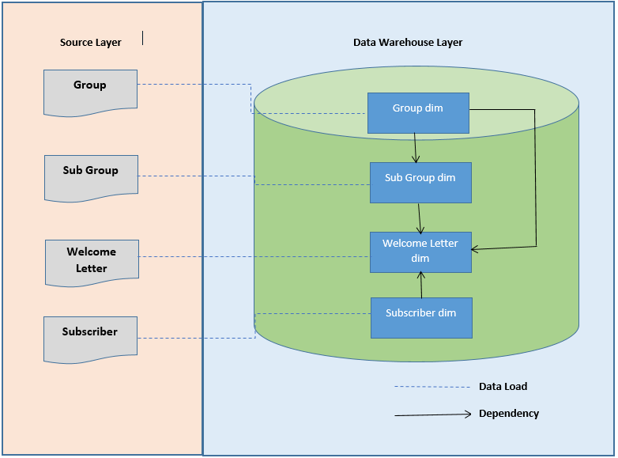

Impact of the System
The data warehousing system is being developed to enhance the decision support and generating customized reports for HealthCare.

Assumptions, Risks / Constraints
Assumptions: Only group, sub group and subscriber tables are considered.

Design Constraints – from the template
Create Target tables in the database and import them into Informatica as Target tables.
Create the DDL for tables as per the constraints mentioned in the source and Target data objects.

Source File Structure
GROUP FIXED WIDTH:
FIELD_NAME | START_POS | END_POS
GROUP_ID | 1 | 8
GROUP_NAME | 9 | 24
EFF_DT | 25 | 34
TERM_DT | 35 | 44
STREET | 45 | 64
CITY | 65 | 80
STATE | 81 | 96
ZIP | 97 | 101
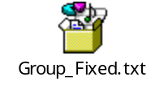
GROUP COMMA DELIMITED:
FIELD_NAME | LENGTH
GROUP_ID | 8
GROUP_NAME | 16
EFF_DT | 10
TERM_DT | 10
STREET | 20
CITY | 16
STATE | 16
ZIP | 5
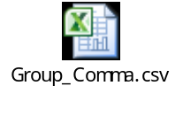
SUBGROUP:
FIELD_NAME | LENGTH
SUBGRP_ID | 4
SUBGRP_NAME | 30
EFF_DT | 10
TERM_DT | 10
GROUP_ID | 8
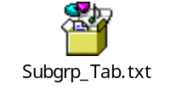
SUBSCRIBER:
FILED_NAME | LENGTH
SUB_ID | 9
LAST_NAME | 30
FIRST_NAME | 30
GENDER | 1
BIRTH_DT | 10
SUBGRP_ID | 4
GRP_ID | 8
EFF_DT | 10
TERM_DT | 10
ELIG_IND | 1
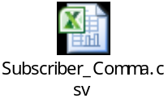

Target Table Structure:
GROUP:
FIELD_NAME | TARGET DATATYPE | TABLE CONSTRAINTS
GRP_SK | NUMBER(10) | NOT NULL
GROUP_ID | VARCHAR2(8) | PRIMARY_KEY
GROUP_NAME | VARCHAR2(30) | NOT NULL
EFF_DT | DATE | NOT NULL
TERM_DT | DATE | NOT NULL
STREET | VARCHAR2(35)
CITY | VARCHAR2(15)
STATE | VARCHAR2(20)
ZIP | NUMBER(5) | NOT NULL

SUBGROUP:
FIELD_NAME | DATATYPE | CONSTRAINT
SUBGRP_SK | NUMBER(10) | NOT NULL
SUBGRP_ID | VARCHAR2(4) | PRIMARY_KEY
SUBGRP_NAME | VARCHAR2(30) | NOT NULL
EFF_DT | DATE | NOT NULL
TERM_DT | DATE | NOT NULL
GROUP_ID | VARCHAR2(8) | PRIMARY_KEY

SUBSCRIBER:
FIELD_NAME | DATA TYPE | CONSTRAINTS
SUB_SK | NUMBER(10) | NOT NULL
SUB_ID | VARCHAR2(9) | PRIMARY KEY
LAST_NAME | VARCHAR2(30)
FIRST_NAME | VARCHAR2(30) | NOT NULL
GENDER | VARCHAR2(1) | NOT NULL
BIRTH_DT | DATE | NOT NULL
SUBGRP_ID | VARCHAR2(4) | NOT NULL
GRP_ID | VARCHAR2(8) | NOT NULL
EFF_DT | DATE | NOT NULL
TERM_DT | DATE | NOT NULL
ELIG_IND | VARCHAR2(1) | NOT NULL

System Requirements

Functional Requirements

Group
DW – Illness
Req-2.1.1
Functional Requirements | 1. Rename the input file as Group_Fixed_<Associate_Id>.txt and Group_Comma_<Associate_Id>.csv.  2. Create a table in sql plus by name Group_<Associate_Id>.  3. Validate the data from the input file and load only valid records into the target table according to the constraints mentioned in the target table.  4. Load only the members who are currently effective. (i.e) SYSDATE BETWEEN EFFT_DT AND TERM_DT.  5. Populate leading zeroes in GROUP_ID field while populating into the target table.  6. GRP_SK is the surrogate key.

Sub Group

DW – Diagnosis
Req-2.1.2
Functional Requirements | 1. Rename the input file as SUBGRP_<Associate_Id>.txt.  2. Create table in sql plus by name SUBGRP_<Associate_Id> with the above structure.  3. Validate the data from the input file and load only valid records into the target table according to the constraints mentioned in the target table.  4. Populate leading zeroes in the fields GROUP_ID and SUBGRP_ID while loading into the table.  5. Also validate the Group Id against the Group table and load only matching data into the target table.  6. Load the non matching values into Target file with the same structure as source and name the file as SUBGRP_Join_Errors_<Associate_Id>.txt  7. SUBGRP_SK is the surrogate key.

Subscriber
DW – Language
Req-2.1.3
Functional Requirements | 1. Rename the input file as SUBSCRIBER_<Associate_Id>.csv  2. Create table in sql plus by name SUBSCRIBER_<Associate_Id> with the above structure.  3. Load only the members who are currently effective. (i.e) SYSDATE BETWEEN EFFT_DT AND TERM_DT.  4. Load subscribers with Elig_Ind as ‘Y’ in the Target table and with Elig_Ind as ‘N’ into Target file with the same structure as source and name the file as SUBSCRIBER_Errors_<Associate_Id>.txt  5. Reject records if the Subscriber_Id has less than 9 characters.  6. Populate leading zeroes in the fields GROUP_ID and SUBGRP_ID while populating data into the Target table.  7. Validate the data from the input file and load only valid records into the target table according to the constraints mentioned in the target table.  8. Also validate the Group Id and Subgrp_Id against the Subgrp table and load only matching data into the target table.  9. SUB_SK is the surrogate key.

Welcome Letter
DW – Language
Req-2.1.3
Functional Requirements | 1. Fetch all valid records from the Group, Subgrp and Subscriber tables based on the below join conditions mentioned:  GROUP.GROUP_ID = SUBGRP.GROUP_ID  AND GROUP.GROUP_ID = SUBSCRIBER.GRP_ID  AND SUBSCRIBER.SUBGRP_ID = SUBGRP.SUBGRP_ID  2. Populate the below fields as per the data objects

SOURCE-TARGET MAPPING
Target XML | Source Column
GroupName | GROUP.GROUP_ID
Street | GROUP.STREET
City | GROUP.CITY
State | GROUP.STATE
Zip | GROUP.ZIP
SubgrpName | SUBGRP.SUBGRP_NAME
LastName | SUBSCRIBER.LAST_NAME
FirstName | SUBSCRIBER.FIRST_NAME
The XSD is attached below. Import the XSD as target into Informatica and populate the required fields using the Source Target mapping given above.
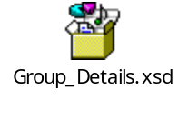

Annexure
NA

Terms & Conditions
Interns shall be solely responsible for all its acts and omissions under this program. Interns will comply at all times with all applicable laws. Interns shall not use Cognizant’s name, logo and trademark in any promotional materials or other communications with third parties without the prior written consent of Cognizant. Any materials used by interns in relation to program will not infringe the copyrights, trademarks, patents, trade secrets or other intellectual property rights, privacy or similar rights of any person or entity. Interns agrees not to post, draw, make, display any content that is threatening, libelous, obscene, defamatory, abusive, pornographic, or advocates/encourages any conduct that could constitute a criminal offence or give rise to any civil liability. Cognizant its associates’ personal details including but not limited to name, address, contact number shall not be shared or forwarded to any third party, without prior written consent of Cognizant, its associates. All intellectual property provided by Cognizant as part of program shall be owned exclusively by Cognizant. Intern shall indemnify, defend and indemnify Cognizant its associates, officers, directors from and against any claims, demands, loss, damage, liability, causes of action, judgments, or costs and expenses of every nature (including attorney’s fees and expenses) incurred by Cognizant based on any claim that any breach of terms and conditions of this program.

Change Log
Please note that this table needs to be maintained even if a Configuration Management tool is used.
Version Number | Changes made
V1.0
V1.1 | <If the change details are not explicitly documented in the table below, reference should be provided here>
V1.1 | Page no | Changed by | Effective date | Changes effected
V1.2 | <If the change details are not explicitly documented in the table below, reference should be provided here>
V1.2 | Page no | Changed by | Effective date | Changes effected

