1. Agree on the purpose of the web site

A theme park’s website should serve information potential visitors might be looking for in a clear, enticing, and intuitive manner. These can include:

* Attractions available
* Accommodations available
* Opening hours
* Entrance fees and/or purchasing of tickets
* Location and navigational details
* Contact information

1. Research theme park web sites

* [Theme Park Tickets & Passes | Gold Coast Attractions | Village Roadshow Theme Parks](https://themeparks.com.au/)
  + Works well:
    - Immediately greeted with information about what makes this theme park unique
    - Details visitors are most likely to be looking for are almost immediately available: pricing/packages, list of ongoing events, accommodations nearby, etc.
  + Not so successful:
    - Too many options to choose from
    - Too much text accompanies each section, not conducive for scanning through the site
* [Walt Disney World Resort in Orlando, Florida](https://www.disneyworld.eu/)
  + Works well:
    - Right on the front page are booking options and ongoing promotions
    - Attractions are presented with just their names without excessive information, users that want to explore have the choice to click to find out more
    - Lots of choices of attractions/accommodations to choose from, but they’ve made it easier to find relevant ones by categorizing them accordingly
    - Main menu is comprehensive and helpful in quickly navigating to required information
    - Detailed information for each attraction is presented with clear headings to divide large amounts of information
  + Not so successful:
    - Potential overload of information, but they do have a lot to offer
    - Every section of content is fighting for attention of the user
* [SeaWorld Theme Park - Florida Aquariums | SeaWorld Orlando](https://seaworld.com/orlando/)
  + Works well:
    - Greeted with awards, promotions, and key attractions to attract visitors to find out more
    - Each attraction has key information presented in simple symbols
  + Not so successful:
    - Almost overwhelmingly filled with text
* [Alton Towers Resort: UK Short Breaks, Theme Park & Waterpark](https://www.altontowers.com/)
  + Works well:
    - Front page is filled with ongoing events, attractions, reviews, packages—all the information someone might be looking for right on landing
    - Attractions can be sorted by height requirement, location, or type, making it easier to narrow your selection
  + Not so successful:
    - Each sub-page does not offer options to navigate to similar/related attractions. To continue exploring the site, you need to return to the previous page or the menu
* [Welcome to Six Flags Magic Mountain - Southern California](https://www.sixflags.com/magicmountain)
  + Works well:
    - Main page header is a video clip of their rides, which does a better job of showcasing the thrill than just static images
    - Different tickets are compared clearly with a table to highlight their differences
    - Attractions are categorized using laymen terms rather than brand names, making it intuitive to navigate the options
  + Not so successful:
    - The pages for the individual rides are presented with just a single image of the ride and a body of text. Important information the user might be looking for like age/height requirements require them to read through the chunk of text to locate

1. Agree on the content for the web site

Information should be presented clearly and intuitively so that our audience get the information they need without much navigation. This will help decide whether our theme parks are fit for them. We list these key features/content for the website:

Landing page

* Showcase main attractions
* Awards and reviews
* Ticket purchasing functionality (check-in & check-out selection, packages)
* Ongoing events

Sub-pages

* Location (Map for the theme pack, Opening times indicators, etc.)
* Information for individual attractions (Rides, dining, accommodation, events)
* Ticket information
* Frequently asked questions
* About the theme park (About Us, Contact Us, etc.)
* Safety information
* Member area (to check status and information of purchased tickets and past visits)

1. **Agree on the structure of the web site**

As of our point of view, We should use the main page as of

[Theme Park Tickets & Passes | Gold Coast Attractions | Village Roadshow Theme Parks](https://themeparks.com.au/) with slight changes in the main banner, and the middle content. by changing the main banner to a video that shows the more excitement of the theme parks and the enjoyment that you will gain. it's a good idea to show the features that our theme parks are offering by showing a brief well most powerful feature that our theme parks have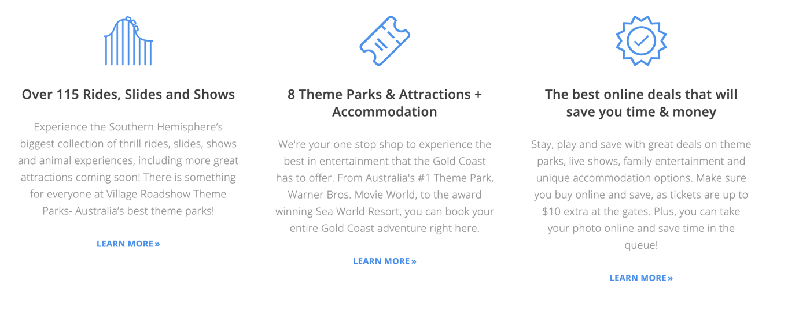

besides, we going to add a booking system where our visitors can search and pick the right time they want to visit our remarkable theme parks, we do believe it's a good idea to add our packages and what we are offering in our theme parks. something like [Six Flags Magic Mountain - Southern California](https://www.sixflags.com/magicmountain)

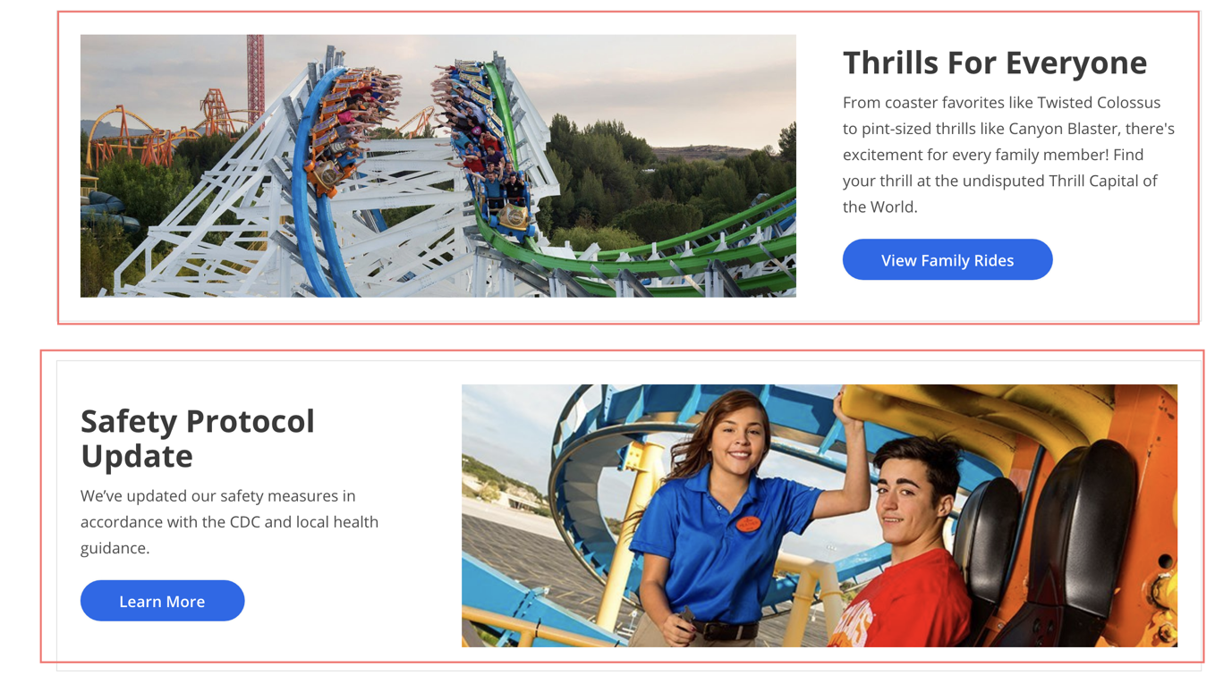

placing an instant support chat bot will boost our customer happiness because a port of our mission is too pleased our customers and support them in a quick & intuitive way! just like the beautiful [Six Flags Magic Mountain - Southern California](https://www.sixflags.com/magicmountain)

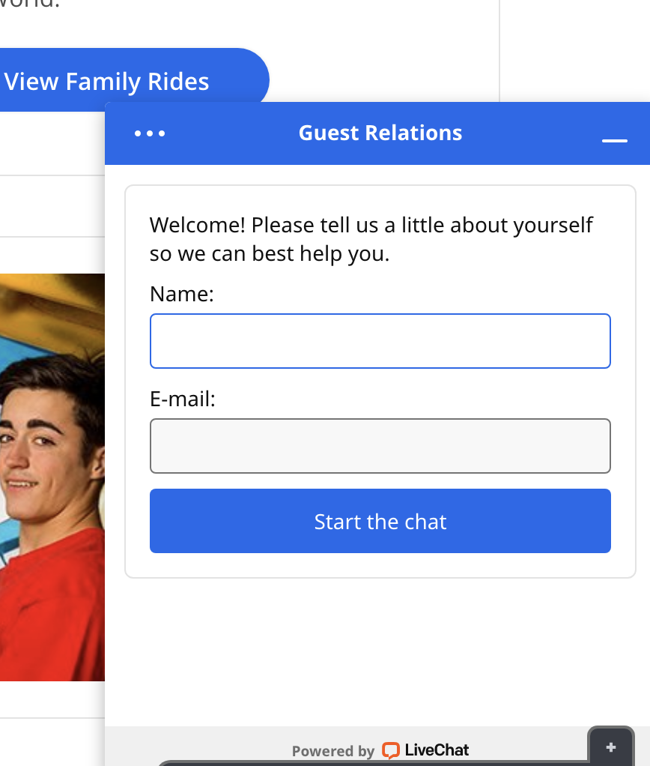

adding the subscription to our news lists so we can target our audiences in our campaign to encourage them to visit our theme parks again by giving them some special offering or special discount ..etc.

the [Alton Towers Resort: UK Short Breaks, Theme Park & Waterpark](https://www.altontowers.com/) enlighten us on how to place your form!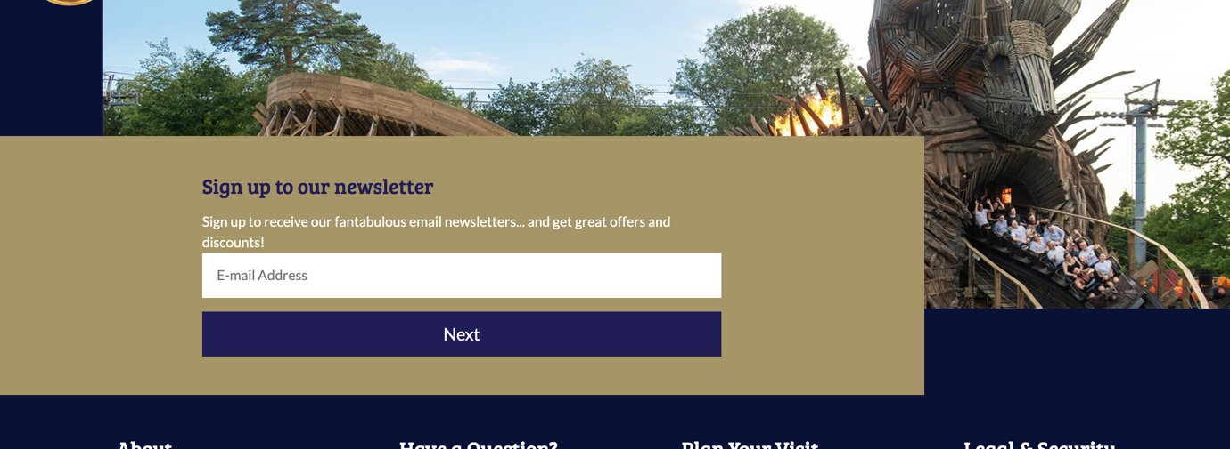

* packages

showing our packages offers, including how to navigate in our theme parks

with information on other parks that we are holding in different provinces

* **attractions**

listing all our attractions

1. Design the wireframes for the web site

* Large Screen

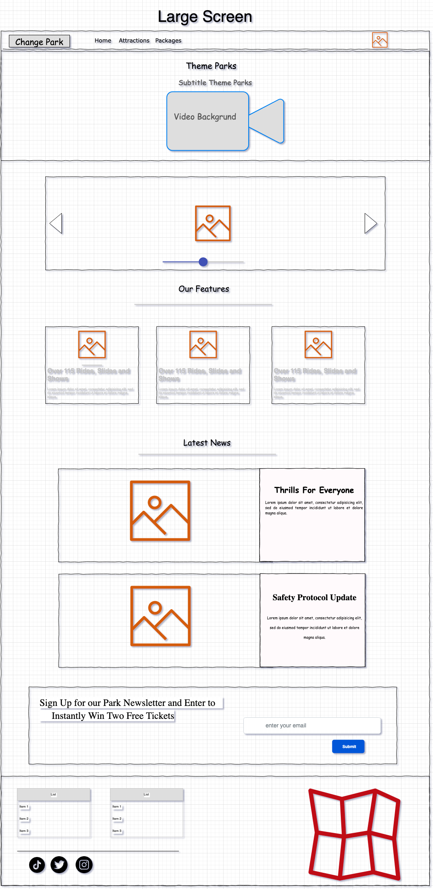

* Tablet Screen

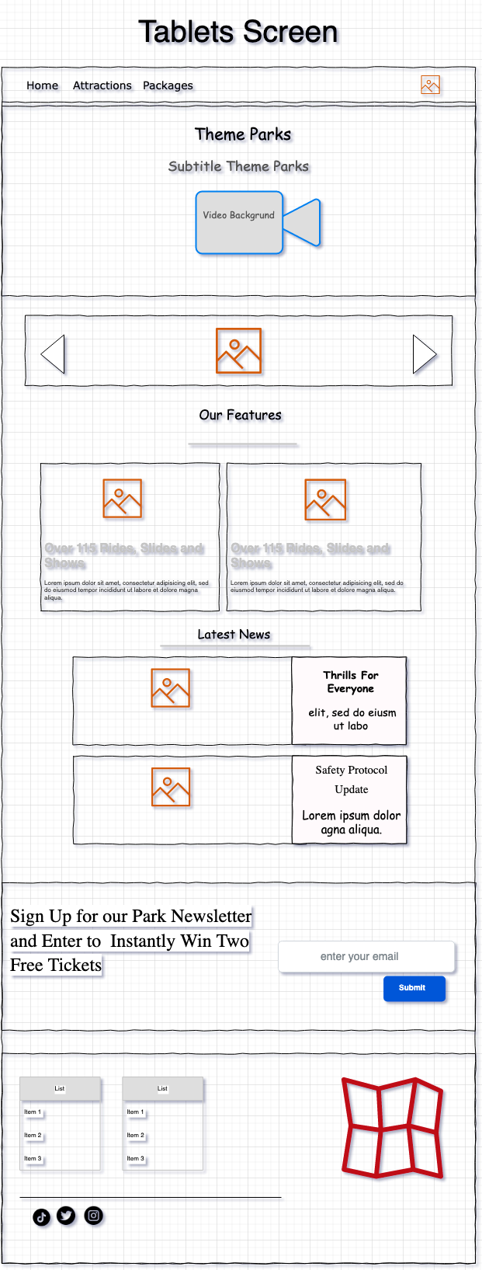

* Mobile Screen

