TIMETABLE NOTIFICATION SYSTEM
A MINI-PROJECT REPORT
Submitted by

SHYAM M 241801267
SRIMAN A 241801276
TARRUN B 241801291

in partial fulfillment of the award of the degree
of
BACHELOR OF TECHNOLOGY
IN
ARTIFICIAL INTELLIGENCE AND DATA SCIENCE

RAJALAKSHMI ENGINEERING COLLEGE, CHENNAI
An Autonomous Institute
CHENNAI
OCTOBER 2025

BONAFIDE CERTIFICATE
Certified that this project “TIMETABLE NOTIFICATION SYSTEM” is the bonafide work of “ SHYAM M , SRIMAN A , TARRUN B ” who carried out the project work under my supervision.

SIGNATURE
Dept. of
Rajalakshmi Engineering College
Chennai

This mini project report is submitted for the viva voce examination to be held on __________

INTERNAL EXAMINER EXTERNAL EXAMINER
ABSTRACT
This project titled “Timetable Notification System” is designed to automate the process of reminding students about their upcoming classes through Telegram notifications. The system integrates Oracle Database for backend data storage and Java (JDBC) for the frontend logic. It retrieves the class schedule for a given batch, displays the daily timetable, and automatically sends reminders to students before each class. The integration with Telegram’s API ensures instant and reliable communication. This system eliminates the need for manual timetable checking and helps improve punctuality and class attendance.

ACKNOWLEDGEMENT

We express our sincere thanks to our beloved and honorable chairman MR. S. MEGANATHAN and the chairperson DR. M.THANGAM MEGANATHAN for their timely support and encouragement.
We are greatly indebted to our respected and honorable principal
Dr. S.N. MURUGESAN for his able support and guidance.
No words of gratitude will suffice for the unquestioning support extended to us by our Head Of The Department Dr. E.M. MALATHY and our Deputy Head Of The Department Dr. J. MANORANJINI for being ever supporting force during our project work
We also extend our sincere and hearty thanks to our internal guide Dr. V. JANANEE , for her valuable guidance and motivation during the completion of this project.
Our sincere thanks to our family members, friends and other staff members of computer science engineering.
1. SHYAM M
2. SRIMAN A
3. TARRUN B

TABLE OF CONTENTS

CHAPTER NO. | TITLE | PAGE NO
 | ABSTRACT | 3
1 | INTRODUCTION | 7
1.1 | Introduction | 7
1.2 | Scope of the Work | 7
1.3 | Problem Statement | 8
1.4 | Aim and Objectives of the Project | 8
2 | System Specifications | 10
2.1 | Hardware Specifications | 10
2.2 | Software Specifications | 10
3 | Module Description | 11
4 | Coding | 13
5 | Screenshots | 22
6 | Conclusion and Future Enhancement | 25
 | References | 26

CHAPTER 1:
INTRODUCTION
1.1 INTRODUCTION
In modern educational institutions, students often face difficulties keeping track of class schedules, especially when the timetable frequently changes. This project addresses that issue by creating an automated reminder system using a Java application connected to an Oracle database. The application retrieves class schedules from the database and sends reminders before each class through Telegram Bot notifications. This reduces human dependency and ensures timely communication.
The system allows the user to:
- View the daily timetable for a specific batch.
- Automatically send Telegram alerts before class start times.
- Configure reminder intervals as per user preference.
1.2 SCOPE OF THE WORK
The proposed system is intended for:
- Colleges and universities with fixed timetables.
- Students who want timely reminders for each class.
- Faculty and administrators who wish to automate communication.
The system can be extended to multiple batches, rooms, and teachers. Its modular design allows future integration with mobile apps or web dashboards.
1.3 PROBLEM STATEMENT
Students often miss classes due to a lack of timely reminders or confusion about schedule timings. Traditional notice boards or printed timetables are not always accessible or up to date. A digital, automated, and reliable system is required to ensure that students are notified in advance about their upcoming classes.

1.4 AIM AND OBJECTIVES OF THE PROJECT
Aim:
To develop an Automated Class Reminder System that uses Oracle Database for data management and Java–Telegram integration for notifications.
Objectives:
- To design a database schema for managing timetables, teachers, and classrooms.
- To build a Java application that fetches and displays timetable details.
- To implement a Telegram Bot that sends reminders before classes begin.
- To enable real-time notifications using a configurable reminder interval.
- To reduce human errors and increase attendance through automation.

CHAPTER 2:
SYSTEM SPECIFICATIONS
2.1 HARDWARE SPECIFICATIONS
Component | Minimum Requirement
Processor | Intel Core i3 or above
RAM | 4 GB or more
Hard Disk | 500 MB free space
Display | 1024 × 768 resolution
Network | Internet connection (for Telegram API)

2.2 SOFTWARE SPECIFICATIONS
Software | Description
Operating System | Windows / Linux / macOS
Programming Language | Java (JDK 17 or higher)
Database | Oracle Database 11g / 12c / 19c
JDBC Driver | Oracle JDBC (ojdbc8.jar)
IDE | IntelliJ IDEA / Eclipse / VS Code
Telegram | Telegram Bot API
Dependencies | java.sql, java.net, java.time
 | Used to automate Java compilation and execution (run.bat)
  Windows Batch File
CHAPTER 3:
MODULE DESCRIPTION
Module 1: Database Design
- The Oracle backend consists of five main tables: batch, course, teacher, classroom, and timetable.
- The schema maintains relationships between these entities using foreign keys.
- Each timetable entry maps a course, teacher, classroom, and batch for a specific day and time.
Module 2: Timetable Display
- The Java frontend connects to Oracle using JDBC.
- Users can input their batch ID and day of the week to display the full timetable.
- Timetable results are sorted by class start time.
Module 3: Telegram Notification System
- The program integrates with Telegram Bot API using HTTP requests.
- Users configure reminder time (in minutes before class).
- The system continuously checks the current time and compares it with class start times.
- When a class is about to begin, a Telegram notification is automatically sent to the group or chat.
Module 4: Reminder Loop
- Runs in the background continuously.
- Sends notifications once per class (avoiding duplicates using a hash set).
- Checks for the next upcoming class every minute.

CHAPTER 4:
CODING
The frontend (Java code) implements the main logic for:
- Establishing database connections
- Fetching timetable data
- Sending Telegram reminders
FRONT END PROGRAM:
import java.io.BufferedReader;
import java.io.InputStreamReader;
import java.net.HttpURLConnection;
import java.net.URI;
import java.net.URL;
import java.net.URLEncoder;
import java.nio.charset.StandardCharsets;
import java.sql.*;
import java.time.LocalDateTime;
import java.time.LocalTime;
import java.util.HashSet;
import java.util.Scanner;
import java.util.Set;

public class OracleConnection {

// ====== Telegram Bot Config (⚠ keep secret) ======
static String BOT_TOKEN = "8450243775:AAHQtiKT-a04rZamTRupMCa3U5mqmb9jvYc";
static String CHAT_ID = "-1003182502541"; // Replace with your actual chat ID

public static void main(String[] args) {
Scanner scanner = new Scanner(System.in);

sendTelegramMessage("✅ Test message: Telegram notifications are working!");

// Get batch id
System.out.print("Enter your Batch ID: ");
int batchId = scanner.nextInt();
scanner.nextLine();

// Get reminder minutes
System.out.print("Enter reminder time (in minutes before class, e.g. 5, 10, 15): ");
int reminderMinutes = scanner.nextInt();
scanner.nextLine();

// Get day input
System.out.print("Enter a day to view timetable (e.g., Monday) or type 'today': ");
String inputDay = scanner.nextLine().trim();

// Resolve day
String dayOfWeek;
if (inputDay.equalsIgnoreCase("today")) {
dayOfWeek = LocalDateTime.now().getDayOfWeek().toString(); // e.g., SATURDAY
dayOfWeek = dayOfWeek.charAt(0) + dayOfWeek.substring(1).toLowerCase();
} else {
dayOfWeek = inputDay;
}

String url = "jdbc:oracle:thin:@localhost:1521:xe";
String user = "shyam";
String password = "password";

try {
// Load Oracle JDBC Driver
Class.forName("oracle.jdbc.driver.OracleDriver");

try (Connection conn = DriverManager.getConnection(url, user, password)) {

// ================= TIMETABLE DISPLAY =================
String timetableQuery = """
SELECT c.course_name, te.teacher_name, r.room_name, t.start_time, t.end_time
FROM timetable t
JOIN course c ON t.course_id = c.course_id
JOIN teacher te ON t.teacher_id = te.teacher_id
JOIN classroom r ON t.room_id = r.room_id
WHERE t.day_of_week = ? AND t.batch_id = ?
ORDER BY TO_DATE(t.start_time, 'HH24:MI')
""";

try (PreparedStatement ps = conn.prepareStatement(timetableQuery)) {
ps.setString(1, dayOfWeek);
ps.setInt(2, batchId);

ResultSet rs = ps.executeQuery();
System.out.println("\n📅 Timetable for " + dayOfWeek + ":");

boolean hasData = false;
while (rs.next()) {
hasData = true;
String course = rs.getString("course_name");
String teacher = rs.getString("teacher_name");
String room = rs.getString("room_name");
String start = rs.getString("start_time");
String end = rs.getString("end_time");

System.out.printf(" - %s | Teacher: %s | Room: %s | %s - %s%n",
course, teacher, room, start, end);
}
if (!hasData) {
System.out.println("No classes scheduled for this day.");
}
}

// ================= REMINDER LOOP =================
String reminderQuery = """
SELECT * FROM (
SELECT c.course_name, te.teacher_name, r.room_name, t.start_time
FROM timetable t
JOIN course c ON t.course_id = c.course_id
JOIN teacher te ON t.teacher_id = te.teacher_id
JOIN classroom r ON t.room_id = r.room_id
WHERE t.day_of_week = ?
AND TO_DATE(t.start_time, 'HH24:MI') > TO_DATE(?, 'HH24:MI')
AND t.batch_id = ?
ORDER BY TO_DATE(t.start_time, 'HH24:MI') ASC
) WHERE ROWNUM = 1
""";

Set<String> notifiedClasses = new HashSet<>();

System.out.println("\n🔁 Reminder service started. Waiting to notify...");

while (true) {
LocalTime now = LocalTime.now();
LocalTime reminderTime = now.plusMinutes(reminderMinutes);

try (PreparedStatement ps = conn.prepareStatement(reminderQuery)) {
ps.setString(1, dayOfWeek);
ps.setString(2, now.toString().substring(0, 5));
ps.setInt(3, batchId);

ResultSet rs = ps.executeQuery();
if (rs.next()) {
String course = rs.getString("course_name");
String teacher = rs.getString("teacher_name");
String room = rs.getString("room_name");
String start = rs.getString("start_time");

String classKey = course + start;

LocalTime classTime = LocalTime.parse(start.substring(0, 5));
if (classTime.isBefore(reminderTime) && !notifiedClasses.contains(classKey)) {
String message = "📢 Class Reminder!\n\nNext class: " + course +
"\nTeacher: " + teacher +
"\nRoom: " + room +
"\nTime: " + start;
sendTelegramMessage(message);

System.out.println("✅ Reminder sent for: " + course + " at " + start);
notifiedClasses.add(classKey);
} else {
System.out.println("⏱ Waiting... Next class at " + start);
}
} else {
System.out.println("✅ No more classes found for today.");
}
} catch (SQLException e) {
System.out.println("❌ Error during reminder check: " + e.getMessage());
}

// Wait 1 minute before next check
try {
Thread.sleep(60 * 1000);
} catch (InterruptedException ie) {
Thread.currentThread().interrupt();
break;
}
}

}
} catch (ClassNotFoundException e) {
System.out.println("❌ Oracle JDBC Driver not found. Include ojdbc jar in classpath.");
} catch (SQLException e) {
System.out.println("❌ Database error: " + e.getMessage());
}
}

// ================= TELEGRAM MESSAGE METHOD =================
public static void sendTelegramMessage(String message) {
try {
String urlString = "https://api.telegram.org/bot" + BOT_TOKEN +
"/sendMessage?chat_id=" + CHAT_ID +
"&text=" + URLEncoder.encode(message, StandardCharsets.UTF_8);

URI uri = URI.create(urlString);
URL url = uri.toURL();

HttpURLConnection conn = (HttpURLConnection) url.openConnection();
conn.setRequestMethod("GET");

BufferedReader in = new BufferedReader(
new InputStreamReader(conn.getInputStream(), StandardCharsets.UTF_8)
);
StringBuilder response = new StringBuilder();
String inputLine;

while ((inputLine = in.readLine()) != null) {
response.append(inputLine);
}
in.close();

System.out.println("📨 Telegram Response: " + response);
conn.disconnect();
} catch (Exception e) {
System.out.println("❌ Failed to send Telegram message: " + e.getMessage());
}
}
}

The backend (Oracle SQL) creates the schema and inserts initial data.
BACKEND PROGRAM :

-- ====== DROP EXISTING TABLES ======
DROP TABLE timetable CASCADE CONSTRAINTS;
DROP TABLE classroom CASCADE CONSTRAINTS;
DROP TABLE teacher CASCADE CONSTRAINTS;
DROP TABLE course CASCADE CONSTRAINTS;
DROP TABLE batch CASCADE CONSTRAINTS;

-- ====== CREATE TABLE: BATCH ======
CREATE TABLE batch (
batch_id INT PRIMARY KEY,
batch_name VARCHAR2(100)
);

-- ====== CREATE TABLE: COURSE ======
CREATE TABLE course (
course_id VARCHAR2(20) PRIMARY KEY,
course_name VARCHAR2(100)
);

-- ====== CREATE TABLE: TEACHER ======
CREATE TABLE teacher (
teacher_id INT PRIMARY KEY,
teacher_name VARCHAR2(100)
);

-- ====== CREATE TABLE: CLASSROOM ======
CREATE TABLE classroom (
room_id VARCHAR2(20) PRIMARY KEY,
room_name VARCHAR2(100)
);

-- ====== CREATE TABLE: TIMETABLE ======
CREATE TABLE timetable (
timetable_id INT PRIMARY KEY,
batch_id INT,
course_id VARCHAR2(20),
teacher_id INT,
room_id VARCHAR2(20),
day_of_week VARCHAR2(20),
start_time VARCHAR2(10),
end_time VARCHAR2(10),
FOREIGN KEY (batch_id) REFERENCES batch(batch_id),
FOREIGN KEY (course_id) REFERENCES course(course_id),
FOREIGN KEY (teacher_id) REFERENCES teacher(teacher_id),
FOREIGN KEY (room_id) REFERENCES classroom(room_id)
);

4.1 Program Execution Using Batch File
To simplify execution, a Windows batch file (run.bat) was created.
This batch file compiles and runs the Java program automatically without needing to open the IDE each time.
Sample run.bat content:
@echo off
javac OracleConnection.java
java OracleConnection
pause

Explanation:
- javac OracleConnection.java → Compiles the Java file.
- java OracleConnection → Executes the compiled program.
- pause → Keeps the console window open until the user presses a key.
Using a batch file makes it easier to test and demonstrate the project directly from the command line.

CHAPTER 5:
SCREENSHOTS
1 . Database Tables in Oracle SQL Developer
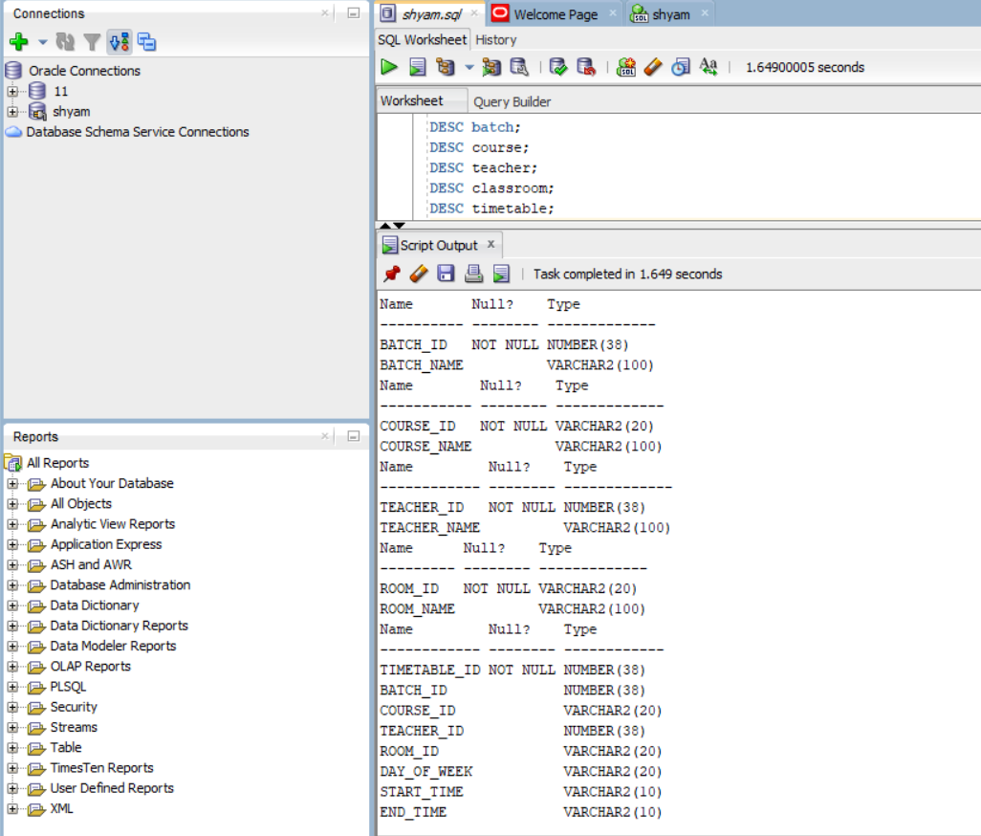

2 . Program Execution :
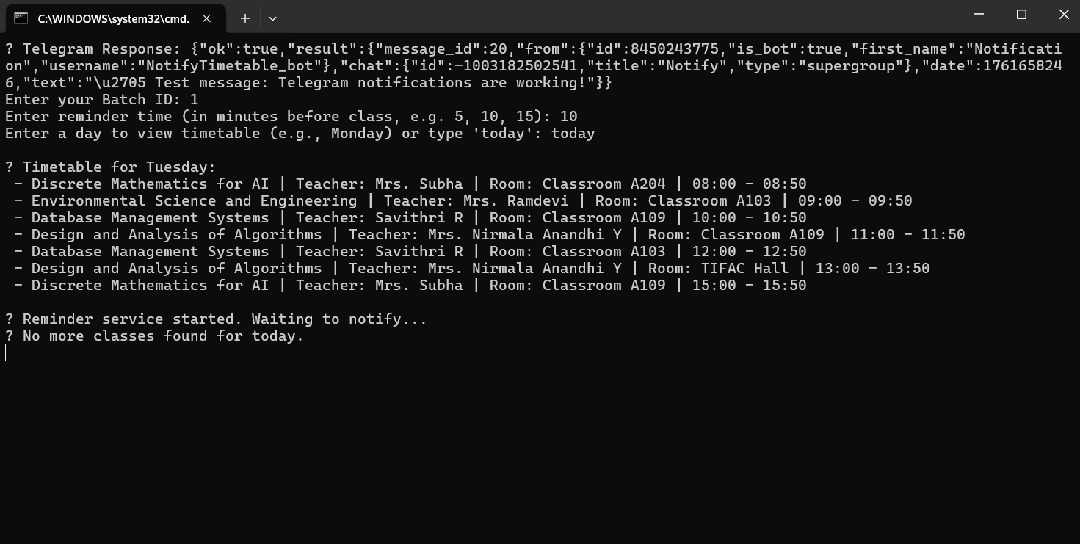

3 . Mobile Notification Screenshot :
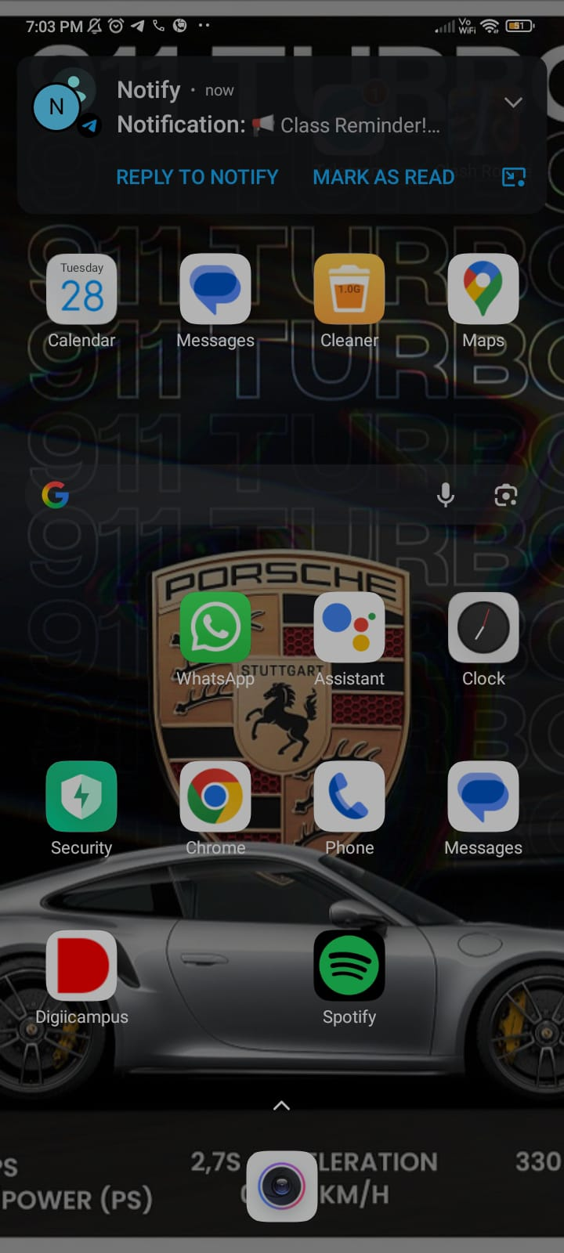
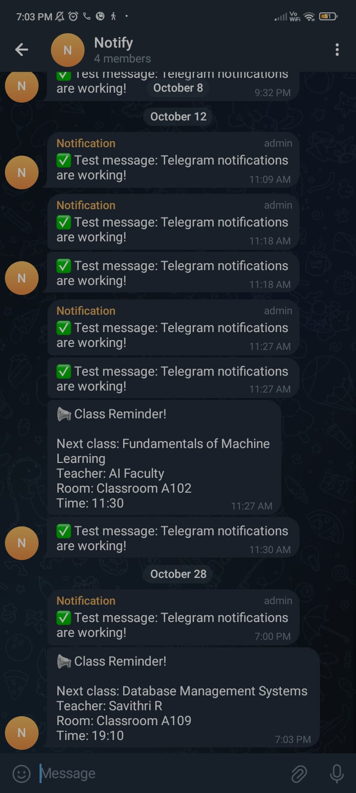

CHAPTER 6:
CONCLUSION AND FUTURE ENHANCEMENT
Conclusion:
The Timetable Reminder and Notification System successfully integrates Oracle and Java technologies to provide an efficient, real-time reminder mechanism through Telegram. It eliminates manual processes, improves student punctuality, and simplifies timetable management. The project demonstrates the effective use of JDBC, SQL, and API integration in a real-world scenario.
Future Enhancements:
- Integration with mobile apps or web portals for better accessibility.
- Support for multiple batches and departments simultaneously.
- Implementation of Google Calendar synchronization.
- Use of machine learning to predict class attendance trends.
- Integration with college ERP systems for full automation.
references:
- Oracle Corporation. Oracle Database SQL Language Reference. Oracle Documentation, 2024.
https://docs.oracle.com/en/database/oracle/oracle-database/ .
- Oracle Corporation. Oracle JDBC Developer’s Guide. Oracle Documentation, 2024.
https://docs.oracle.com/en/database/oracle/oracle-database/21/jjdbc/ .
- Telegram. Bot API Documentation. Telegram, 2024.
https://core.telegram.org/bots/api .
- Schildt, Herbert. Java: The Complete Reference, 11th Edition. McGraw-Hill Education, 2021.
- Baeldung. Guide to JDBC with Oracle.
https://www.baeldung.com/java-jdbc-oracle .

